Supporting Information

Title
Fungal and bacterial species richness in biodeteriorated 17th century Venetian manuscripts

Authors
Maria Stratigaki,^{a*} Andrea Armirotti,^{b} Giuliana Ottonello,^{b} Sabrina Manente,^{c} Arianna Travigliaª

Author affiliations
ª Center for Cultural Heritage Technology (CCHT), Istituto Italiano di Tecnologia, Via Torino 155, 30172 Venice, Italy
^{b} Analytical Chemistry Facility, Istituto Italiano di Tecnologia, Via Morego 30, 16163 Genova, Italy
^{c} Department of Molecular Sciences and Nanosystems, Ca’ Foscari University of Venice, Via Torino 155, 30172 Venice, Italy

*Corresponding author, maria.stratigaki@iit.it

Fig. SI_1 Images of the fibre network of Whatman Grade 1 filter paper at different magnifications captured with: (a) stereoscope, scale bar 500 µm, (b) optical microscope, scale bar 100 µm, (c) scanning electron microscope, scale bars as denoted individually.

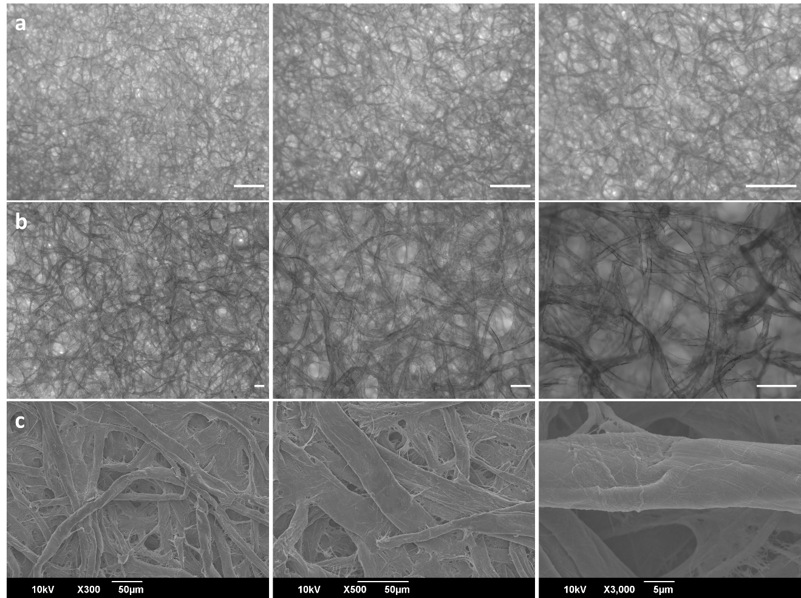

Fig. SI_2 (a) SEM image of fragment #3, scale bar 50 µm, and (b) stereoscopic view of a golden-brown coloured parasite of approximate length of 3 mm and width 1 mm, discovered between the letters, scale bar 500 µm.

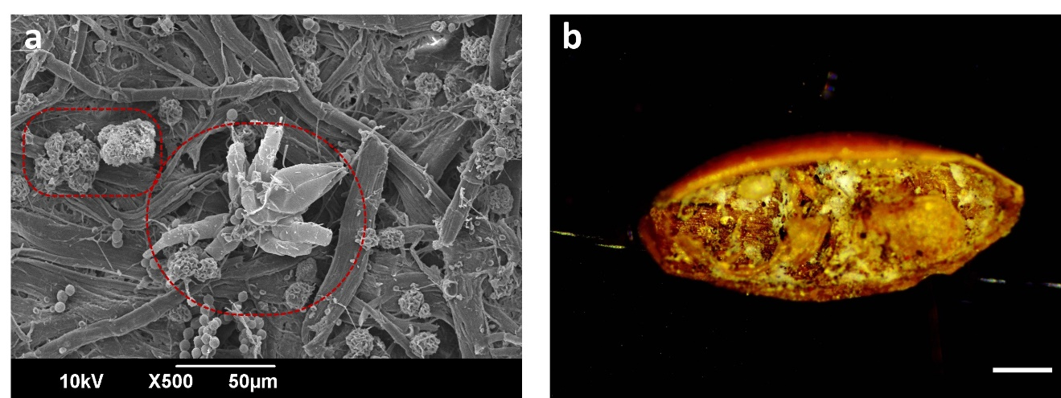

Fig. SI_3 Images of Petri dishes showing the growth evolution of microorganisms after inoculation of the fragments on agar plates captured at different days: (i) day 1, (ii) day 8, (iii) day 11, (iv) day 15, (v) day 24, and (vi) day 30. Media are: (a) PCA, (b) DG18, and (c) MEA.

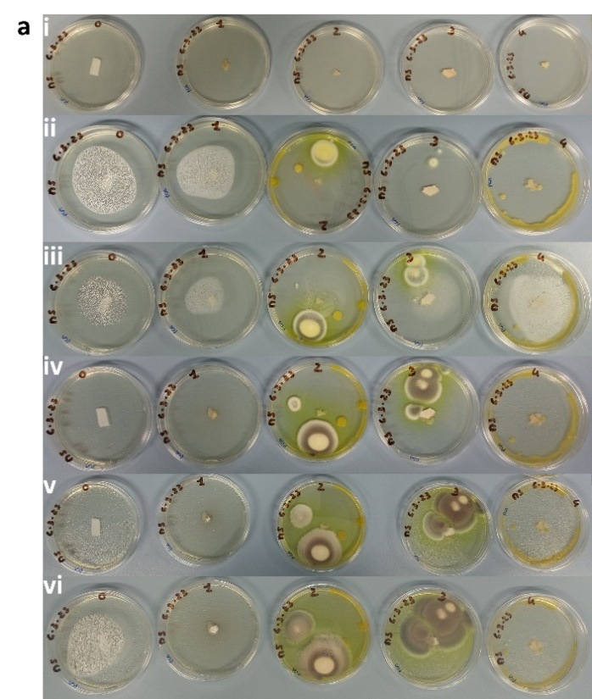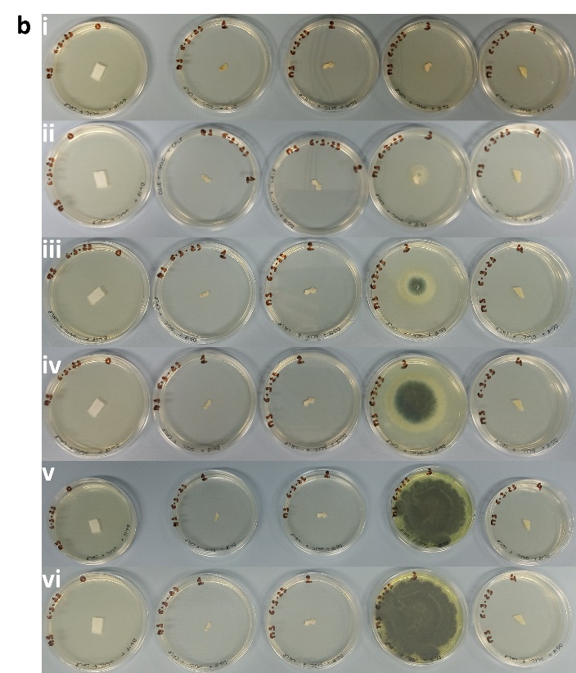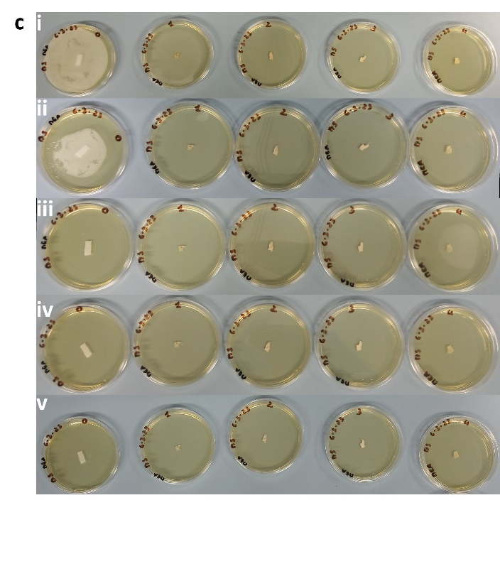

Fig. SI_4 Images of Petri dishes showing re-cultures after separating the different species from the original colonies: (a) sample 1-PCA on two new plates of PCA (left) and MEA (right) media, day 21, (b) sample 2-PCA on three new plates of PCA media, day 7, (c) sample 4-PCA on four new plates of PCA media, day 7.

