Supplementary Data
White and gray matter integrity evaluated by MRI-DTI can serve as noninvasive and reliable indicators of structural and functional alterations in chronic neurotrauma

Lan-Wan Wang ^{1,2}, Kuan-Hung Cho ³, Pi-Yu Chao ⁴, Li-Wei Kuo ^{3,5}, Chia-Wen Chiang ³, Chien-Ming Chao ^{6,7}, Mao-Tsun Lin ⁴, Ching-Ping Chang ^{4,*}, Hung-Jung Lin ^{8,9,*}, Chung-Ching Chio ^{10,*}
¹Department of Pediatrics, Chi Mei Medical Center, Tainan 710, Taiwan
²Department of Biotechnology and Food Technology, Southern Taiwan University of Science and Technology, Tainan 710, Taiwan
³ Department of Electronic Engineering, National United University, Maioli City 360, Taiwan
⁴Department of Medical Research, Chi Mei Medical Center, Tainan 710, Taiwan
⁵Institute of Biomedical Engineering and Nanomedicine, National Health Research Institutes, Miaoli County 350, Taiwan.
⁶Institute of Medical Device and Imaging, National Taiwan University College of Medicine, Taipei 100, Taiwan
⁷Department of Intensive Care Medicine, Chi Mei Medical Center, Liouying, Tainan 73657, Taiwan.
⁸Department of Nursing, Min-Hwei College of Health Care Management, Tainan, Taiwan.
⁹Department of Emergency Medicine, Chi Mei Medical Center, Tainan 710, Taiwan
¹⁰School of Medicine, Taipei Medical University, Taipei 110, Taiwan
¹¹Division of Neurosurgery, Department of Surgery, Chi Mei Medical Center, Tainan 710, Taiwan
Correspondence to:
Ching-Ping Chang, Ph.D., Department of Medical Research, Chi Mei Medical Center. Address: No. 901, Zhonghua Rd, Yongkang District, Tainan City 710, Taiwan. Phone: +886-6-2812811 ext 52657; fax: +886-6-2832639; e-mail: jessica.cpchang@gmail.com or a50831@mail.chimei.org.tw
Hung-Jung Lin, MD., Department of Emergency Medicine, Chi Mei Medical Center. Address: No. 901, Zhonghua Rd, Yongkang District, Tainan City 710, Taiwan. Phone: +886-6-2812811 ext 52000; fax: +886-6-2832639; e-mail: 790001@mail.chimei.org.tw
Chung-Ching Chio, M.D., Division of Neurosurgery, Department of Surgery, Chi Mei Medical Center. Address: No. 901, Zhonghua Rd, Yongkang District, Tainan City 710, Taiwan. Phone: +886-6-2812811 ext 52000; fax: +886-6-2832639; e-mail: chiocc@ms28.hinet.net

Total figure number: 7
Legends for supplementary video 1:
The time-dependent changes in DTI, T2WI, T1WI, and CE-T1WI whole-brain images from D3 to M9 from a sham rat, a TBI rat, and a rmTBI rat are shown in video format.
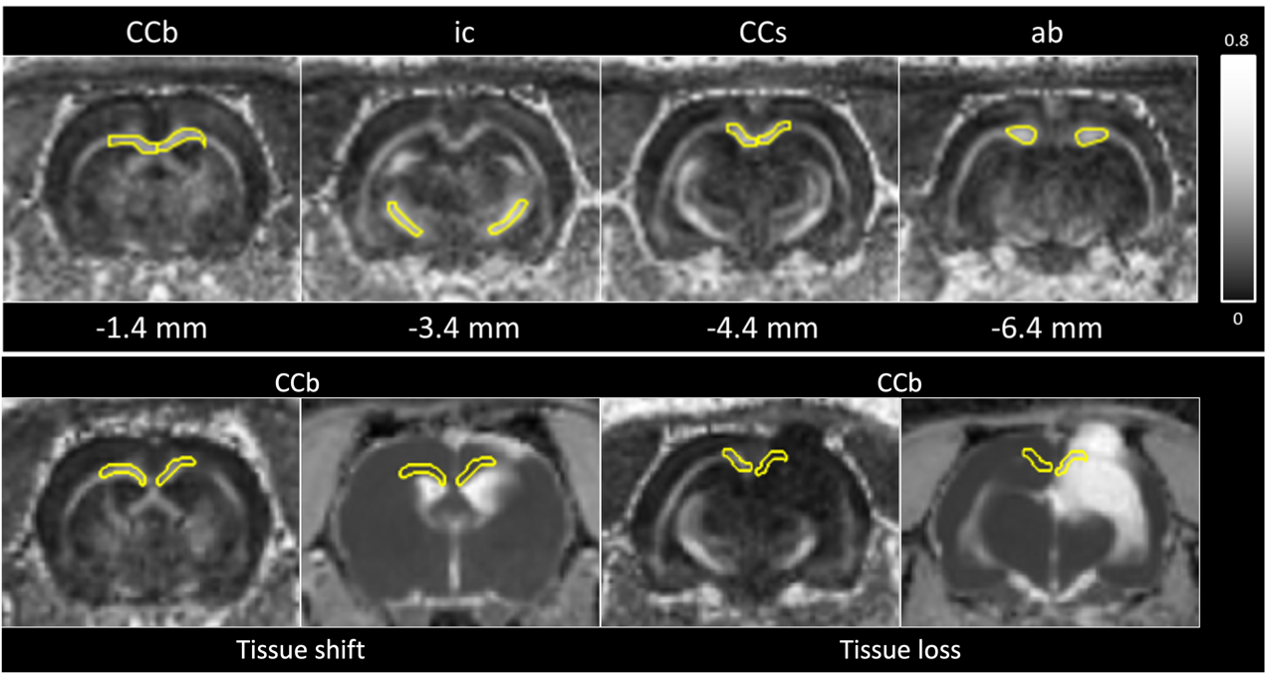
Figure S1: Top: Region of interests (ROIs) included in the DTI analysis. ROIs are outlined in a representative coronal FA map of a sham-operated animal. Four ROIs are outlined on body of corpus callosum (CCb), internal capsule (ic), splenium of corpus callosum (CCs) and angular bundle (ab) respectively. The contralateral hemisphere is on the left of image and the ipsilateral hemisphere is on the right of image. Gray scale indicates FA values between 0 (black) and 0.8 (white). Bottom: Examples of ROI selection for cases of shift of CCb (left) and loss of CCb (right). With the case of tissue loss, the ROI is outlined based on the rat brain atlas no matter the ROI is filled by CSF or not.

Figure S2: ROIs included in the T2WI analysis. ROIs are outlined in a representative coronal T2WI map of a sham-operated animal. Three ROIs are outline on striatum, hippocampus and cortex, respectively. The contralateral hemisphere is on the left of the image and the ipsilateral hemisphere is on the right of the image. All gray matter ROIs are selected based on the rat brain atlas no matter the ROI is filled by CSF or not.
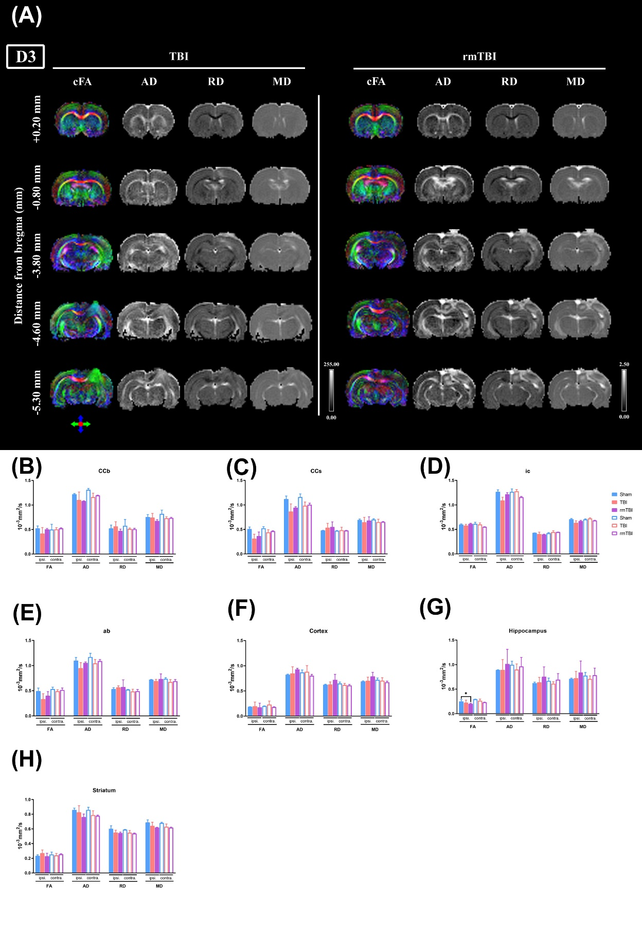
Figure S3: TBI causes alterations in DTI parameters at D3 after injury. (A) Coronal images of the diffusion parameter map (bregma +0.20 mm to -5.3 mm) were obtained from an TBI and an rmTBI rat on day 3 (D3) post-injury. (A) Coronal brain sections presented the colored fractional anisotropy (cFA), mean diffusivity (MD), radial diffusivity (RD), and axial diffusivity (AD) maps. The cFA brain map with direction encoded color maps were based on the extracted direction: red was for medial-lateral (x-axis), green was for rostral-caudal (y-axis), and blue was for dorsal-ventral (z-axis). The grayscale indicates FA values between 0 (black) and 1 (white) and AD, RD, and MD values between 0 (black) and 255 (white). The four indices FA, AD, RD, and MD for each brain structure are quantified at D3 of post-injury, including (B) CCb, (C) CCs, (D) ic, (E) ab, (F) cortex, (G) hippocampus, and (H) striatum. Blue bars represents Sham group (n = 2), orange bars TBI group (n = 4), and purple bars rmTBI group (n=2). The statistical analysis data are summarized in “Table S2”.

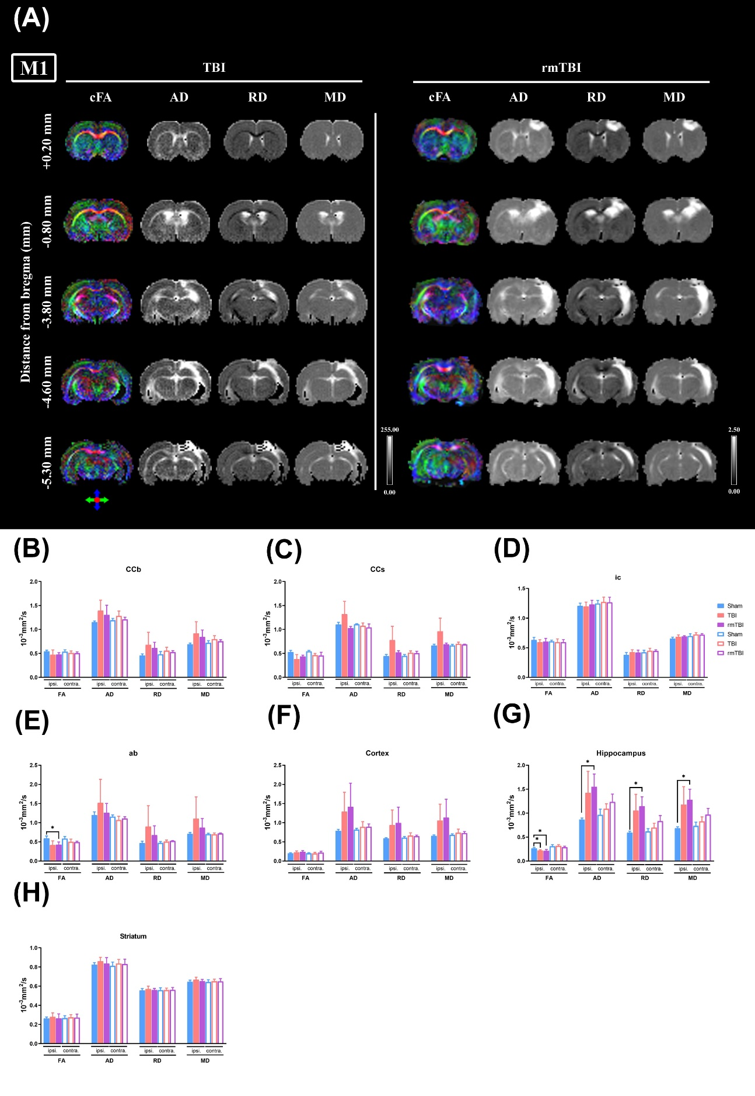
Figure S4: TBI causes alterations in DTI parameters at M1 after injury. (A) Coronal images of the diffusion parameter map (bregma +0.20 mm to -5.3 mm) were obtained from an TBI and an rmTBI rat on month 1 (M1) post-injury. Coronal brain sections presented the colored fractional anisotropy (cFA), mean diffusivity (MD), radial diffusivity (RD), and axial diffusivity (AD) maps. The cFA brain map with direction encoded color maps were based on the extracted direction: red was for medial-lateral (x-axis), green was for rostral-caudal (y-axis), and blue was for dorsal-ventral (z-axis). The grayscale indicates FA values between 0 (black) and 1 (white) and AD, RD, and MD values between 0 (black) and 255 (white). The four indices FA, AD, RD, and MD for each brain structure are quantified at M1 of post-injury, including (B) CCb, (C) CCs, (D) ic, (E) ab, (F) cortex, (G) hippocampus, and (H) striatum. Blue bars represents Sham group (n = 5), orange bars TBI group (n = 6), and purple bars rmTBI group (n = 4). The statistical analysis data were summarized in “Table S3”.

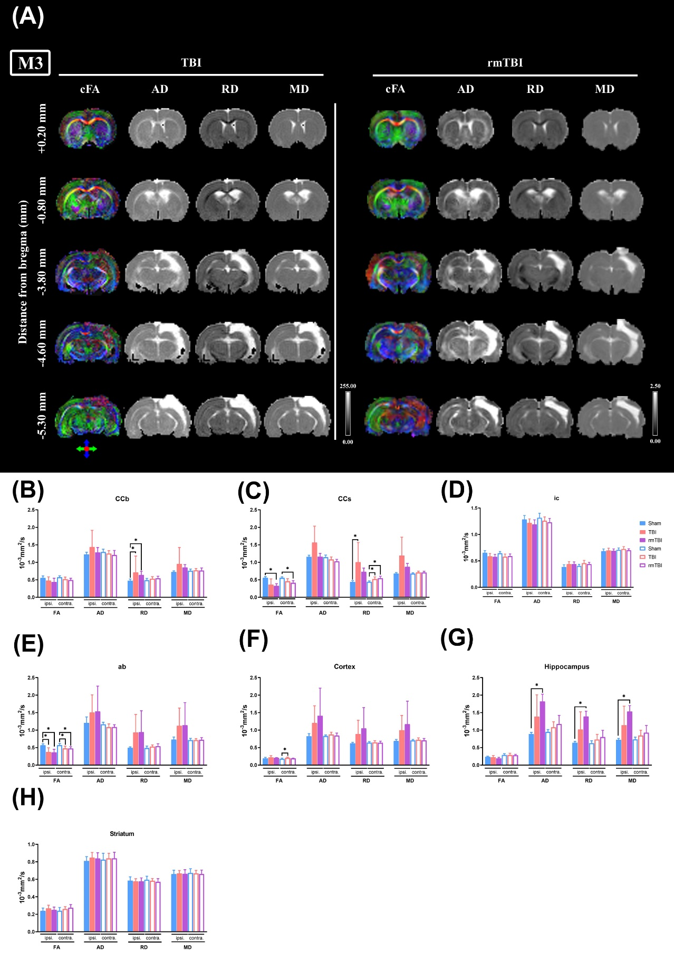
Figure S5: TBI causes alterations in DTI parameters at M3 after injury. (A) Coronal images of the diffusion parameter map (bregma +0.20 mm to -5.3 mm) were obtained from an mTBI and an rTBI rat on month 3 (M3) post-injury. Coronal brain sections presented the colored fractional anisotropy (cFA), mean diffusivity (MD), radial diffusivity (RD), and axial diffusivity (AD) maps. The cFA brain map with direction encoded color maps were based on the extracted direction: red was for medial-lateral (x-axis), green for rostral-caudal (y-axis), and blue for dorsal-ventral (z-axis). The grayscale indicates FA values between 0 (black) and 1 (white) and AD, RD, and MD values between 0 (black) and 255 (white). The four indices FA, AD, RD, and MD for each brain structure are analyzed at M3 of post-injury, including (B) CCb, (C) CCs, (D) ic, (E) ab, (F) cortex, (G) hippocampus, and (H) striatum. Blue bars represents Sham group (n = 6), orange bars TBI group (n = 5), and purple bars rmTBI group (n = 6). The statistical analysis data were summarized in in “Table S4”.

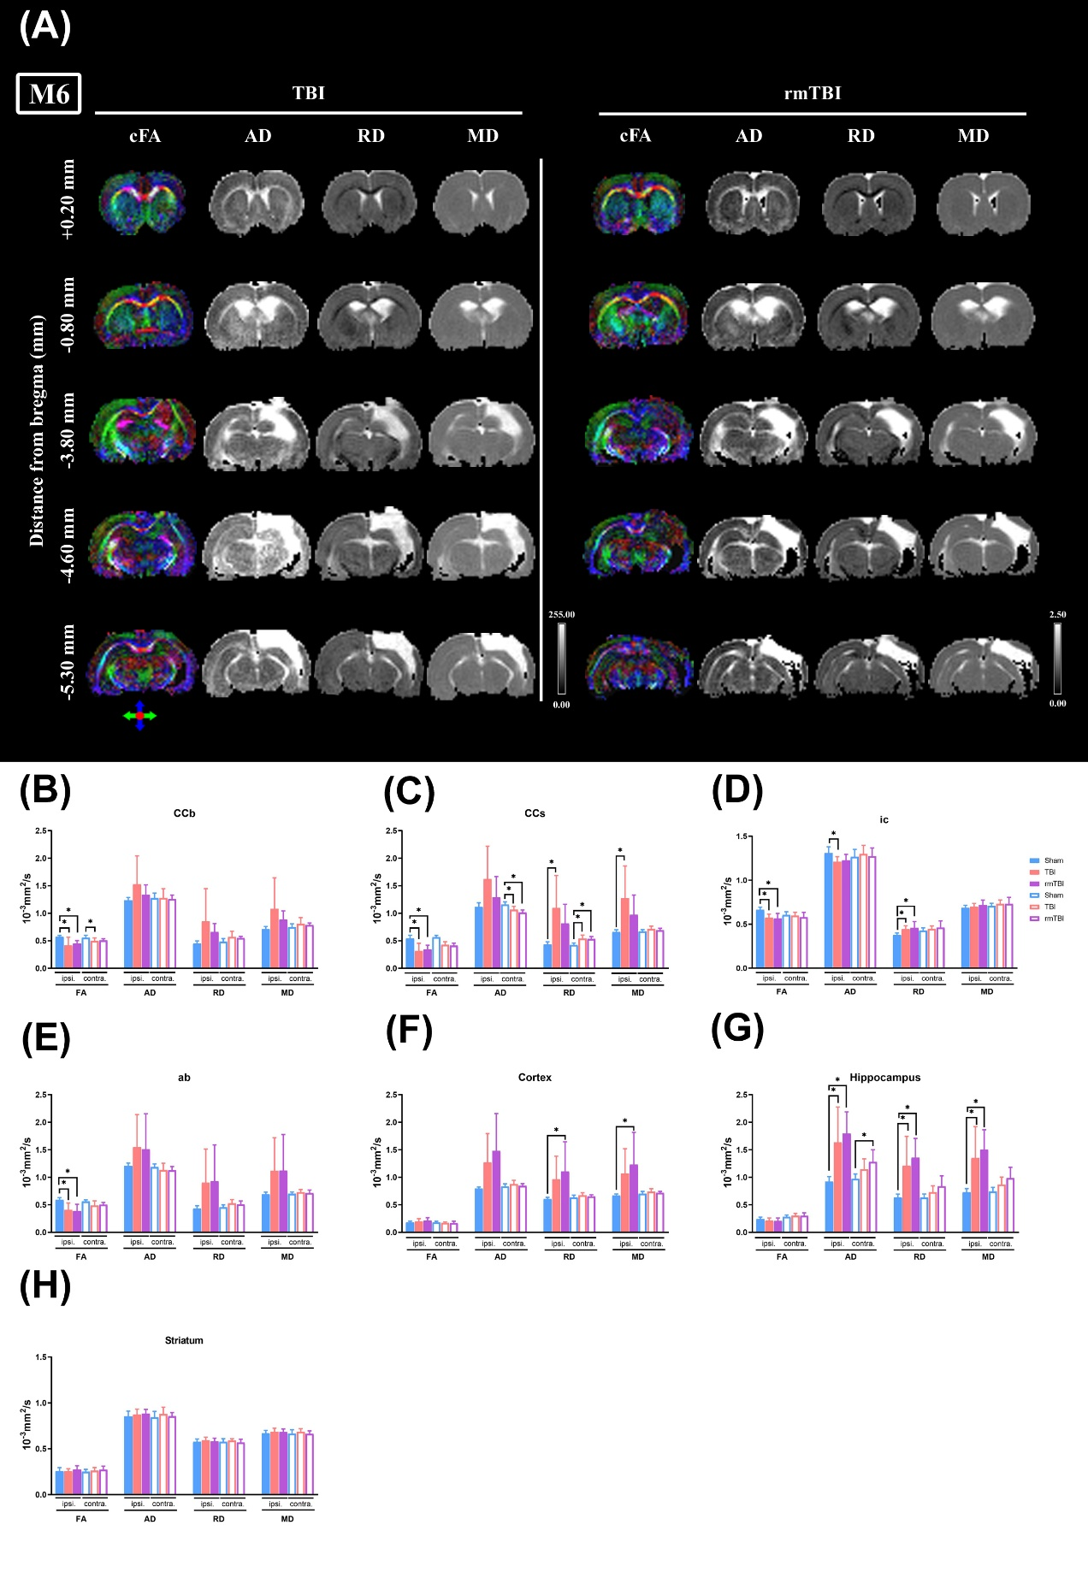
Figure S6: TBI causes alterations in DTI parameters at M6 after injury. (A) Coronal images of the diffusion parameter map (bregma +0.20 mm to -5.3 mm) were obtained from an mTBI and an rTBI rat on month 6 (M6) post-injury. Coronal brain sections presented the colored fractional anisotropy (cFA), mean diffusivity (MD), radial diffusivity (RD), and axial diffusivity (AD) maps. The cFA brain map with direction encoded color maps were based on the extracted direction: red was for medial-lateral (x-axis), green for rostral-caudal (y-axis), and blue for dorsal-ventral (z-axis). The grayscale indicates FA values between 0 (black) and 1 (white) and AD, RD, and MD values between 0 (black) and 255 (white). The four indices FA, AD, RD, and MD for each brain structure are analyzed at M6 of post-injury, including (B) CCb, (C) CCs, (D) ic, (E) ab, (F) cortex, (G) hippocampus, and (H) striatum. Blue bars represents Sham group (n = 9), orange bars TBI group (n = 10), and purple bars rmTBI group (n = 8). The statistical analysis data were summarized in “Table S5”.
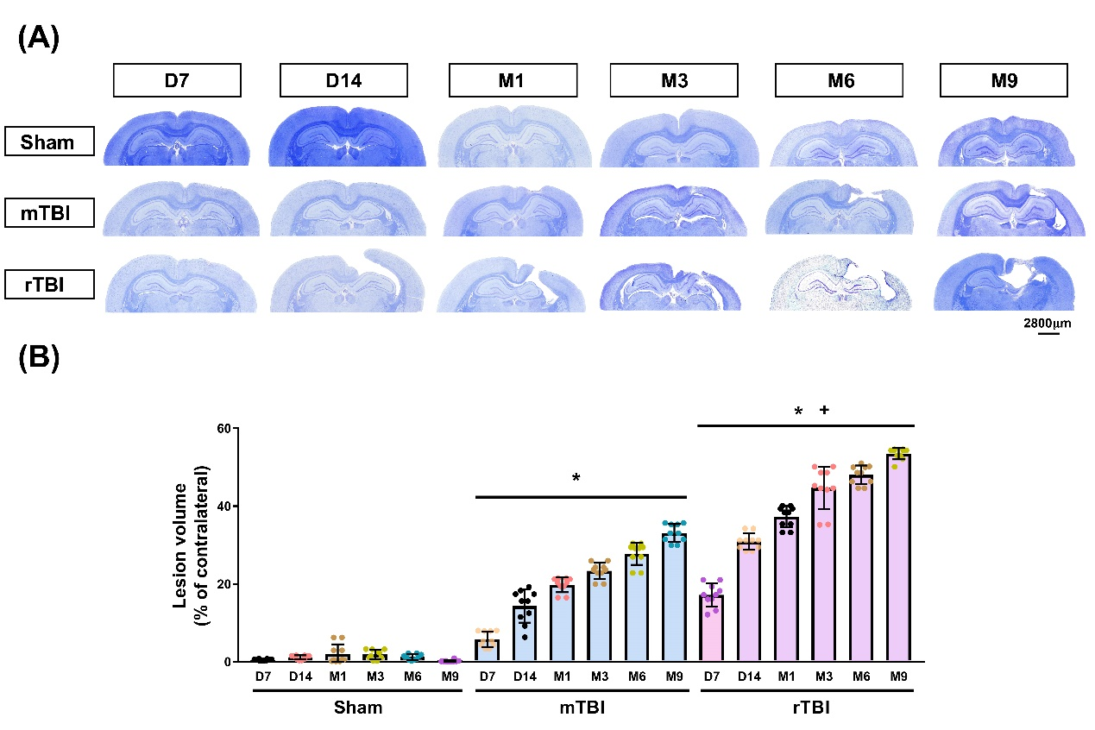
Figure S7: TBI causes a reduction of both brain cavity and white matter thickness. Luxol Fast Blue (LFB) and cresyl violet (or Nissl) staining show the brain lesion's temporal progression. LFB stain is used to identify myelin. Cresyl violet is used to stain neuronal cell bodies, processes, and Nissl bodies. (A) The representative of LFB with Nissl staining from day 7 (D7) to months 9 (M9) post-sham operation, post-TBI, and post-rmTBI. (B) Quantification of brain cavity volume (lesion volume) in different severities of TBI. Data are presented as mean±SD (n=10). * P <0.05, compared with the Sham group. + P <0.05, compared with mTBI group.

Table S1: All figures' statistical data
Figure No. | Statistics data
2A | Survival | Chi² / df | P value
2A | Log-rank (Mantel-Cox) test (recommended) | 25.19 / 2 | <0.0001
2A | Logrank test for trend (recommended) | 2.403 / 1 | 0.1211
2A | Gehan-Breslow-Wilcoxon test | 22.25 / 2 | <0.0001
2C | Contusion volume | F (DFn, DFd) | P value
2C | Interaction (Group × Time) | F (10, 107) = 40.48 | P<0.0001
2C | Time Factor | F (5, 107) = 86.10 | P<0.0001
2C | Group Factor | F (2, 107) = 317.6 | P<0.0001
3A | Y maze | F (DFn, DFd) | P value
3A | Interaction (Group × Time) | F (12, 319) = 10.83 | P<0.0001
3A | Time Factor | F (6, 319) = 20.38 | P<0.0001
3A | Group Factor | F (2, 319) = 170.1 | P<0.0001
3B | Radial maze: Retention time | F (DFn, DFd) | P value
3B | Interaction (Group × Time) | F (12, 319) = 8.6831 | P<0.0001
3B | Time Factor | F (6, 319) = 34.53 | P<0.0001
3B | Group Factor | F (2, 319) = 8.683 | P<0.0001
3C | Radial maze: working memory | F (DFn, DFd) | P value
3C | Interaction (Group × Time) | F (12, 319) = 3.211 | P=0.0012
3C | Time Factor | F (6, 319) = 9.497 | P<0.0001
3C | Group Factor | F (2, 319) = 57.42 | P<0.0001
3D | Radial maze: reference memory | F (DFn, DFd) | P value
3D | Interaction (Group × Time) | F (12, 319) = 4.155 | P<0.0001
3D | Time Factor | F (6, 319) = 55.29 | P<0.0001
3D | Group Factor | F (2, 319) = 97.26 | P<0.0001
3E | Passive avoidance: latency | F (DFn, DFd) | P value
3E | Interaction (Group × Time) | F (12, 319) = 5.687 | P<0.0001
3E | Time Factor | F (6, 319) = 30.64 | P<0.0001
3E | Group Factor | F (2, 266) = 26.89 | P<0.0001
3F | Passive avoidance: number of error | F (DFn, DFd) | P value
3F | Interaction (Group × Time) | F (12, 319) = 5.133 | P<0.0001
3F | Time Factor | F (6, 319) = 22.58 | P<0.0001
3F | Group Factor | F (2, 319) = 11.29 | P<0.0001
3G | Rotarod: Mean velocity | F (DFn, DFd) | P value
3G | Interaction (Group × Time) | F (12, 319) = 48.9 | P<0.0001
3G | Time Factor | F (6, 319) = 78.11 | P<0.0001
3G | Group Factor | F (2, 319) = 612 | P<0.0001
3H | Rotarod: latency | F (DFn, DFd) | P value
3H | Interaction (Group × Time) | F (12, 319) = 52.93 | P<0.0001
3H | Time Factor | F (6, 319) = 77.64 | P<0.0001
3H | Group Factor | F (2, 319) = 705.9 | P<0.0001
3I | Inclined plane | F (DFn, DFd) | P value
3I | Interaction (Group × Time) | F (12, 319) = 69.54 | P<0.0001
3I | Time Factor | F (6, 319) = 282.3 | P<0.0001
3I | Group Factor | F (2, 319) = 796.6 | P<0.0001
3J | mNSS | F (DFn, DFd) | P value
3J | Interaction (Group × Time) | F (12, 319) = 94.69 | P<0.0001
3J | Time Factor | F (6, 319) = 541.5 | P<0.0001
3J | Group Factor | F (2, 319) = 1508 | P<0.0001
4B | HE stain-Hippocampus-CA1 | F (DFn, DFd) | P value
4B | Interaction (Group × Time) | F (10, 135) = 4.751 | P<0.0001
4B | Time Factor | F (5, 135) = 25.59 | P<0.0001
4B | Group Factor | F (2, 135) = 289.9 | P<0.0001
4C | HE stain-Hippocampus-CA2 | F (DFn, DFd) | P value
4C | Interaction (Group × Time) | F (10, 135) = 2.783 | P=0.1853
4C | Time Factor | F (5, 135) = 19.25 | P<0.0001
4C | Group Factor | F (2, 135) = 374.4 | P<0.0001
4D | HE stain-Hippocampus-CA3 | F (DFn, DFd) | P value
4D | Interaction (Group × Time) | F (10, 135) = 3.510 | P=0.0004
4D | Time Factor | F (5, 135) = 14.04 | P<0.0001
4D | Group Factor | F (2, 135) = 308.6 | P<0.0001
4E | HE stain-Hippocampus-DG | F (DFn, DFd) | P value
4E | Interaction (Group × Time) | F (10, 135) = 1.353 | P=0.1921
4E | Time Factor | F (5, 135) = 2.289 | P<0.0001
4E | Group Factor | F (2, 135) = 139.7 | P<0.0001
4F | HE stain-cortex | F (DFn, DFd) | P value
4F | Interaction (Group × Time) | F (10, 135) = 44.152 | P<0.0001
4F | Time Factor | F (5, 135) = 22.33 | P<0.0001
4F | Group Factor | F (2, 135) = 236.5 | P<0.0001
4G | HE stain-Hypothalamus | F (DFn, DFd) | P value
4G | Interaction (Group × Time) | F (10, 135) = 1.72 | P=0.5973
4G | Time Factor | F (5, 135) = 1.0443 | P=0.5206
4G | Group Factor | F (2, 135) = 2.892 | P=0.0094
4H | HE stain-striatum | F (DFn, DFd) | P value
4H | Interaction (Group × Time) | F (10, 135) = 2.699 | P=0.0053
4H | Time Factor | F (5, 135) = 2.621 | P=0.0026
4H | Group Factor | F (2, 135) = 7.595 | P=0.028
5B | Contusion volume: TTC with MRI-T2WI | F (DFn, DFd) | P value
5B | Interaction (Group × Time) | F (20, 93) = 0.2927 | P=0.9986
5B | Time Factor | F (4, 93) = 0.6377 | P=0.6369
5B | Group Factor | F (5, 93) = 67.35 | P<0.0001
6B | MRI-T1WI | F (DFn, DFd) | P value
6B | Interaction (Group × Time) | F (8, 53) = 1.085 | P=0.3877
6B | Time Factor | F (4, 53) = 8.742 | P<0.0001
6B | Group Factor | F (2, 53) = 2.852 | P=0.0759
8B | LFB stain-Hippocampus | F (DFn, DFd) | P value
8B | Interaction (Group × Time) | F (10, 135) = 129.7 | P<0.0001
8B | Time Factor | F (5, 135) = 407.8 | P<0.0001
8B | Group Factor | F (2, 135) = 5631 | P<0.0001
9B | LFB stain-CCb-Ipsilateral | F (DFn, DFd) | P value
9B | Interaction (Group × Time) | F (10, 135) = 7.282 | P<0.0001
9B | Time Factor | F (5, 135) = 58.36 | P<0.0001
9B | Group Factor | F (2, 135) = 228.7 | P<0.0001
9C | LFB stain-CCb-Contralateral | F (DFn, DFd) | P value
9C | Interaction (Group × Time) | F (10, 135) = 4.534 | P<0.0001
9C | Time Factor | F (5, 135) = 1.534 | P<0.0001
9C | Group Factor | F (2, 135) = 222.7 | P<0.0001
9D | LFB stain-ab-Ipsilateral | F (DFn, DFd) | P value
9D | Interaction (Group × Time) | F (10, 135) = 3.574 | P<0.0001
9D | Time Factor | F (5, 135) = 10.08 | P<0.0001
9D | Group Factor | F (2, 135) = 399.6 | P<0.0001
9E | LFB stain-ab-Contralateral | F (DFn, DFd) | P value
9E | Interaction (Group × Time) | F (10, 135) = 3.5744 | P=0.0742
9E | Time Factor | F (5, 135) = 6.237 | P=0.0003
9E | Column Factor | F (2, 135) = 51.05 | P<0.0001
10B | Ankyrin G+Caspr-CCb | F (DFn, DFd) | P value
10B | Interaction (Group × Time) | F (10, 135) = 10.25 | P<0.0001
10B | Time Factor | F (5, 135) = 28.43 | P<0.0001
10B | Group Factor | F (2, 135) = 735.1 | P<0.0001
10C | Ankyrin G+Caspr-LD | F (DFn, DFd) | P value
10C | Interaction (Group × Time) | F (10, 135) = 0.5735 | P=0.8324
10C | Time Factor | F (5, 135) = 0.9880 | P=0.4285
10C | Group Factor | F (2, 135) = 0.4572 | P=0.5273
10D | Ankyrin G+Caspr-VPL-VPM | F (DFn, DFd) | P value
10D | Interaction (Group × Time) | F (10, 135) = 1.344 | P=0.2674
10D | Time Factor | F (5, 135) = 1.301 | P=0.1493
10D | Column Factor | F (2, 135) = 0.1929 | P=0.2134
10E | Ankyrin G+Caspr-ic | F (DFn, DFd) | P value
10E | Interaction (Group × Time) | F (10, 135) = 1.299 | P=0.2402
10E | Time Factor | F (5, 135) = 1.202 | P=0.3128
10E | Group Factor | F (2, 135) = 0.6889 | P=0.5114
10F | Ankyrin G+Caspr-ab | F (DFn, DFd) | P value
10F | Interaction (Group × Time) | F (10, 135) = 8.366 | P<0.0001
10F | Time Factor | F (5, 135) = 4.139 | P=0.0016
10F | Group Factor | F (2, 135) = 390.5 | P<0.0001

TABLE S2: Fractional anisotropy (FA) and axial diffusivity (AD), radial diffusivity (RD), mean diffusivity (MD) from ipsilateral and contralateral hemisphere in sham control rats (n=2) and rats post-mTBI (n=4) or post-rTBI at day3 (n=2) obtained using in vivo DTI.
 |  | FA |  |  |  |  |  | AD (µm²/ms) |  |  |  |  |  | RD (µm²/ms) |  |  |  |  |  | MD (µm²/ms)
 |  | Sham | mTBI | rTBI | F (DFn, DFd) | P value |  | Sham | mTBI | rTBI | F(DFn, DFd) | P value |  | Sham | mTBI | rTBI | F (DFn, DFd) | P value |  | Sham | mTBI | rTBI | F(DFn, DFd) | P value
Ipsilateral | WM:
Ipsilateral | CCb | 0.52±0.05 | 0.42±0.12 | 0.50±0.02 | F (2,5) = 1.835 | 0.3527 |  | 1.22±0.02 | 1.10±0.16 | 1.08±0.01 | F (2,5) = 16.17 | 0.0582 |  | 0.52±0.07 | 0.56±0.10 | 0.47±0.04 | F (2,5) = 1.588 | 0.3864 |  | 0.75±0.05 | 0.74±0.09 | 0.67±0.03 | F (2,5) = 4.619 | 0.178
Ipsilateral | CCs | 0.51±0.04 | 0.31±0.09 | 0.36±0.08 | F (2,5) = 24.55 | 0.0391 |  | 1.12±0.06 | 0.86±0.16 | 0.94±0.02 | F (2,5) = 3.109 | 0.2434 |  | 0.48±0.00 | 0.53±0.09 | 0.55±0.10 | F (2,5) = 0.3966 | 0.716 |  | 0.69±0.02 | 0.64±0.10 | 0.68±0.08 | F(2,5)=1.201 | 0.375
Ipsilateral | ic | 0.60±0.01 | 0.58±0.03 | 0.61±0.01 | F (2,5) = 1.859 | 0.3497 |  | 1.27±0.04 | 1.09±0.07 | 1.22±0.03 | F (2,5) = 7.308 | 0.0328 |  | 0.43±0.00 | 0.40±0.04 | 0.40±0.01 | F (2,5) = 35.50 | 0.0274 |  | 0.71±0.01 | 0.63±0.04 | 0.67±0.02 | F (2,5) = 5.677 | 0.1498
Ipsilateral | ab | 0.49±0.06 | 0.33±0.11 | 0.40±0.08 | F(2,5)=1.914 | 0.2415 |  | 1.10±0.07 | 0.95±0.11 | 1.05±0.02 | F (2,5) = 1.986 | 0.3349 |  | 0.53±0.03 | 0.56±0.03 | 0.57±0.14 | F (2,5) = 0.2100 | 0.8264 |  | 0.72±0.00 | 0.69±0.03 | 0.73±0.10 | F (2,5) = 0.4847 | 0.6735
Ipsilateral | GM:
Ipsilateral | Cortex | 0.18±0.00 | 0.20±0.08 | 0.17±0.08 | F (2,5) = 0.05497 | 0.9479 |  | 0.82±0.01 | 0.85±0.13 | 0.93±0.02 | F (2,5) = 8.218 | 0.1085 |  | 0.62±0.01 | 0.63±0.05 | 0.72±0.11 | F (2,5) = 2.411 | 0.2932 |  | 0.69±0.01 | 0.70±0.07 | 0.79±0.08 | F (2,5) = 7.931 | 0.112
Ipsilateral | Hippo. | 0.21±0.01 | 0.23±0.07 | 0.24±0.05 | F (2,5) = 1.834 | 0.3529 |  | 0.88±0.00 | 0.94±0.15 | 0.99±0.15 | F (2,5) = 0.2511 | 0.7993 |  | 0.64±0.00 | 0.67±0.07 | 0.69±0.04 | F (2,5) = 1.012 | 0.4971 |  | 0.72±0.00 | 0.76±0.09 | 0.79±0.07 | F (2,5 ) = 0.6238 | 0.6158
Ipsilateral | Stria. | 0.22±0.01 | 0.22±0.03 | 0.24±0.03 | F (2,2) = 1.039 | 0.4904 |  | 0.83±0.00 | 0.77±0.09 | 0.76±0.02 | F (2,5) = 6.971 | 0.1255 |  | 0.61±0.02 | 0.57±0.05 | 0.55±0.01 | F (2,5) = 2.353 | 0.2983 |  | 0.68±0.02 | 0.64±0.06 | 0.62±0.00 | F (2,5) = 13.70 | 0.068
Contralateral | WM:
Contralateral | CCb | 0.50±0.11 | 0.50±0.03 | 0.52±0.01 | F (2,5) = 0.1262 | 0.8841 |  | 1.31±0.03 | 1.16±0.08 | 1.20±0.01 | F (2,5) = 44.65 | 0.0219 |  | 0.58±0.13 | 0.51±0.02 | 0.51±0.02 | F (2,5) = 0.8650 | 0.5362 |  | 0.82±0.08 | 0.73±0.03 | 0.74±0.01 | F (2,5) = 0.3250 | 0.1247
Contralateral | CCs | 0.52±0.03 | 0.44±0.05 | 0.46±0.01 | F (2,5) = 2.381 | 0.2958 |  | 1.16±0.06 | 0.98±0.07 | 1.00±0.03 | F (2,5) = 5.355 | 0.1574 |  | 0.47±0.01 | 0.48±0.06 | 0.48±0.00 | F (2,5) = 5.788 | 0.1473 |  | 0.70±0.02 | 0.65±0.06 | 0.65±0.01 | F (2,5) = 25.03 | 0.0384
Contralateral | ic | 0.62±0.03 | 0.60±0.03 | 0.55±0.00 | F (2,5) = 3.655 | 0.2148 |  | 1.27±0.06 | 1.28±0.03 | 1.16±0.01 | F (2,5) = 8.794 | 0.1021 |  | 0.42±0.01 | 0.45±0.03 | 0.45±0.00 | F (2,5) = 1.222 | 0.4501 |  | 0.70±0.01 | 0.72±0.01 | 0.68±0.00 | F (2,5) = 6.887 | 0.1268
Contralateral | ab | 0.53±0.04 | 0.49±0.03 | 0.52±0.04 | F(2,5)=  1.109 | 0.4741 |  | 1.17±0.07 | 1.05±0.08 | 1.09±0.03 | F (2,5) = 18.75 | 0.0506 |  | 0.52±0.00 | 0.49±0.05 | 0.49±0.3 | F (2,5) = 4.101 | 0.196 |  | 0.74±0.02 | 0.67±0.05 | 0.69±0.03 | F (2,5) = 34.83 | 0.0279
Contralateral | GM:
Contralateral | Cortex | 0.20±0.00 | 0.23±0.07 | 0.18±0.01 | F (2,5) = 6.158 | 0.1397 |  | 0.87±0.05 | 0.88±0.12 | 0.80±0.03 | F (2,5) = 16.17 | 0.0583 |  | 0.65±0.03 | 0.62±0.03 | 0.61±0.02 | F (2,5) = 5.201 | 0.1613 |  | 0.72±0.04 | 0.71±0.06 | 0.67±0.02 | F (2,5) = 7.865 | 0.1128
Contralateral | Hippo. | 0.25±0.01 | 0.22±0.04 | 0.24±0.01 | F(2,5)= 44.73 | 0.0219 |  | 0.95±0.02 | 0.87±0.10 | 0.93±0.11 | F (2,5) = 0.4618 | 0.6841 |  | 0.66±0.01 | 0.62±0.03 | 0.64±0.06 | F (2,5) = 1.051 | 0.4875 |  | 0.76±0.02 | 0.71±0.05 | 0.74±0.08 | F (2,5) = 0.7100 | 0.5848
Contralateral | Stria. | 0.25±0.02 | 0.24±0.03 | 0.24±0.02 | F (2,5) = 0.3227 | 0.7382 |  | 0.85±0.02 | 0.79±0.05 | 0.74±0.01 | F (2,5)= 24.22 | 0.0396 |  | 0.60±0.00 | 0.56±0.03 | 0.54±0.01 | F (2,5) = 104.6 | 0.0095 |  | 0.68±0.01 | 0.63±0.03 | 0.61±0.00 | F (2,5) = 112.5 | 0.0088

Abbreviations: CCb, body of the corpus callosum; CCs, splenium of the corpus callosum; ic, internal capsule; ab, anterior commissure; Hippo, hippocampus; Stria.: striatum; WM, white matter; GM, gray matter.
TABLE S3: Fractional anisotropy (FA) and axial diffusivity (AD), radial diffusivity (RD), mean diffusivity (MD) from ipsilateral and contralateral hemisphere in sham control (n=5) and rats after mTBI (n=6) or rTBI at Month 1 (n=4) obtained using in vivo DTI.
 |  | FA |  |  |  |  |  | AD (µm²/ms) |  |  |  |  |  | RD (µm²/ms) |  |  |  |  |  | MD (µm²/ms)
 |  | Sham | mTBI | rTBI | F (DFn, DFd) | P value |  | Sham | mTBI | rTBI | F (DFn, DFd) | P value |  | Sham | mTBI | rTBI | F (DFn, DFd) | P value |  | Sham | mTBI | rTBI | F (DFn, DFd) | P value
Ipsilateral | WM:
Ipsilateral | CCb | 0.54±0.03 | 0.47±0.01 | 0.48±0.04 | F (2,12) = 1.673 | 0.2286 |  | 1.15±0.02 | 1.40±0.22 | 1.30±0.20 | F (2,12) = 2.671 | 0.1098 |  | 0.46±0.03 | 0.68±0.26 | 0.61±0.12 | F(2,12)=2.103 | 0.1648 |  | 0.69±0.03 | 0.92±0.24 | 0.84±0.14 | F (2,12) = 2.389 | 0.1339
Ipsilateral | CCs | 0.53±0.03 | 0.38±0.09 | 0.43±0.03 | F (2,12) = 6.902 | 0.0101 |  | 1.10±0.05 | 1.32±0.27 | 1.03±0.03 | F (2,12) = 3.779 | 0.0533 |  | 0.44±0.03 | 0.78±0.29 | 0.52±0.03 | F (2,12) = 4.838 | 0.0288 |  | 0.66±0.03 | 0.96±0.28 | 0.69±0.02 | F (2,12) = 4.440 | 0.036
Ipsilateral | ic | 0.63±0.04 | 0.59±0.05 | 0.60±0.05 | F (2,12) = 1.035 | 0.4039 |  | 1.21±0.05 | 1.20±0.07 | 1.23±0.07 | F (2,12) = 0.2970 | 0.7484 |  | 0.38±0.04 | 0.43±0.04 | 0.42±0.04 | F (2,12) = 1.992 | 0.2066 |  | 0.66±0.02 | 0.68±0.03 | 0.69±0.01 | F (2,12) = 2.773 | 0.1298
Ipsilateral | ab | 0.59±0.06 | 0.42±0.11 | 0.43±0.07 | F(2,12)=  7.888 | 0.0161 |  | 1.20±0.09 | 1.52±0.61 | 1.26±0.24 | F (2,12) = 1.323 | 0.3255 |  | 0.47±0.05 | 0.90±0.55 | 0.68±0.24 | F (2,12) = 2.958 | 0.1172 |  | 0.71±0.04 | 1.11±0.57 | 0.87±0.24 | F (2,12) = 2.289 | 0.1718
Ipsilateral | GM:
Ipsilateral | Cortex | 0.20±0.02 | 0.23±0.04 | 0.24±0.03 | F (2,12) = 2.017 | 0.2034 |  | 0.79±0.04 | 1.29±0.51 | 1.41±0.62 | F (2,12) = 2.582 | 0.1168 |  | 0.59±0.02 | 0.94±0.39 | 0.99±0.41 | F (2,12) =2.168 | 0.1571 |  | 0.66±0.03 | 1.05±0.43 | 1.33±0.48 | F (2,12) = 2.344 | 0.1383
Ipsilateral | Hippo. | 0.25±0.03 | 0.22±0.01 | 0.23±0.02 | F (2,12) = 11.00 | 0.0069 |  | 0.87±0.04 | 1.23±0.33 | 1.39±0.31* | F (2,12) = 6.210 | 0.0141 |  | 0.60±0.02 | 0.89±0.24 | 0.99±0.20* | F (2,12) = 7.262 | 0.0086 |  | 0.69±0.02 | 1.00±0.27 | 1.12±0.24 | F (2,12) = 6.845 | 0.0104
Ipsilateral | Stria. | 0.24±0.01 | 0.24±0.03 | 0.25±0.05 | F (2,12) = 0.7807 | 0.4942 |  | 0.78±0.03 | 0.88±0.08 | 0.88±0.05 | F (2,12) = 1.111 | 0.381 |  | 0.57±0.02 | 0.63±0.06 | 0.63±0.05 | F (2,12) = 0.6098 | 0.5595 |  | 0.64±0.02 | 0.71±0.06 | 0.71±0.05 | F (2,12) = 1.421 | 0.2793
Contralateral | WM:
Contralateral | CCb | 0.54±0.04 | 0.51±0.04 | 0.51±0.03 | F (2,12) = 0.8951 | 0.4342 |  | 1.19±0.04 | 1.28±0.10 | 1.21±0.04 | F (2,12) = 2.275 | 0.1453 |  | 0.48±0.05 | 0.56±0.07 | 0.53±0.03 | F (2,12) = 3.42 | 0.092 |  | 0.72±0.05 | 0.80±0.07 | 0.76±0.03 | F (2,12) = 3.743 | 0.0785
Contralateral | CCs | 0.54±0.02 | 0.46±0.04 | 0.46±0.07 | F (2,12) = 6.216 | 0.0281 |  | 1.11±0.01 | 1.08±0.06 | 1.04±0.07 | F (2,12) = 1.702 | 0.25 |  | 0.45±0.03 | 0.51±0.04 | 0.51±0.04 | F (2,12) = 5.083 | 0.0433 |  | 0.67±0.02 | 0.70±0.04 | 0.69±0.01 | F (2,12) = 2.085 | 0.167
Contralateral | ic | 0.61±0.02 | 0.59±0.06 | 0.59±0.05 | F (2,12) = 0.426 | 0.669 |  | 1.25±0.05 | 1.27±0.08 | 1.27±0.09 | F (2,12) =0.1665 | 0.85 |  | 0.42±0.04 | 0.45±0.04 | 0.45±0.02 | F (2,12) = 0.8925 | 0.4352 |  | 0.70±0.04 | 0.72±0.03 | 0.72±0.02 | F (2,12) = 1.044 | 0.4009
Contralateral | ab | 0.59±0.05 | 0.50±0.07 | 0.49±0.02 | F(2,12)=  3.996 | 0.0468 |  | 1.16±0.04 | 1.07±0.10 | 1.11±0.05 | F (2,12) = 2.110 | 0.164 |  | 0.47±0.04 | 0.51±0.04 | 0.52±0.01 | F (2,12) = 2.739 | 0.1322 |  | 0.70±0.02 | 0.69±0.04 | 0.72±0.01 | F (2,12) =0.862 | 0.4626
Contralateral | GM:
Contralateral | Cortex | 0.20±0.02 | 0.20±0.03 | 0.22±0.03 | F (2,12) = 0.8183 | 0.4793 |  | 0.82±0.03 | 0.89±0.14 | 0.89±0.07 | F (2,12) = 0.9206 | 0.425 |  | 0.61±0.03 | 0.66±0.07 | 0.65±0.03 | F (2,12) = 1.334 | 0.2999 |  | 0.68±0.03 | 0.74±0.09 | 0.73±0.04 | F (2,12) = 1.144 | 0.3509
Contralateral | Hippo. | 0.26±0.04 | 0.25±0.03 | 0.27±0.01 | F (2,12) = 1.450 | 0.2973 |  | 0.91±0.07 | 0.99±0.10 | 1.10±0.11 | F (2,12) = 5.083 | 0.043 |  | 0.62±0.02 | 0.67±0.07 | 0.74±0.06 | F (2,12) = 6.647 | 0.0241 |  | 0.71±0.03 | 0.78±0.08 | 0.86±0.08 | F (2,12) = 6.163 | 0.0286
Contralateral | Stria. | 0.25±0.02 | 0.26±0.02 | 0.26±0.02 | F (2,12) = 0.08544 | 0.8191 |  | 0.79±0.03 | 0.82±0.03 | 0.82±0.03 | F (2,12) = 0.3977 | 0.6804 |  | 0.56±0.02 | 0.57±0.02 | 0.58±0.01 | F (2,12) =0.0131 | 0.987 |  | 0.64±0.02 | 0.65±0.02 | 0.66±0.01 | F (2,12) =0.172 | 0.8455
Abbreviations: CCb, body of the corpus callosum; CCs, splenium of the corpus callosum; ic, internal capsule; ab, anterior commissure; Hippo, hippocampus; Stria.: striatum; WM, white matter; GM, gray matter.
TABLE S4: Fractional anisotropy (FA) and axial diffusivity (AD), radial diffusivity (RD), mean diffusivity (MD) from ipsilateral and contralateral hemisphere in sham control (n=6) and rats after mTBI (n=5) or rTBI at Month 3 (n=6) obtained using in vivo DTI.
 |  | FA |  |  |  |  |  | AD (µm²/ms) |  |  |  |  |  | RD (µm²/ms) |  |  |  |  |  | MD (µm²/ms)
 |  | Sham | mTBI | rTBI | F (DFn, DFd) | P value |  | Sham | mTBI | rTBI | F (DFn, DFd) | P value |  | Sham | mTBI | rTBI | F (DFn, DFd) | P value |  | Sham | mTBI | rTBI | F (DFn, DFd) | P value
Ipsilateral | WM:
Ipsilateral | CCb | 0.55±0.06 | 0.48±0.11 | 0.44±0.11 | F(2,17)=2.296 | 0.131 |  | 1.22±0.06 | 1.44±0.48 | 1.28±0.14 | F (2,17) = 0.5554 | 0.5906 |  | 0.47±0.05 | 0.71±0.47 | 0.64±0.11* | F (2,17) = 6.574 | 0.015 |  | 0.72±0.03 | 0.95±0.47 | 0.85±0.08 | F (2,17) = 5.736 | 0.0219
Ipsilateral | CCs | 0.56±0.04 | 0.36±0.17 | 0.33±0.06 | F (2,17) = 7.401 | 0.0107 |  | 1.16±0.05 | 1.56±0.47 | 1.16±0.10 | F (2,17) = 4.180 | 0.0334 |  | 0.44±0.04 | 1.00±0.56 | 0.73±0.11 | F (2,17) = 4.054 | 0.0363 |  | 0.68±0.03 | 1.19±0.53 | 0.87±0.10 | F (2,17) = 3.957 | 0.0388
Ipsilateral | ic | 0.65±0.04 | 0.59±0.05 | 0.58±0.05 | F (2,17) = 4.968 | 0.0318 |  | 1.28±0.08 | 1.22±0.08 | 1.19±0.09 | F (2,17) = 2.614 | 0.1221 |  | 0.38±0.04 | 0.44±0.05 | 0.44±0.04 | F (2,17) = 2.933 | 0.0995 |  | 0.68±0.04 | 0.70±0.04 | 0.69±0.04 | F (2,17) = 0.2342 | 0.7954
Ipsilateral | ab | 0.57±0.04 | 0.37±0.12 | 0.36±0.09 | F (2,17) = 9.547 | 0.0048 |  | 1.20±0.17 | 1.50±0.50 | 1.53±0.72 | F (2,17) = 0.7862 | 0.4818 |  | 0.49±0.03 | 0.93±0.51 | 0.94±0.61 | F (2, 17) = 1.961 | 0.1912 |  | 0.73±0.07 | 1.12±0.51 | 1.14±0.65 | F (2,17) = 1.493 | 0.2708
Ipsilateral | GM:
Ipsilateral | Cortex | 0.19±0.03 | 0.22±0.05 | 0.21±0.01 | F (2,17 ) = 0.9648 | 0.401 |  | 0.82±0.08 | 1.20±0.49 | 1.41±0.79 | F (2,17) = 1.910 | 0.1984 |  | 0.62±0.03 | 0.89±0.39 | 1.05±0.60 | F (2,17) = 1.833 | 0.2097 |  | 0.69±0.05 | 0.99±0.42 | 1.17±0.66 | F (2,17) = 1.869 | 0.2043
Ipsilateral | Hippo. | 0.22±0.02 | 0.22±0.04 | 0.21±0.02 | F (2, 17) = 1.865 | 0.205 |  | 0.88±0.06 | 1.28±0.58 | 1.71±0.29 | F (2,17) = 7.496 | 0.0046 |  | 0.63±0.04 | 0.93±0.47 | 1.27±0.22 | F (2,17) = 7.428 | 0.0048 |  | 0.72±0.04 | 1.04±0.51 | 1.42±0.24 | F (2,17) = 7.522 | 0.0046
Ipsilateral | Stria. | 0.25±0.03 | 0.24±0.03 | 0.24±0.03 | F (2,17) = 1.272 | 0.3206 |  | 0.83±0.06 | 0.85±0.08 | 0.89±0.08 | F (2,17) = 1.052 | 0.3837 |  | 0.59±0.03 | 0.62±0.06 | 0.64±0.05 | F (2,17) = 0.1147 | 0.8928 |  | 0.67±0.04 | 0.70±0.07 | 0.72±0.06 | F (2,17) = 0.06942 | 0.9334
Contralateral | WM:
Contralateral | CCb | 0.57±0.04 | 0.52±0.06 | 0.49±0.05 | F (2,17) = 3.677 | 0.0471 |  | 1.29±0.08 | 1.25±0.08 | 1.21±0.13 | F (2,17) = 1.226 | 0.334 |  | 0.49±0.05 | 0.53±0.06 | 0.54±0.06 | F (2,17) = 2.045 | 0.1801 |  | 0.76±0.05 | 0.77±0.05 | 0.77±0.07 | F (2,17) = 0.1493 | 0.8632
Contralateral | CCs | 0.55±0.03 | 0.46±0.07 | 0.41±0.06 | F (2,17) = 10.93 | 0.003 |  | 1.15±0.06 | 1.08±0.07 | 1.03±0.06 | F (2,17) = 5.148 | 0.029 |  | 0.44±0.02 | 0.52±0.06 | 0.55±0.05 | F (2,17) = 12.69 | 0.0018 |  | 0.68±0.02 | 0.71±0.04 | 0.71±0.04 | F (2,17) = 2.260 | 0.1549
Contralateral | ic | 0.64±0.03 | 0.58±0.05 | 0.59±0.04 | F (2,17) = 4.108 | 0.035 |  | 1.32±0.08 | 1.26±0.07 | 1.23±0.07 | F (2,17) = 1.928 | 0.176 |  | 0.40±0.03 | 0.46±0.05 | 0.44±0.03 | F (2,17) = 5.097 | 0.0298 |  | 0.71±0.04 | 0.72±0.05 | 0.70±0.03 | F (2,17) = 1.274 | 0.3215
Contralateral | ab | 0.57±0.05 | 0.48±0.06 | 0.47±0.05 | F (2, 17) = 6.104 | 0.01 |  | 1.17±0.06 | 1.08±0.09 | 1.09±0.07 | F (2,17) = 3.967 | 0.0539 |  | 0.49±0.06 | 0.53±0.05 | 0.54±0.07 | F (2, 17) = 2.258 | 0.1552 |  | 0.71±0.05 | 0.71±0.04 | 0.72±0.07 | F (2,17) = 0.1137 | 0.8937
Contralateral | GM:
Contralateral | Cortex | 0.18±0.02 | 0.21±0.02* | 0.19±0.01 | F (2,17 ) = 4.048 | 0.0365 |  | 0.83±0.03 | 0.87±0.07 | 0.85±0.07 | F (2,17) = 1.076 | 0.3774 |  | 0.64±0.03 | 0.65±0.05 | 0.64±0.05 | F (2,17) = 0.1055 | 0.9009 |  | 0.72±0.06 | 0.72±0.06 | 0.71±0.05 | F (2,17) = 0.3367 | 0.7219
Contralateral | Hippo. | 0.24±0.03 | 0.24±0.03 | 0.24±0.03 | F (2, 17) = 0.04337 | 0.9577 |  | 0.90±0.06 | 0.98±0.09 | 1.03±0.14 | F (2,17) = 3.508 | 0.0701 |  | 0.63±0.04 | 0.69±0.07 | 0.72±0.09 | F (2,17) = 3.924 | 0.0552 |  | 0.72±0.04 | 0.79±0.08 | 0.82±0.11 | F (2,17) = 3.951 | 0.0544
Contralateral | Stria. | 0.23±0.02 | 0.25±0.03 | 0.25±0.02 | F (2,17) = 1.770 | 0.2197 |  | 0.80±0.06 | 0.83±0.07 | 0.81±0.06 | F (2,17) = 0.1540 | 0.8592 |  | 0.59±0.03 | 0.58±0.03 | 0.58±0.04 | F (2,17) = 1.424 | 0.2857 |  | 0.66±0.04 | 0.66±0.04 | 0.66±0.05 | F (2,17) = 0.2171 | 0.8085
Abbreviations: CCb, body of the corpus callosum; CCs, splenium of the corpus callosum; ic, internal capsule; ab, anterior commissure; Hippo, hippocampus; Stria.: striatum; WM, white matter; GM, gray matter.
TABLE S5: Fractional anisotropy (FA) and axial diffusivity (AD), radial diffusivity (RD), mean diffusivity (MD) from ipsilateral and contralateral hemisphere in sham control (n=9) and rats after mTBI (n=10) or rTBI at Month 6 (n=8) obtained using in vivo DTI.
 |  | FA |  |  |  |  |  | AD (µm²/ms) |  |  |  |  |  | RD (µm²/ms) |  |  |  |  |  | MD (µm²/ms)
 |  | Sham | mTBI | rTBI | F(DFn,DFd) | P value |  | Sham | mTBI | rTBI | F (DFn, DFd) | P value |  | Sham | mTBI | rTBI | F (DFn, DFd) | P value |  | Sham | mTBI | rTBI | F (DFn, DFd) | P value
Ipsilateral | WM:
Ipsilateral | CCb | 0.57±0.02 | 0.42±0.15* | 0.45±0.05* | F (2,24) = 7.411 | 0.0058 |  | 1.23±0.05 | 1.53±0.52 | 1.34±0.18 | F (2,24) = 1.945 | 0.1649 |  | 0.45±0.05 | 0.86±0.59 | 0.66±0.15 | F (2,24) = 2.808 | 0.0802 |  | 0.71±0.05 | 1.08±0.56 | 0.88±0.16 | F (2,24) = 2.547 | 0.0993
Ipsilateral | CCs | 0.54±0.06 | 0.32±0.14* | 0.34±0.08* | F (2,24) = 14.65 | 0.0003 |  | 1.11±0.07 | 1.62±0.60 | 1.29±0.38 | F (2,24) = 4.052 | 0.0392 |  | 0.43±0.05 | 1.10±0.59* | 0.81±0.35 | F (2,24) = 6.964 | 0.0073 |  | 0.66±0.04 | 1.27±0.59* | 0.97±0.36 | F (2,24) = 5.927 | 0.0127
Ipsilateral | ic | 0.66±0.03 | 0.57±0.04* | 0.57±0.06* | F (2,24) = 14.72 | 0.0003 |  | 1.31±0.07 | 1.21±0.06* | 1.23±0.07 | F (2,24) = 6.351 | 0.01 |  | 0.38±0.02 | 0.44±0.04* | 0.46±0.07* | F (2,24) = 9.285 | 0.0024 |  | 0.69±0.03 | 0.70±0.04 | 0.72±0.06 | F (2,24) = 1.268 | 0.3098
Ipsilateral | ab | 0.59±0.04 | 0.41±0.13* | 0.39±0.13* | F (2,24) = 16.43 | 0.0002 |  | 1.21±0.05 | 1.55±0.59 | 1.51±0.65 | F(2,24)=1.991 | 0.171 |  | 0.43±0.05 | 0.90±0.61 | 0.93±0.66 | F (2,24) = 4.455 | 0.0303 |  | 0.69±0.04 | 1.12±0.60 | 1.12±0.66 | F (2, 24) = 3.537 | 0.0552
Ipsilateral | GM:
Ipsilateral | Cortex | 0.18±0.02 | 0.20±0.05 | 0.21±0.06 | F (2,24) = 0.9411 | 0.4041 |  | 0.80±0.03 | 1.27±0.52 | 1.48±0.69 | F (2,24) = 4.479 | 0.0222 |  | 0.61±0.03 | 0.96±0.42 | 1.11±0.54* | F (2,24) = 3.831 | 0.036 |  | 0.67±0.03 | 1.07±0.45 | 1.23±0.58* | F (2,24) = 4.110 | 0.0448
Ipsilateral | Hippo. | 0.21±0.02 | 0.21±0.04 | 0.21±0.03 | F (2,24) = 2.006 | 0.169 |  | 0.87±0.04 | 1.42±0.57* | 1.67±0.44* | F (2,24) = 10.47 | 0.0014 |  | 0.63±0.03 | 1.05±0.47* | 1.24±0.36* | F (2,24) = 10.03 | 0.0017 |  | 0.71±0.03 | 1.18±0.50* | 1.39±0.39* | F (2,24 = 10.33 | 0.0015
Ipsilateral | Stria. | 0.24±0.02 | 0.24±0.03 | 0.24±0.03 | F (2,24) = 0.8637 | 0.4415 |  | 0.83±0.05 | 0.91±0.15 | 0.93±0.08 | F(2,24)=0.566 | P=-0.5752 |  | 0.59±0.03 | 0.66±0.11 | 0.66±0.06 | F (2,24) = 0.5667 | 0.5791 |  | 0.67±0.04 | 0.74±0.12 | 0.75±0.06 | F (2,24) = 0.5525 | 0.5826
Contralateral | WM:
Contralateral | CCb | 0.56±0.04 | 0.49±0.06 | 0.51±0.03 | F (2,24) = 5.414 | 0.017 |  | 1.28±0.09 | 1.28±0.17 | 1.26±0.07 | F (2,24) = 0.06417 | 0.938 |  | 0.49±0.05 | 0.57±0.10 | 0.55±0.03 | F (2,24) = 3.364 | 0.0516 |  | 0.75±0.06 | 0.81±0.12 | 0.79±0.04 | F (2,24) = 1.195 | 0.3202
Contralateral | CCs | 0.57±0.03 | 0.43±0.06 | 0.41±0.04 | F (2,24) = 36.06 | <0.0001 |  | 1.16±0.05 | 1.06±0.06 | 1.02±0.04 | F (2,24) = 16.45 | <0.0001 |  | 0.42±0.04 | 0.54±0.06 | 0.53±0.04 | F (2,24) = 19.75 | <0.0001 |  | 0.67±0.03 | 0.72±0.05 | 0.69±0.03 | F (2,24) = 3.551 | 0.0546
Contralateral | ic | 0.60±0.04 | 0.60±0.04 | 0.58±0.05 | F (2,24) = 0.9290 | 0.4165 |  | 1.27±0.08 | 1.30±0.10 | 1.27±0.09 | F (2,24) = 0.2933 | 0.7484 |  | 0.43±0.03 | 0.45±0.03 | 0.46±0.08 | F (2,24) = 1.516 | 0.2514 |  | 0.71±0.03 | 0.73±0.04 | 0.73±0.07 | F (2,24) = 0.6995 | 0.5123
Contralateral | ab | 0.56±0.03 | 0.49±0.08 | 0.50±0.04 | F (2,24) = 4.238 | 0.0348 |  | 1.19±0.06 | 1.13±0.12 | 1.13±0.07 | F(2,24)=1.166 | 0.3384 |  | 0.46±0.04 | 0.53±0.07 | 0.51±0.06 | F (2,24) = 4.494 | 0.0296 |  | 0.70±0.03 | 0.73±0.05 | 0.71±0.06 | F (2, 24) = 0.9817 | 0.3892
Contralateral | GM:
Contralateral | Cortex | 0.18±0.02 | 0.17±0.02 | 0.17±0.03 | F (2,24) = 0.6577 | 0.5271 |  | 0.83±0.05 | 0.87±0.07 | 0.84±0.04 | F (2,24) = 1.360 | 0.2758 |  | 0.64±0.04 | 0.67±0.05 | 0.65±0.03 | F (2, 24) = 2.518 | 0.1141 |  | 0.70±0.04 | 0.74±0.05 | 0.72±0.03 | F (2,24) = 2.066 | 0.1612
Contralateral | Hippo. | 0.23±0.02 | 0.24±0.04 | 0.24±0.03 | F (2,24) = 0.7573 | 0.4861 |  | 0.91±0.05 | 1.01±0.10 | 1.09±0.11 | F (2,24) = 6.778 | 0.0046 |  | 0.64±0.04 | 0.70±0.06 | 0.75±0.09 | F (2, 24) = 5.404 | 0.0115 |  | 0.73±0.04 | 0.81±0.07 | 0.87±0.09 | F (2,24) = 6.249 | 0.0065
Contralateral | Stria. | 0.24±0.02 | 0.23±0.02 | 0.24±0.03 | F (2,24) = 0.8616 | 0.4351 |  | 0.82±0.05 | 0.84±0.06 | 0.83±0.02 | F (2,24) = 0.7403 | 0.4936 |  | 0.58±0.03 | 0.60±0.02 | 0.59±0.03 | F (2,24) = 1.632 | 0.2284 |  | 0.66±0.03 | 0.68±0.03 | 0.67±0.02 | F (2,24) = 1.269 | 0.3096

Abbreviations: CCb, body of the corpus callosum; CCs, splenium of the corpus callosum; ic, internal capsule; ab, anterior commissure; Hippo, hippocampus; Stria.: striatum; WM, white matter; GM, gray matter.
TABLE S6: The correlation between contusion (or lesion) volume (by T2WI) and fractional anisotropy (FA), radial diffusivity (RD), and mean diffusivity (MD) in splenium of the corpus callosum (CCs) and anterior commissure (ab) in both TBI, and rmTBI group rats obtained during day 3 to month 9 of after surgery.

DTI parameters & regions  Time & correlation |  | FA |  | RD |  | MD
 |  | CCs | ab | CCs | ab | CCs | ab
D3 | P | 0.6112 | 0.8584 | 0.9476 | 0.9366 | 0.7146 | 0.6574
D3 | R² | 0.04571 | 0.005749 | 0.000783 | 0.001145 | 0.02392 | 0.03499
M1 | P | 0.0022* | 0.0038* | 0.0122* | 0.0239* | 0.0315* | 0.0389*
M1 | R² | 0.5261 | 0.4873 | 0.3941 | 0.3346 | 0.3087 | 0.2886
M3 | P | <0.0001* | <0.0001* | 0.0003* | 0.0011* | 0.0017* | 0.0028*
M3 | R² | 0.6769 | 0.5968 | 0.5329 | 0.4528 | 0.4287 | 0.3984
M6 | P | <0.0001* | <0.0001* | <0.0001* | 0.0002* | <0.0001* | 0.0004*
M6 | R² | 0.7457 | 0.5799 | 0.6695 | 0.4259 | 0.5868 | 0.3948
M9 | P | <0.0001* | <0.0001* | <0.0001* | <0.0001* | <0.0001* | <0.0001*
M9 | R² | 0.7278 | 0.7281 | 0.6605 | 0.5577 | 0.5777 | 0.5091
*P significant <0.05. The R-squared value, denoted by R², is the square of the correlation.

