Supplementary Materials

Table S1: Homozygosity-by-descent (HBD) regions for seven (out of eight) multiplex families. Coordinates are given as GRCh37/hg19. HomozygosityMapper (HM) score is related to length of HBD block and number of shared alleles in the family⁴⁷. We have also used a size threshold of ≥ 1 Mb for HBD regions, as has been used previously³⁶.
Chr | start SNP | end SNP | start bp | end bp | size Mb | HM Score
PKASD04
1 | rs1418440 | rs3010323 | 57290659 | 59567263 | 2.277 | 256
1 | rs9436444 | rs835342 | 50589798 | 53064034 | 2.474 | 94
3 | rs7629490 | rs1458006 | 87241497 | 88461825 | 1.22 | 104
4 | rs17686529 | rs6846723 | 166267383 | 167837707 | 1.57 | 181
6 | rs197988 | rs9379671 | 23593375 | 24614392 | 1.021 | 160
8 | rs7832023 | rs16893344 | 132370660 | 134206279 | 1.836 | 185
9 | rs11244336 | rs11137376 | 134118740 | 141025328 | 6.907 | 254
9 | rs10816710 | rs12003641 | 111511992 | 114279497 | 2.768 | 257
11 | rs11025963 | rs753688 | 21227542 | 44360545 | 23.133 | 257
13 | rs6491182 | rs2025237 | 27615791 | 37305641 | 9.69 | 256
14 | rs17119380 | rs4900375 | 84460068 | 98229487 | 13.769 | 256
18 | rs1116701 | rs11080474 | 9746909 | 11048468 | 1.302 | 257
20 | rs6139074 | rs1018493 | 63244 | 3,682,011 | 3.619 | 350
PKASD13
1 | rs11579207 | rs680285 | 92203190 | 93489113 | 1.286 | 7
1 | rs10493887 | rs4839069 | 97410506 | 111137811 | 13.727 | 8
2 | rs1354905 | rs785260 | 189446471 | 191020013 | 1.574 | 8
2 | rs6713102 | rs6745660 | 197174387 | 198349536 | 1.175 | 8
6 | rs1539348 | rs9343101 | 73710903 | 74739868 | 1.029 | 8
8 | rs12548521 | rs7822849 | 119552755 | 121827840 | 2.275 | 9
10 | rs914700 | rs1870519 | 45467703 | 47596804 | 2.129 | 65
11 | rs11224705 | rs361266 | 101176069 | 103937879 | 2.762 | 12
12 | rs254694 | rs2630218 | 115589524 | 128872849 | 13.283 | 17
12 | rs6486559 | rs7294615 | 131103914 | 133168145 | 2.064 | 10
13 | rs1331533 | rs9550238 | 104378857 | 114494245 | 10.115 | 23
21 | rs2223080 | rs2832390 | 29801854 | 30914526 | 1.113 | 17
22 | rs4607032 | rs1640350 | 17841068 | 20210363 | 2.369 | 500
PKASD14
2 | rs13036193 | rs6735385 | 5700470 | 9237190 | 3.537 | 259
3 | rs322707 | rs11916758 | 25319260 | 45131916 | 19.813 | 258
3 | rs9842685 | rs12489864 | 96167389 | 97322741 | 1.155 | 3
5 | rs4569852 | rs819571 | 71441589 | 72828213 | 1.387 | 42
6 | rs1358980 | rs6910674 | 43764551 | 71722821 | 27.958 | 12
6 | rs12524612 | rs34156731 | 132093249 | 157777283 | 25.684 | 15
6 | rs750618 | rs4392700 | 158982921 | 162724247 | 3.741 | 11
7 | rs1375238 | rs255142 | 17566398 | 30754949 | 13.189 | 14
12 | rs1480082 | rs2712623 | 98676087 | 101613488 | 2.937 | 18
PKASD17
6 | rs9348836 | rs9471831 | 11227987 | 42252385 | 31.024 | 500
8 | rs6987070 | rs7293734 | 41877317 | 47338235 | 5.461 | 176
11 | rs1323860 | rs2176611 | 30035236 | 33982853 | 3.948 | 500
17 | rs4646410 | rs9889937 | 17408699 | 18571366 | 1.163 | 80
17 | rs8072510 | rs8067765 | 33772658 | 34815551 | 1.043 | 140
17 | rs1230094 | rs4968280 | 43470156 | 44930363 | 1.460 | 130
PKASD25
7 | rs1718582 | rs2178044 | 68664061 | 70223193 | 1.559 | 5
8 | rs16938118 | rs1117213 | 49514893 | 51284360 | 1.769 | 82
10 | rs7086393 | rs1505908 | 58250470 | 59433399 | 1.183 | 11
11 | rs10838698 | rs9667626 | 47385923 | 48485877 | 1.1 | -
16 | rs149156 | rs11075692 | 66912706 | 68681792 | 1.769 | 9
PKASD26
1 | rs2297684 | rs4653002 | 32146764 | 33770526 | 1.624 | 83
2 | rs11690543 | rs7597006 | 106037635 | 145209076 | 39.171 | 15
6 | rs3734694 | rs9349331 | 44118612 | 45808357 | 1.69 | 11
6 | rs2812152 | rs9353764 | 67143902 | 91529722 | 24.386 | 8
6 | rs10457161 | rs9400534 | 107505241 | 112661761 | 5.157 | 10
7 | rs12539724 | rs10808024 | 108358839 | 139763994 | 31.405 | 15
8 | rs10105278 | rs924184 | 26600068 | 28296171 | 1.696 | 257
8 | rs7815781 | rs10216833 | 109888569 | 123989445 | 14.101 | 254
8 | rs6577898 | rs2958522 | 139247027 | 146024952 | 6.778 | 257
10 | rs332114 | rs6481463 | 28925701 | 61102489 | 32.177 | 19
11 | rs4322381 | rs7931829 | 44741200 | 87248455 | 42.507 | 14
14 | rs11845309 | rs1980615 | 66513063 | 67958372 | 1.445 | 6
16 | rs12325368 | rs3112594 | 25776919 | 52671529 | 26.895 | 256
21 | rs7276198 | rs2827819 | 19582240 | 24440785 | 4.859 | 257
PKASD34 (N.B. affected sibs are monozygotic twins)
1 | rs3121532 | rs7641084 | 49369206 | 51989591 | 2.620 | 202
1 | rs6699043 | rs4641034 | 154913021 | 156342917 | 1.430 | 180
2 | rs13385191 | rs992996 | 20888265 | 22036018 | 1.148 | 212
2 | rs7589293 | rs6717323 | 81583557 | 82769739 | 1.186 | 172
3 | rs1351043 | rs9840698 | 82739213 | 84037979 | 1.299 | 166
4 | rs1238741 | rs3737483 | 99983312 | 101114999 | 1.430 | 278
5 | rs12517650 | rs7725903 | 20553425 | 21575563 | 1.022 | 122
5 | rs2619728 | rs1501908 | 155128570 | 156398169 | 1.270 | 184
6 | rs628629 | rs9450163 | 83894382 | 85818790 | 1.924 | 154
10 | rs17100087 | rs4402239 | 84213251 | 85276201 | 1.063 | 230
10 | rs2689700 | rs12769370 | 95946520 | 97032612 | 1.086 | 208
11 | rs6483110 | rs529911 | 91047120 | 92320830 | 1.274 | 162
14 | rs10138962 | rs17112078 | 104995893 | 107231967 | 2.048 | 162
15 | rs3825786 | rs7165146 | 42431142 | 44951174 | 2.520 | 250
16 | rs12445911 | rs4405548 | 47018079 | 49152331 | 2.134 | 122

Table S2: Primer sequences for Sanger sequencing validation of variants (5’ to 3’)
Primer name | Amplicon size (bp) | Primer sequence (5' to 3')
CDKL5_F | 220 | ACATCTCTCTTCGGCCTCAA
CDKL5_R | 220 | CACAGAGGACACATGCCAAC
TTC19_F | 150 | AAATGGCTGATTATTGATTTTGC
TTC19_R | 150 | AATGCCCAGATAATGGGTTTC
ZNF292_F | 211 | TTTGTACAGTTTGCCAATCCA
ZNF292_R | 211 | CTCTGCCTGTGGCTTTACCTA
SLC35A2_F | 223 | CCTCACTTCACCAGCACTGA
SLC35A2_R | 223 | ACCCATTATTTGCCCTTGG
NEDD4_F | 200 | CATTTACCAAGACCAAAGGAAA
NEDD4_R | 200 | TGGGAGGAGCTTATCCAAAT
EFCAB12_F | 197 | GGCACAATATCTGTGGCTGA
EFCAB12_R | 197 | TCGACACACATTCACACACG
PDZD4_F | 249 | GGCCAGCAGAGAGTCCAT
PDZD4_R | 249 | TAGCCCGGAAACGAAGAG
ARAP1_F | 342 | CAGTAGGCTCTTGGTGGGACA
ARAP1_R | 342 | GAGGATGGCGGTTGATGGTG
CSMD2_F | 223 | CCCTGAGAGAAAATTGGTTGG
CSMD2_R | 223 | CTTAACATGAGGCCCCTGAA
TMEM214_F | 229 | TATTAAGGGCTGGCAGATGG
TMEM214_R | 229 | CTGGGTGTCAGGGAGTTGTT
POLR3G_F | 249 | TTTCAGAATTTGCCCACTCA
POLR3G_R | 249 | GCTATAATCATACATCCAGTCCCATA
TMEM232_F | 219 | TGTTTTGATCCTAAAACAGATGTCA
TMEM232_R | 219 | TCTCTGGACCATGCTTCCTT
TRANK1a_F | 270 | GCAAGAACCTCTGAACTACTTCC
TRANK1a_R | 270 | CAGCAAGTCACACTGCACAG
TRANK1b_F | 267 | TGCCACTACTCACGCTTAAC
TRANK1b_R | 267 | TCCACACTGACTTGCTTTGC
EIF3H_F | 207 | AGCACTCACAAGGCCATCTA
EIF3H_R | 207 | CACGCGAGACTTGTACTTCC
GML_F | 286 | ATTCAGGTGGGCAGAGTCAG
GML_R | 286 | CAGCCAATCATCCCAGTGAC

Figure S1: Pedigrees and electropherograms for all reported variants. Blue bar in electropherogram corresponds to the position of the sequence variant. In some cases where indicated, supporting evidence from whole exome sequence (WES) using the Integrated Genome Browser (IGV) was available where Sanger sequence was not.
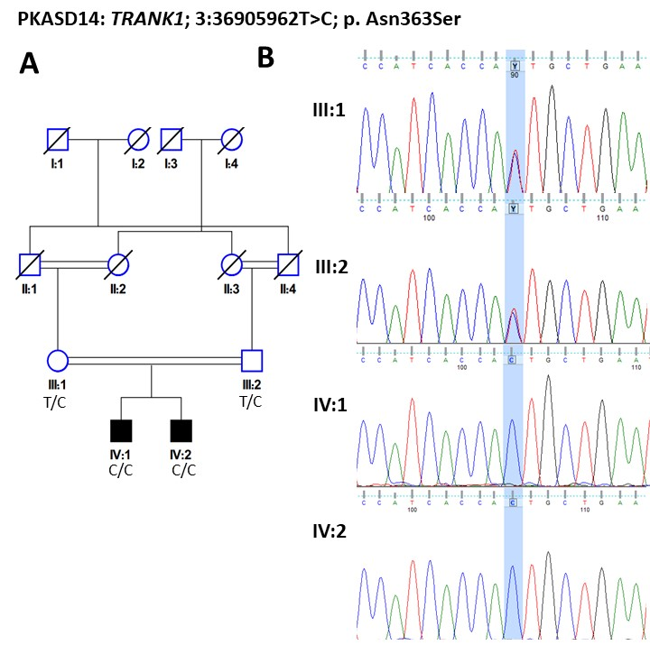

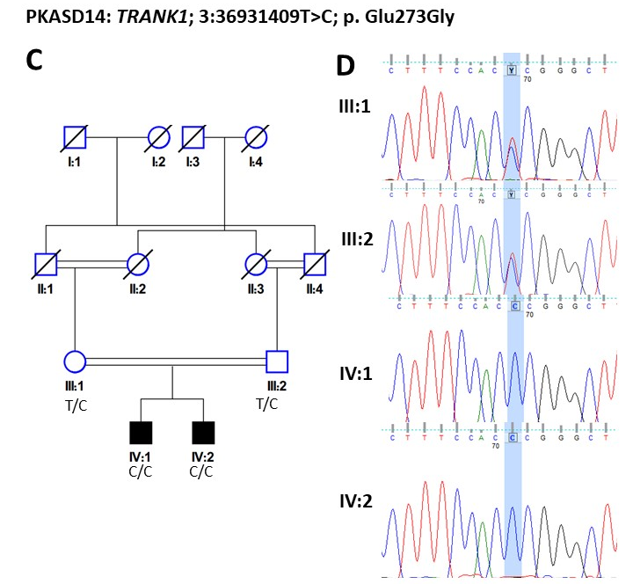
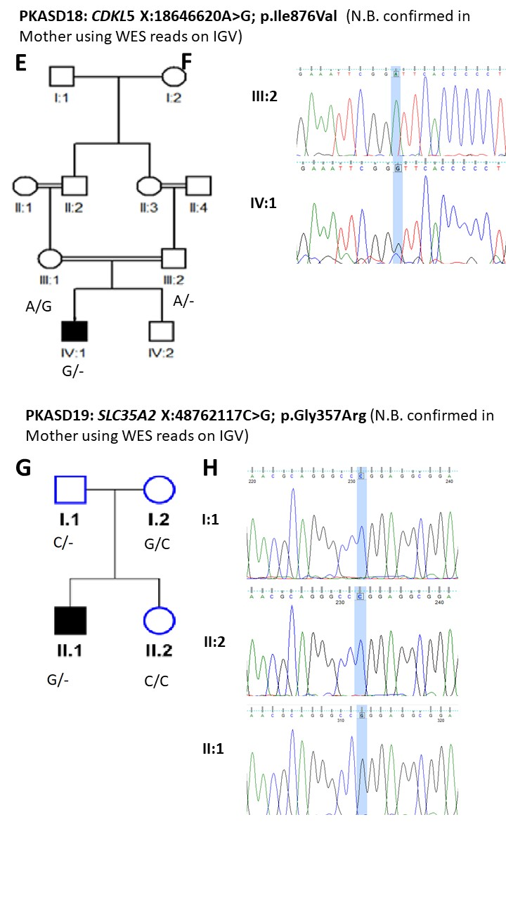
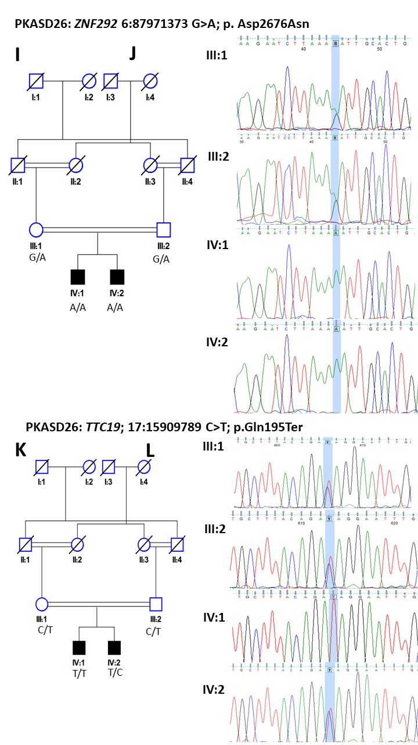
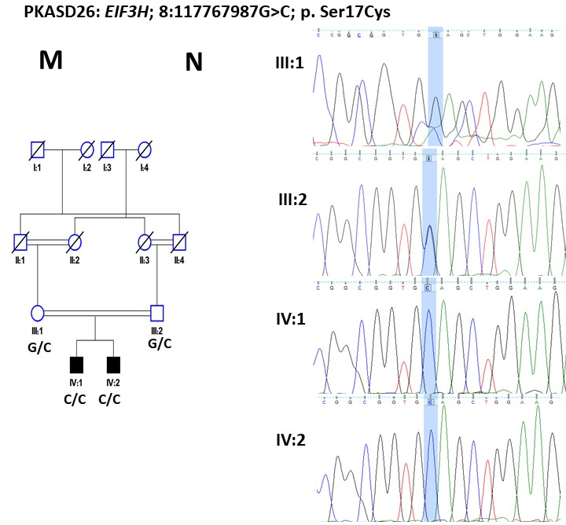
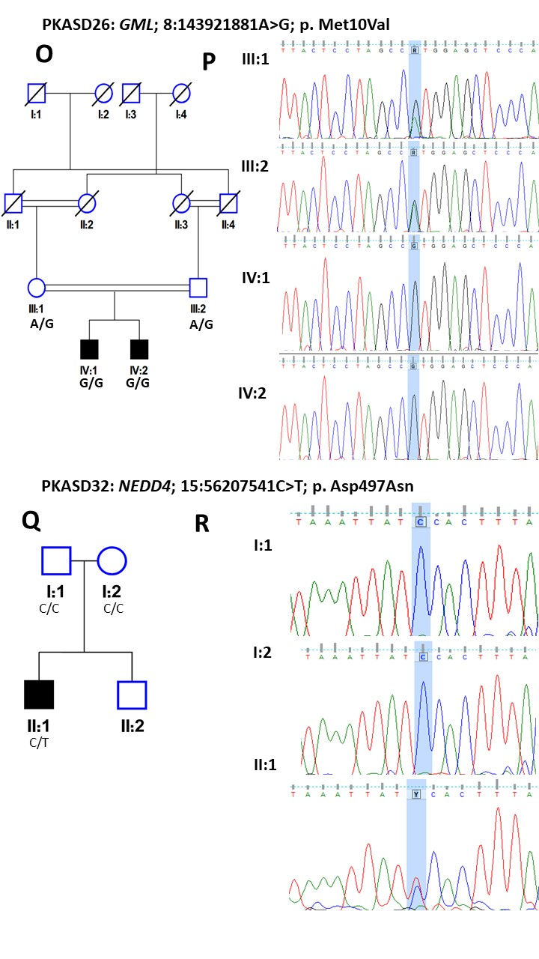

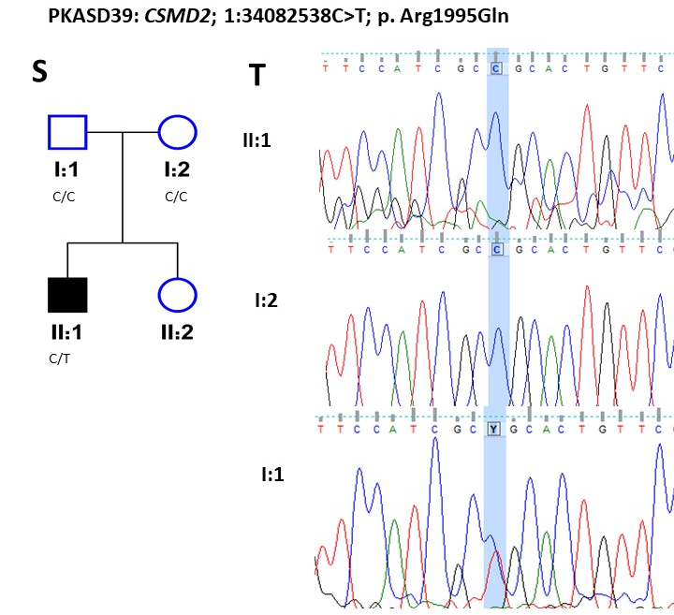
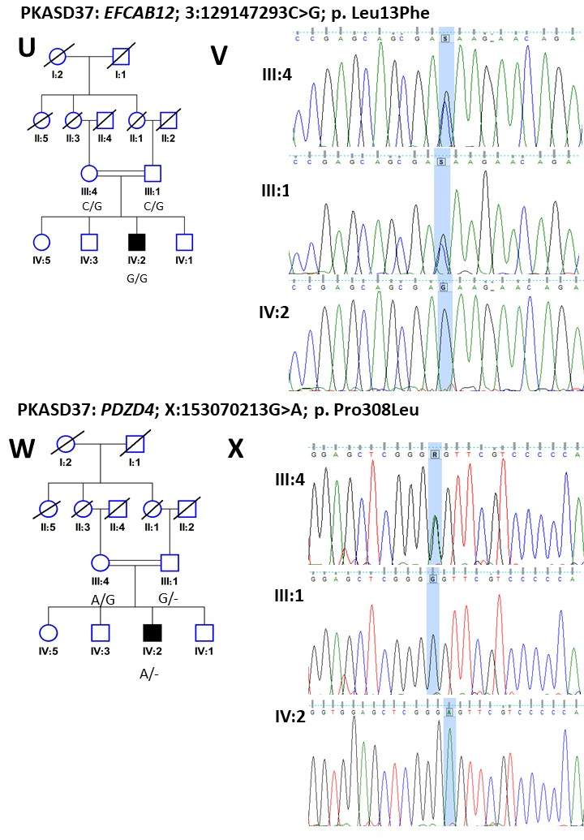
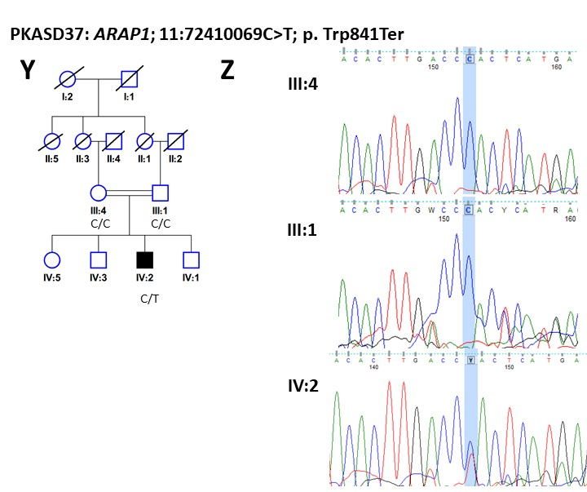
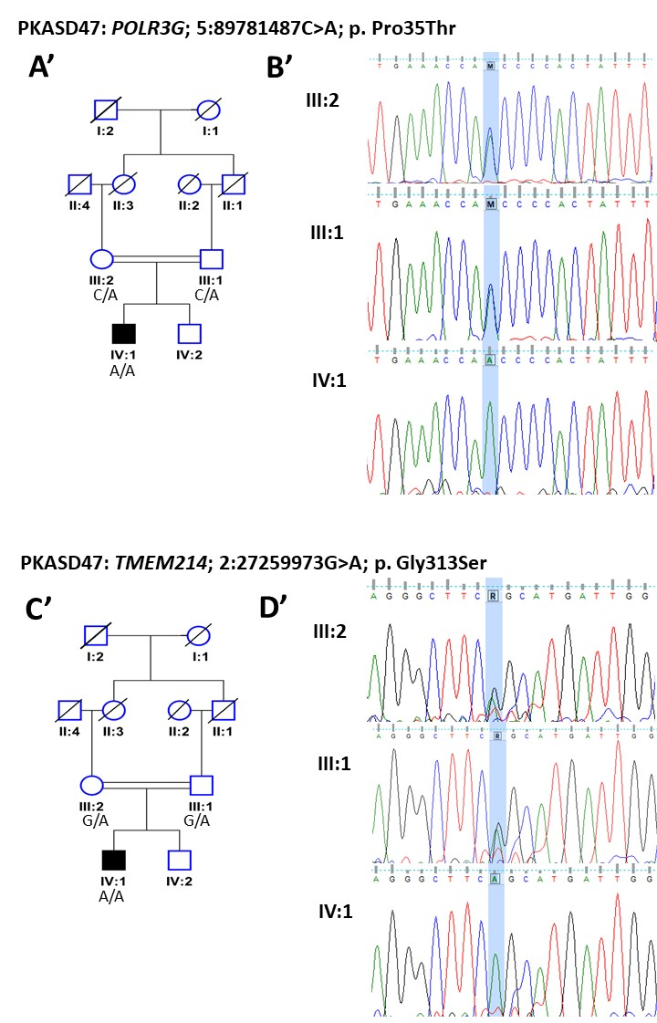
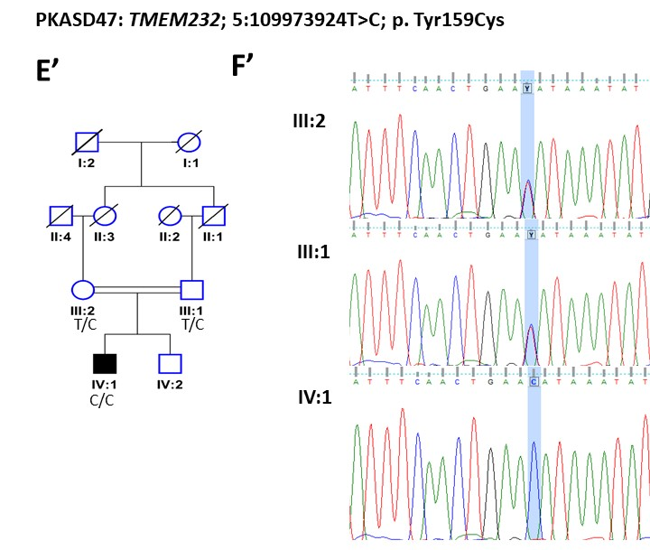
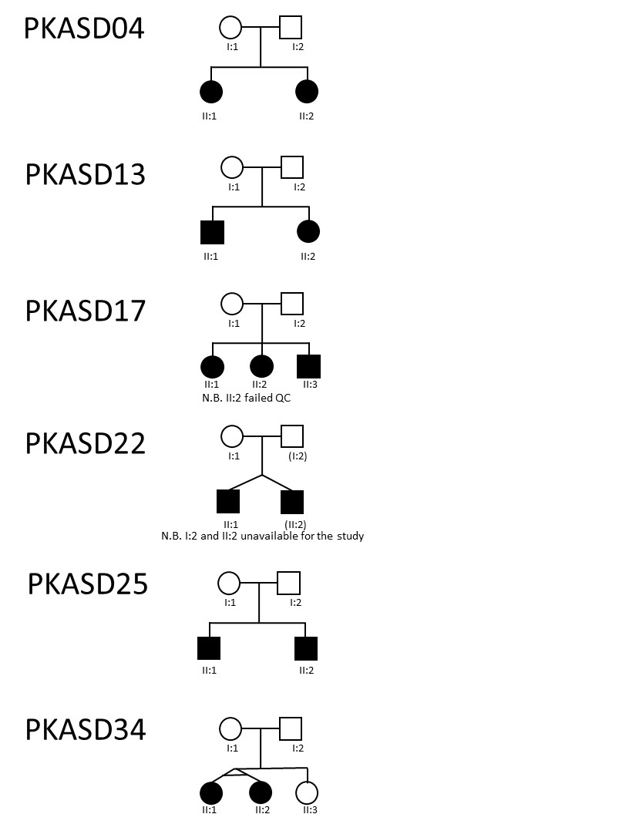

Table S3: Candidate variants: Genomic coordinates are given relative to GRCh37/hg19 build. gnomAD minor allele frequency (MAF) v2.1.1 is provided, with number of homozygotes or hemizygotes for X-linked genes given in parentheses. * indicates the variant is located within an HBD block (in a multiplex family). Candidate genes were cross-referenced with the MSSNG dataset ((N>11,500 individuals; research.mss.ng; accessed Aug 2023), as well as the Autism Sequencing Consortium dataset (asc.broadinstitute.org; accessed Aug 2023). For MSSNG, high quality coding change variants, either de novo, homozygous (autosomal), or hemizygous (X-chromosomal) that were rare or absent in the gnomAD control datasets (accessed Aug 2023), and with no hemizygotes or homozygotes among the gnomAD controls, are indicated.
Family ID | Sex | Chromosome | Gene | Protein variant | Mutation type | Mutation effect | gnomAD MAF all | gnomAD MAF S. Asian | ASC case | ASC control | MSSNG case
PKASD-14 | M | 3:36905962T>C* | TRANK1 | Asn363Ser | Homo | missense | 2.99E-05 (0) | 2.00E-04 (0) | 0 | 0 | No homozygous or de novo
PKASD-14 | M | 3:36931409T>C* | TRANK1 | Glu273Gly | Homo | missense | 7.62E-04 (0) | 4.84E-04 (0) | 0 | 0 | No homozygous or de novo
PKASD-18 | M | X:18646620A>G | CDKL5 | Ile876Val | XL | missense | 0 | 0 | 1 (splice acceptor) | 0 | 3 missense hemi(M):  NM_003159:c.16A>G:p.I6V (no hemis in gnomAD)  c.92G>A:p.R31K (no hemis in gnomAD); c.2572C>T:p.R858C (no hemis in gnomAD);  1 frameshift del het(F):  NM_003159:c.2635_2636del:p.L879fs (no hemis in gnomAD)
PKASD-19 | M | X:48762117C>G | SLC35A2 | Gly357Arg | XL | missense | 1.1E-05 (1) | 5.304E-05 (1) | 0 | 0 | 2 affected brothers with missense hemizygous ( maternal): NM_005660:c.109T>C:p.Y37H (no alleles in gnomAD controls)
PKASD-26 | M | 17:15909789C>T | TTC19 | Gln195* | Homo | Stop gain | 3.18E-05 (0) | 3.266E-05 (0) | 0 | 0 | No homozygous or de novo
PKASD-26 | M | 6:87971373G>A* | ZNF292 | Asp2676Asn | Homo | missense | 3.891E-04 (0) | 3.486E-03 (0) | 1 | 0 | 1 missense homo: NM_015021:c.6946C>T:p.R2316W  0 de novo
PKASD-26 | M | 8:117767987G>C* | EIF3H | Ser17Cys | Homo | missense | 7.562E-05 (0) | 6.206E-04 (0) | 0 | 1 | No homozygous or de novo
PKASD-26 | M | 8:143921881A>G* | GML | Met10Val | Homo | missense | 4.95E-05 (0) | 1.96E-04 (0) | 0 | 0 | No homozygous or de novo
PKASD-32 | M | 15:56207541C>T | NEDD4 | Asp497Asn | De novo | missense | 0 | 0 | 0 | 0 | No homozygous or de novo
PKASD-37 | M | 3:129147293C>G | EFCAB12 | Leu13Phe | Homo | missense | 1.871E-4 (0) | 1.489E-3 (0) | 0 | 0 | No homozygous or de novoh
PKASD-37 | M | X:153070213G>A | PDZD4 | Pro308Leu | XL | missense | 5.5E-06 (0) | 0 | 0 | 0 | 2 missense hemi (M):  NM_032512:c.1334C>T:p.A445V (no hemis in gnomAD) NM_032512:c.976G>A:p.D326N (no hemis in gnomAD)
PKASD-37 | M | 11:72410069C>T | ARAP1 | Trp841* | De novo | Stop gain | 0 | 0 | 0 | 0 | No homozygous or de novo
PKASD-39 | M | 1:34082538C>T | CSMD2 | Arg1995Gln | De novo | missense | 0 | 0 | 1 de novo (c.24delC; p.G9Afs*303) | 0 | No homozygous (except where homozygotes also in gnomAD controls) or de novo
PKASD-47 | M | 2:27259973G>A | TMEM214 | Gly313Ser | Homo | missense | 1.21E-04 (0) | 8.496E-04 (0) | 3 de novo (c.499C>A; p.H167N; c.661A>G; p.I221V; c.1654T>C; p.S552P) | 0 | No homozygous or de novo
PKASD-47 | M | 5:89781487C>A | POLR3G | Pro35Thr | Homo | missense | 1.429E-04 (0) | 2.973E-04 (0) | 0 | 0 | No homozygous or de novo
PKASD-47 | M | 5:109973924T>C | TMEM232 | Tyr159Cys | Homo | missense | 0 | 0 | 0 | 0 | No homozygous or de novo

Table S4: Consanguinity through microarray genotype analysis. Runs of homozygosity (RoH) was also calculated from autosomal genotype data, using PLINK 1.9, and used to generate an F-coefficient of consanguinity for the probands (and affected siblings), F_{RoH}, as described in McQuillan et al, 2008,⁴⁸ where F_{roh} = ∑ L_{roh}/L_{auto}. Autosome size L_{auto} estimated at 2,673,768 Kb. Relatedness of parents: Identity-by-descent estimation using Pi_Hat scores provided by PLINK analysis of microarray genotype data, where available. UA= unaffected sibling.
Child ID | Σ_{LRoH} (Kb) | F_{RoH} | Mother ID | Father ID | PI_HAT | Approximate Relatedness of parents
PKASD-01_C | 45691 | 0.017
PKASD-02_C | 203338 | 0.076 | PKASD-02_M | PKASD-02_F | 0.1144 | 3rd degree
PKASD-03_C | 31162 | 0.012 | PKASD-03_F | PKASD-03_M | 0 | parents unrelated
PKASD-04_C1 | 196924 | 0.074 | PKASD-04_M | PKASD-04_F | 0.2279 | 2nd degree
PKASD-04_C2 | 331829 | 0.124
PKASD-05_C | 50148 | 0.019 | PKASD-05_M | PKASD-05_F | 0.0033 | distantly related
PKASD-06_C | 278727 | 0.104 | PKASD-06_M | PKASD-06_F | 0.0765
PKASD-07_C | 46179 | 0.017 | PKASD-07_M | PKASD-07_F | 0 | parents unrelated
PKASD-08_C | 46509 | 0.017 | PKASD-08_M | PKASD-08_F | 0 | parents unrelated
PKASD-10_C | 42287 | 0.016 | PKASD-10_M | PKASD-10_F | 0 | parents unrelated
PKASD-11_C | 57522 | 0.022 | PKASD-11_M | PKASD-11_F | 0 | parents unrelated
PKASD-13_C1 | 226114 | 0.085
PKASD-13_C2 | 142320 | 0.053
PKASD-14_C1 | 229569 | 0.086 | PKASD-14_M | PKASD-14_F | 0.1266 | 3rd degree
PKASD-14_C2 | 339961 | 0.127
PKASD-15_C | 35629 | 0.013 | PKASD-15_M | PKASD-15_F | 0 | parents unrelated
PKASD-16_C | 152861 | 0.057 | PKASD-16_M | PKASD-16_F | 0.1353 | 2nd to 3rd degree
PKASD-17_C | 256631 | 0.096 | PKASD-17_M | PKASD-17_F | 0.1719 | 2nd to 3rd degree
PKASD-18_C | 43655 | 0.016 | PKASD-18_M | PKASD-18_F | 0.0159 | distantly related
PKASD-19_C1 | 188988 | 0.071 | PKASD-19_M | PKASD-19_F | 0 | parents unrelated
PKASD-19_C2 (UA) | 36879 | 0.014
PKASD-20_C | 56993 | 0.021 | PKASD-20_M | PKASD-20_F | 0.0121 | distantly related
PKASD-21_C | 38192 | 0.014
PKASD-22_C2 | 244335 | 0.091
PKASD-25_C1 | 41811 | 0.016 | PKASD-25_M | PKASD-25_F | 0 | parents unrelated
PKASD-25_C2 | 43132 | 0.016
PKASD-26_C1 | 498088 | 0.186 | PKASD-26_F | PKASD-26_M | 0.2278 | 2nd degree (1st cousin marriage)
PKASD-26_C2 | 458022 | 0.171
PKASD-27C | 42965 | 0.016 | PKASD-27_F | PKASD-27_M | 0 | parents unrelated
PKASD-28C | 55873 | 0.021 | PKASD-28_M | PKASD-28_F | 0 | parents unrelated
PKASD-29C | 52767 | 0.020 | PKASD-29_M | PKASD-29_F | 0 | parents unrelated
PKASD-30C | 42627 | 0.016 | PKASD-30_M | PKASD-30_F | 0 | parents unrelated
PKASD-31C | 501066 | 0.187
PKASD-32C | 44753 | 0.017 | PKASD-32_M | PKASD-32_F | 0 | parents unrelated
PKASD-33_C | 254375 | 0.095 | PKASD-33_M | PKASD-33_F | 0.1797 | 2nd to 3rd degree
PKASD-34_C1 | 40999 | 0.015 | PKASD-34_M | PKASD-34_F | 0 | parents unrelated
PKASD-34_C2 | 42053 | 0.016
PKASD-34_C3 (UA) | 44267 | 0.017
PKASD-35_C | 255486 | 0.096 | PKASD-35_M | PKASD-35_F | 0.1648 | 2nd to 3rd degree
PKASD-36_C1 | 39648 | 0.015 | PKASD-36_M | PKASD-36_F | 0 | parents unrelated
PKASD-36_C2 (UA) | 50993 | 0.019
PKASD-37_C | 70853 | 0.026 | PKASD-37_M | PKASD-37_F | 0 | parents unrelated
PKASD-38_C1 | 35221 | 0.013 | PKASD-38_F | PKASD-38_M | 0 | parents unrelated
PKASD-38_C2 (UA) | 55717 | 0.021
PKASD-39C | 39157 | 0.015 | PKASD-39_F | PKASD-39_M | 0 | parents unrelated
PKASD-47_C | 431250 | 0.161 | PKASD-47_F | PKASD-47_M | 0.1588 | 2nd to 3rd degree

