Supplementary figures:

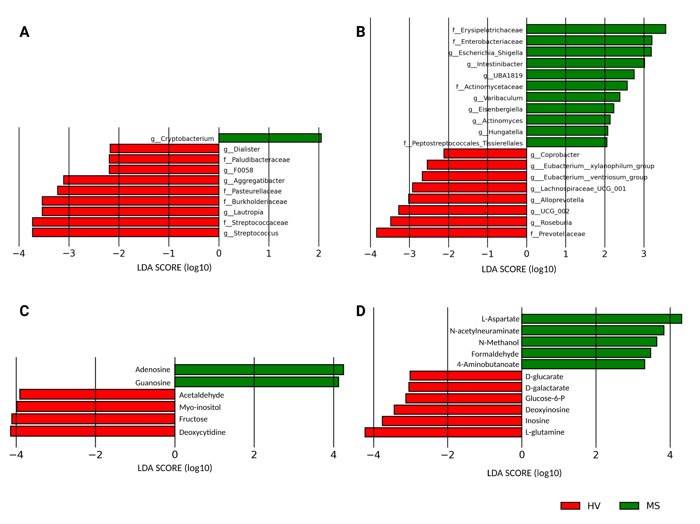
Figure S1: LDA analysis: calculation of the most discriminating variables between HV and MS patients for A: Oral microbiome taxonomy, B: Fecal microbiome taxonomy, C: Oral microbiome-derived metabolites bioavailability, D: Fecal microbiome-derived metabolites bioavailability
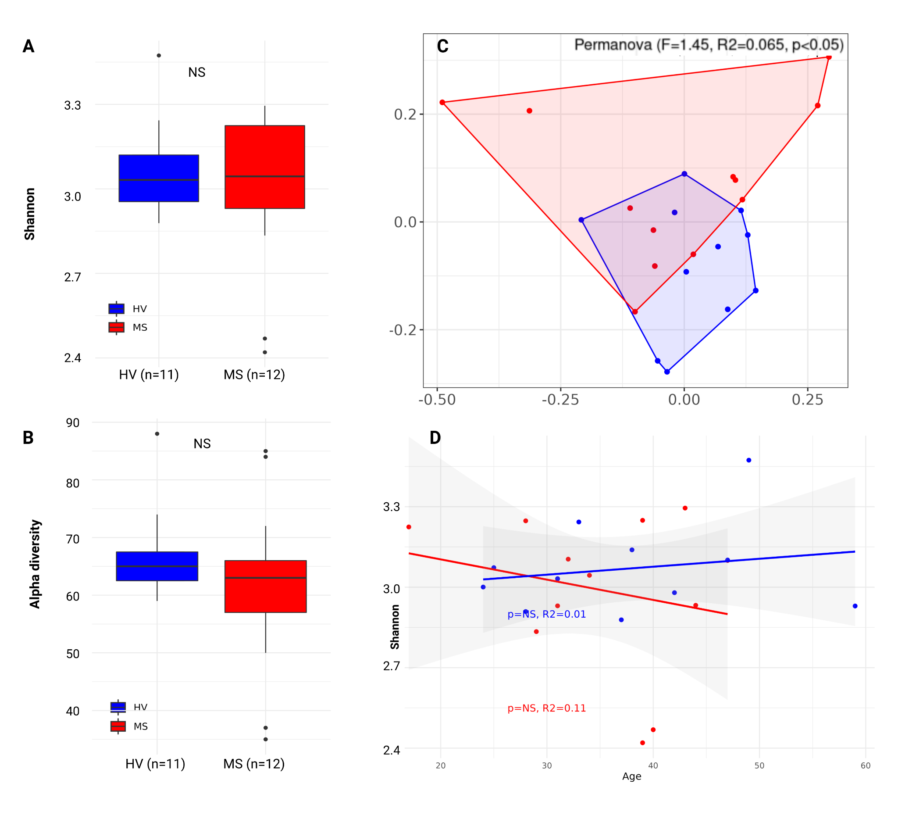
Figure S2: Fecal diversity indices: α diversity and Shannon indices are not different between MS and HV (A, B). Bars represent standard deviation (SD). β-diversity PERMANOVA analysis showed differences in the overall microbiome of MS patients compared to HV, confirming dysbiosis state in the gut of MS patients (C, p<0.05). Shannon index from feces microbiome is not associated with age (D). β-diversity PERMANOVA analysis.

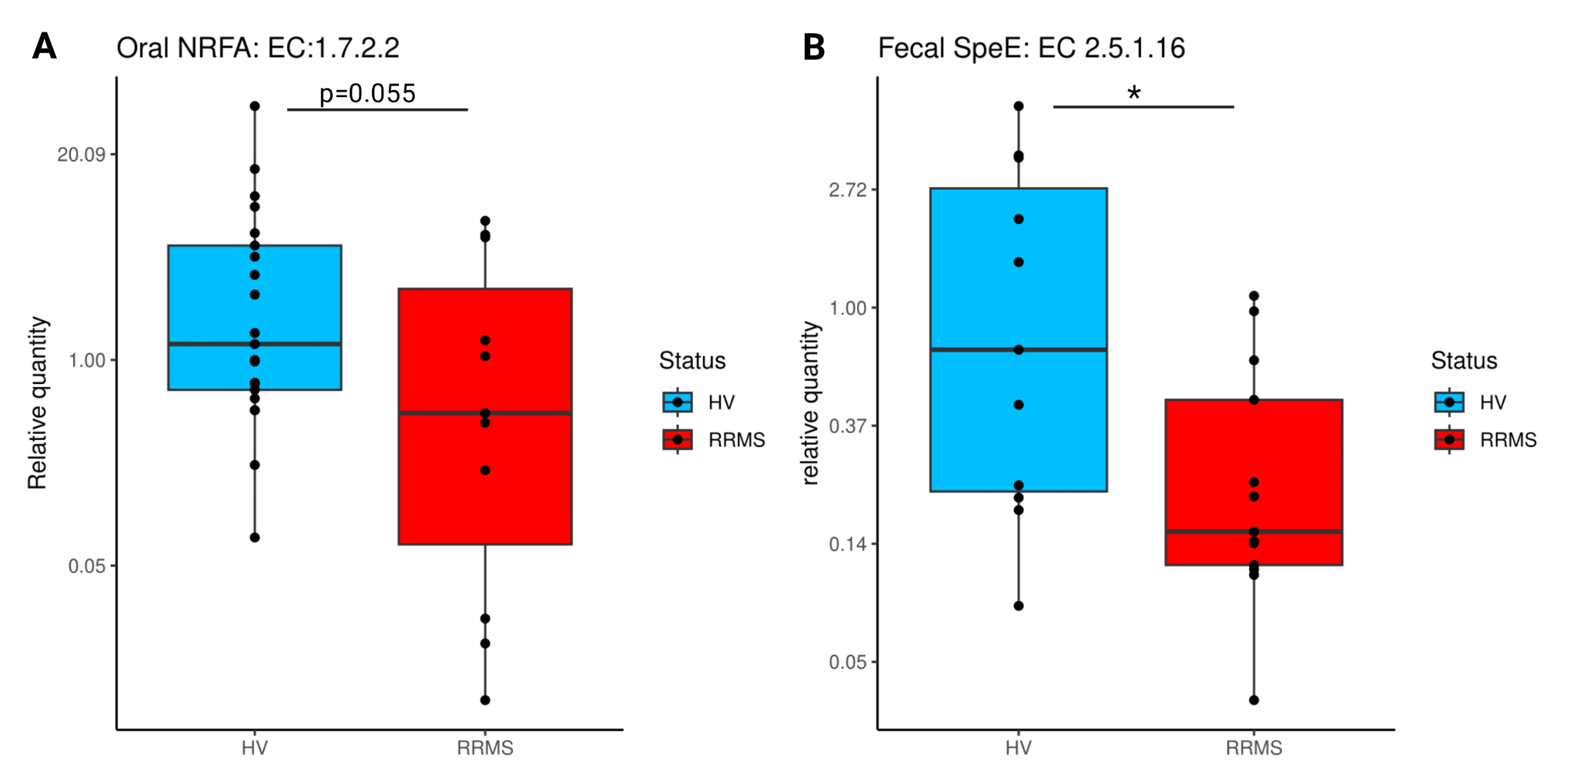
Figure S3: qPCR relative quantification of gene copy number of A: Oral nitrite reductase and B: Fecal Spermidine synthase, predicted to be altered in MS by Picrust analysis

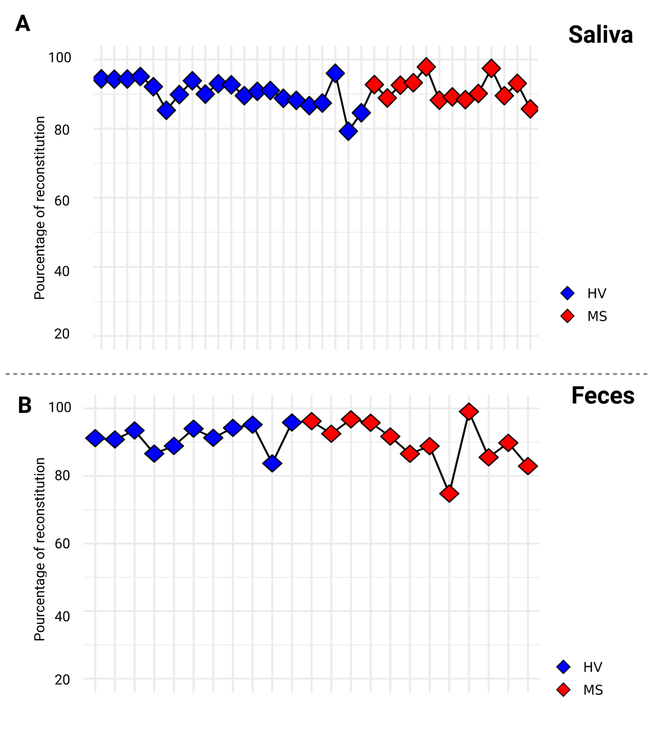

Figure S4: Levels of metabolic reconstruction for each individual. Bacterial metabolism models were merged together and pondered to reflect the abundance of each bacteria for a given individual. A: Oral microbial metabolism reconstruction, B: Fecal microbial metabolism reconstructions.

