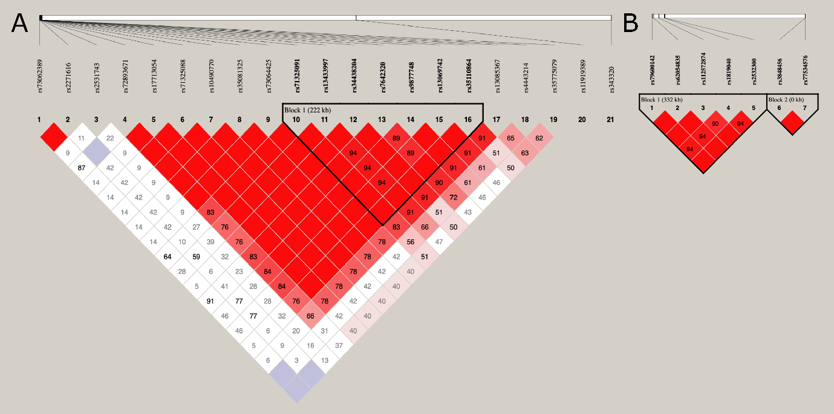
Supplementary Figure 1. Linkage disequilibrium analysis. Linkage disequilibrium between the SNPs located on chromosome 3 (A) and 17 (B) was analyzed by the Haploview 4.2 software. The squares show inside the value of D'. For the intense red squares in which numerical values are not included, D' = 1.

