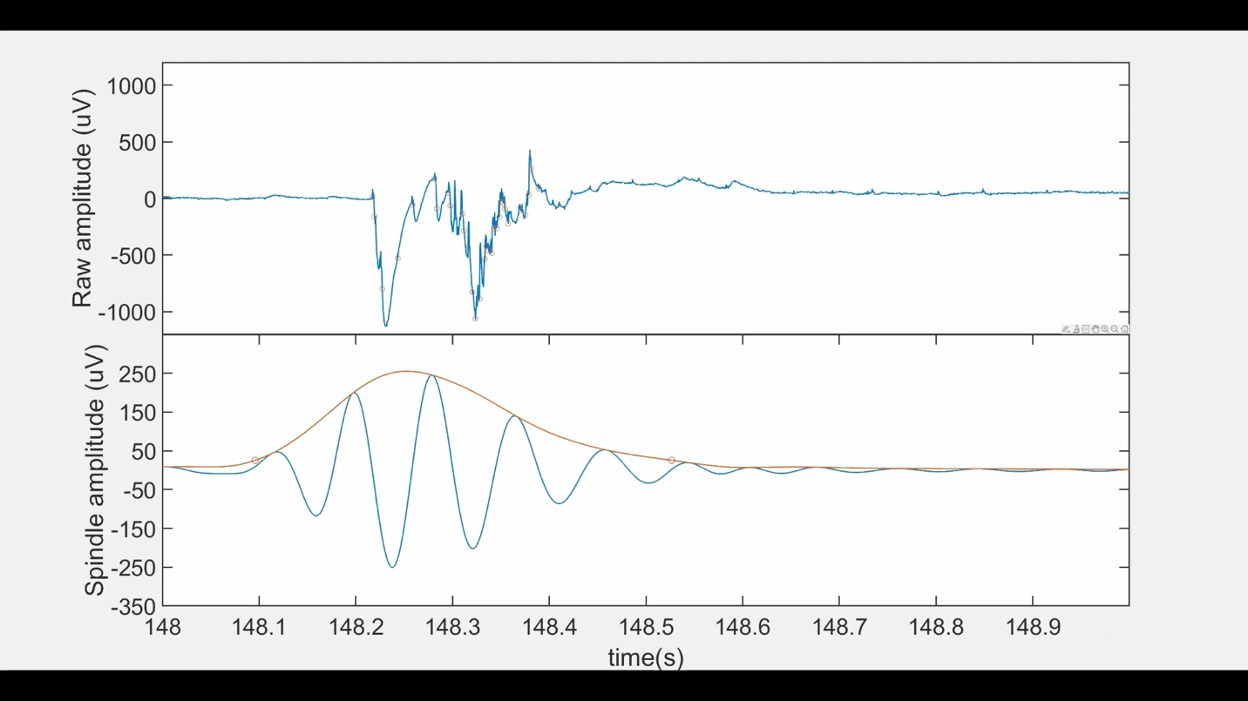
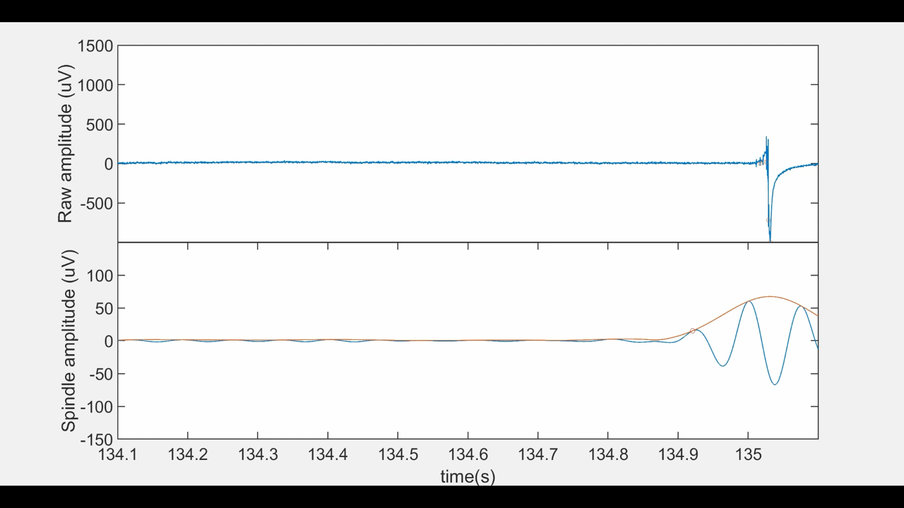
Supplementary figures, Wang et al.

A) CA3-CA1 feedforward spindles (M7-M6)

B) CA3 to DG feedback spindles (F10-G10)

Supplementary Figure 1. Spindle videos. Top panel, raw data, including spikes marked at their peak (o). Bottom panel, spindle oscillation from 10-16 Hz filter. Start and end of spindle marked by orange (o). Orange trace marks spindle envelope.
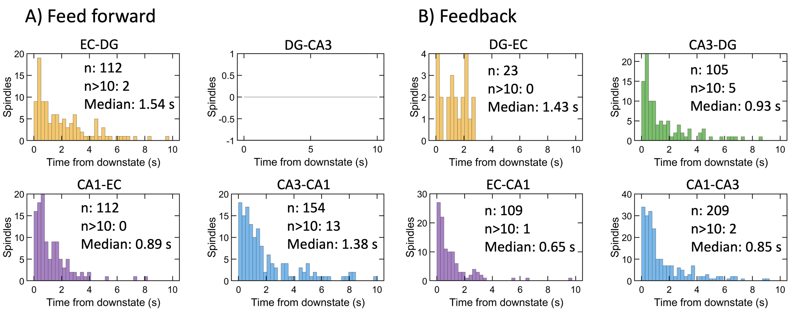Supplementary Fig. 3. Distributions of spindles in time from the onset of a slow wave by subregions. A) feed forward axons, and B) feedback axons
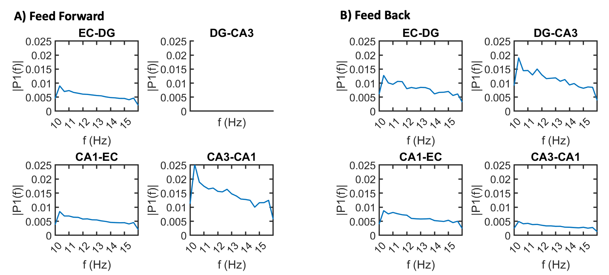Supplementary Fig. 2. 10-12 Hz peaks in power distributions of fast Fourier transforms within the 10-16 Hz range of spindle frequencies from nine arrays by subregion and A) feed forward axons, and B) feedback axons.

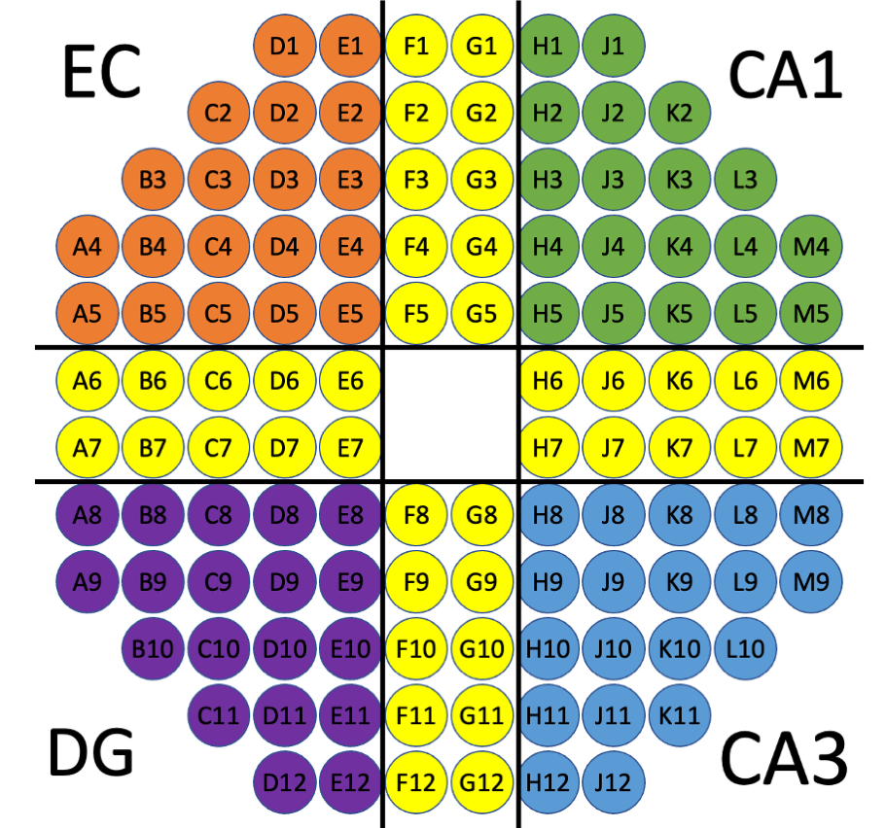Supplementary Fig. 4. Electrode names in each subregional compartment and their interconnecting axon tunnels (yellow). Half of recordings had this counter-clockwise order reversed with CA1 and DG swapped.

