Supplementary file, Fossati et al. 2024

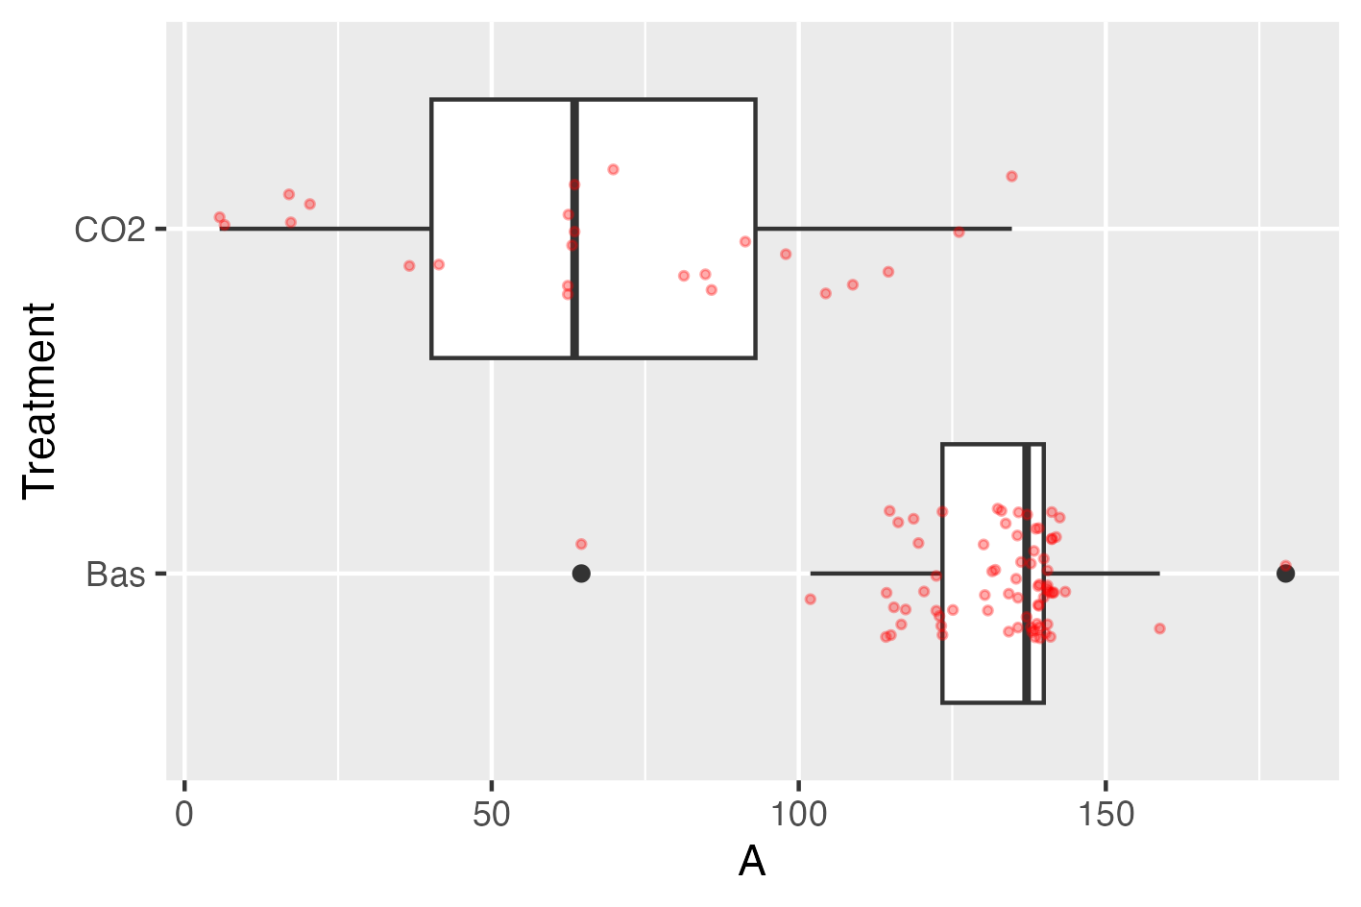
Fig. 1: Boxplots of variable A given treatment

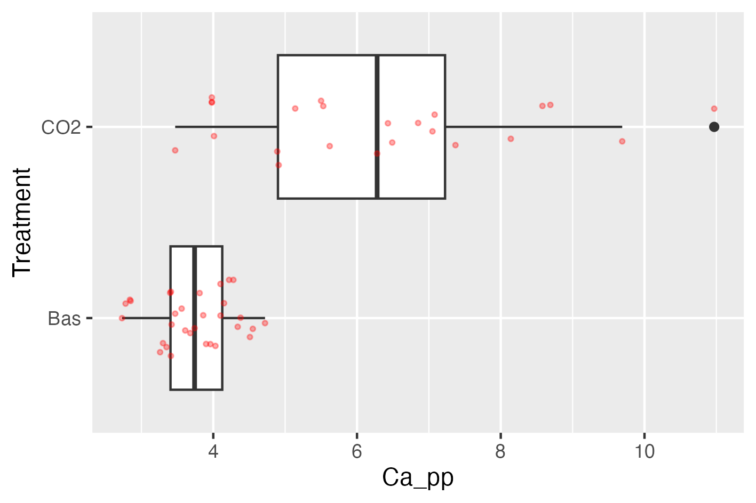

Fig. 2: Boxplots of variable Ca given treatment.

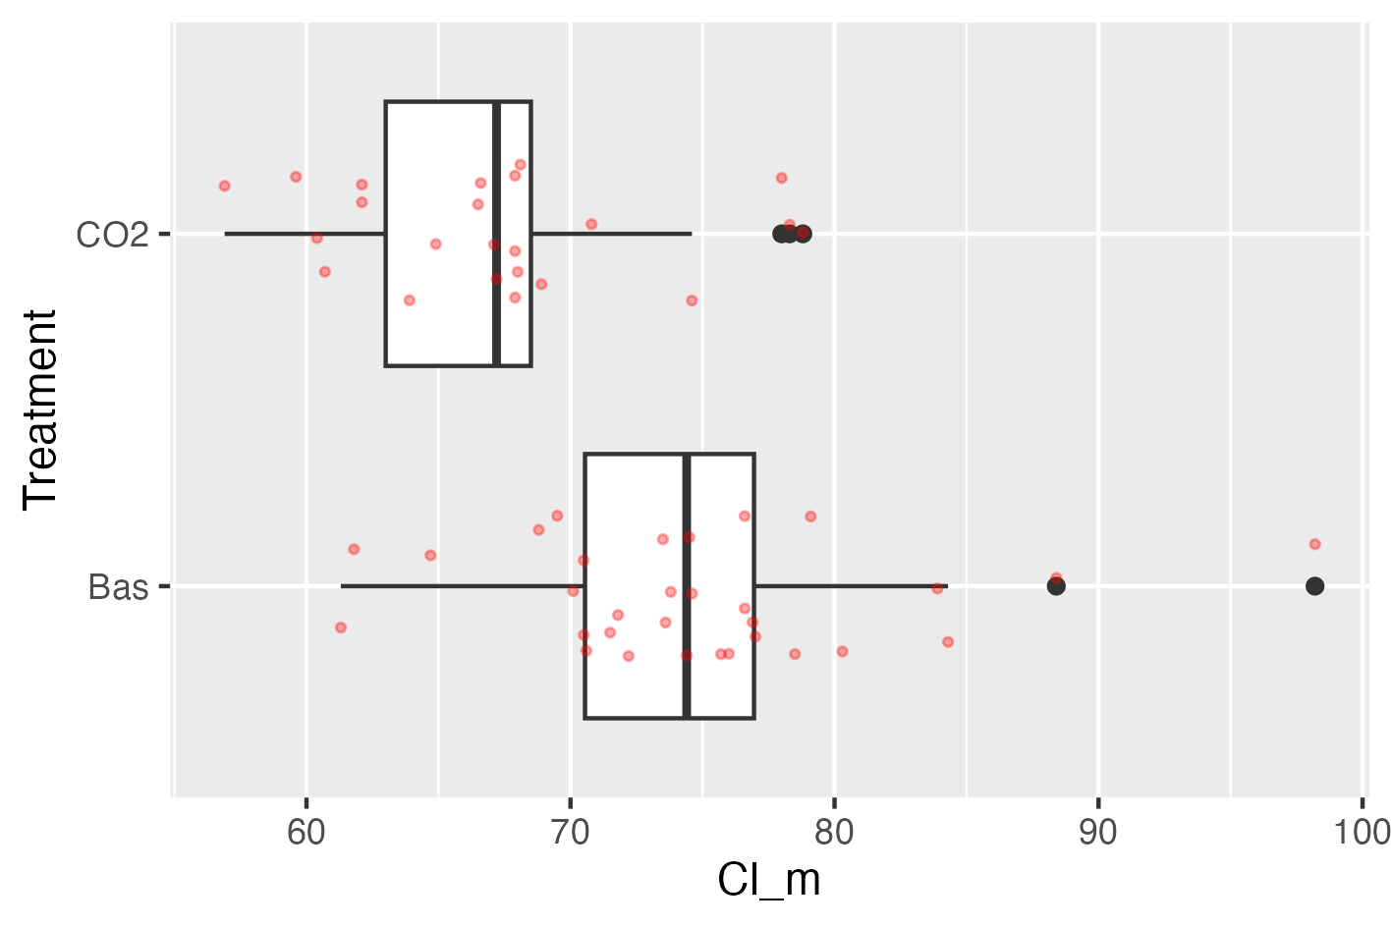

Fig. 3: Boxplots of variable Cl given treatment.

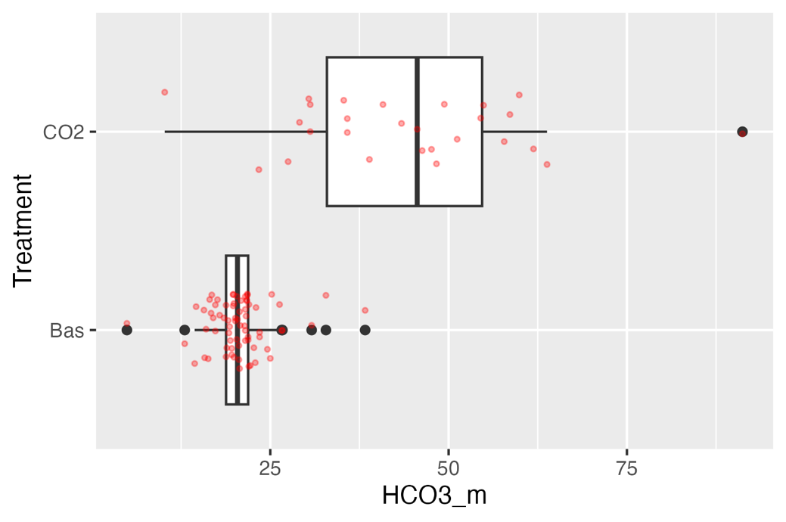

Fig. 4: Boxplots of variable HCO3 given treatment.

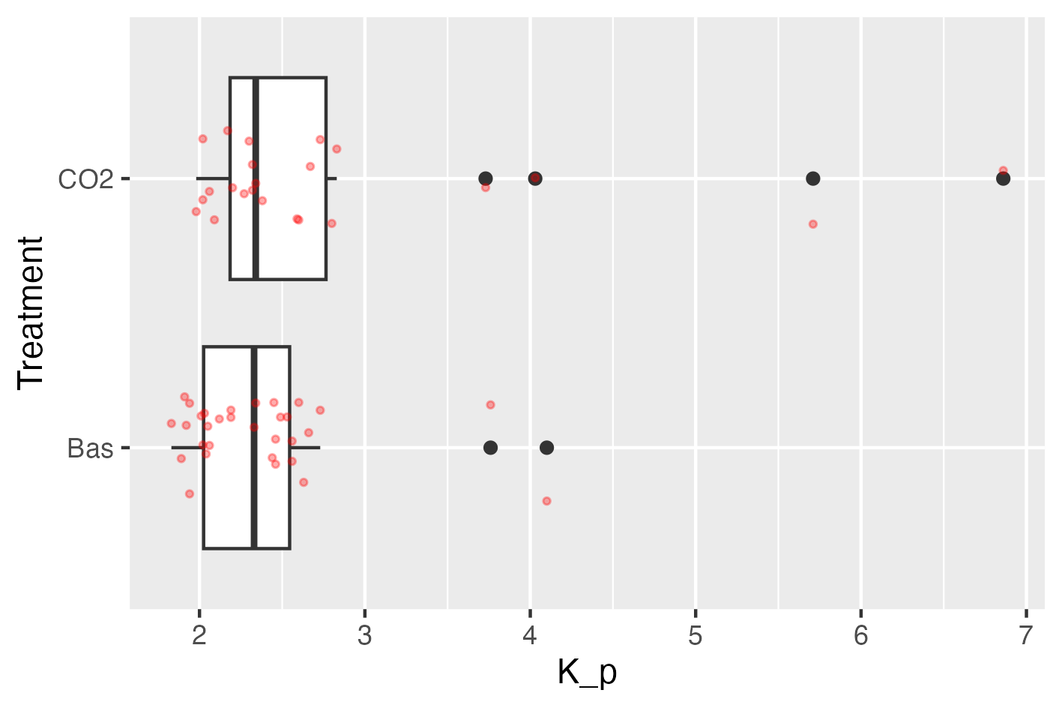

Fig. 5: Boxplots of variable K given treatment.

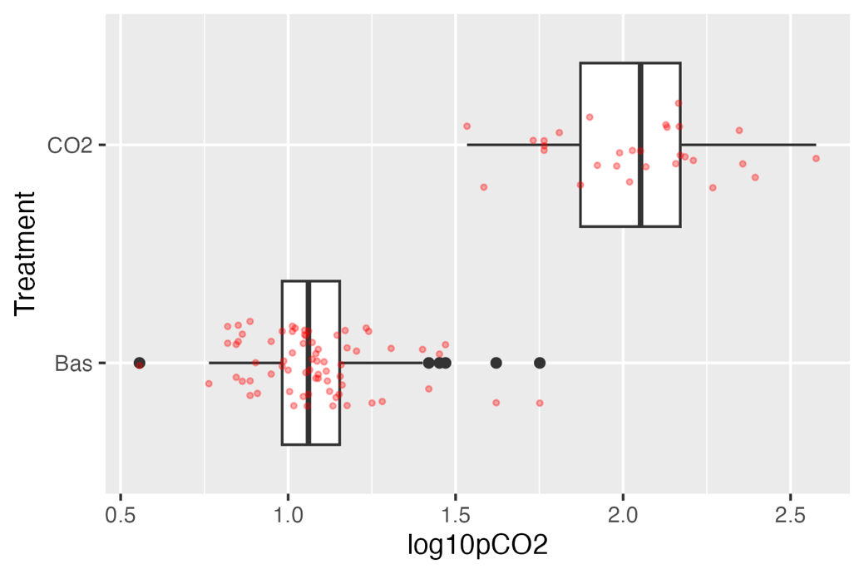

Fig. 6: Boxplots of variable pCO2 (natural log scale) given treatment.

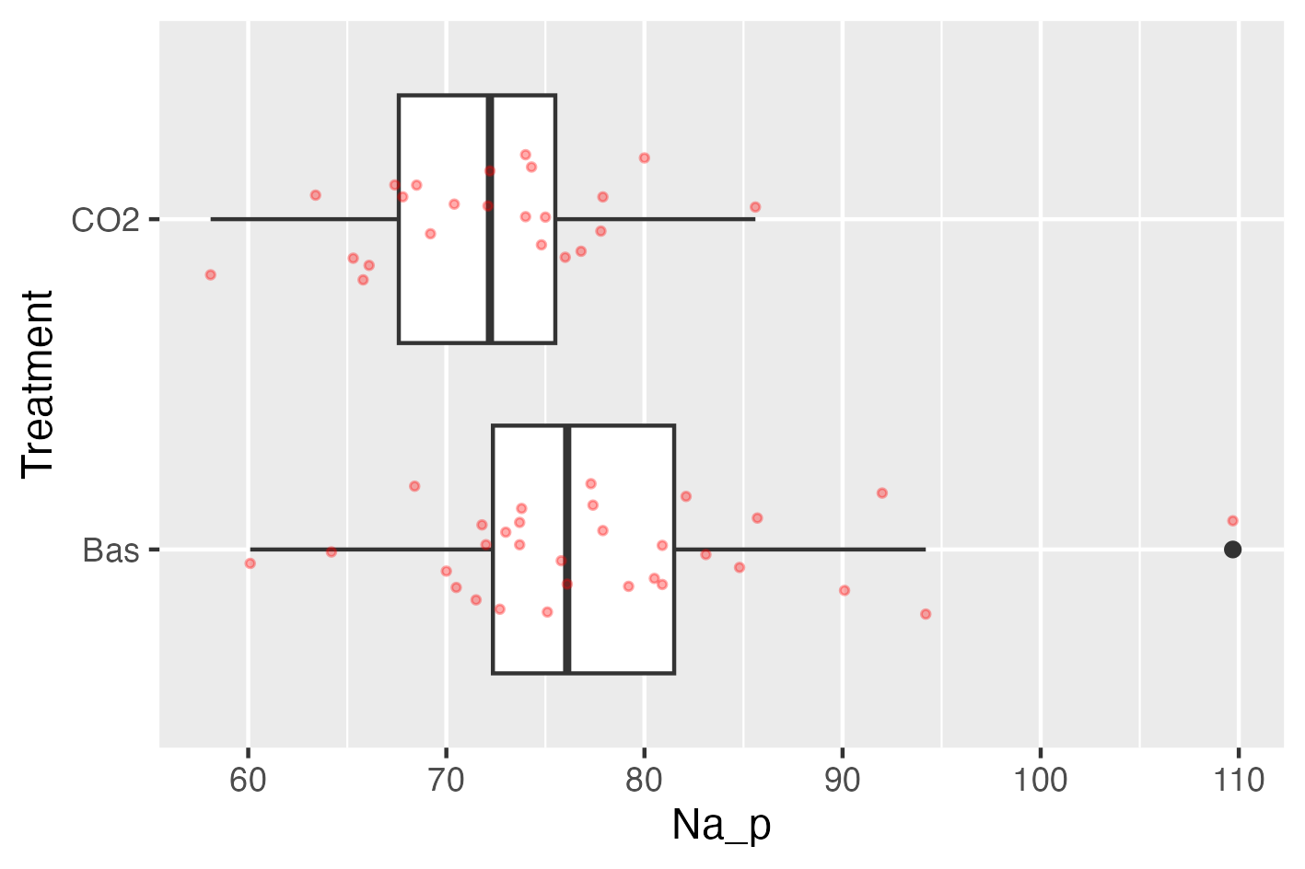

Fig. 7: Boxplots of variable Na given treatment.

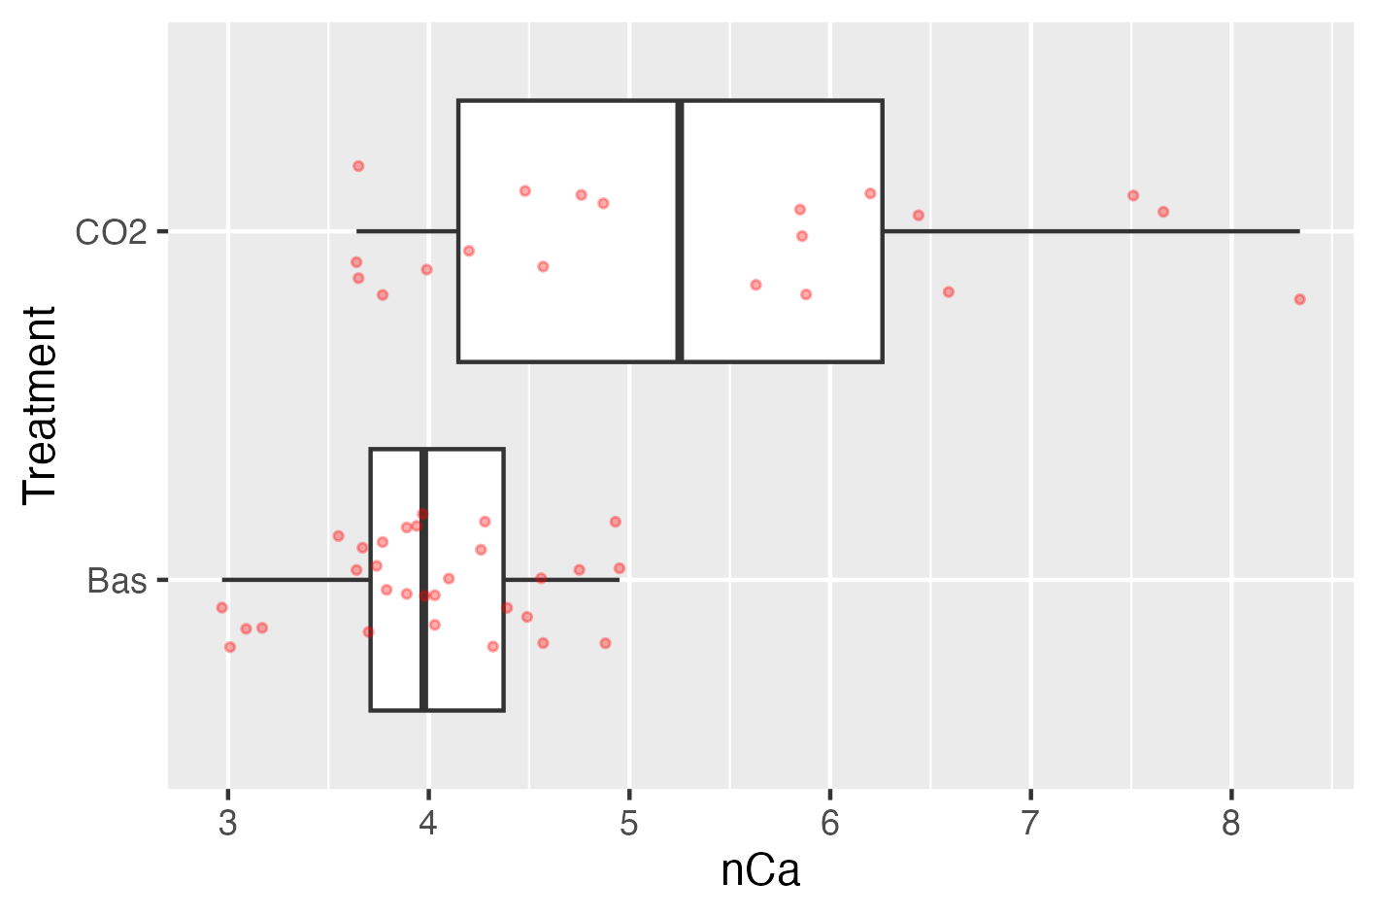

Fig. 8: Boxplots of variable nCa given treatment.

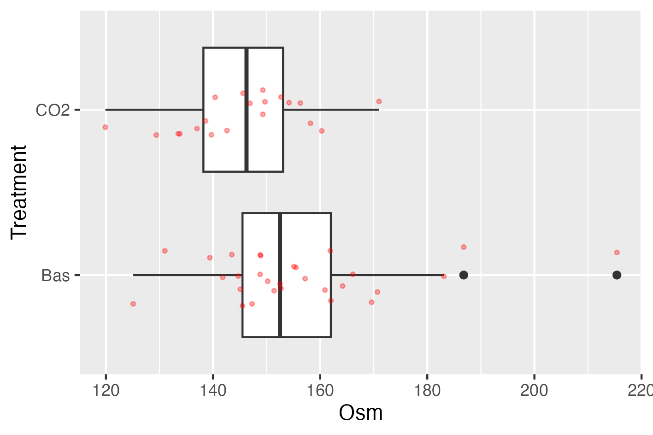
Fig. 9: Boxplots of variable Osm given treatment.

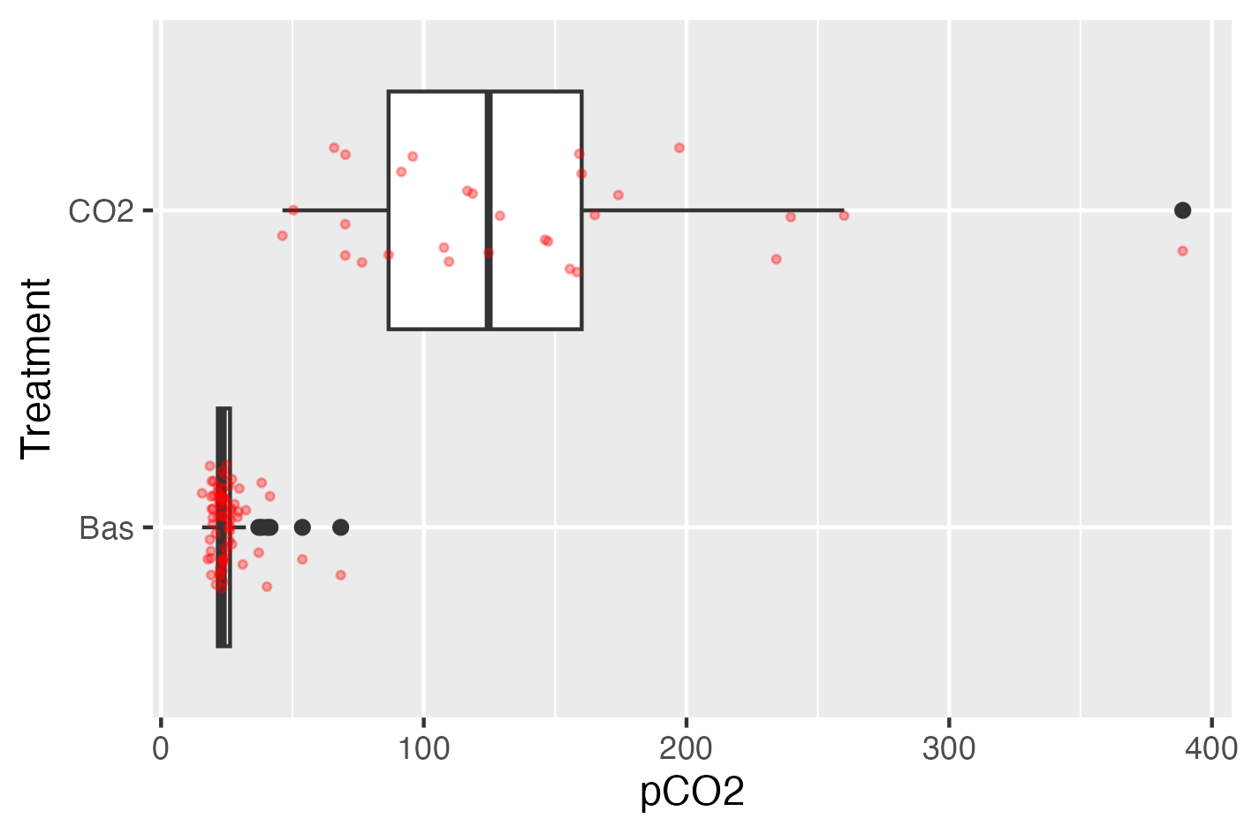

Fig. 10: Boxplots of variable pCO2 given treatment.

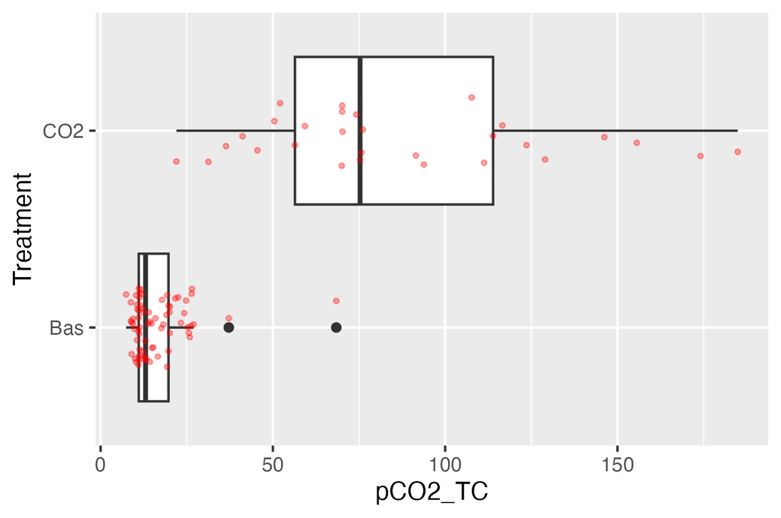
Fig. 11: Boxplots of variable pCO2_T given treatment.

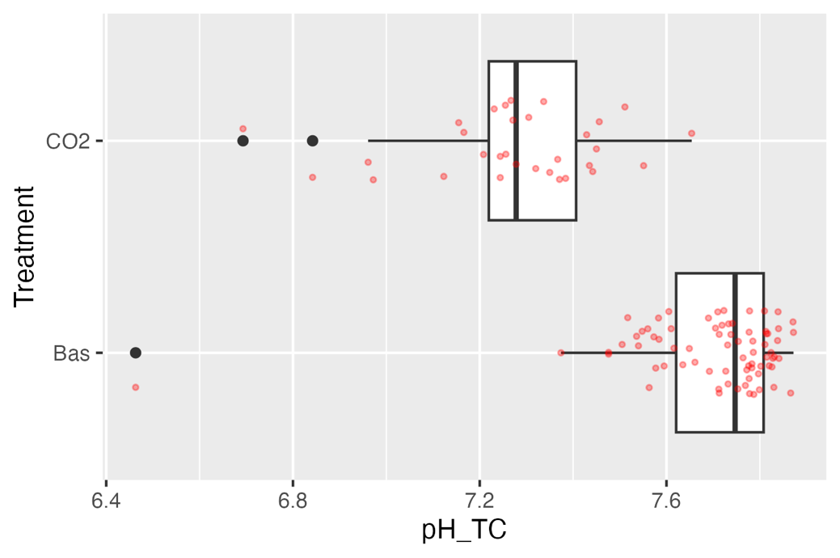
Fig. 12: Boxplots of variable pH_TC given treatment.

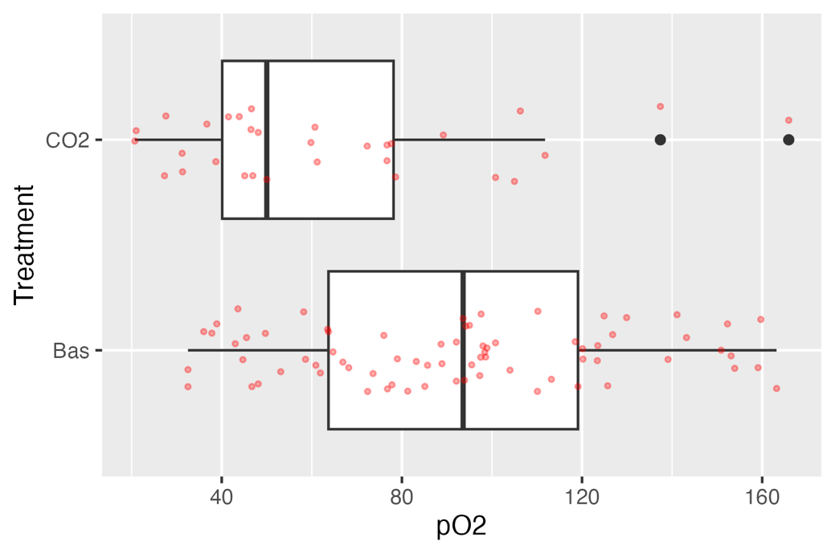

Fig. 13: Boxplots of variable pO2 given treatment.

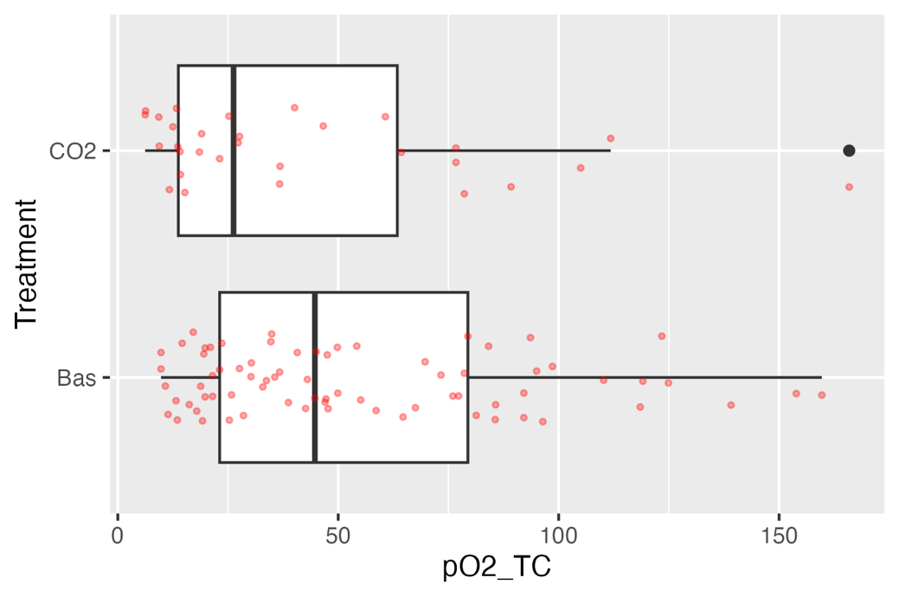

Fig. 14: Boxplots of variable pO2_TC given treatment.

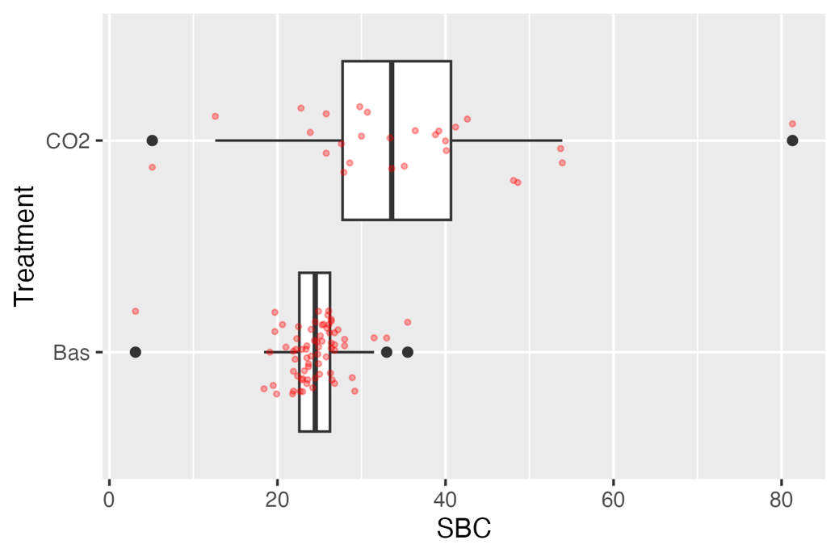

Fig. 15: Boxplots of variable SBC given treatment.

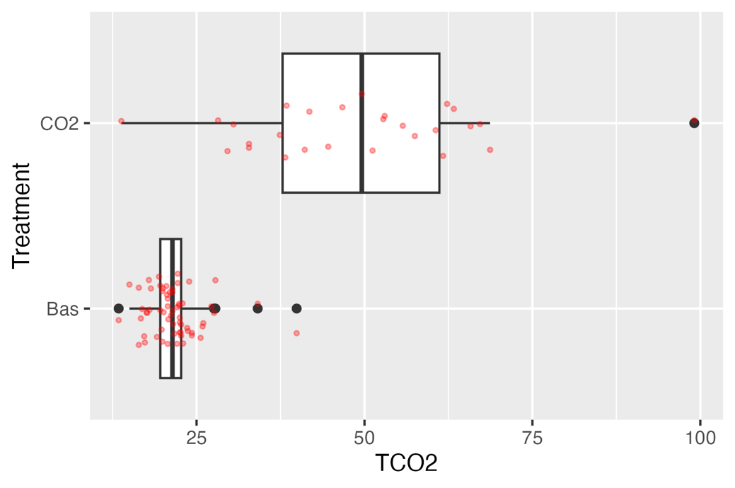

Fig. 16: Boxplots of variable TCO2 given treatment.

