ELECTRONIC SUPPLEMENTARY MATERIAL
Unravelling the Complex Interplay among Vitamin D Metabolites in Obesity: Insights from an LC-MS/MS Study
Supplementary Table and Figure given below

Table S1. Correlations between vitamin D metabolites and the severity of weight excess (BMI) and CRP
Vitamin D Metabolite | BMI | CRP
Vitamin D3(ng/ml) | r=.004  p=0.948 | r=-.081  p=0.181
Vitamin D2(ng/ml) | r=.001  p=989 | r=-.055  p=0.359
25OHD3(ng/ml) | r=.040  p=0.513 | r=-.073  p=0.227
25OHD2(ng/ml) | r=.234  p=0.349 | r=.164  p=0.490
1α,25(OH)₂D3 (ng/ml) | r=.221  p=0.001 | r=.088  p=0.203
3-Epi-25OHD3 (ng/ml) | r=.169  p=0.025 | r=.007  P=0.930
7αC4 (ng/ml) | r=.141  p=0.021 | r=.017  P=0.779

Abbreviations: 25OHD3, 25-hydroxyvitamin-D3; 25OHD2, 25-hydroxyvitamin-D2; 1α,25(OH)₂D3, 1-α-25 dihydroxyvitamin-D3; 3-Epi-25OHD3, 3-epi-25-hydroxyvitamin-D3; 7αC4, 7-α-hydroxy-4-cholesten-3-one; BMI, Body mass index; CRP, C-reactive protein.

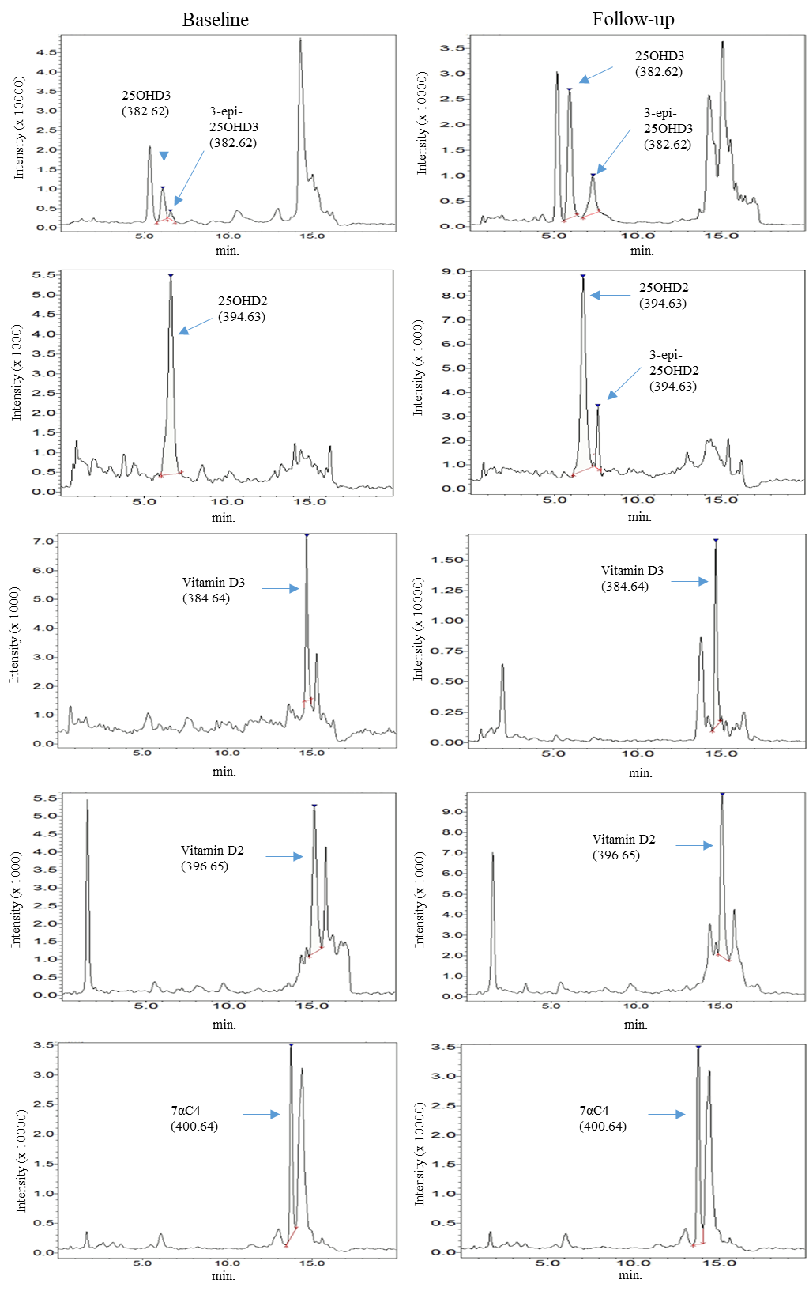
Figure S1. Vitamin D metabolites Chromatogram in human samples. The chromatogram illustrates the vitamin D metabolites along with their molecular weights expressed in g/mol in two obese groups (Baseline and Follow-up). 3-epi-25OHD2 was not detected in baseline group.

