Supplemental Material

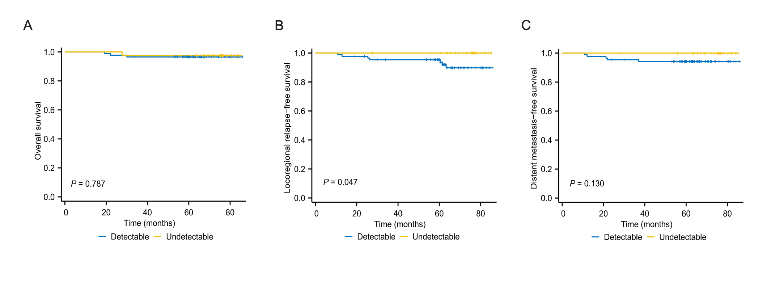
Supplemental Figure S1 Kaplan‒Meier curves for overall survival (A), locoregional relapse-free survival (B), and distant metastasis-free survival (C) using 0 copies/ml as the cut-off value of miR-BART8-3p.

Category | Sequence
BART8-3p TaqMan Probe | 5’- CGCACTGGATACGACTCTACG - 3’
BART8-3p Forward primer | 5’- ATCGTCACAATCTATGGGGT-3’
BART8-3p Reverse primer | 5’- GCAGGGTCCGAGGTATTC-3’
BART8-3p Reverse transcription primer | GTCGTATCCAGTGCAGGGTCCGAGGTATTCGCACTGGATACGACTCTACG
Synthetic BART8-3p mimics | 5’- GUCACAAUCUAUGGGGUCGUAGA-3’
EBV DNA Forward Primer | 5’-TGCCAAAGAGCCAGATCTAAGG-3’
EBV DNA Reverse primer | 5’-AAAGTGTCAGATTTTGGGTCCAA-3’
EBV DNA Probe | 5’-FAM-CAGCCCCAAAGCGGGTGCAGTAAC-BHQ1-3’
EBV DNA Reverse transcription primer | 5’-GTCGTATCCAGTGCAGGGTCCGAGGTATTCGCACTGGATACGACCCCTGG-3’
Supplementary Table 1 The sequence of the forward primers, reverse primers, probe, and synthetic mimics.

