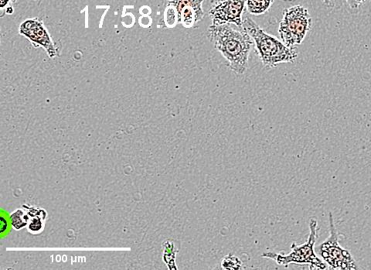
Video S3. Cell to cell dissemination (2): Kiss and run: J774.1 macrophages were infected in DMEM-Glucose at an MOI of 100 with wild-type F. novicida expressing pKK214::pGrogfp (designated WT-GFP). The infected cell moves and gets in contact with several uninfected cells. After numerous contacts with the same uninfected cell, cell-to-cell transfer of Francisella occurs.

