Figure S1
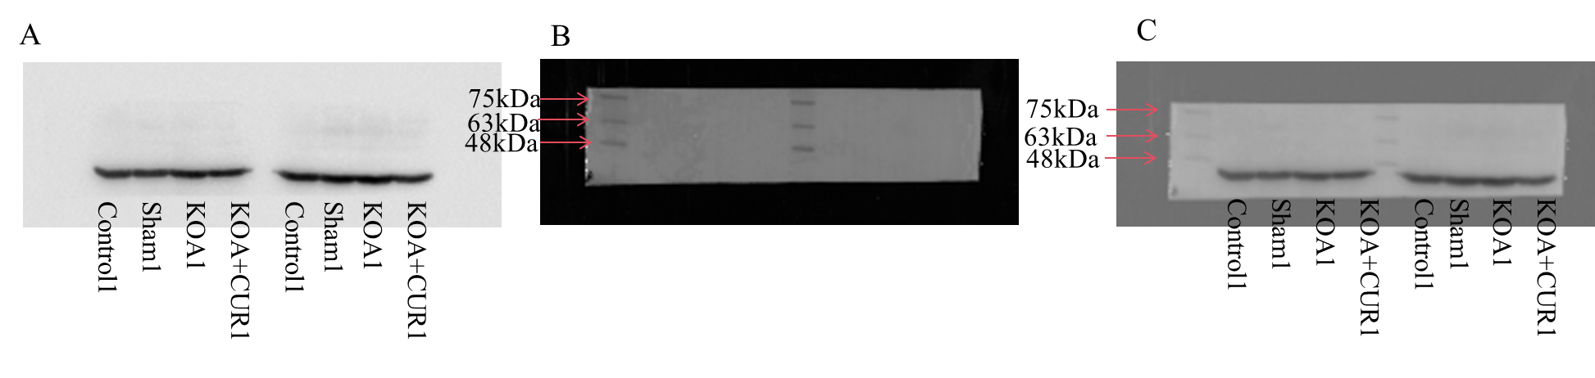
Original blot images of Atrogin-1. The left side of the blot (A) we used in Figure 4.
(A) Blot image of Atrogin-1.
(B) Protein marker image of Atrogin-1.
(C) Blot image of Atrogin-1 (A) merged with protein marker image (B).

Figure S2
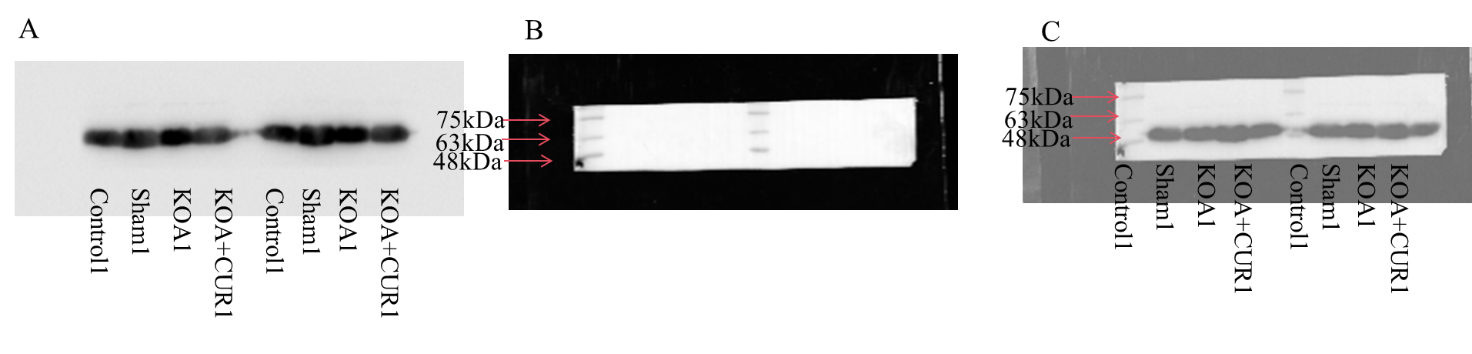
Original blot images of MuRF-1. The right side of the blot (A) we used in Figure 4.
(A) Blot image of MuRF-1.
(B) Protein marker image of MuRF-1.
(C) Blot image of MuRF-1 (A) merged with protein marker image (B).

Figure S3
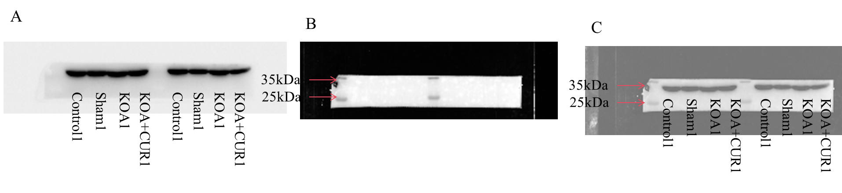
Original blot images of GAPDH. The left side of the blot (A) we used in Figure 4.
(A) Blot image of GAPDH.
(B) Protein marker image of GAPDH.
(C) Blot image of GAPDH (A) merged with protein marker image (B).

Figure S4
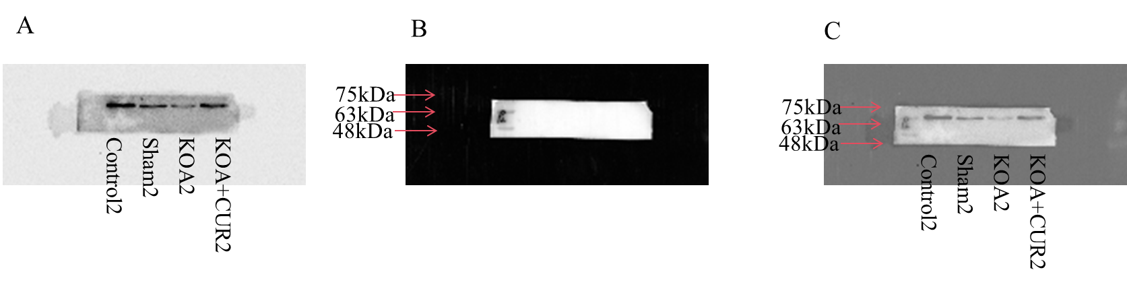
Original blot images of P62. The blot (A) we used in Figure 5.
(A) Blot image of P62.
(B) Protein marker image of P62.
(C) Blot image of P62 (A) merged with protein marker image (B).

Figure S5
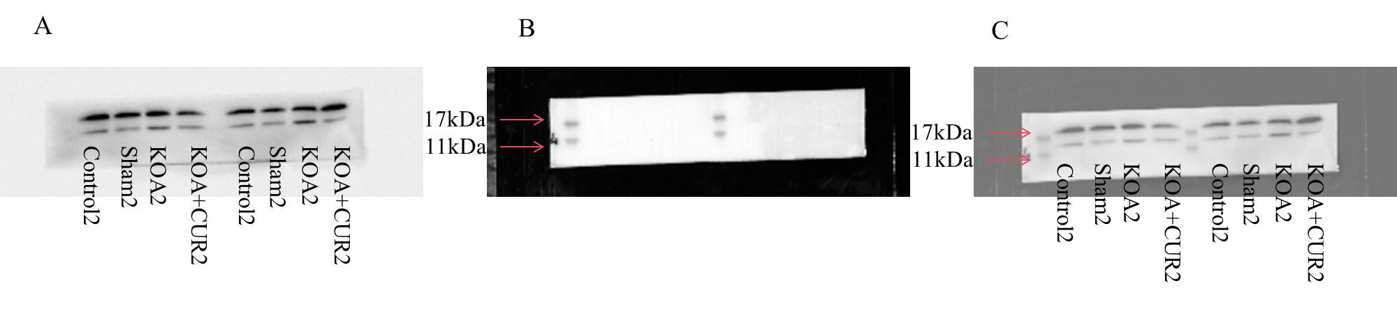
Original blot images of LC3. The right side of the blot (A) we used in Figure 5.
(A) Blot image of LC3.
(B) Protein marker image of LC3.
(C) Blot image of LC3 (A) merged with protein marker image (B).

Figure S6
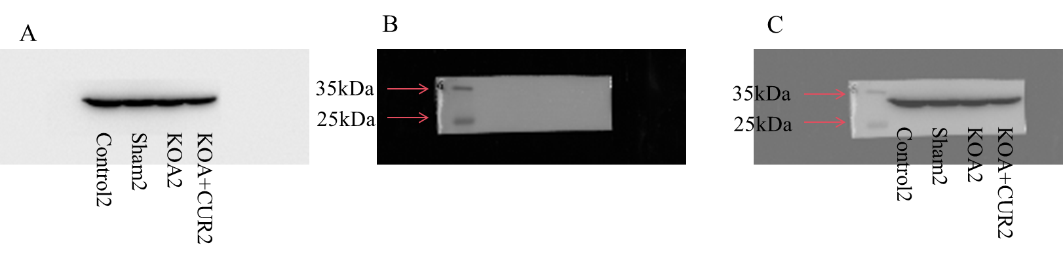
Original blot images of GAPDH. The blot (A) we used in Figure 5.
(A) Blot image of GAPDH.
(B) Protein marker image of GAPDH.
(C) Blot image of GAPDH (A) merged with protein marker image (B).

Figure S7
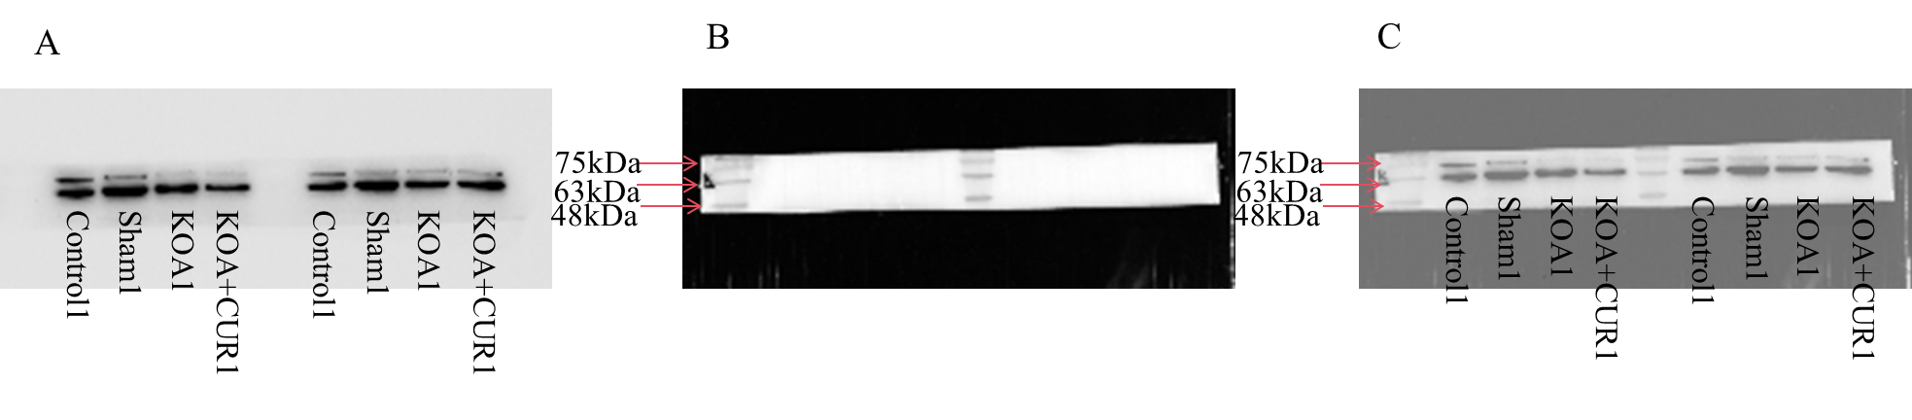
Original blot images of P62. The right side of the blot (A) we used in Figure 6.
(A) Blot image of P62.
(B) Protein marker image of P62.
(C) Blot image of P62 (A) merged with protein marker image (B).

Figure S8
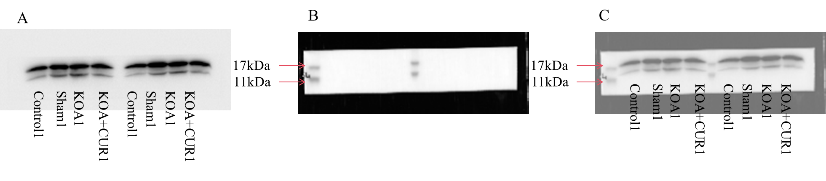
Original blot images of LC3. The left side of the blot (A) we used in Figure 6.
(A) Blot image of LC3.
(B) Protein marker image of LC3.
(C) Blot image of LC3 (A) merged with protein marker image (B).

Figure S9
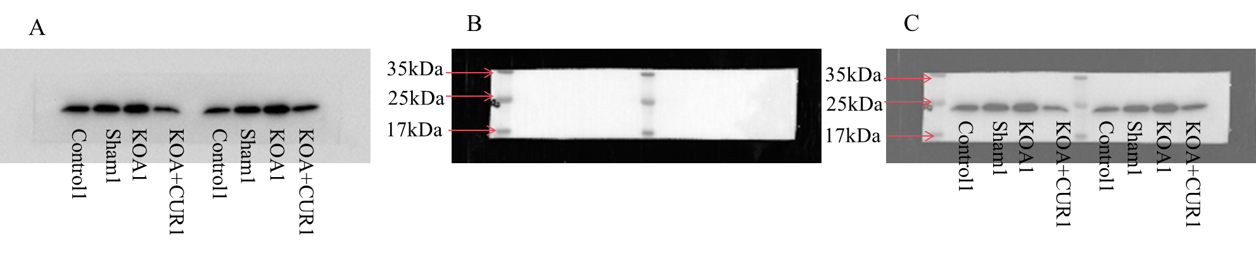
Original blot images of Ac-SOD2. The right side of the blot (A) we used in Figure 6.
(A) Blot image of Ac-SOD2.
(B) Protein marker image of Ac-SOD2.
(C) Blot image of Ac-SOD2 (A) merged with protein marker image (B).

Figure S10
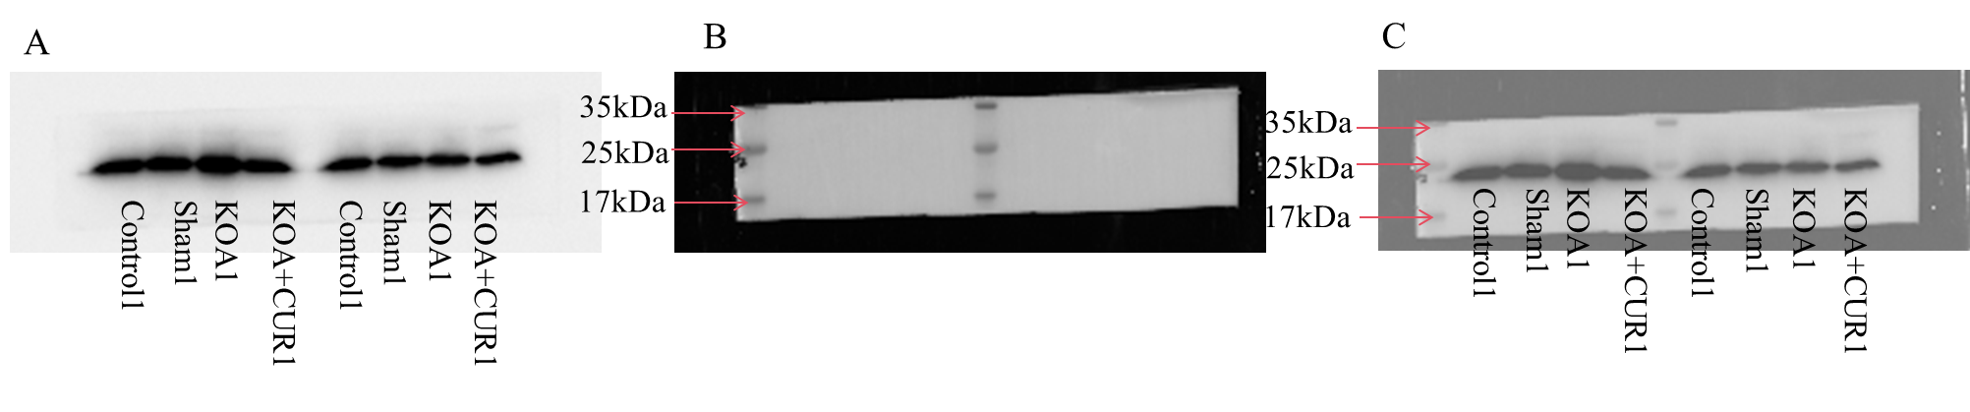
Original blot images of SOD2. The right side of the blot (A) we used in Figure 6.
(A) Blot image of SOD2.
(B) Protein marker image of SOD2.
(C) Blot image of SOD2 (A) merged with protein marker image (B).

Figure S11
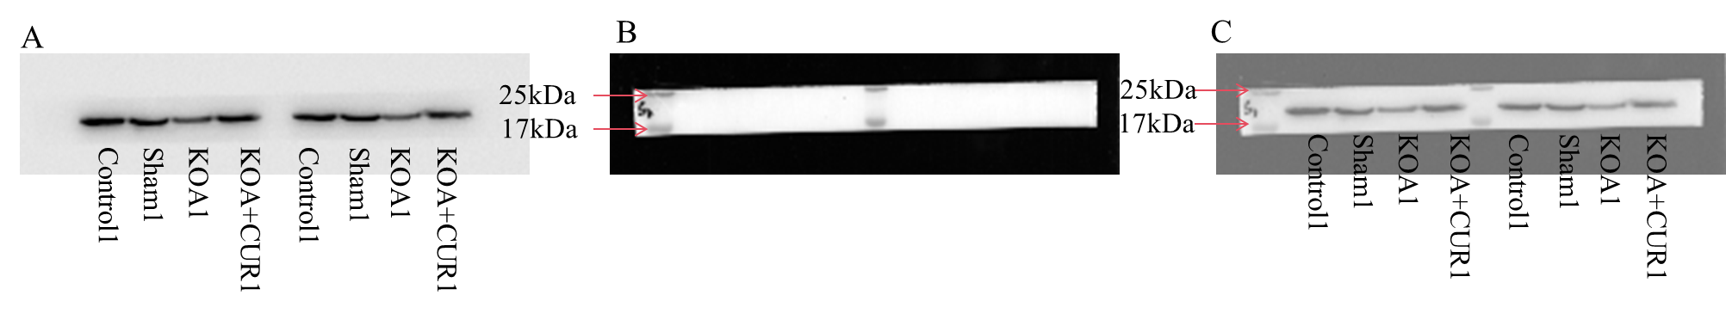
Original blot images of SIRT3. The left side of the blot (A) we used in Figure 6.
(A) Blot image of SIRT3.
(B) Protein marker image of SIRT3.
(C) Blot image of SIRT3 (A) merged with protein marker image (B).

Figure S12
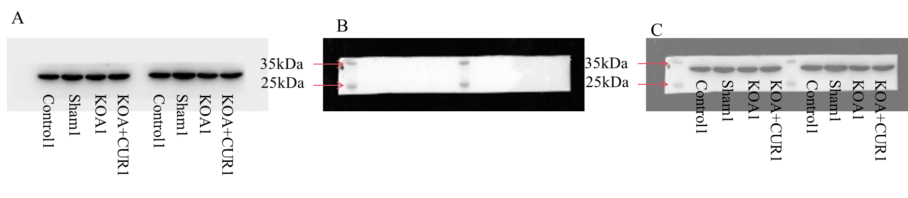
Original blot images of GAPDH. The right side of the blot (A) we used in Figure 6.
(A) Blot image of GAPDH.
(B) Protein marker image of GAPDH.
(C) Blot image of GAPDH (A) merged with protein marker image (B).

The following images of the original blots were from replicate western blotting experiments using different rats. Not presented in the manuscript.
Figure S13
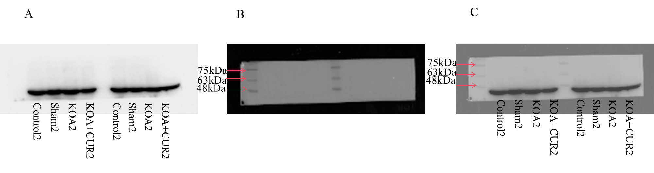
Original blot images of Atrogin-1.
(A) Blot image of Atrogin-1.
(B) Protein marker image of Atrogin-1.
(C) Blot image of Atrogin-1 (A) merged with protein marker image (B).
Figure S14
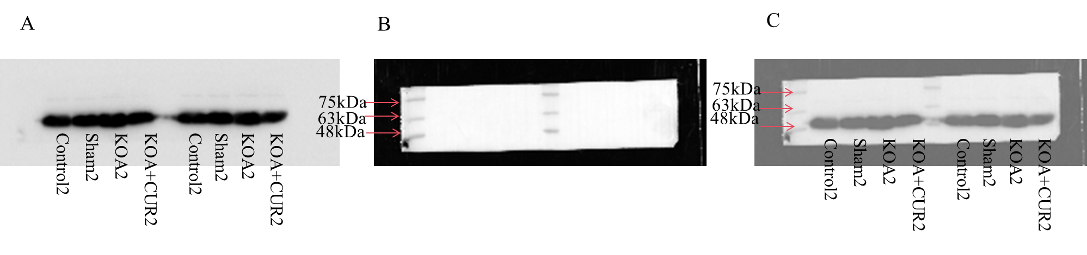
Original blot images of MuRF-1.
(A) Blot image of MuRF-1.
(B) Protein marker image of MuRF-1.
(C) Blot image of MuRF-1 (A) merged with protein marker image (B).

Figure S15
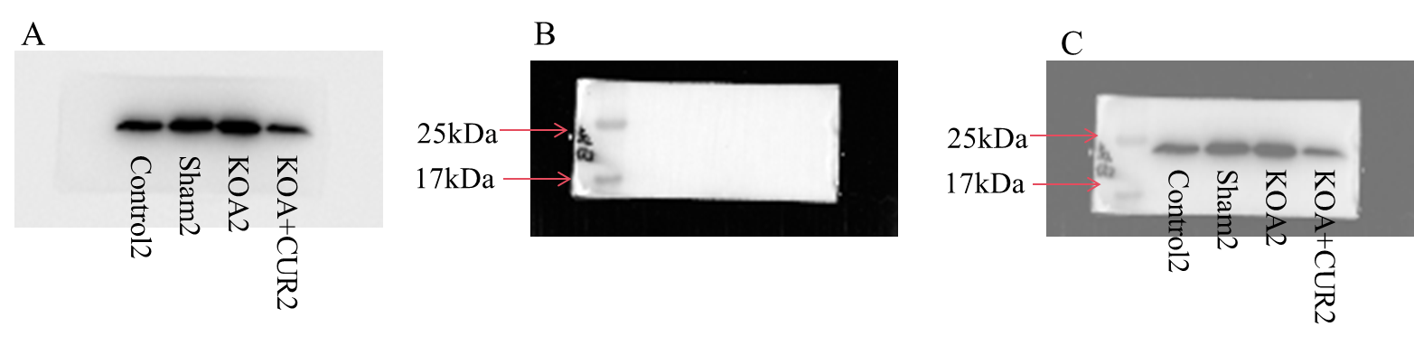
Original blot images of Ac-SOD2.
(A) Blot image of Ac-SOD2.
(B) Protein marker image of Ac-SOD2.
(C) Blot image of Ac-SOD2 (A) merged with protein marker image (B).

Figure S16
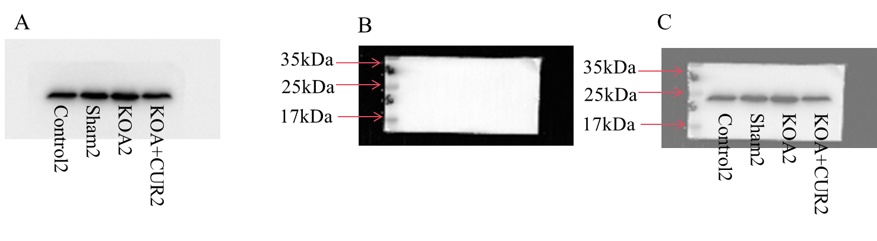
Original blot images of SOD2.
(A) Blot image of SOD2.
(B) Protein marker image of SOD2.
(C) Blot image of SOD2 (A) merged with protein marker image (B).

Figure S17
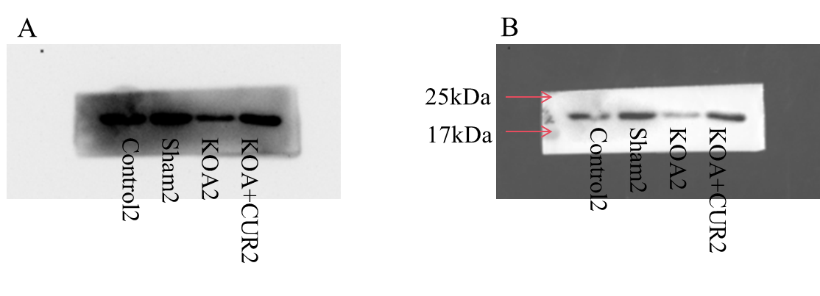
Original blot images of SIRT3.
(A) Blot image of SIRT3.
(B) Protein marker image of SIRT3.
(C) Blot image of SIRT3 (A) merged with protein marker image (B).

Figure S18
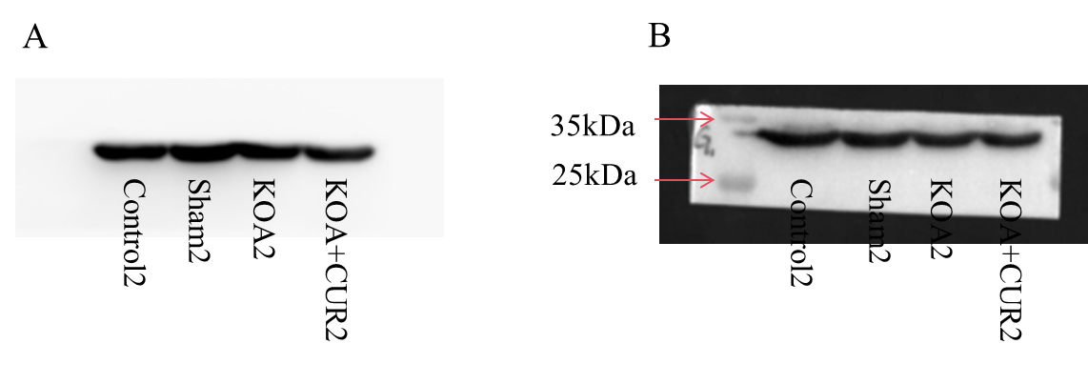
Original blot images of GAPDH.
(A) Blot image of GAPDH.
(B) Protein marker image of GAPDH.
(C) Blot image of GAPDH (A) merged with protein marker image (B).

The following images of the original blots were from replicate western blotting experiments using different rats. Not presented in the manuscript.
Figure S19
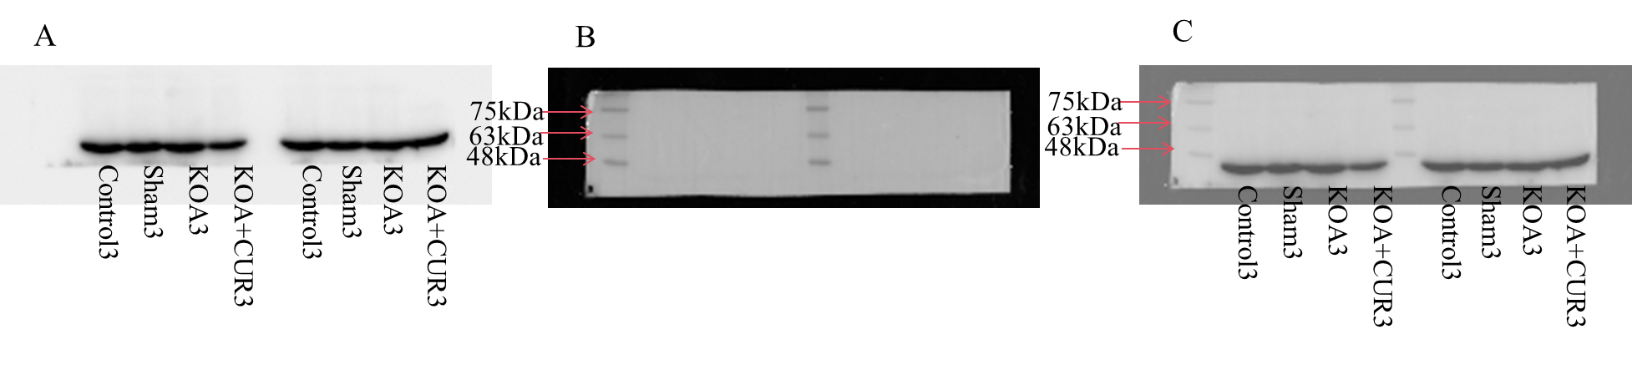
Original blot images of Atrogin-1.
(A) Blot image of Atrogin-1.
(B) Protein marker image of Atrogin-1.
(C) Blot image of Atrogin-1 (A) merged with protein marker image (B).

Figure S20
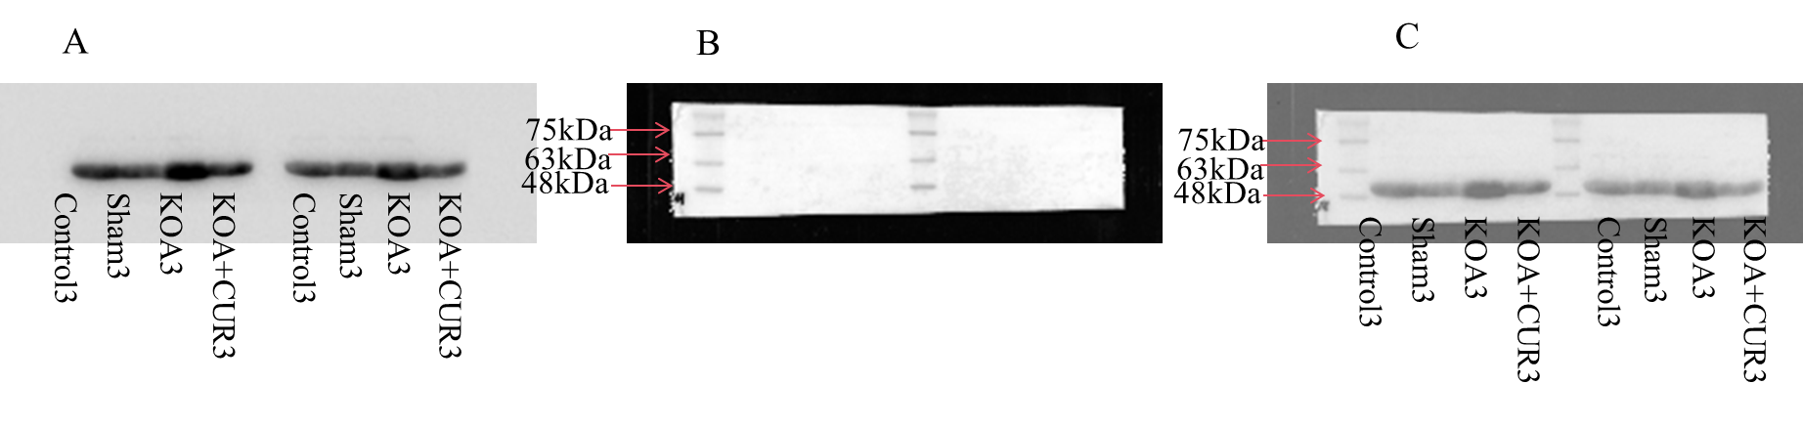
Original blot images of MuRF-1.
(A) Blot image of MuRF-1.
(B) Protein marker image of MuRF-1.
(C) Blot image of MuRF-1 (A) merged with protein marker image (B).

Figure S21
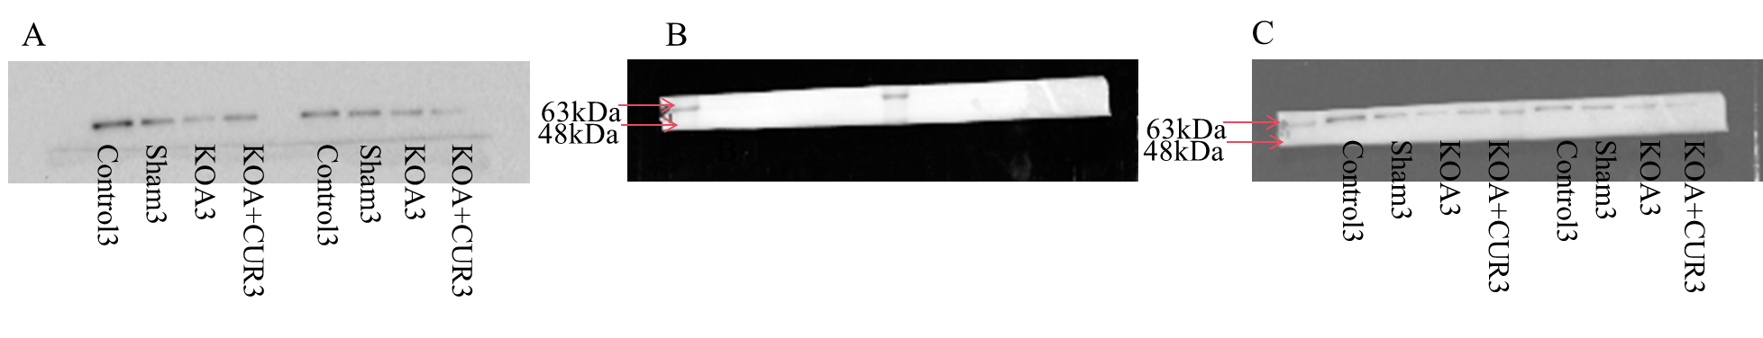
Original blot images of P62.
(A) Blot image of P62.
(B) Protein marker image of P62.
(C) Blot image of P62 (A) merged with protein marker image (B).

Figure S22
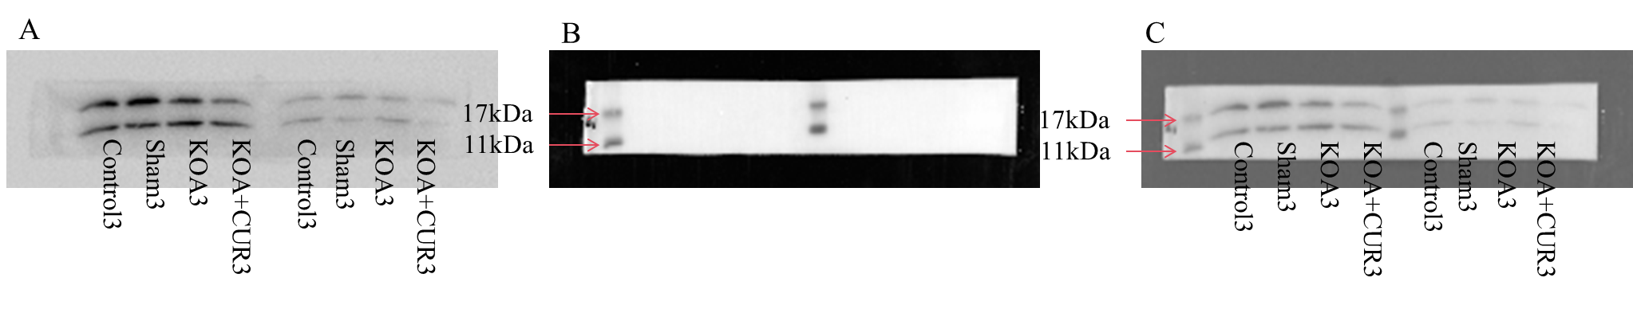
Original blot images of LC3.
(A) Blot image of LC3.
(B) Protein marker image of LC3.
(C) Blot image of LC3 (A) merged with protein marker image (B).

Figure S23
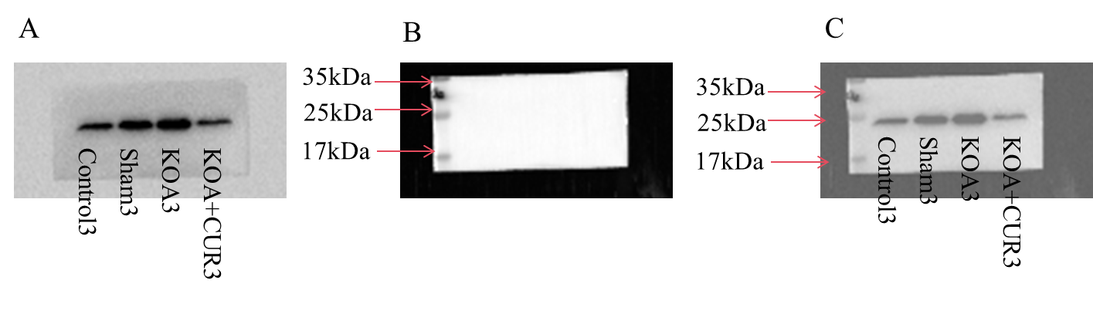
Original blot images of Ac-SOD2.
(A) Blot image of Ac-SOD2.
(B) Protein marker image of Ac-SOD2.
(C) Blot image of Ac-SOD2 (A) merged with protein marker image (B).

Figure S24
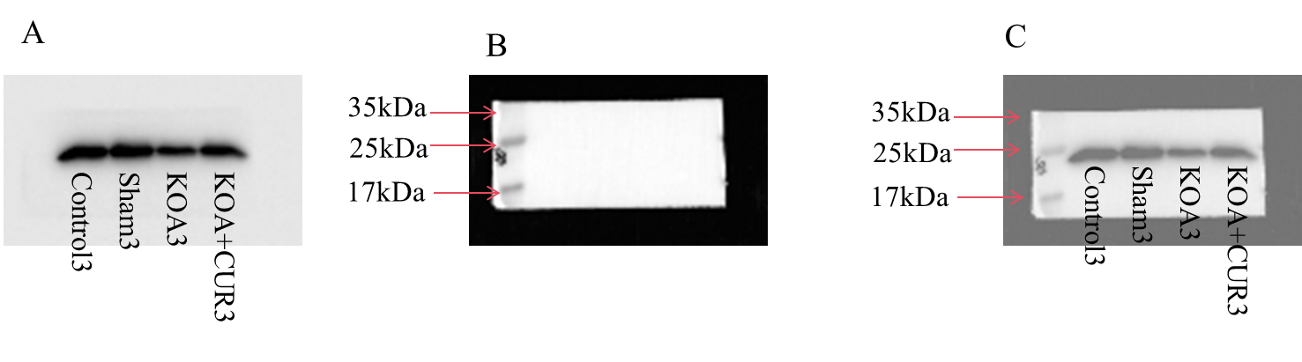
Original blot images of SOD2.
(A) Blot image of SOD2.
(B) Protein marker image of SOD2.
(C) Blot image of SOD2 (A) merged with protein marker image (B).

Figure S25
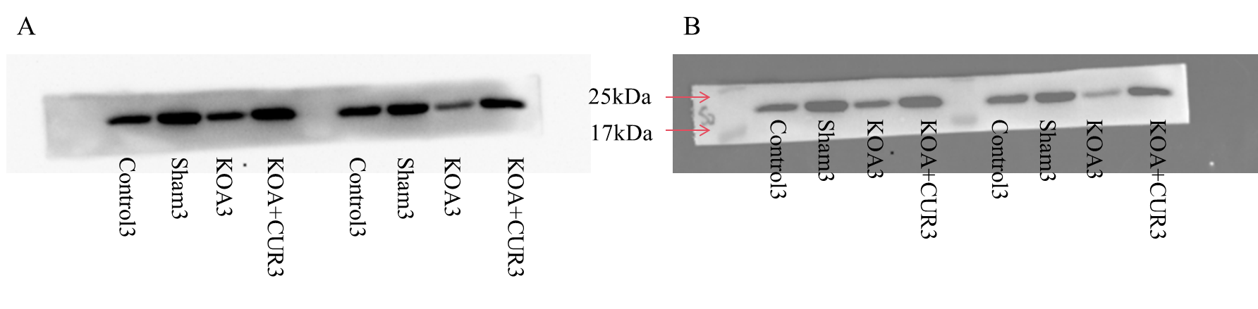
Original blot images of SIRT3.
(A) Blot image of SIRT3.
(B) Protein marker image of SIRT3.
(C) Blot image of SIRT3 (A) merged with protein marker image (B).

Figure S26
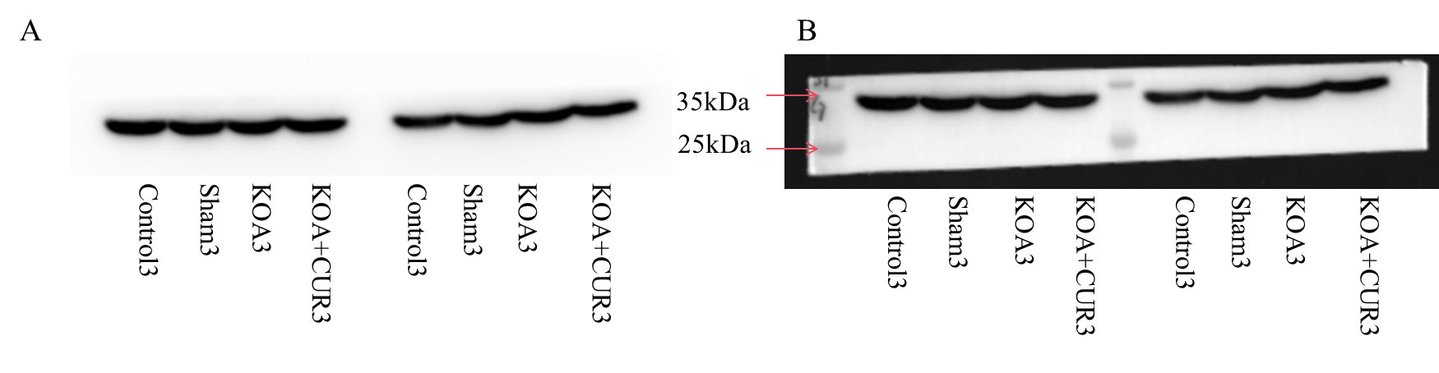
Original blot images of GAPDH.
(A) Blot image of GAPDH.
(B) Protein marker image of GAPDH.
(C) Blot image of GAPDH (A) merged with protein marker image (B).
The brand and item number of the ColorMixed Protein Marker we used is PR1910, Solarbio, China.
