Supplementary Materials

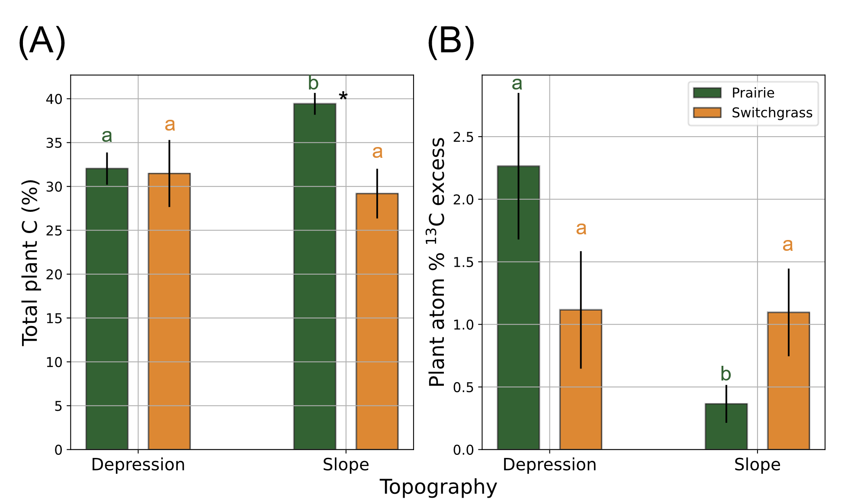
Figure S1. Total C (A) and atom %¹³C excess (B) of the switchgrass belowground biomass grown in the soils from multi-year monoculture switchgrass and restored prairie cropping systems in topographical slopes and depressions. Shown are means with error bars representing standard errors. Asterisk * indicates the significant difference between the two system (prairie vs. switchgrass) within the same topography and biomass type (p< 0.10). Letters mark significant differences between topographical positions within the same system and biomass type.

.

Table S1. ANOVA F-test results (p-values) for the plant tissue, plant system, topography, and their interaction effects for C contents in newly grown switchgrass plant. Only p-values less than 0.10 were underlined. The same statistical results were presented in Fig. 2.

Effect | Plant total C | Plant atom%¹³C excess
Tissue | < 0.01 | < 0.01
System | 0.08 | 0.44
System x Tissue | 0.04 | 0.00
Topography | 0.35 | 0.07
Topography x Tissue | 0.34 | 0.92
System x Topography | 0.07 | 0.20
System x Topography x Tissue | 0.12 | 0.09

Table S2. ANOVA F-test results (p-values) for the plant system, topography, plant treatment, and their interaction effects for the soil C, microbial biomass C, and cumulative CO₂ mineralization. Only p-values less than 0.10 were underlined. The same statistical results were presented in Fig. 3, 4, and 5A.
Effect | Soil total C | Soil atom%¹³C excess | MBC | MB atom%¹³C excess | Cumulative CO₂-C
System | 0.01 | 0.25 | 0.13 | 0.04 | 0.94
Topography | 0.08 | 0.22 | <0.01 | 0.49 | 0.12
System x Topography | 0.10 | 0.77 | 0.10 | 0.09 | 0.43
Plant treatment | 0.71 | < 0.01 | 0.07 | < 0.01 | 0.01
System x Plant treatment | 0.42 | 0.22 | 0.70 | 0.13 | 0.73
Topography x Plant treatment | 0.81 | 0.09 | 0.38 | 0.90 | 0.05
System x Topography x Plant treatment | 0.83 | 0.82 | 0.53 | 0.23 | 0.13

Table S3. ANOVA F-test results (p-values) for the plant system, topography, plant treatment, day of incubation. and their interaction effects for ¹³C-CO₂ mineralization. Only p-values less than 0.10 were underlined. The same statistical results were presented in Fig. 5B and C.

Effect | atom%¹³C-CO₂ excess
System | 0.50
Topography | 0.10
System x Topography | 0.36
Plant treatment | < 0.01
System x Plant treatment | 0.73
Topography x Plant treatment | 0.08
System x Topography x Plant treatment | 0.40
Day | < 0.01
System x Day | < 0.01
Topography x Day | 0.00
System x Topography x Day | 0.19
Plant treatment x Day | < 0.01
System x Plant treatment x Day | 0.00
Topography x Plant treatment x Day | 0.00
System x Topography x Plant treatment x Day | 0.83

