Supplementarny materials.

Bioactive and biodegradable cotton fabrics produced via synergic effect of plant extracts and essential oils in chitosan coating system

Bolesław Szadkowski^{1,*}, Magdalena Śliwka-Kaszyńska², Anna Marzec^{1,*}

¹Institute of Polymer and Dye Technology, Faculty of Chemistry, Lodz University of Technology, Stefanowskiego 16, 90-537 Lodz, Poland
²Department of Organic Chemistry, Faculty of Chemistry, Gdansk University of Technology, Narutowicza 11/12, 80-233 Gdansk, Poland
*boleslaw.szadkowski@p.lodz.pl and anna.marzec@p.lodz.pl

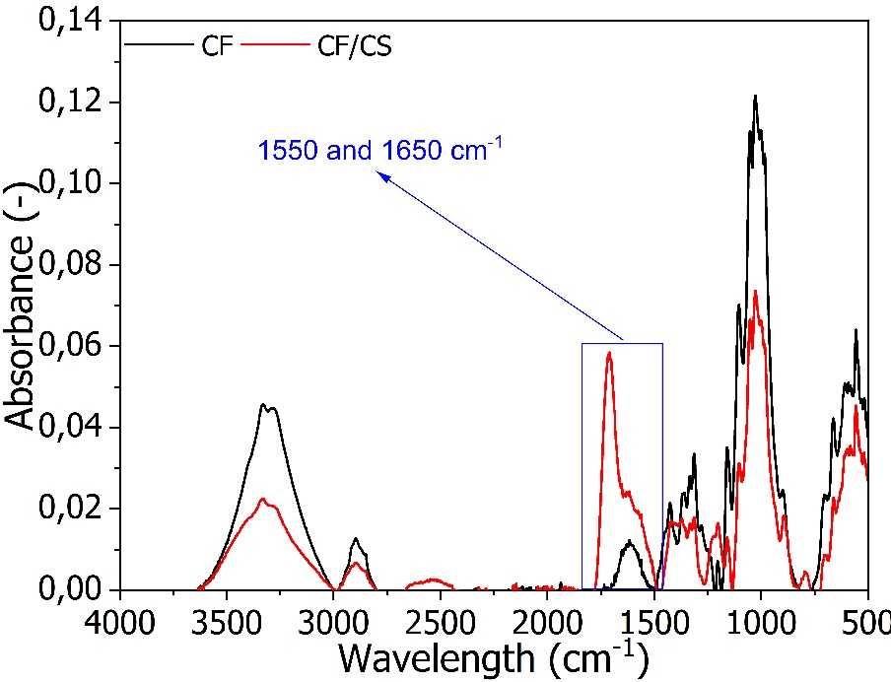
Figure S1. FTIR spectra of the studied cotton fabrics.

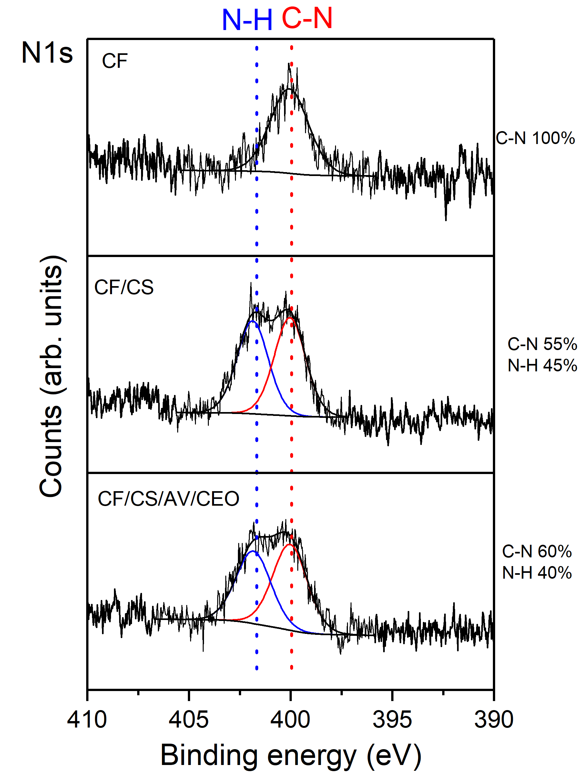
Figure S2. N1s XPS spectra of the studied cotton fabrics.

Sample name | %N
CF | 0.5
CF/CS | 1.2
CF/CS/AV/CEO | 1.1

Table S1. Nitrogen elemental analysis of the studied cotton fabrics obtained from XPS experiment.

