Supplementary Material

Supplementary table 1 – Statistical values for main and interaction effect analyses of temporal and spatial movement parameters, including correct trials, only.
 | df | F | p | η_{p}²
Reaction time
Age group | 1 | 4.46 | 0.04 | 0.12
Residuals | 34
Condition | 1 | 18.74 | < 0.001 | 0.36
Residuals | 34
Age group × Condition | 1 | 1.16 | 0.29 | 0.03
Residuals | 34
Movement duration
Age group | 1 | 1.66 | 0.21 | 0.05
Residuals | 32
Condition | 1 | 1.97 | 0.17 | 0.06
Residuals | 32
Age group × Condition | 1 | 0.19 | 0.67 | 0.01
Residuals | 32
Path length
Age group | 1 | 2.56 | 0.12 | 0.11
Residuals | 21
Condition | 1 | 0.54 | 0.47 | 0.03
Residuals | 21
Age group × Condition | 1 | 0.55 | 0.47 | 0.03
Residuals | 21

Supplementary table 2 – Statistical values for main and interaction effects involving Age group for variability in fingertip position referring to all valid trials.
 | df | F | p | η_{p}²
Age group | 1 | 0.645 | 0.43 | 0.04
Residuals | 17
Age group × Condition | 1 | 0.01 | 0.91 | < 0.001
Residuals | 17
Age group × Sample | 2.29ᵃ | 0.63ᵃ | 0.56ᵃ | 0.01
Residuals | 38.99ᵃ
Age group × Condition × Sample | 2.80ᵃ | 1.36ᵃ | 0.27ᵃ | 0.006
Residuals | 47.51ᵃ
ª Greenhouse-Geisser corrected values

Supplementary table 3 – Statistical values for main and interaction effect analyses of variability in fingertip position referring to correct trials, only.
 | df | F | p | η_{p}²
Variability in fingertip position
Age group | 1 | 0.02 | 0.89 | 0.001
Residuals | 17
Condition | 1 | 4.19 | 0.06 | 0.20
Residuals | 17
Sample | 2.56ª | 24.42 ª | < 0.001 ª | 0.59
Residuals | 43.44 ª
Age group × Condition | 1 | 0.32 | 0.58 | 0.02
Residuals | 17
Age group × Sample | 2.56ª | 3.59 ª | 0.03 ª | 0.17
Residuals | 43.44 ª
Condition × Sample | 3.50 ª | 4.92 ª | 0.003 ª | 0.02
Residuals | 59.49 ª
Age group × Condition × Sample | 3.50 ª | 3.37 ª | 0.02 ª | 0.01
Residuals | 59.49 ª
ª Greenhouse-Geisser corrected values
Supplementary table 4 – Bonferroni corrected post-hoc comparisons of variability in fingertip position for the three-way interaction Age Group × Condition × Pointing sample for correct trials only. Only statistical values for significant differences of comparisons within individual sampling points are presented. Significant effects spanning different pointing samples are neglected. All other comparisons are non-significant.
Pointing sample | Age group × Condition | Mean difference | SE | t | p
0% | older adults_{simple} vs.  young adults_{complex} | 4.77 | 1.124 | 4.25 | 0.04*
10% | young adults_{simple} vs.  older adults_{complex} | 4.77 | 1.124 | 4.25 | 0.04*
10% | young adults_{complex} vs.  older adults_{complex} | 5.48 | 1.124 | 4.88 | 0.003**
significant at a level of * p < .05, ** p < .01

Supplementary table 5 – Statistical values for main and interaction effect analyses of endpoint variability in fingertip position, separately for the two analyses including all valid trials, i.e. both correct and incorrect trials, as well as correct trials, only.
 | df | F | p | η_{p}²
 | All valid trials
Age group | 1 | 0. 53 | 0.48 | 0.02
Residuals | 28
Condition | 1 | 1.06 | 0.31 | 0.04
Residuals | 28
Age group × Condition | 1 | 0.47 | 0.52 | 0.02
Residuals | 28
Correct trials, only
Age group | 1 | 1.92 | 0.18 | 0.06
Residuals | 29
Condition | 1 | 1.00 | 0.33 | 0.03
Residuals | 29
Age group × Condition | 1 | 1.48 | 0.23 | 0.05
Residuals | 29

Supplementary figure 1
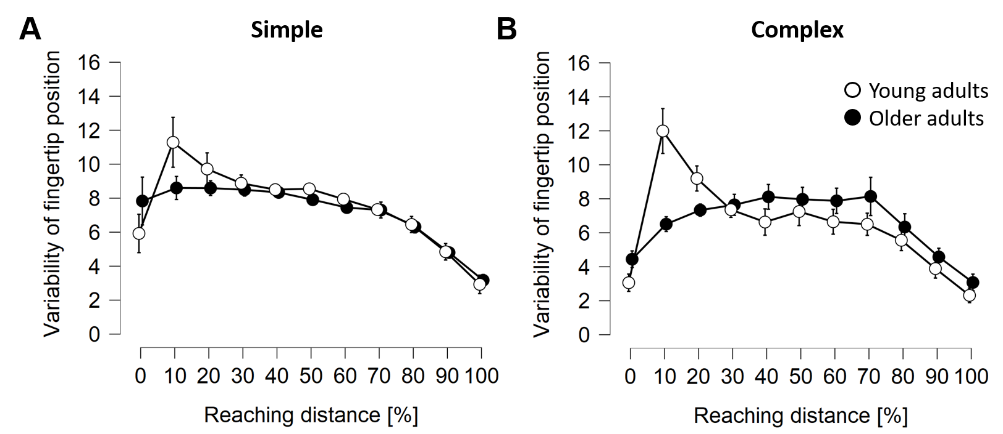
Supplementary figure 1 – Depiction of the three-way interaction of Age group × Condition × Pointing sample for variability in fingertip position for correct trials only. Mean values ± SEM are depicted. A Time course of variability in fingertip position for young and older adults in the simple condition. B Time course of variability in fingertip position for young and older adults in the complex conditions.

