Supplementary material
DeepReg, a deep learning hybrid model for predicting transcription factors in eukaryotic and prokaryotic genomes

 | TF sequences | Non-TF sequences
Amino acid | Frequency | Frequency
A | 14346789 | 543174
C | 2238261 | 127245
D | 9210935 | 382153
E | 11210328 | 533702
F | 6615516 | 244172
G | 12201403 | 464934
H | 3799109 | 205779
I | 10191609 | 353133
K | 9739927 | 429896
L | 16343454 | 666740
M | 4156009 | 174059
N | 6672399 | 315272
P | 7753147 | 421480
Q | 6373169 | 359092
R | 9337439 | 448417
S | 10612839 | 612324
T | 8921577 | 386700
V | 11802116 | 413335
W | 1888028 | 63697
X | 7258 | 115
Y | 0 | 194741

Table S1. Distribution of amino acids in TF and non-TF sequences

# | Definition | GO TERMS | Functional description
1 | transcription factor | GO:0000976 | transcription regulatory region sequence-specific DNA binding
2 | transcription factor | GO:0000977 | RNA polymerase II transcription regulatory region sequence-specific DNA binding
3 | transcription factor | GO:0000978 | RNA polymerase II cis-regulatory region sequence-specific DNA binding
4 | transcription factor | GO:0000979 | RNA polymerase II core promoter sequence-specific DNA binding
5 | transcription factor | GO:0000981 | DNA-binding transcription factor activity, RNA polymerase II-specific
6 | transcription factor | GO:0000984 | bacterial-type RNA polymerase transcription regulatory region sequence-specific DNA binding
7 | transcription factor | GO:0000985 | bacterial-type RNA polymerase core promoter sequence specific DNA binding
8 | transcription factor | GO:0000986 | bacterial-type cis-regulatory region sequence-specific DNA binding
9 | transcription factor | GO:0000987 | cis-regulatory region sequence-specific DNA binding
10 | transcription factor | GO:0000992 | RNA polymerase III cis-regulatory region sequence specific DNA binding
11 | transcription factor | GO:0000995 | RNA polymerase III general transcription initiation factor activity
12 | transcription factor | GO:0001046 | core promoter sequence-specific DNA binding
13 | transcription factor | GO:0001163 | RNA polymerase I transcription regulatory region sequence-specific DNA binding
14 | transcription factor | GO:0001164 | RNA polymerase I core promoter sequence-specific DNA binding
15 | transcription factor | GO:0001165 | RNA polymerase I cis-regulatory region sequence-specific DNA binding
16 | transcription factor | GO:0001216 | DNA-binding transcription activator activity
17 | transcription factor | GO:0001227 | DNA-binding transcription repressor activity, RNA polymerase II-specific
18 | transcription factor | GO:0003700 | DNA-binding transcription factor activity
19 | transcription factor | GO:0034246 | mitochondrial sequence-specific DNA-binding transcription factor activity
20 | transcription factor | GO:0098531 | ligand-activated transcription factor activity
21 | transcription factor | GO:0106250 | DNA-binding transcription repressor activity, RNA polymerase III-specific
22 | transcription regulation | GO:0001228 | DNA-binding transcription activator activity, RNA polymerase II-specific
23 | transcription regulation | GO:0006351 | transcription, DNA-templated
24 | transcription regulation | GO:0006355 | regulation of transcription, DNA-templated
25 | transcription regulation | GO:0043433 | negative regulation of DNA-binding
26 | transcription factor activity transcription regulation | GO:0045892 | negative regulation of transcription, DNA-templated 19
27 | transcription regulation | GO:0045893 | positive regulation of transcription, DNA-templated
28 | transcription regulation | GO:0051090 | regulation of DNA-binding transcription factor activity
29 | transcription regulation | GO:0051091 | positive regulation of DNA-binding
30 | transcription factor activity transcription regulation | GO:2000142 | regulation of DNA-templated transcription, initiation
31 | transcription regulation | GO:2000143 | negative regulation of DNA-templated transcription, initiation
32 | transcription regulation | GO:2000144 | positive regulation of DNA-templated transcription, initiation
33 | DNA binding | GO:0003677 | DNA binding
34 | DNA binding | GO:0008301 | DNA binding, bending
35 | DNA binding | GO:0043565 | sequence-specific DNA binding
36 | DNA binding | GO:0050692 | DNA binding domain binding

Table S2. GO annotations used to construct the TF database. The following Gene Ontology annotations were used to retrieve the TFs from SwissProt.

Set | Accuracy | Loss | AUC | F1-Score | MCC
Total | 0.9735 | 0.1187 | 0.9696 | 0.9187 | 0.9038
Prokaryote | 0.9803 | 0.0970 | 0.9818 | 0.9485 | 0.9370
Eukaryote | 0.9638 | 0.1547 | 0.9655 | 0.8855 | 0.8661

Table S3. DeepReg Performance on Prokaryotes and Eukaryotes organisms in the validation dataset.

Metrics | DeepReg (40000 sequences) | Best model in ML (SVM)
AUC | 0.9739 | 0.8862
Accuracy | 0.9383 | 0.8920
Precision | 0.9531 | 0.8983
Recall | 0.9263 | 0.8886
Specificity | 0.9511 | 0.8955
F1-Score | 0.9395 | 0.8879
MCC | 0.8769 | 0.7840

Table S4. DeepReg performance with the same data of ML. 40000 sequences were considered to this comparison.

$$\left(a\right)Saccharomyces cerevisiae$$  Variance DeepTFactor: 0.0232  Variance DeepReg: 0.0164 | $$(b)Neurospora crassa$$  Variance DeepTFactor: 0.0245  Variance DeepReg: 0.0214 | (c)Aspergillus nidulans  Variance DeepTFactor: 0.0234  Variance DeepReg: 0.0171

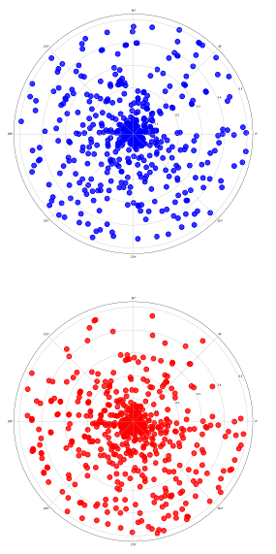
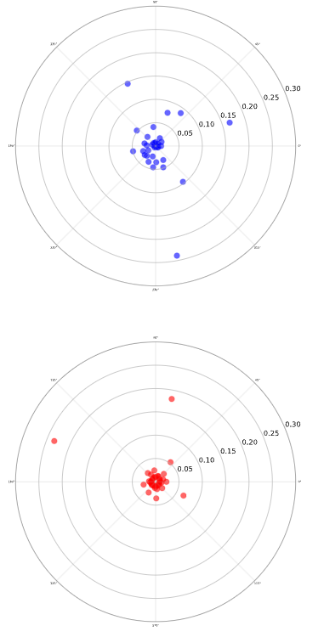
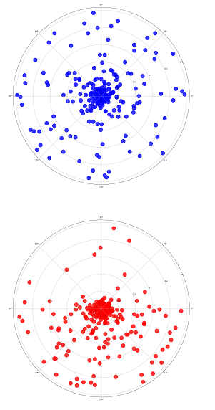
- (b) (c)

Figure S1. Bull-eye bias-variance tradeoff from all true predictions from each model in (a) Saccharomyces cerevisiae (b) Neurospora crassa, and (c) Aspergillus nidulans. Each point represents a true prediction where the radius with respect to the center is the score obtained and the angle is distributed to fill all the circumference. In blue is indicated DeepTFactor and in red, DeepReg.

