Supplementary Table 1. Comparison of IgG and IgA titers
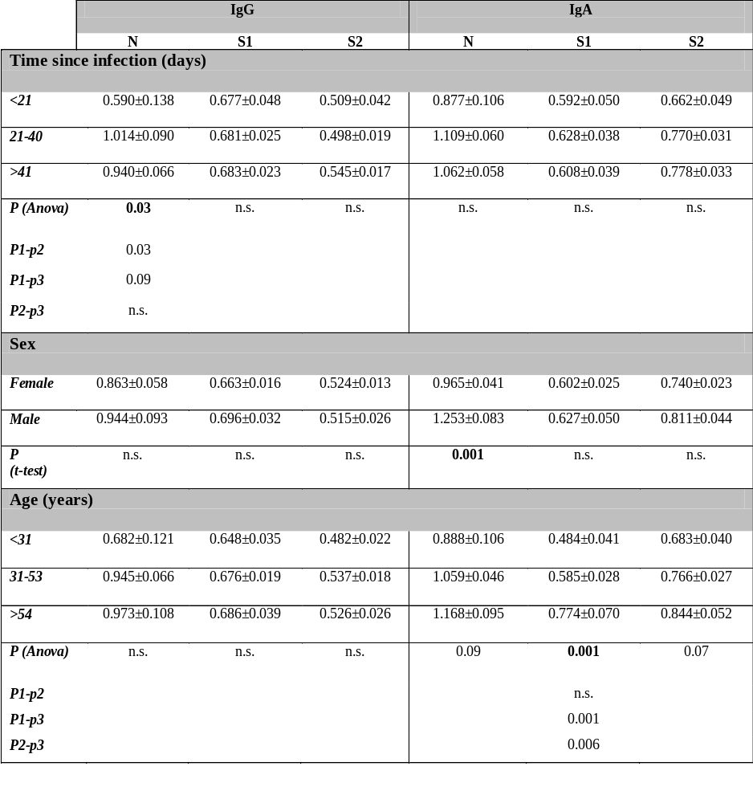

Supplementary Table 2. Correlation matrix of Ab titers in HWs with and without IgM anti-SARS-CoV2 antibodies

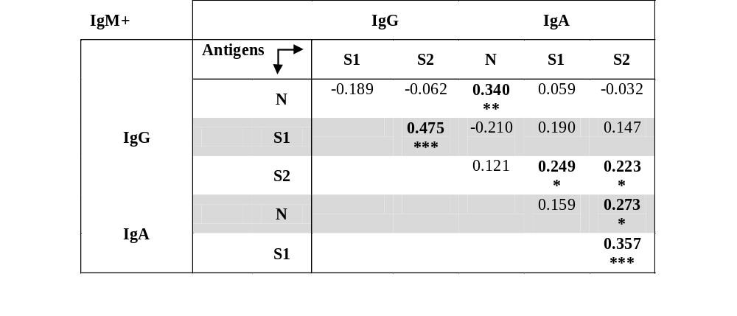
IgM- |  |  | IgG |  | IgA
 | Antigens |  | S1 | S2 | N | S1 | S2
IgG |  | N | 0.238  * | 0.201  * | 0.495  *** | 0.157 | 0.318  **
IgG |  | S1 |  | 0.582  *** | 0.186 | 0.277  * | 0.348  **
IgG |  | S2 |  |  | 0.118 | 0.231  * | 0.408  ***
IgA |  | N |  |  |  | 0.244  * | 0.264  *
IgA |  | S1 |  |  |  |  | 0.468  ***
Pearson's correlation coefficients are shown, and significant values are highlighted in bold. (***p < 0.001, * p < 0.05).

Supplementary Table 3. IgG and IgA titers according to infection symptoms.

 | IgM+ |  |  |  |  |  | IgM -
 | IgG |  |  | IgA |  |  | IgG |  |  | IgA
 | N | S1 | S2 | N | S1 | S2 | N | S1 | S2 | N | S1 | S2
FEVER | 1.035  ±0.095  ** | 0.672  ±0.024 | 0.503  ±0.020  ** | 1.241  ±0.079  ** | 0.588  ±0.041 | 0.787  ±0.041 | 0.815  ±0.090  * | 0.643  ±0.020 | 0.546  ±0.023 | 1.008  ±0.082  * | 0.552  ±0.037 | 0.666  ±0.033
FEVER | 0.681  ±0.100 | 0.632  ±0.036 | 0.436  ±0.015 | 0.878  ±0.088 | 0.634  ±0.058 | 0.739  ±0.047 | 0.625  ±0.094 | 0.658  ±0.032 | 0.510  ±0.031 | 0.816  ±0.072 | 0.556  ±0.039 | 0.695  ±0.045
COUGH | 0.893  ±0.093 | 0.673  ±0.032 | 0.501  ±0.021 | 1.177  ±0.082  ** | 0.609  ±0.050 | 0.800  ±0.045 | 0.846  ±0.080  ** | 0.626  ±0.027 | 0.540  ±0.024 | 1.085  ±0.076  ** | 0.569  ±0.043 | 0.694  ±0.035  *
COUGH | 0.754  ±0.089 | 0.609  ±0.027 | 0.457  ±0.018 | 0.945  ±0.076 | 0.578  ±0.038 | 0.721  ±0.040 | 0.412  ±0.065 | 0.660  ±0.027 | 0.529  ±0.028 | 0.674  ±0.044 | 0.540  ±0.034 | 0.612  ±0.027
ANOSMIA | 0.721  ±0.082 | 0.615  ±0.027 | 0.480  ±0.021 | 1.017  ±0.066 | 0.634  ±0.045 | 0.834  ±0.044 | 0.745  ±0.104 | 0.665  ±0.028 | 0.587  ±0.026  ** | 0.901  ±0.064 | 0.539  ±0.044 | 0.692  ±0.038
ANOSMIA | 1.055  ±0.118  ** | 0.694  ±0.036  * | 0.475  ±0.018 | 1.158  ±0.102  * | 0.547  ±0.043 | 0.733  ±0.042 | 0.751  ±0.093 | 0.620  ±0.027 | 0.486  ±0.025 | 0.861  ±0.073 | 0.560  ±0.034 | 0.627  ±0.027
PNEUMONIA | 0.94  ±0.171 | 0.712  ±0.082 | 0.504  ±0.051 | 1.469  ±0.132  ** | 0.595  ±0.090 | 0.877  ±0.097 | 1.042  ±0.254 | 0.574  ±0.044 | 0.416  ±0.044 | 0.892  ±0.109 | 0.478  ±0.092 | 0.640  ±0.059
PNEUMONIA | 0.888  ±0.084 | 0.651  ±0.024 | 0.488  ±0.017 | 1.017  ±0.061 | 0.581  ±0.032 | 0.762  ±0.031 | 0.707  ±0.069 | 0.657  ±0.022 | 0.547  ±0.020  ** | 0.897  ±0.057 | 0.562  ±0.028 | 0.666  ±0.025
DYSPNEA | 0.609  ±0.110 | 0.479  ±0.043 | 0.384  ±0.033 | 0.784  ±0.096 | 0.481  ±0.058 | 0.609  ±0.051 | 0.682  ±0.133 | 0.608  ±0.034 | 0.505  ±0.030 | 0.867  ±0.093 | 0.528  ±0.065 | 0.691  ±0.048
DYSPNEA | 0.921  ±0.086  * | 0.659  ±0.023  ** | 0.486  ±0.014  ** | 1.104  ±0.064  ** | 0.591  ±0.032  * | 0.782  ±0.032  ** | 0.748  ±0.079 | 0.644  ±0.023 | 0.545  ±0.022 | 0.883  ±0.058 | 0.559  ±0.029 | 0.652  ±0.027
MYALGIA | 0.911  ±0.080  ** | 0.648  ±0.028 | 0.481  ±0.017 | 1.093  ±0.067 | 0.591  ±0.034 | 0.565  ±0.060 | 0.838  ±0.103  * | 0.624  ±0.024 | 0.544  ±0.025 | 0.888  ±0.065 | 0.542  ±0.035 | 0.639  ±0.028
MYALGIA | 0.638  ±0.102 | 0.640  ±0.033 | 0.450  ±0.017 | 1.03  ±0.113 | 0.565  ±0.060 | 0.796  ±0.047 | 0.548  ±0.065 | 0.664  ±0.029 | 0.524  ±0.027 | 0.869  ±0.076 | 0.566  ±0.040 | 0.663  ±0.036
CEPHALEA | 0.933  ±0.098  * | 0.692  ±0.035 | 0.476  ±0.020 | 1.144  ±0.080 | 0.581  ±0.044 | 0.803  ±0.041 | 0.849  ±0.124 | 0.669  ±0.034 | 0.534  ±0.033 | 0.899  ±0.082 | 0.464  ±0.053 | 0.695  ±0.040
CEPHALEA | 0.699  ±0.091 | 0.637  ±0.026 | 0.479  ±0.018 | 0.983  ±0.081 | 0.604  ±0.044 | 0.760  ±0.045 | 0.685  ±0.080 | 0.632  ±0.025 | 0.527  ±0.023 | 0.866  ±0.062 | 0.592  ± 0.02  ** | 0.627  ±0.025
DIARRHEA | 1.097  ±0.139  ** | 0.678  ±0.036 | 0.450  ±0.023 | 1.166  ±0.096 | 0.546  ±0.041 | 0.758  ±0.050 | 0.874  ±0.131 | 0.643  ±0.030 | 0.557  ±0.033 | 0.907  ±0.090 | 0.521  ±0.047 | 0.556  ±0.033
DIARRHEA | 0.777  ±0.084 | 0.650  ±0.031 | 0.464  ±0.017 | 1.026  ±0.073 | 0.622  ±0.043 | 0.794  ±0.039 | 0.686  ±0.080 | 0.638  ±0.025 | 0.517  ±0.023 | 0.891  ±0.064 | 0.564  ±0.033 | 0.711  ±0.028  **

Mean O.D. values +/- s.e.m. are expressed with symptom presence (gray row) or symptom absence (white row). Statistically relevant differences (Kolmogorov-Smirnov test) are highlighted, and the highest values are represented (* p<0.05 or ** p<0.005). Green color represents significantly higher with symptom presence, Red color represents lower with symptom presence.

Supplementary Table 4. Kinetics of IgG and IgA titers according to symptoms

 | IgM+ |  |  |  |  |  | IgM -
 | IgG |  |  | IgA |  |  | IgG |  |  |  | IgA
 | N | S1 | S2 | N | S1 | S2 | N | S1 | S2 | N |  | S1 | S2
FEVER | 1.150 | 1.060 | 1.054 | 1.360 | 1.162 | 1.190 | 1.234 | 1.061 | 1.035 | 1.351 |  | 1.060 | 1.060
FEVER | 1.079 | 1.060 | 1.058 | 1.352 | 1.142 | 1.082 | 1.119 | 1.075 | 1.031 | 1.412 |  | 1.047 | 1.167
COUGHT | 1.150 | 1.086 | 1.084 | 1.316 | 1.196 | 1.140 | 1.182 | 1.083 | 1.009 | 1.444 |  | 1.131  * | 1.132
COUGHT | 1.108 | 1.034 | 1.042 | 1.423 | 1.120 | 1.151 | 1.197 | 1.053 | 1.050 | 1.326 |  | 1.005 | 1.073
ANOSMIA | 1.089 | 1.049 | 1.066 | 1.354 | 1.174 | 1.197 | 1.244 | 1.063 | 1.023 | 1.310 |  | 1.080 | 1.114
ANOSMIA | 1.160 | 1.060 | 1.033 | 1.385 | 1.135 | 1.127 | 1.147 | 1.071 | 1.038 | 1.467 |  | 1.049 | 1.091
PNEUMONIA | 1.163 | 1.119 | 1.090 | 1.275 | 1.282 | 1.134 | 1.270 | 1.106 | 0.924 | 1.440 |  | 1.107 | 1.051
PNEUMONIA | 1.124 | 1.049 | 1.052 | 1.388 | 1.135 | 1.148 | 1.174 | 1.062 | 1.044 | 1.383 |  | 1.057 | 1.109
DYSPNEA | 1.067 | 1.012 | 0.981 | 1.349 | 1.146 | 1.072 | 1.319 | 1.044 | 0.964 | 1.274 |  | 1.056 | 1.026
DYSPNEA | 1.140 | 1.066 | 1.069 * | 1.370 | 1.156 | 1.158 | 1.152 | 1.075 | 1.054 | 1.437 |  | 1.064 | 1.131 *
MYALGIA | 1.125 | 1.073 | 1.065 | 1.350 | 1.140 | 1.144 | 1.203 | 1.051 | 1.009 | 1.342 |  | 1.055 | 1.072
MYALGIA | 1.142 | 1.028 | 1.042 | 1.409 | 1.185 | 1.148 | 1.170 | 1.085 | 1.056 | 1.449 |  | 1.069 | 1.131
CEPHALEA | 1.039 | 1.053 | 1.022 | 1.320 | 1.120 | 1.107 | 1.267 | 1.076 | 1.027 | 1.296 |  | 1.081 | 1.090
CEPHALEA | 1.272 | 1.064 | 1.091 | 1.418 | 1.188 | 1.184 | 1.143 | 1.061 | 1.033 | 1.453 |  | 1.053 | 1.109
DIARRHEA | 1.139 | 1.073 | 1.037 | 1.284 | 1.102 | 1.100 | 1.228 | 1.109 | 1.064 | 1.393 |  | 1.045 | 1.064
DIARRHEA | 1.121 | 1.050 | 1.069 | 1.432 | 1.181 | 1.171 | 1.169 | 1.049 | 1.015 | 1.388 |  | 1.069 | 1.116
T1/T2 ratio is expressed in the table (cut off =1) with symptom presence (gray row) or symptom absence (white row). Values with statistical significance are highlighted and the highest value is represented (Kolmogorov-Smirnov test * p<0.05).

Supplementary Figure 1

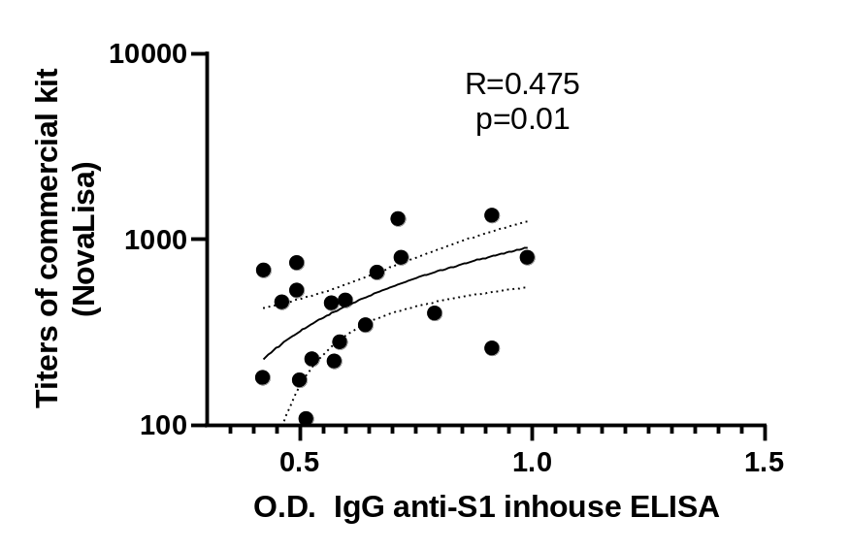
Correlation of in-house ELISA values with commercial kit (NovaLisa) (Pearson correlation coefficient is shown).

