Supplementary Information

Non-Animal Models for Blood-Brain Barrier Permeability Evaluation of Drug-Like Compounds
Frederic O. Dehnbostel¹, Vaibhav A. Dixit², Robert Preissner¹ and Priyanka Banerjee¹*
¹ Institute for Physiology, Charité – University Medicine Berlin, Berlin, 10115, Germany
^{2.} Department of Medicinal Chemistry, National Institute of Pharmaceutical Education and Research, Guwahati, (NIPER Gu-wahati), Department of Pharmaceuticals, Ministry of Chemicals & Fertilizers, Govt. of India, Sila Katamur (Halugurisuk), P.O.: Changsari, Dist: Kamrup, Pin: 781101, Guwahati, Assam, India

Table S1: Results of Random Forest (RF) and Euclidean distance
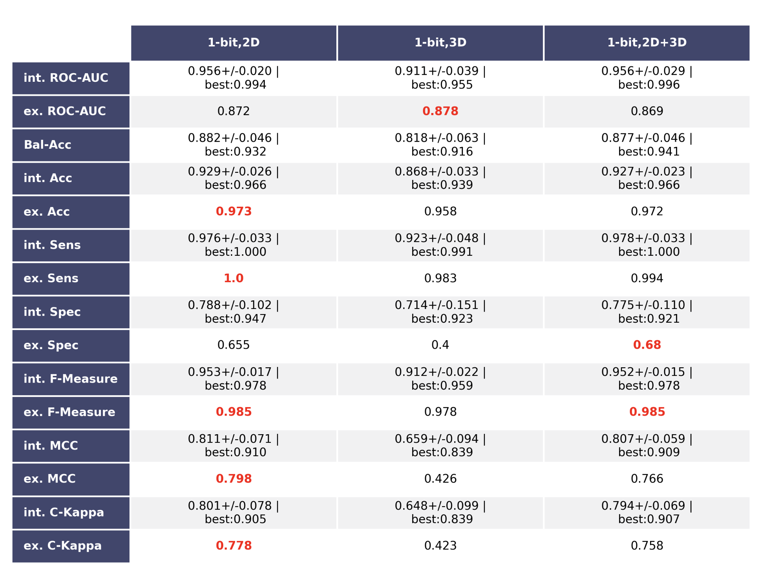
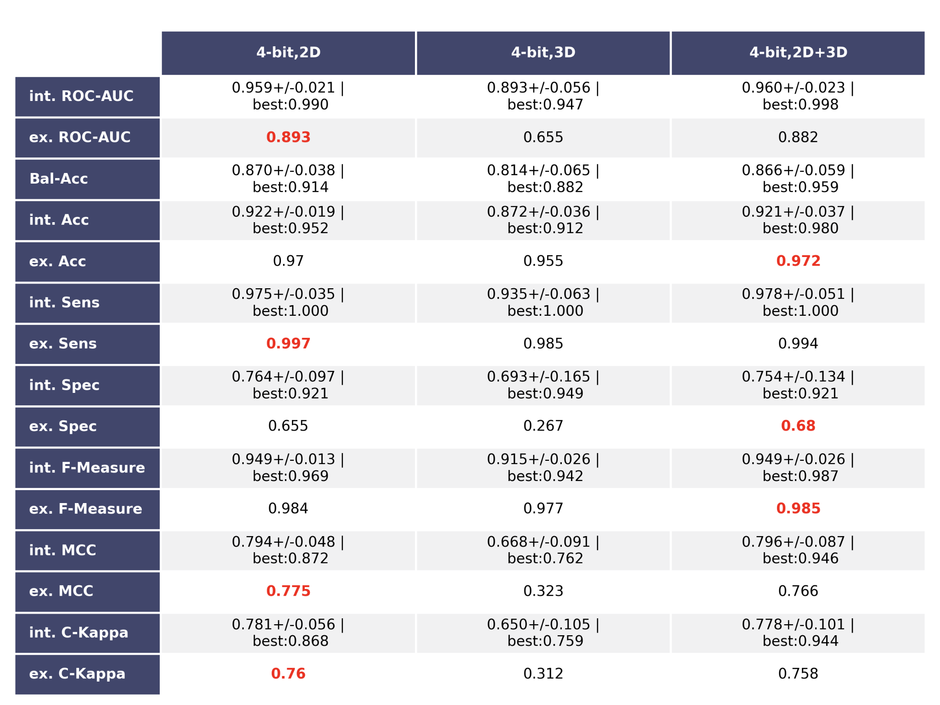
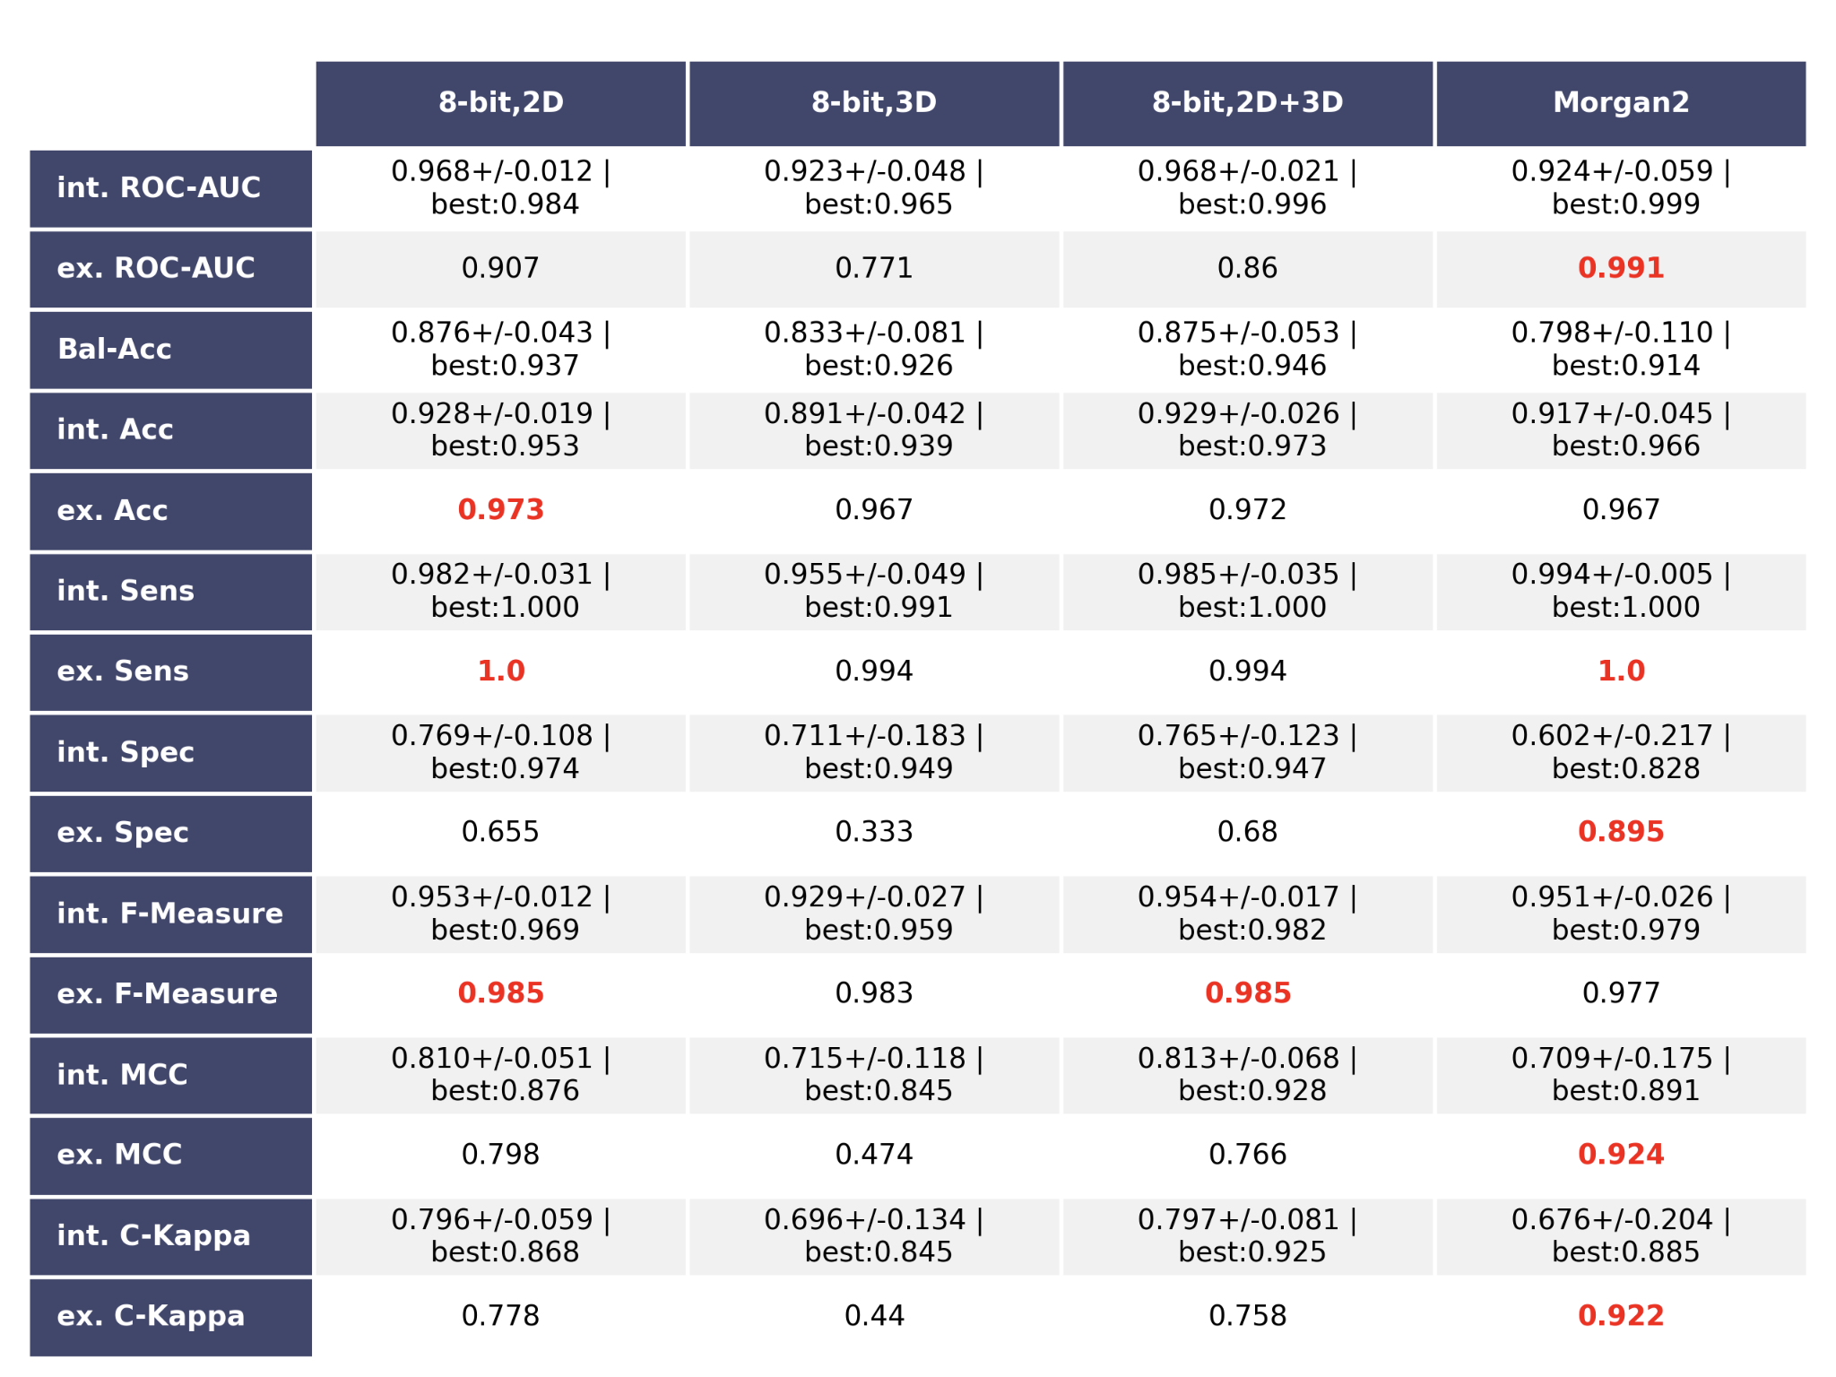

Table S2: Results of Polynomial Kernel Support Vector Machine (SVM) and Euclidean distance
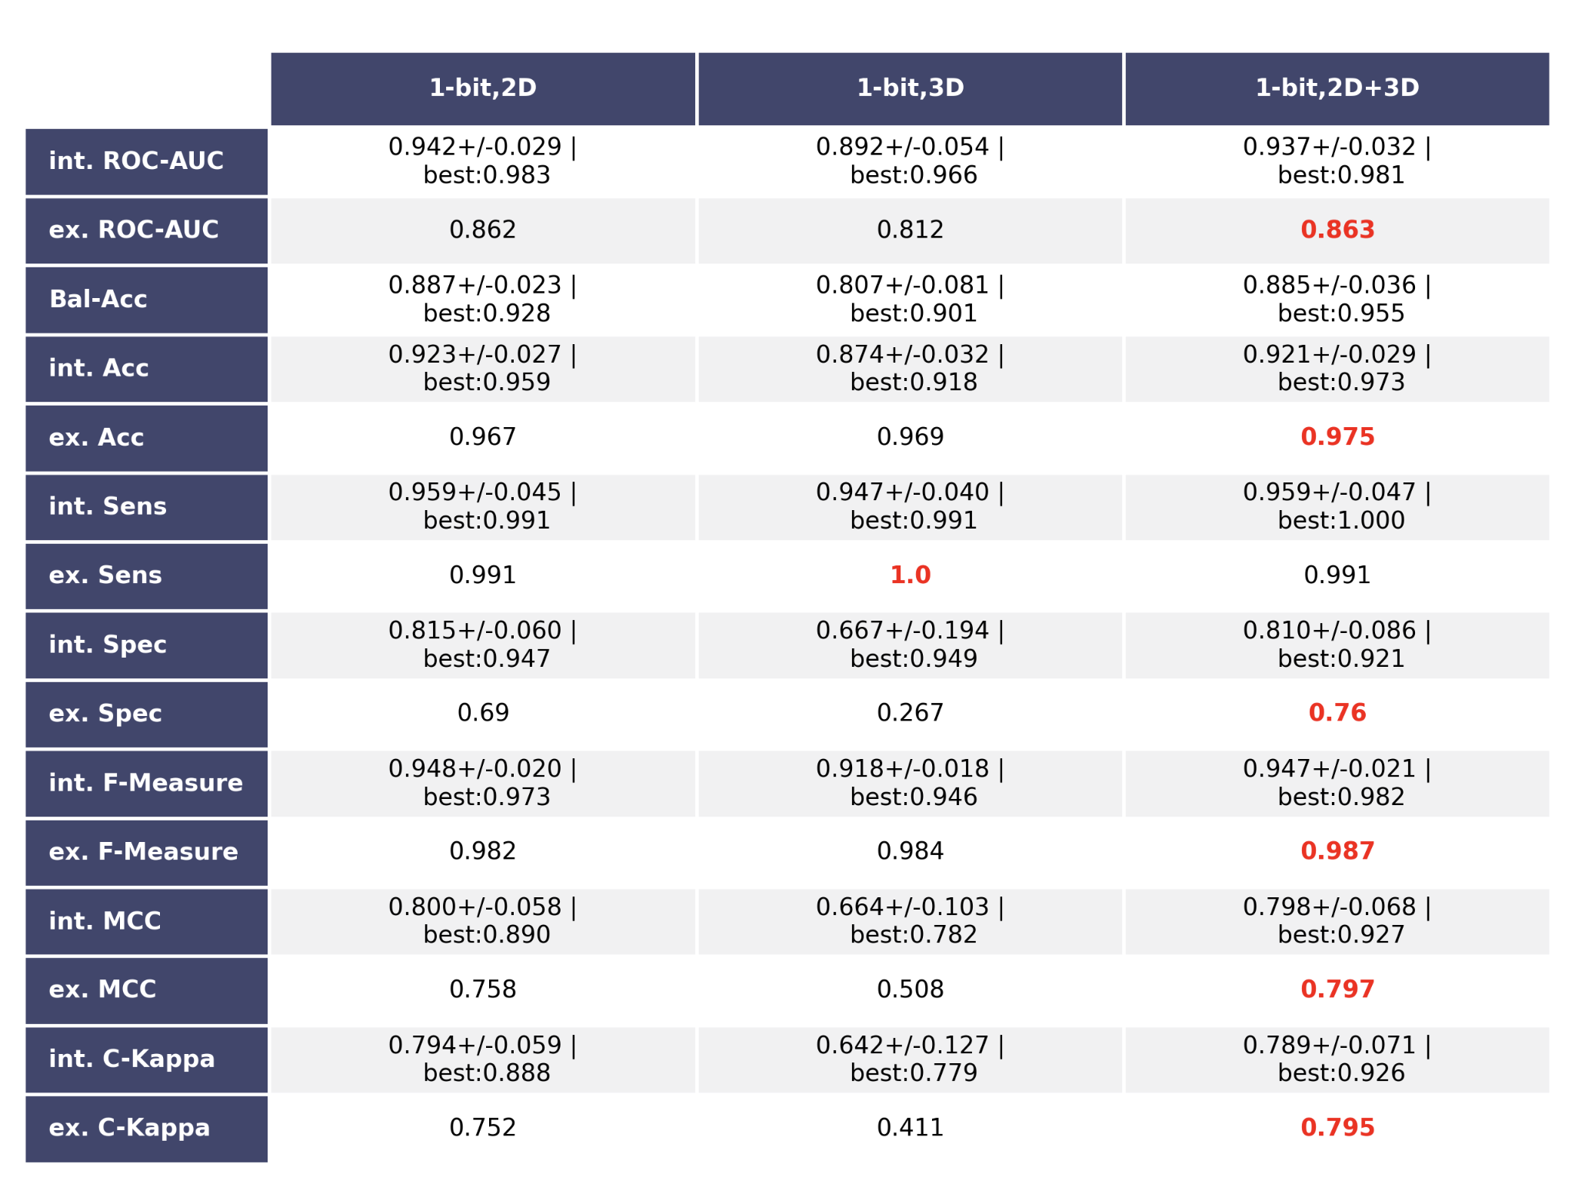
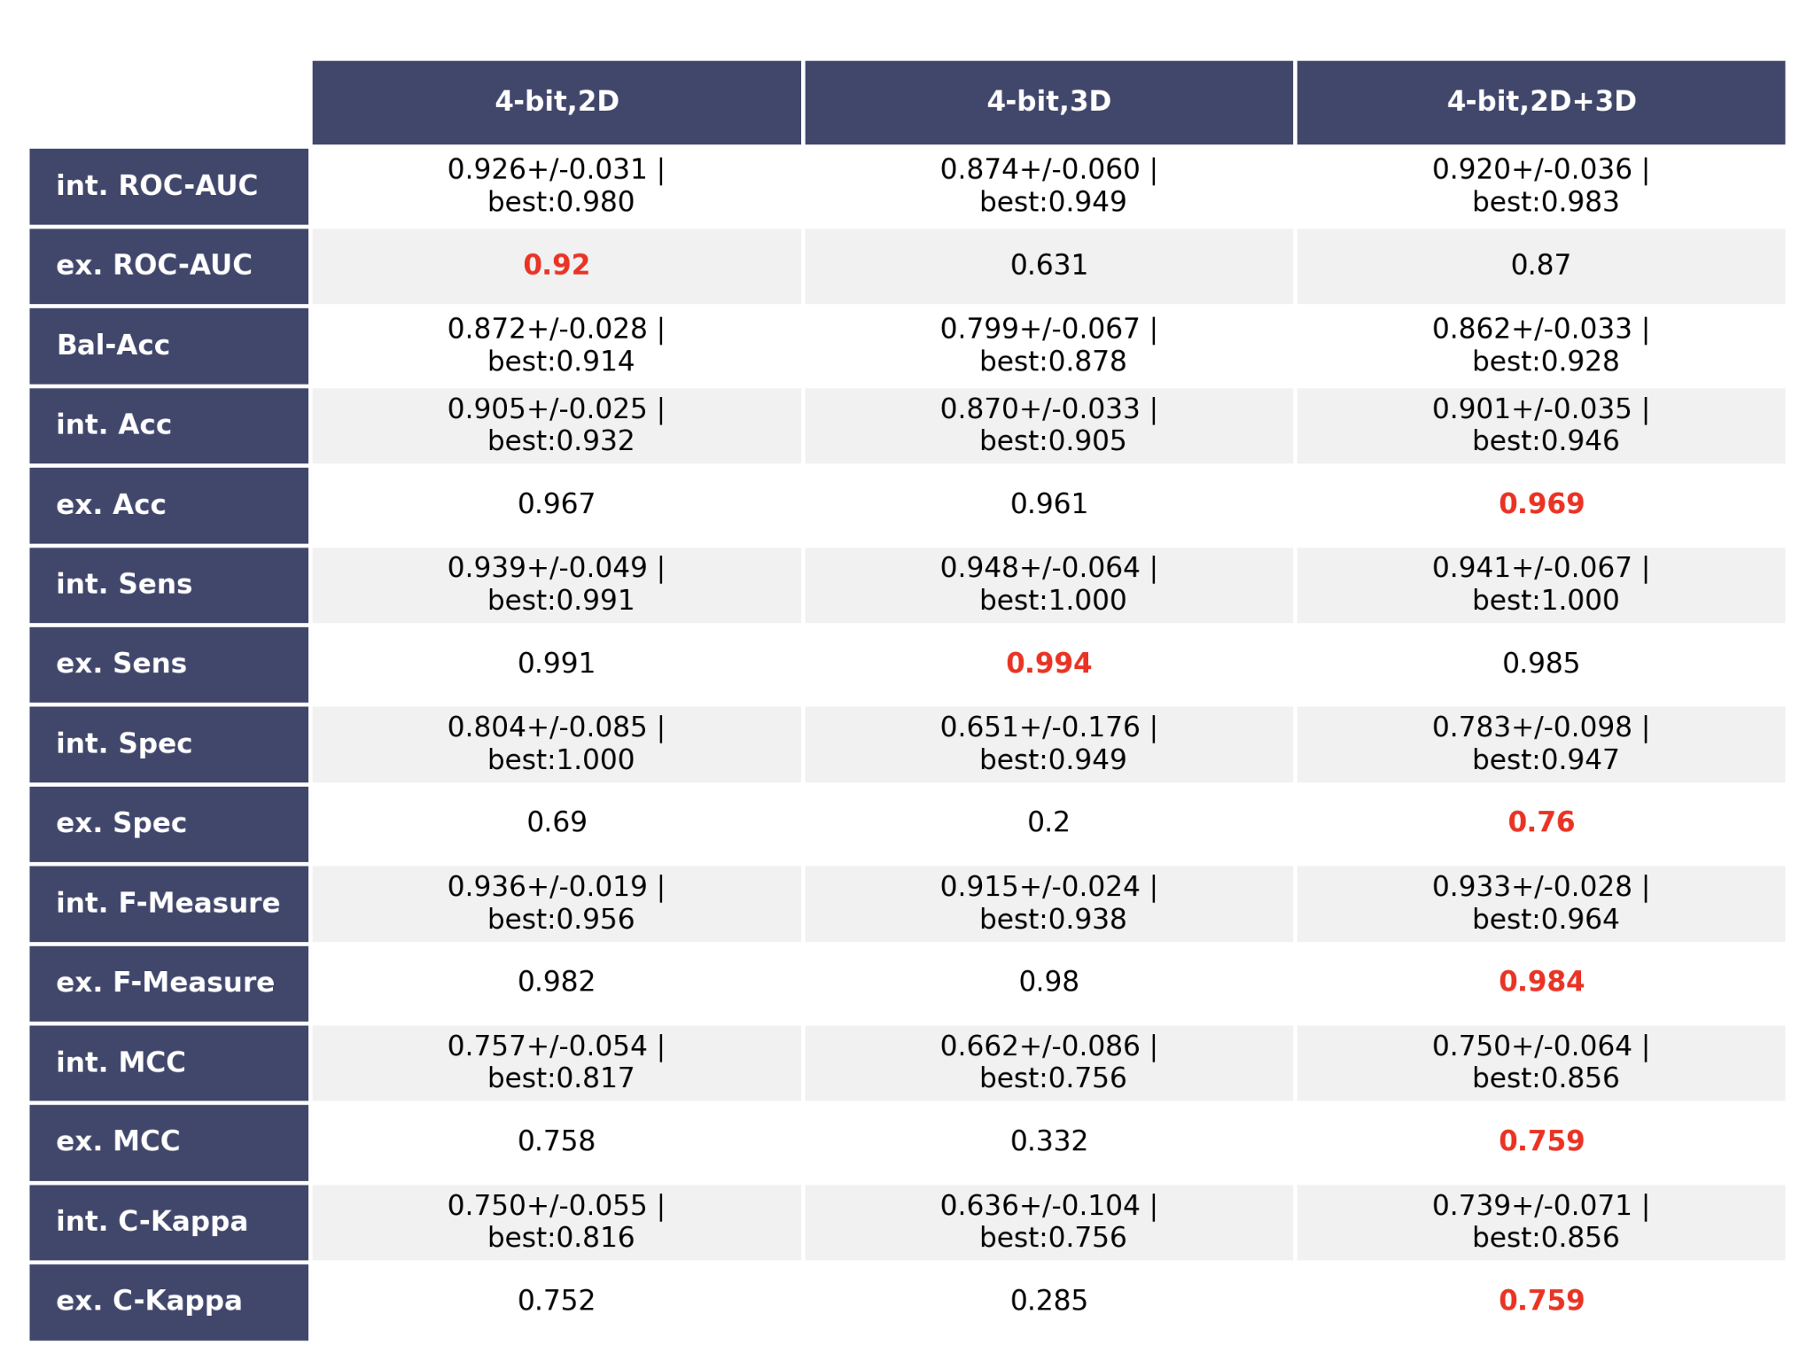
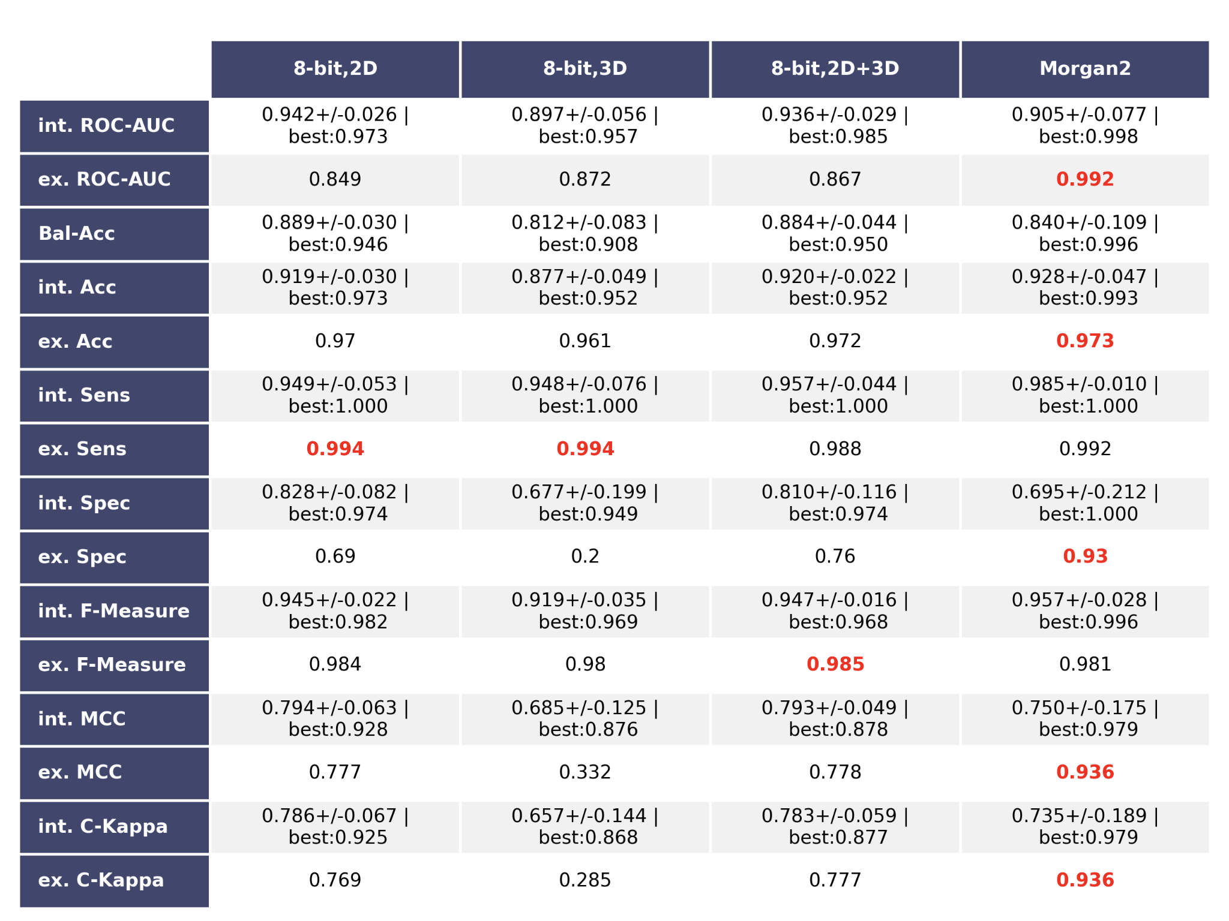

Table S3: Results of Radial Basis Function (RBF) SVM and Euclidean distance
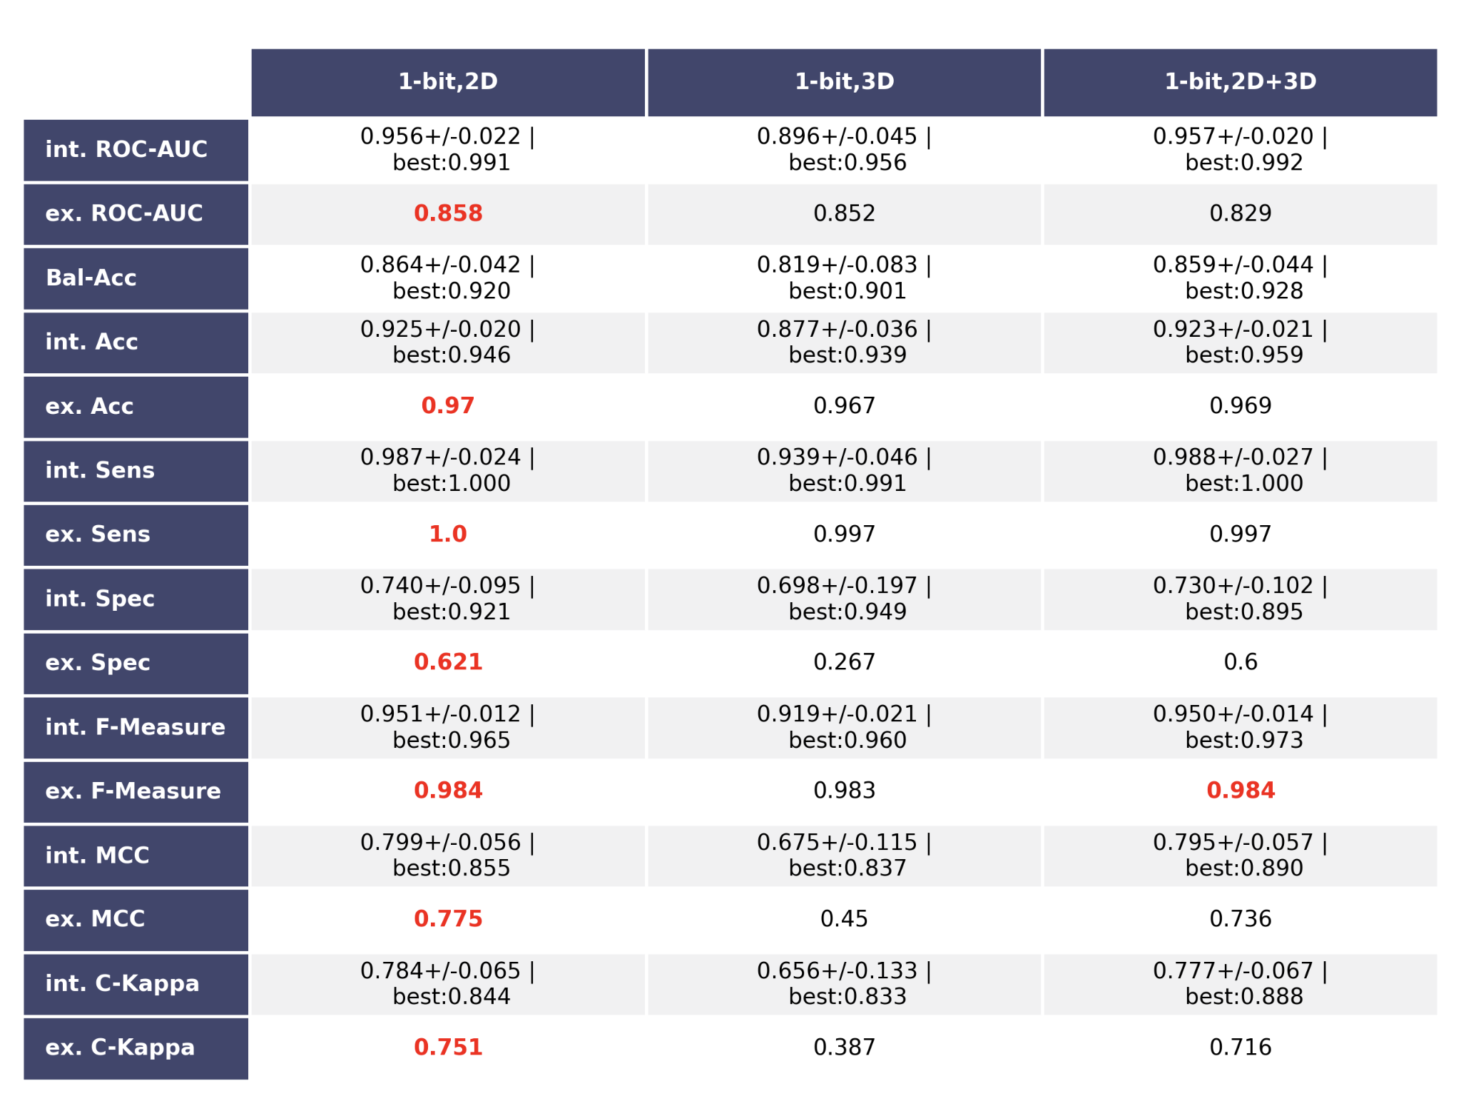
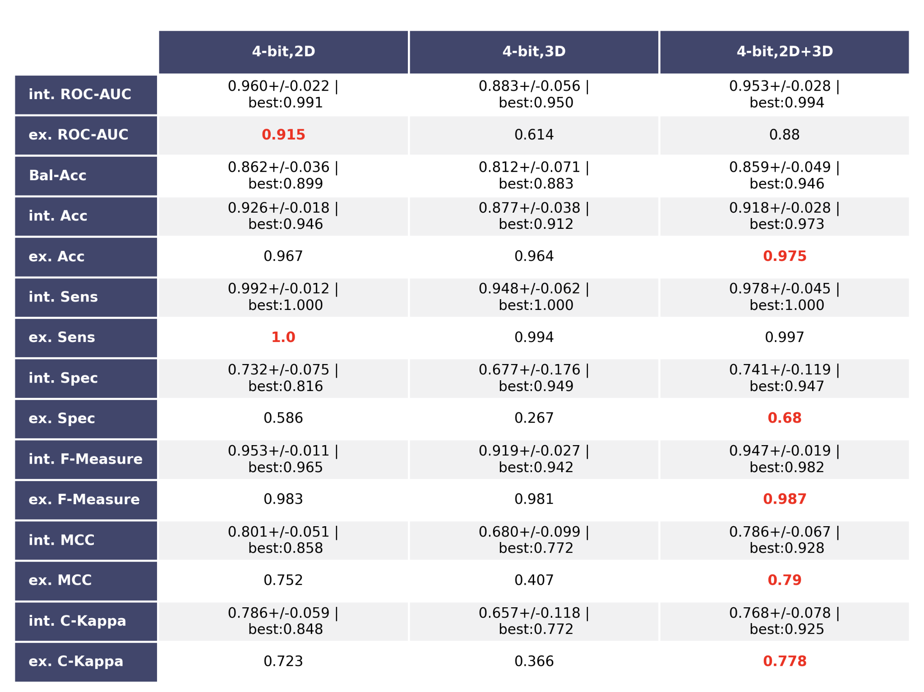
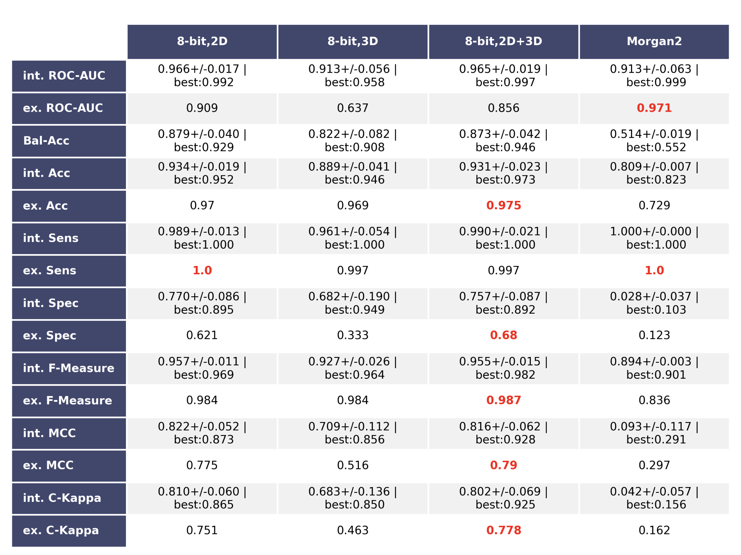

Table S4: Results of RF and Mahanalobis distance
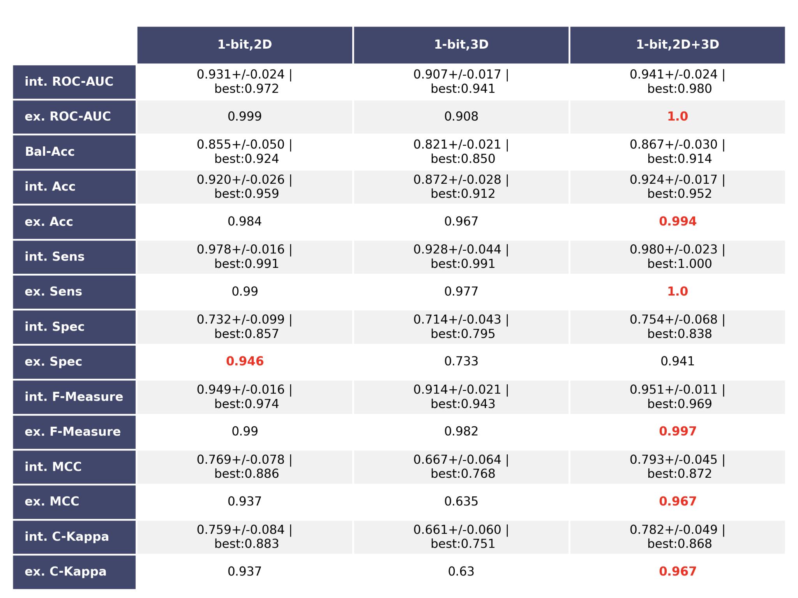
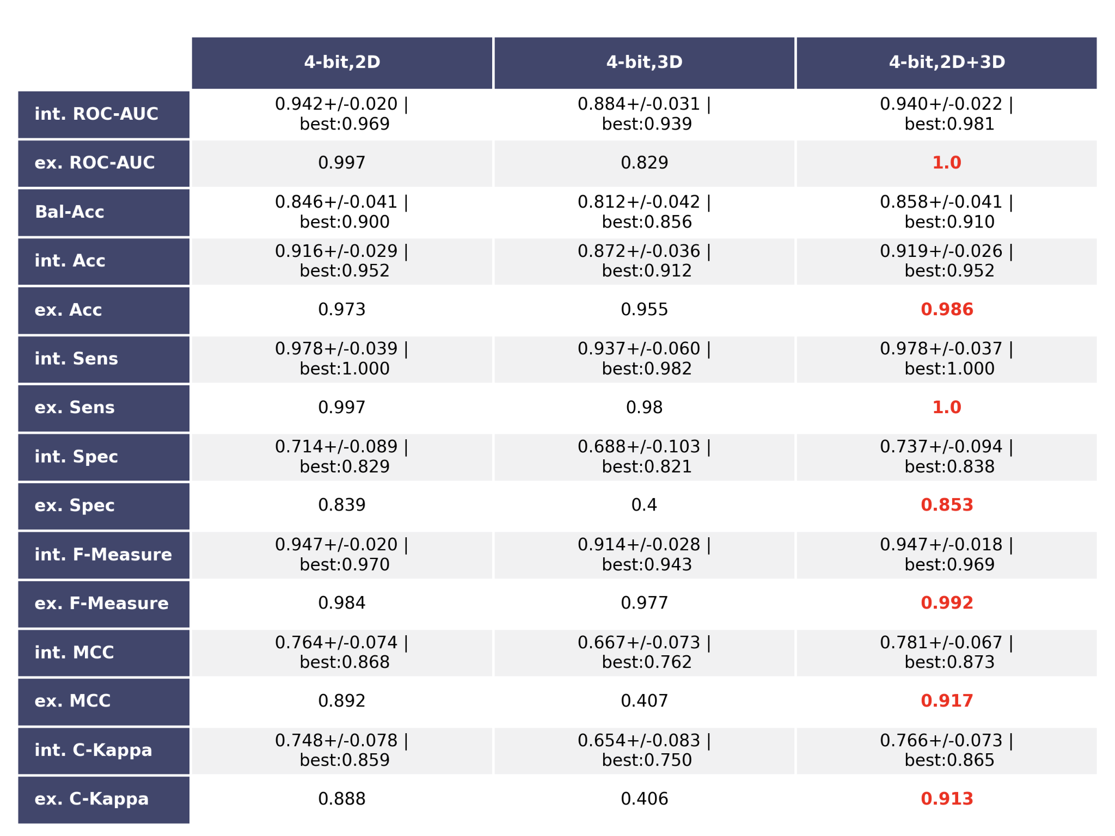
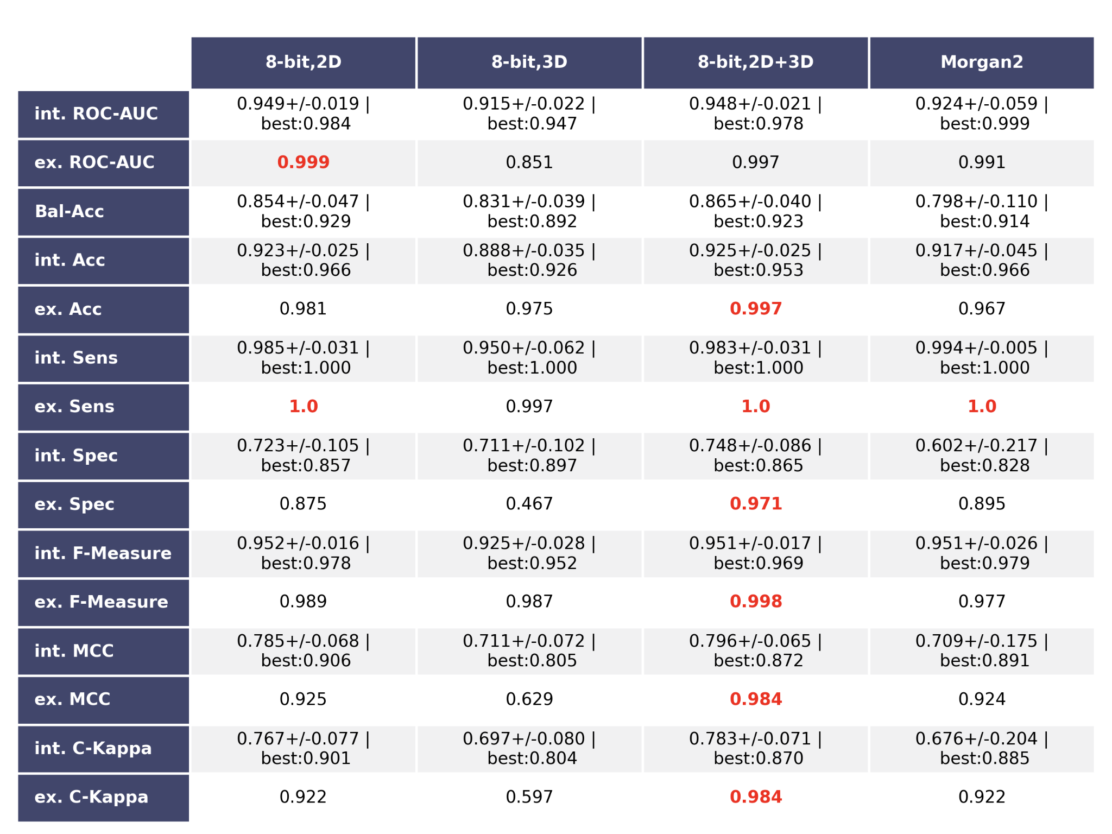

Table S5: Results of Polynomial Kernel SVM and Mahanalobis distance
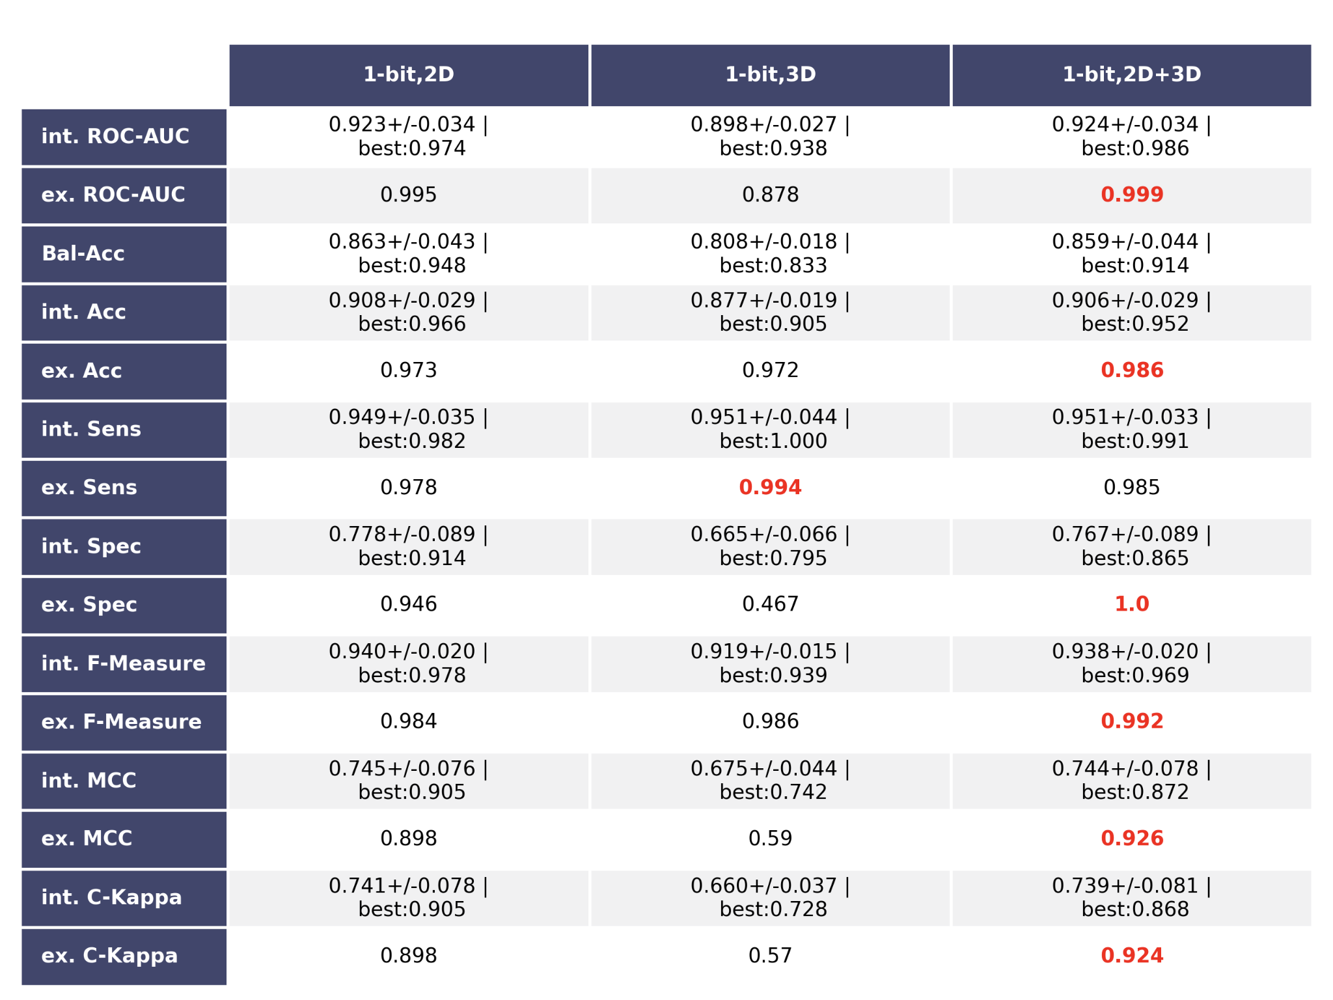
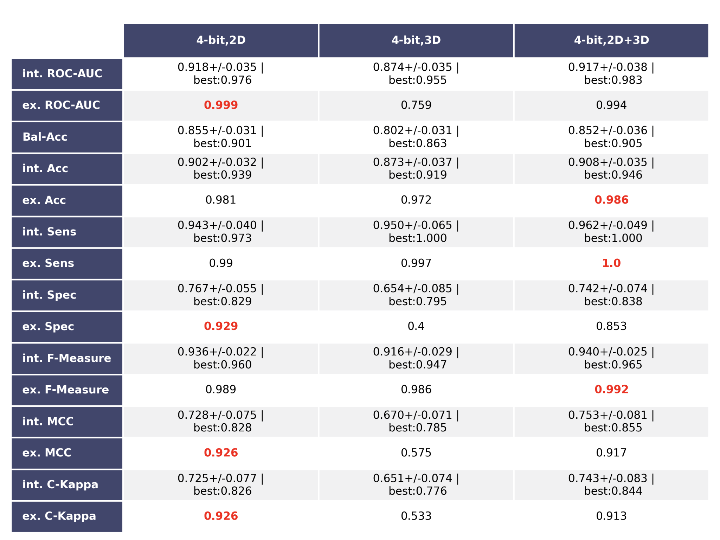
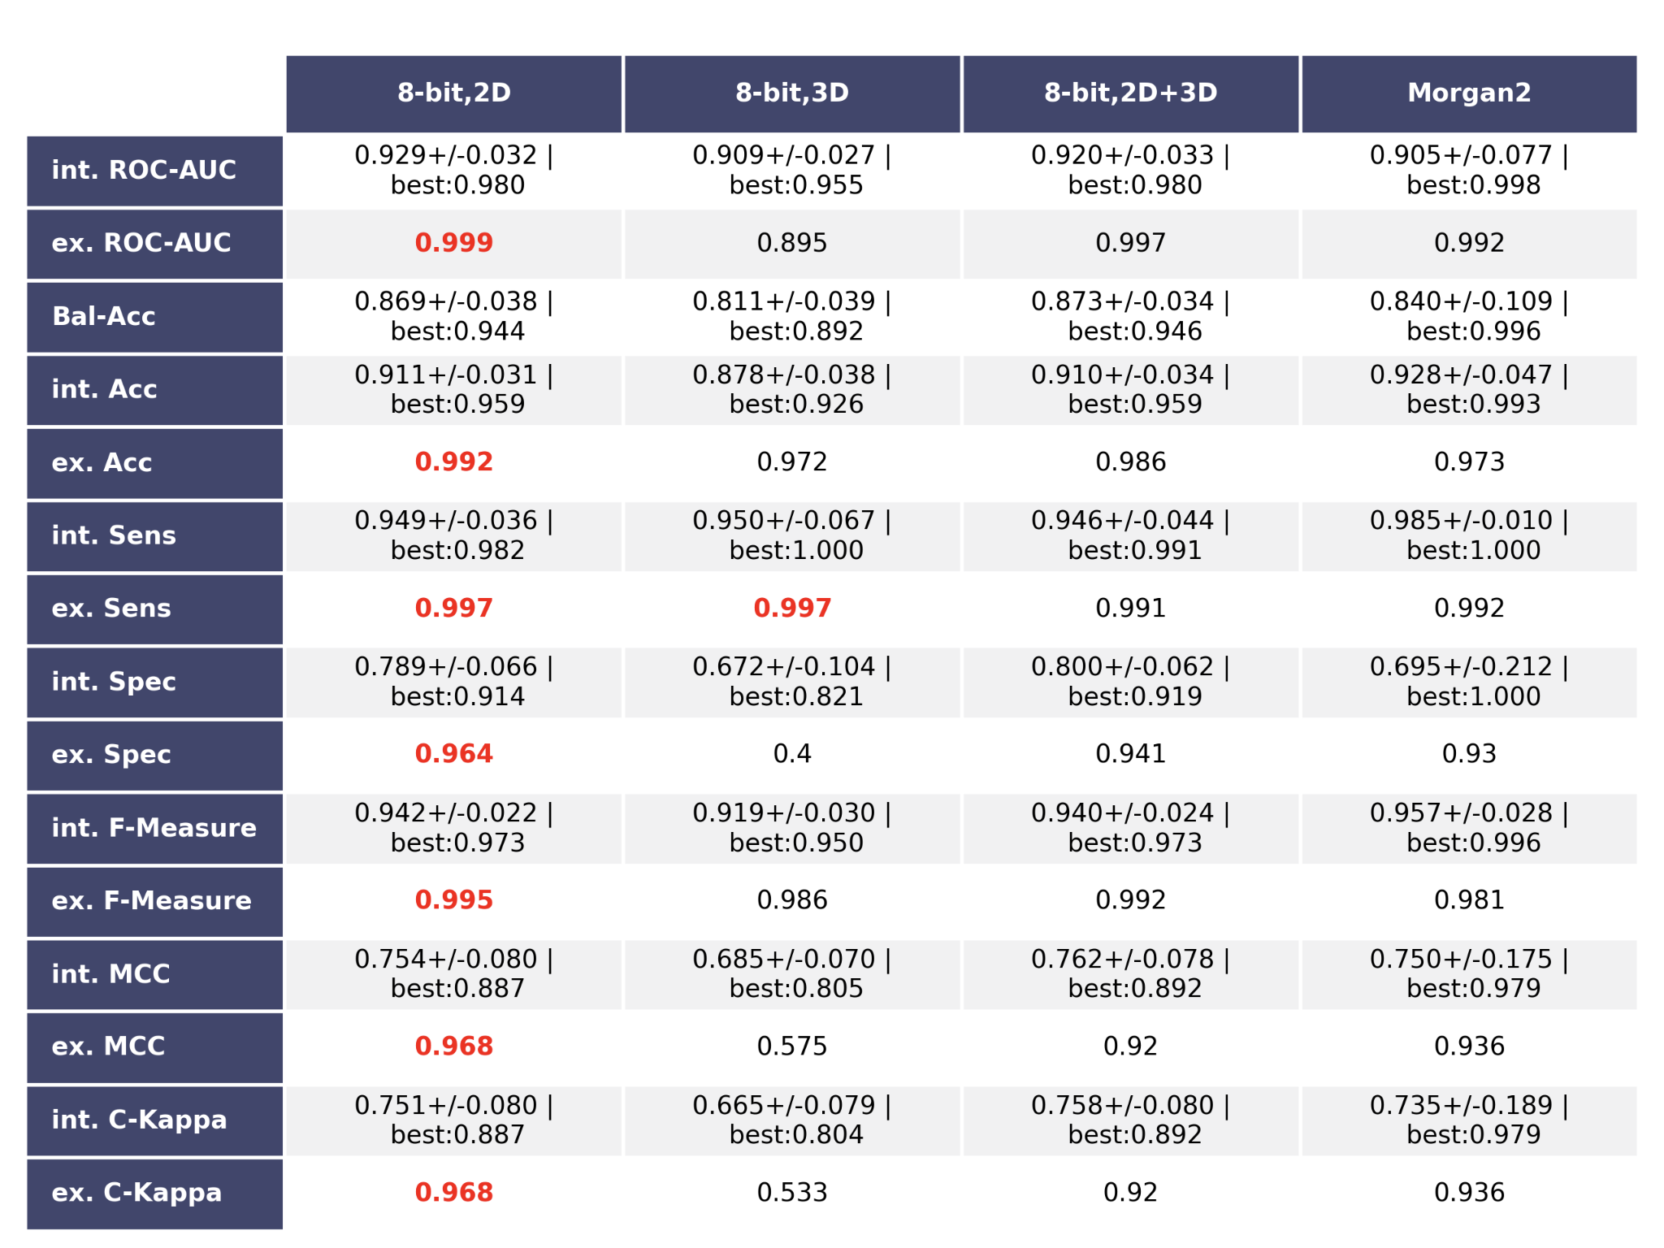

Table S6: Results of RBF SVM and Mahanabolis distance
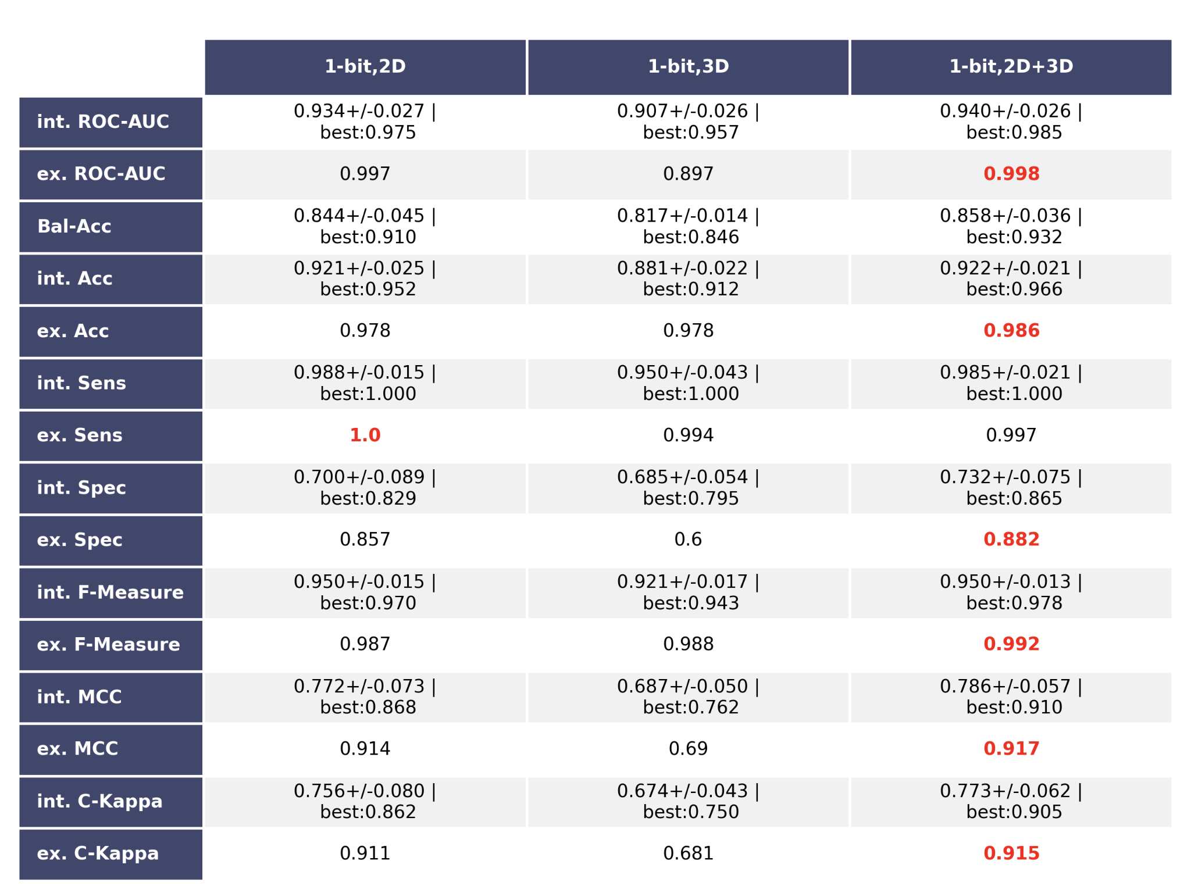
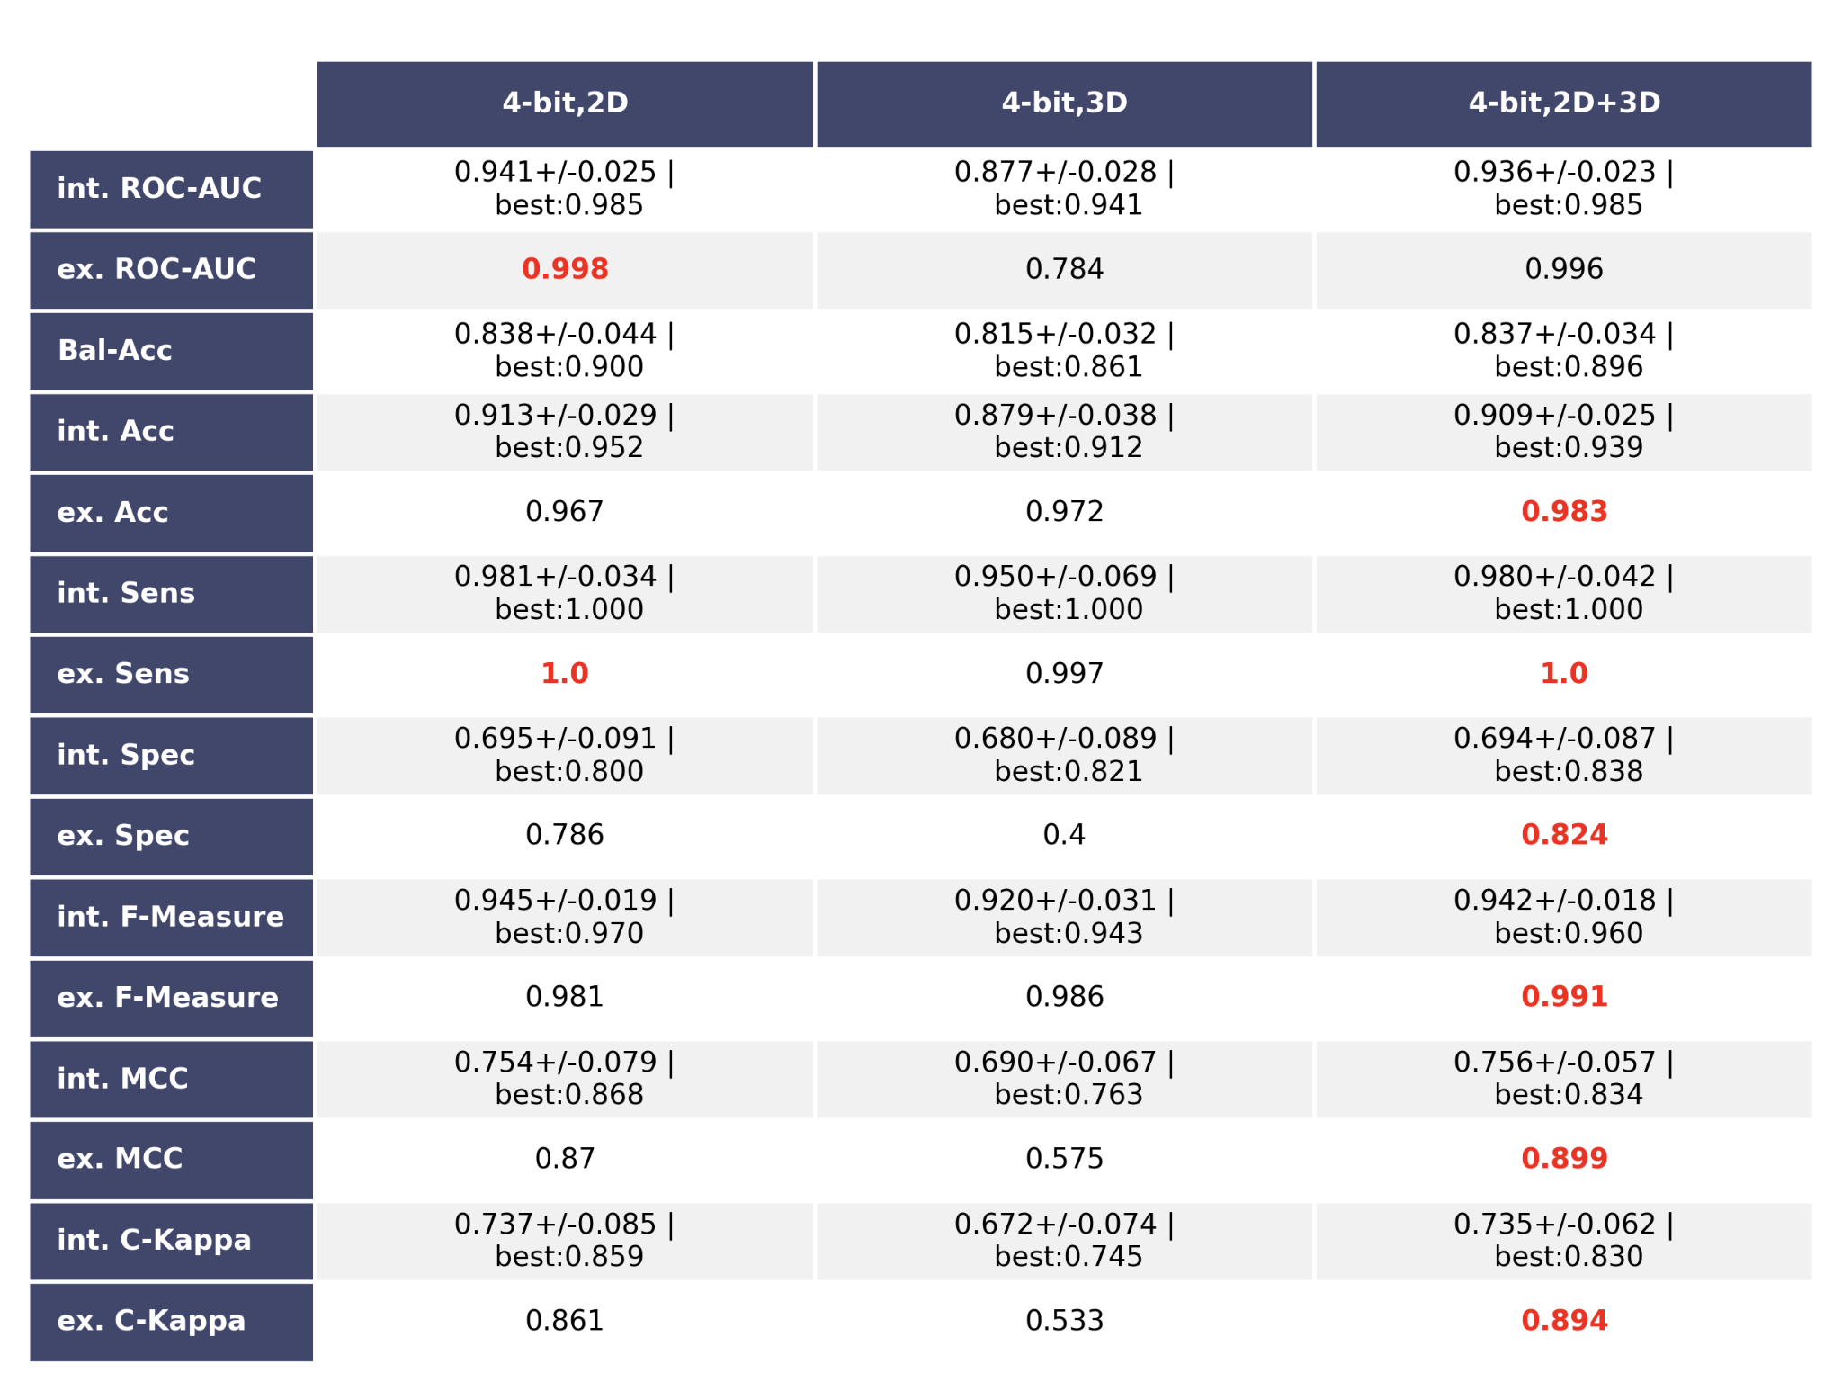
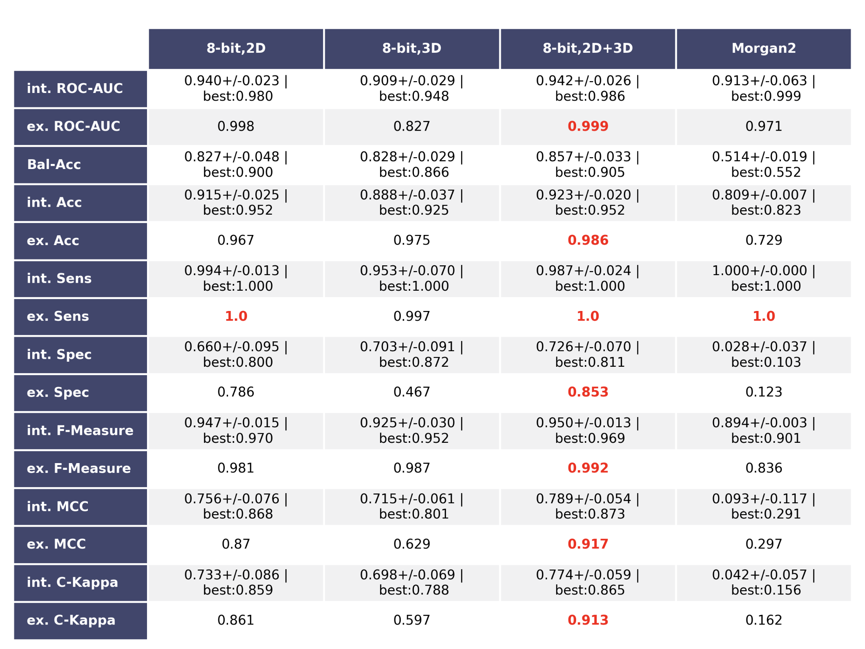

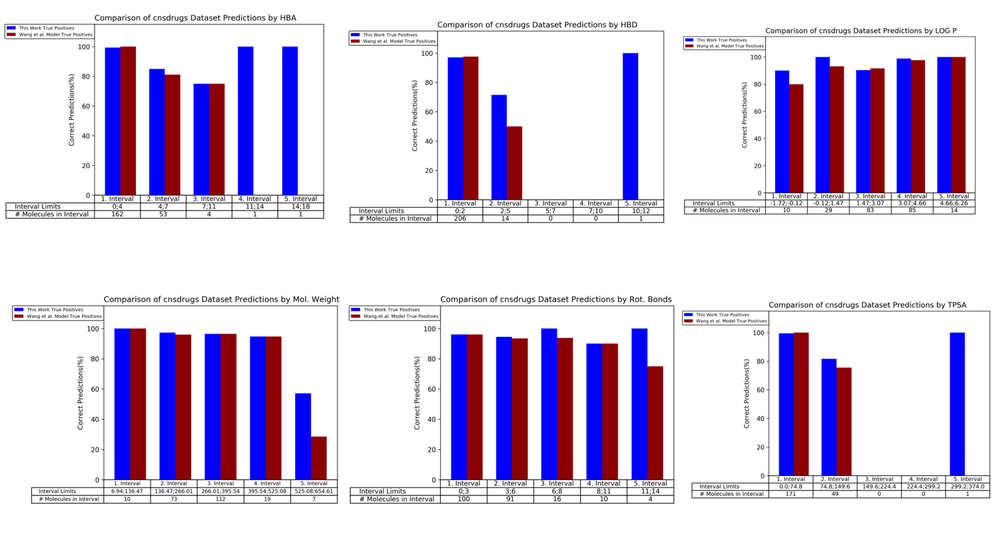

Figure S7: Shown are the correct predictions (in percent) per bin of the respective descriptor’s value range for both the best model of this work and the webserver of Wang et al.¹⁵. As shown, our model bbbPythoN-imb (blue) performed well for different intervals as compared to the published model (red).

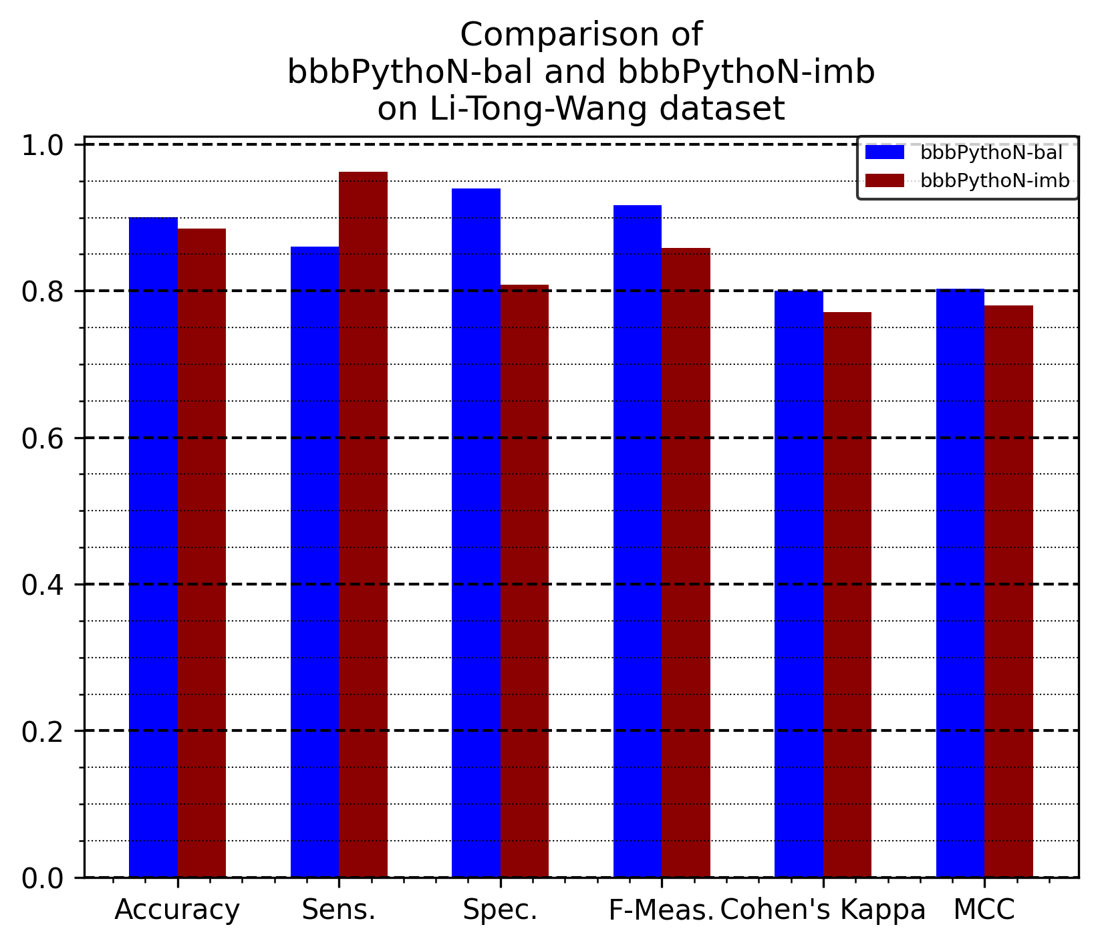
Figure S8: Comparison of predictive performance on the external validation dataset compiled from Li et al.⁵², Wang et al. ¹⁵., and Tong et al.⁵⁴ of bbbPythoN-bal and bbbPythoN-imb.

Table S9: The distribution of active and inactive class for both training and independent test set used in this study.

 | Training set | Active/inactive ratio | Independent test | Active/inactive ratio
2D, Euclidean | 1474 | 1100/374 | 368 | 339/29
3D, Euclidean | 1474 | 1089/385 | 359 | 344/15
2D+3D, Euclidean | 1474 | 1099/375 | 359 | 334/25
2D, Mahalanobis | 1474 | 1127/347 | 368 | 312/56
3D, Mahalanobis | 1474 | 1089/385 | 359 | 344/15
2D+3D, Mahalanobis | 1474 | 1108/366 | 359 | 325/34
Morgan2 | 1474 | 1185/289 | 369 | 255/114
2D+3D, Mahalanobis,  Balanced | 3291 | 1537/1754 | 765 | 479/286

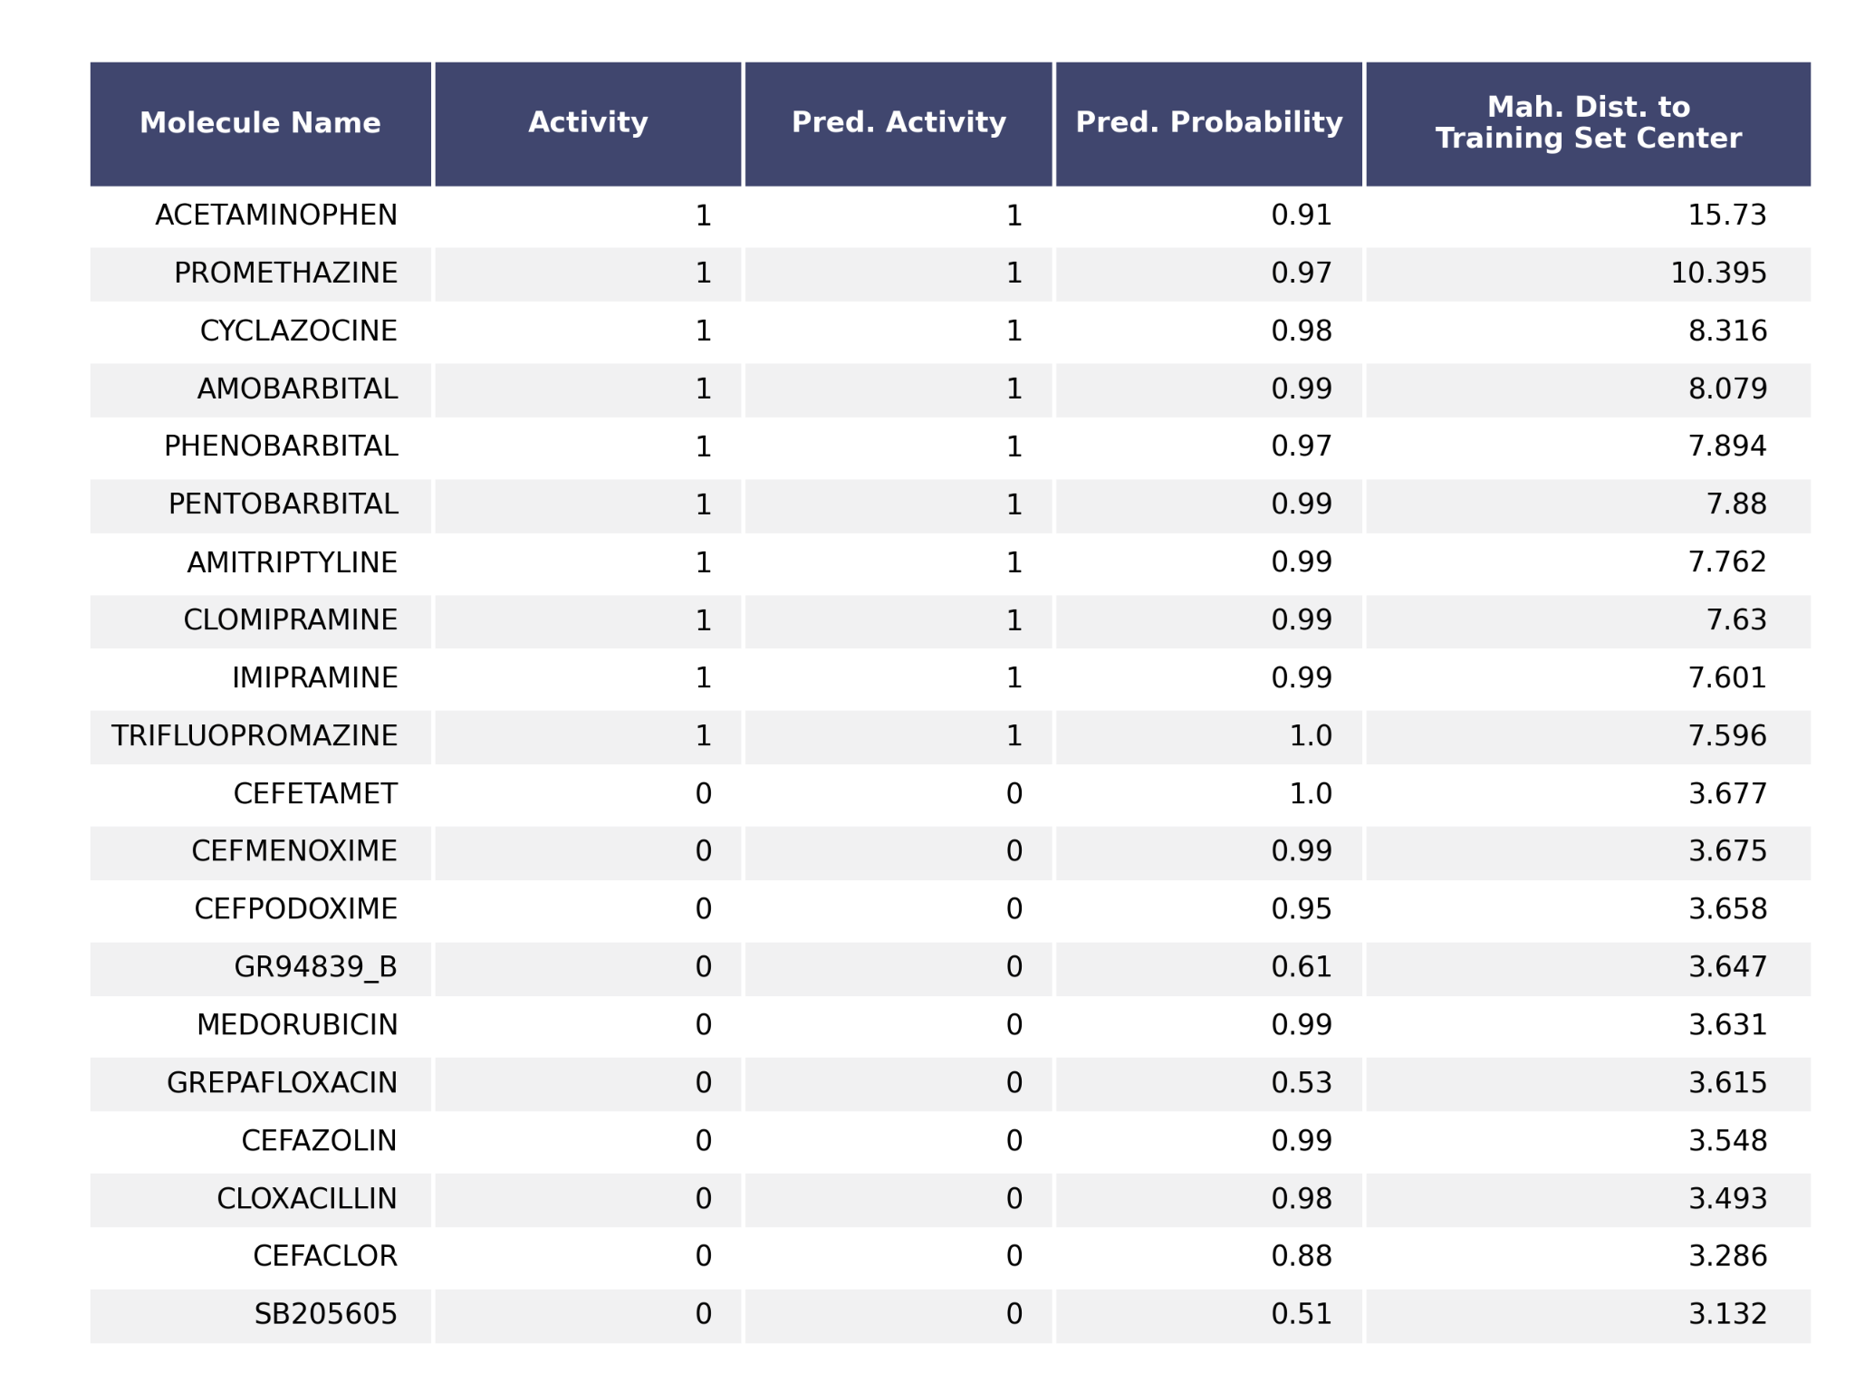
Table S10: Twenty test set compounds closest and farthest away from the training set center, ten compounds each, measured in Mahalanobis distance. Activity Predictions and Prediction Probability produced by best performing imbalanced model (Random Forest using 2D+3D, 8-bit descriptor-based MI-DSE Fingerprints trained and tested on Mahalanobis Distance Kennard-Stone training and test sets).

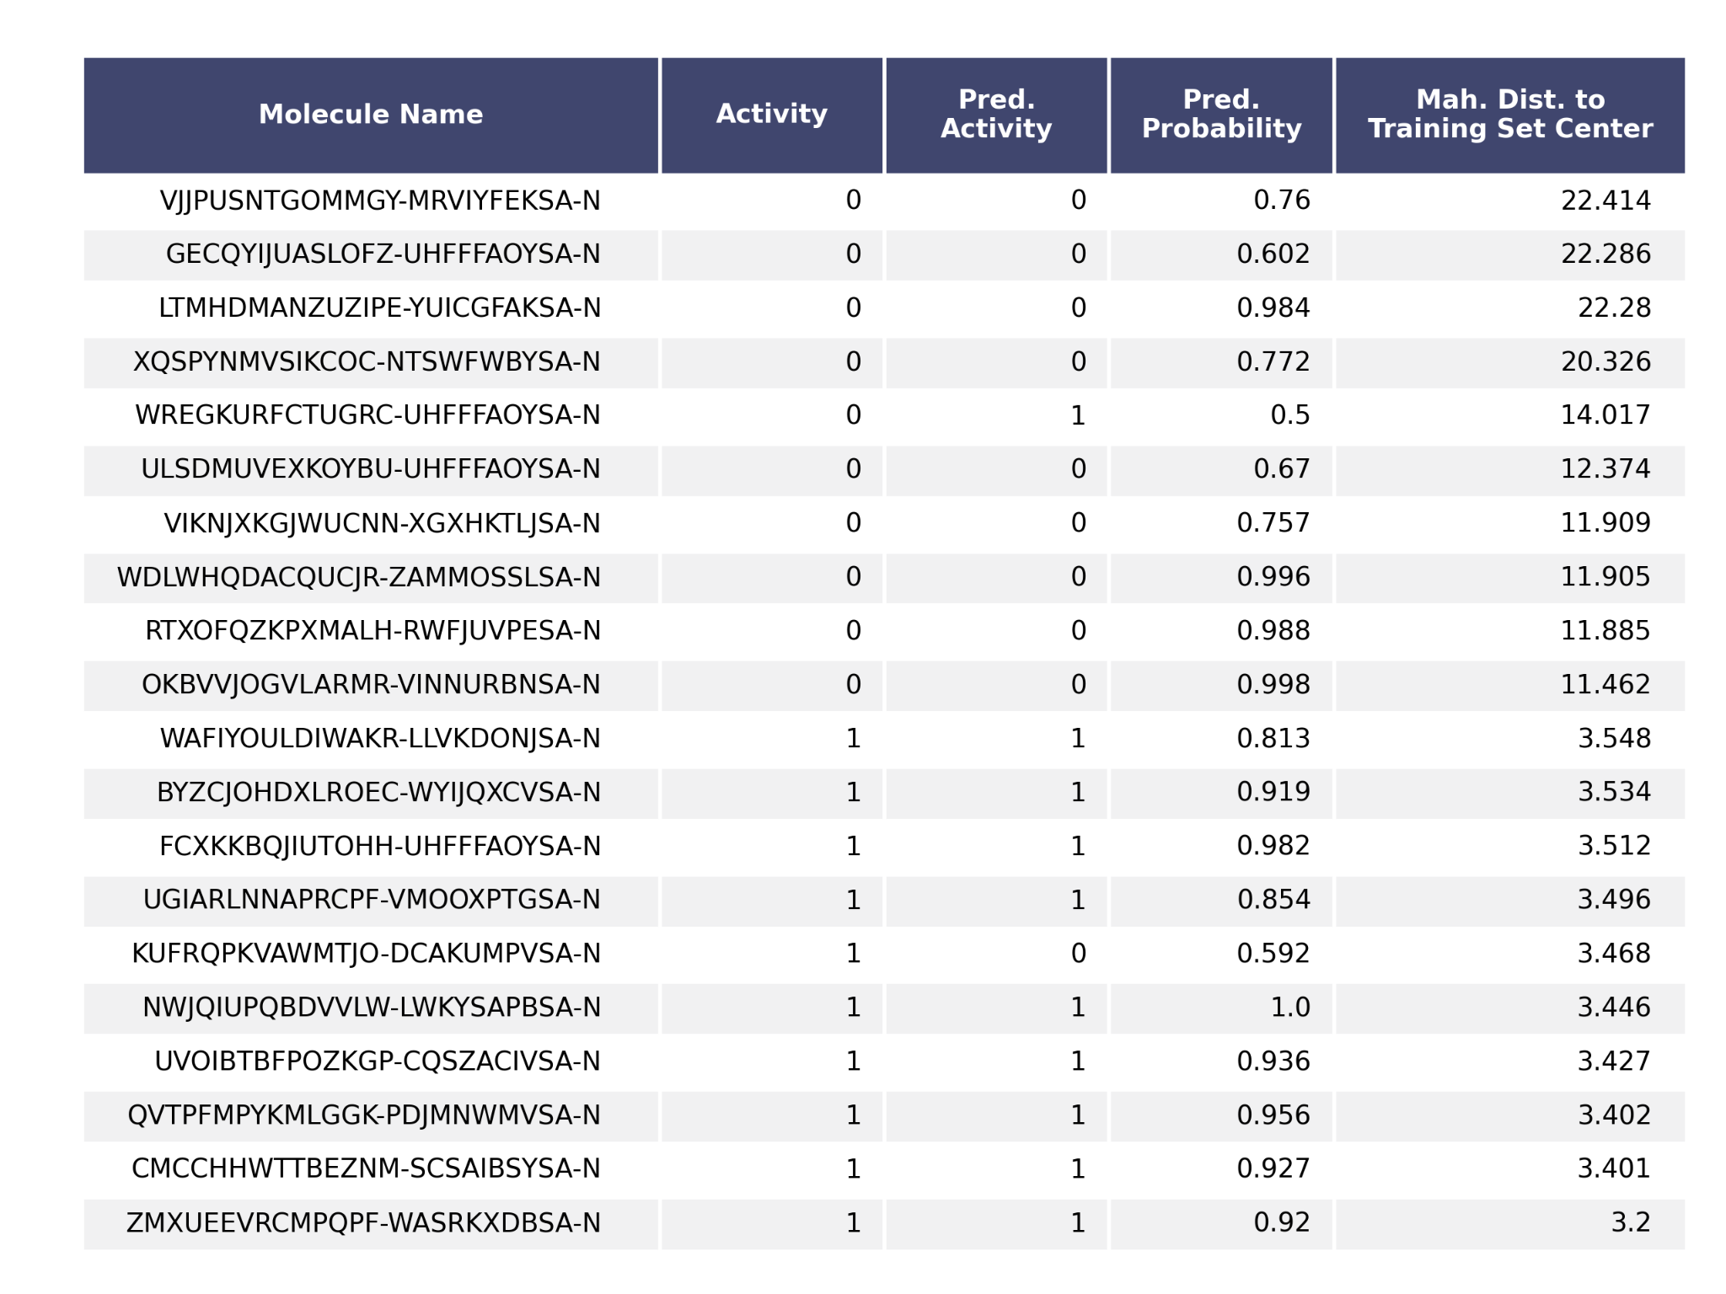
Table S11: Twenty test set compounds closest and farthest away from the training set center, ten compounds each, measured in Mahalanobis distance. Activity Predictions and Prediction Probability produced by best performing balanced model (Random Forest using 2D+3D, 8-bit descriptor-based MI-DSE Fingerprints trained and tested on Mahalanobis Distance Kennard-Stone training and test sets).

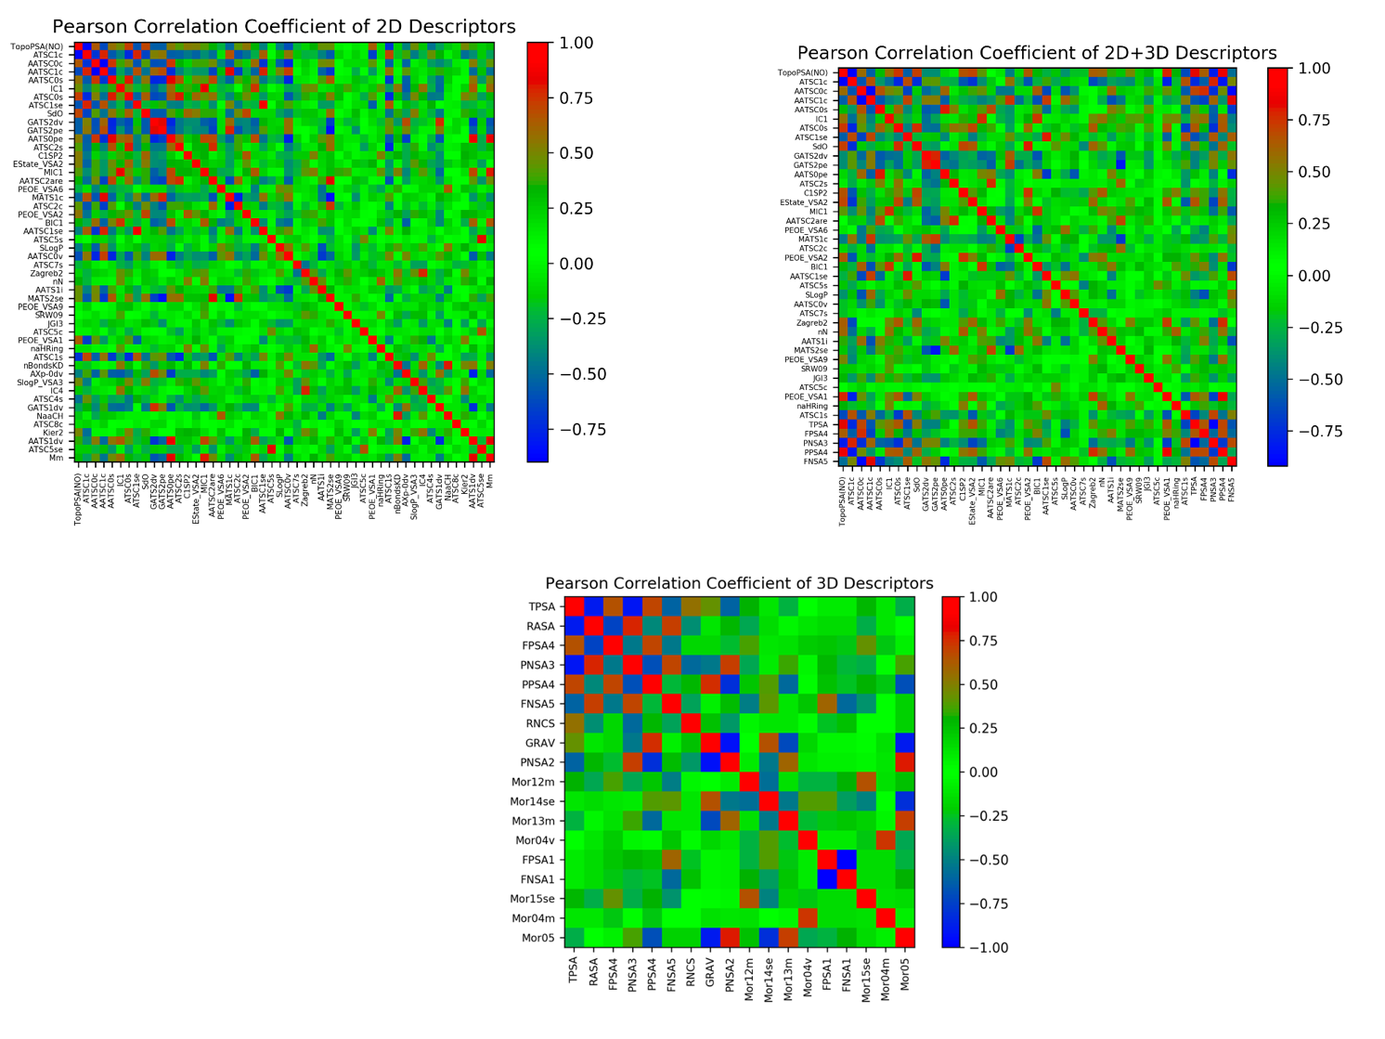
Figure S12: Pearson Correlation Coefficient analysis of the applied descriptors.

Table S13: The 2D and 3D descriptors encoded in the best-performing MI-DSE fingerprint with their respective MI-DSE scores.
Descriptor Name (Dimension) | MI-DSE Score
TopoPSA(NO) (2D) | 0.569
ATSC1c (2D) | 0.319
AATSC0c (2D) | 0.296
IC1 (2D) | 0.293
AATSC0s (2D) | 0.293
ATSC0s (2D) | 0.289
ATSC1se (2D) | 0.285
SdO (2D) | 0.272
GATS2dv (2D) | 0.257
GATS2pe (2D) | 0.249
ATSC2s (2D) | 0.227
AATS0se (2D) | 0.225
EState_VSA2 (2D) | 0.209
MIC1 (2D) | 0.208
BIC1 (2D) | 0.198
ATSC2c (2D) | 0.195
VSA_EState3 (2D) | 0.195
PEOE_VSA6 (2D) | 0.191
AATSC2are (2D) | 0.187
AATSC0v (2D) | 0.187
PEOE_VSA2 (2D) | 0.186
ATSC5s (2D) | 0.182
ATSC7s (2D) | 0.179
AATS1i (2D) | 0.174
nN (2D) | 0.172
Zagreb2 (2D) | 0.169
PEOE_VSA9 (2D) | 0.169
AATSC1c (2D) | 0.163
SRW09 (2D) | 0.162
ATSC5c (2D) | 0.161
PEOE_VSA1 (2D) | 0.159
AATSC1are (2D) | 0.159
MATS2are (2D) | 0.159
naHRing (2D) | 0.151
IC4 (2D) | 0.15
SlogP_VSA3 (2D) | 0.149
CIC2 (2D) | 0.145
AATS1dv (2D) | 0.144
JGI3 (2D) | 0.144
Xch-5d (2D) | 0.143
ATSC4c (2D) | 0.142
ATSC4s (2D) | 0.142
NaaCH (2D) | 0.141
TPSA (3D) | 0.439
PNSA3(3D) | 0.362
FPSA5(3D) | 0.321
DPSA4(3D) | 0.317
FNSA5(3D) | 0.264
RNCS(3D) | 0.154

Table S14: Structural key features encoded in the best-performing MI-DSE fingerprint.

Descriptor Name
MDEO-11
MAXdO
MAXsOH
MAXdssC
MDEN-22
MDEO-12
MAXaaN
MDEN-23
MAXaasN
MAXaaNH
MDEN-12

