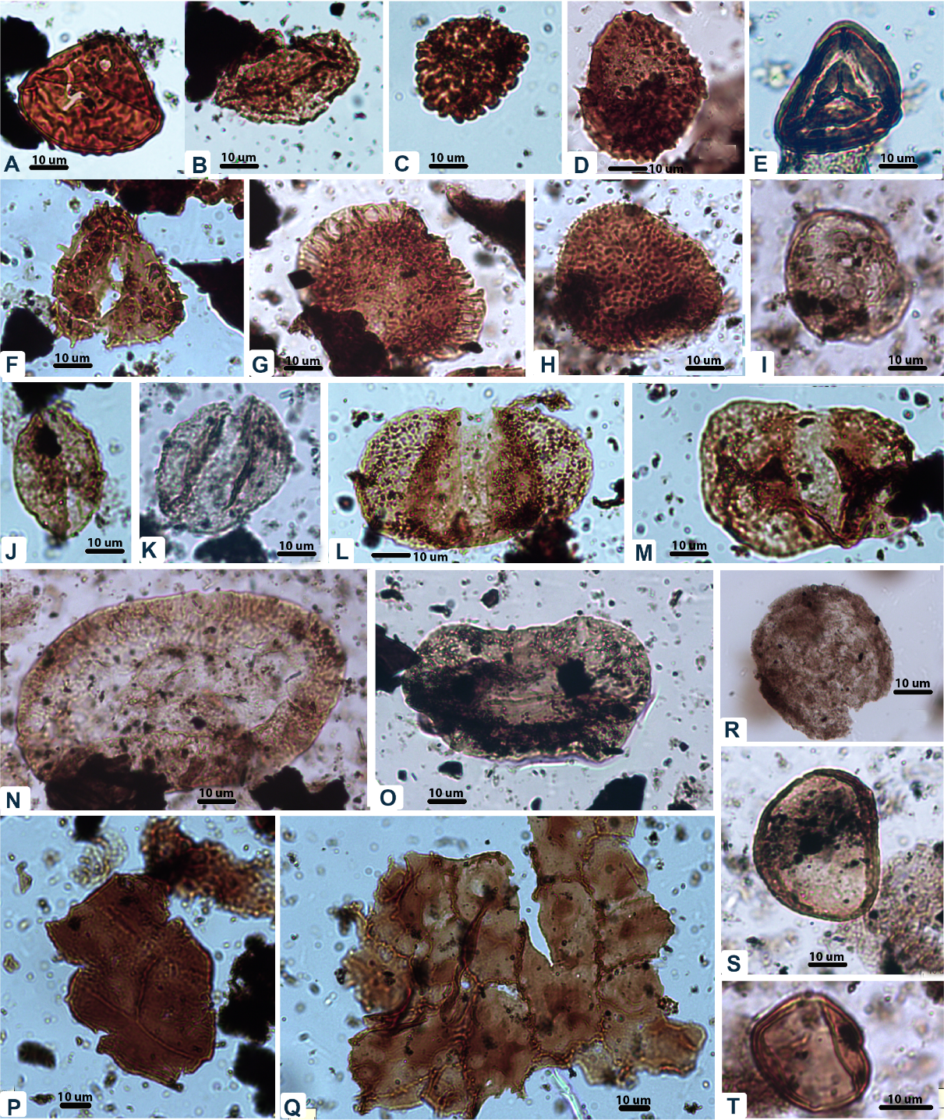
FIG. SI-1. The Palynomorphs Plate includes several important taxa. A. Camarozonosporites rudis (Leschik 1955) Klaus 1960, 83.4 m; B. Aratrisporites minimus Schulz 1967, 83.4 m; C. Uvaesporites argenteaeformis (Bolkhovitina 1953) Schulz 1967, 83.6 m; D. Apiculatisporites sp., 120.15 m; E. Striatella seebergensis Mädler, 1964; 120.15 m; F. Acanthotriletes microspinosus (Ibrahim, 1933) Potonié & Kremp, 1955; 200.05 m; G. Limbosporites denmeadii (de Jersey 1962) de Jersey & Raine 1990, 153.3 m; H. Osmundacidites wellmanii Couper 1953, 154.1 m; I. Craterisporites rotundus de Jersey, 1970, 167.4 m; J. Monosulcites spp., 83.4 m; K. Scheuringipollenites ovatus, 233.3 m; L. Alisporites australis de Jersey 1962, 120.15 m; M. Pteruchipollenites sp., 154.1; N. Parasaccites spp. 233.3 m; O. Staurosaccites quadrifidus, 167.4; P. cuticle of Dicroidium sp. Q. cuticle of Dicroidium odontopteroides Morris 1845, 83.4; R. Tasmanites sp., 289.1 m; S-T. Pilasporites calculus Balme and Hennelly 1956; 233.3 m.

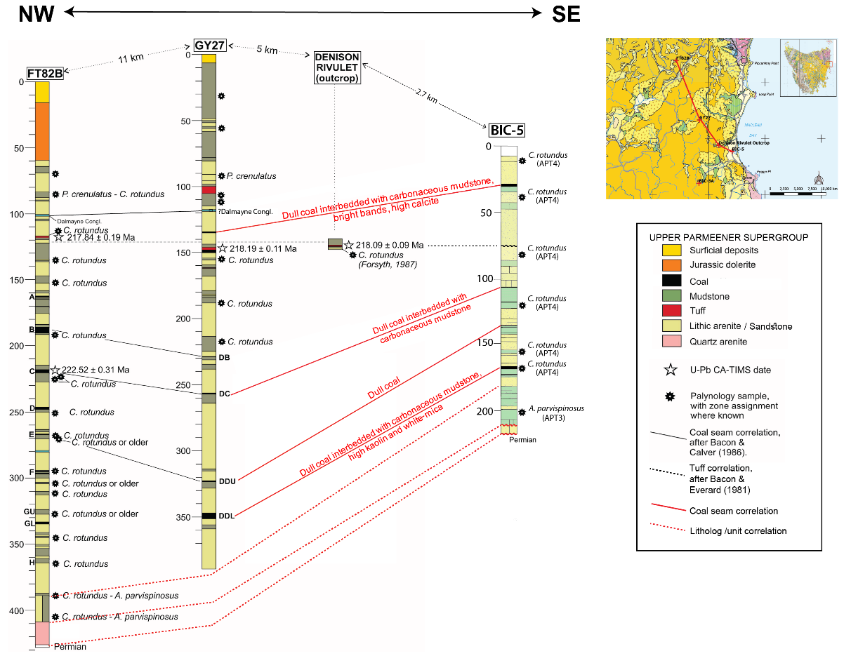
FIG. SI-2 Supplementary figure showing the location of core sites (inset adapted from 1:250,000 Digital Geological Data from from www.mrt.tas.gov.au, State of Tasmania). Detailed lithostratigraphy and chemostratigraphy correlation, including several coal seams, were performed between the Bicheno-5 (BIC-5) and GY27 detailed borehole description after Ford and Bos (1985). Palynological results Bicheno-5 support the correlation with nearby deposits of FT82B, GY27, and Denison Rivulet outcrops (after Calver et al., 2021). Detailed Bicheno-5 lithology can be found in Fig. 3 and Fig 4.

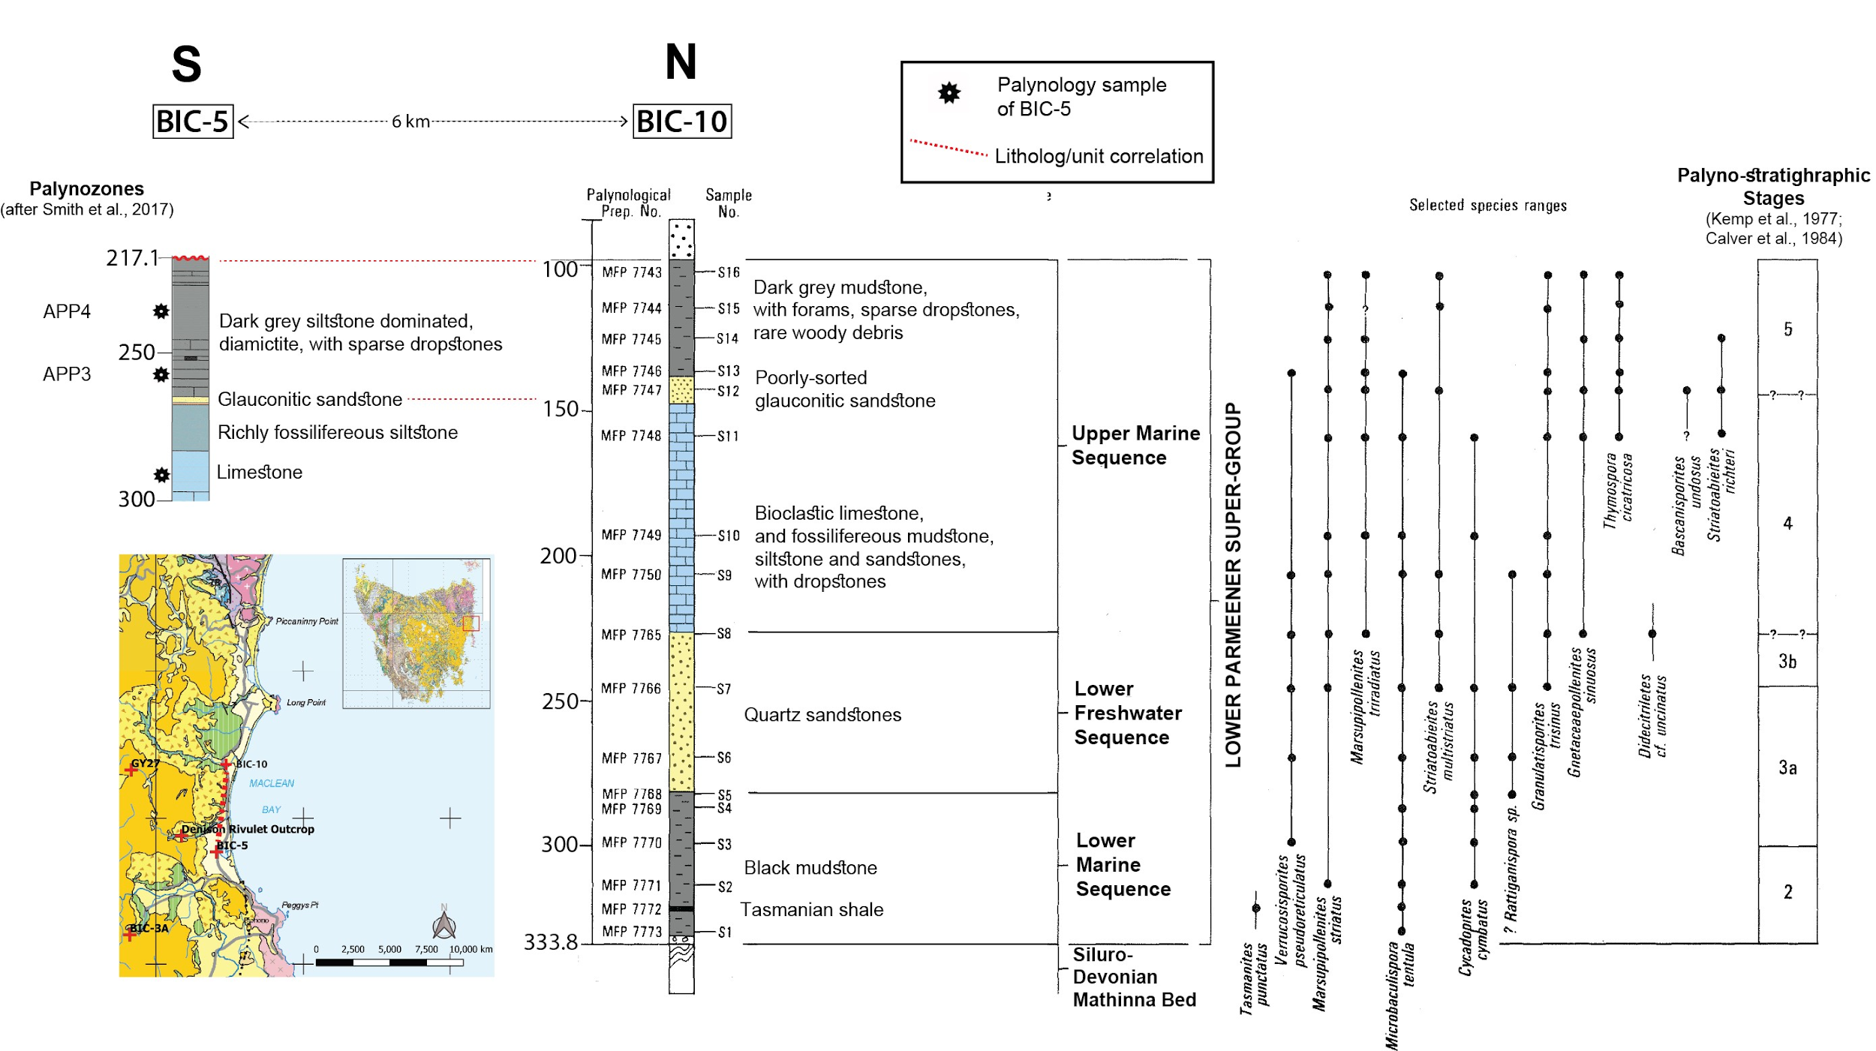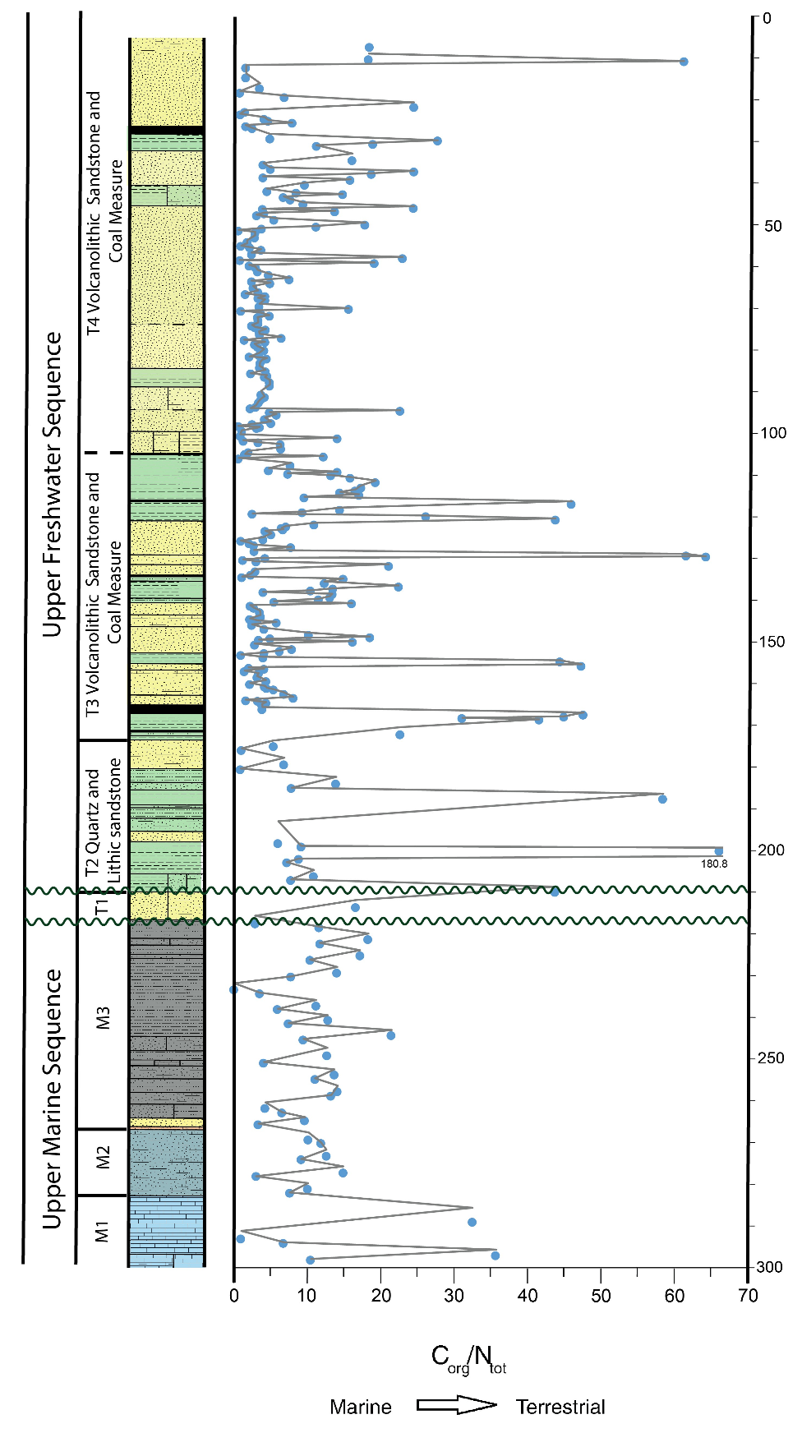
FIG. SI-3. Supplementary figure showing the location of core sites (inset adapted from 1:250,000 Digital Geological Data from from www.mrt.tas.gov.au, State of Tasmania). Bicheno-10 (BIC-10) based on palynostratigraphic stages boundaries on the right-hand side (after Kemp et al., 1977; Calver et al., 1984), which coherence with the palynology study in Bicheno-5 (BIC-5) showing APP 4 and APP 3 (left-hand side, data is from this study ) from The Australian Guadalupian to Lopingian, Permian palynostratigraphic zonation (after Smith and Mantle 2013; Smith et al.,2017).

FIG. SI-4 The graph displays C_{org}/N_{tot} ratios at different depths in the Bicheno-5 section. The typical C_{org}/N_{tot} ratio of marine and terrestrial organic matter follows Meyers (1997).

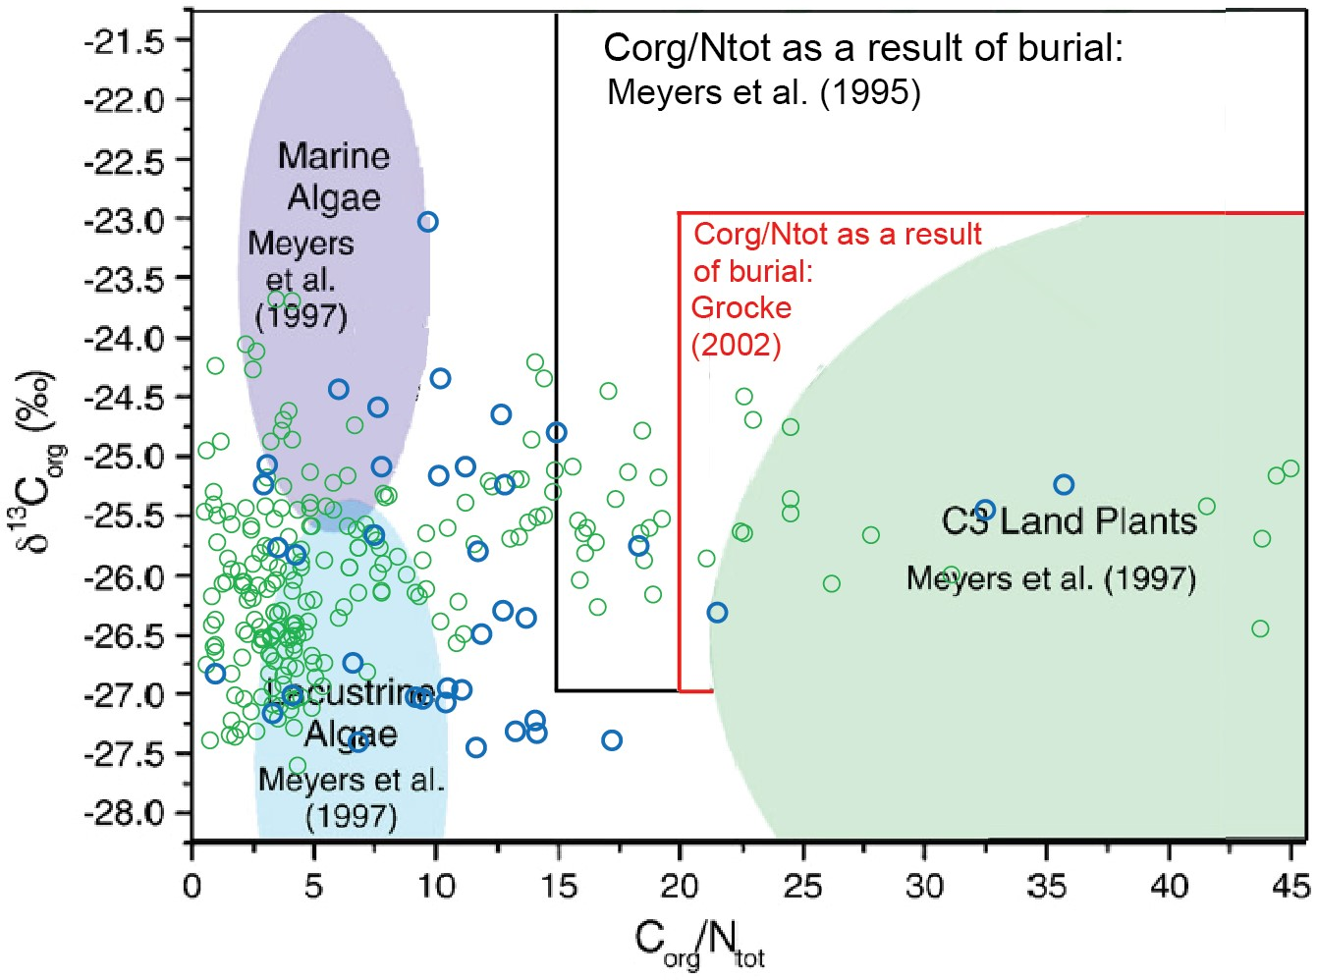
FIG. SI-5 Cross plots of total organic carbon content (% C), total nitrogen content (% N_{tot}), C_{org}/N_{tot}, and δ13Corg data obtained from the Bicheno-5 section. Samples from a depth of 0 to 217.7m (Triassic) are green open circles, and samples from 217.1 to 300m (Middle Permian) are blue open circles. Plotted fields are based on Meyers (1997) and Gröcke (2002).

