Supplemental Figure 1

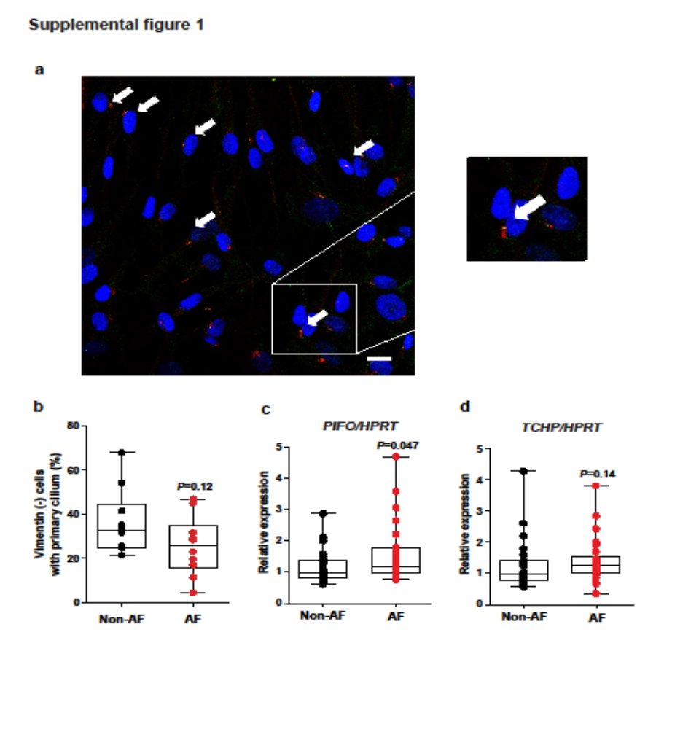
Supplemental figure 1
(a) Representative images of human atrial fibroblasts doubled stained with antibodies against acetylated α-tubulin (ciliary axoneme, red) and γ-tubulin (basal body, green), showing the ciliary structure as indicated by the white arrows. Scale bar, 20μm. (b) The proportion of vimentin-negative cells with primary cilia (%) in the left atrial tissue of the non-AF and AF patients. N=10/group. (c-d) The gene expression of PIFO (c) and TCHP (d) in the left atrial tissue of non-AF (N=25) and AF patients (N=26). The statistical significance was tested using the Mann-Whitney U test.

Supplemental figure 2
Supplemental figure 2
(a, b, c) Full-length Western Blots, including the corresponding ladders that reveal the blot edges. (b) The box indicates samples not relevant to the study.

