Supplementary Table S1. Gene expression marker (RT-qPCR) development for selected genes in resistant genotypes
Sr. No | Gene ID | Gene description | Primer sequence (5’→3’) | Resistant genotype | Gene expression  (Log₂ FC)
 |  |  |  |  | RNA-seq | RT-qPCR
1. | PGSC0003DMG400022263 | Fructose-bisphosphate aldolase | F: GCCATGGACACTGTCATTTTC  R: CTGAATTAGCCTTGCACCTTG | P7 | 3.16 | 2.57
 |  |  |  | Crd6 | 5.16 | 4.82
 |  |  |  | KG | 2.44 | 2.10
2. | PGSC0003DMG400024281 | Gamma aminobutyrate transaminase isoform2 | F: GAAAGCATTTATCGACAGTCCC  R: GTACCAACACCCCATTCTAGTG | P7 | 2.61 | 2.30
 |  |  |  | Crd6 | 6.69 | 5.98
 |  |  |  | KG | 3.04 | 2.68
3. | PGSC0003DMG400000021 | Carbonyl reductase | F: AGATCAATTGTGTCTGCCCTG  R: AGAACAAACCAGAAGGACCG | P7 | 2.71 | 2.35
 |  |  |  | Crd6 | 3.21 | 3.10
 |  |  |  | KG | 5.22 | 4.92
4. | PGSC0003DMG400029406 | Glyceraldehyde-3-phosphate dehydrogenase B subunit | F: TGAGCCTCTTGTGTCAGTTG  R: ATCCCCATTCGTTGTCATACC | P7 | 2.05 | 1.79
 |  |  |  | Crd6 | 4.06 | 3.87
 |  |  |  | KG | 2.96 | 2.48
Kufri Bahar was used as control in RT-qPCR study

Supplementary Table S2: Gene Ontology statistics description

Combination | DEGs | Gene Counts
 |  | Biological Process | Cellular Component | Molecular Function
P7 | Downregulated | 169 | 113 | 196
 | Exclusive_Control | 134 | 126 | 177
 | Exclusive_Treated | 190 | 142 | 238
 | Expressed_Both | 8,986 | 7,998 | 10,924
 | Upregulated | 184 | 133 | 207
 | Sub-total | 9663 | 8512 | 11742
Crd6 | Downregulated | 168 | 109 | 188
 | Exclusive_Control | 161 | 148 | 207
 | Exclusive_Treated | 184 | 136 | 212
 | Expressed_Both | 8,799 | 7,837 | 10,626
 | Upregulated | 131 | 102 | 139
 | Sub-total | 9443 | 8332 | 11372
Kufri Jyoti | Downregulated | 122 | 99 | 124
 | Exclusive_Control | 74 | 64 | 83
 | Exclusive_Treated | 124 | 99 | 133
 | Expressed_Both | 8,897 | 7,945 | 10,802
 | Upregulated | 233 | 157 | 274
 | Sub-total | 9450 | 8364 | 11416
Kufri Girdhari | Downregulated | 234 | 154 | 258
 | Exclusive_Control | 105 | 85 | 128
 | Exclusive_Treated | 182 | 142 | 194
 | Expressed_Both | 9,155 | 8,147 | 11,189
 | Upregulated | 138 | 110 | 160
 | Sub-total | 9814 | 8638 | 11929
 | Total | 54476 | 48301 | 65645
Kufri Bahar was used as control in gene expression study.

Supplementary Table S3. KEGG annotation statistics summary

Sr. No. | Genotype* | Identified Gene Counts | KEGG Annotated Gene Counts
1 | P7 | 19,930 | 5,448
2 | Crd6 | 19,363 | 5,428
3 | Kufri Jyoti | 19,496 | 5,414
4 | Kufri Girdhari | 20,324 | 5,478
*Kufri Bahar was used as control in gene expression study.

Supplementary Table S4. KEGG Pathways analysis of potato genotypes

Sr. No. | Pathways | Gene Counts
 |  | P7 | Crd6 | Kufri Jyoti | Kufri Girdhari
Metabolism
 | Carbohydrate metabolism | 490 | 486 | 485 | 495
 | Energy metabolism | 314 | 312 | 316 | 315
 | Lipid metabolism | 280 | 281 | 272 | 279
 | Nucleotide metabolism | 97 | 96 | 95 | 96
 | Amino acid metabolism | 324 | 326 | 318 | 325
 | Metabolism of other amino acids | 150 | 153 | 152 | 153
 | Glycan biosynthesis and metabolism | 133 | 129 | 131 | 133
 | Metabolism of cofactors and vitamins | 219 | 220 | 221 | 219
 | Metabolism of terpenoids and polyketides | 160 | 158 | 151 | 158
 | Biosynthesis of other secondary metabolites | 173 | 179 | 166 | 176
 | Xenobiotics biodegradation and metabolism | 83 | 82 | 83 | 83
Genetic Information Processing
 | Transcription | 215 | 214 | 214 | 214
 | Translation | 491 | 492 | 490 | 492
 | Folding, sorting and degradation | 423 | 420 | 426 | 427
 | Replication and repair | 116 | 111 | 118 | 117
Environmental Information Processing
 | Membrane transport | 28 | 28 | 29 | 28
 | Signal transduction | 646 | 641 | 644 | 651
 | Signaling molecules and interaction | 2 | 2 | 2 | 2
Cellular Processes
 | Transport and catabolism | 381 | 381 | 386 | 386
 | Cell growth and death | 276 | 273 | 272 | 274
 | Cellular community - eukaryotes | 61 | 61 | 61 | 63
 | Cellular community - prokaryotes | 47 | 47 | 45 | 49
 | Cell motility | 41 | 43 | 41 | 43
Organismal Systems
 | Environmental adaptation | 298 | 293 | 296 | 300

Supplementary Table S5. Selected potential genes used for sequence diversity and motif analyses for providing late blight resistance in potato genotypes
Sr. No. | Gene ID | Peptide ID | Gene description
 | PGSC0003DMG400033334 | PGSC0003DMP400055978  PGSC0003DMP400055979  PGSC0003DMP400055980 | Bacterial spot disease resistance protein 4
 | PGSC0003DMG400018429 | PGSC0003DMP400032105 | Bacterial spot disease resistance protein 4
 | PGSC0003DMG400008596 | PGSC0003DMP400015106  PGSC0003DMP400015107 | Cc-nbs-lrr resistance protein
 | PGSC0003DMG400028081 | PGSC0003DMP400048785 | Cc-nbs-lrr resistance protein
 | PGSC0003DMG400008394 | PGSC0003DMP400014729  PGSC0003DMP400014730  PGSC0003DMP400014731  PGSC0003DMP400014732  PGSC0003DMP400014733  PGSC0003DMP400014734 | Cc-nbs-lrr resistance protein
 | PGSC0003DMG400016616 | PGSC0003DMP400029044 | Cytochrome P450
 | PGSC0003DMG400018462 | PGSC0003DMP400032157  PGSC0003DMP400032158  PGSC0003DMP400032159  PGSC0003DMP400032160  PGSC0003DMP400032161  PGSC0003DMP400032162 | Disease resistance protein
 | PGSC0003DMG400018464 | PGSC0003DMP400032164  PGSC0003DMP400032165  PGSC0003DMP400032166  PGSC0003DMP400032167 | Disease resistance protein
 | PGSC0003DMG400029405 | PGSC0003DMP400051212 | Disease resistance protein RPM1
 | PGSC0003DMG400025545 | PGSC0003DMP400044305  PGSC0003DMP400044306  PGSC0003DMP400044307 | Late blight resistance protein homolog R1B-23
 | PGSC0003DMG400018264 | PGSC0003DMP400031818 | Leucine-rich repeat family protein / protein kinase family protein
 | PGSC0003DMG400008146 | PGSC0003DMP400014331 | Leucine-rich repeat receptor kinase
 | PGSC0003DMG400011048 | PGSC0003DMP400019518 | MYB transcription factor
 | PGSC0003DMG400000340 | PGSC0003DMP400000664 | MYB transcription factor
 | PGSC0003DMG401010943 | PGSC0003DMP400019327  PGSC0003DMP400019328 | Nbs-lrr resistance protein
 | PGSC0003DMG400002426 | PGSC0003DMP400004305 | Resistance gene
 | PGSC0003DMG400010894 | PGSC0003DMP400019247  PGSC0003DMP400019248 | Transcription factor
 | PGSC0003DMG400002272 | PGSC0003DMP400004053 | Transcription factor AP2-EREBP

Supplementary Table S6. RT-qPCR analysis of selected genes
Sr. No | Gene ID | Gene description | Primer sequence (5’→3’) | Gene expression  (Log₂ FC)
 |  |  |  | RNA-seq | RT-qPCR
P7
1. | PGSC0003DMG400018462 | Disease resistance protein | F: CATATGGAGCATAGAAGCCTGG  R: GTAGAACACGCATTGGAAAAGG | 5.62 | 4.04
2. | PGSC0003DMG400021508 | C2H2-type zinc finger protein | F: GCCACCGTGATTTTGACTTG  R: TTGGAGGTAGAGATAGCCGAG | -7.71 | -5.10
Crd6
3. | PGSC0003DMG400024281 | Gamma aminobutyrate transaminase isoform2 | F: GAAAGCATTTATCGACAGTCCC  R: GTACCAACACCCCATTCTAGTG | 6.69 | 5.52
4. | PGSC0003DMG400006369 | AP2/ERF domain-containing transcription factor | F: GGCTAATCCGATGTATACAGGG  R: AACCCCACTCTCCCTCTC | -4.673 | -3.06
Kufri Girdhari
5. | PGSC0003DMG400033334 | Bacterial spot disease resistance protein 4 | F: ATGAAGACGGAGTTAGAGATTAGTATG  R: TTTGTAAGATGAGGTTGGAGGTC | 6.99 | 5.42
6. | GSC0003DMG400030009 | Leucine-rich repeat protein | F: CAGACCCAAACAATGTGCTTC  R: TTCCCAATTGAGGTACCAAGG | -6.11 | -5.23
Kufri Jyoyi
7. | PGSC0003DMG400018464 | Disease resistance protein | F: TCCTTCAAGACGCTATTGGC  R: GTCTGATATCTTCCCAGGCTTC | 5.12 | 4.06
8. | PGSC0003DMG400020660 | Protein kinase domain containing protein | F: GCTTTCCAACTTGCTCAACAG  R: AACCTCAGCATTGTCTCCG | -4.89 | -4.12
Kufri Bahar was used as control in the RT-PCR/gene expression study

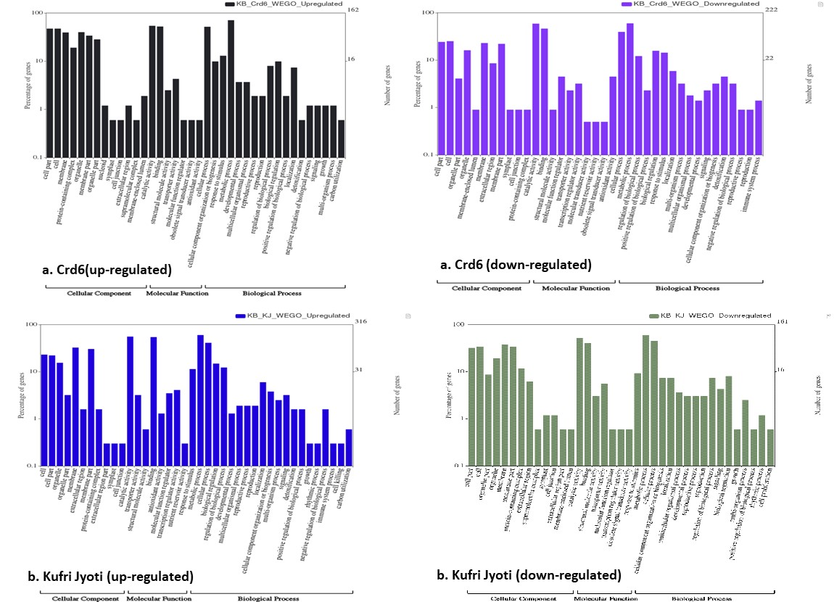
Supplementary Figure S1: GO annotation of genes in Crd6 and Kufri Jyoti

Supplementary Figure S2. Scatter plots of genes in P7, Crd6, Kufri Jyoti and Kufri Girdhari
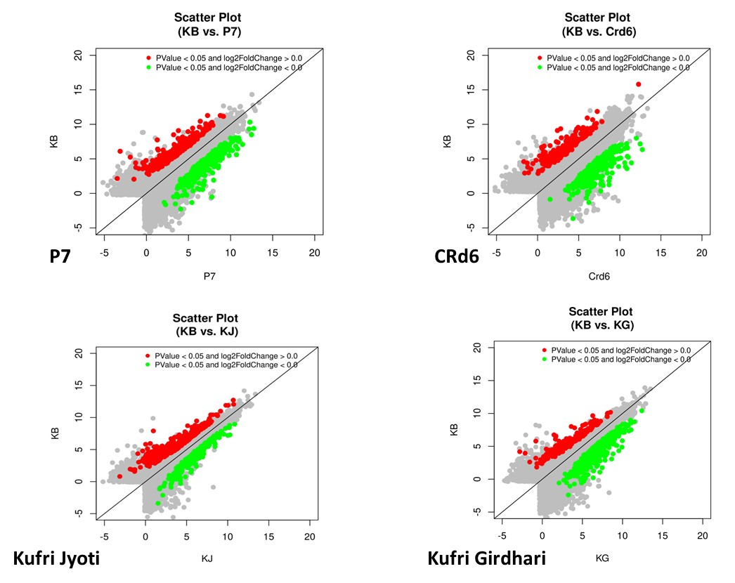

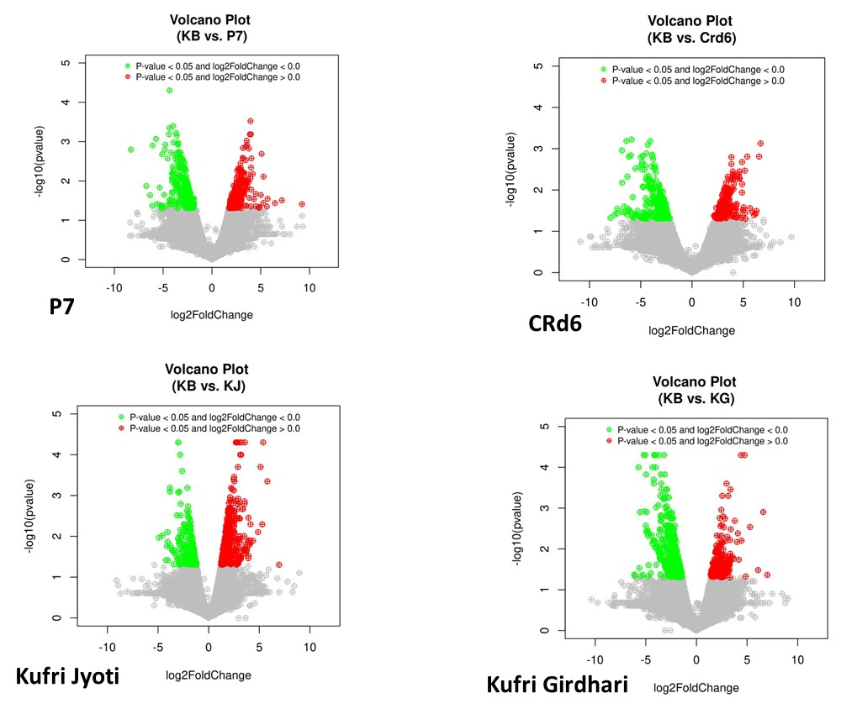
Supplementary Figure S3. Volcano plots of genes in P7, Crd6, Kufri Jyoti and Kufri Girdhari

