Microwave-Assisted Synthesis, Characterization and in vitro Biomedical Applications of Hibiscus rosa-sinensis Linn.-mediated Carbon Quantum Dots
Shweta Yalshetti¹, Bothe Thokchom¹, Santosh Mallikarjun Bhavi¹, Sapam Riches Singh¹, Sneha R. Patil¹, B. P. Harini², Mika Sillanpää³, J. G. Manjunatha⁴, B. S. Srinath⁵, Ramesh Babu Yarajarla¹*

¹Drosophila and Nanoscience Research Laboratory, Department of Applied Genetics, Karnatak University, Dharwad, Karnataka 580003, India.
²Department of Zoology, Bangalore University, Bangalore, Karnataka 560056, India.
³Department of Biological and Chemical Engineering, Aarhus University, Norrebrogade 44, 8000 Aarhus C, Denmark.
⁴Department of Chemistry, FMKMC College, Mangalore University Constituent College, Madikeri, Karnataka 571201, India.
⁵Department of Microbiology and Biotechnology, Bangalore University, Bangalore, Karnataka 560056, India.

*Corresponding author: Ramesh Babu Yarajarla
Drosophila and Nanoscience Research Laboratory, Department of Applied Genetics, Karnatak University, Dharwad, Karnataka 580003, India
E-mail: rameshy@kud.ac.in

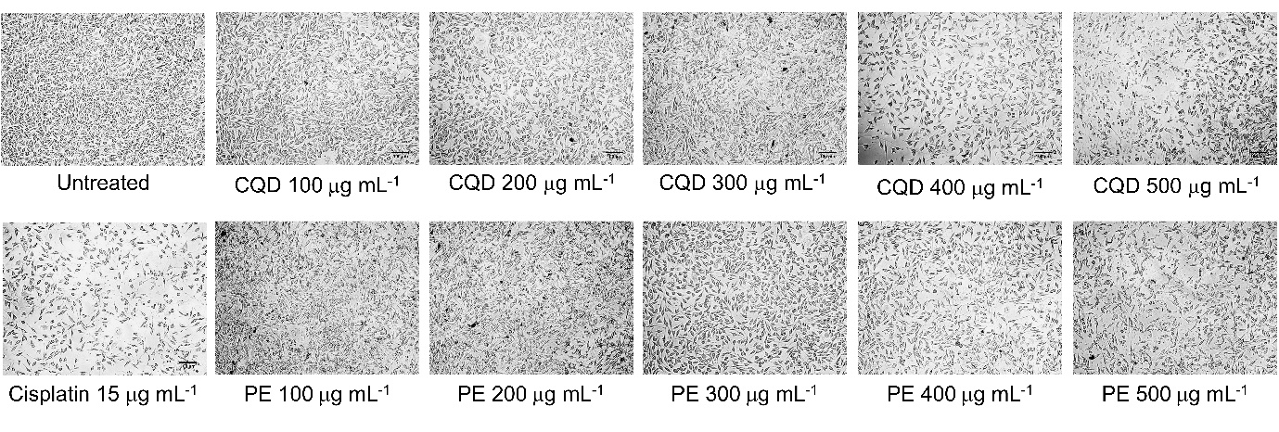
Figure S1: MTT assay images of L929 cells treated with different concentrations of CQDs and plant extract, with cisplatin as standard control; PE stands for plant extract

Figure S2: MTT assay images of HaCaT cells treated with different concentrations of CQDs along with bar graph. Bars represent mean ± SD (^{ns}p > 0.05, n = 4)

Figure S3: Flow cytometry dot plots (FSC vs SSC and Annexin V-FITC vs PI) of unstained, Annexin V-FITC only stained, PI only stained, control (untreated) and CQDs treated HaCaT cells
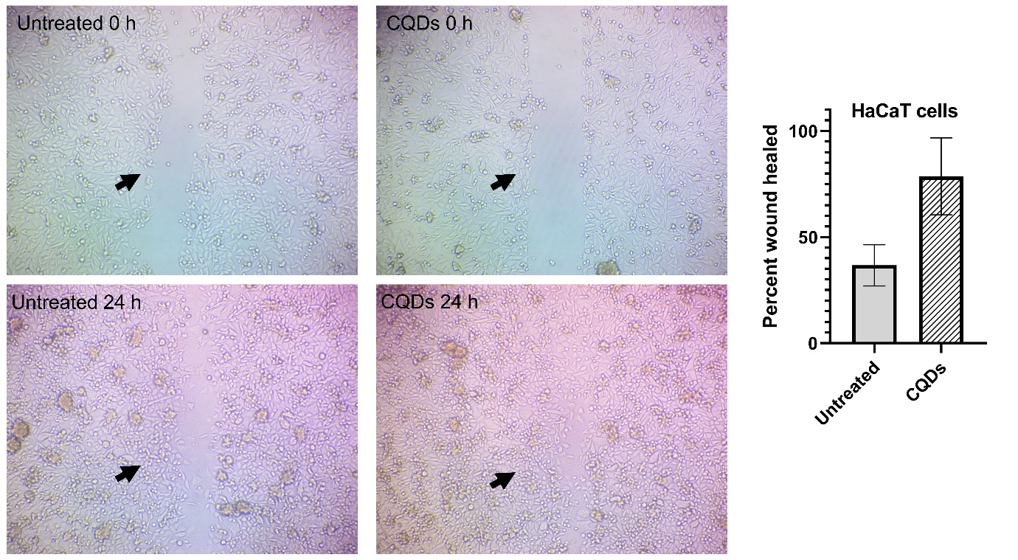
Figure S4: Scratch wound healing of untreated and 250 μg mL⁻¹ CQDs treated HaCaT cells after 24 h and its respective graph. Bars represent mean ± SD, n = 3
Figure S5: Colony counting assay: colonies of B. cereus and K. pneumoniae after 12 h culture with specific concentrations of CQDs, PE and 50 μg mL⁻¹ kanamycin. PE = plant extract; (100), (125) and (150) represent the concentration of CQDs and plant extract in μg mL⁻¹

Table S1: Cytotoxicity of CQDs against L929 cells compared with plant extract
Sample | Concentration (μg mL⁻¹) | Cytotoxicity test by MTT assay
Sample | Concentration (μg mL⁻¹) | Cell viability (%) | IC₅₀ (μg mL⁻¹)
CQDs | 100 | 76.12 ± 0.1064 | 314.01
CQDs | 200 | 62.58 ± 0.6385 | 314.01
CQDs | 300 | 49.51 ± 0.0461 | 314.01
CQDs | 400 | 41.85 ± 0.0532 | 314.01
CQDs | 500 | 28.08 ± 0.0355 | 314.01
Plant extract | 100 | 78.80 ± 0.1596 | 356.02
Plant extract | 200 | 67.95 ± 0.0320 | 356.02
Plant extract | 300 | 55.37 ± 0.2483 | 356.02
Plant extract | 400 | 43.92 ± 0.4966 | 356.02
Plant extract | 500 | 35.19 ± 0.5676 | 356.02
Cisplatin | 15 | 45.02 ± 0.1064 | -
The results were analysed using one-way ANOVA (p < 0.05) and are expressed as mean ± SEM, n = 3

Table S2: Data of wound closure analyzed using ImageJ
Cell | Label | Area (unit²) | Area % | Width (unit) | Standard deviation (unit) | Wound Closure %
L929 | Untreated 0 h | 0.625 | 10.006 | 0.246 | 0.019 | 0
L929 | Untreated 12 h | 0.62 | 9.919 | 0.245 | 0.011 | 0.8
L929 | Untreated 24 h | 0.618 | 9.896 | 0.242 | 0.011 | 1.12
L929 | Standard 0 h | 0.928 | 14.847 | 0.371 | 0.02 | 0
L929 | Standard 12 h | 0.54 | 8.645 | 0.221 | 0.045 | 41.81034
L929 | Standard 24 h | 0.003 | 0.053 | 0.023 | 0.023 | 99.67672
L929 | Plant Extract 0 h | 0.921 | 14.737 | 0.365 | 0.031 | 0
L929 | Plant Extract 12 h | 0.886 | 14.173 | 0.357 | 0.04 | 3.800217
L929 | Plant Extract 24 h | 0.86 | 13.76 | 0.346 | 0.033 | 6.623236
L929 | CQDs 0 h | 0.764 | 12.223 | 0.306 | 0.028 | 0
L929 | CQDs 12 h | 0.374 | 5.983 | 0.156 | 0.048 | 51.04712
L929 | CQDs 24 h | 0.001 | 0.016 | 0.015 | 0.012 | 99.87
HaCaT | Untreated 0 h | 1075006 | 10.915 | 411.555 | 122.306 | 0
HaCaT | Untreated 24 h | 680623 | 6.911 | 266.628 | 105.242 | 36.6866
HaCaT | CQDs 0 h | 1349017 | 13.697 | 490.372 | 56.709 | 0
HaCaT | CQDs 24 h | 289011 | 2.934 | 189.878 | 87.412 | 78.5761

Table S3: Percentage wound closure observed in L929 Cell line
Cell line | Treatment | Concentration  (In µg mL⁻¹) | Wound Closure at 12 h  (%) | Wound Closure at 24 h  (%)
L929 | Untreated | 0 | 0.8 | 1.12
L929 | Standard Ascorbic Acid | 15 | 41.81 | 99.68
L929 | Plant Extract | 35.60 | 3.8 | 6.62
L929 | Carbon Quantum Dots | 31.40 | 51.05 | 99.87
HaCaT | Untreated | 0 | - | 39.45
HaCaT | Carbon Quantum Dots | 250 | - | 57.59

Table S4: Anti-inflammatory effect of CQDs compared with plant extract and aspirin
Sample | Concentration (μg mL⁻¹) | Anti-inflammatory assay by protein denaturation
Sample | Concentration (μg mL⁻¹) | % of inhibition | IC₅₀ (μg mL⁻¹)
CQDs | 50 | 23.78 ± 2.2001 | 106.20
CQDs | 100 | 35.15 ± 2.8596 | 106.20
CQDs | 150 | 56.51 ± 3.3064 | 106.20
CQDs | 200 | 73.65 ± 3.5299 | 106.20
CQDs | 250 | 89.42 ± 3.7487 | 106.20
Plant extract | 50 | 18.28 ± 2.9017 | 187.28
Plant extract | 100 | 33.09 ± 3.3459 | 187.28
Plant extract | 150 | 48.68 ± 3.0251 | 187.28
Plant extract | 200 | 60.32 ± 3.6843 | 187.28
Plant extract | 250 | 73.33 ± 2.3999 | 187.28
Aspirin | 50 | 35.47 ± 2.1572 | 93.41
Aspirin | 100 | 54.04 ± 2.7353 | 93.41
Aspirin | 150 | 67.61 ± 3.0314 | 93.41
Aspirin | 200 | 78.47 ± 3.1401 | 93.41
Aspirin | 250 | 94.03 ± 2.908 | 93.41
The results were analysed using one-way ANOVA (p < 0.05) and are expressed as mean ± SEM, n = 3
Table S5: Antibacterial activity of CQDs and plant extract
Bacteria | Zone of Inhibition (in mm)
Bacteria | Kanamycin  (50 μg) | CQDs |  |  | Plant extract
Bacteria | Kanamycin  (50 μg) | 100 μg | 125 μg | 150 μg | 100 μg | 125 μg | 150 μg
Bacillus cereus | 24.08 ± 0.3700 | 19.20 ± 0.4580 | 22.56 ± 0.6537 | 24.91 ± 1.2581 | 15.21 ± 0.2890 | 18.62 ± 0.8875 | 18.75 ± 0.1230
Klebsiella pneumoniae | 23.82 ± 0.4966 | 16.77 ± 0.0261 | 19.96 ± 0.0367 | 22.57 ± 0.7426 | 13.86 ± 0.5754 | 15.45 ± 0.3685 | 16.99 ± 0.1363
The results are expressed as mean ± SEM, n = 3

