SUPPLEMENTARY TABLES AND FIGURES
Table S1: Baseline characteristics of participants by response status
 | Mepolizumab |  | Omalizumab
 | Responder | Non-responder | Responder | Non-responder
N | 7 | 11 | 7 | 14
Age in years, mean (SD) | 58.9 (9.4) | 54.0 (13.5) | 46.4 (19.2) | 44.6 (13.6)
Female, n (%) | 3 (43) | 10 (91) | 6 (86) | 12 (86)
White race, n (%) | 4 (57) | 9 (82) | 5 (71) | 14 (100)
Current smoker, n (%) | 0 (0) | 1 (9) | 0 (0) | 0 (0)
Former smoker, n (%) | 0 (0) | 5 (46) | 2 (29) | 1 (7)
BMI, kg/m²; mean (SD) | 32.3 (7.3) | 29.4 (7.4) | 30.5 (7.8) | 28.8 (8.3)
Baseline annualized exacerbation rate, mean (SD) | 3.6 (1.5) | 2.6 (2.0) | 2.7 (1.7) | 1.9 (1.5)
Baseline pre-bronchodilator FEV1, L; mean (SD)ª | 2.41 (0.87) | 1.82 (0.81) | 2.46 (1.11) | 2.55 (0.77)
Baseline pre-bronchodilator FEV1 % predicted, mean (SD)ª | 81.6 (10.8) | 65.0 (25.5) | 78.0 (25.2) | 89.3 (17.8)
Peripheral blood eosinophil counts, cells/µL; median [IQR]^{b}
At mepolizumab initiation | 362 [291-391] | 140 [27-269] | 152 [89-247] | 100 [67-300]
Maximum count within 3 years of mepolizumab initiation | 480 [391-650] | 600 [225-1710] | 152 [95-247] | 239 [93-644]
Immunoglobulin E (IgE), IU/µL; median [IQR]^{b} | 332 [241-448] | 96 [43-546] | 185 [61-257] | 77 [34-256]
Allergic rhinitis, n (%) | 7 (100) | 8 (73) | 7 (100) | 14 (100)
Atopic dermatitis, n (%) | 0 (0) | 0 (0) | 0 (0) | 0 (0)
COPD, n (%) | 0 (0) | 1 (9) | 0 (0) | 0 (0)
BMI, Body mass index; COPD, chronic obstructive pulmonary disease; FEV1, forced expiratory volume in one second; IQR, interquartile range; OCS, oral corticosteroids; SD, standard deviation
ªThree omalizumab non-responders and two responders were missing baseline pulmonary function test and two mepolizumab responders with missing baseline pulmonary function test.
^{b}One omalizumab non-responder was missing baseline blood eosinophil counts and one mepolizumab responder with missing baseline IgE.

Table S2: Adjusted differential expression analysis (limma) results for mepolizumab response
Cytokine | Abbreviation | EntrezGeneSymbol | logFC | 95% CI (lower bound) | 95% CI  (upper bound) | Average Expression | *P-value
Interleukin-13 | IL-13 | IL13 | 0.425 | 0.021 | 0.828 | 9.934 | 0.040
Tumor necrosis factor | TNF-a | TNF | -0.775 | -1.994 | 0.444 | 9.201 | 0.197
Interleukin-5 | IL-5 | IL5 | 0.278 | -0.181 | 0.738 | 11.111 | 0.218
Growth-regulated alpha protein | Gro-a | CXCL1 | 0.504 | -0.341 | 1.348 | 10.582 | 0.225
C-X-C motif chemokine 10 | IP-10 | CXCL10 | 0.256 | -0.192 | 0.705 | 9.459 | 0.245
Interleukin-17B | IL-17B | IL17B | 0.168 | -0.145 | 0.482 | 8.579 | 0.274
C-C motif chemokine 1 | I-309 | CCL1 | -0.211 | -0.617 | 0.195 | 10.031 | 0.288
Interferon gamma | IFN-g | IFNG | 0.158 | -0.195 | 0.511 | 8.712 | 0.358
Interleukin-22 | IL-22 | IL22 | -0.191 | -0.633 | 0.250 | 9.540 | 0.373
Interleukin-1 alpha | IL-1a | IL1A | -0.080 | -0.291 | 0.130 | 9.120 | 0.432
Interleukin-25 | IL-17E | IL25 | -0.146 | -0.554 | 0.263 | 8.218 | 0.463
Interleukin-17A | IL-17 | IL17A | 0.185 | -0.342 | 0.713 | 8.221 | 0.468
Interleukin-6 | IL-6 | IL6 | -0.142 | -0.572 | 0.288 | 8.467 | 0.495
Interleukin-8 | IL-8 | CXCL8 | 0.068 | -0.148 | 0.284 | 9.567 | 0.514
C-C motif chemokine 22 | MDC | CCL22 | 0.171 | -0.410 | 0.752 | 10.378 | 0.543
Interleukin-4 | IL-4 | IL4 | -0.174 | -0.769 | 0.421 | 8.896 | 0.545
Interleukin-17F | IL-17F | IL17F | -0.037 | -0.167 | 0.092 | 9.700 | 0.550
Thymic stromal lymphopoietin | TSLP | TSLP | 0.063 | -0.182 | 0.308 | 8.604 | 0.592
Interleukin-21 | IL-21 | IL21 | 0.089 | -0.297 | 0.475 | 10.176 | 0.633
Interleukin-17C | IL-17C | IL17C | -0.039 | -0.305 | 0.227 | 10.218 | 0.761
C-C motif chemokine 17 | TARC | CCL17 | -0.056 | -0.594 | 0.482 | 8.817 | 0.829
Interleukin-1 beta | IL-1b | IL1B | 0.029 | -0.294 | 0.352 | 10.498 | 0.851
Interleukin-17D | IL-17D | IL17D | 0.032 | -0.420 | 0.484 | 8.390 | 0.883
Interleukin-23 | IL-23 | IL12B|IL23A | 0.017 | -0.395 | 0.429 | 9.556 | 0.933
Interleukin-10 | IL-10 | IL10 | 0.005 | -0.209 | 0.219 | 7.515 | 0.961
Interleukin-9 | IL-9 | IL9 | -0.007 | -0.333 | 0.319 | 8.036 | 0.966
CI: Confidence interval
*P-value is not corrected for multiple testing

Table S3: Adjusted differential expression analysis (limma) results for top 20 cytokine/chemokine ratios associated with mepolizumab response
Cytokine ratio | Log Fold Change | 95% CI (lower bound) | 95% CI  (upper bound) | Average Expression | *P-value
IL-13/CCL1 | 0.061 | 0.008 | 0.114 | 0.991 | 0.027
IL-13/IL-1a | 0.056 | 0.006 | 0.106 | 1.090 | 0.031
IL-13/IL-25 | 0.072 | 0.007 | 0.137 | 1.211 | 0.032
IL-13/TNF-a | 0.111 | 0.008 | 0.214 | 1.093 | 0.036
IL-13/IL-17F | 0.048 | 0.001 | 0.094 | 1.024 | 0.044
IL-13/IL-22 | 0.063 | -0.001 | 0.126 | 1.043 | 0.053
IL-13/IL-17C | 0.045 | -0.002 | 0.092 | 0.973 | 0.059
IP-10/IL-6 | 0.049 | -0.004 | 0.103 | 1.119 | 0.069
TNF-a/CCL22 | -0.084 | -0.179 | 0.011 | 0.887 | 0.081
TNF-a/CXCL1 | -0.104 | -0.224 | 0.016 | 0.874 | 0.085
IL-13/IL-6 | 0.071 | -0.012 | 0.153 | 1.177 | 0.088
IL-13/IL-4 | 0.065 | -0.011 | 0.142 | 1.121 | 0.091
IL-13/IL-10 | 0.057 | -0.011 | 0.124 | 1.323 | 0.095
TNF-a/CXCL10 | -0.113 | -0.249 | 0.023 | 0.977 | 0.097
IFN-g/IL-25 | 0.038 | -0.008 | 0.084 | 1.061 | 0.100
TNF-a/IL-17B | -0.108 | -0.242 | 0.026 | 1.073 | 0.107
IL-13/IL-1b | 0.037 | -0.009 | 0.084 | 0.947 | 0.112
IL-5/CCL1 | 0.048 | -0.013 | 0.110 | 1.109 | 0.113
TNF-a/IL-5 | -0.089 | -0.203 | 0.025 | 0.830 | 0.117
TNF-a/IFN-g | -0.109 | -0.249 | 0.031 | 1.058 | 0.118
CI: Confidence interval
*P-value is not corrected for multiple testing

Table S4: Adjusted differential expression analysis (limma) results for omalizumab response
Cytokine | Abbreviation | EntrezGeneSymbol | logFC | 95% CI (lower bound) | 95% CI  (upper bound) | Average Expression | *P-value
C-X-C motif chemokine 10 | IP-10 | CXCL10 | 0.926 | 0.173 | 1.680 | 9.550 | 0.018
Interleukin-21 | IL-21 | IL21 | -0.302 | -0.615 | 0.011 | 10.073 | 0.058
Interleukin-25 | IL-17E | IL25 | 0.812 | -0.055 | 1.680 | 8.355 | 0.065
Interleukin-17D | IL-17D | IL17D | 0.352 | -0.079 | 0.783 | 8.283 | 0.104
Growth-regulated alpha protein | Gro-a | CXCL1 | 0.398 | -0.161 | 0.957 | 10.801 | 0.153
Interleukin-23 | IL-23 | IL12B|IL23A | 0.266 | -0.113 | 0.645 | 9.766 | 0.159
Interleukin-13 | IL-13 | IL13 | -0.189 | -0.507 | 0.128 | 9.715 | 0.228
Interleukin-1 beta | IL-1b | IL1B | 0.260 | -0.194 | 0.715 | 10.410 | 0.246
Interleukin-17A | IL-17 | IL17A | 0.147 | -0.189 | 0.483 | 8.184 | 0.374
C-C motif chemokine 22 | MDC | CCL22 | 0.279 | -0.379 | 0.937 | 10.469 | 0.387
Interleukin-6 | IL-6 | IL6 | 0.156 | -0.219 | 0.532 | 8.508 | 0.396
Tumor necrosis factor | TNF-a | TNF | -0.068 | -0.241 | 0.104 | 8.794 | 0.420
Interleukin-10 | IL-10 | IL10 | 0.113 | -0.182 | 0.408 | 7.454 | 0.436
C-C motif chemokine 1 | I-309 | CCL1 | -0.070 | -0.257 | 0.117 | 9.925 | 0.443
Interleukin-5 | IL-5 | IL5 | 0.090 | -0.174 | 0.355 | 11.043 | 0.485
C-C motif chemokine 17 | TARC | CCL17 | 0.169 | -0.358 | 0.695 | 8.858 | 0.511
Interleukin-17B | IL-17B | IL17B | -0.141 | -0.685 | 0.404 | 8.549 | 0.596
Interleukin-1 alpha | IL-1a | IL1A | 0.128 | -0.533 | 0.790 | 9.337 | 0.690
Interleukin-8 | IL-8 | CXCL8 | 0.047 | -0.216 | 0.310 | 9.588 | 0.712
Interleukin-22 | IL-22 | IL22 | -0.123 | -0.875 | 0.629 | 9.609 | 0.737
Interleukin-17C | IL-17C | IL17C | 0.048 | -0.260 | 0.357 | 10.217 | 0.749
Interleukin-17F | IL-17F | IL17F | 0.030 | -0.168 | 0.229 | 9.768 | 0.753
Interferon gamma | IFN-g | IFNG | 0.029 | -0.217 | 0.275 | 8.595 | 0.810
Thymic stromal lymphopoietin | TSLP | TSLP | 0.022 | -0.246 | 0.290 | 8.637 | 0.865
Interleukin-9 | IL-9 | IL9 | 0.019 | -0.211 | 0.248 | 7.813 | 0.868
Interleukin-4 | IL-4 | IL4 | -0.002 | -0.262 | 0.258 | 8.825 | 0.988
CI: Confidence interval
*P-value is not corrected for multiple testing

Table S5: Adjusted differential expression analysis (limma) results for top 20 cytokine/chemokine ratios associated with omalizumab response
Cytokine ratio | Log Fold Change | 95% CI (lower bound) | 95% CI  (upper bound) | Average Expression | *P-value
CXCL10/IL-21 | 0.126 | 0.036 | 0.215 | 0.950 | 0.008
CXCL10/IL-13 | 0.116 | 0.030 | 0.201 | 0.985 | 0.010
CXCL10/CCL17 | 0.077 | 0.020 | 0.135 | 1.078 | 0.010
CXCL10/IL-4 | 0.106 | 0.024 | 0.188 | 1.083 | 0.013
CXCL10/IL-17B | 0.123 | 0.027 | 0.218 | 1.120 | 0.014
CXCL10/IL-17F | 0.090 | 0.018 | 0.162 | 0.978 | 0.016
CXCL10/TSLP | 0.104 | 0.021 | 0.188 | 1.106 | 0.017
CXCL10/IL-10 | 0.101 | 0.019 | 0.182 | 1.281 | 0.018
CXCL10/TNF-a | 0.117 | 0.021 | 0.213 | 1.087 | 0.019
CXCL10/CCL1 | 0.103 | 0.017 | 0.189 | 0.963 | 0.021
CXCL10/IL-8 | 0.092 | 0.014 | 0.169 | 0.996 | 0.023
IL-21/IL-23 | -0.058 | -0.107 | -0.008 | 1.033 | 0.024
IL-21/IL-25 | -0.118 | -0.219 | -0.016 | 1.218 | 0.025
IL-21/IL-17D | -0.080 | -0.149 | -0.010 | 1.220 | 0.026
CXCL10/IL-9 | 0.116 | 0.015 | 0.217 | 1.223 | 0.027
CXCL10/IL-5 | 0.076 | 0.008 | 0.144 | 0.865 | 0.029
CXCL10/IL-17A | 0.089 | 0.010 | 0.168 | 1.167 | 0.030
CXCL10/IL-6 | 0.085 | 0.009 | 0.162 | 1.122 | 0.031
IL-25/IL-17A | 0.073 | 0.007 | 0.140 | 1.019 | 0.031
CXCL10/IL-17C | 0.086 | 0.008 | 0.164 | 0.935 | 0.033
CI: Confidence interval
*P-value is not corrected for multiple testing

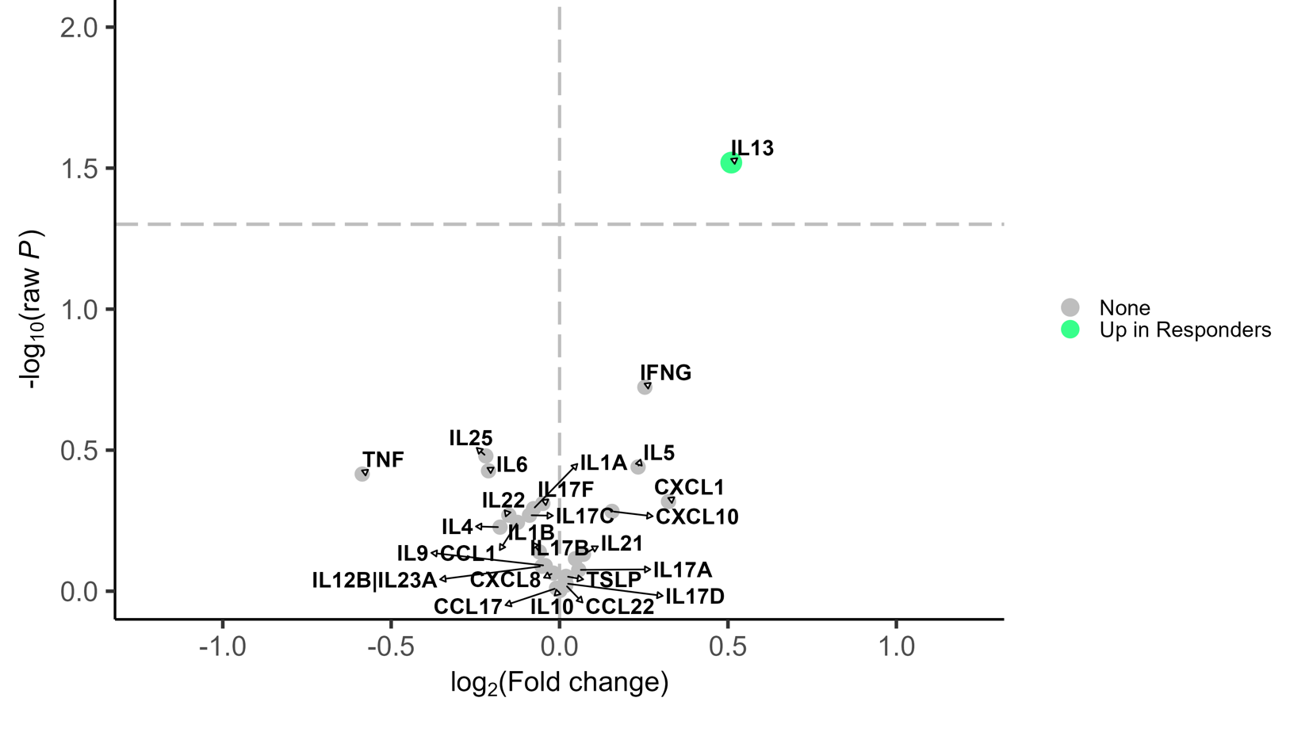
Figure S1. Differential expression analysis for 26 cytokines and response status in the mepolizumab group adjusted for pre-treatment annualized exacerbation rate and time between sample collection and initiation of mepolizumab. Cytokines with raw P-value < 0.05 were considered statistically significant. Effect sizes were presented as log2 of fold change where positive (negative) values indicated up-regulation in responders (non-responders). The vertical dashed line represents no difference. The horizontal dashed line represents P-value < 0.05. Green dot indicates levels of the cytokine are higher in responders; Gray dot ‘None’ indicates levels of that cytokine are not different between responders and nonresponders.

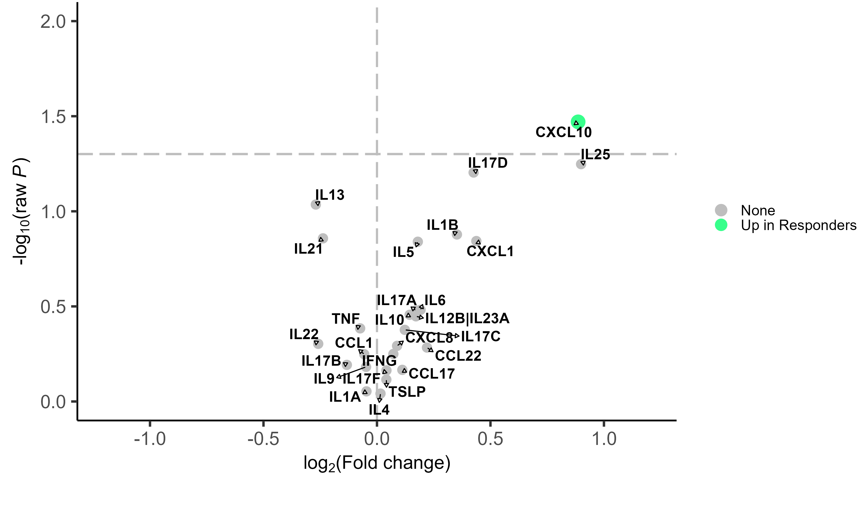Figure S2. Differential expression analysis for 26 cytokines and response status in the omalizumab group adjusted for pre-treatment annualized exacerbation rate and time between sample collection and initiation of omalizumab. Cytokines with raw P-value < 0.05 were considered statistically significant. Effect sizes were presented as log2 of fold change where positive (negative) values indicated up-regulation in responders (non-responders). The vertical dashed line represents no difference. The horizontal dashed line represents P-value < 0.05. Green dot indicates levels of the cytokine are higher in responders; Gray dot ‘None’ indicates levels of that cytokine are not different between responders and nonresponders.

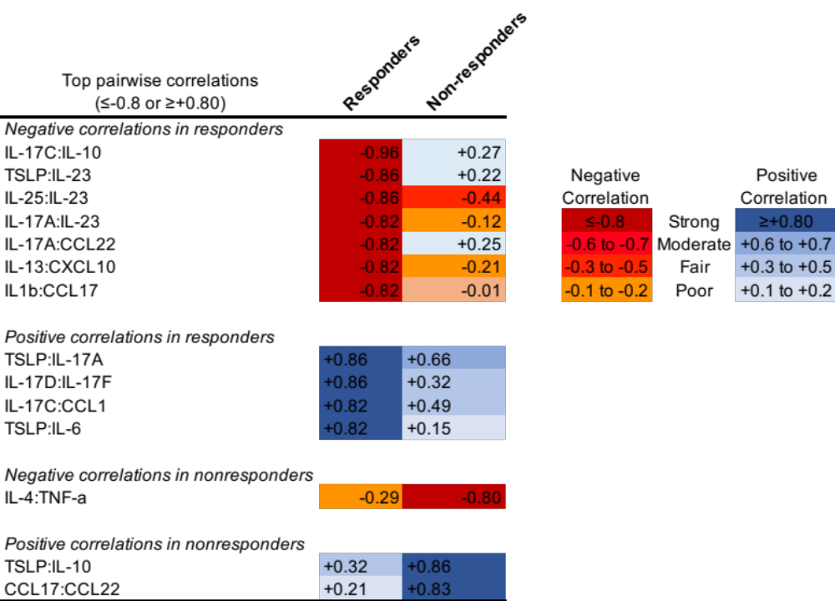

Figure S3. Top correlation coefficients of pairwise correlations between baseline levels of cytokines or chemokines in mepolizumab responders and non-responders. The Spearman’s rho was calculated to evaluate the correlation between each pair of cytokines. Blue cells represent positive correlations and red cells negative correlations.

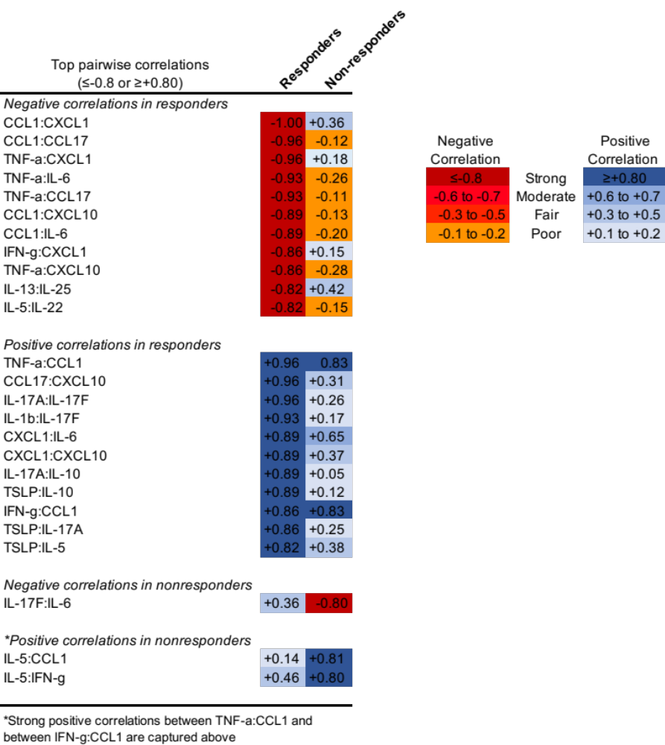
Figure S4. Top correlation coefficients of pairwise correlations between baseline levels of cytokines or chemokines in omalizumab responders and non-responders. The Spearman’s rho was calculated to evaluate the correlation between each pair of cytokines. Blue cells represent positive correlations and red cells negative correlations.

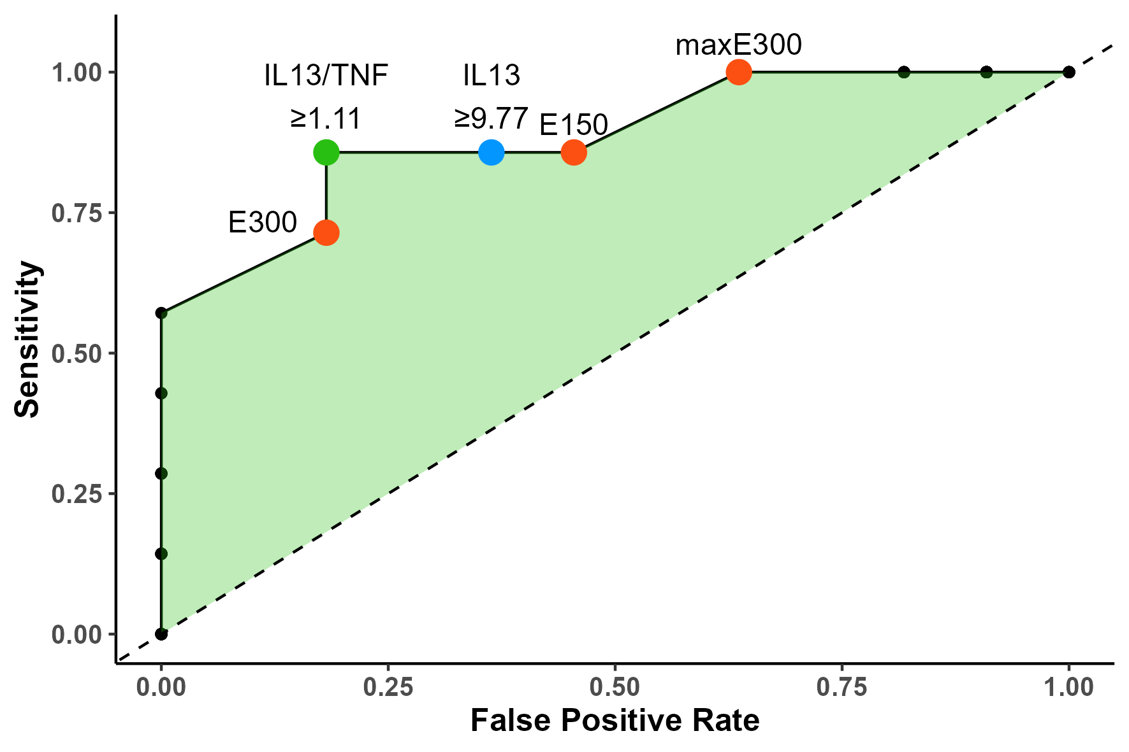
Figure S5: The receiver operating characteristic (ROC) curve showing the predictive accuracy (sensitivity and false positive rate (FPR)) of the optimal cut-off points for IL-13 and IL-13/TNF-alpha in differentiating responders from nonresponders to mepolizumab benchmarked against the predictive performance of the baseline eosinophil count of ≥150 (E150) or ≥300 (E300) and the maximum eosinophil counts within one year before mepolizumab initiation of ≥300 (maxE300) cells/μL.

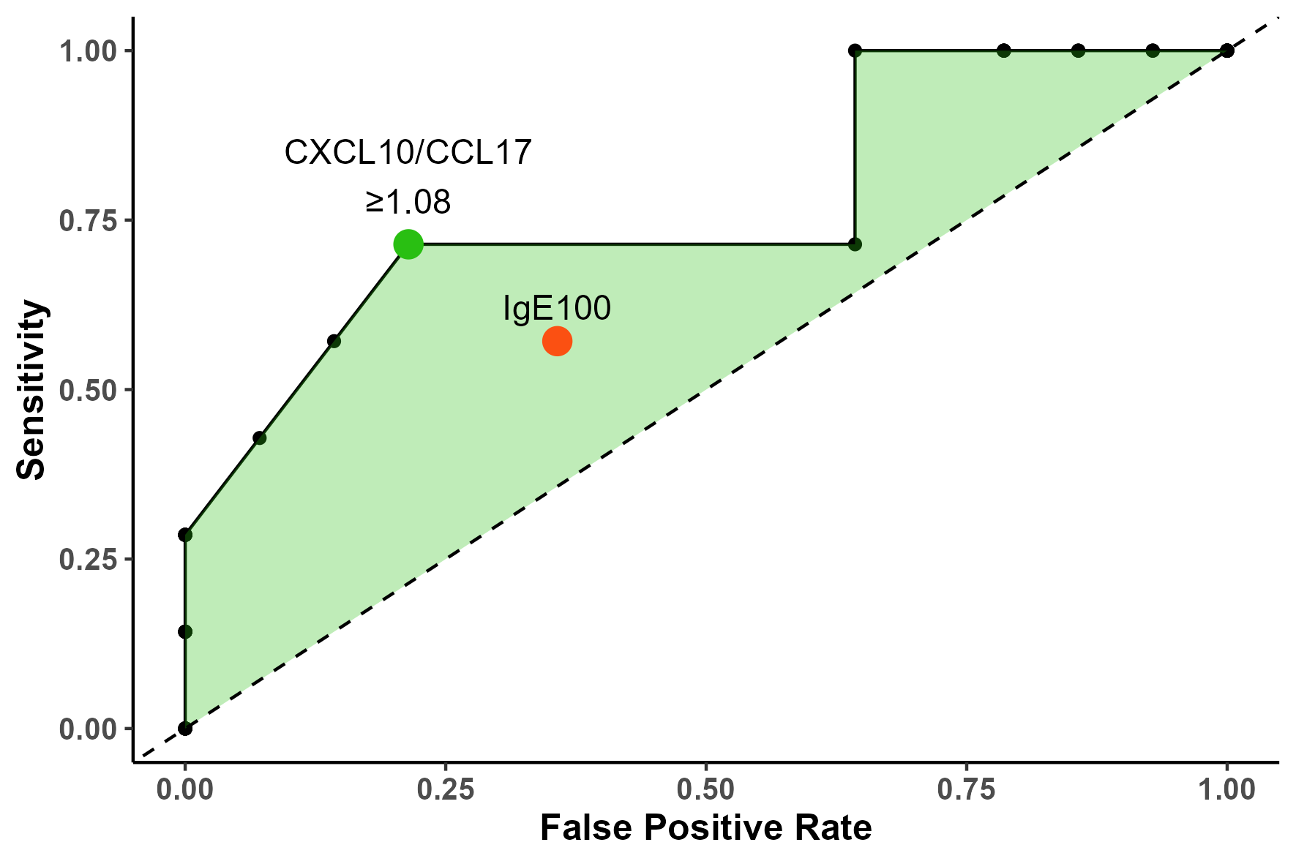

Figure S6: The receiver operating characteristic (ROC) curve showing the predictive accuracy (sensitivity and false positive rate (FPR)) of the optimal cut-off points for CXCL10/CCL17 in differentiating responders from nonresponders to omalizumab benchmarked against the predictive performance of baseline immunoglobulin E level of ≥100 ku/L (IgE100) cells/μL.

