Supplementary Figure 1 MR leave‐one‐out and funnel plots sensitivity analysis for accelerated biological aging on periodontitis
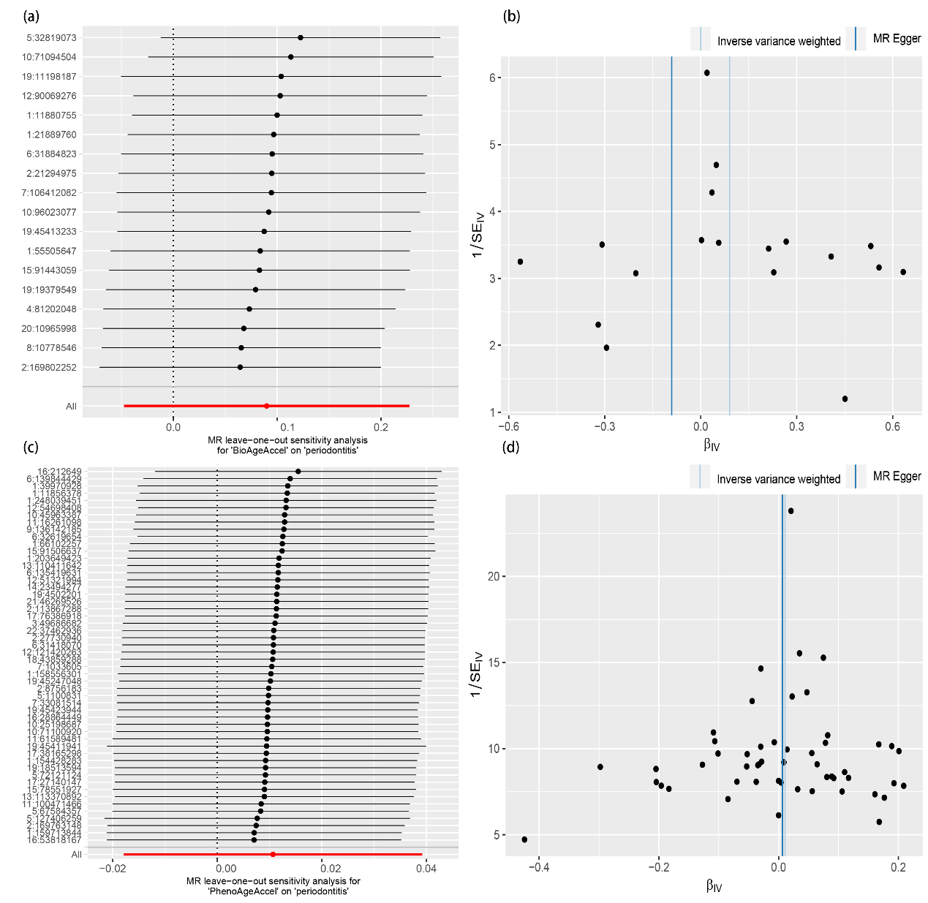

Supplementary Figure 1. MR leave‐one‐out and funnel plots sensitivity analysis for accelerated biological aging on periodontitis. (a), (b) Leave‐one‐out and funnel plots sensitivity analysis for BioAgeAccel on periodontitis. (c), (d) Leave‐one‐out and funnel plots sensitivity analysis for PhenoAgeAccel on periodontitis.

