Supplementary Material
Uncertainty Quantification in Multivariable Regression for Material Property Prediction with Bayesian Neural Networks
Longze Li, Jiang Chang, Aleksandar Vakanski, Yachun Wang, Tiankai Yao, Min Xian

Figures S.1 to S.3 present the histograms of the input features for the three datasets.

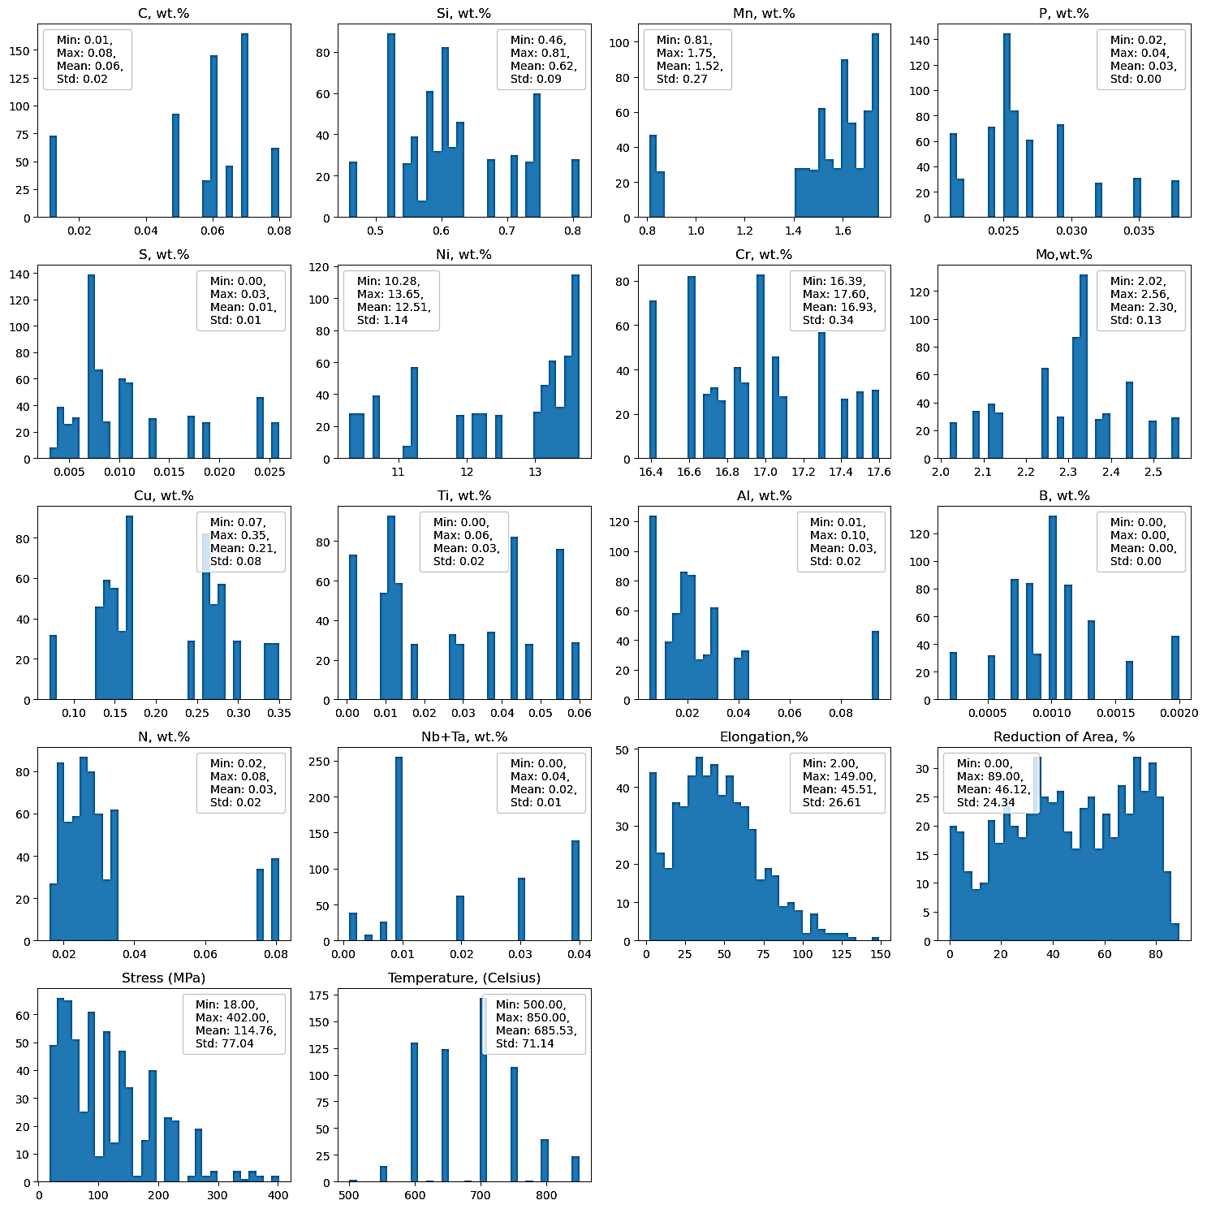 Figure S.1. Histograms of the input features for the stainless steel SS316 alloys dataset. “Min”, “Max”, “Mean”, and “Std” represent the minimum, maximum, mean, and standard deviation values, respectively.
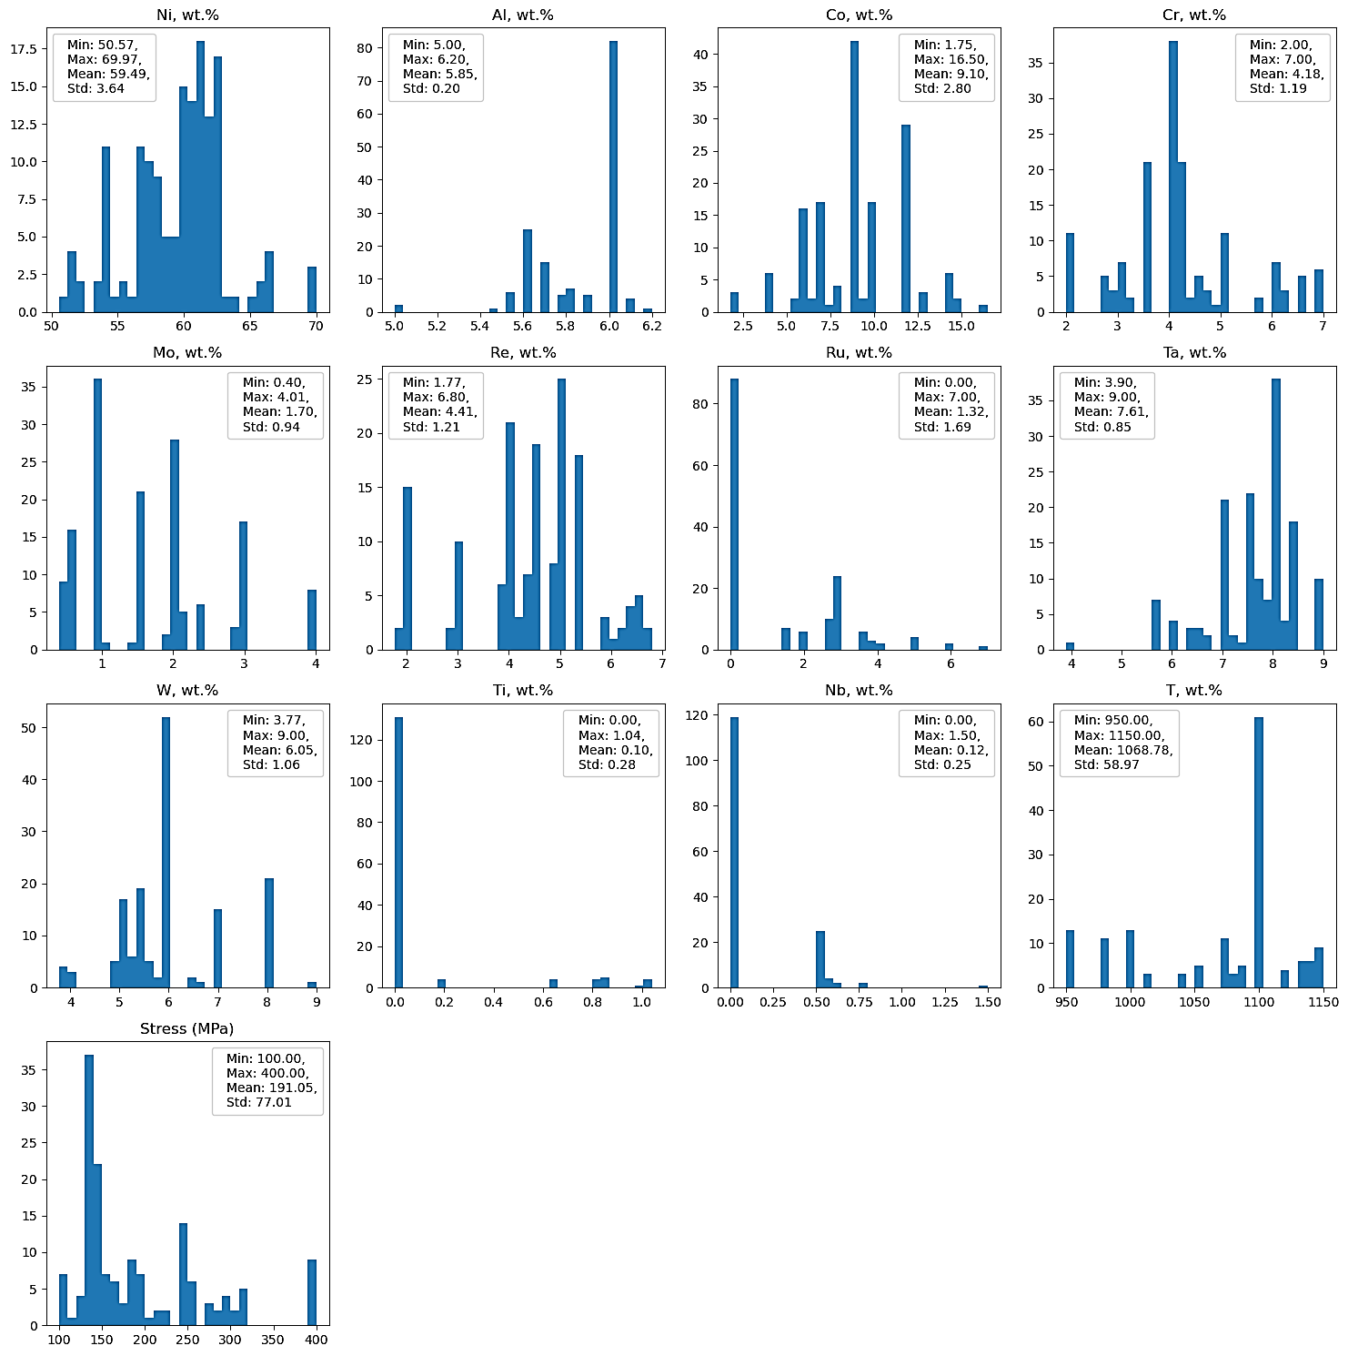
Figure S.2. Histograms of the input features for the Nickel-based superalloys dataset. “Min”, “Max”, “Mean”, and “Std” represent the minimum, maximum, mean, and standard deviation values, respectively.
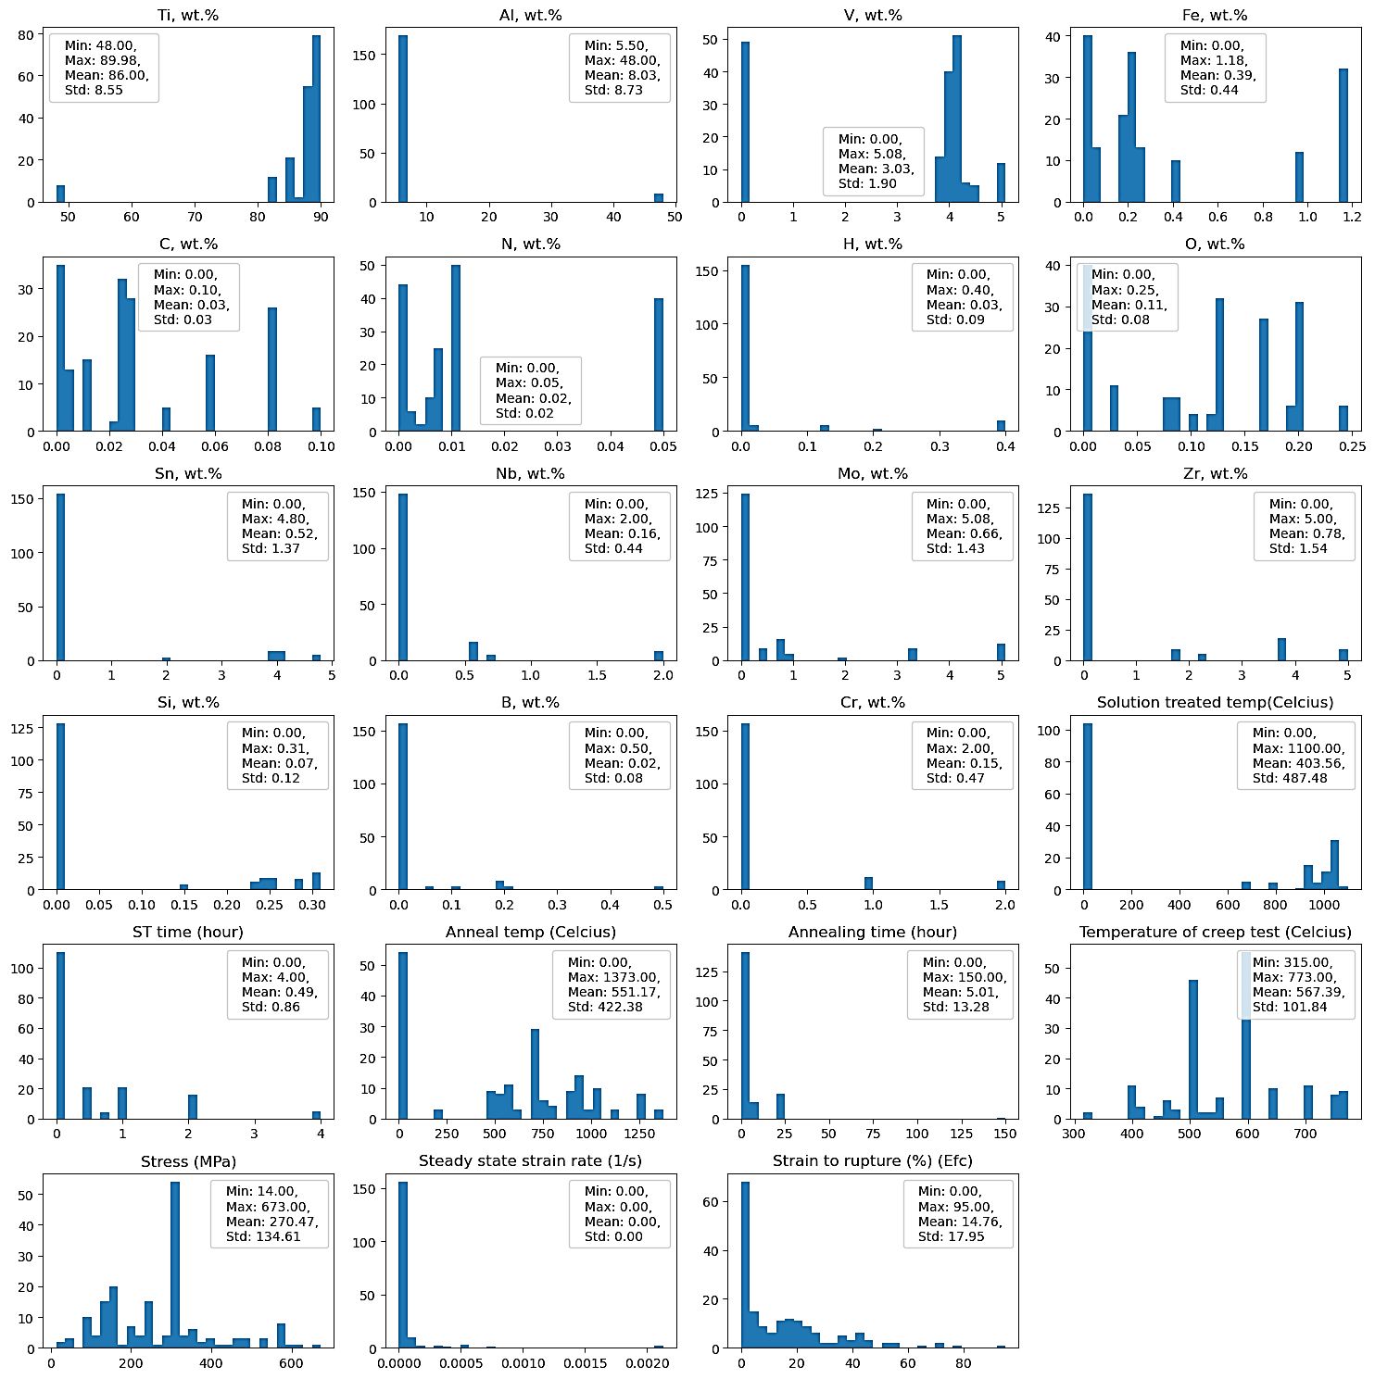
Figure S.3. Histograms of the input features for the Titanium-based alloys dataset. “Min”, “Max”, “Mean”, and “Std” represent the minimum, maximum, mean, and standard deviation values, respectively.

