Enhancing Curcumin's Therapeutic Potential in Cancer Treatment through Ultrasound-Mediated Liposomal Delivery

Remya Radha¹, Vinod Paul^{1,2}, Shabana Anjum¹, Ayache Bouakaz³, William G. Pitt⁴, Ghaleb A. Husseini^{1,2,*}

¹Department of Chemical and Biological Engineering, American University of Sharjah, Sharjah, UAE
²Material Science and Engineering PhD program, College of Arts and Sciences, American University of Sharjah, Sharjah, UAE
³UMR 1253, iBrain, Université de Tours, Inserm, Tours, France
⁴Department of Chemical Engineering, Brigham Young University, Provo, UT, 84604, USA
*corresponding author: ghusseini@aus.edu

SUPPLEMENTARY DATA

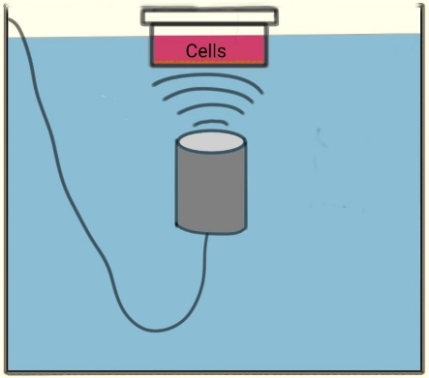

Figure S1. Ultrasound treatment setup for cells within a custom-built water tank. The cells to be treated were initially seeded on mylar sheets and after 24 hours of incubation in the incubator, the mylar sheets were taken for US treatment.

Figure. S2 Effect of ultrasound/MBs conditions for 100% culture viability. The MTT assay data with wells treated at different ultrasound intensities of 0.07, 0.12, and 0.16 W/cm² for 15 s in the presence of varying volume ratios of MBs of 1.5×10⁷ (red bar) and 0.6×10⁷ (green bar) MBs/mL of media. The error bars indicate the standard deviation values from triplicate readings for the three different sets of experiments.

Figure. S3 Effect of treatment time on cytotoxicity assay. Bar plots indicate the cytotoxicity effect of CLs on HCC 1954 cells when incubated for A) 24 hours and B) 48 hours during MTT assay. The error bars indicate the mean ± standard deviation data of the three different sets of experiments (n=9).

