Supporting information

Amperometry approach curve profiling to understand the regulatory mechanisms governing the concentration of intestinal extracellular serotonin
Mark S. Yeoman^{1,2} (ORCID ID: 0000-0003-2113-8650), Sara Fidalgo^{1,2}, Gianluca Marcelli³ (ORCID ID: 0000-0002-7475-7327) and Bhavik Anil Patel^{1,2}* (ORCID ID: 0000-0002-8773-3850)
¹School of Applied Sciences and ²Centre for Lifelong Health, University of Brighton, Huxley Building, Brighton, BN2 4GJ
³School of Engineering, University of Kent, Jennison Building, Canterbury, CT2 7NZ

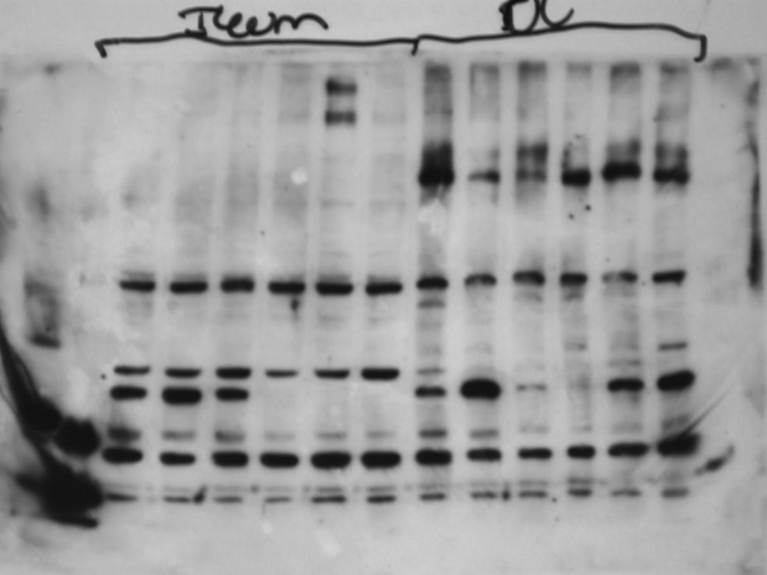
Figure S1. Full length Western blot to investigate the expression of SERT in ileum and colon tissue

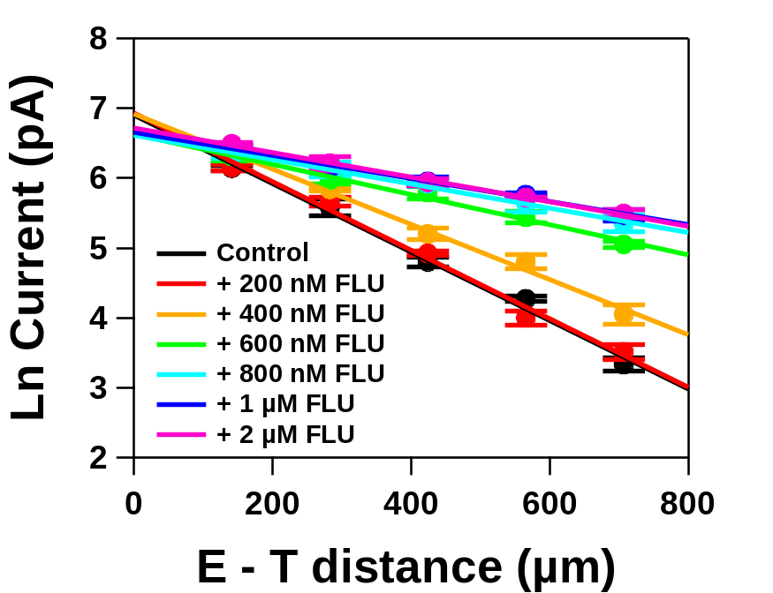

Figure S2. Plot showing natural log of current versus the E-T distance from colon tissue in the presence of varying concentrations of fluoxetine (ranging from 200 nM to 2 µM).

