Supporting Information

Design, Synthesis, Molecular Docking Study, and α-glucosidase Inhibitory Evaluation of Novel Hydrazide-Hydrazone Derivatives of 3,4-Dihydroxyphenylacetic Acid
Hammad Khanª, Faheem Jan^{b,c}, Abdul Shakoor^{d}, Ajmal Khan^{e}, Abdullah F. AlAsmari^{f}, Fawaz Alasmari^{f}, Saeed Ullah^{e}, Ahmed Al-Harrasi^{e}*, Momin Khan^{d}*, Shaukat Aliª*
ªOrganic Synthesis and Catalysis Research Laboratory, Institute of Chemical Sciences, University of Peshawar, Peshawar 25120, Khyber Pakhtunkhwa, Pakistan.
^{b}Shenyang national laboratory for Materials Science, Institute of Metal Research Chineses Academy of Sciences, Shenyang, 110016, Liaoning, China
^{c}School of Materials Science and Engineering, University of Science and Technology of China, Shenyang 110016, Liaoning, China
^{d}Department of Chemistry, Abdul Wali Khan University, Mardan-23200, Pakistan
^{e}Natural and Medical Sciences Research Center, University of Nizwa, PO Box 33, 616 Birkat Al Mauz, Nizwa, Oman
^{f}Department of Pharmacology and Toxicology, College of Pharmacy, King Saud University, Riyadh 11451, Saudi Arabia
Corresponding Author: drshaukatali@uop.edu.pk; mominkhan@awkum.edu.pk; aharrasi@unizwa.edu.om;

Characterization data of compounds (1-28)
- (3,4-dihydroxyphenyl)-N'-(2-hydroxybenzylidene)acetohydrazide (1)
Yield: 0.25 g (82%); (white crystalline). M.P.: 164ºC; ¹H-NMR (600 MHz, DMSO-d_{6,} δ, ppm): 11.63(s, 1H, -NH), 10.75 (s, 1H, H-OH), 9.15 (s, 2H, (-OH)₂), 8.46 (s, 1H, =CH), 7.48-7.47 (d, 1H, J _{6’,5’} = 7.2 Hz, H-6’), 7.21-7.19 (t, 1H, J _{4’(5’,6’)} = 7.2, H-4’), 6.91-6.89 (t, 1H, J _{5’(4’,6’)} = 7.2 Hz, H-5’), 6.70-6.68 (d, 1H, J_{3’,4’} = 7.2 Hz, H-3’), 6.53 (s, 1H, H-2), 6.32-6.31 (d, 1H, J _{5,6} = 7.2 Hz, H-5), 6.20-6.18 (d, 1H, J_{6,5} = 7.2 H-6), 3.97 (s, 2H,-CH₂, H-Ph); ¹³C NMR (150 MHz, DMSO‑d₆): δ 171.0, 157.2, 138.3, 138.3, 137.4, 132.8, 132.3, 127.2, 123.4, 121.6, 119.2, 117.7, 116.5, 115.4, 40.6; LC-HRMS (ESI⁺): [M+H]⁺ calcld for C₁₅H₁₄N₂O₄: 286.287; found 287.287.
2-(3,4-dihydroxyphenyl)-N'-(4-hydroxybenzylidene)acetohydrazide (2)
Yield: 0.23 g (71%); (Pale yellow powder); M.P.: 210ºC; ¹H-NMR (600 MHz, DMSO-d_{6,} δ, ppm): 11.13 (s, 1H, -NH), 9.76 (s, 1H, -OH, H-4’), 9.53 (s, 2H, (-OH)_{2,} H-3/4), 8.46 (s, 1H, =CH), 7.76-7.75 (d, 2H, J _{2’,3’/6’,5’} = 7.2 Hz, H-2’/6’). 6.97-6.96 (t, 3H, J = 7.2 H-2/3’/5’), 6.73-6.72 (d, 1H, J _{5,6} = 7.2 Hz, H-5), 6.61-6.60 (d, 1H, J _{6,5} = 6.6 Hz, H-6), 3.92 (s, 2H,-CH₂, H-Ph); ¹³C NMR (150 MHz, DMSO‑d₆): δ 171.0, 160.2, 146.2, 146.2, 144.7, 132.3, 130.2. 130.2, 126.8, 123.3, 116.8, 116.2, 116.2, 115.6, 40.6; LC-HRMS (ESI⁺): [M+H]⁺ calcld for C₁₅H₁₄N₂O₄: 286.287; found 287.099.
N'-(3,4-dihydroxybenzylidene)-2-(3,4-dihydroxyphenyl)acetohydrazide (3)
Yield: 0.19 g (67%); (Off white powder); M.P.: 212ºC; ¹H-NMR (600 MHz, DMSO-d_{6,} δ, ppm): 11.18 (s, 1H, -NH), 9.54 (s, 4H, (-OH)₄, H-3/3’/4/4’), 8.45 (s, 1H, =CH), 7.34-7.33 (d, 2H, J _{2’,4’/6’,5’} = 7.2 Hz, H-2’/6’), 6.87 (s, 1H, H-2), 6.78-6.77 (d, 1H, J _{5’,6’} = 7.2 Hz, H-5’), 6.64-6.63 (d, 1H, J _{5,6} = 7.2 Hz, H-5), 6.52-6.51 (d, 1H, J _{6,5} = 7.2, H-6), 3.86 (s, 2H, -CH₂, H-Ph), 2.12 (s, 3H, -CH3, H-4’); ¹³C NMR (150 MHz, DMSO‑d₆): δ 171.4, 156.4, 148.3, 147.5, 147.5, 145.7, 132.6, 132.4, 128.3, 124.2, 122.5, 117.4, 116.2, 115.6, 40.6; LC-HRMS (ESI⁺): [M+H]⁺ calcld for C₁₅H₁₄N₂O₅: 302.286; found 303.094 .
N'-(2,4-dihydroxybenzylidene)-2-(3,4-dihydroxyphenyl)acetohydrazide (4)
Yield: 0.25 g (82%); (Yellow crystalline). M.P.: 198ºC; ¹H-NMR (600 MHz, DMSO-d_{6,} δ, ppm): 11.44 (s, 1H, -NH), 11.14 (s, 1H,-OH, H-2’), 10.11 (s, 1H,-OH, H-4’), 9.53 (s, 2H, (-OH)_{2,} H-3/4), 8.75 (s, 1H, =CH), 7.65-7.54 (m, 2H, H-3’/6’), 6.84 (s, 1H, H-2), 6.68-6.67 (d, 1H, J _{5,6} = 7.2, H-5), 6.54-6.53 (d, 1H, J _{6,5} = 7.2, H-6), 6.33-6.32 (d, 1H, J _{5’,6’} = 7.2 Hz, H-5’), 3.86 (s, 2H,-CH₂, H-Ph); ¹³C NMR (150 MHz, DMSO‑d₆): δ 171.4, 163.2, 162.1, 148.8, 148.8, 148.2, 133.7, 132.5, 123.6, 116.8, 115.4, 111.5, 108.3, 103.8, 40.6; LC-HRMS (ESI⁺): [M+H]⁺ calcld for C₁₅H₁₄N₂O₄: 302.286; found 303.094.
2-(3,4-dihydroxyphenyl)-N'-(2,3,4-trihydroxybenzylidene)acetohydrazide (5)
Yield: 0.24 g (78%); (Off white powder). M.P.: 212ºC; ¹H-NMR (600 MHz, DMSO-d_{6,} δ, ppm): 11.38 (s, 1H, -NH), 11.16 (s, 1H,-OH, H-2’), 10.11 (s, 1H,-OH, H-3’), 9.57 (s, 3H, (-OH)_{3,} H-3/4/4’), 8.74 (s, 1H, =CH), 7.65-7.63 (d, 1H, J _{6’,5’} = 7.2, H-6’), 6.84 (s, 1H, H-2), 6.68-6.67 (d, 1H, J _{5,6} = 7.2, H-5), 6.54-6.53 (d, 1H, J _{6,5} = 7.2, H-6), 6.33-6.32 (d, 1H, J _{5’,6’} = 7.2 Hz, H-5’), 3.86 (s, 2H,-CH₂, H-Ph); ¹³C NMR (150 MHz, DMSO‑d₆): δ 171.4, 162.9, 161.1, 148.7, 148.7, 148.2, 133.5, 132.8, 123.3, 116.4, 115.6, 111.7, 108.3, 103.6, 40.6; LC-HRMS (ESI⁺): [M+H]⁺ calcld for C₁₅H₁₄N₂O₆: 318.285; found 319.089.
2-(3,4-dihydroxyphenyl)-N'-(4-hydroxy-3-methoxybenzylidene)acetohydrazide (6)
Yield: 0.24 g (79%); (Yellow powder). M.P.: 189ºC; ¹H-NMR (600 MHz, DMSO-d_{6,} δ, ppm): 11.21 (s, 1H, -NH), 9.73 (s, 1H, H-OH), 9.67 (s, 2H, (-OH)₂), 8.58 (s, 1H, =CH), 7.45-7.34 (m, 2H, H-2’/6’), 6.91-6.89 (d, 1H, J _{5’,6’} = 6.6 Hz, H-5’), 6.74 (s, 1H, H-2), 6.61-6.59 (d, 1H, J _{5,6} = 6.6 Hz, H-5), 6.41-6.39 (d, 1H, J _{6,5} = 6.6 Hz, H-6), 3.85 (s, 3H,-OCH_{3,} H-3’), 3.79 (s, 2H,-CH₂, H-Ph); ¹³C NMR (150 MHz, DMSO‑d₆): δ 171.0, 151.8, 149.4, 147.2, 146.8, 146.8, 132.4, 131.3, 123.3, 122.7, 117.2, 116.2, 115.3, 112.1, 58.2, 40.6; LC-HRMS (ESI⁺): [M+H]⁺ calcld for C₁₆H₁₆N₂O₅: 316.313; found 317.109.
2-(3,4-dihydroxyphenyl)-N'-(2-hydroxy-3-methoxybenzylidene)acetohydrazide (7)
Yield: 0.28 g (89%); (Pale yellow powder). M.P.: 204ºC; ¹H-NMR (600 MHz, DMSO-d_{6,} δ, ppm): 11.24 (s, 1H, -NH), 9.28 (s, 1H, H-OH), 8.10 (s, 2H, (-OH)₂), 7.64 (s, 1H, =CH), 6.61-6.59 (d, 1H, J _{6’,5’} = 7.2 Hz, H-6’), 6.38-6.37 (d, 1H, J _{4’,5’} = 7.2 Hz, H-4’), 6.21-6.14 (m, 2H, H-2/5’), 5.95-5.94 (d, 1H, J _{5,6} = 7.2 Hz, H-5), 5.87-5.86 (d, 1H, J _{6,5} = 7.2 Hz, H-6), 3.97 (s, 2H, -CH₂, H-Ph), 3.87 (s, 3H, -OCH3, H-3’); 6¹³C NMR (150 MHz, DMSO‑d₆): δ 171.4, 161.4, 159.3, 146.8, 146.8, 146.2, 143.3, 124.4, 123.3, 119.6, 116.8, 116.3, 115.2, 115.2, 67.2, 40.6; LC-HRMS (ESI⁺): [M+H]⁺ calcld for C₁₆H₁₆N₂O₅: 316.313; found 317.109 .
2-(3,4-dihydroxyphenyl)-N'-(2-hydroxy-4-methoxybenzylidene)acetohydrazide (8)
Yield: 0.23 g (84%); (Off white powder); M.P.: 206ºC; ¹H-NMR (600 MHz, DMSO-d_{6,} δ, ppm): 11.82 (s, 1H, -NH), 11.13 (s, 1H, H-OH), 9.53 (s, 2H, (-OH)₂), 8.84 (s, 1H, =CH), 6.84-6.83 (d, 1H, J _{6’,5’} = 7.2 Hz, H-6’), 6.81 (s, 1H, H-2), 6.69-6.68 (d, 1H, J _{5,6} = 7.2 Hz, H-5), 6.57-6.56 (m, 2H, H-5’/6), 6.49 (s, 1H, H-3’), 3.87(s, 2H, -CH₂, H-Ph), 3.75 (s, 3H, -OCH3, H-4’); ¹³C NMR (150 MHz, DMSO‑d₆): δ 171.4, 161.4, 159.3, 146.2, 146.2, 145.8, 133.2, 132.8, 123.3, 116.4, 115.2, 110.4, 107.3, 104.5, 55.2, 40.6; LC-HRMS (ESI⁺): [M+H]⁺ calcld for C₁₆H₁₆N₂O₅: 316.313; found 317.109.
2-(3,4-dihydroxyphenyl)-N'-(3-ethoxy-4-hydroxybenzylidene)acetohydrazide (9)
Yield: 0.26 g (86%); (Pale yellow powder). M.P.: 184ºC; ¹H-NMR (600 MHz, DMSO-d_{6,} δ, ppm): 11.21 (s, 1H, -NH), 9.89 (s, 1H, H-OH), 8.41 (s, 2H, (-OH)₂), 8.34 (s, 1H, =CH), 7.25-7.14 (m, 2H, H-2’/6’), 6.71-6.69 (d, 1H, J _{5’,6’} = 6.6 Hz, H-5’), 6.54 (s, 1H, H-2), 6.41-6.39 (d, 1H, J _{5,6} = 6.6 Hz, H-5), 6.21-6.19 (d, 1H, J _{6,5} = 6.6 Hz, H-6), 3.97-3.76 (m, 2H, -OCH₂-, H-3’), 3.56 (s, 2H, -CH₂, H-Ph), 1.63-1.62 (t, 3H, -CH₃, J = 4.2 Hz, H-3’); 6¹³C NMR (150 MHz, DMSO‑d₆): δ 171.4, 163.8, 162.4, 146.6, 146.6, 145.4, 134.6, 133.5, 122.8, 118.9, 116.7, 110.3, 107.8, 103.9, 65.2, 40.6, 14.7; LC-HRMS (ESI⁺): [M+H]⁺ calcld for C₁₇H₁₈N₂O₅: 330.340; found 331.125.
2-(3,4-dihydroxyphenyl)-N'-(4-ethoxy-2-hydroxybenzylidene)acetohydrazide (10)
Yield: 0.25 g (82%); (white crystalline); M.P.: 164ºC; ¹H-NMR (600 MHz, DMSO-d_{6,} δ, ppm): 11.51 (s, 1H, -NH), 10.89 (s, 1H, H-OH), 8.84 (s, 2H, (-OH)₂), 8.24 (s, 1H, =CH), 7.98-7.97 (d, 1H, J _{6’,5’} = 7.2 Hz, H-6’), 7.01 (s, 1H, H-2), 6.84-6.83 (d, 1H, J _{5,6} = 7.2 Hz, H-5), 6.74-6.73 (d, 1H, J _{6,5} = 7.2 Hz, H-6), 6.61 (s, 1H, H-3’), 6.58-6.57 (d, 1H, J _{5’,6’} = 7.2 Hz, H-5’), 4.37-4.26 (m, 2H, -OCH₂-, H-4’), 3.97 (s, 2H,-CH₂, H-Ph), 1.43-1.42 (t, 3H, -CH_{3,} J = 4.2 Hz, H-4’); ¹³C NMR (150 MHz, DMSO‑d₆): δ 171.1, 163.6, 162.8, 146.5, 146.5, 145.9, 134.3, 133.5, 123.5, 118.9, 117.3, 110.1, 108.4, 104.2, 64.2, 40.6, 14.8; LC-HRMS (ESI⁺): [M+H]⁺ calcld for C₁₇H₁₈N₂O₅: 330.340; found 331.125.
2-(3,4-dihydroxyphenyl)-N'-(3-hydroxy-4-methylbenzylidene)acetohydrazide (11)
Yield: 0.26 g (87%); (Off white powder); M.P.: 210ºC; ¹H-NMR (600 MHz, DMSO-d_{6,} δ, ppm): 11.34 (s, 1H, -NH), 9.87 (s, 1H, -OH, H-3’), 9.74 (s, 2H, (-OH)₂), 8.65 (s, 1H, =CH), 7.54-7.53 (d, 1H, J _{6’,5’} = 7.6 Hz, H-6’), 7.31 (s, 1H, H-2’) 7.24-7.23 (d, 1H, J _{5’,6’} = 7.2 Hz, H-5’), 6.84 (s, 1H, H-2), 6.68-6.67 (d, 1H, J _{5,6} = 7.2 Hz, H-5), 6.54-6.53 (d, 1H, J _{6,5} = 7.2, H-6), 3.86 (s, 2H, -CH₂, H-Ph), 2.12 (s, 3H, -CH3, H-4’); ¹³C NMR (150 MHz, DMSO‑d₆): δ 171.4, 156.2, 148.4, 147.3, 147.3, 136.7, 132.8, 132.2, 128.2, 124.4, 122.6, 117.2, 116.6, 115.8, 40.6, 15.4; LC-HRMS (ESI⁺): [M+H]⁺ calcld for C₁₆H₁₆N₂O₄: 300.314; found 301.114.
2-(3,4-dihydroxyphenyl)-N'-(2-methoxybenzylidene)acetohydrazide (12)
Yield: 0.26 g (85%); (Off white powder). M.P.: 190-193ºC; H-NMR (600 MHz, DMSO-d_{6,} δ, ppm): 11.21 (s, 1H, -NH), 9.74 (s, 2H, H,(-OH)₂), 8.84 (s, 1H, =CH), 7.98-7.97 (d, 1H, J _{6’,5’} = 7.2 Hz, H-6’), 7.78-7.64 (m, 1H, H-4’), 7.45-7.35 (m, 1H, H-5’), 7.28-7.27 (d, 1H, J _{3’,4’} = 7.2, H-3’), 6.93 (s, 1H, H-2) 6.76-6.75 (d, 1H, J _{5,6} = 7.2, H-5), 6.68-6.67 (d, 1H, J _{6,5} = 7.2, H-6), 3.96 (s, 3H, -OCH₃, H-2’), 3.87 (s, 2H,-CH₂, H-Ph); ¹³C NMR (150 MHz, DMSO‑d₆): δ 171.6, 158.4, 146.5, 146.5, 146.1, 132.7, 131.2, 122.8, 121.3, 116.8, 116.3, 115.0, 111.2, 55.7, 40.6; LC-HRMS (ESI⁺):[M+H]⁺ calcld for C₁₆H₁₆N₂O₄: 300.314; found 301.114.
2-(3,4-dihydroxyphenyl)-N'-(4-methoxybenzylidene)acetohydrazide (13)
Yield: 0.27 g (88%); (Pale yellow powder); M.P.: 198ºC; H-NMR (600 MHz, DMSO-d_{6,} δ, ppm): 11.24 (s, 1H, -NH), 9.53 (s, 2H, H,(-OH)₂), 8.58 (s, 1H, =CH), 7.95-7.94 (d, 2H, J _{2’,4’/6’,5’} = 7.2 Hz, H-2’/6’), 7.24-7.23 (d, 2H, J _{3’,2’/5’,6’} = 7.2 Hz, H-3’/5’), 6.87 (s, 1H, H-2), 6.74-6.73 (d, 1H, J _{5,6} = 7.2, H-5), 6.64-6.63 (d, 1H, J _{6,5} = 7.2, H-6), 3.95 (s, 2H,-CH₂, H-Ph), 3.86 (s, 3H, -CH₃, H-4’); ¹³C NMR (150 MHz, DMSO‑d₆): δ 171.4, 163.2, 148.4, 148.4, 146.3, 131.6, 130.1, 130.1, 126.7, 124.4, 118.5, 116.9, 116.2, 116.2, 58.6, 40.6; LC-HRMS (ESI⁺): [M+H]⁺ calcld for C₁₆H₁₆N₂O₄: 300.314; found 301.114.
2-(3,4-dihydroxyphenyl)-N'-(3,4-dimethoxybenzylidene)acetohydrazide (14)
Yield: 0.28 g (89%); (Yellow powder); M.P.: 210ºC; ¹H-NMR (600 MHz, DMSO-d_{6,} δ, ppm): 11.18 (s, 1H, -NH), 9.35 (s, 2H, (-OH)₂), 8.24 (s, 1H, =CH), 7.34-7.21 (m, 2H, H-2’/6’) 6.71-6.69 (d, 1H, J _{5’,6’} = 6.6 Hz, H-5’), 6.41 (s, 1H, H-2), 6.31-6.29 (d, 1H, J _{5,6} = 6.6 Hz, H-5), 6.21-6.19 (d, 1H, J _{6,5} = 6.6 Hz, H-6), 3.85 (s, 6H, (-OCH₃)_{2,} H-3’/4’), 3.79 (s, 2H, -CH₂, H-Ph); ¹³C NMR (150 MHz, DMSO‑d₆): δ 171.0, 151.9, 149.7, 147.2, 146.8, 146.8, 131.4, 130.3, 123.4, 122.3, 117.2, 116.2, 111.3, 109.1, 56.2, 56.2, 40.6; LC-HRMS (ESI⁺): [M+H]⁺ calcld for C₁₇H₁₈N₂O₅: 330.340; found 331.125.
- (3,4-dihydroxyphenyl)-N'-(4-(dimethylamino)benzylidene)acetohydrazide (15)
Yield: 0.28 g (85%); (Orange powder). M.P.: 203ºC; ¹H-NMR (600 MHz, DMSO-d_{6,} δ, ppm): 11.11 (s, 1H, -NH), 9.48 (s, 2H, (-OH)₂), 8.48 (s, 1H, =CH), 7.51-7.49 (d, 2H, J _{2’.3’/6’, 5’} = 6.6 H-2’/6’), 6.91 (s, 1H, H-2), 6.81-6.79 (d, 1H, J _{3’,2’/5’, 6’} = 6.6 Hz, H-3’/5’), 6.61-6.55 (d, 1H, J _{5,6} = 6.6 Hz, H-5), 6.41-6.39 (d, 1H, J _{6,5} = 6.6 Hz, H-6), 3.85 (s, 2H,-CH₂, H-Ph), 3.01 (s, 6H,(-CH₃)₂ H-4’); 6¹³C NMR (150 MHz, DMSO‑d₆): δ 171.2, 153.3, 146.4, 146.4, 144.2, 132.5, 128.3, 128.3, 123.3, 117.2, 116.2, 115.3, 112.1, 112.1, 41.5, 41.5, 40.6; LC-HRMS (ESI⁺): [M+H]⁺ calcld for C₁₇H₁₉N₃O₃: 313.357; found 314.146.
2-(3,4-dihydroxyphenyl)-N'-(4-methylbenzylidene)acetohydrazide (16)
Yield: 0.27 g (82%); (Off white powder); M.P.: 201ºC; ¹H-NMR (600 MHz, DMSO-d_{6,} δ, ppm): 11.18 (s, 1H, -NH), 9.65 (s, 2H, (-OH)₂), 8.58 (s, 1H, =CH), 8.01-7.99 (d, 1H, J _{2’,3’/6’,5’} = 7.2 Hz, H-2’/6’). 7.34-7.33 (d, 2H, J _{3’,2’/5’,6’} = 7.2 H-3’/5’), 6.84 (s, 1H, H-2), 6.76-6.75 (d, 1H, J _{5,6} = 7.2 Hz, H-5), 6.63-6.52 (d, 1H, J _{6,5} = 6.6 Hz, H-6), (d, 1H, J _{6,6} = 6.6 Hz, H-6), 2.54 (s, 3H, -CH₃,H-4’); ¹³C NMR (150 MHz, DMSO‑d₆): δ 171.7, 148.2, 148.2, 146.5, 143.6, 132.2, 130.6. 129.4, 129.4, 127.6, 127.6, 124.3, 118.3, 116.7, 40.6, 21.3; LC-HRMS (ESI⁺): [M+H]⁺ calcld for C₁₆H₁₆N₂O₃: 284.315; found 285.119.
2-(3,4-dihydroxyphenyl)-N'-(naphthalen-1-ylmethylene)acetohydrazide (17)
Yield: 0.21 g (69%); (Yellow powder); M.P.: 210ºC; ¹H-NMR (600 MHz, DMSO-d_{6,} δ, ppm): 11.23 (s, 1H, -NH), 9.53 (s, 2H, (-OH)_{2,} H-3/4), 8.65-8.64 (d, 1H, J _{2’,3’} = 7.2 Hz, H-2’), 8.54-8.43 (m, 2H, H-( =CH)/4’), 8.12-7.94 (m, 3H, H-3’/6’/9’), 7.89-7.87 (t, 1H, J _{8’(7’,9’)}= 7.2Hz, H-8’), 7.58-7.56 (t, 1H, J _{7’(6’,8’)}= 7.2Hz, H-7’), 6.91 (s, 1H, H-2), 6.64-6.62 (d, 1H, J _{6,5} = 6.6 Hz, H-6), 6.57-6.54 (d, 1H, J_{5,6} = 7.2Hz, H-5), 3.92 (s, 2H,-CH₂, H-Ph); ¹³C NMR (150 MHz, DMSO‑d₆): δ 171.0, 146.2, 146.2, 144.7, 133.6, 132.3. 131.2, 130.1, 128.8, 128.3, 127.3, 126.8, 126.8, 125.4, 123.3, 122.6, 116.8, 115.6, 40.6; LC-HRMS (ESI⁺): [M+H]⁺ calcld for C₁₉H₁₆N₂O₃: 320.348; found 321.119.
N'-(2-chlorobenzylidene)-2-(3,4-dihydroxyphenyl)acetohydrazide (18)
Yield: 0.26 g (83%); (Pale yellow).M.P.: 164ºC; ¹H-NMR (600 MHz, DMSO-d_{6,} δ, ppm): 11.23 (s, 1H, -NH), 9.75 (s, 2H, H,(-OH)₂), 9.15 (s, 1H, =CH), 7.98-7.97 (d, 1H, J _{6’5’} = 7.2 Hz, H-6’), 7.86-7.85 (d, 2H, J _{3’4’/4’5’} = 7.2 Hz, H-3’/4’), 7.61-7.43 (m, 1H, H-5’), 6.94 (s, 1H, H-2), 6.73-6.72 (d, 1H, J _{5,6} = 7.2, H-5), 6.68-6.67 (d, 1H, J _{6,5} = 7.2, H-6), 3.97 (s, 2H,-CH₂, H-Ph). (s, 2H, H(-CH₂)); ¹³C NMR (150 MHz, DMSO‑d₆): δ 171.8, 147.8, 147.8, 139.3, 135.4, 134.1, 133.1, 132.4, 130.1, 124.8, 120.3, 118.1, 117.5, 40.6; LC-HRMS (ESI⁺): [M+H]⁺ calcld for C₁₅H₁₃ClN₂O₃: 304.730; found 305.730.
N'-(4-chlorobenzylidene)-2-(3,4-dihydroxyphenyl)acetohydrazide (19)
Yield: 0.26 g (79%); (Yellow powder); M.P.: 198ºC; ¹H-NMR (600 MHz, DMSO-d_{6,} δ, ppm): 11.18 (s, 1H, -NH), 9.72 (s, 2H, (-OH)_{2,} H-3/4), 8.49 (s, 1H, =CH), 7.96-7.95 (d, 2H, J _{2’,3’/6’,5’} = 7.2 Hz, H-2’/6’), 7.57-7.56 (d, 2H, J_{3’,2’/5’, 6’} = 7.2Hz, H-3’/5’), 6.96 (s, 1H, H-2), 6.73-6.72 (d, 1H, J _{6,5} = 6.6 Hz, H-6), 6.61-6.60 (d, 1H, J_{5,6} = 7.2Hz, H-5), 3.92 (s, 2H,-CH₂, H-Ph); ¹³C NMR (150 MHz, DMSO‑d₆): δ 171.4, 146.2, 146.2, 144.7, 139.5, 132.2. 131.2, 130.2, 130.2, 129.8, 129.8, 123.3, 116.2, 115.6, 40.6; LC-HRMS (ESI⁺): [M+H]⁺ calcld for C₁₅H₁₃ClN₂O₃: 304.730; found 305.065 .
N'-(3-chlorobenzylidene)-2-(3,4-dihydroxyphenyl)acetohydrazide (20)
Yield: 0.28 g (79%); (Yellow powder); M.P.: 196ºC; ¹H-NMR (600 MHz, DMSO-d_{6,} δ, ppm): 11.14 (s, 1H, -NH), 9.52 (s, 2H, (-OH)_{2,} H-3/4), 8.46 (s, 1H, =CH), 7.96 (s, 1H, H-2’), 7.85-7.77 (m, 1H, H-6’), 7.66-7.58 (m, 2H, H-4’/5’), 6.96 (s, 1H, H-2), 6.73-6.72 (d, 1H, J _{5,6} = 6.6 Hz, H-5), 6.61-6.60 (d, 1H, J _{6,5} = 7.2Hz, H-6), 3.92 (s, 2H,-CH₂, H-Ph); ¹³C NMR (150 MHz, DMSO‑d₆): δ 171.0, 147.4, 146.2, 146.2 144.9, 133.3, 132.2. 131.8, 130.3, 128.8, 127.4, 123.7, 116.8, 115.6, 40.6; LC-HRMS (ESI⁺): [M+H]⁺ calcld for C₁₅H₁₃ClN₂O₃: 304.730; found 305.065. N'-(2,3-dichlorobenzylidene)-2-(3,4-dihydroxyphenyl)acetohydrazide (21)
Yield: 0.28 g (79%); (Yellow powder); M.P.: 196ºC; ¹H-NMR (600 MHz, DMSO-d_{6,} δ, ppm): 11.10 (s, 1H, -NH), 9.51 (s, 2H, (-OH)_{2,} H-3/4), 9.02 (s, 1H, =CH), 7.68-7.67 (s, 1H, J _{6’,5’} = 7.2Hz, H-6’), 7.51-7.42 (m, 2H, H-4’/5’), 6.89 (s, 1H, H-2), 6.64-6.63 (d, 1H, J _{5,6} = 7.2Hz, H-5), 6.54-6.53 (d, 1H, J _{6,5} = 7.2Hz, H-6), 3.81 (s, 2H,-CH₂, H-Ph); ¹³C NMR (150 MHz, DMSO‑d₆): δ 171.4, 146.7, 146.7, 142.7, 139.4, 136.6, 133.6. 132.1, 130.0, 128.4, 125.2, 123.7, 116.4, 115.3, 40.6; LC-HRMS (ESI⁺): [M+H]⁺ calcld for C₁₅H₁₂Cl₂N₂O₃: 339.172; found 340.020.
N'-(2,6-dichlorobenzylidene)-2-(3,4-dihydroxyphenyl)acetohydrazide (22)
Yield: 0.21 g (81%); (Dark brown powder); M.P.: 262ºC; ¹H-NMR (600MHz, DMSO-d_{6,} δ, ppm): 11.12 (s, 1H, -NH), 9.48 (s, 2H, (-OH)_{2,} H-3/4), 8.35 (s, 1H, =CH), 7.42 (s, 3H, H-3’/4’/5’), 6.89 (s, 1H, H-2), 6.64-6.63 (d, 1H, J _{5,6} = 6.6 Hz, H-5), 6.54-6.53 (d, 1H, J _{6,5} = 6.6 Hz, H-6), 3.81 (s, 2H, -CH₂, H-Ph); ¹³C NMR (150 MHz, DMSO‑d₆): δ 171.4, 148.3, 148.3, 138.7, 133.6, 133.6, 132.1, 130.0, 129.4, 128.2, 128.2, 123.7, 116.4, 115.3, 40.6; LC-HRMS (ESI⁺): [M+H]⁺ calcld for C₁₅H₁₂C_{l2}N₂O₃: 340.020; found 287.099.
2-(3,4-dihydroxyphenyl)-N'-(4-nitrobenzylidene)acetohydrazide (23)
Yield: 0.22 g (77%); (Deep yellow powder); M.P.: 201ºC; ¹H-NMR (600 MHz, DMSO-d_{6,} δ, ppm): 11.24 (s, 1H, -NH), 9.53 (s, 2H, (-OH)₂), 8.58 (s, 1H, =CH), 8.45-8.44 (d, 2H, J _{3’,2’/5’,6’} = 7.2 H-3’/5’), 8.14-8.13 (d, 1H, J _{2’,3’/6’,5’} = 7.2 Hz, H-2’/6’), 6.87 (s, 1H, H-2), 6.74-6.73 (d, 1H, J _{5,6} = 6.6 Hz, H-5), 6.51-6.49 (d, 1H, J _{6,5} = 6.6 Hz, H-6), 3.85 (s, 2H,-CH₂, H-Ph); 6¹³C NMR (150 MHz, DMSO‑d₆): δ 171.0, 150.2, 146.4, 146.4, 145.2, 139.8, 130.1, 124.8, 124.8, 124.2, 124.2, 123.3, 118.1, 116.5, 40.6; LC-HRMS (ESI⁺): [M+H]⁺ calcld for C₁₅H₁₃N₃O₅: 315.285; found 316.089.
2-(3,4-dihydroxyphenyl)-N'-(2-nitrobenzylidene)acetohydrazide (24)
Yield: 0.28 g (87%); (Yellow powder); M.P.: 204ºC; ¹H-NMR (600 MHz, DMSO-d_{6,} δ, ppm): 11.28 (s, 1H, -NH), 9.64 (s, 2H, (-OH)₂), 8.73 (s, 1H, =CH), 8.45-8.44 (d, 1H, J _{6’,5’} = 7.2, H-6’), 8.34-8.33 (d, 1H, J _{3’,4’} = 7.2 Hz, H-3’), 7.97-7.96 (t, 1H, J _{5’(4’,6’)} = 7.6 Hz, H-5’), 7.84-7.83 (t, 1H, J _{4’(3’,5’)} = 7.6 Hz, H-4’), 6.97 (s, 1H, H-2), 6.81-6.79 (d, 1H, J _{5,6} = 6.6 Hz, H-5), 6.61-6.59 (d, 1H, J _{6,5} = 6.6 Hz, H-6), 3.95 (s, 2H,-CH₂, H-Ph); ¹³C NMR (150 MHz, DMSO‑d₆): δ 171.3, 150.4, 148.4, 148.4, 144.2, 139.5, 130.2, 126.6, 126.6, 125.7, 125.7, 123.3, 116.1, 113.5 40.6; LC-HRMS (ESI⁺): [M+H]⁺ calcld for C₁₅H₁₃N₃O₅: 315.285; found 316.089.
2-(3,4-dihydroxyphenyl)-N'-(3-nitrobenzylidene)acetohydrazide (25)
Yield: 0.24 g (82%); (Yellow powder); M.P.: 206ºC; ¹H-NMR (600 MHz, DMSO-d_{6,} δ, ppm): 11.11 (s, 1H, -NH), 9.56 (s, 2H, (-OH)₂), 8.53 (s, 2H,H-(=CH)/2’), 8.21-8.10 (m, 2H, H- 4’/6’), 7.84-7.83 (t, 1H, J _{5’(4’,6’ )} = 7.2 Hz, H-5’), 6.89 (s, 1H, H-2), 6.76-6.75 (d, 1H, J _{5,6} = 7.2 Hz, H-5), 6.62-6.61 (d, 1H, J _{6,5} = 7.2 Hz, H-6), 3.95 (s, 2H,-CH₂, H-Ph); ¹³C NMR (150 MHz, DMSO‑d₆): δ 171.3, 147.4, 146.2, 146.2, 142.5, 134.2, 132.6, 131.7, 129.3, 126.1, 123.7, 121.6, 116.3, 115.4, 40.6; LC-HRMS (ESI⁺): [M+H]⁺ calcld for C₁₅H₁₃N₃O₅: 315.285; found 316.089.
2-(3,4-dihydroxyphenyl)-N'-(4-formylbenzylidene)acetohydrazide (26)
Yield: 0.28 g (89%); (Pale yellow powder). M.P.: 204ºC; ¹H-NMR (600 MHz, DMSO-d_{6,} δ, ppm): 11.10 (s, 1H, -NH), 9.98 (s, 1H, =CH, H-4’), 9.48 (s, 2H, (-OH)₂), 8.45 (s, 1H, =CH), 8.00-7.98 (d, 2H, J _{3’,2’/5’, 6} = 8.4 Hz, H-3’/5’), 7.84-7.83 (d, 2H, J _{2’,3’/6’,5’} = 7.2 Hz, H-2’/6’), 6.89 (s, 1H, H-2), 6.74-6.73 (d, 1H, J _{6’,5’} = 7.2 Hz, H-6’), 6.64-6.63 (d, 1H, J _{5’,6’} = 6.6 Hz, H-5’), 3.81 (s, 2H, -CH₂, H-Ph); 6¹³C NMR (150 MHz, DMSO‑d₆): δ 171.4, 170.2, 148.2, 148.2, 146.4, 139.2, 138.7, 132.6, 130.0, 130.0, 129.4, 129.4, 122.3, 116.4, 115.2, 40.6; LC-HRMS (ESI⁺): [M+H]⁺ calcld for C₁₆H₁₄N₂O₄: 298.298; found 299.099.
2-(3,4-dihydroxyphenyl)-N'-(furan-2-ylmethylene)acetohydrazide (27)
Yield: 0.23 g (71%); (Off white powder); M.P.: 156 ºC; ¹H-NMR (600 MHz, DMSO-d_{6,} δ, ppm): 11.67 (s, 1H, -NH), 10.45 (s, 2H, (-OH)_{2,} H-3/4), 9.23 (s, 1H, =CH), 8.547-8.53 (d, 1H, J _{2’,3’}= 7.2 Hz, H-2’), 7.56-7.54 (d, 1H, J _{4’,3’}= 7.2 Hz, H-4’), 7.28 (s, 1H, H-2) 7.18-6.97(m, 3H, H-3’/5/6), 3.92 (s, 2H,-CH₂, H-Ph); ¹³C NMR (150 MHz, DMSO‑d₆): δ 171.2, 160.2, 149.9, 148.2, 148.2, 140.5, 137.3, 124.4, 118.5, 116.3, 115.8, 112.4, 40.6; LC-HRMS (ESI⁺): [M+H]⁺ calcld for C₁₃H₁₂N₂O₄: 260.249; found 261.083;
2-(3,4-dihydroxyphenyl)-N'-(4-(methylthio)benzylidene)acetohydrazide (28)
Yield: 0.22 g (81%); (Off white powder); M.P.: 198ºC; ¹H-NMR (600 MHz, DMSO-d_{6,} δ, ppm): 11.10 (s, 1H, -NH), 9.47 (s, 2H, (-OH)₂), 8.45 (s, 1H, =CH), 7.84-7.83 (d, 2H, J _{2’,4’/6’,5’} = 7.2 Hz, H-2’/6’), 7.24-7.23 (d, 2H, J _{4’,2’/5’ ,6’} = 7.2 Hz, H-4’/5’), 6.87 (s, 1H, H-2), 6.68-6.67 (d, 1H, J _{5,6} = 7.2 Hz, H-5), 6.54-6.53 (d, 1H, J _{6,5} = 7.2 Hz, H-6), 3.86 (s, 2H, -CH₂, H-Ph), 2.31 (s, 3H, -SCH₃, H-4’); ¹³C NMR (150 MHz, DMSO‑d₆): δ 171.4, 146.2, 146.2, 144.5, 142.7 132.6, 130.4, 129.3, 129.3, 127.7, 127.7, 124.2, 116.2, 115.6, 40.6, 15.4; LC-HRMS (ESI⁺): [M+H]⁺ calcld for C₁₆H₁₆N₂O₃S: 316.375; found 317.092.

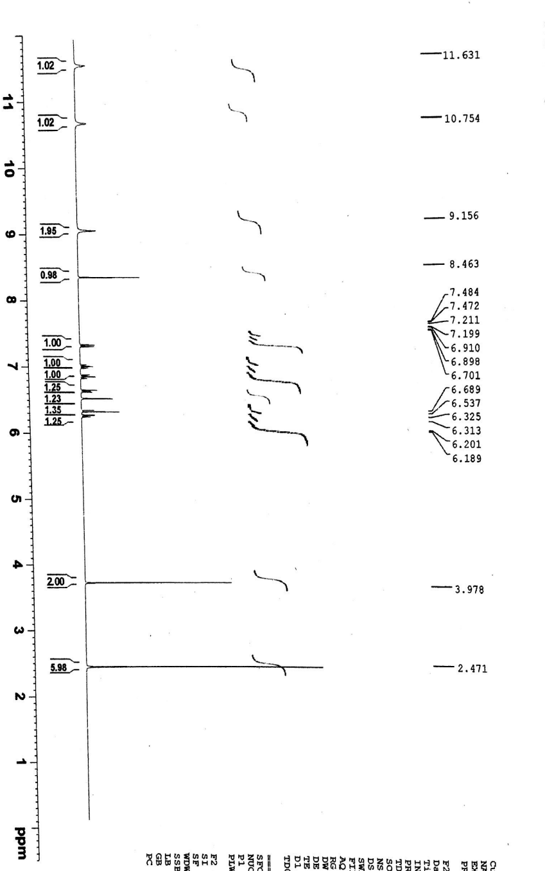
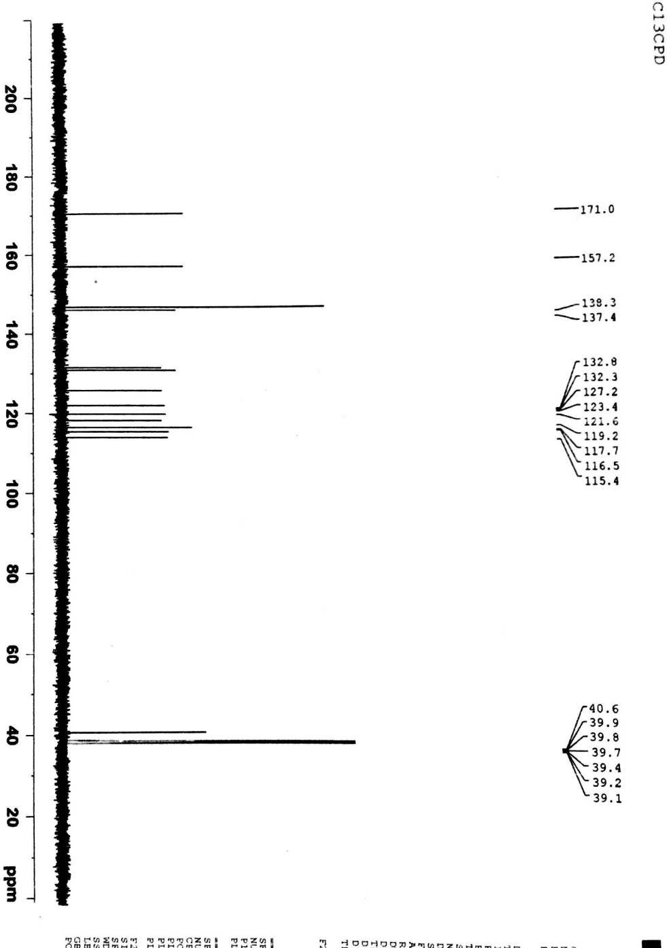
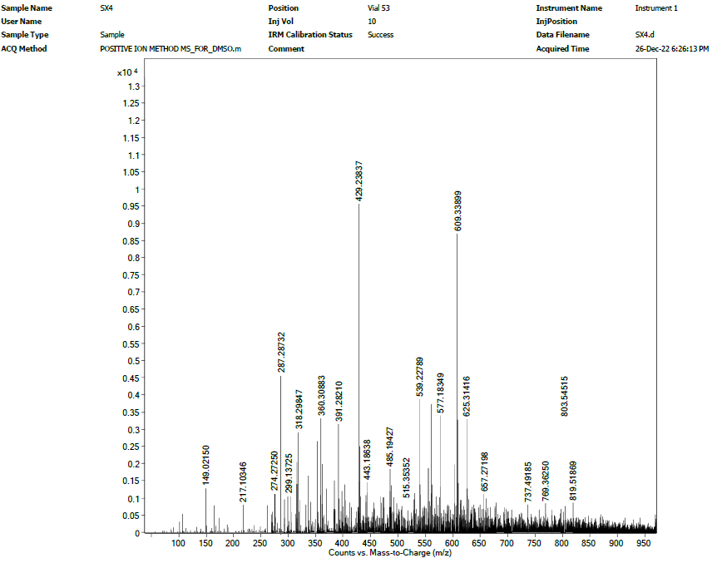
Fig S1: ¹H-, ¹³C-NMR and HR-ESI-MS spectra of compound 1

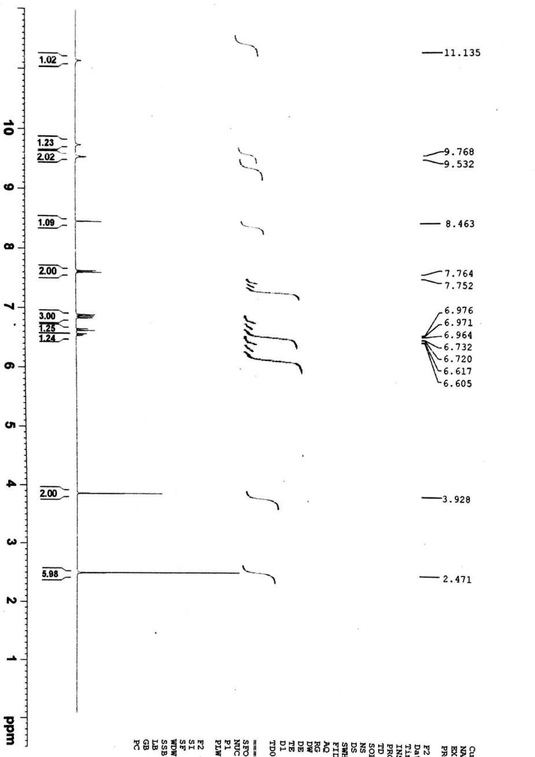
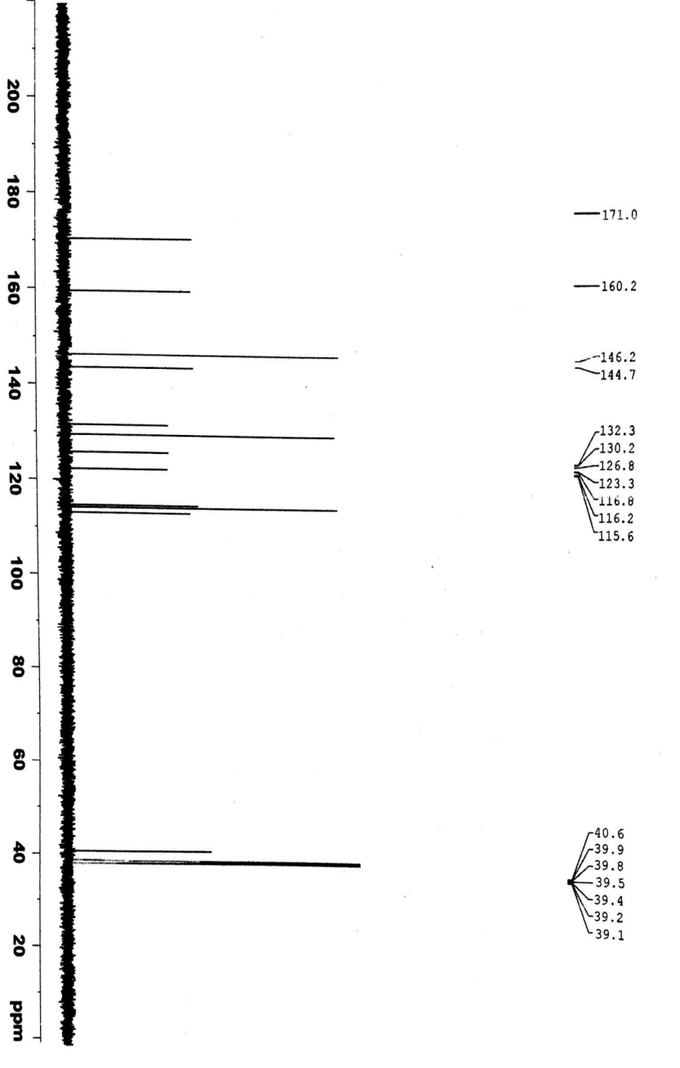
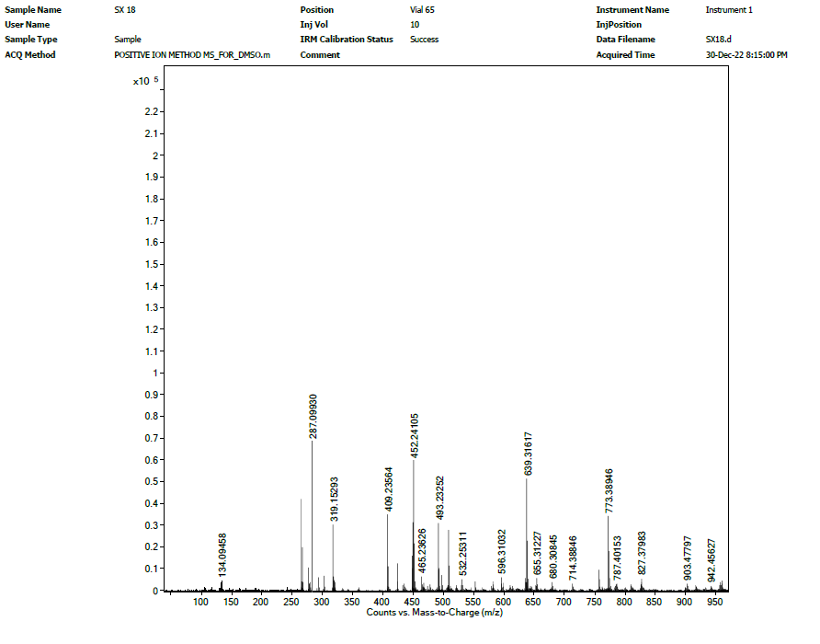
Fig S2: ¹H-, ¹³C-NMR and HR-ESI-MS spectra of compound 2

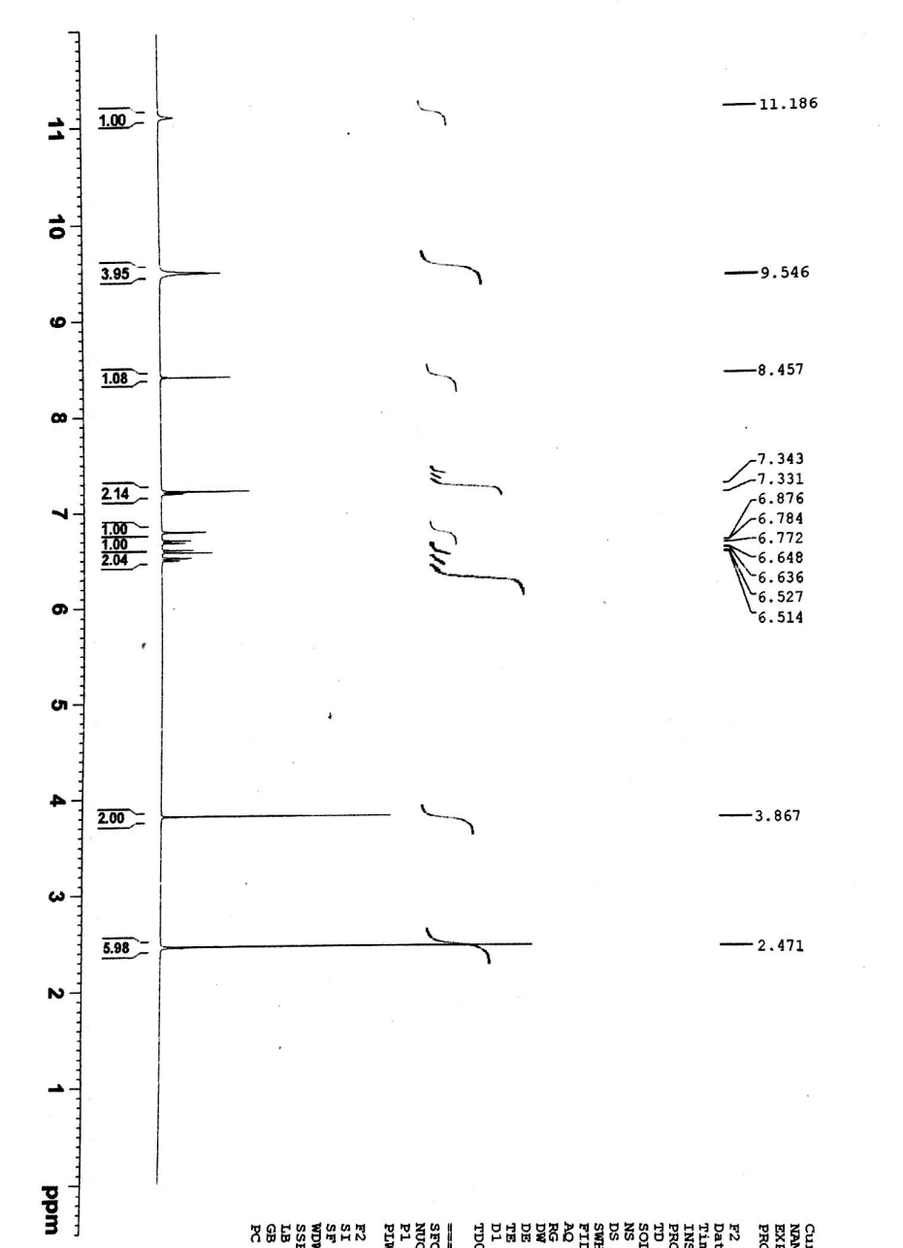
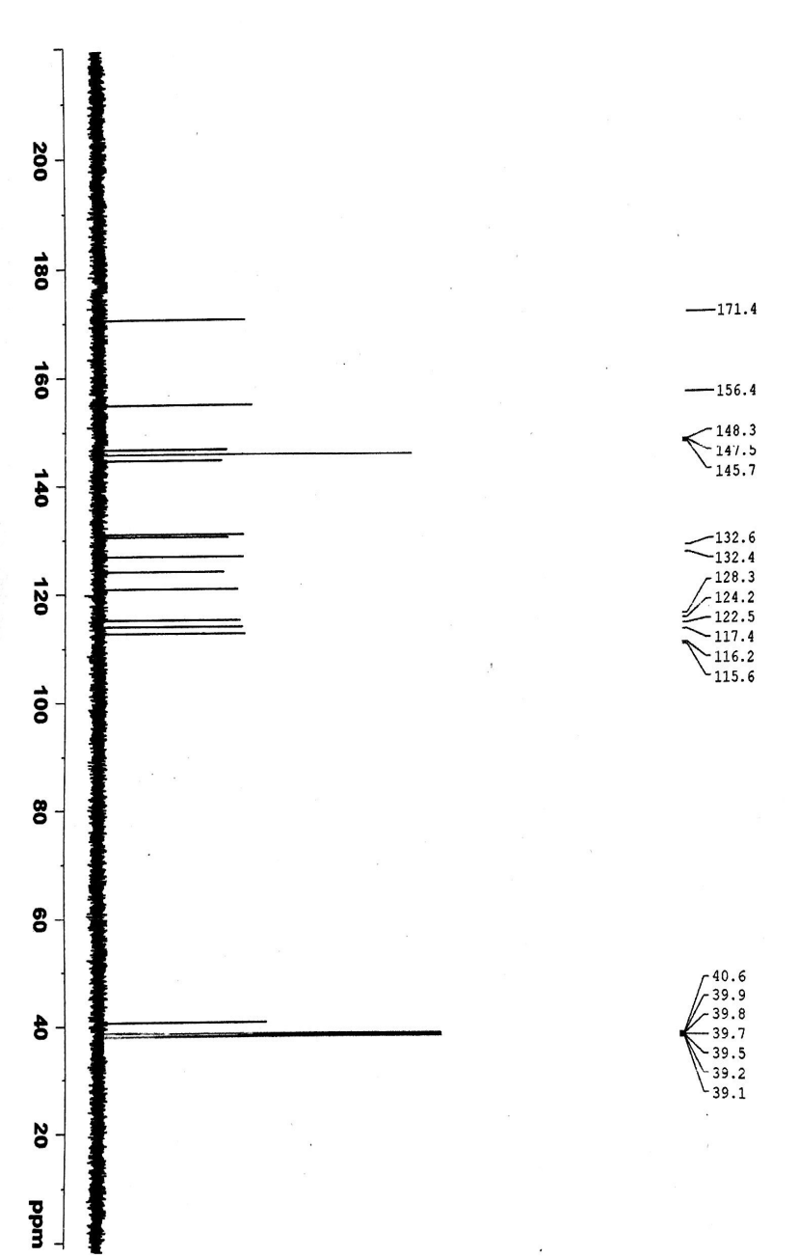
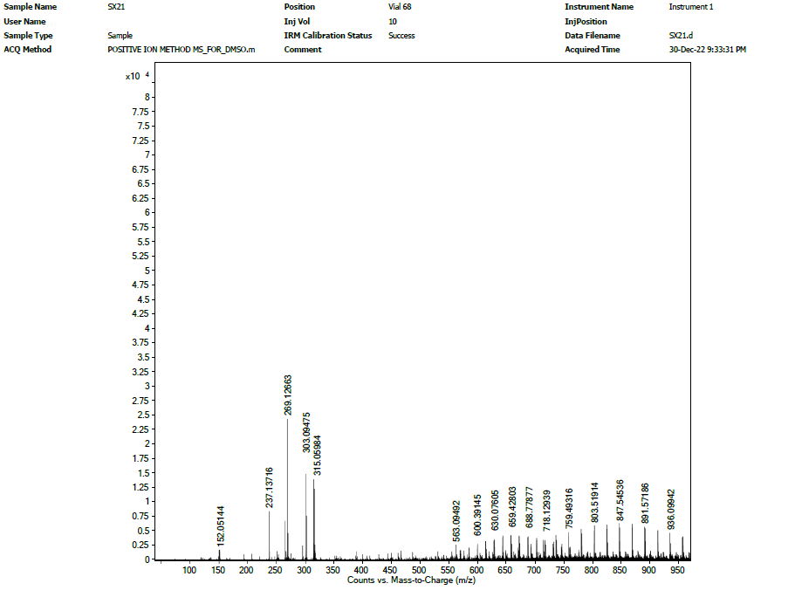
Fig S3: ¹H-, ¹³C-NMR and HR-ESI-MS spectra of compound 3
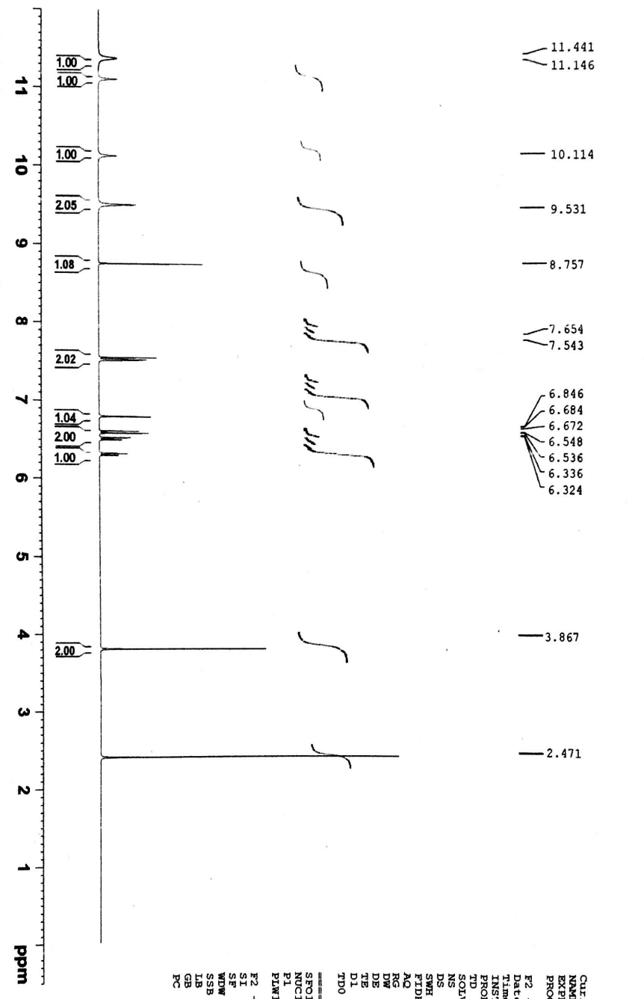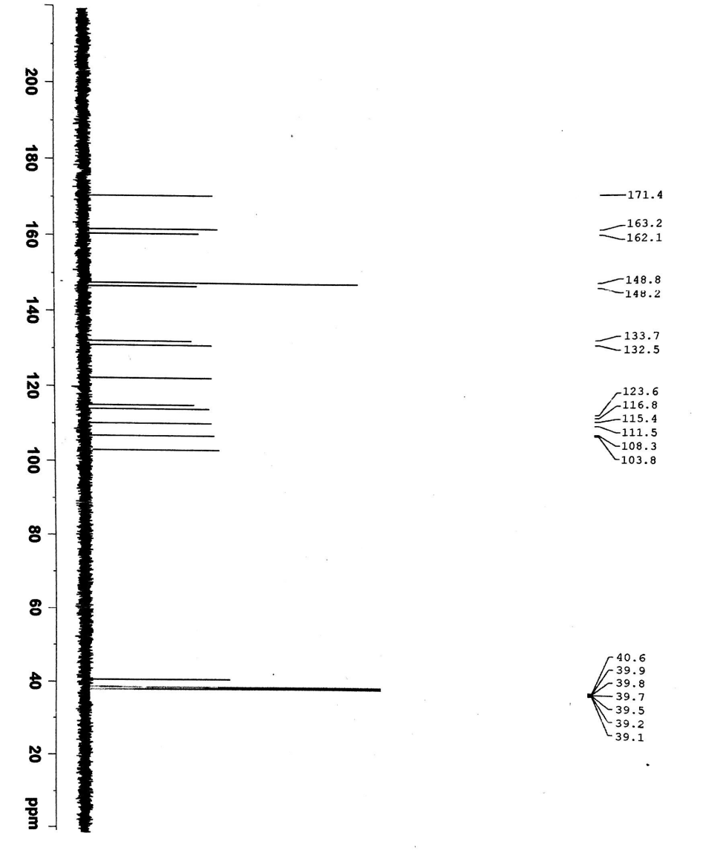
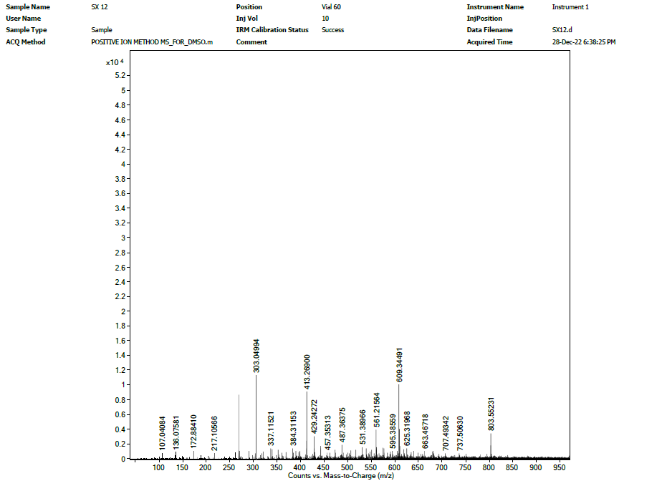
Fig S4: ¹H-, ¹³C-NMR and HR-ESI-MS spectra of compound 4

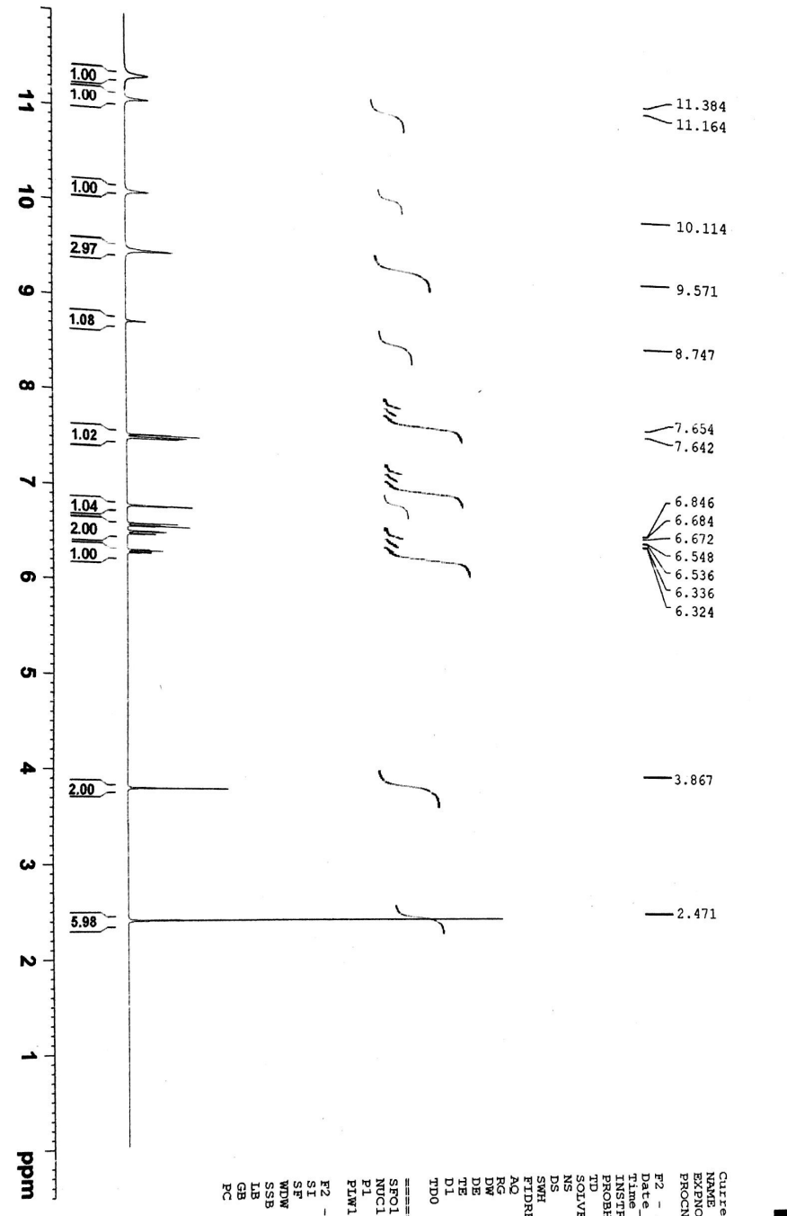
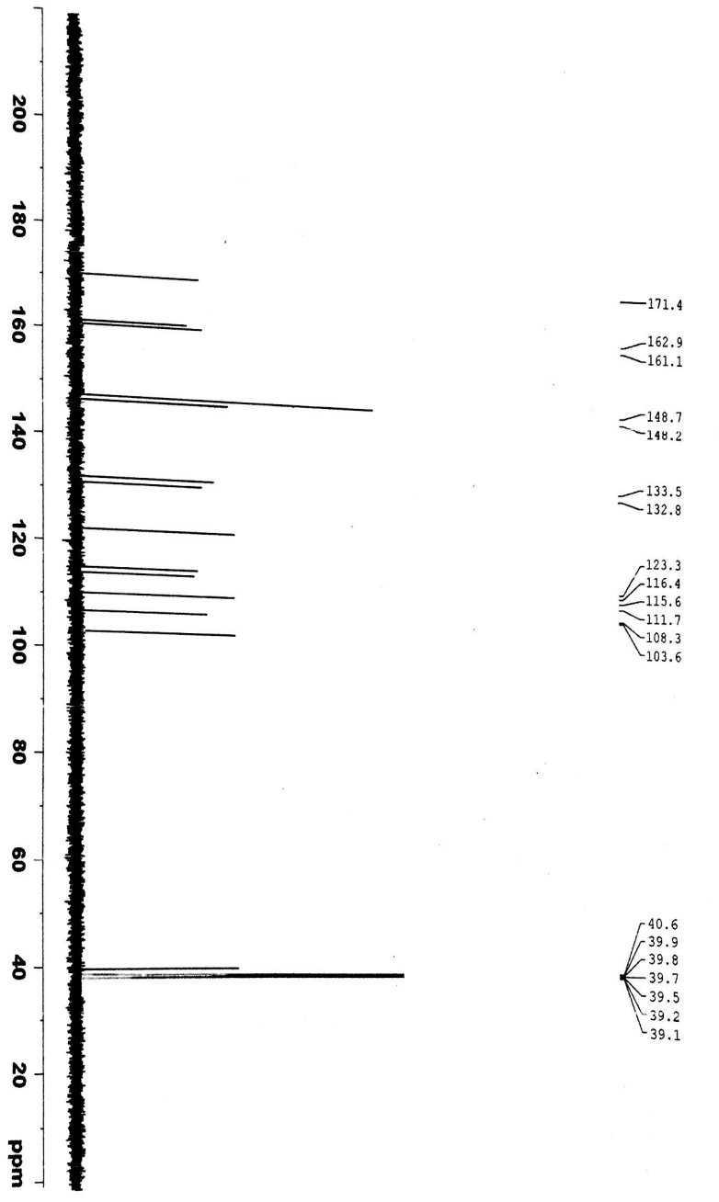
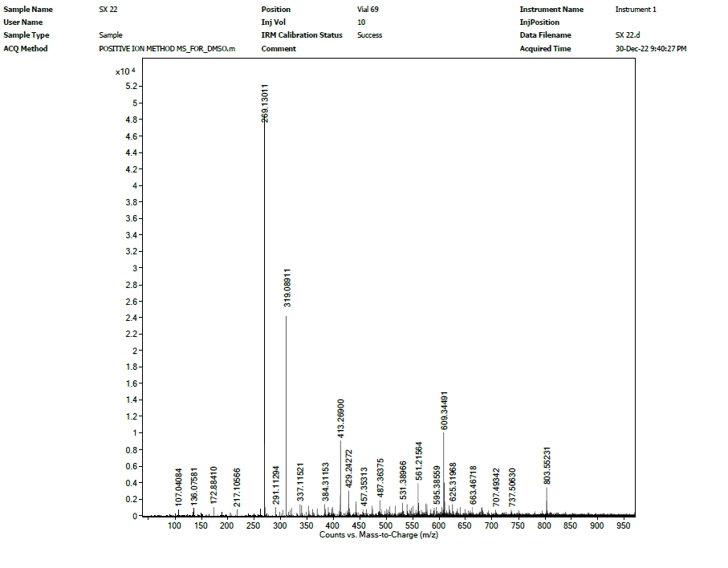
Fig S5: ¹H-, ¹³C-NMR and HR-ESI-MS spectra of compound 5

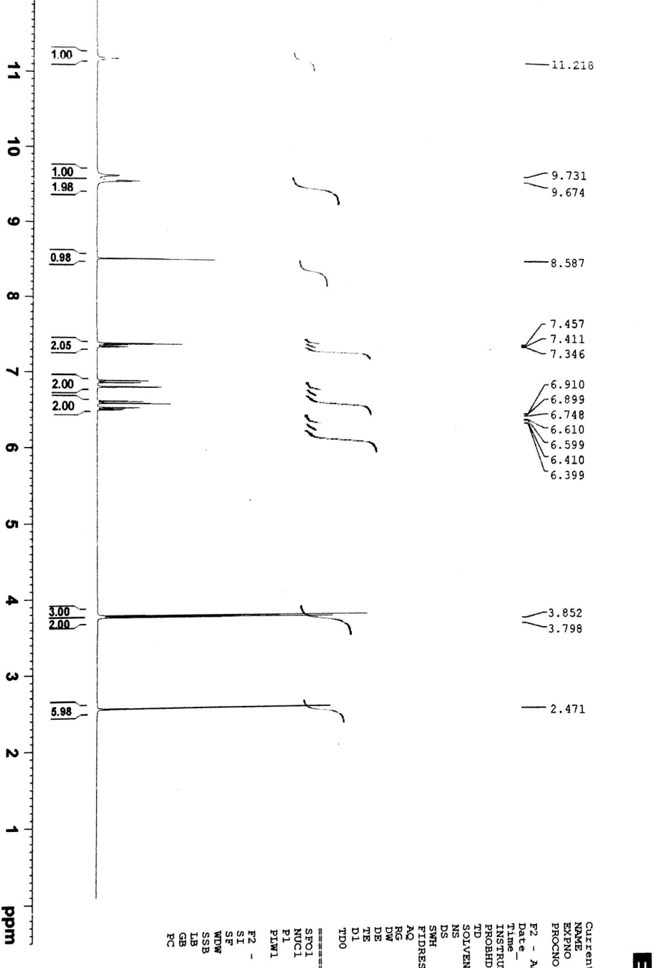
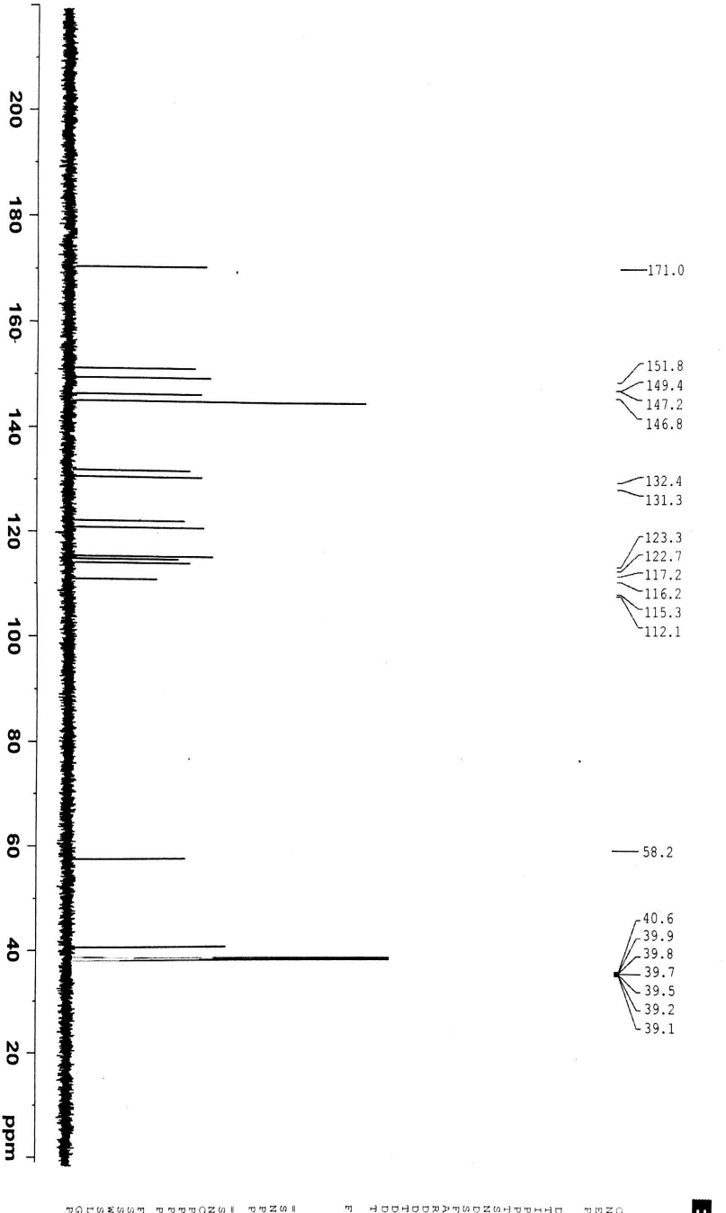
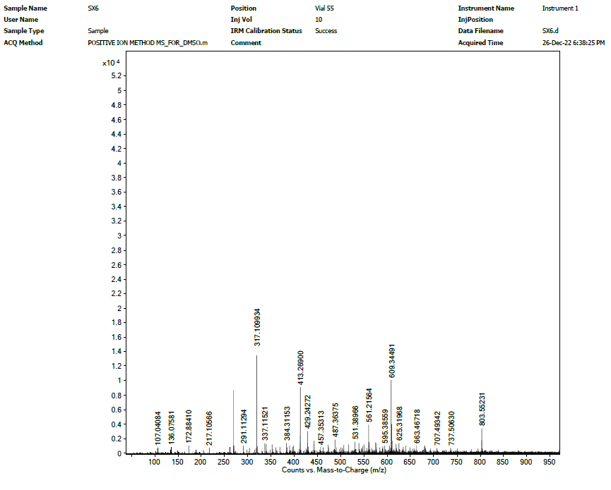 Fig S6: ¹H-, ¹³C-NMR and HR-ESI-MS spectra of compound 6

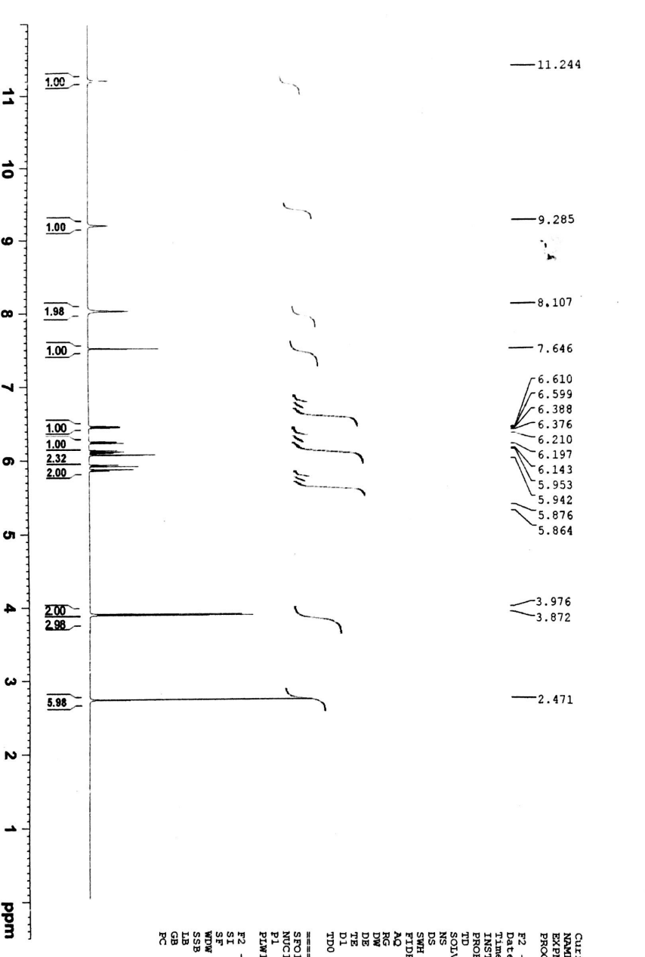
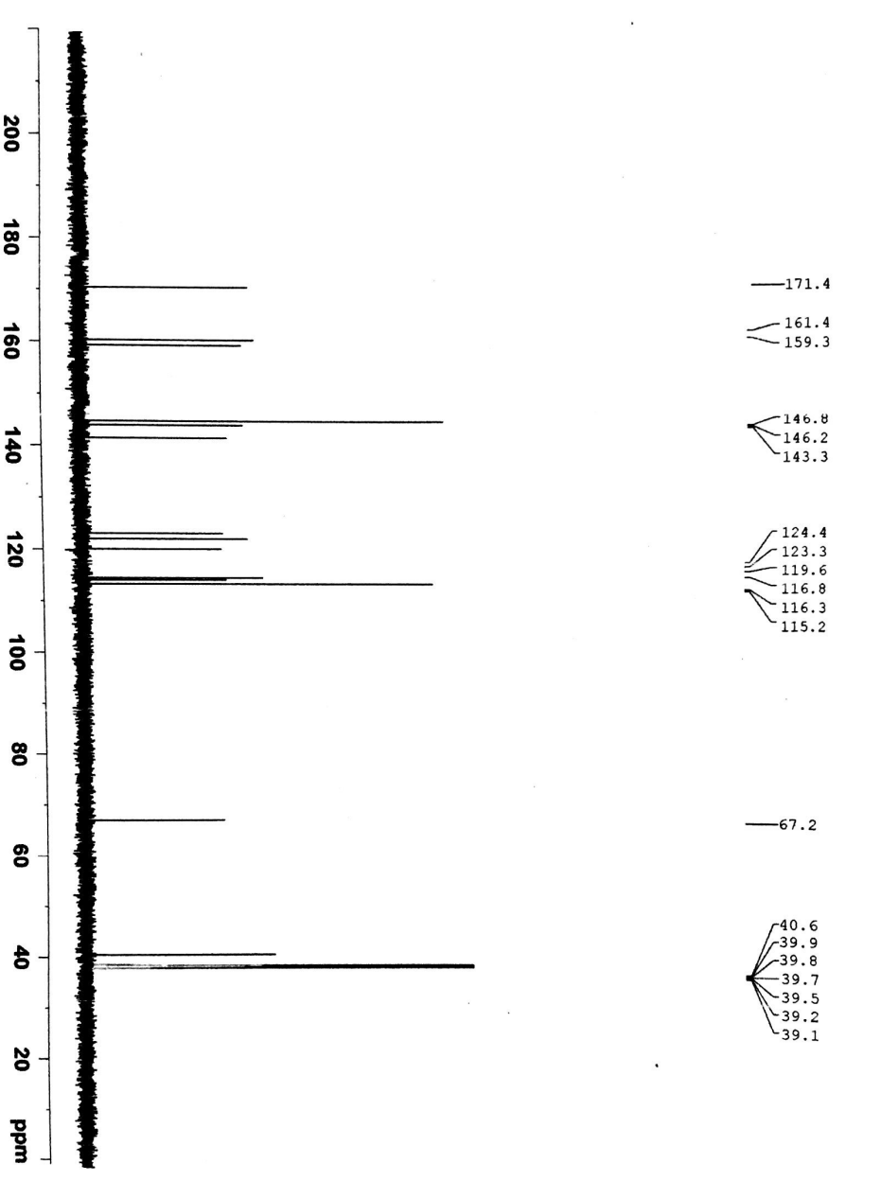
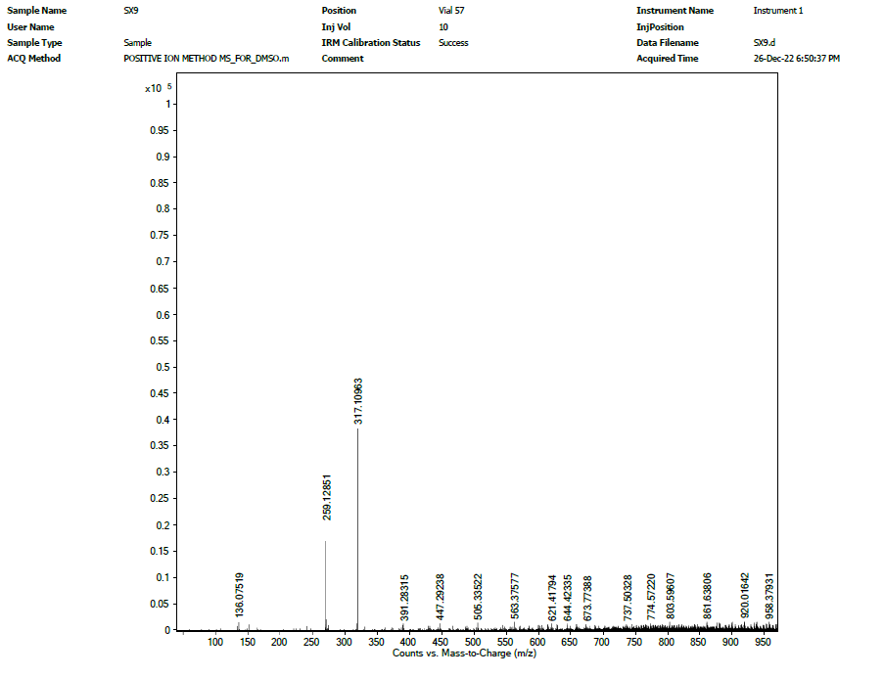
Fig S7: ¹H-, ¹³C-NMR and HR-ESI-MS spectra of compound 7

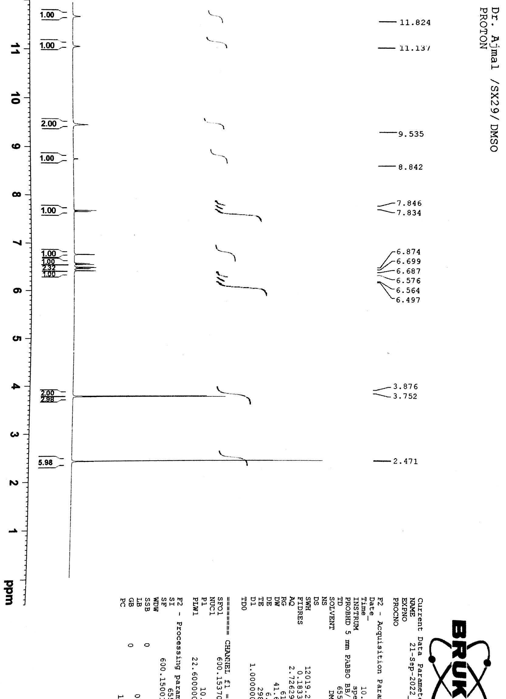
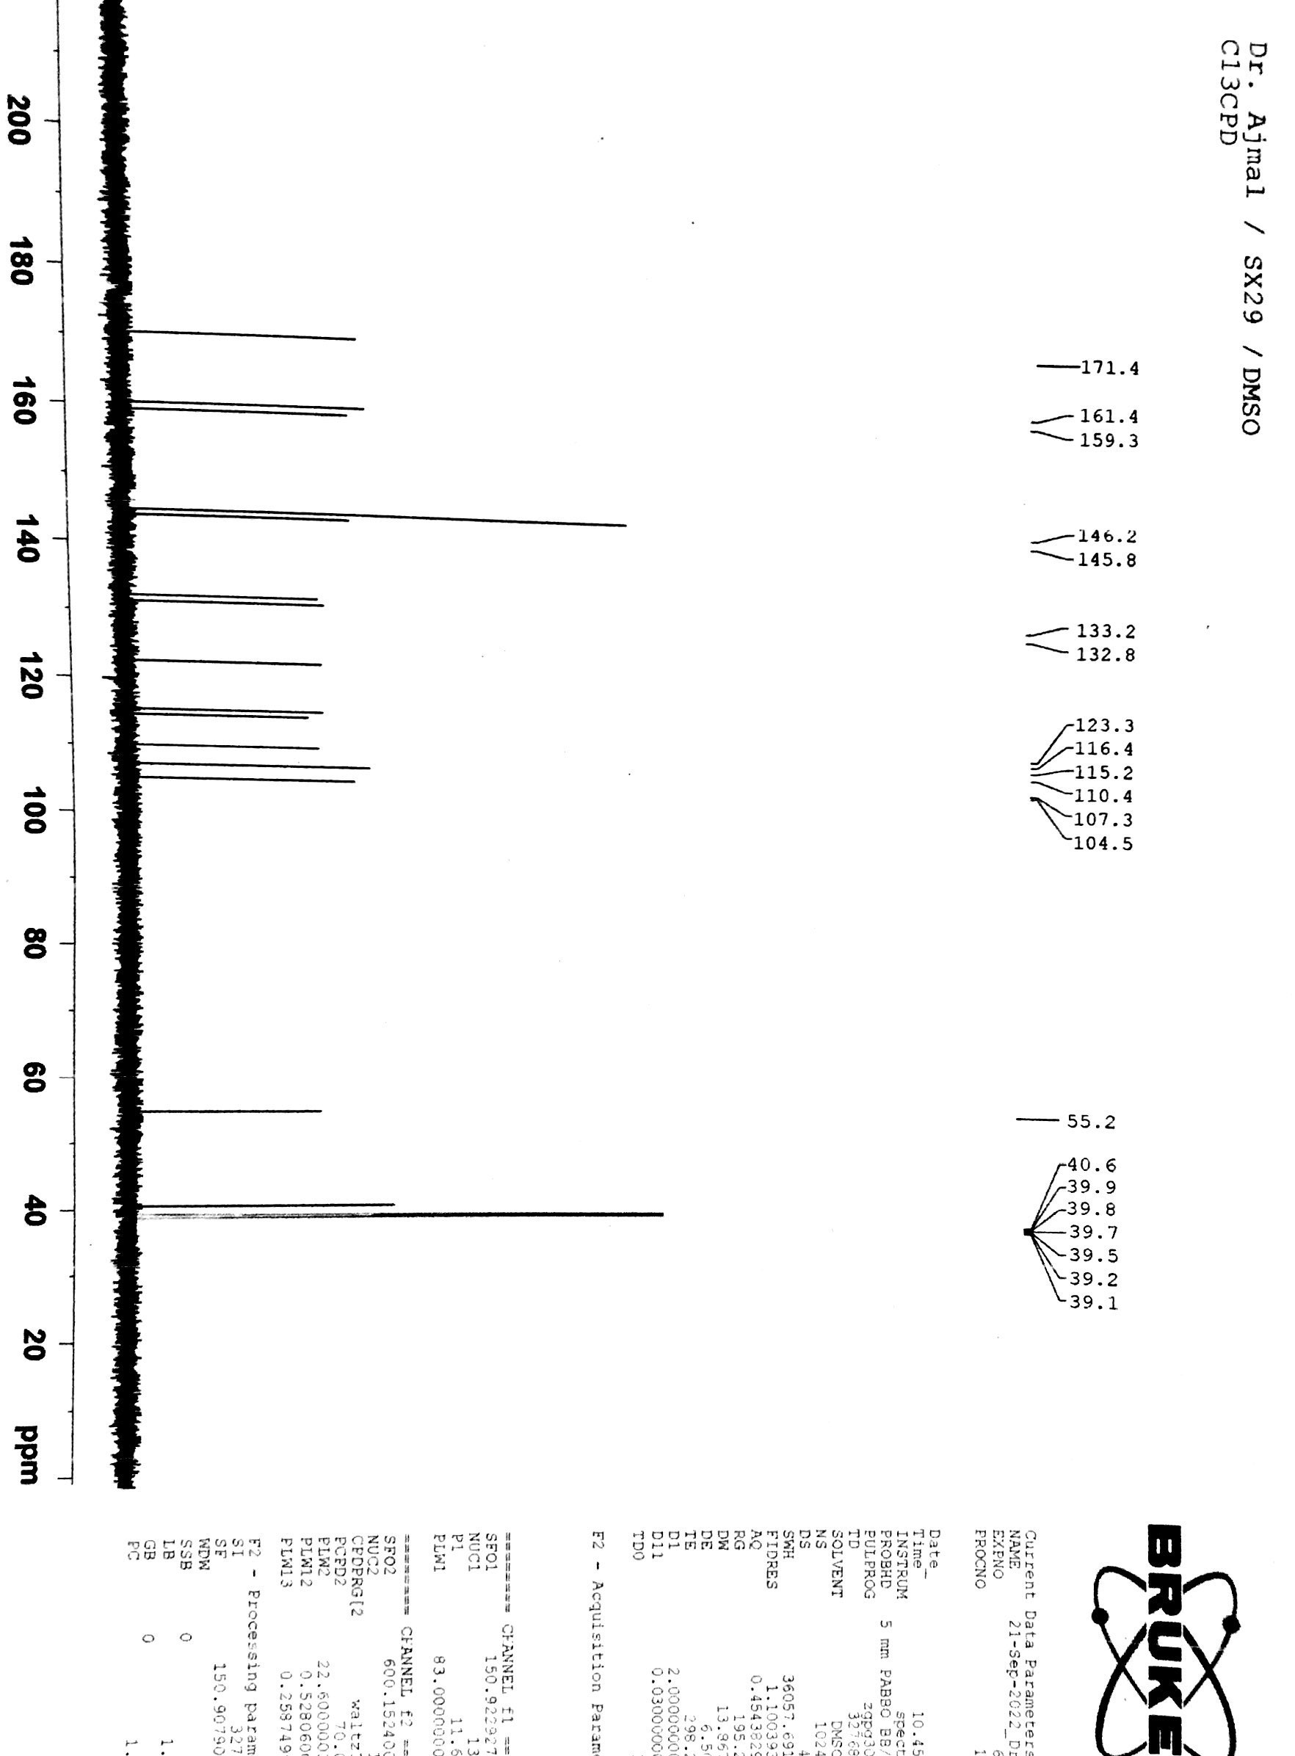
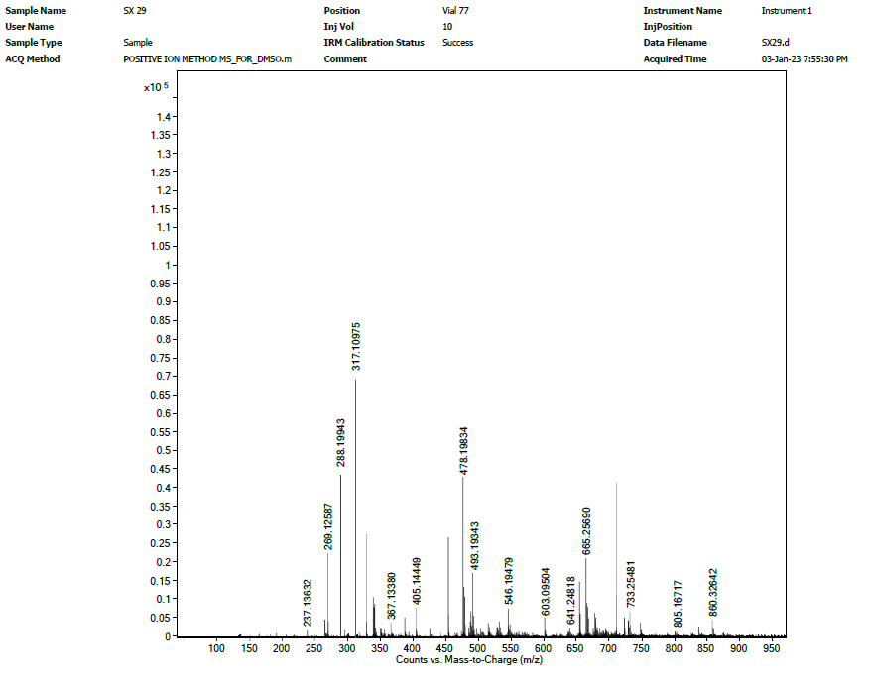
Fig S8: ¹H-, ¹³C-NMR and HR-ESI-MS spectra of compound 8
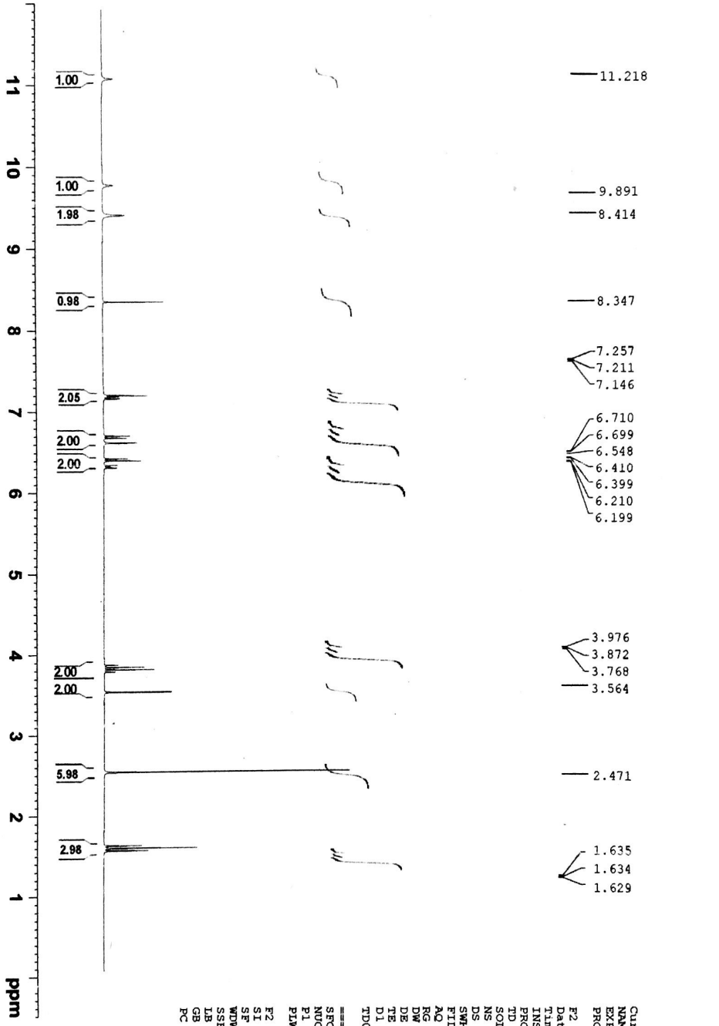
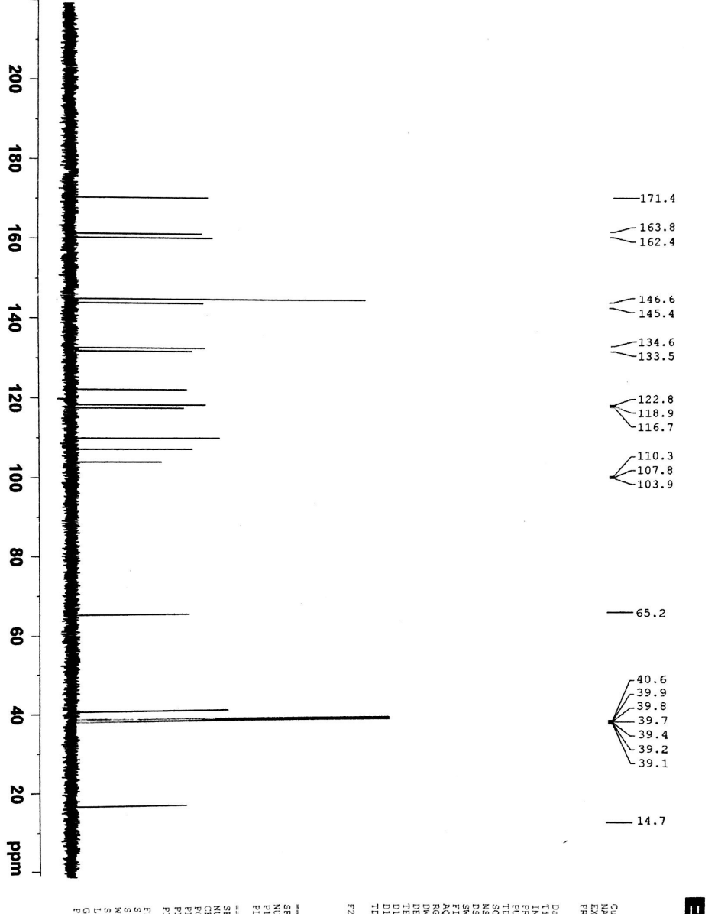
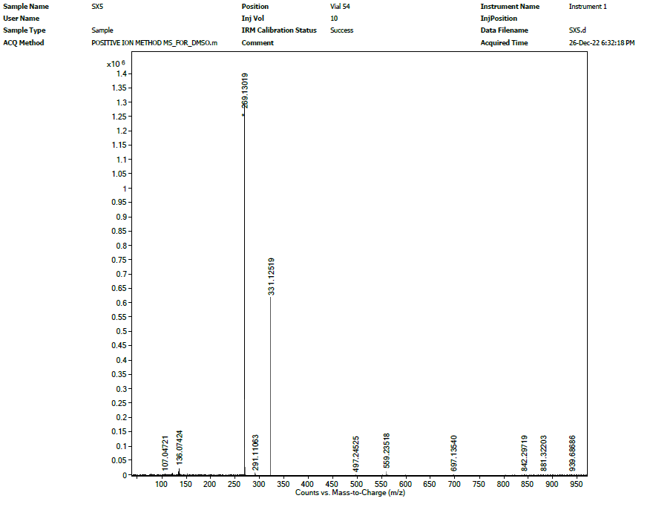
Fig S9: ¹H-, ¹³C-NMR and HR-ESI-MS spectra of compound 9

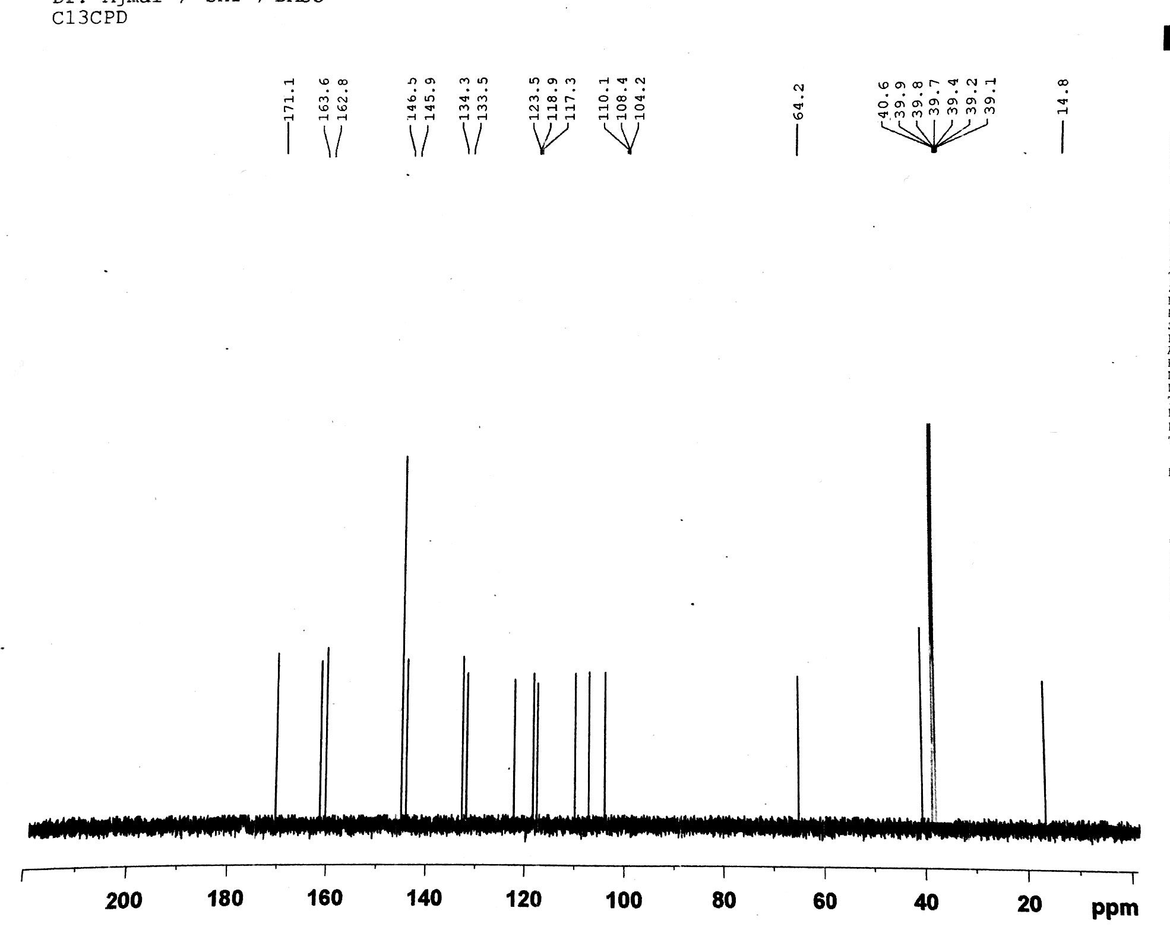

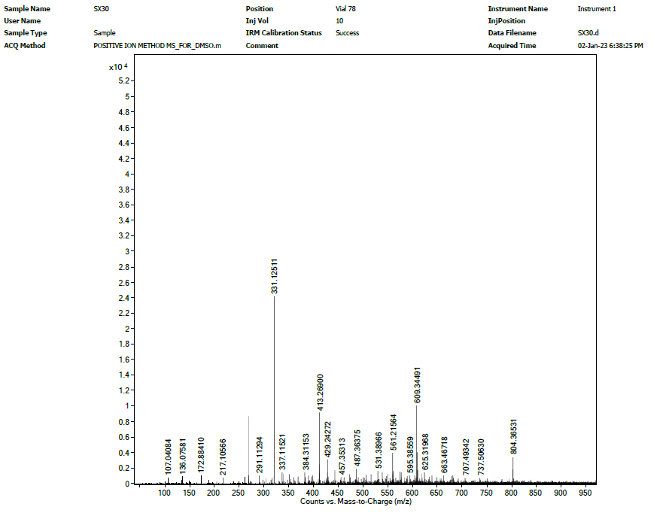
Fig S10: ¹H-, ¹³C-NMR and HR-ESI-MS spectra of compound 10

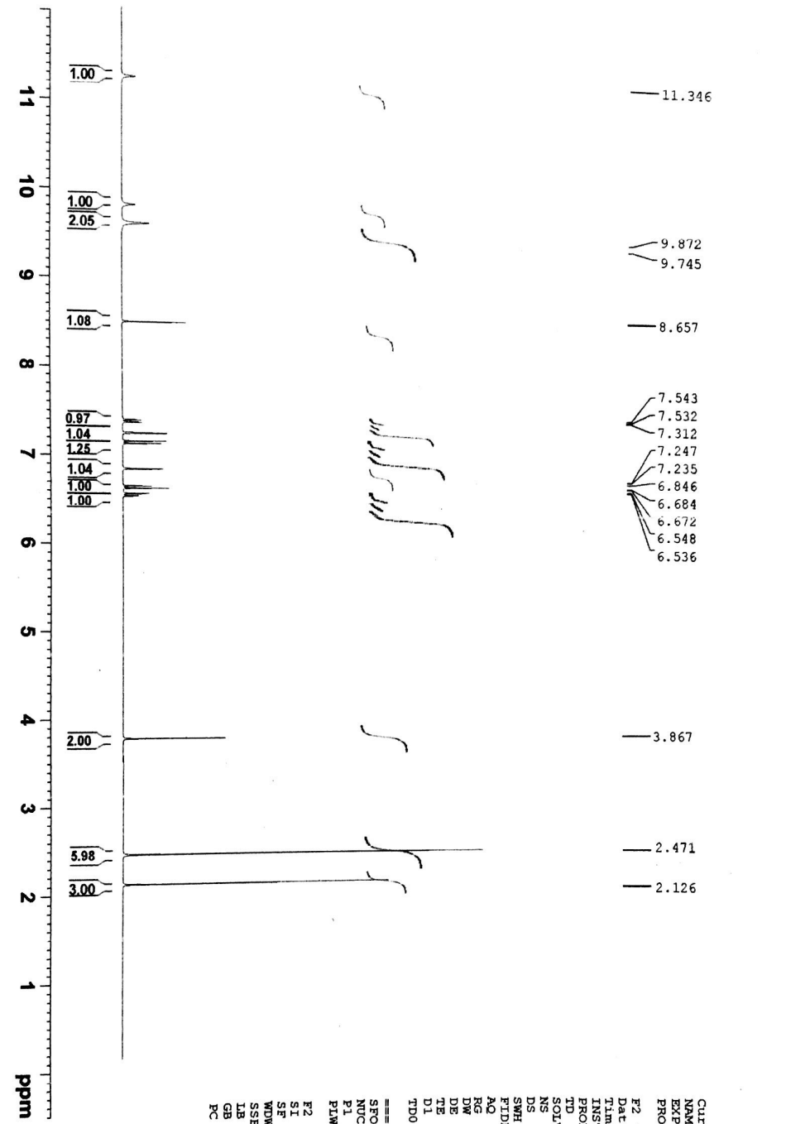
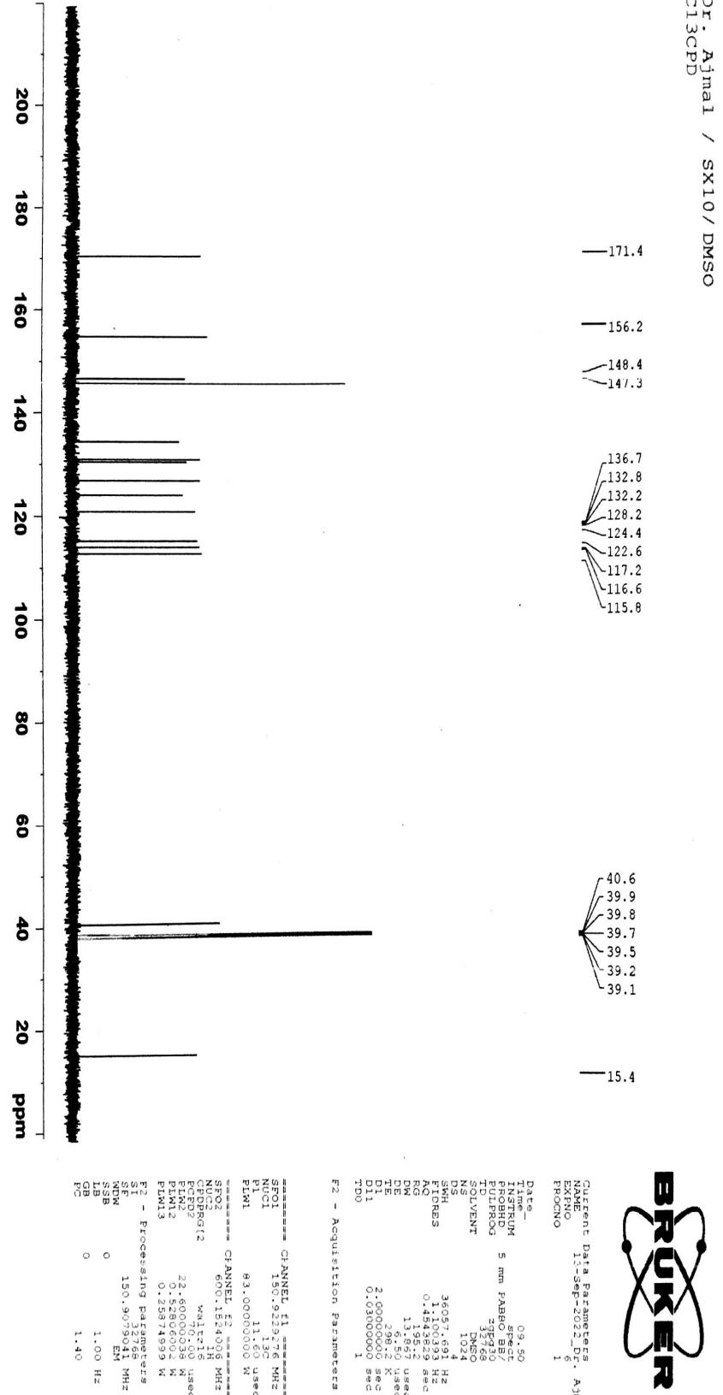
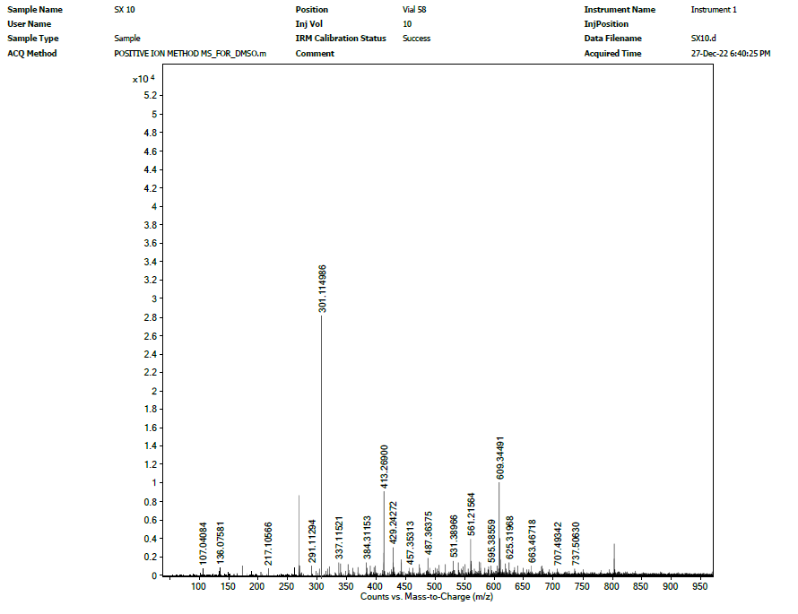
Fig S11: ¹H-, ¹³C-NMR and HR-ESI-MS spectra of compound 11
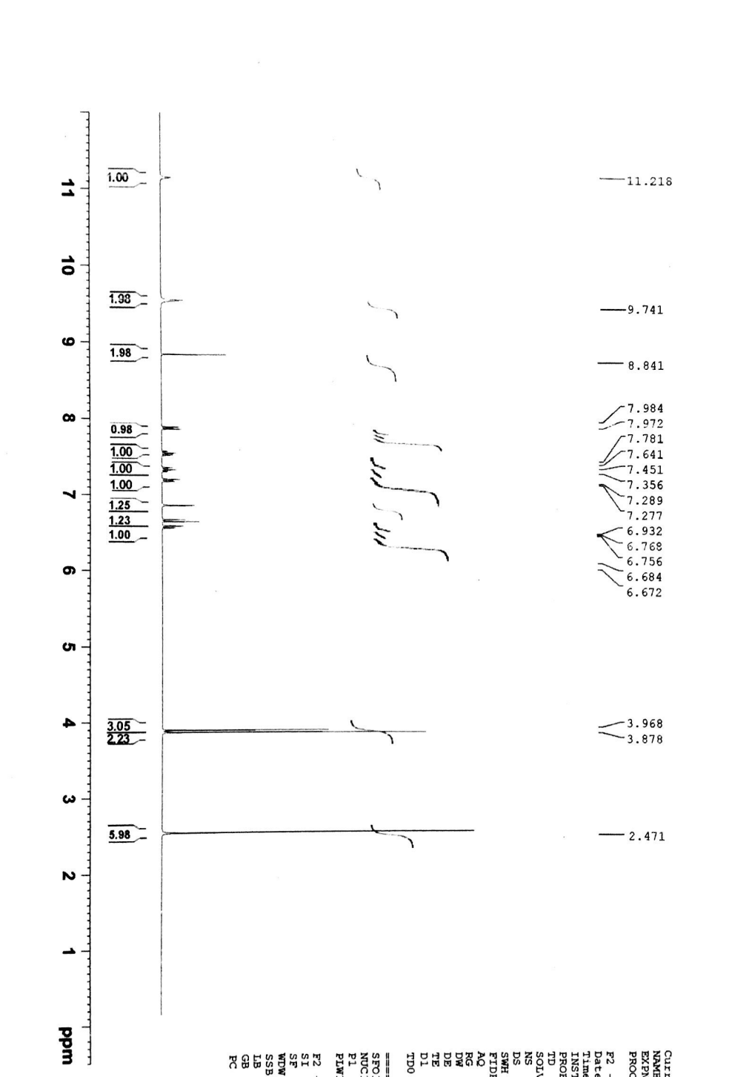
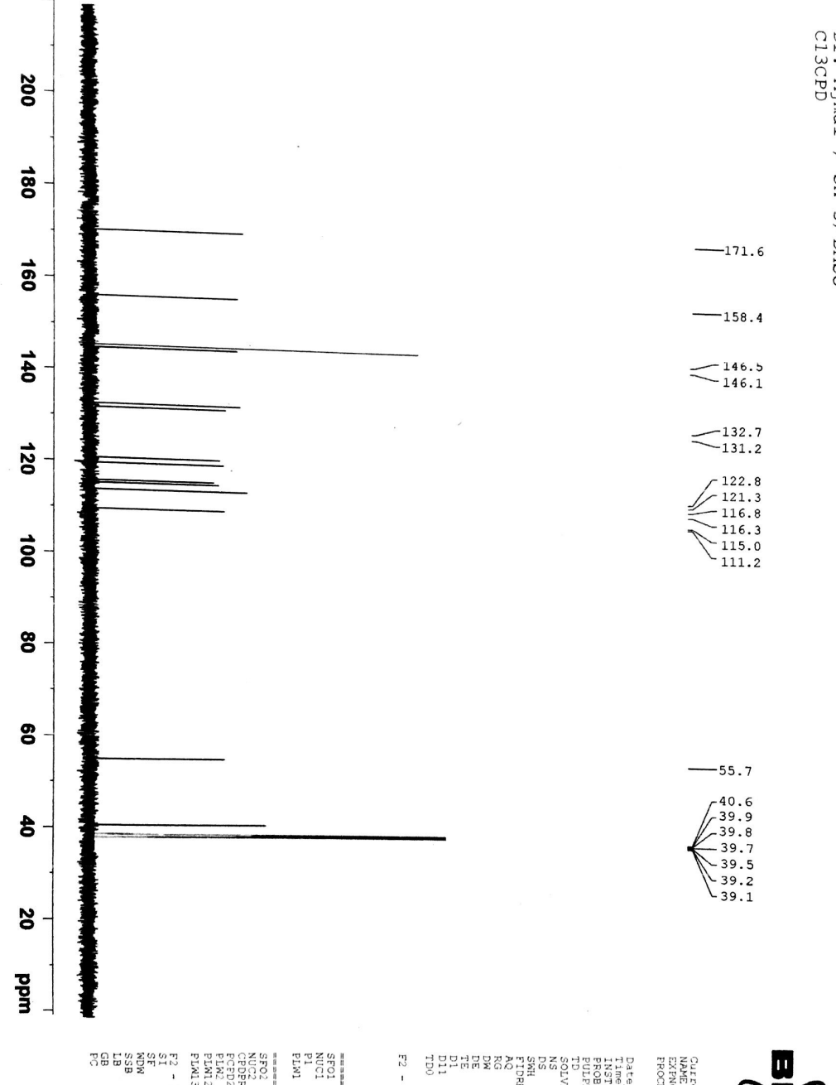
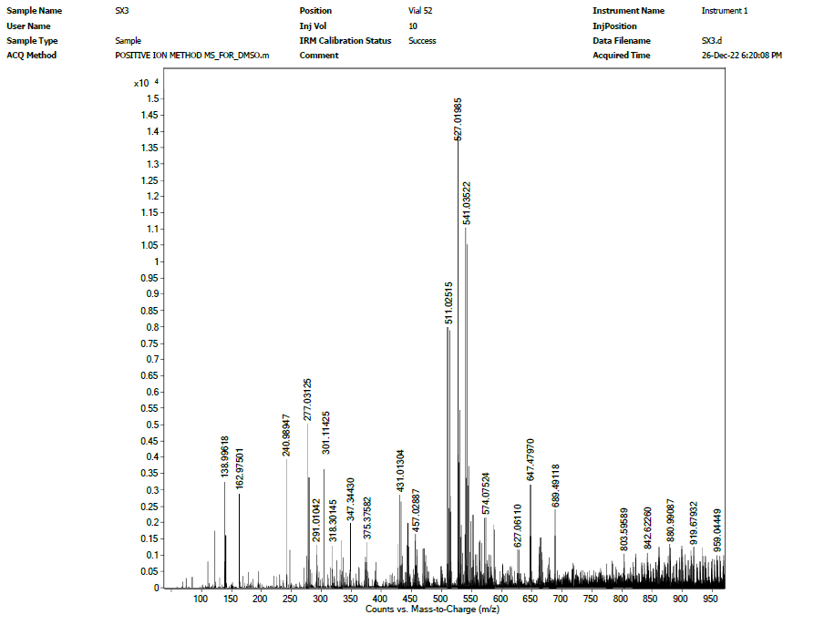

Fig S12: ¹H-, ¹³C-NMR and HR-ESI-MS spectra of compound 12
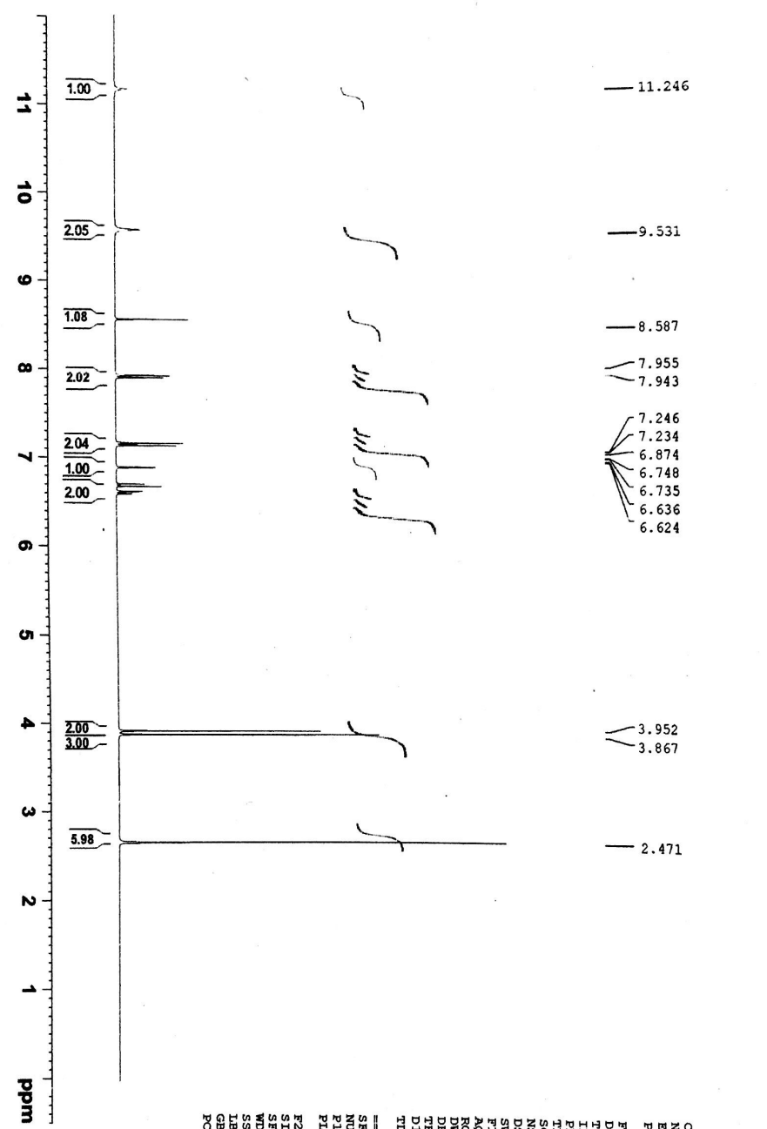
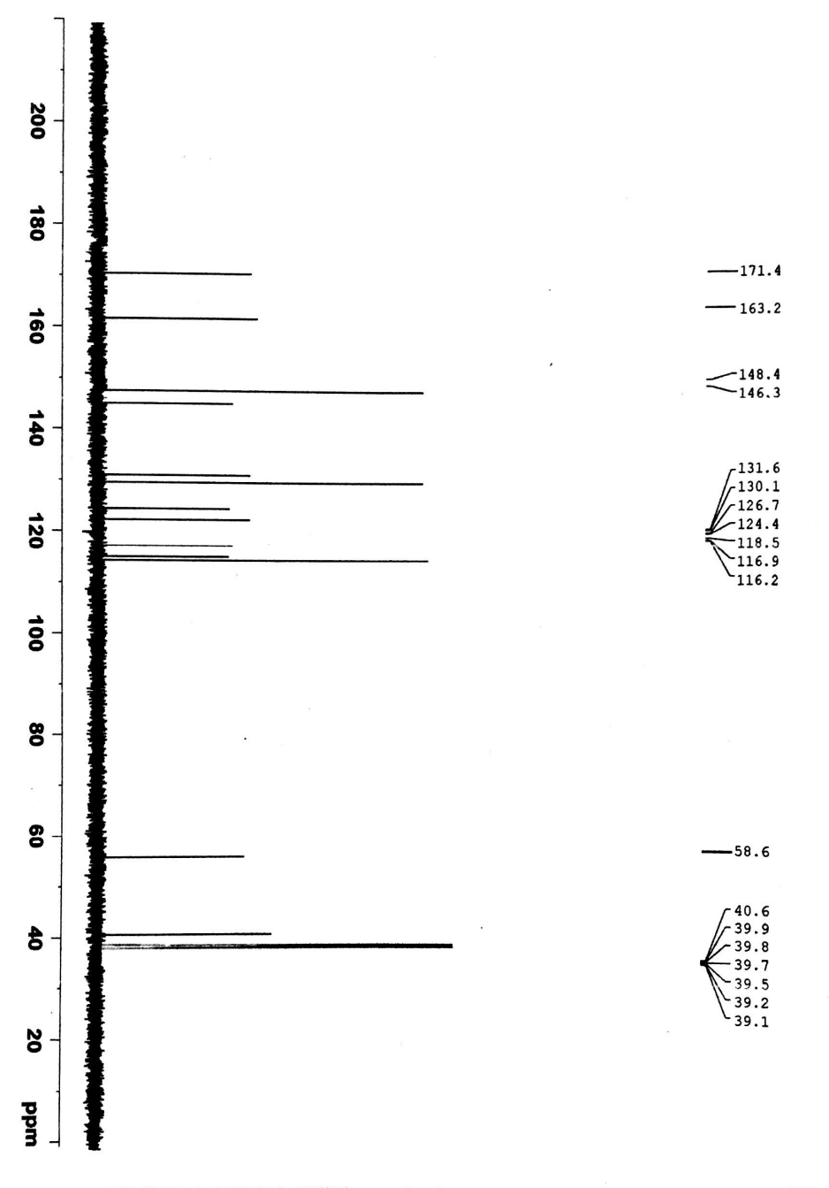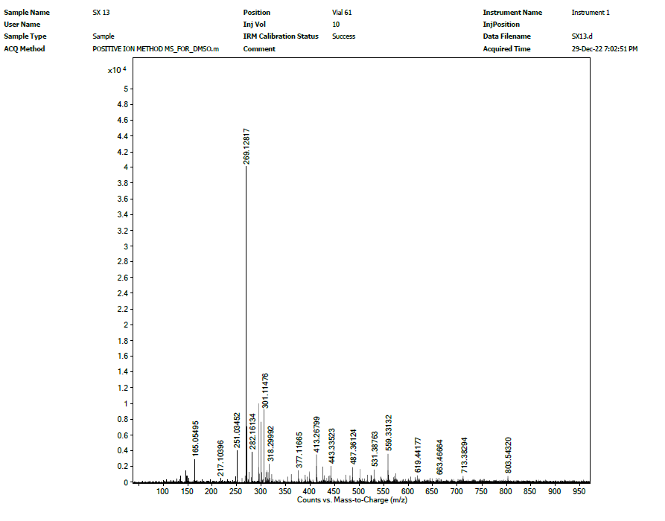 Fig S13: ¹H-, ¹³C-NMR and HR-ESI-MS spectra of compound 13

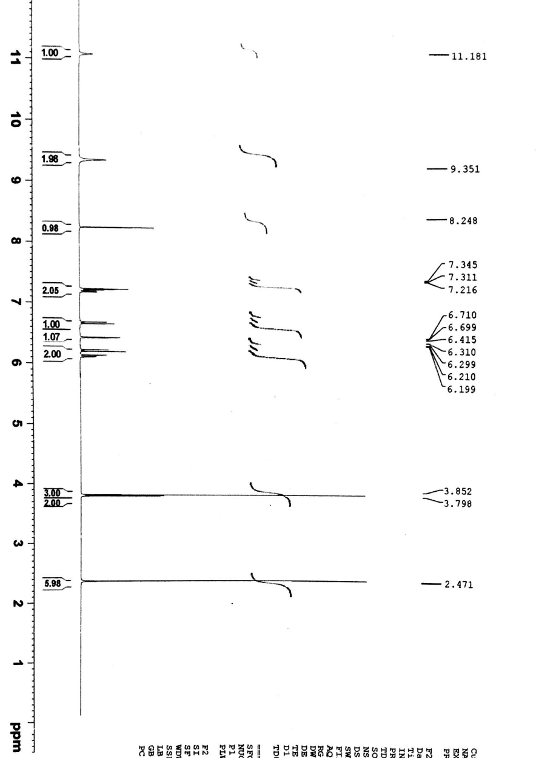
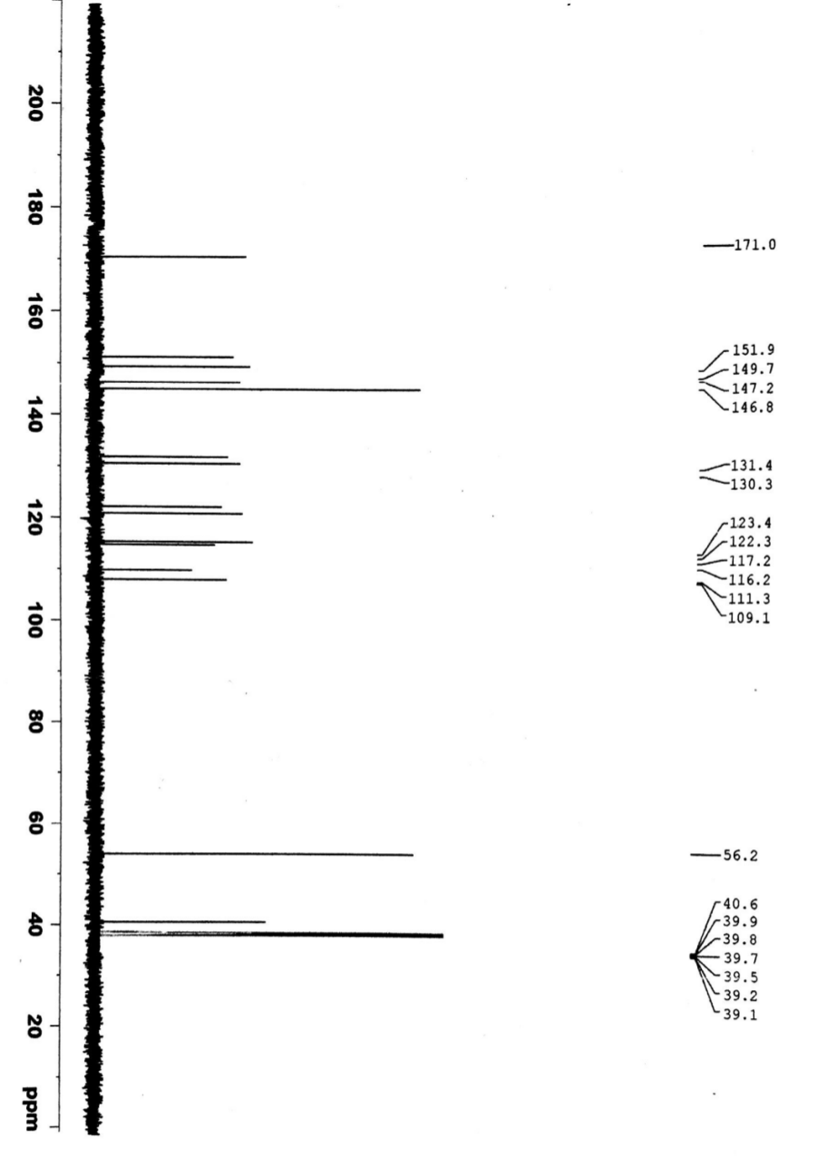
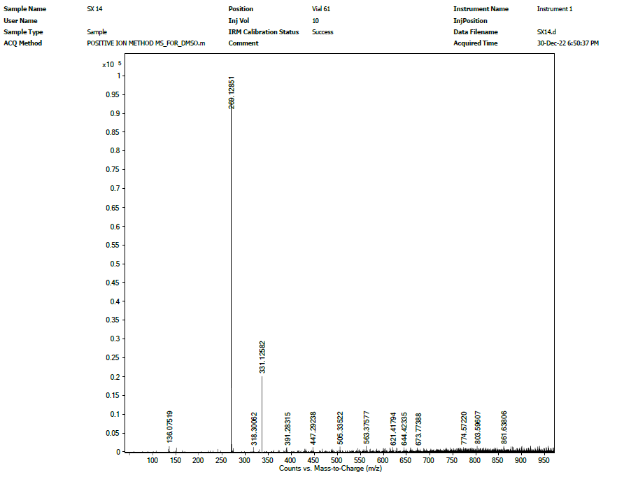
Fig S14: ¹H-, ¹³C-NMR and HR-ESI-MS spectra of compound 14

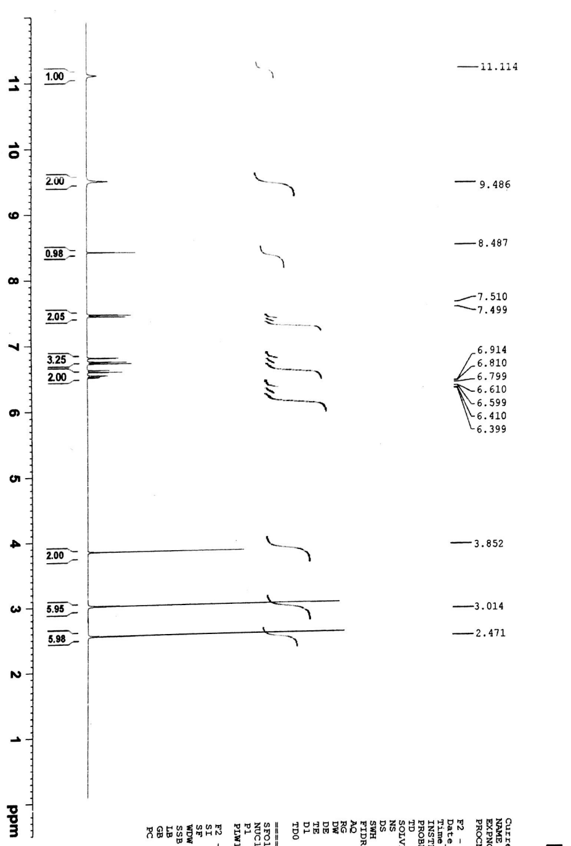
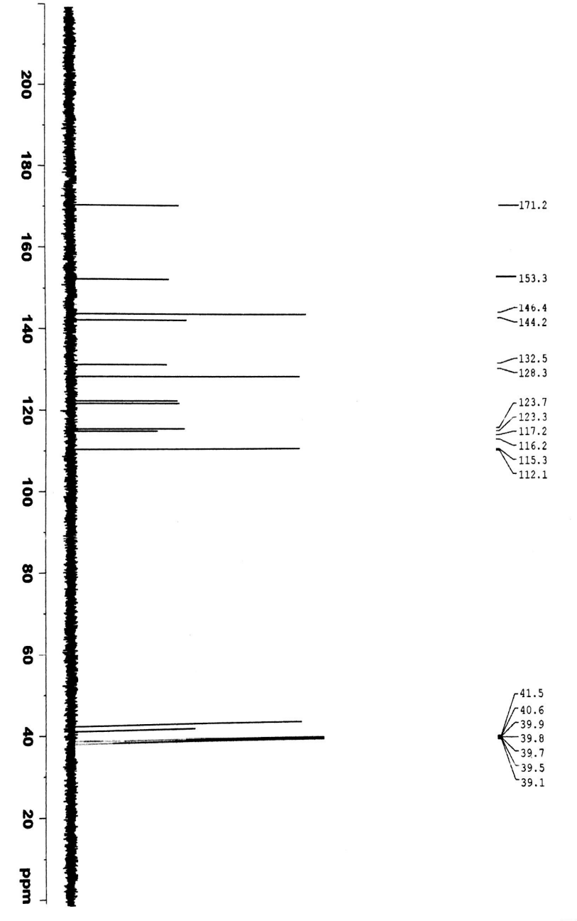
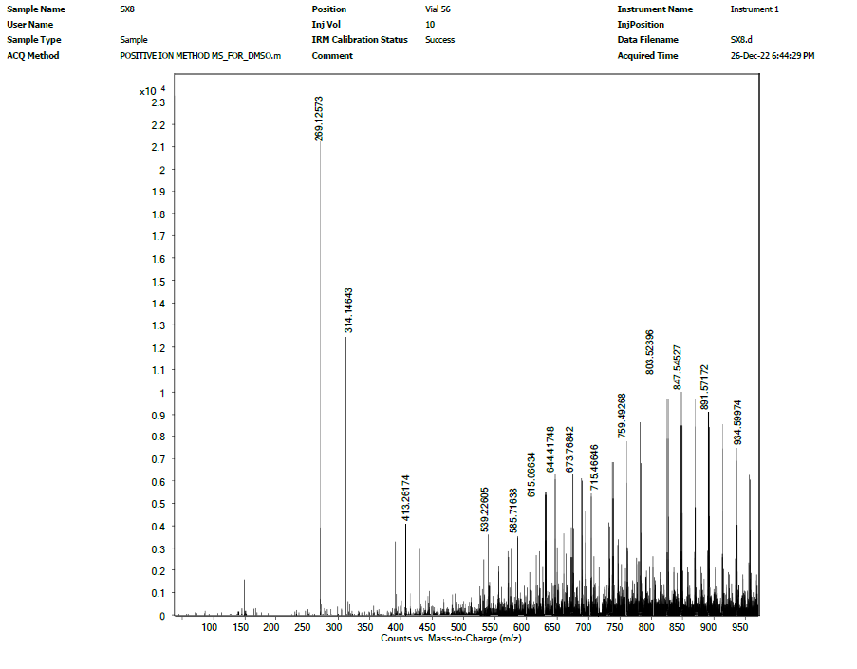 Fig S15: ¹H-, ¹³C-NMR and HR-ESI-MS spectra of compound 15
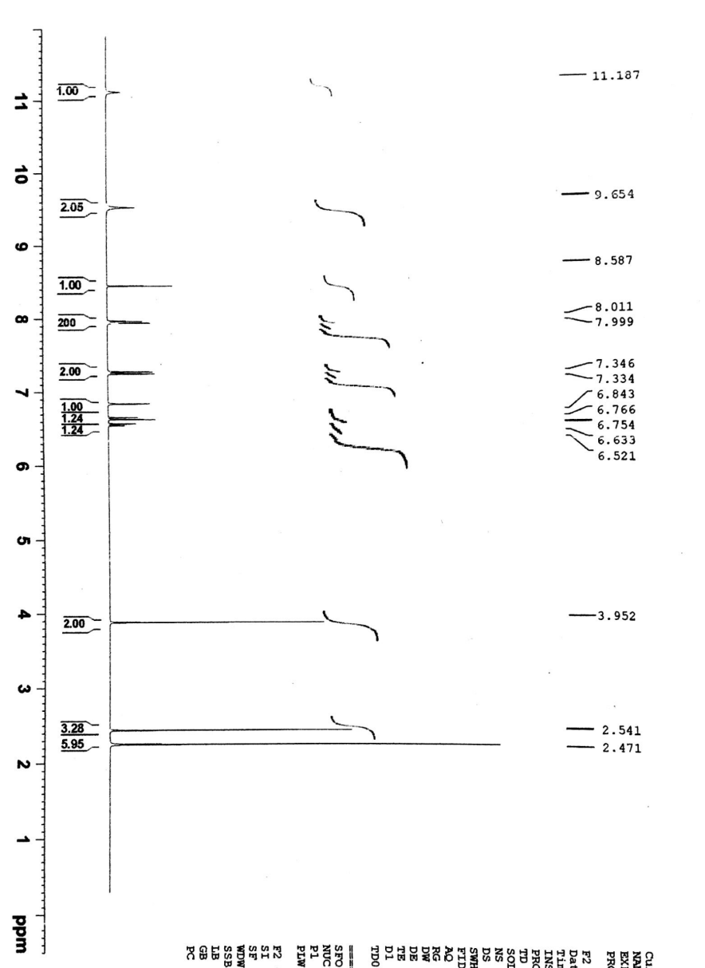
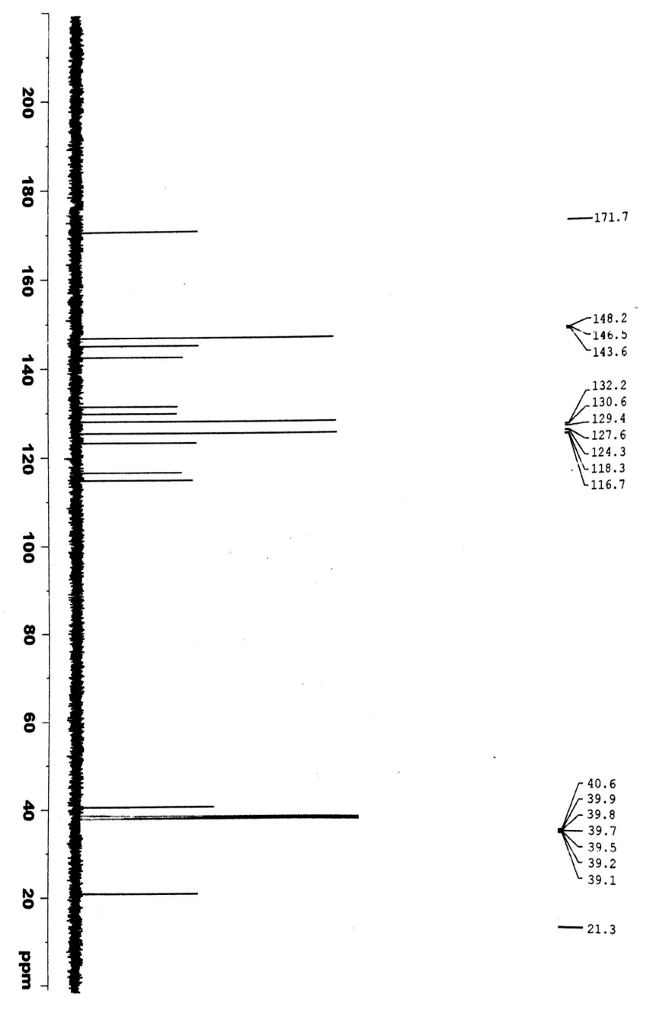
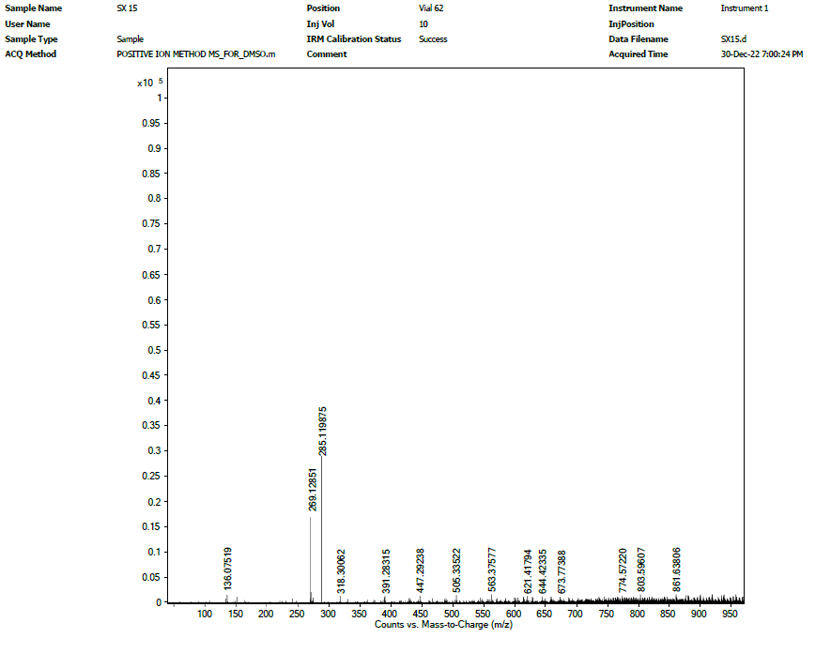
Fig S16: ¹H-, ¹³C-NMR and HR-ESI-MS spectra of compound 16

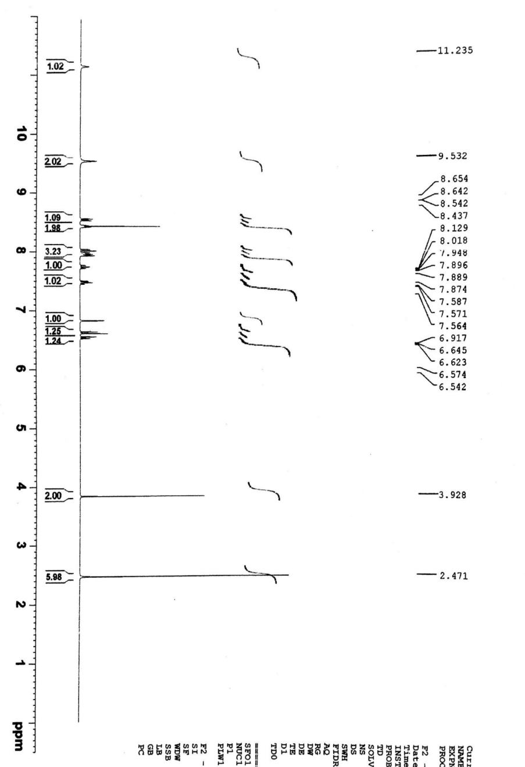
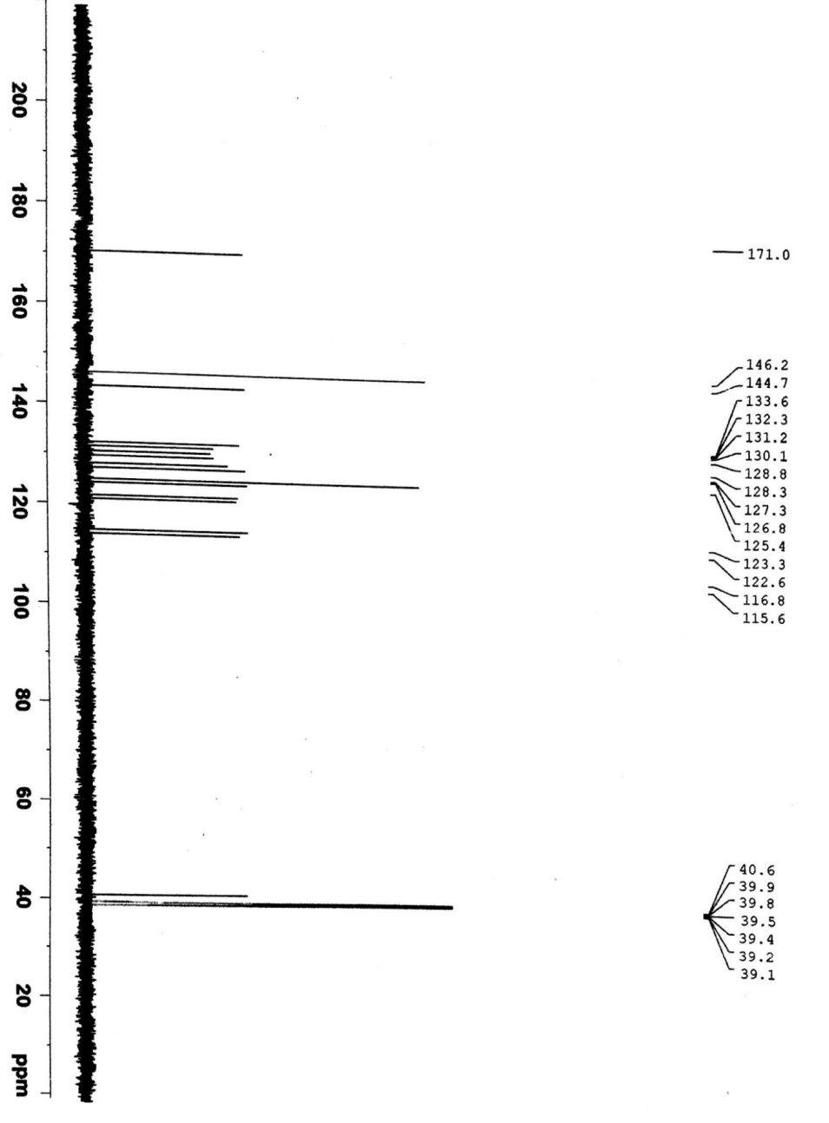
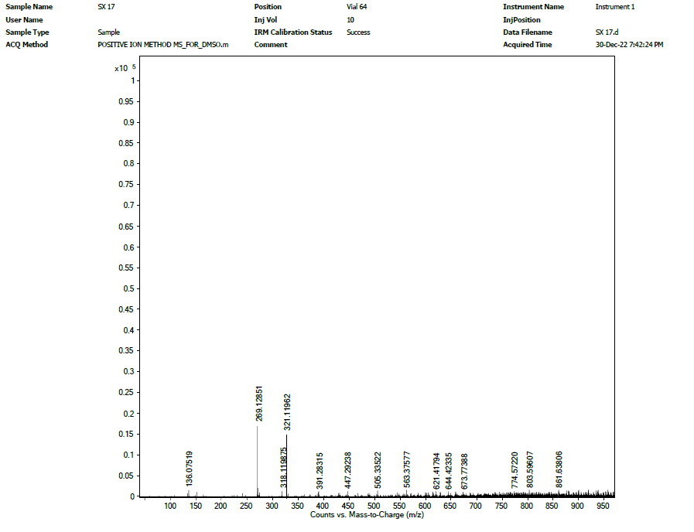 Fig S17: ¹H-, ¹³C-NMR and HR-ESI-MS spectra of compound 17
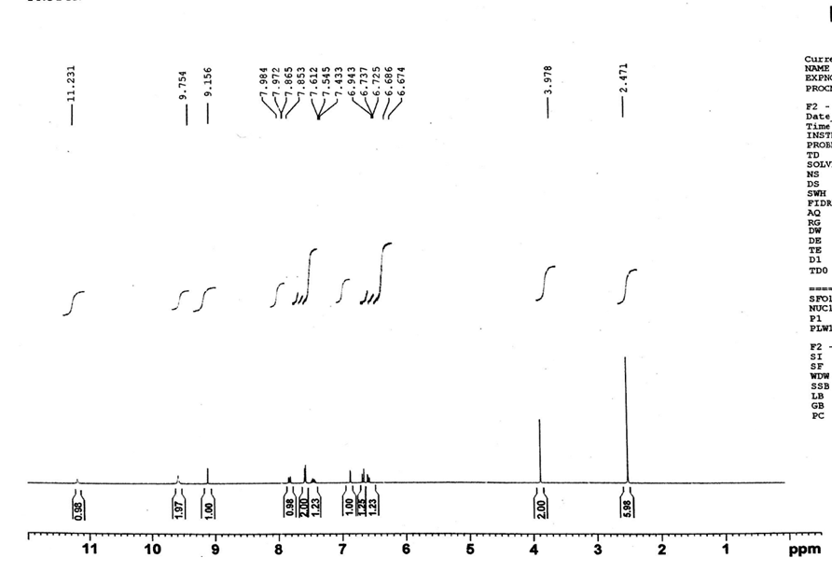
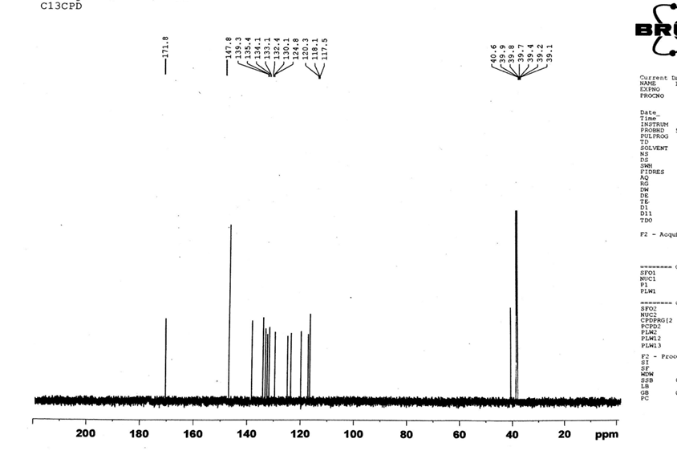
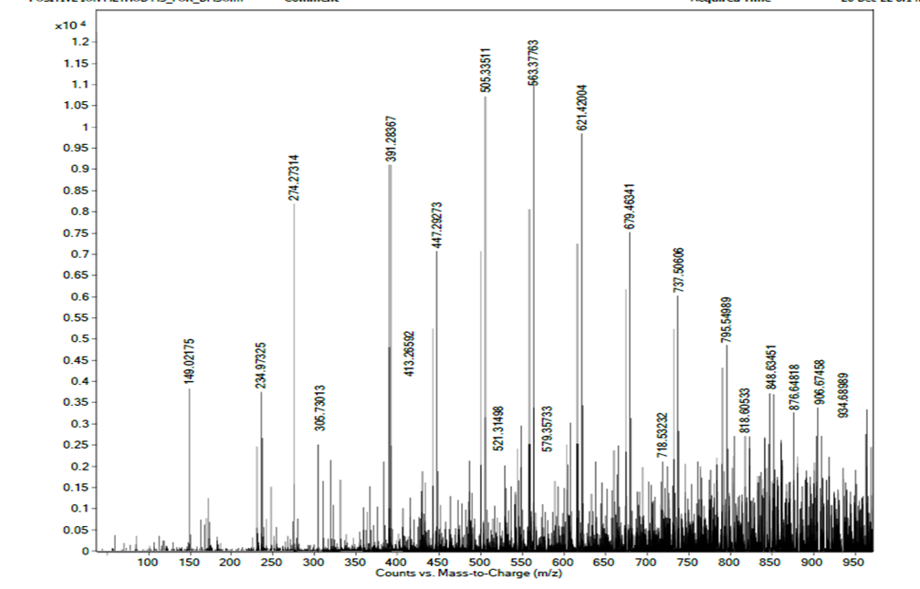
Fig S18: ¹H-, ¹³C-NMR and HR-ESI-MS spectra of compound 18
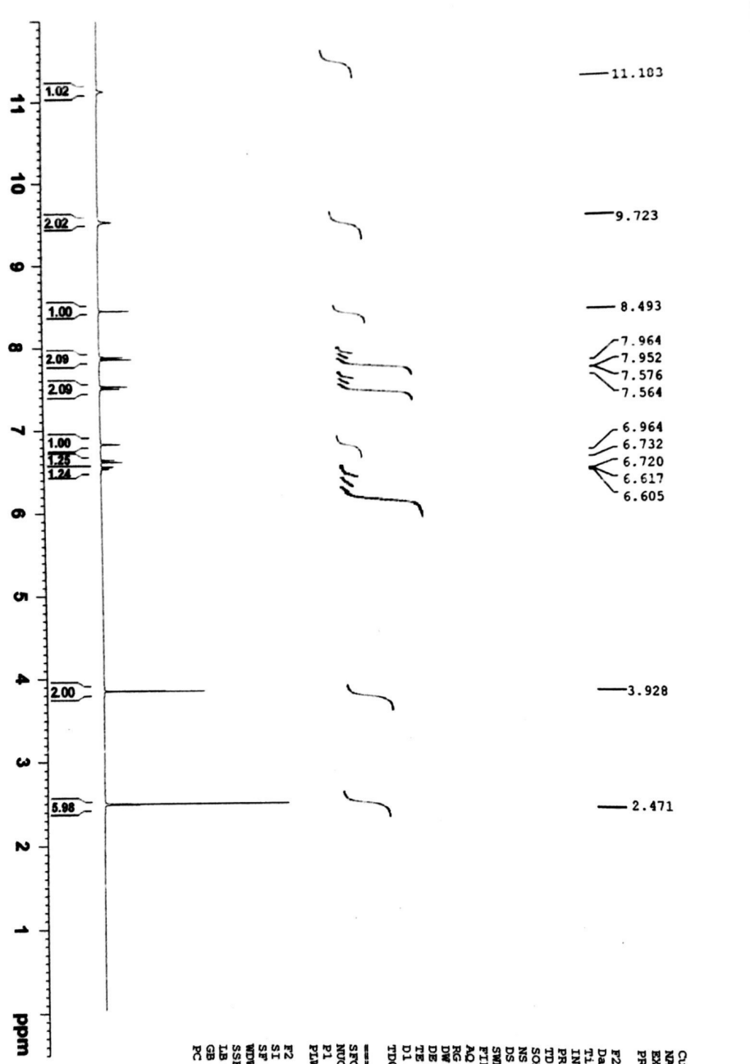
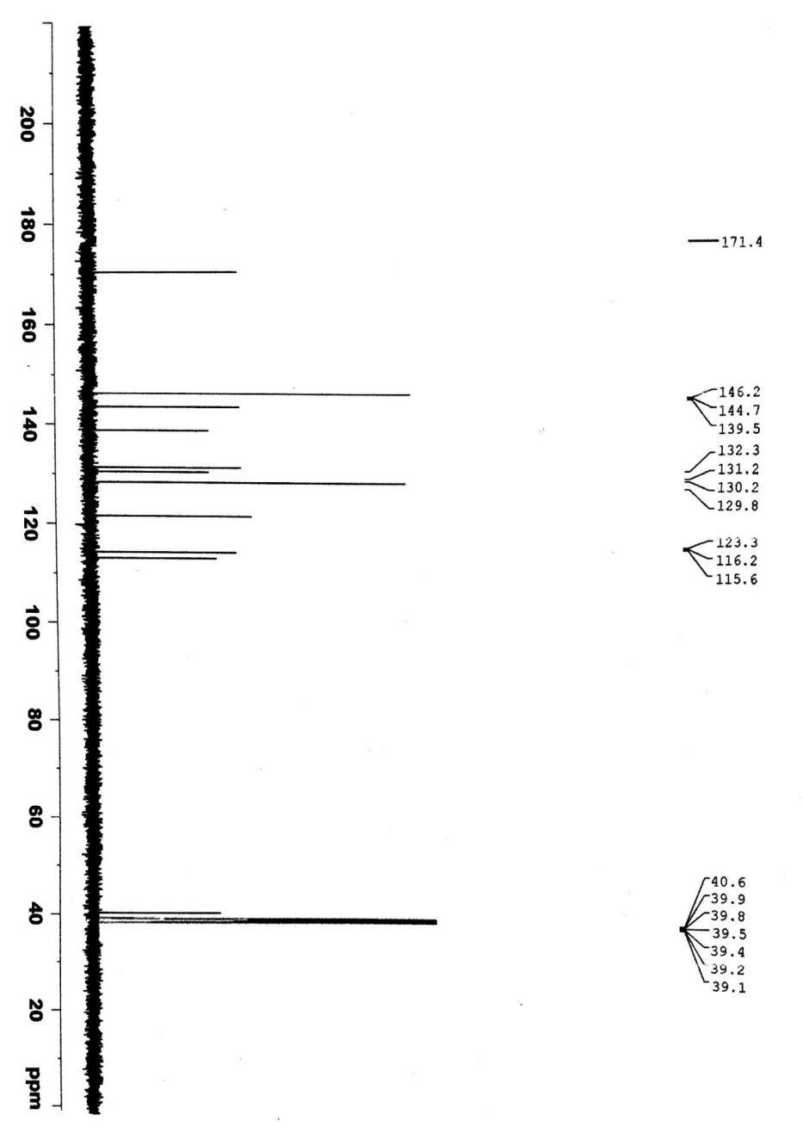
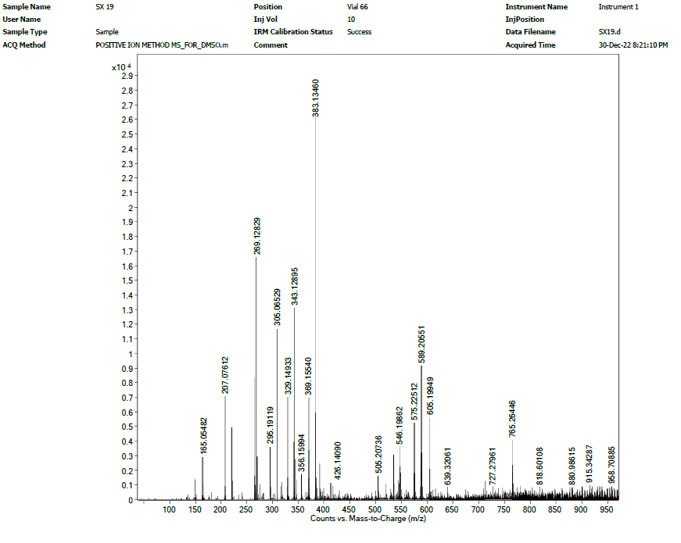
Fig S19: ¹H-, ¹³C-NMR and HR-ESI-MS spectra of compound 19
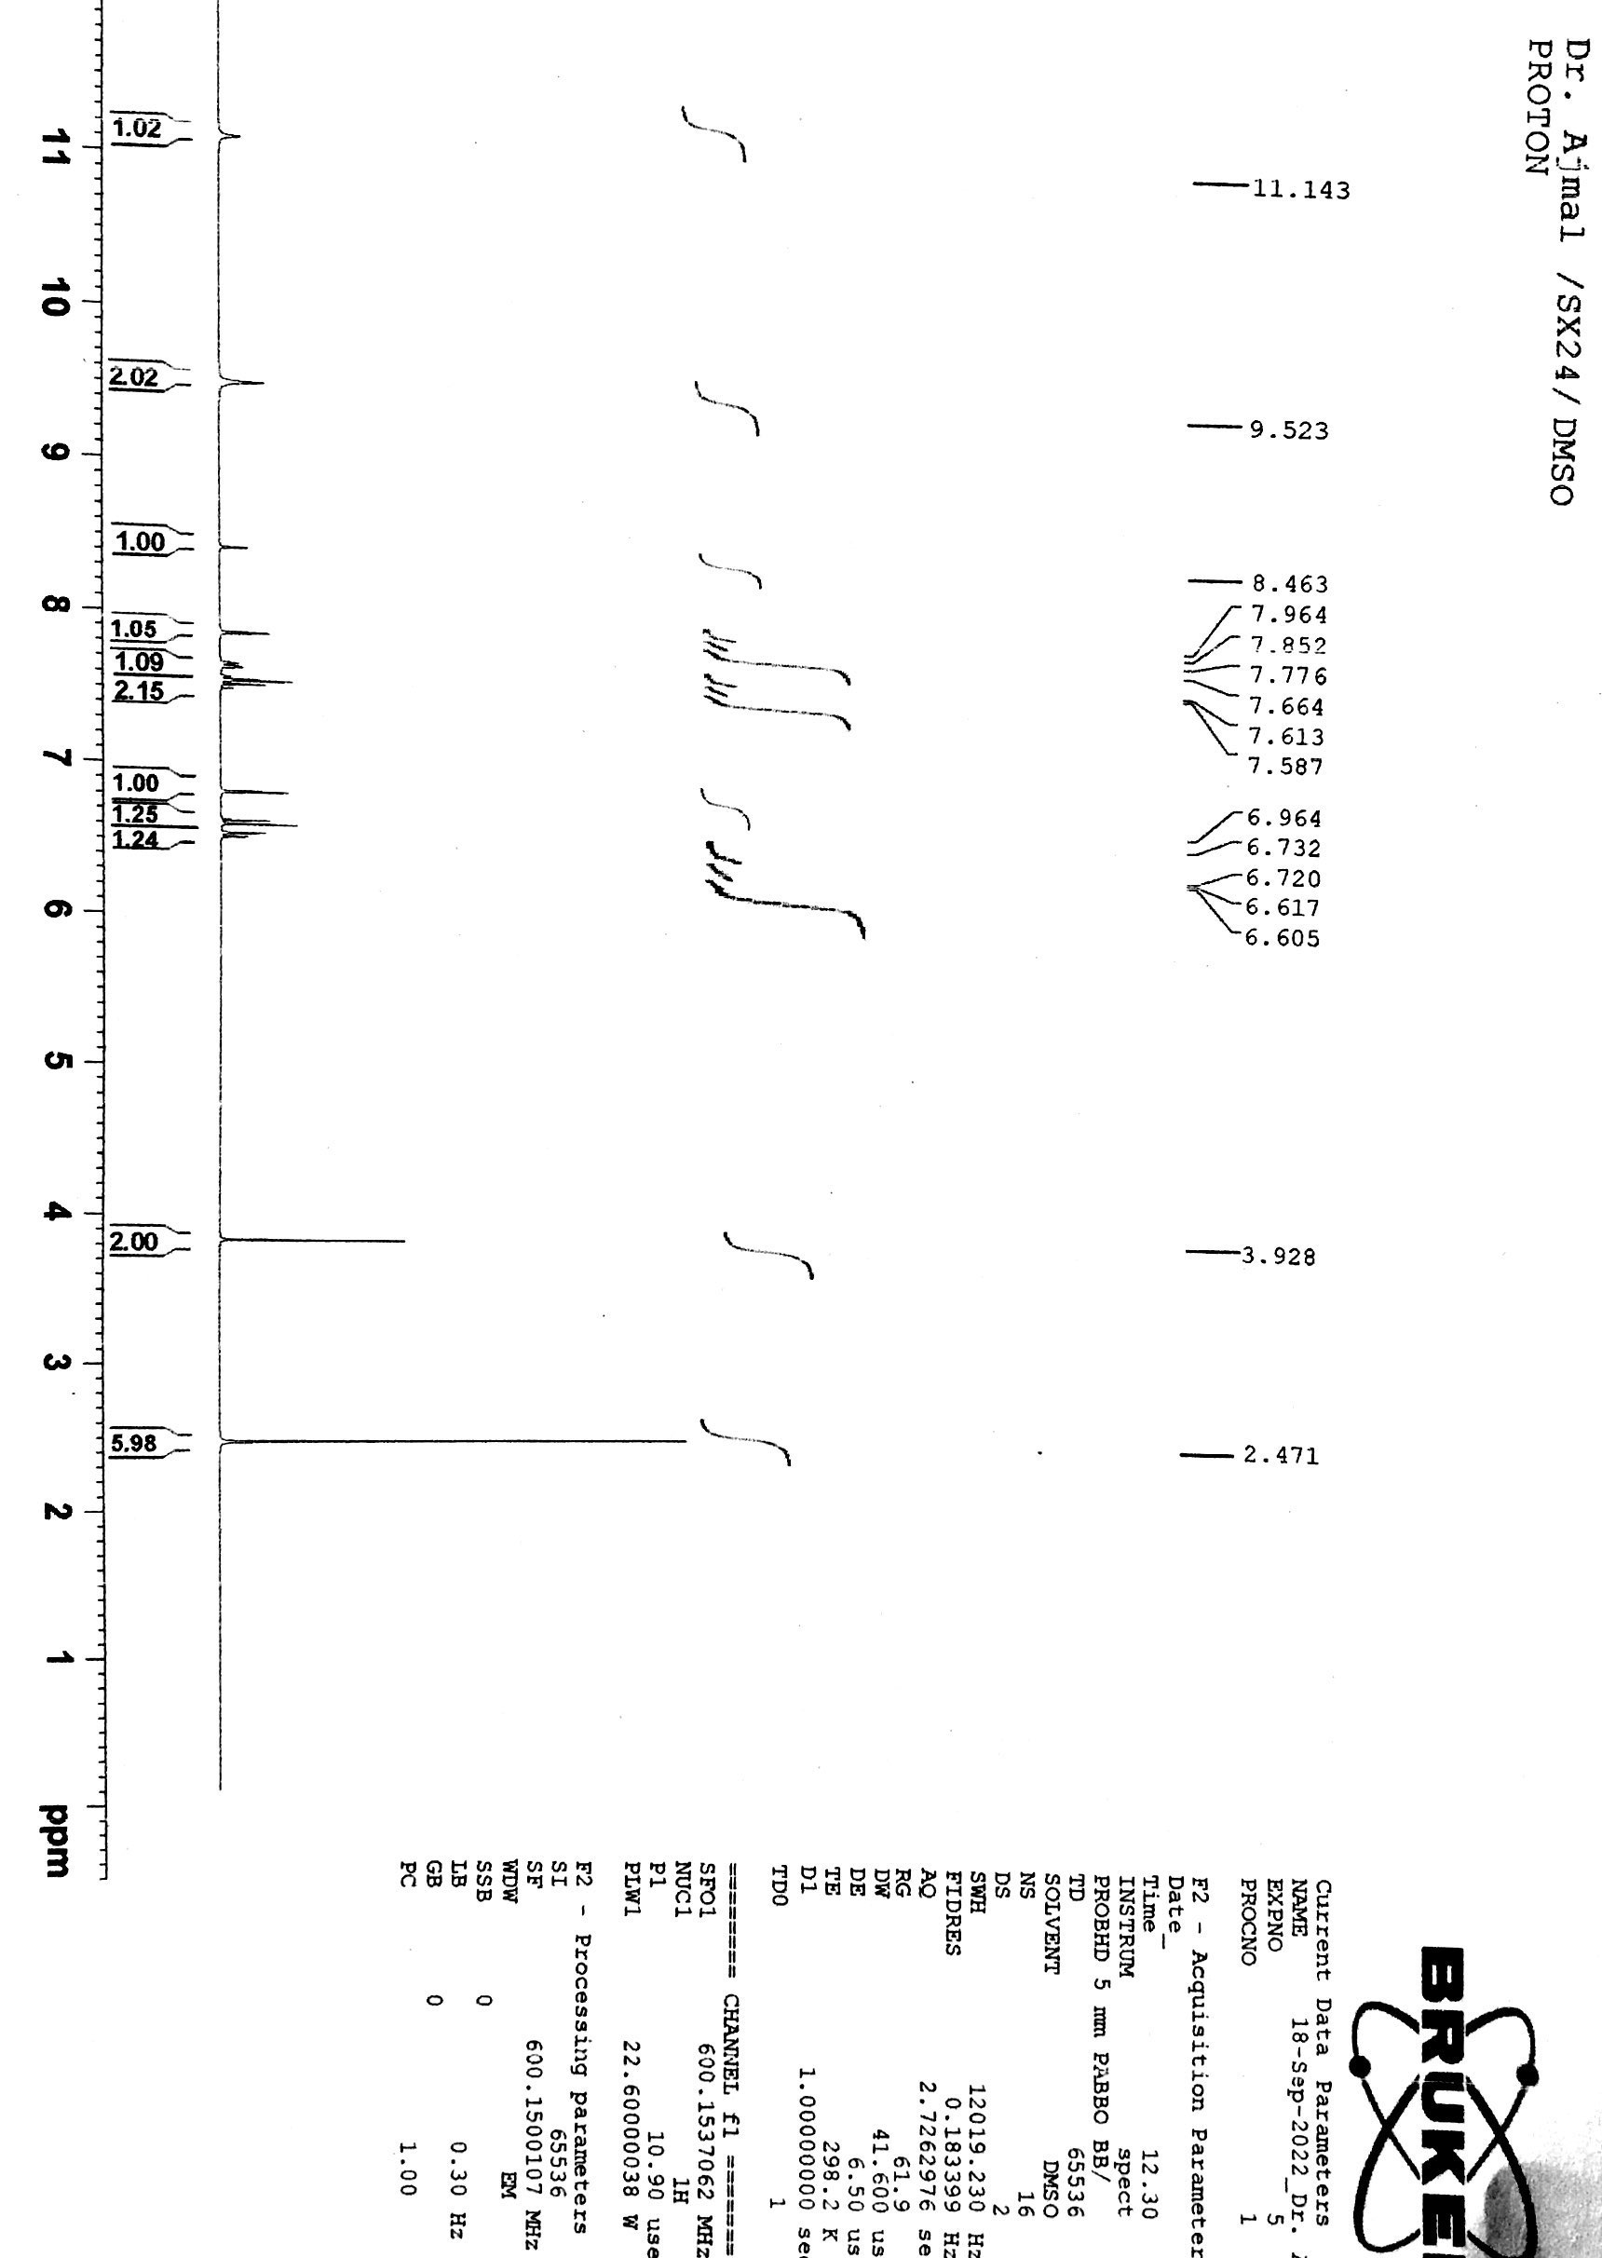
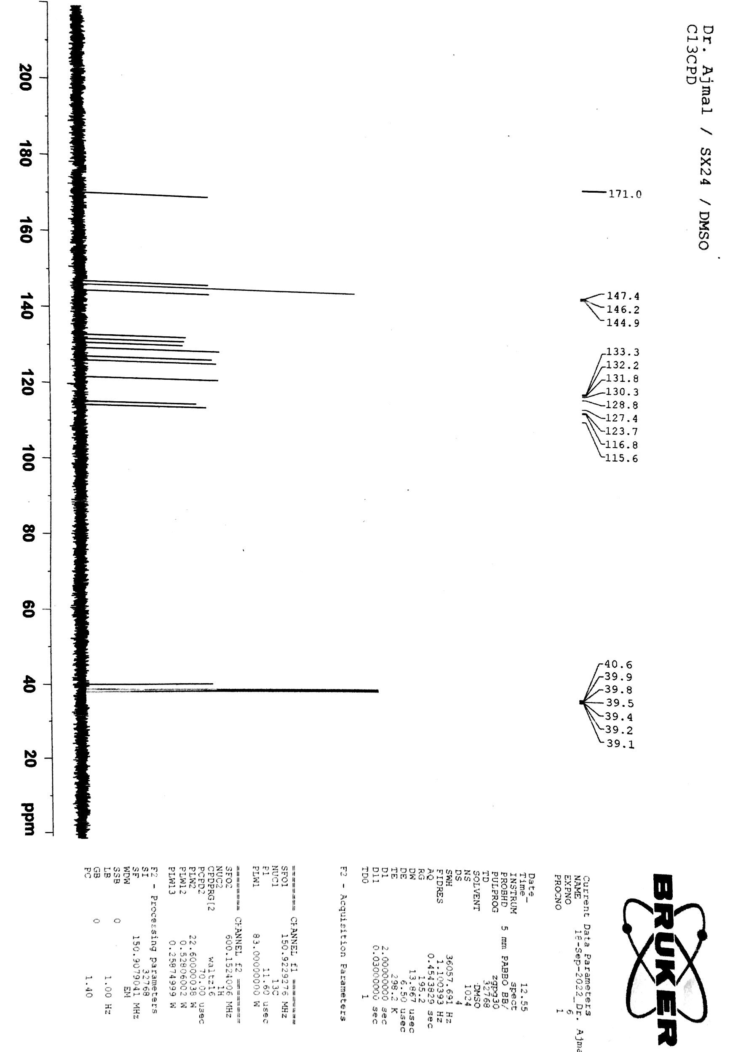
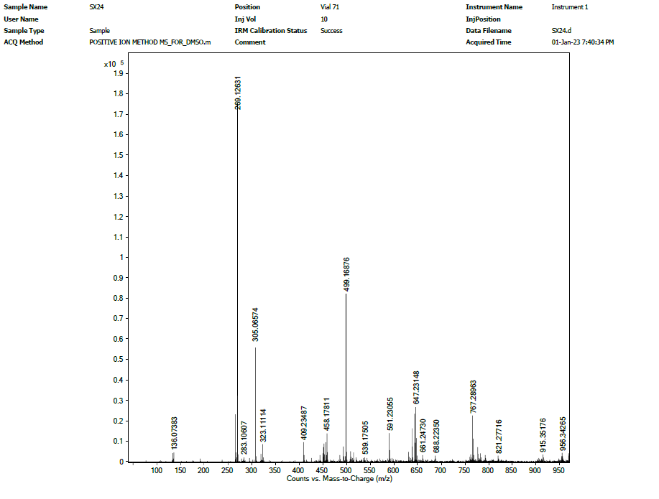
Fig S20: ¹H-, ¹³C-NMR and HR-ESI-MS spectra of compound 20

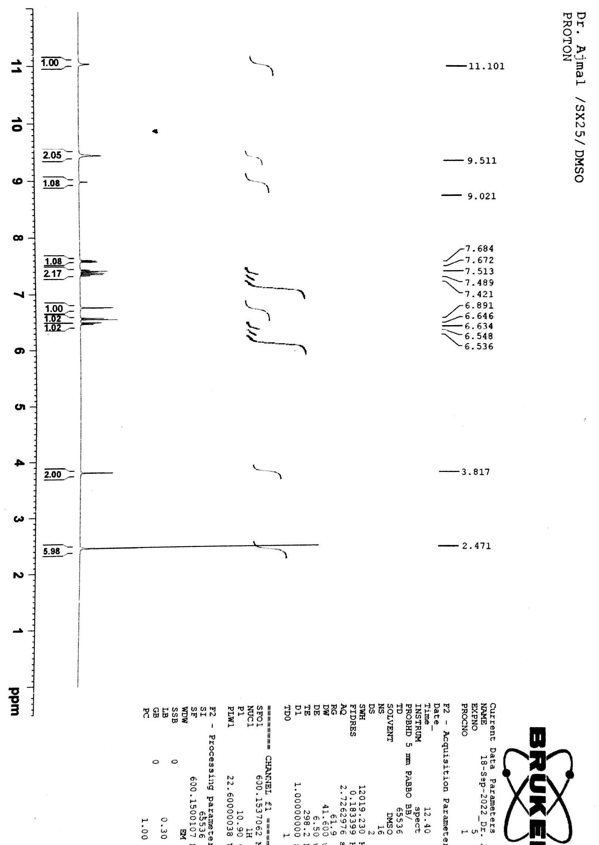
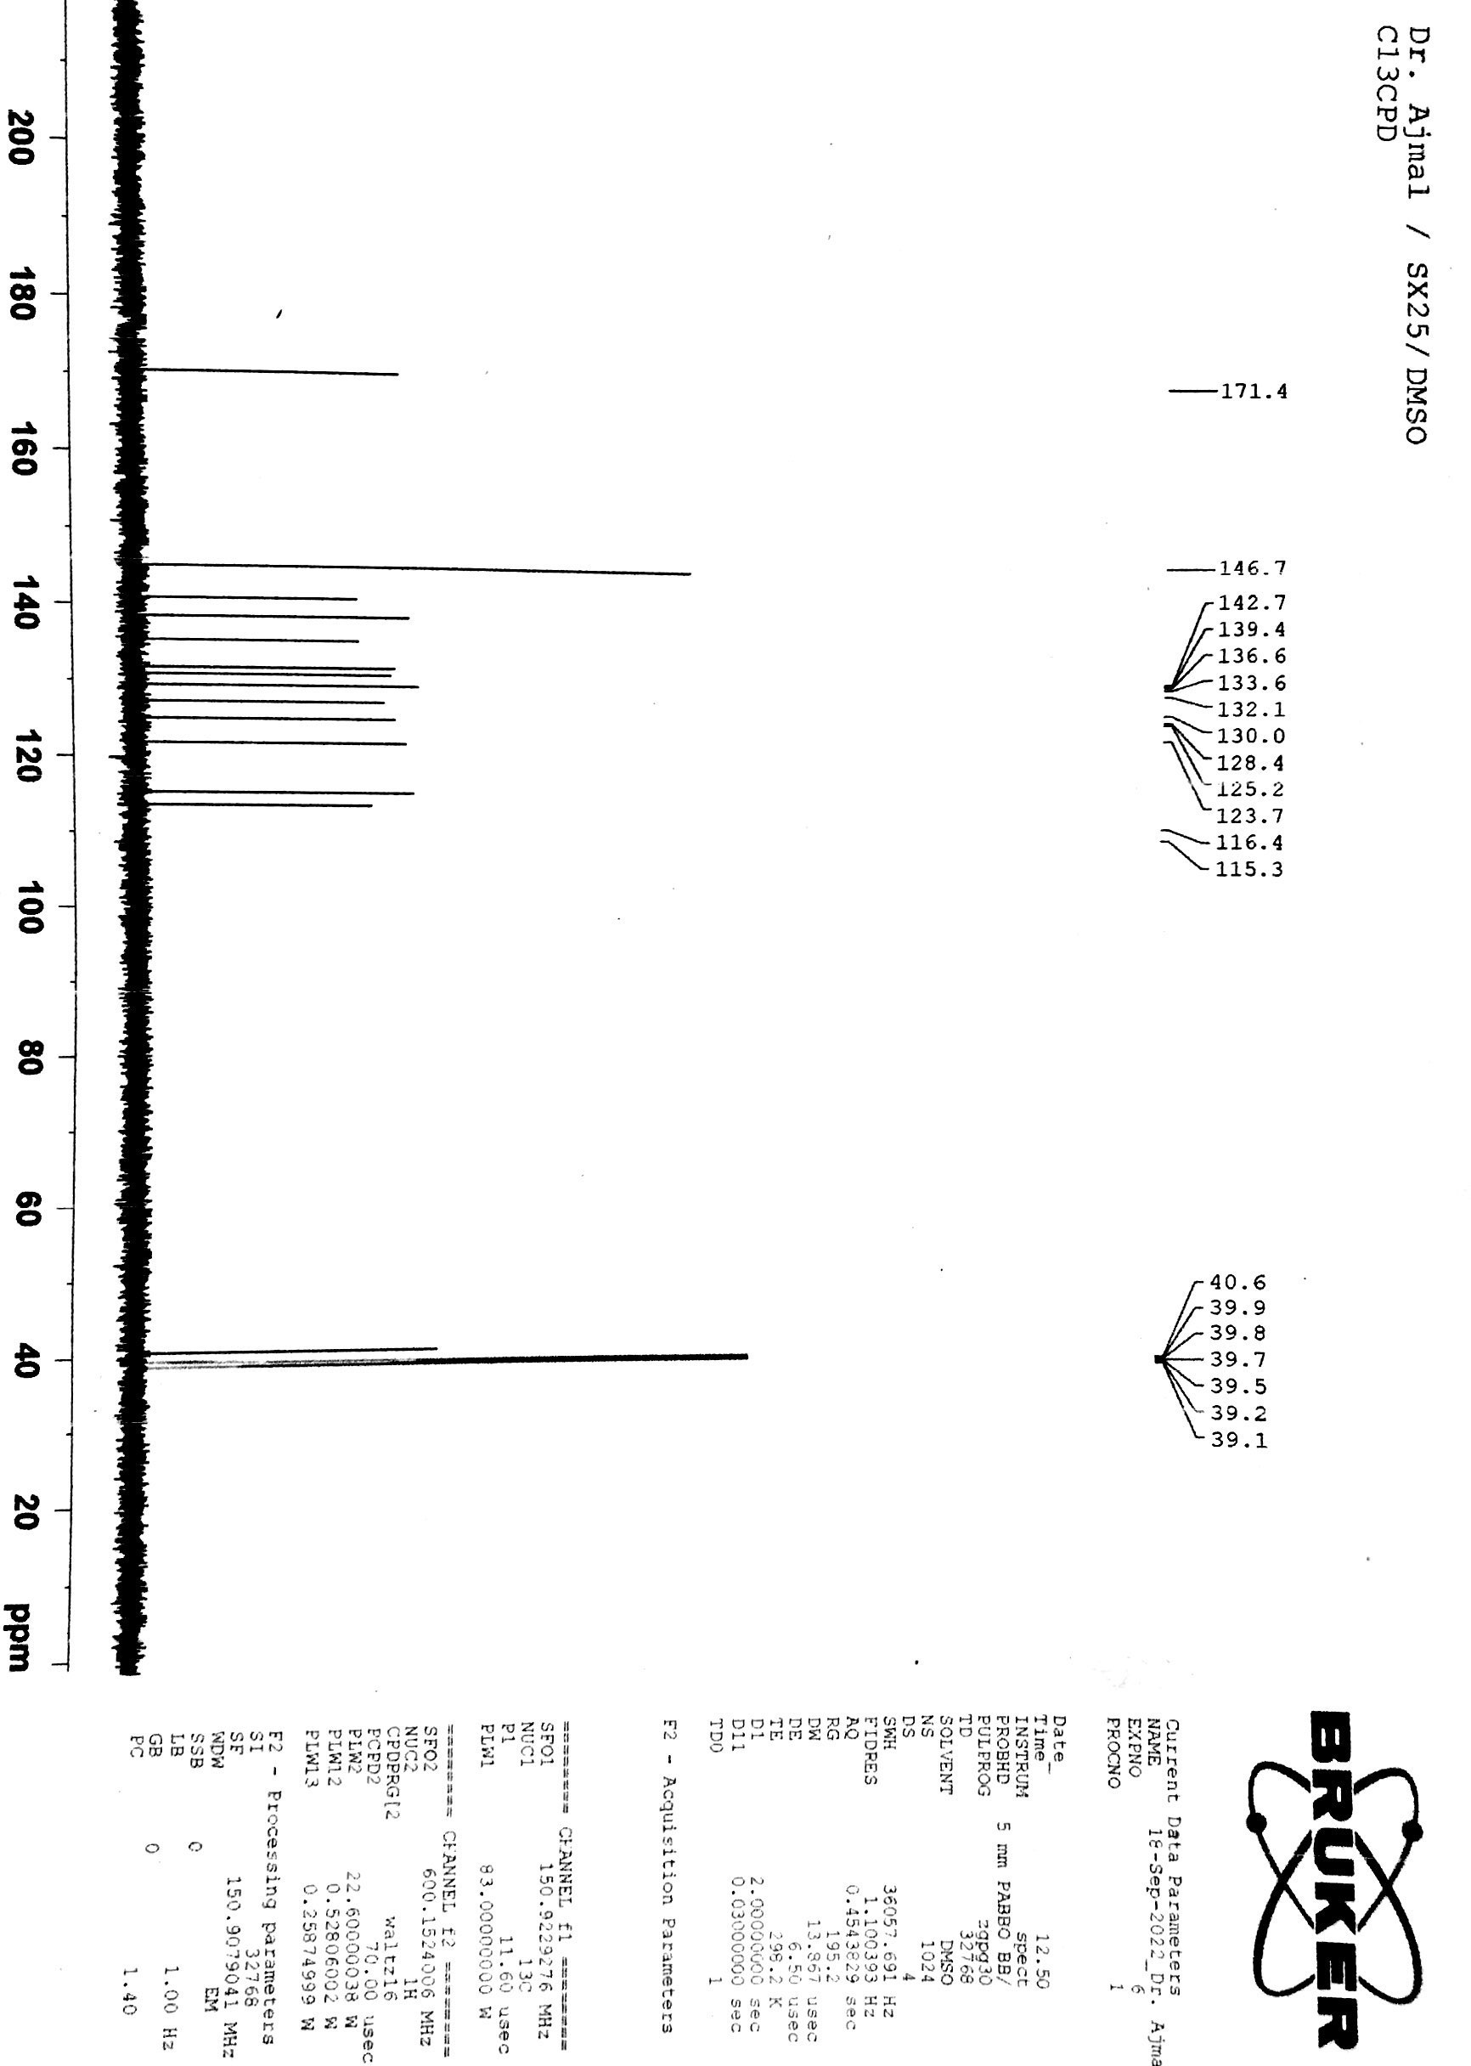
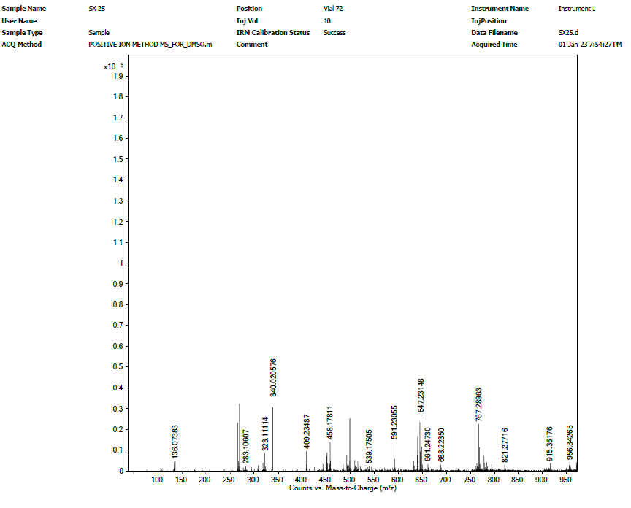
Fig S21: ¹H-, ¹³C-NMR and HR-ESI-MS spectra of compound 21
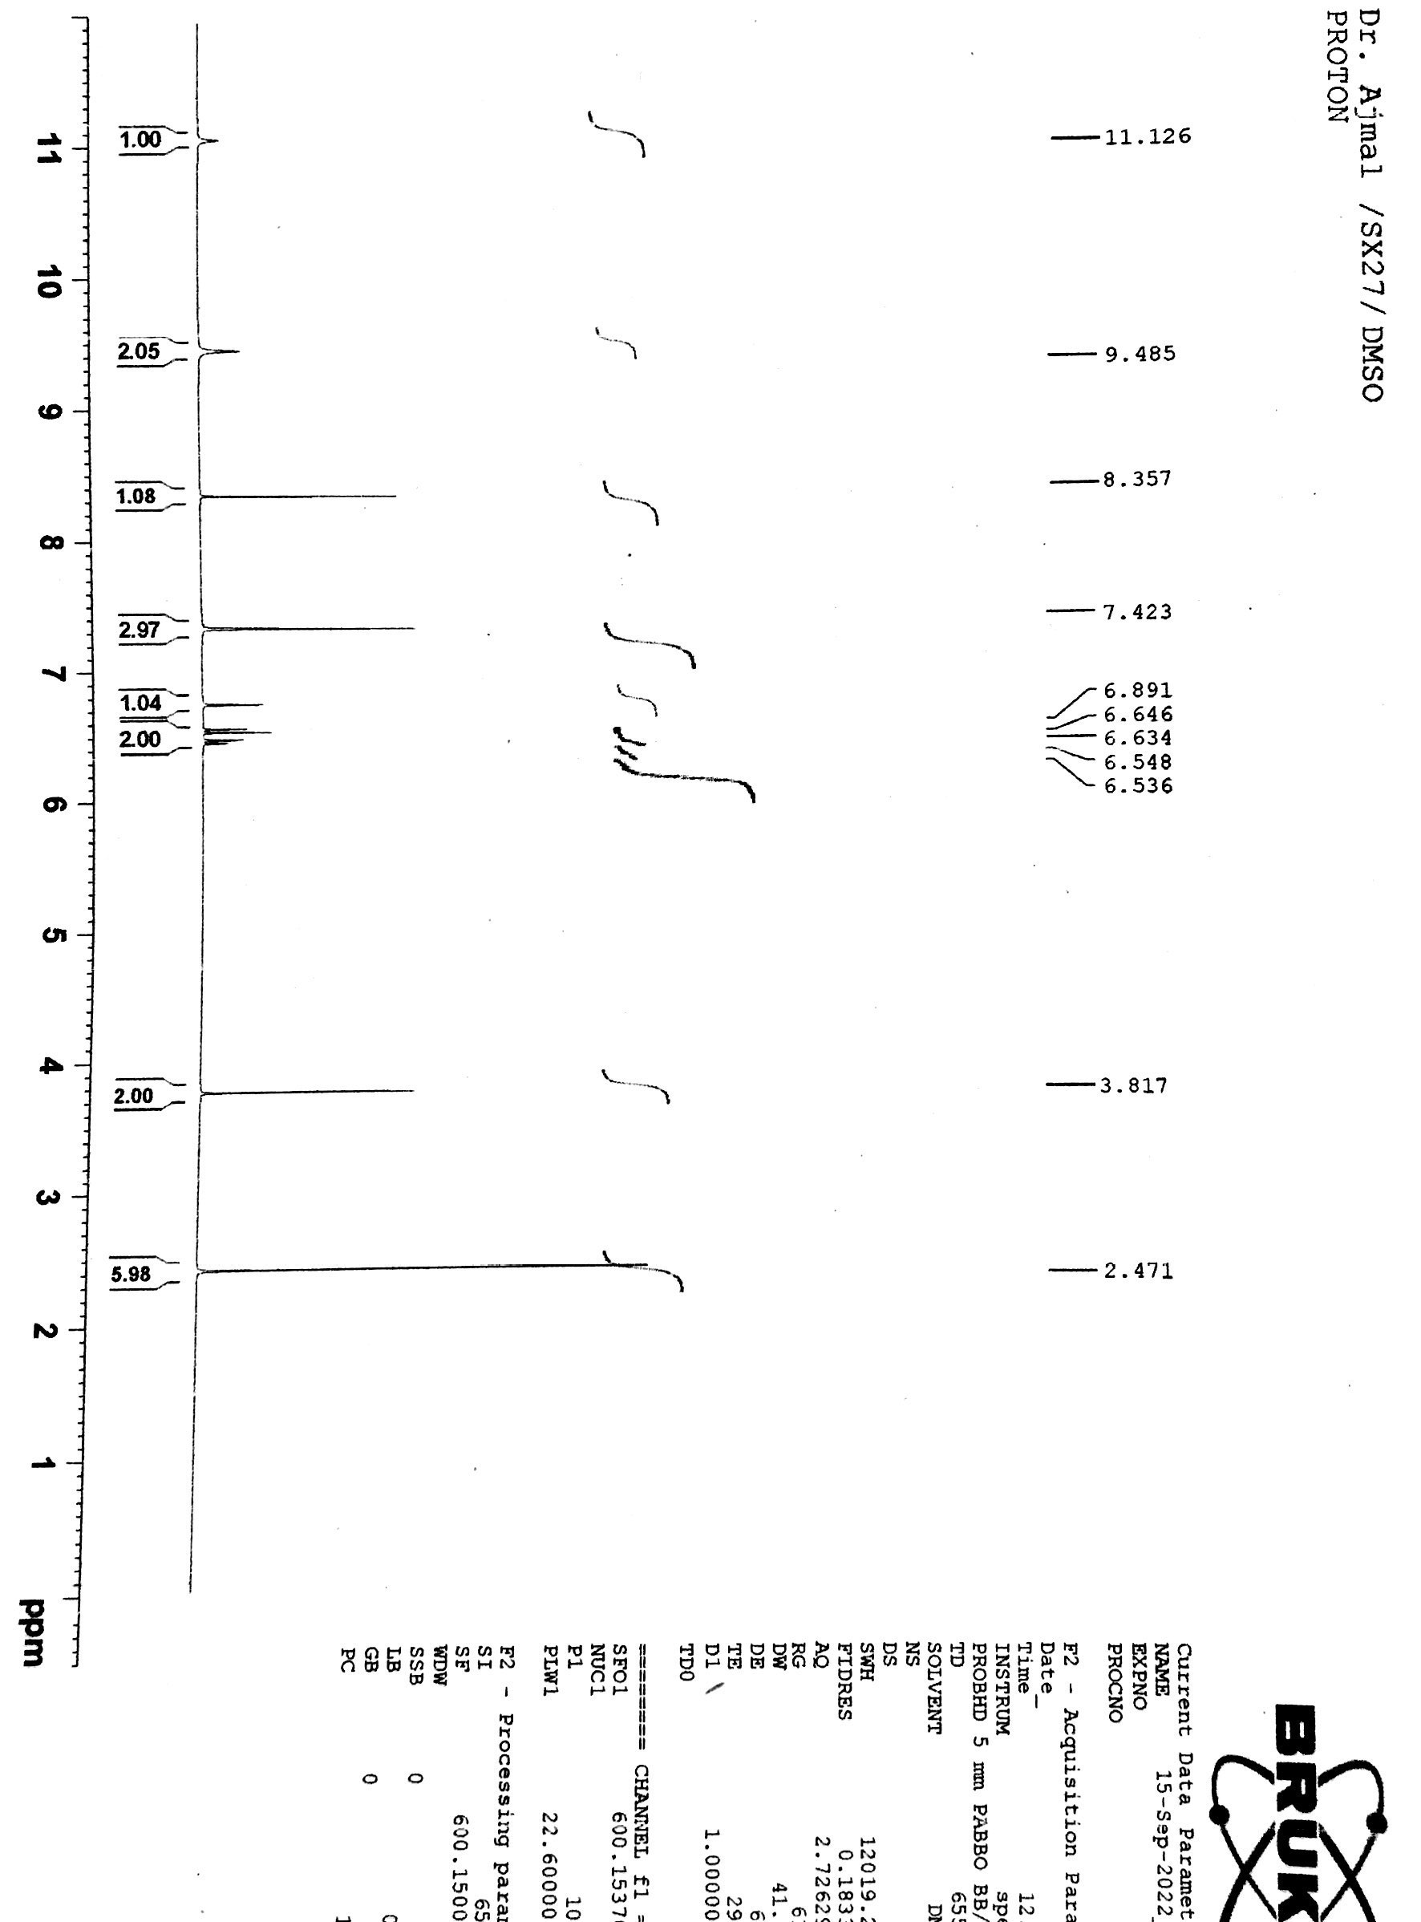
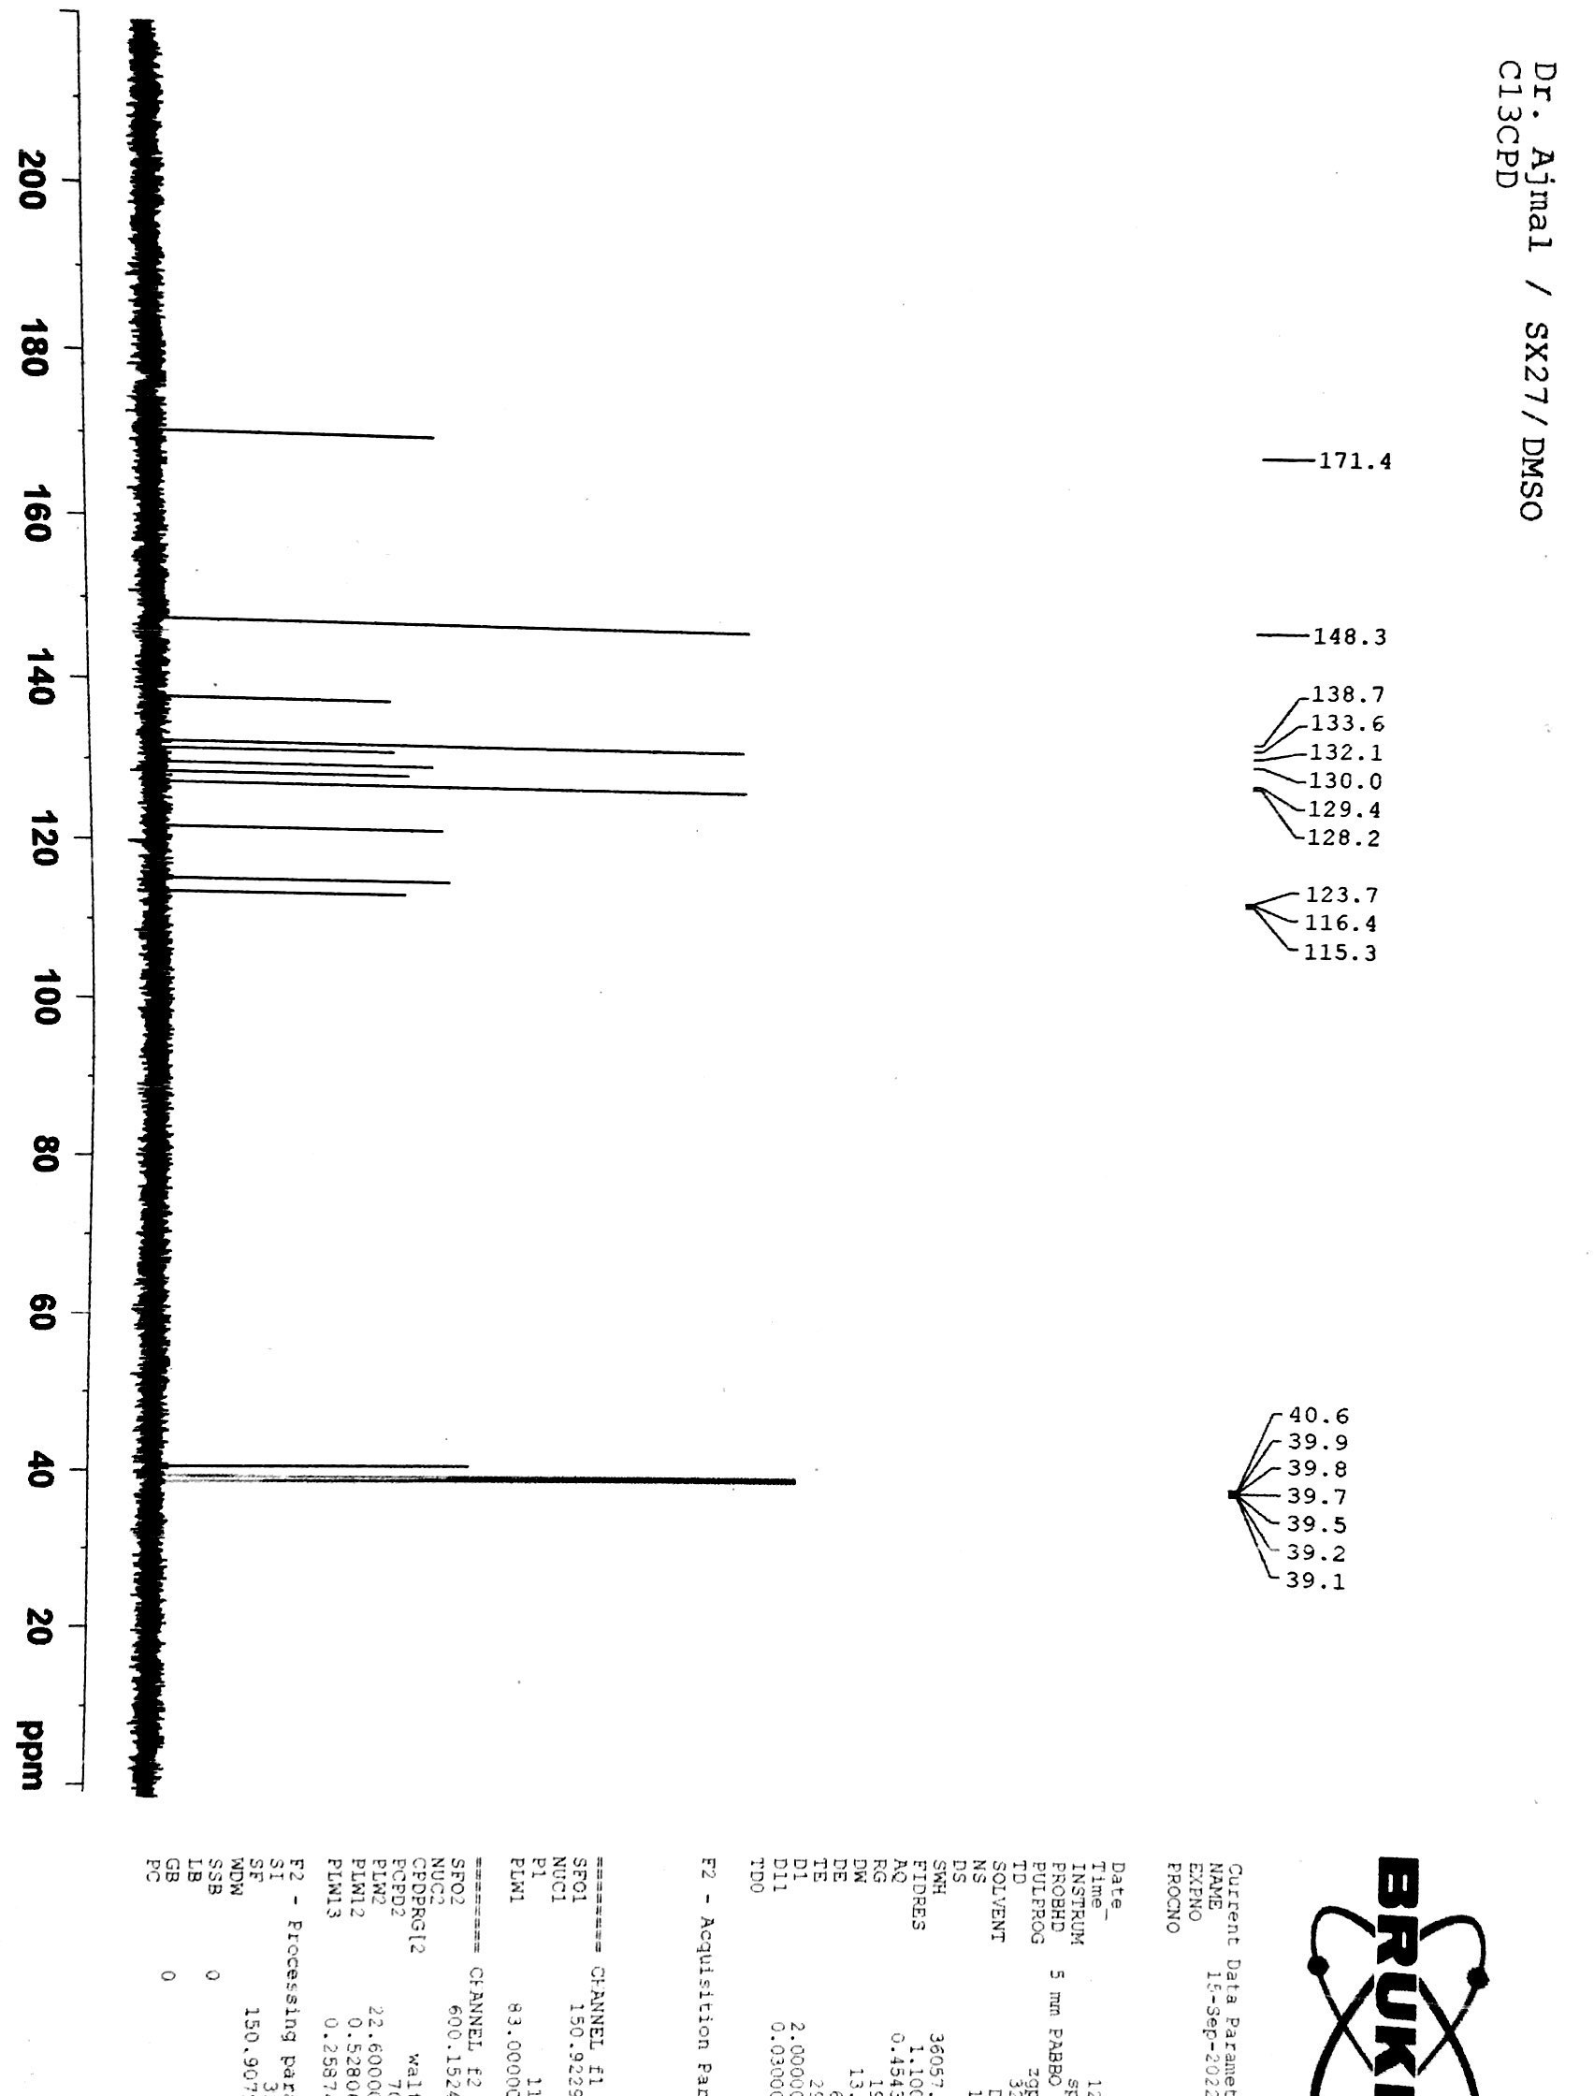
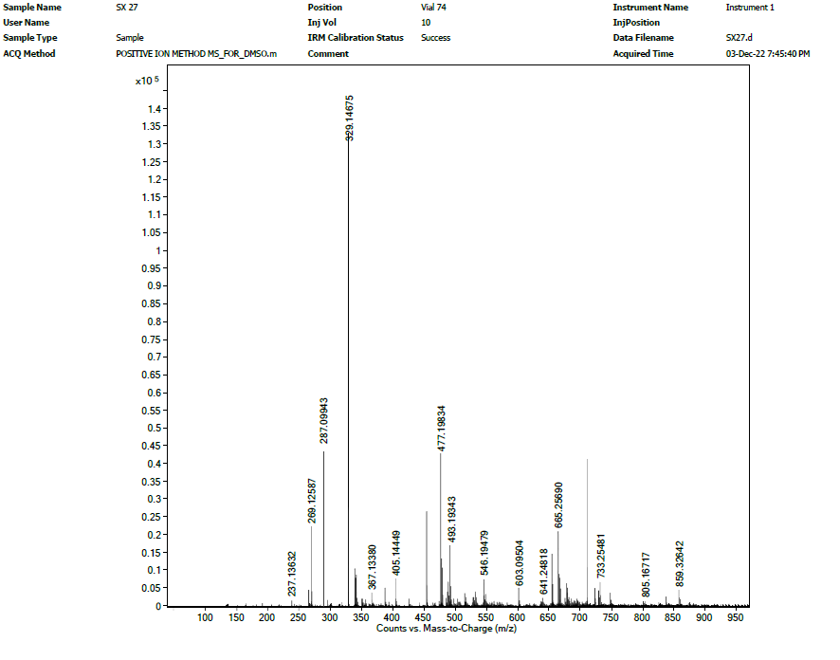
Fig S22: ¹H-, ¹³C-NMR and HR-ESI-MS spectra of compound 22
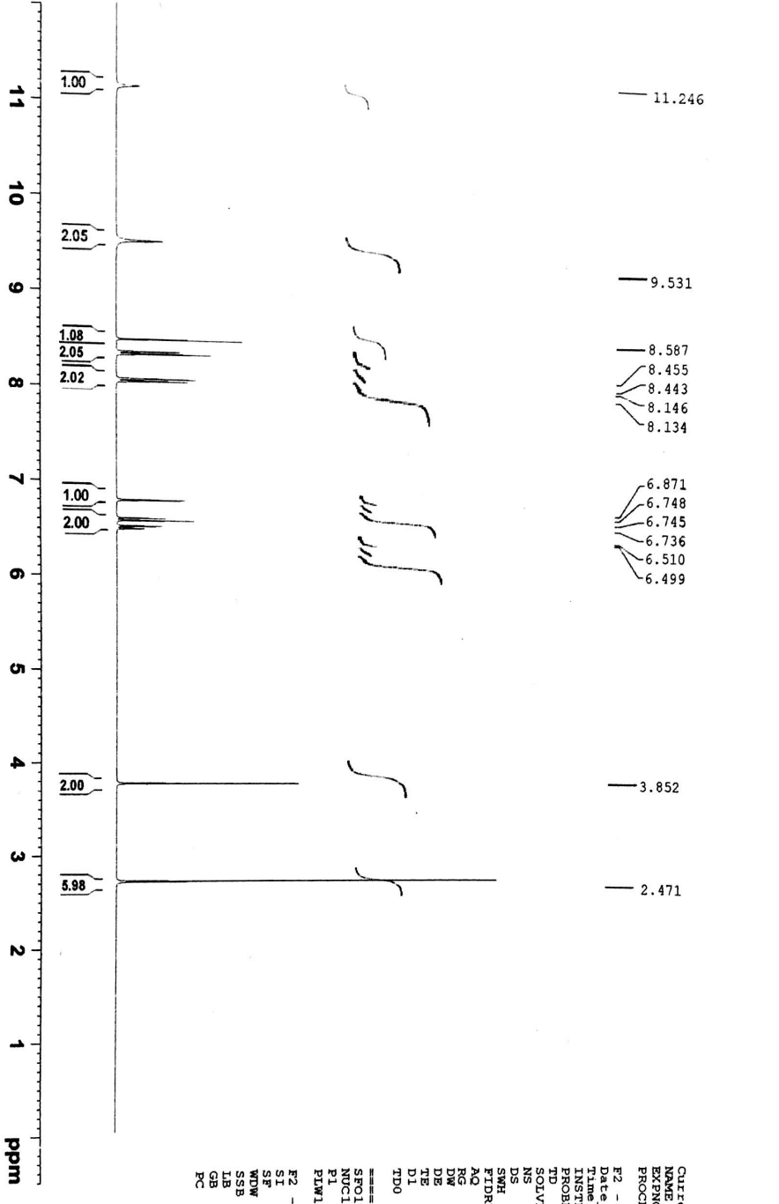
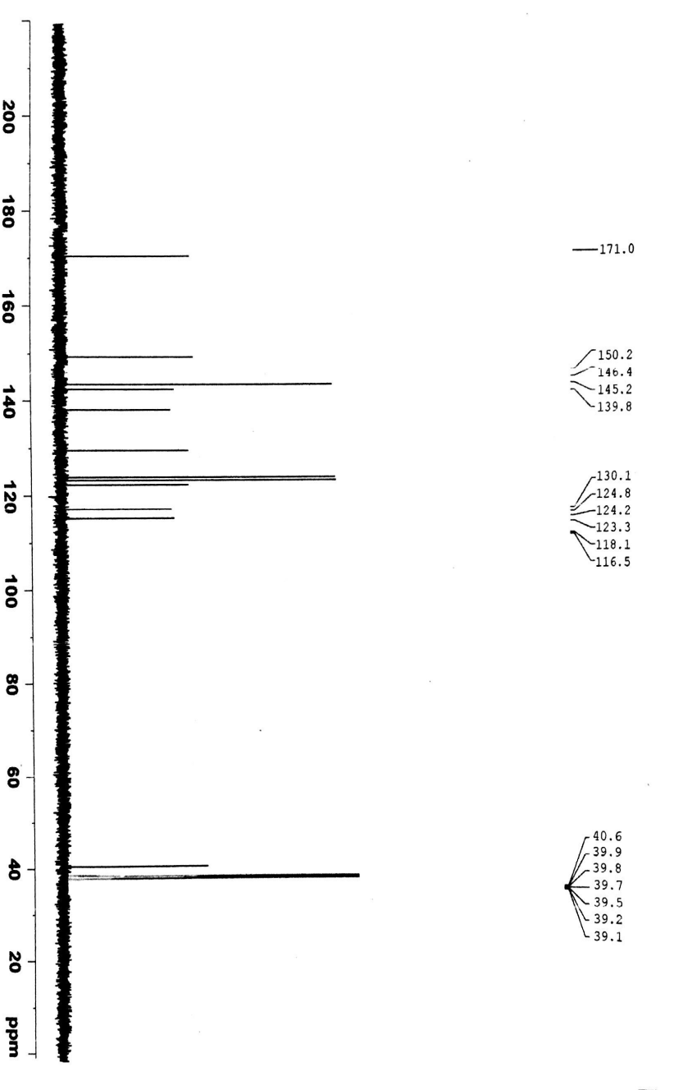
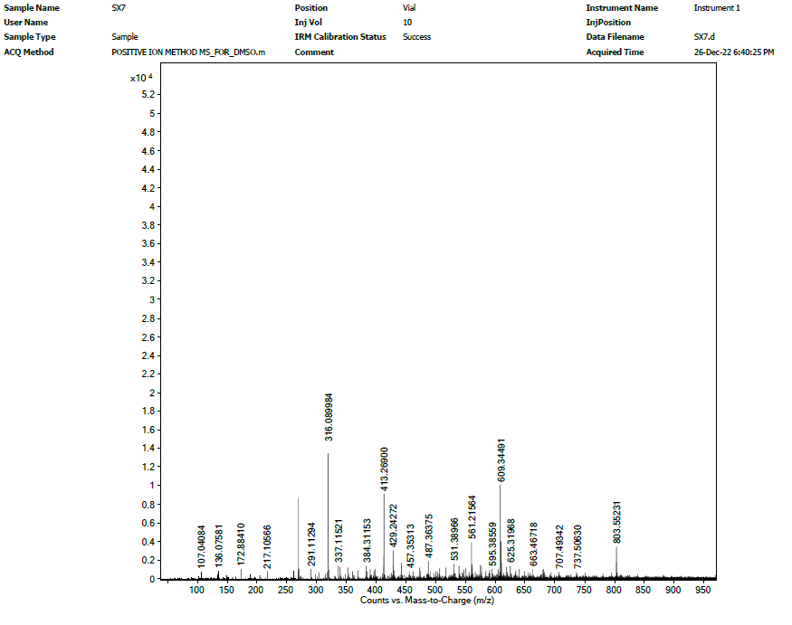 Fig S23: ¹H-, ¹³C-NMR and HR-ESI-MS spectra of compound 23
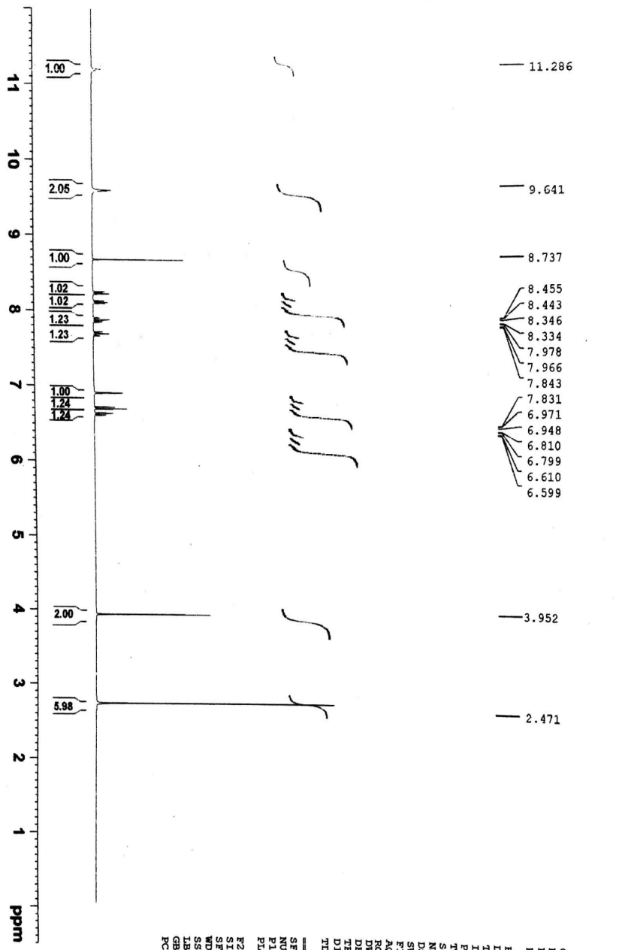
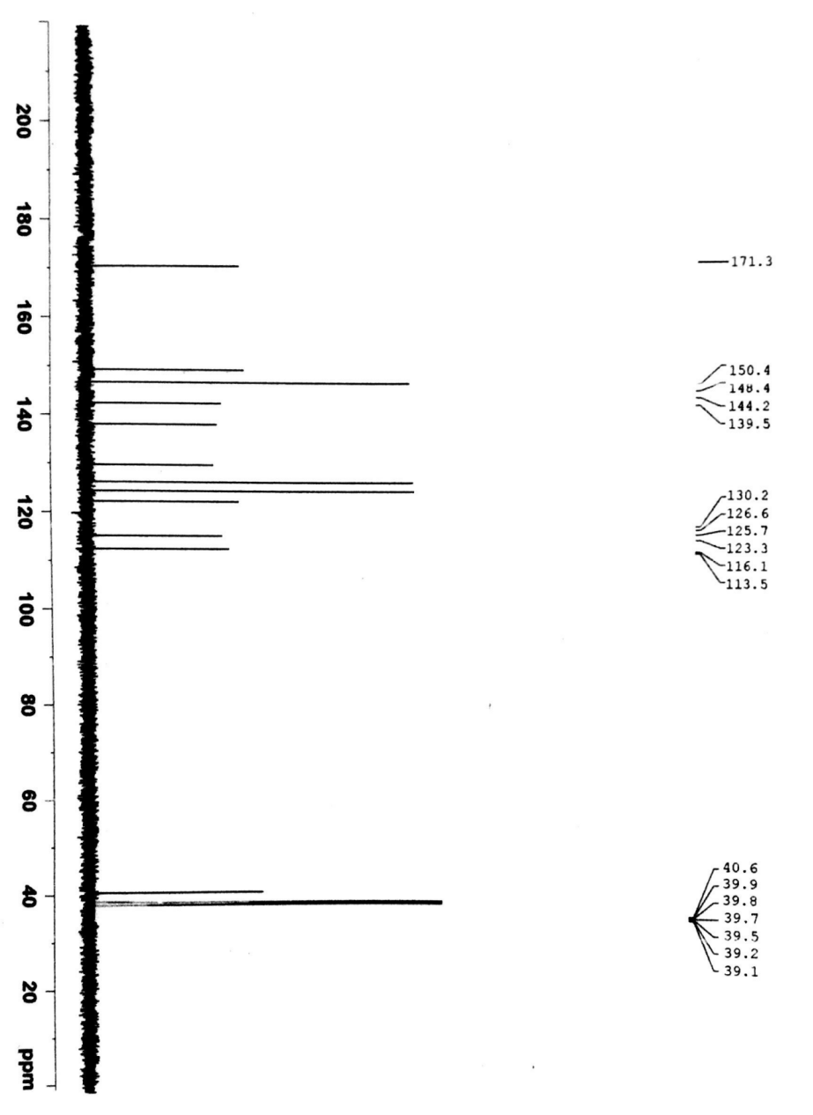
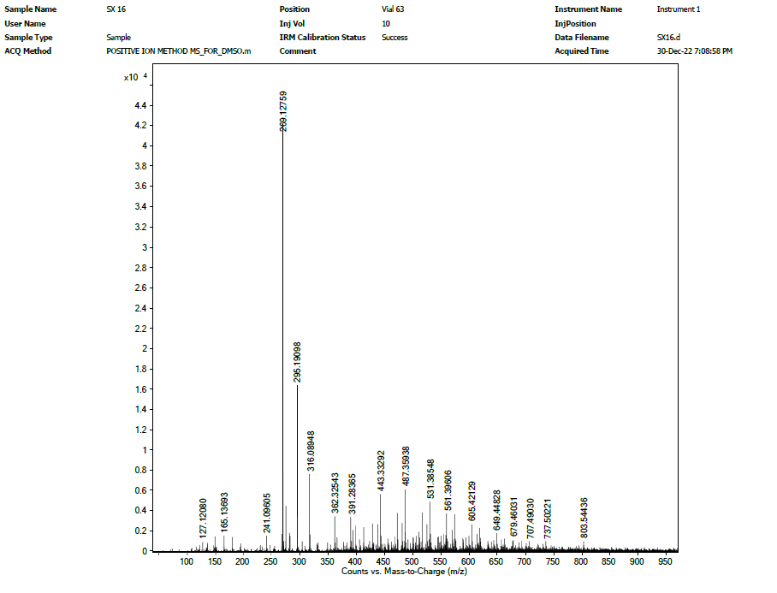 Fig S24: ¹H-, ¹³C-NMR and HR-ESI-MS spectra of compound 24
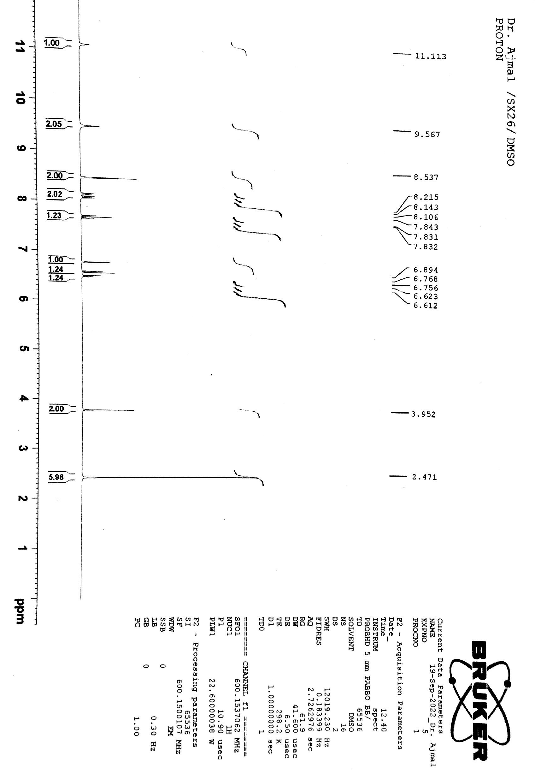
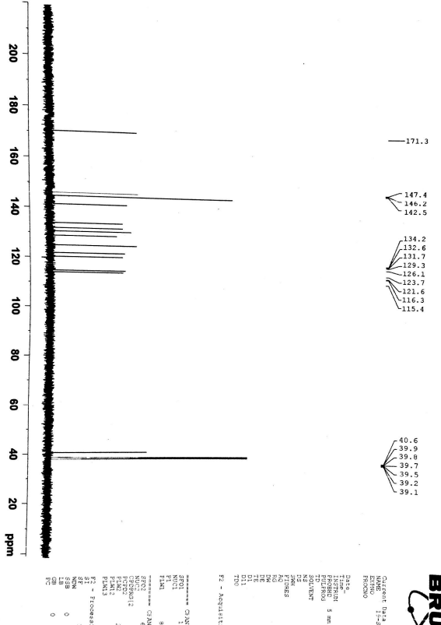
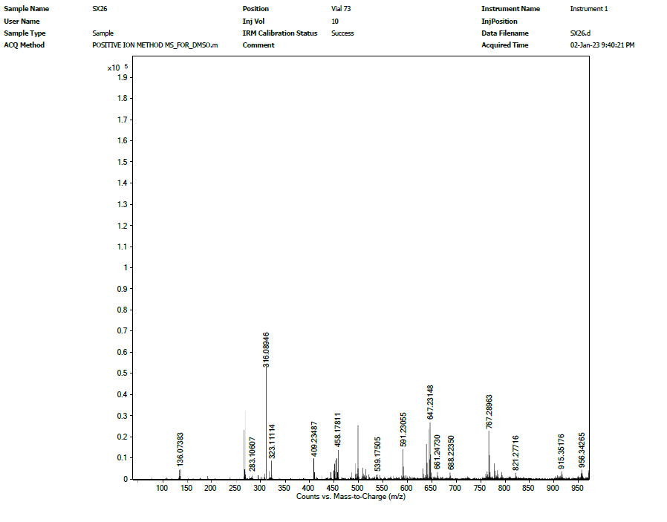
Fig S25: ¹H-, ¹³C-NMR and HR-ESI-MS spectra of compound 25

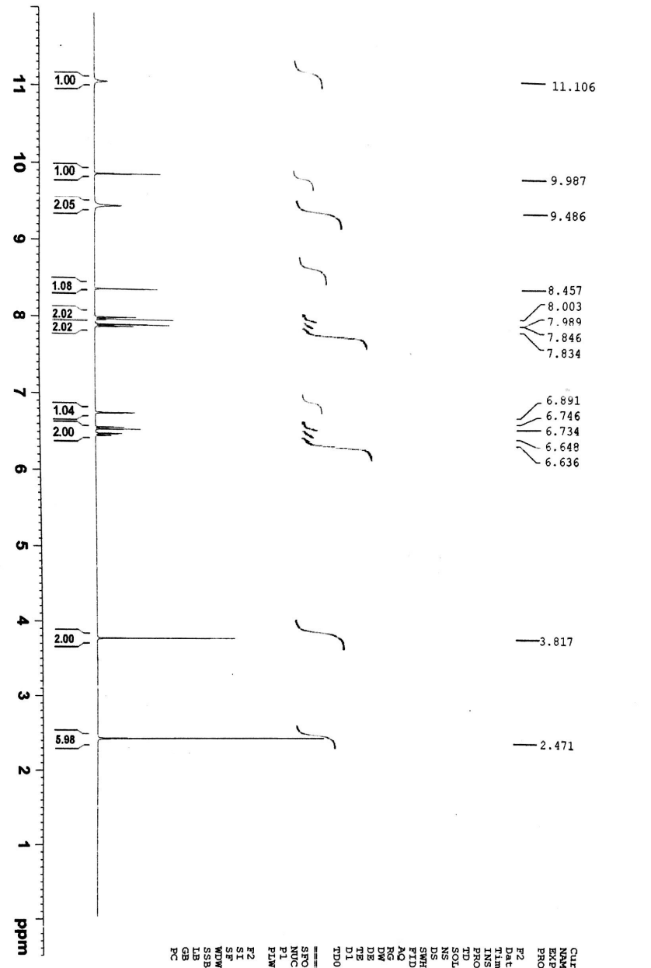
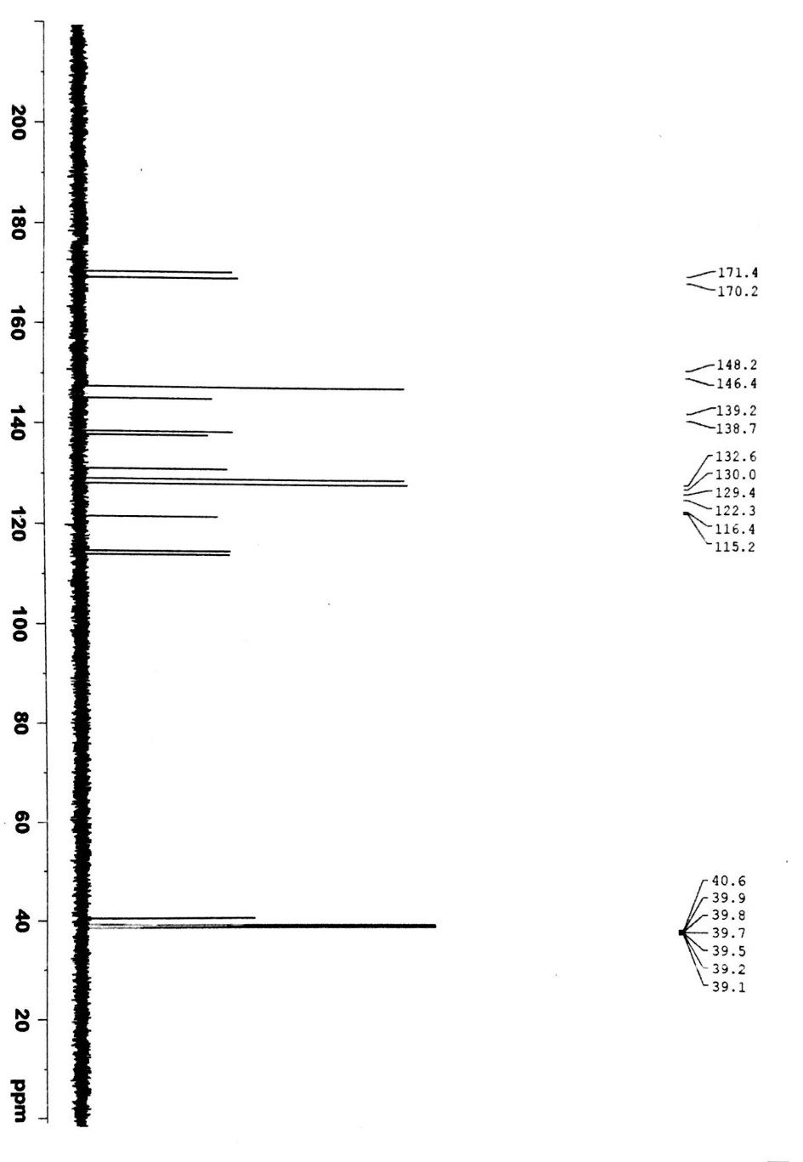
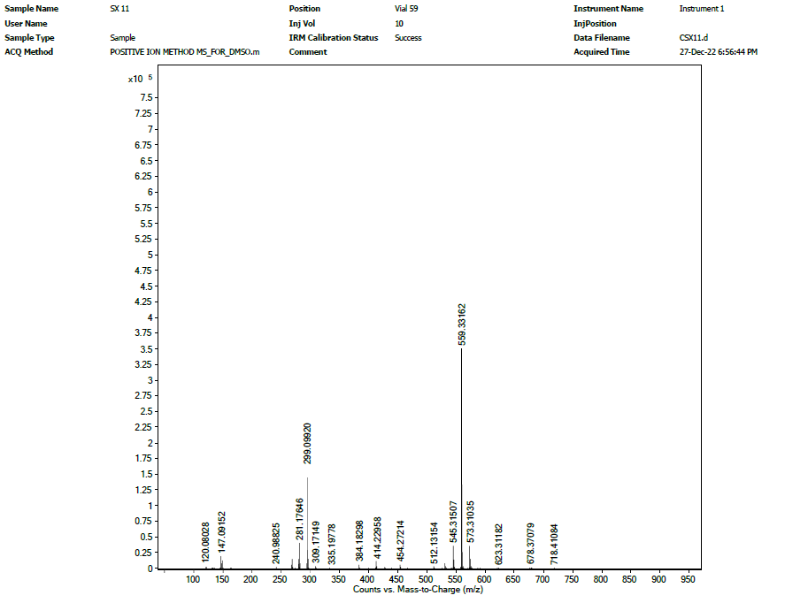
Fig S26: ¹H-, ¹³C-NMR and HR-ESI-MS spectra of compound 26

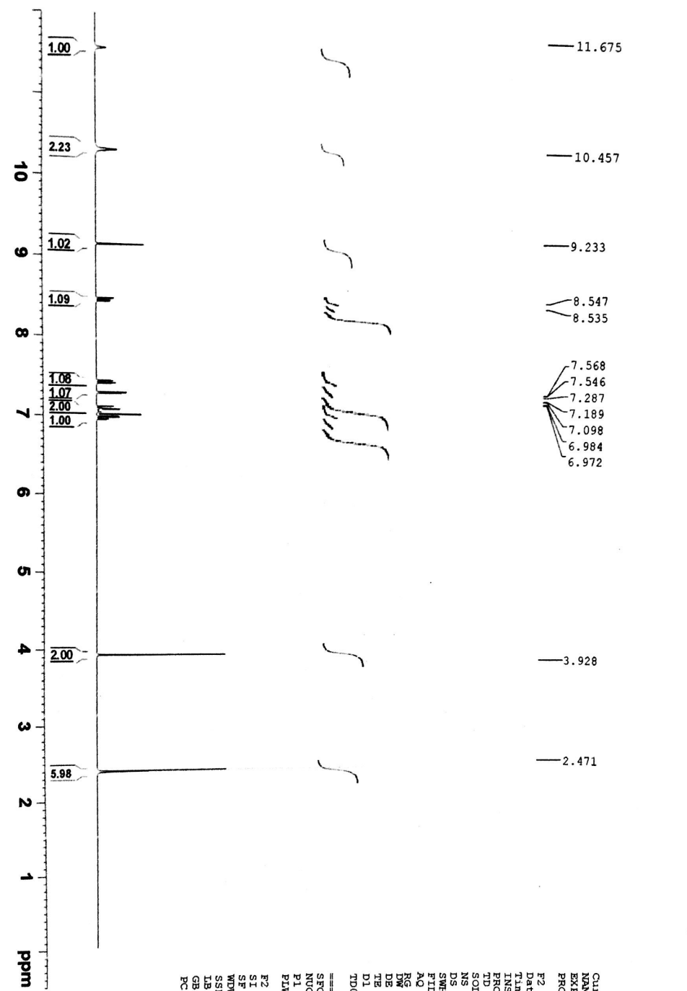
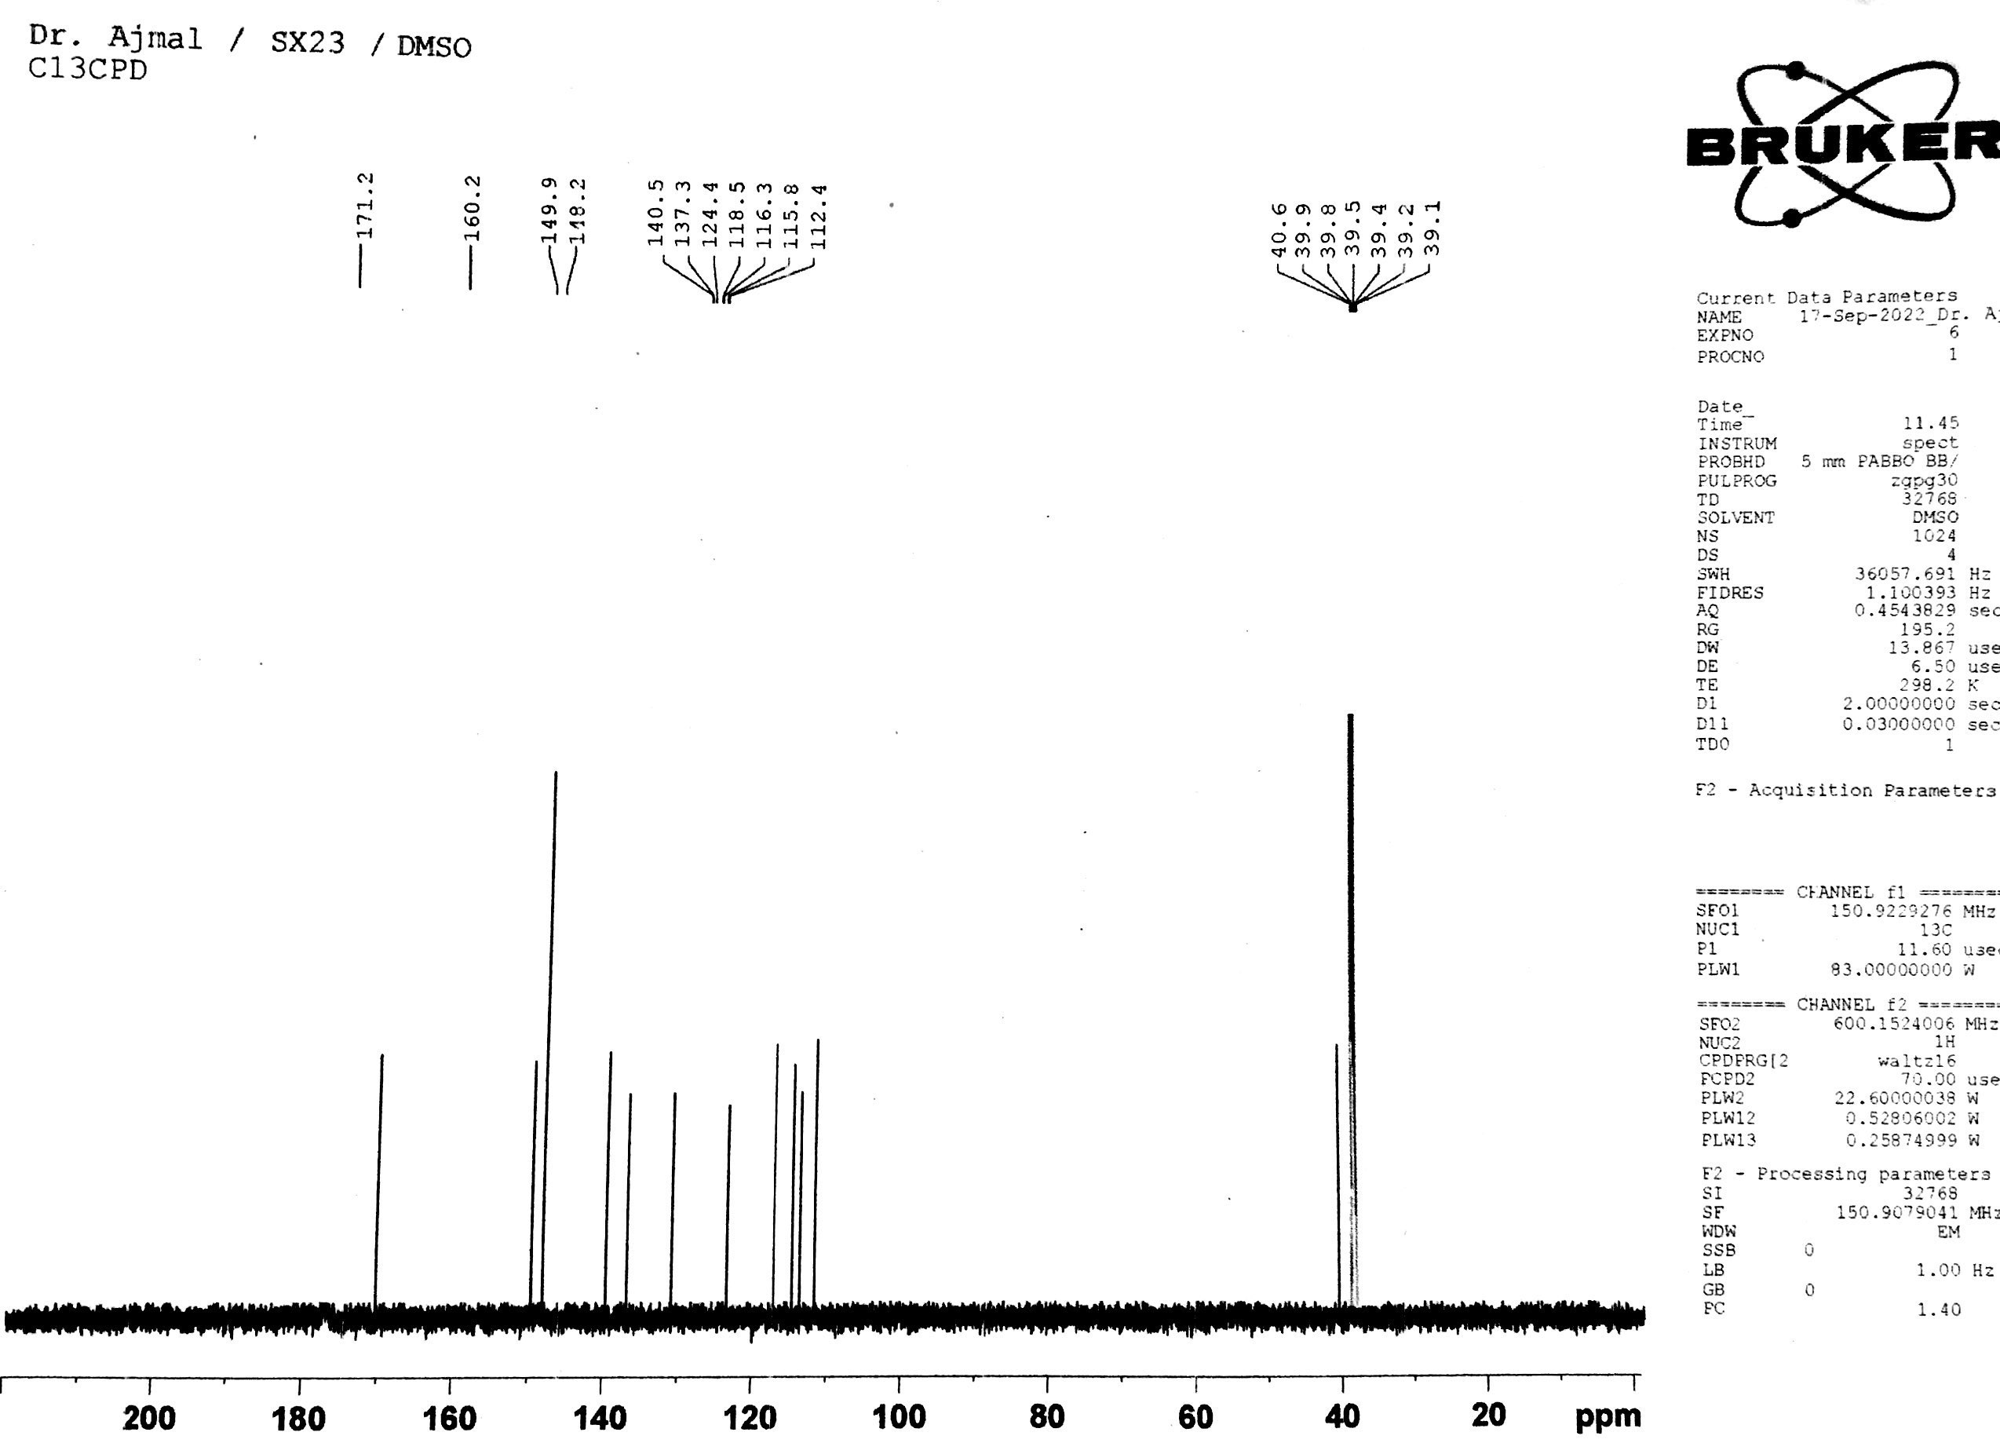
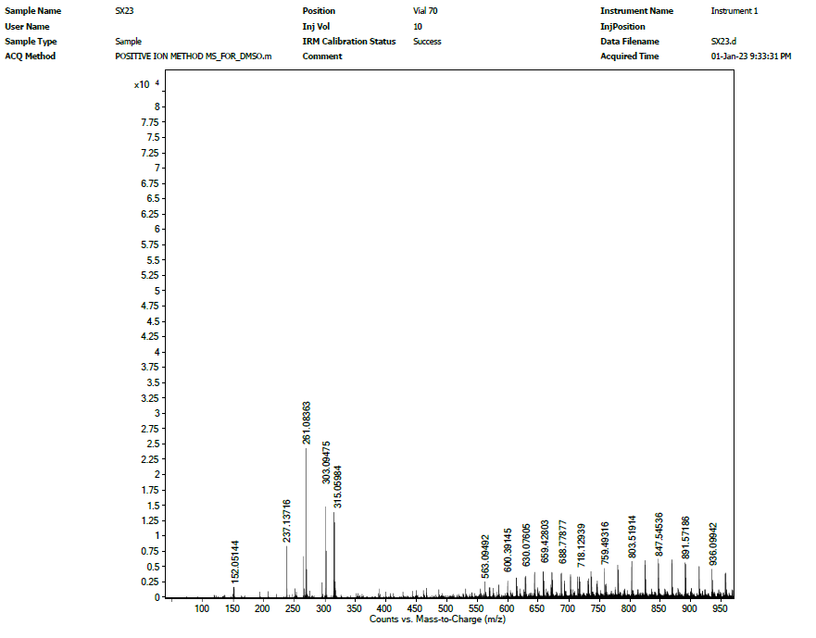
Fig S27: ¹H-, ¹³C-NMR and HR-ESI-MS spectra of compound 27

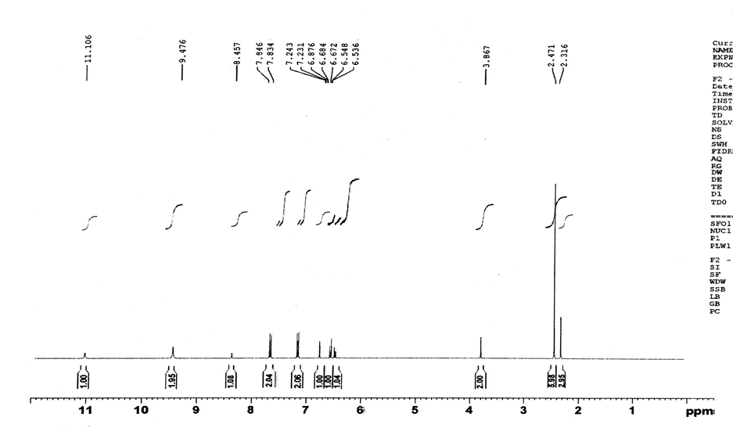
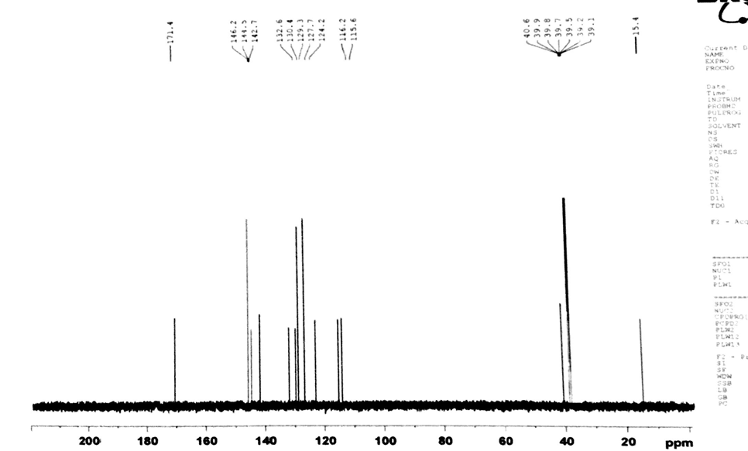
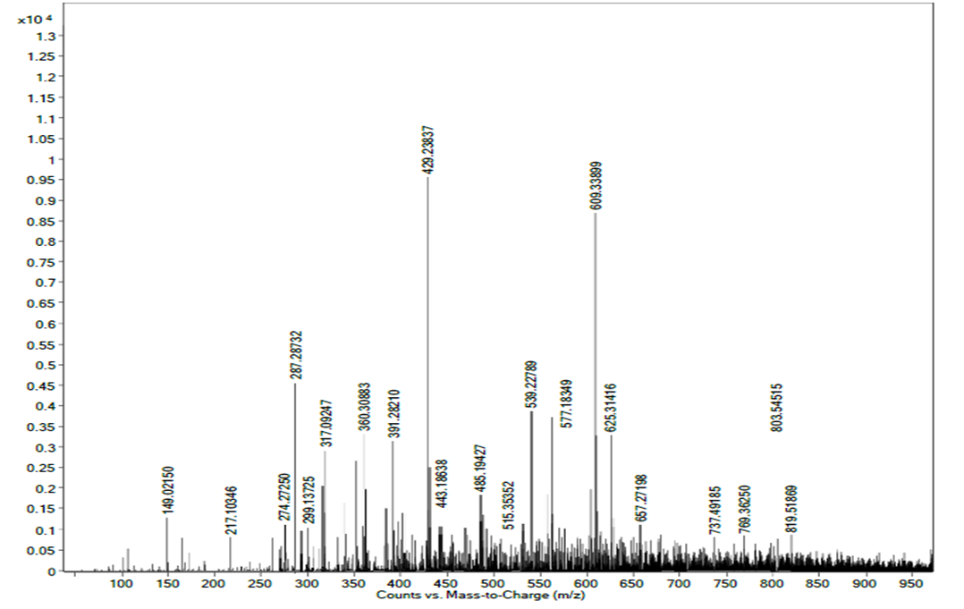
Fig S28: ¹H-, ¹³C-NMR and HR-ESI-MS spectra of compound 28
Protocol for the α-glucosidase inhibition assay
The α-glucosidase inhibition activity was performed with slight modifications as given by Rahim et al. Total volume of 100 μL reaction mixture contained, 70 μL 50mM phosphate buffer pH 6.8, 10μL (0.5mM in methanol) test compound, followed by the addition of 10μL (0.057 units, Sigma Inc.) enzyme solution in the buffer. The contents were mixed, pre-incubated for 10 min at 37 °C and pre-read at 400 nm. The reaction was initiated by the addition of 10 μL of 0.5mM substrate(p-nitrophenyl glucopyranoside, Sigma Inc.). After 30 min of incubation at 37 °C, the absorbance of p-nitrophenol was measured at 400 nm using the Synergy HT 96-well plate reader, BioTek, USA. Acarbose was used as positive control. All experiments were carried out in triplicates (mean ± SEM, n=3). Percent inhibition was calculated by the following equation: Inhibition (%) = (Abs of Control−Abs of Test/Abs of Control) × 100 Active compound solutions were suitably diluted, and their inhibition studies were determined. Data obtained was used for the determination of IC50 values (concentration at which there is 50% enzyme inhibition) using EZ-Fit Enzyme Kinetics Software (PerrellaScientificInc. Amherst, USA).
Raw data for the α-glucosidase inhibition assay

 |  |  | Exp 1-5
Result Data
 | 1 | 2 | 3 | 4 | 5 | 6 | 7 | 8 | 9 | 10 | 11 | 12
A | 2.501726 | 2.00273 | 1.793763 | 4.210274 | 4.30235 | 4.72534 | 7.8253 | 8.62735 | 9.02736 | 11.2837 | 11.8965 | 12.5347
B | 2.6712 | 2.3846 | 2.7354 | 5.7344 | 6.1226 | 6.20165 | 11.234 | 10.0287 | 11.02737 | 16.6528 | 15.57294 | 17.62543
C | 4.67321 | 6.3848 | 5.3374 | 7.34618 | 8.102355 | 7.632274 | 13.1028 | 12.78355 | 12.12762 | 3.41873 | 3.62937 | 3.8711
D | 9.374746 | 8.363546 | 9.654242 | 12.4866 | 11.3645 | 11.60263 | 16.83551 | 17.346 | 17.87354 | 6.2366 | 6.401828 | 5.89236
E | 10.4726 | 10.6524 | 11.03635 | 20.346 | 19.36524 | 18.28365 | 2.102763 | 2.63543 | 3.102874 | 10.238 | 9.563827 | 9.749287
F | 13.23631 | 12.83467 | 13.00264 | 2.294515 | 1.902635 | 2.001726 | 6.017262 | 5.4827 | 4.762552 | 11.456 | 12.0388 | 12.4038
G | 15.623 | 14.60274 | 16.31028 | 4.283645 | 4.49353 | 5.001244 | 6.582726 | 7.450283 | 8.102827 | 16.8636 | 18.237 | 17.73535
H | 3.674881 | 2.6124 | 2.301655 | 6.5237 | 7.201827 | 6.004531 | 8.502663 | 9.1376 | 9.623356 | 25.65012 | 24.85012 | 25.00001

 |  |  | Exp 6-11
Result Data
 | 1 | 2 | 3 | 4 | 5 | 6 | 7 | 8 | 9 | 10 | 11 | 12
A | 2.501726 | 2.00273 | 2.101828 | 7.3487 | 7.803837 | 8.302784 | 9.238 | 10.408 | 11.0023 | 3.724 | 3.87 | 4.5128
B | 2.4712 | 2.43846 | 2.57354 | 10.2339 | 10.523 | 9.73652 | 13.10233 | 13.847 | 14.29341 | 6.20377 | 5.8376 | 6.8364
C | 4.567321 | 6.333848 | 5.63374 | 12.23 | 11.4562 | 10.83636 | 2.102763 | 2.63543 | 2.6033 | 8.10727 | 7.3825 | 8.407333
D | 9.212337 | 8.213635 | 9.541654 | 15.73 | 16.89274 | 16.386 | 4.196 | 3.765 | 3 | 9.3082 | 10.00274 | 10.6923
E | 10.74726 | 10.49652 | 11.10364 | 1.80266 | 1.5637 | 2.37 | 6.017262 | 5.4827 | 4.762552 | 11.487 | 10.836 | 11.02837
F | 14.6432 | 15.0213 | 15.621 | 4.283645 | 4.49353 | 5.001244 | 8.31055 | 7.3065 | 6.418 | 16.69274 | 17.2038 | 19.827
G | 3.12938 | 3.84 | 3.6012 | 6.5237 | 7.201827 | 6.004531 | 8.502663 | 9.1376 | 9.623356 | 16.8636 | 17.27452 | 17.73535
H | 4.82736 | 5.30828 | 5.6833 | 7.87 | 8.56672 | 7.203847 | 14.7 | 16.2 | 15.61 | 25.65012 | 26.85012 | 25.76
 | Result Data |  | Exp 12-17
 | 1 | 2 | 3 | 4 | 5 | 6 | 7 | 8 | 9 | 10 | 11 | 12
A | 2.401727 | 1.63826 | 1.827602 | 4.622 | 5.10227 | 5.51286 | 10.60282 | 10.20374 | 9.963534 | 18.8926 | 17.42838 | 18.20277
B | 3.63512 | 4.10273 | 4.302365 | 6.3017 | 6.74928 | 7.20188 | 11.69822 | 11.02838 | 11.29365 | 6.20377 | 5.8376 | 5.2018
C | 6.238162 | 6.109274 | 5.745256 | 9.2034 | 8.6963 | 9.583344 | 14.20177 | 15.4822 | 15.79264 | 8.10727 | 7.3825 | 8.407333
D | 9.21288 | 8.836442 | 9.601277 | 10.72543 | 10.36242 | 11.00233 | 3.81625 | 3.502727 | 3 | 9.3082 | 8.7362 | 9.692535
E | 11.03938 | 10.49236 | 10.82039 | 14.48477 | 15.23937 | 14.022 | 6.102 | 5.3826 | 4.59626 | 10.40283 | 9.592635 | 11.1028
F | 12.0287 | 11.69264 | 11.90374 | 3.201727 | 2.791625 | 1.793636 | 8.002837 | 7.420182 | 6.10736 | 14.62424 | 15.10287 | 16.502
G | 17.82534 | 15.61227 | 16.73027 | 6.23017 | 6.655749 | 7.311029 | 9.501727 | 9.019837 | 8.593636 | 25.4 | 27.001 | 26.5028
H | 2.82736 | 1.8026 | 2.735441 | 9.002728 | 8.472525 | 9.391717 | 10.60283 | 11.10374 | 10.47826 | 25.2365 | 26.85012 | 26.876
 |  |  | Exp 18-23
Result Data
 | 1 | 2 | 3 | 4 | 5 | 6 | 7 | 8 | 9 | 10 | 11 | 12
A | 2.470173 | 2.1297 | 1.7634 | 7.30172 | 6.8344 | 7.592725 | 19.865 | 20.672 | 21.328 | 2.401827 | 2.736524 | 3.01827
B | 3.6132 | 3.2076 | 3.489155 | 10.38625 | 10.72543 | 9.8533 | 1.68235 | 2.40283 | 1.401277 | 4.19278 | 4.59277 | 4.8623
C | 5.293663 | 5.63087 | 4.89355 | 12.3017 | 11.49273 | 11.63737 | 3.293641 | 3.62535 | 4.10746 | 6.82652 | 7.02736 | 7.420187
D | 9.374746 | 8.363546 | 9.654242 | 4.725 | 4.301626 | 4.59625 | 5.1028 | 4.792534 | 5.482635 | 8.397161 | 9.018236 | 8.753133
E | 10.3922 | 10.349 | 11.30274 | 6.23751 | 6.72534 | 5.81625 | 7.20377 | 6.592635 | 7.502635 | 10.238 | 11.3736 | 10.79364
F | 15.623 | 14.60274 | 16.31028 | 7.8265 | 8.102737 | 7.39262 | 9.381653 | 10.4762 | 9.692636 | 17.632 | 17.2037 | 19.8354
G | 3.674881 | 4.012 | 4.59235 | 9.4017 | 10.736 | 9.69236 | 15.735 | 14.26142 | 16.8254 | 16.8636 | 15.3521 | 17.73535
H | 5.3092 | 6.20176 | 5.792534 | 11.4846 | 12.30475 | 11.45828 | 1.4652 | 2.02837 | 1.20133 | 27.87 | 27.5102 | 28.1028
 |  |  | Exp 24-33
Result Data
 | 1 | 2 | 3 | 4 | 5 | 6 | 7 | 8 | 9 | 10 | 11 | 12
A | 2.861424 | 2.89365 | 3.70836 | 7.230172 | 6.798834 | 7.659273 | 10.3653 | 11.36356 | 10.62038 | 17.229 | 15.3928 | 18.236
B | 4.28176 | 3.871524 | 4.59625 | 10.32863 | 10.57254 | 9.78533 | 14.4927 | 14.827 | 15.3028 | 0.388 | 1.2939 | 0.938
C | 6.490228 | 6.71028 | 6.39 | 12.3017 | 11.49273 | 11.63737 | 4.0012 | 5.2038 | 4.410293 | 0.0038 | 0.383737 | 0.01828
D | 9.374746 | 8.363546 | 9.654242 | 14.902 | 14.387 | 15.62535 | 6.2366 | 7.1028 | 6.428 | 0.01828 | 0.01828 | 0.3838
E | 10.23922 | 10.2349 | 11.23027 | 1.63 | 2.10287 | 2.455633 | 7.20377 | 6.592635 | 7.502635 | 0.3838 | 0.3838 | 0.28387
F | 18.402 | 16.823 | 17.69264 | 3.28622 | 3.610287 | 4.1029 | 9.481653 | 10.64762 | 9.892636 | 0.283837 | 0.283837 | 0.38873
G | 3.102827 | 2.3018 | 2.401726 | 5.3018 | 5.742029 | 6.20187 | 11.393 | 12.00188 | 11.29374 | 0.38873 | 0.38873 | 0.3737
H | 5.3092 | 4.201374 | 5.792534 | 8.39176 | 8.591726 | 8.82635 | 16.203 | 16.82535 | 18.3028 | 26.10236 | 26.8 | 27

Compd | Dose Curve response | Percent Inhibition (0.5mM) | IC₅₀ ± µM (SEM)
1 | 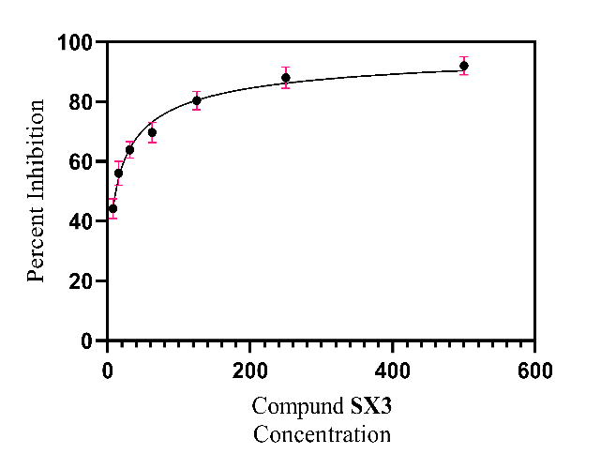 | 86.33 | 24.37 ± 0.83
2 | 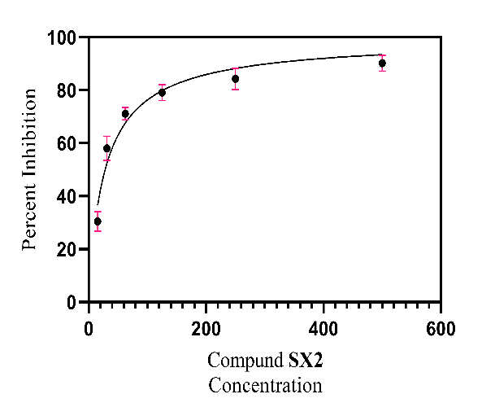 | 90.43 | 20.35 ± 1.27
3 | 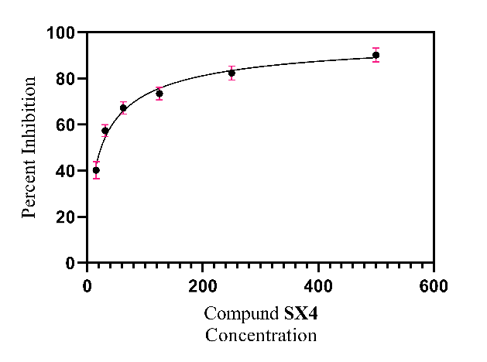 | 91.33 | 18.45 ± 1.21
4 | 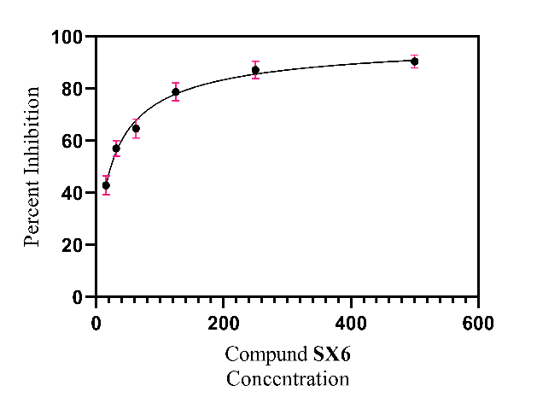 | 95.71 | 13.64 ± 0.58
5 | 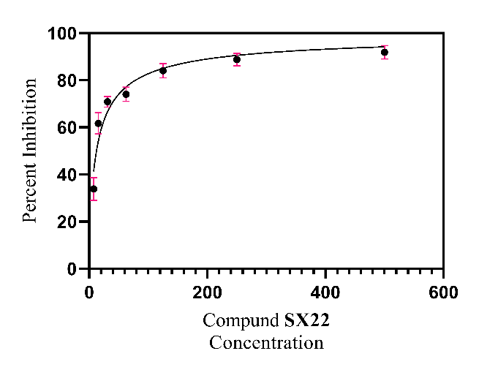 | 96.12 | 12.84 ± 0.52
6 | 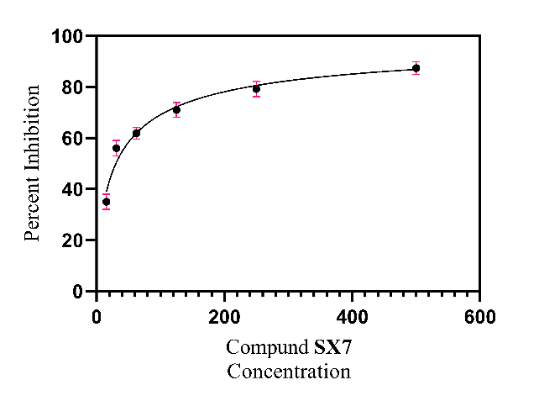 | 86.42 | 23.69 ± 1.11
7 | 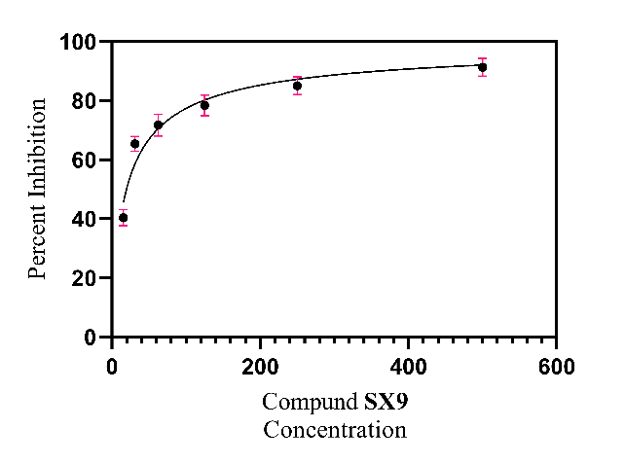 | 91.73 | 19.68 ± 0.82
8 | 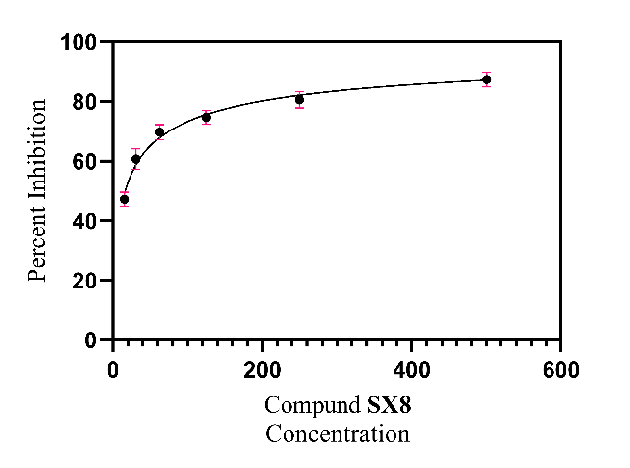 | 90.98 | 20.88 ± 0.53
9 | 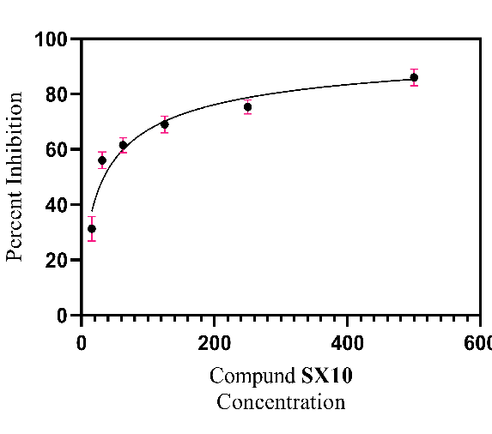 | 83.30 | 27.29 ± 1.15
10 | 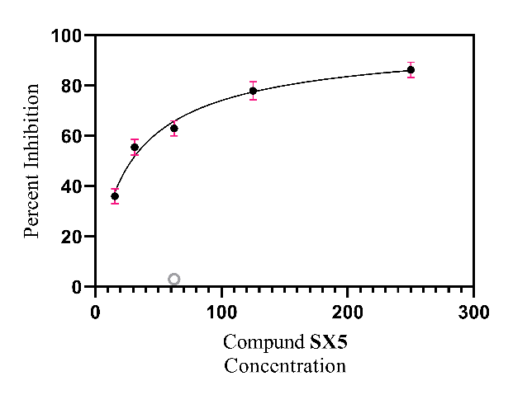 | 81.91 | 28.66 ± 1.21
11 | 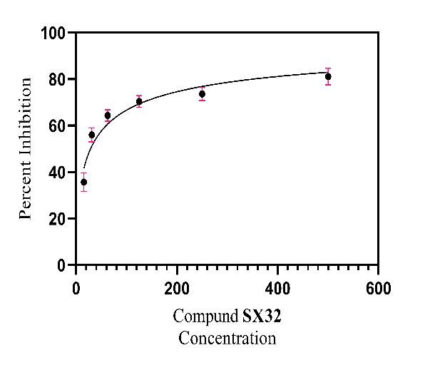 | 77.47 | 33.51 ± 1.22
12 | 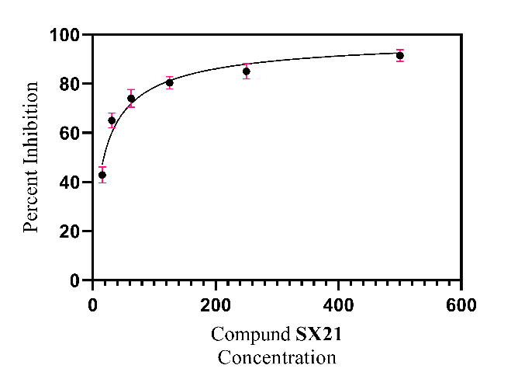 | 96.68 | 15.73 ± 0.71
13 | 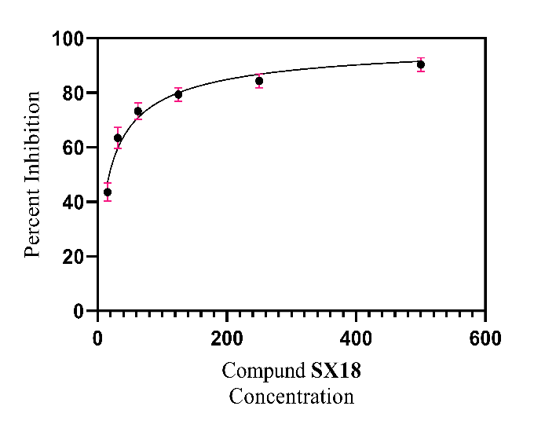 | 95.25 | 16.62 ± 0.47
14 | 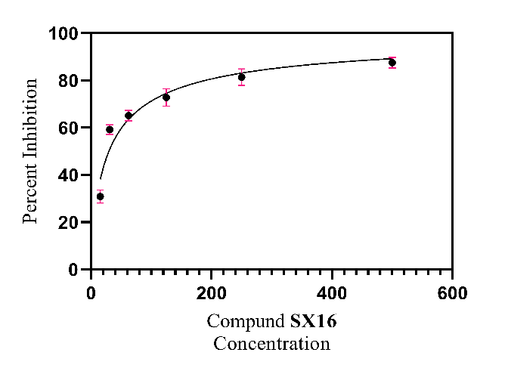 | 92.16 | 20.61 ± 0.59
15 | 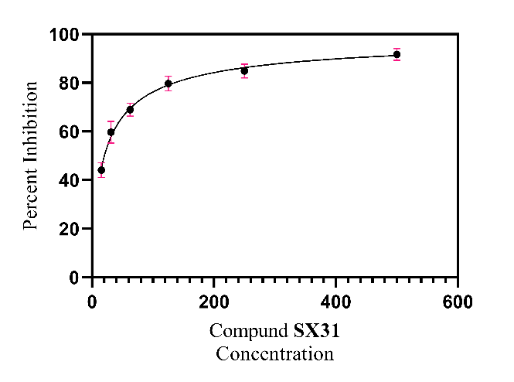 | 92.76 | 17.405 ± 0.74
16 | 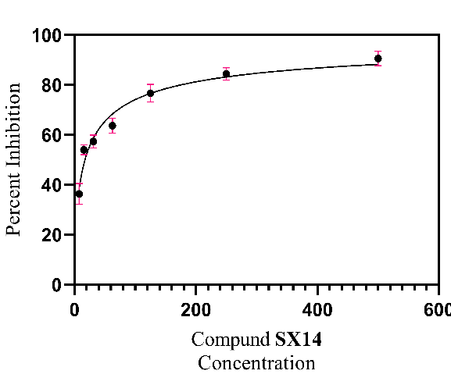 | 84.12 | 26.41 ± 1.10
17 | 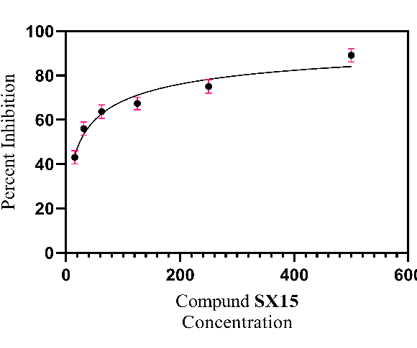 | 71.97 | 43.76±2.34
18 | 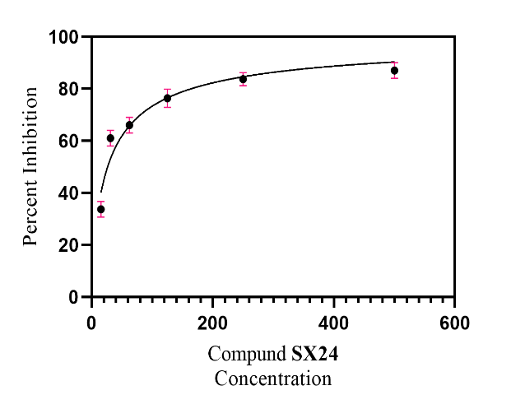 | 85.30 | 28.16 ± 1.09
19 | 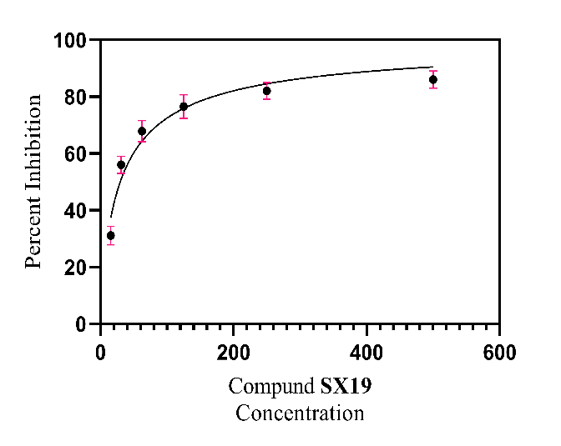 | 79.43 | 31.22 ± 1.40
20 | 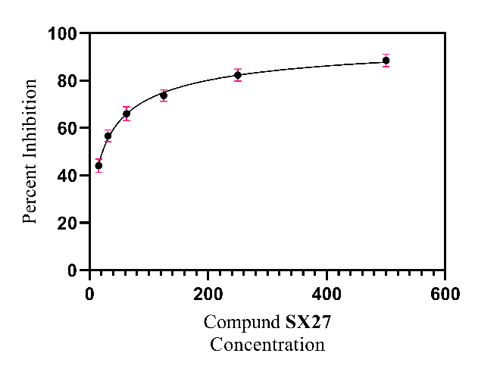 | 84.40 | 27.26 ± 0.83
21 | 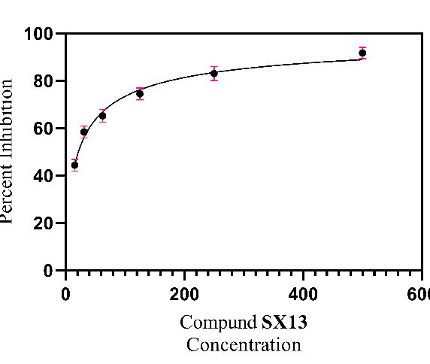 | 86.42 | 24.16 ± 0.52
22 |  |  | N/A
23 | 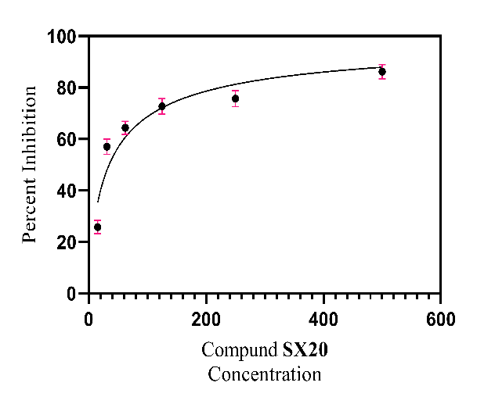 | 80.90 | 30.46 ± 1.28
24 | 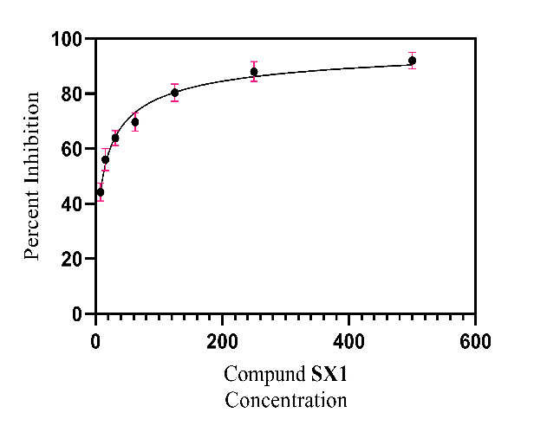 | 82.71 | 29.67 ± 0.98
25 | 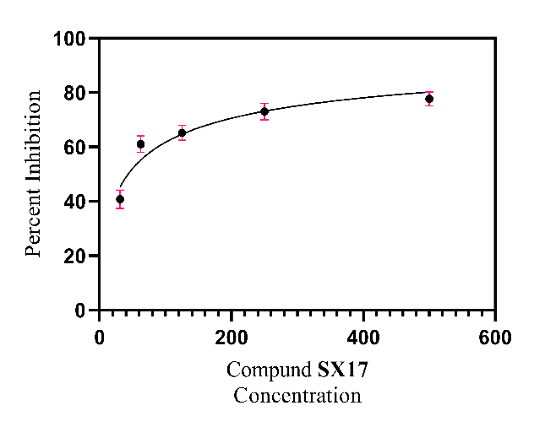 | 78.21 | 34.46 ± 1.48
26 |  |  | N/A
27 |  |  | N/A
28 |  |  | N/A
Standard Acarbose |  | 59.37 | 873.34 ± 1.67

α-Glucosidase Inhibition Assay Raw data table with dose Curve and Percent Inhibition

