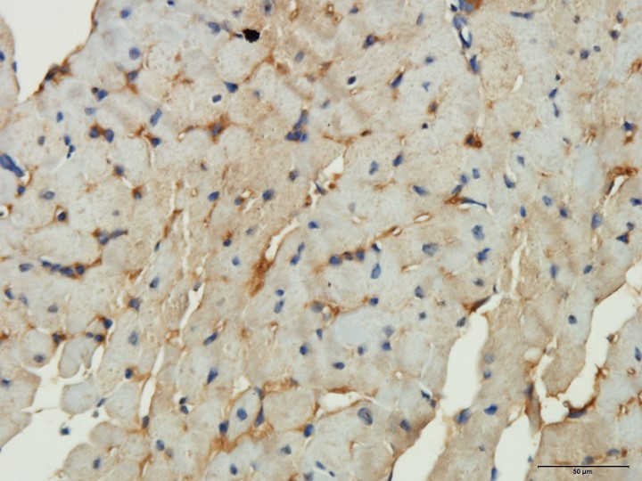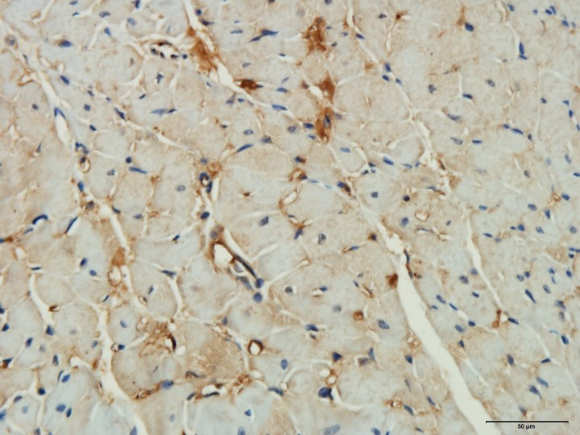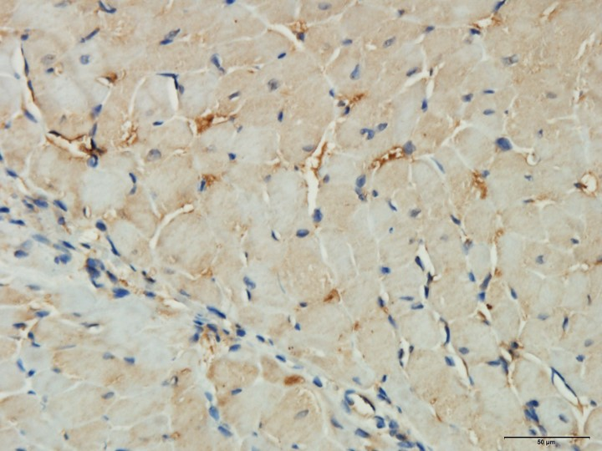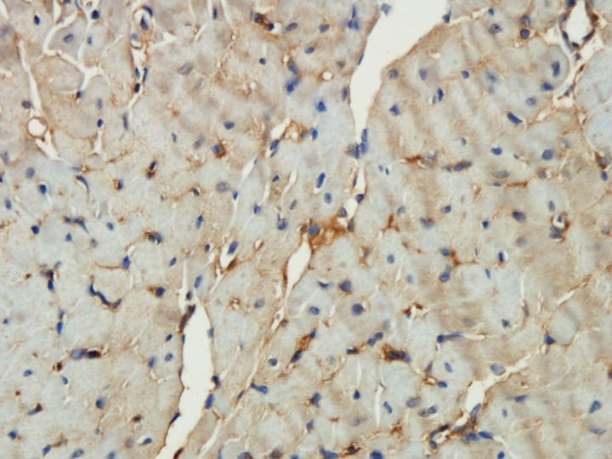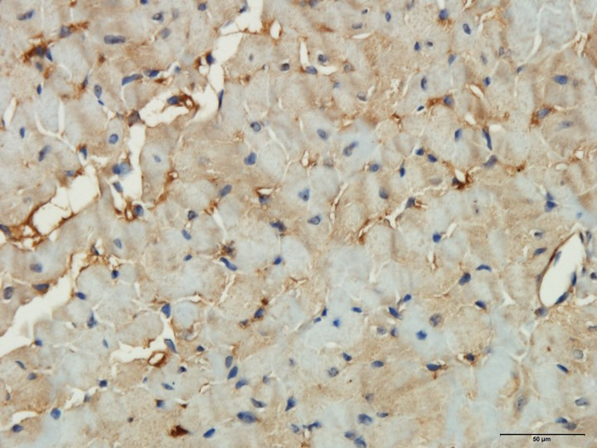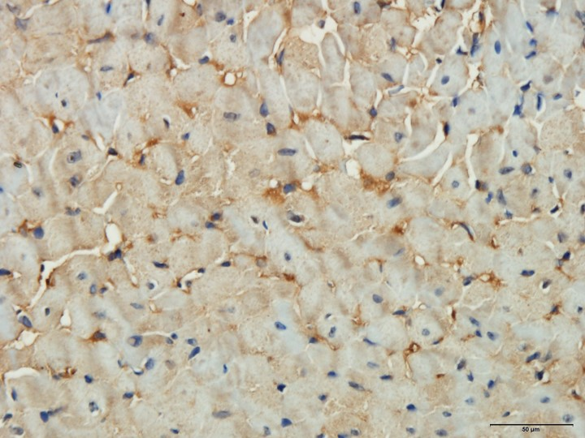
This picture was used for statistics.

This picture was used for statistics.
This picture was showed in our manuscript (Fig. 3F).
IL18-TAC+Semaglutide+HCQ
This picture was used for statistics.
This picture was used for statistics.
This picture was used for statistics.

