S1. Dimensions of single mesh-type cell models and concentric ellipsoidal geometry-type cell models
Single cell model |  | Geometry-type model |  | Mesh-type model
 |  | Cytoplasm | Nucleus | Cytoplasm | Nucleus
Length of projection ($μm$) | X-axis | 24.97 | 21.39 | 24.97 | 21.39
Length of projection ($μm$) | Y-axis | 78.21 | 25.45 | 78.21 | 25.45
Length of projection ($μm$) | Z-axis | 45.03 | 24.98 | 45.03 | 24.98
Volume (${μm}^{3}$) |  | 38905.00 | 7116.54 | 20401.26 | 5147.87

S2. Elemental components of nucleus and cytoplasm in the cell population model for MC simulation
Element | Elemental Mass Composition (%)
Element | Nucleus | Cytoplasm
Hydrogen | 21.77 | 21.86
Carbon | 12.25 | 13.01
Nitrogen | 2.13 | 1.29
Oxygen | 62.35 | 62.34
Silicon | 0.01 | 0.05
Phosphorus | 0.60 | 0.48
Natrium | 0.04 | -
Magnesium | 0.03 | -
Sulphur | 0.01 | 0.11
Chlorine | 0.10 | 0.29
Kalium | 0.60 | 0.57
Total | 100.00 | 100.00

S3. Particle numbers of simulations for different cumulative dose
Initial Energy |  | Renormalized dose of petri dish with water | Renormalized dose of petri dish with geometry-type cells | Renormalized dose of petri dish with mesh-type cells
100keV |  | 1.00E-09 mGy | 1.06E-09 mGy | 1.20E-09 mGy
200keV |  | 2.35E-09 mGy | 2.45E-09 mGy | 2.76E-09 mGy
500keV |  | 6.39E-09 mGy | 6.83E-09 mGy | 7.58E-09 mGy
1MeV |  | 1.10E-08 mGy | 1.20E-08 mGy | 1.36E-08 mGy
500keV |  | 6.39E-09 mGy | 6.83E-09 mGy | 7.58E-09 mGy
500keV |  | 6.39E-09 mGy | 6.83E-09 mGy | 7.58E-09 mGy
500keV |  | 6.39E-09 mGy | 6.83E-09 mGy | 7.58E-09 mGy
500keV |  | 6.39E-09 mGy | 6.83E-09 mGy | 7.58E-09 mGy
500keV |  | 6.39E-09 mGy | 6.83E-09 mGy | 7.58E-09 mGy
Initial Energy | Particle numbers | Cumulative dose of petri dish with water | Cumulative dose of petri dish with geometry-type cells | Cumulative dose of petri dish with mesh-type cells
100keV | 4.98E+09 | 5.00 mGy | 5.34 mGy | 5.99 mGy
200keV | 2.13E+09 | 5.00 mGy | 5.20 mGy | 5.86 mGy
500keV | 7.82E+08 | 5.00 mGy | 5.34 mGy | 5.93 mGy
1MeV | 4.56E+08 | 5.00 mGy | 5.45 mGy | 6.20 mGy
500keV | 3.91E+09 | 25.00 mGy | 26.72 mGy | 29.66 mGy
500keV | 7.82E+09 | 50.00 mGy | 53.45 mGy | 59.32 mGy
500keV | 1.56E+10 | 100.00 mGy | 106.89 mGy | 118.64 mGy
500keV | 3.13E+10 | 200.00 mGy | 213.78 mGy | 237.28 mGy
500keV | 7.82E+10 | 499.99 mGy | 534.45 mGy | 593.21 mGy
Note that “Renormalized dose of petri dish with water” represents the macroscopic dose of petri dish per radiation particle with the materials of liquid water without cells. “Renormalized dose of petri dish with geometry-type cells” and “Renormalized dose of petri dish with mesh-type cells” represent the macroscopic doses per radiation particle of petri dish filled with geometry-type or mesh-type cells with the cell materials listed in the S2.

S4. Methods of convolution integral
In general, $D_{1}$ represents the absorbed dose of a single event with the distribution of $f_{1}\left(z\right)$. If there exists a specific energy distribution $f_{a}\left(z\right)$ with a dose value of $D_{a}$, it can be considered as the convoluted distribution. when the cumulative dose reaches $D$, $v$ can be determined as follows
$v=D/D_{a}$, (1)
In this case, $D$ values should be set to be divisible by $D_{a}$ so that $v$ should be an integer. As shown in figure 3, $D_{1}$ was 5 mGy, and $D$ were 25 mGy, 50 mGy, 100 mGy, 200 mGy and 500 mGy, whose $v$ were 5, 10, 20, 40, 100, separately, for obtaining convolution distributions.
The multiplicative character of the convolution operation can be utilized to obtain $f_{v}\left(z\right)$ from $f_{a}\left(z\right)$ by a sequence of convolutions that corresponds to the splitting of $v$ into integer powers of 2. For example
$f_{84}\left(z\right)=f_{4}\left(z\right)*f_{16}\left(z\right)*f_{64}\left(z\right)=f_{\left|2\right|}(z)*f_{\left|4\right|}(z)*f_{\left|6\right|}(z)$ (2)
The $\left|v\right|$ represents $2^{v}$ and the $f_{\left|v\right|}(z)$ represents integer powers $2^{v}$ of $f_{a}\left(z\right)$. There are recurrence relations
$f_{\left|0\right|}\left(z\right)=f_{a}\left(z\right)$ (3)

S5. Mean specific energies and dispersions of monolayer cell population model
1. Values of mean specific energies and dispersions within the simulated conditions in the Fig.2
 |  | Mean specific energy (mGy) |  | Mean dispersion
Initial energy | Region | Mesh-type model | Geometry-type model | Mesh-type model | Geometry-type model
100keV | Cytoplasm | 5.94±0.01 | 5.88±0.01 | 15.08% | 11.66%
 | Nucleus | 5.82±0.02 | 5.82±0.04 | 30.98% | 26.02%
200keV | Cytoplasm | 5.89±0.01 | 5.90±0.01 | 17.41% | 13.78%
 | Nucleus | 5.97±0.05 | 5.86±0.03 | 33.21% | 29.05%
500keV | Cytoplasm | 6.07±0.01 | 5.99±0.01 | 14.26% | 11.99%
 | Nucleus | 6.09±0.01 | 5.97±0.02 | 26.42% | 23.09%
1MeV | Cytoplasm | 6.29±0.02 | 6.17±0.01 | 13.96% | 13.03%
 | Nucleus | 6.30±0.05 | 6.13±0.03 | 22.74% | 21.51%

2. Values of mean specific energies within the simulated conditions in the Fig.3
Cumulative dose (mGy) | Mean specific energy (mGy) | Ratio between mean specific energy and cumulative dose
5 | 5.82 | 1.16
25 | 27.69 | 1.11
50 | 59.65 | 1.19
100 | 119.22 | 1.19
200 | 238.67 | 1.19
500 | 596.95 | 1.19

S6. Specific energy distributions of cell nucleus and cytoplasm dose in the mesh-type or geometric-type monolayer cell population model for monoenergetic photons with initial energies of 0.1 MeV (A, E), 0.2 MeV (B, F), 0.5 MeV (C, G), and 1 MeV (D, H) at the macroscopic dose level of 5 mGy
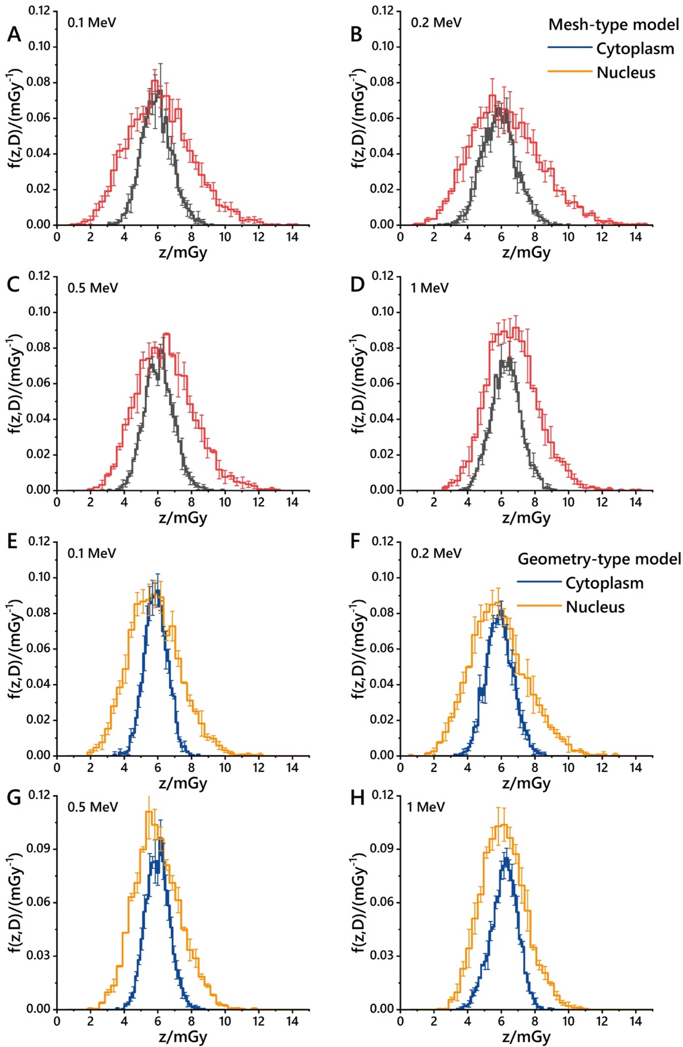

S7. Cell nucleus dose distribution in a monolayer ellipsoidal cell population model with different parameters resulting from external irradiation of Cs-137 monoenergetic photons at various cumulative macroscopic dose levels. (A-B) corresponds to large-sized culture flask, (C-H) to small-sized culture flask, (A-E) represents population models with a high cell number density, and (F-H) represents population models with a low cell number density. For 10 mGy (B, D, and G) and 100 mGy (E, H), the cell nucleus dose distribution includes those obtained through Monte Carlo simulations (red line) and those obtained by convoluting distributions through the same geometric setup conditions at 1 mGy (A, C, F) (brown line), as well as normal distributions fitted to the distributions obtained through Monte Carlo simulations in each case (black line)
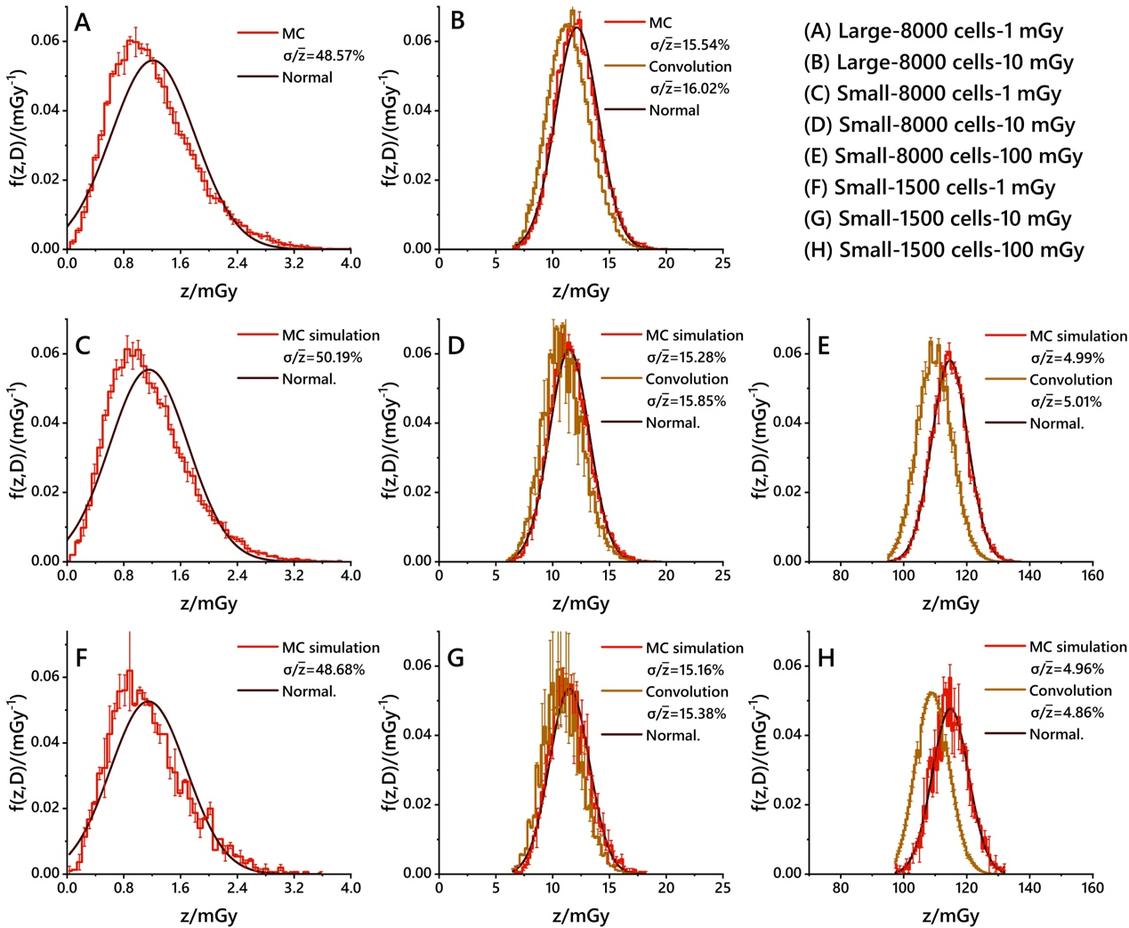

S8. RMSE values obtained by comparing various distributions.
1. RMSE values between two distributions in Figure 2 in the manuscript
 | Mesh-type model | Geometry-type model
Incident energy | MC vs. normal | MC vs. normal | Distribution figure
100 keV | 3.67E-03 | 3.67E-03 | Figure2 Panel A
200 keV | 3.95E-03 | 3.85E-03 | Figure2 Panel B
500 keV | 4.07E-03 | 4.26E-03 | Figure2 Panel C
1 MeV | 4.23E-03 | 2.49E-03 | Figure2 Panel D
2. RMSE values between three distributions in Figure 3 in the manuscript
Cumulative macroscopic dose | MC vs. Normal | MC vs. Convolution | Normal vs. Convolution | Distribution figure
5 mGy | 3.20E-03 | - | - | Figure3 Panel A
25 mGy | 1.04E-02 | 2.67E-03 | 9.67E-03 | Figure3 Panel B
50 mGy | 5.97E-03 | 2.34E-03 | 4.96E-03 | Figure3 Panel C
100 mGy | 1.02E-02 | 4.87E-03 | 7.71E-03 | Figure3 Panel D
200 mGy | 1.48E-02 | 8.10E-03 | 1.18E-02 | Figure3 Panel E
500 mGy | 2.64E-02 | 1.44E-02 | 2.04E-02 | Figure3 Panel F
3. RMSE values between three distributions in S5 in the supplementary material
Plate size and cell number | Cumulative macroscopic dose | MC vs. Normal | MC vs. Convolution | Distribution figure
Large-8000 cells | 1 mGy | 6.14E-03 | - | S5 Panel A
Large-8000 cells | 10 mGy | 7.88E-03 | 2.06E-03 | S5 Panel B
Small-8000 cells | 1 mGy | 6.07E-03 | - | S5 Panel C
Small-8000 cells | 10 mGy | 7.45E-03 | 1.98E-03 | S5 Panel D
Small-8000 cells | 100 mGy | 1.65E-02 | 1.49E-03 | S5 Panel E
Small-1500 cells | 1 mGy | 6.28E-03 | - | S5 Panel F
Small-1500 cells | 10 mGy | 7.83E-03 | 3.58E-03 | S5 Panel G
Small-1500 cells | 100 mGy | 1.81E-02 | 3.73E-03 | S5 Panel H

S9. Differential gene names, where “Microdosimetric merge” represents the top 100 differential genes that conform to microdosimetric characteristics, “Statistic merge” represents the top 100 differential genes that meet statistical differences, “Multi-filtered genes” represents the genes that intersect between “Statistic merge” and “Microdosimetric merge”
No. | Microdosimetric merge | Statistic merge | Multi-filtered genes
1 | RPS5 | RPL37A | RPS5
2 | RPL18 | UBB | RPL18
3 | RPS23 | NEDD8 | RPS23
4 | RPL30 | RPL36AL | RPL30
5 | LGALS1 | RPL30 | RPL18A
6 | RPL18A | EDF1 | RPL39
7 | RPL39 | RPL28 | RACK1
8 | RACK1 | RPL36 | RPS15A
9 | RPS15A | RPL18 | RPL28
10 | RPL28 | RPL18A | RPS18
11 | RPS18 | EEF2 | RPS21
12 | RPS21 | RPL31 | RPS12
13 | RPS12 | SEC61B | RPL7L1
14 | RPL7L1 | RPL7A | RPS16
15 | DNMT1 | RPS12 | UBA52
16 | SF3B2 | RPL7L1 | RPS11
17 | CTTN | RPS16 | RPS9
18 | CAPZA1 | RPL8 | FAU
19 | RPS16 | ETF1 | RPL13
20 | P4HB | RPL35A | RPL27A
21 | UBA52 | MTREX | RPS15
22 | RPS11 | RPS5 | RPLP2
23 | RPS9 | RPS4X | RPS28
24 | FAU | RPL24 | RPL9
25 | CBX5 | RPL7 | RPL21
26 | SYNCRIP | RPL23A | RPL37A
27 | RPL13 | RPS27 | RPL7A
28 | RPL27A | RPL11 | RPL17
29 | POLR2J3 | RPL10 | RPL29
30 | ZFAS1 | SRP68 | RPS25
31 | CDC37 | RPL34 | RPL8
32 | NR3C1 | RPS29 | RPL37
33 | APLP2 | SEC61G | RPL34
34 | NFIB | RPS13 | RPS3
35 | RPS15 | RPL19 | RPS27
36 | RPLP2 | RPL10A | RPL36
37 | RPS28 | RPL27 | RPL36A
38 | LRRC59 | RPS19 | RPL11
39 | RNPS1 | RPS4Y1 | RPS14
40 | SUMO2 | MRPL11 | RPL26
41 | RPL9 | RPS17 | RPL7
42 | RPL21 | RPL17
43 | ACTR3 | EIF3B
44 | TMSB10 | RPLP1
45 | S100A13 | RPL35
46 | RPL37A | RPS15A
47 | SRSF4 | FAU
48 | CD44 | RPS11
49 | USP9X | RPL26
50 | POLR2L | RPLP2
51 | RPL7A | RPL37
52 | RPL17 | RPS3
53 | RPL29 | RPS8
54 | TGOLN2 | RPL23
55 | NONO | EIF6
56 | PRKAR2A | RPS25
57 | HINT1 | RPL29
58 | BRD4 | RPS18
59 | RAD21 | RPS23
60 | HELLS | RPL9
61 | RPS25 | RPL13
62 | RPL8 | RACK1
63 | TLE5 | RPS24
64 | RPL37 | RPL15
65 | HSPA9 | RPL32
66 | NDUFA13 | SPCS1
67 | CYB5R3 | RPL38
68 | PRRC2C | RPS14
69 | G3BP1 | RPS9
70 | HNRNPK | RAD23B
71 | RPL34 | SRP14
72 | RPS3 | RPS10
73 | CORO1C | RPL41
74 | RPS27 | EEF1B2
75 | RPL36 | STT3B
76 | HSPA4 | RPS3A
77 | SSRP1 | NACA
78 | CSE1L | SNU13
79 | GNG12 | RPL21
80 | TMSB4X | NHP2
81 | ODC1 | RPS27L
82 | SPAG9 | RPL22
83 | ATP5MC1 | ATF4
84 | SSR4 | RPL14
85 | RPL36A | MED1
86 | PEA15 | ISG15
87 | RPL11 | RPL26L1
88 | MYL6 | RPS26
89 | PLEC | MRPL22
90 | RPS14 | RPL22L1
91 | TOMM7 | RPS28
92 | PAWR | RPL36A
93 | SON | RPS27A
94 | CD63 | RPS7
95 | TRIM44 | RPL27A
96 | RPL26 | RPL39
97 | QKI | UBA52
98 | RPL7 | RPS21
99 | UQCRH | BTF3
100 | NF2 | RPS15

S10. Expression level of selected differential genes in BEAS-2B cells irradiated with different doses (10 mGy, 100 mGy, and 1 Gy) following single-cell sequencing analysis.


