Supplement materials
Table S1. Sequence information used in this study
Name | Sequence
P4HA1 NC | 5’- UUCUCCGAACGUGUCACGUTT -3’
P4HA1 shRNA1 | 5’-AUAUACCAGAUCAUCUUGGAA -3’
P4HA1 shRNA2 | 5’-UAAUAUAUACCAGAUCAUCUU -3’

Table S2. The qPCR primers used in this study
Gene |  | Primer Sequence
P4HA1 | Forward | 5’-AAAAGTGCCTGGCTCTCTGG-3’
 | Reverse | 5’-TGGCTCATCTTTCCGTGCAA -3’
GAPDH | Forward | 5’-GGAGTCCACTGGCGTCTTCA -3’
 | Reverse | 5’-GTCATGAGTCCTTCCACGATACC -3’

Table S3. Information on antibodies used in this study
Antibody | Cat. No. | WB | IHC | Specificity | Source
P4HA1 | 12658-1-AP | 1：4000 | 1：100 | Rabbit | Proteintech Antibody
AKT | 10176-2-AP | 1：2000 |  | Rabbit | Proteintech Antibody
HIF1α | 20960-1-AP | 1：2000 |  | Rabbit | Proteintech Antibody
β-actin | 20536-1-AP | 1：2000 |  | Rabbit | Proteintech Antibody
GAPDH | 10494-1-AP | 1：5000 |  | Rabbit | Proteintech Antibody

Table S4. The correlation between P4HA1 and marker genes of immune pathways in HNSC.
Variable | Partial.cor | p
Purity | 0.140432502 | 0.001773853
B Cell | -0.020276712 | 0.659019091
CD8+ T Cell | -0.051605231 | 0.262157562
CD4+ T Cell | 0.214549267 | 2.10E-06
Macrophage | 0.27424581 | 8.82E-10
Neutrophil | 0.092871322 | 0.042187058
Dendritic Cell | 0.206774841 | 4.71E-06

Table S5. The correlation between P4HA2 and marker genes of immune pathways in HNSC.
Variable | Partial.cor | p
Purity | -0.117905222 | 0.008782126
B Cell | -0.097055467 | 0.034265551
CD8+ T Cell | -0.146315089 | 0.001401698
CD4+ T Cell | 0.176234957 | 0.000103827
Macrophage | 0.102817328 | 0.023834899
Neutrophil | 0.152955298 | 0.000783307
Dendritic Cell | 0.156889265 | 0.000546402

Table S6. The correlation between P4HA3 and marker genes of immune pathways in HNSC.
Variable | Partial.cor | p
Purity | -0.093124675 | 0.038739058
B Cell | 0.160796592 | 0.000428487
CD8+ T Cell | 0.022883843 | 0.619212923
CD4+ T Cell | 0.304693987 | 9.04E-12
Macrophage | 0.390449148 | 4.87E-19
Neutrophil | 0.079875471 | 0.080744289
Dendritic Cell | 0.25060644 | 2.45E-08

Original images:

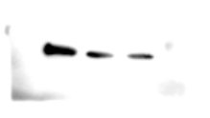
Western blot assays :
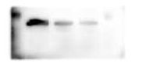
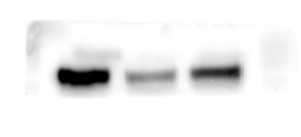
P4HA1 AKT HIF-1α
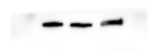
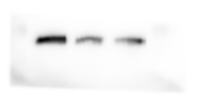

PI3K β-actin

Immunohistochemistry:

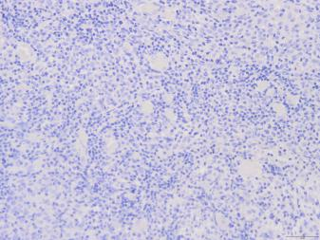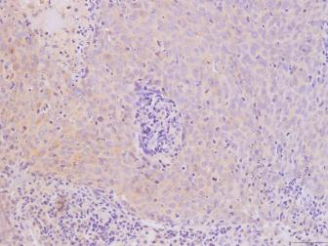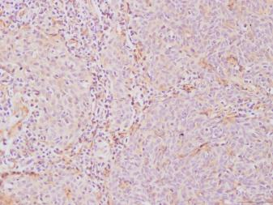
Adjacent normal tissue (x200) Tumor tissue 1 (x200) Tumor tissue 2 (x200)

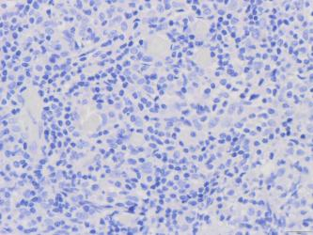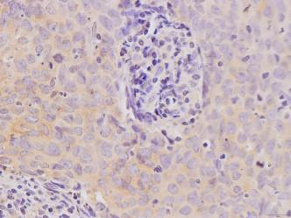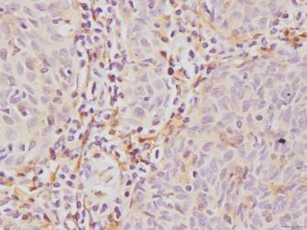
Adjacent normal tissue (x400) Tumor tissue 1 (x400) Tumor tissue 2 (x400)

Colony formation assays:

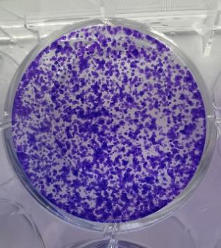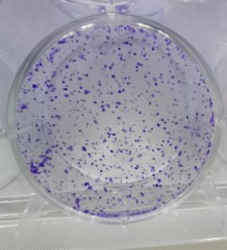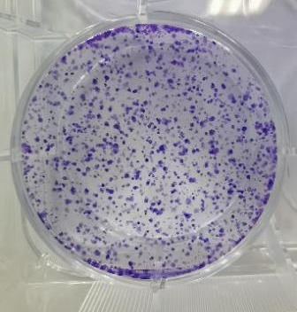
NC sh1-P4HA1 sh2-P4HA1

Transwell assay：
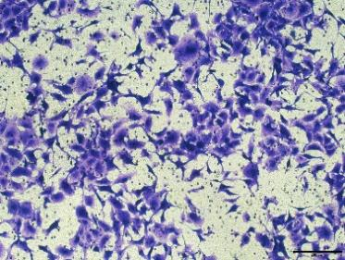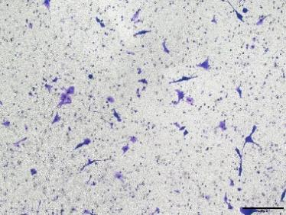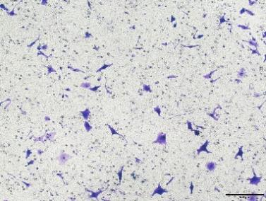
NC sh1-P4HA1 sh2-P4HA1

