Supplementary Information
Table S1. The mouse primer sequences used in RT-PCR
Gene | Primer sequences
IL-6 | Forward | CCC ACC AAG AAC GAT AGT CA
IL-6 | Reverse | CTC CGA CTT GTG AAG TGG TA
TNF-α | Forward | TGG AAC TGG CAG AAG AGG
TNF-α | Reverse | AGA CAG AAG AGC GTG GTG
COX-2 | Forward | ATC TGG CTT CGG GAG CAC AA
COX-2 | Reverse | GTG GTA ACC GCT CAG GTG TT
IL-13 | Forward | CCT GGC TCT TGC CCT T
IL-13 | Reverse | GGT CTT GTG TGA TGT TGC TCA
IL-31 | Forward | CCT ACC CTG GTG CGT CTT TG
IL-31 | Reverse | CTG ACA TCC CAG ATG CCT GC
IL-15 | Forward | TGA GGA ACG TGC TGT ACC TG
IL-15 | Reverse | GGT CTT CTC CTC CAG CTC CT
IFN-γ | Forward | TCA AGT GGC ATA GAT GTG GAA GAA
IFN-γ | Reverse | TGG CTC TGC AGG ATT TTC ATG
TARC | Forward | TAC TAT ACT CTC AAT CCT ATC CCT
TARC | Reverse | ACT TCT TGT GCC ATT TCC TG
TSLP | Forward | AGA GAA GCC CTC AAT GAC CAT
TSLP | Reverse | GGA CTT CTG TGC CAT TCC

Table S2. The human primer sequences used in RT-PCR
Gene | Primer sequences
IL-6 | Forward | AGG GCT CTT CGG GAA ATG T
IL-6 | Reverse | GAA GAA GGA ATG CCC ATT AAC AAC
COX-2 | Forward | AAG CAG GCT AAT ACT GAT AGG
COX-2 | Reverse | TGT TGA AAA GTA GTT CTG GG
TNF-α | Forward | CTA TCT GGG AGG GGT CTT CC
TNF-α | Reverse | ATG TTC GTC CTC CTC ACA GG

Figure S1. Effect of ESS on TNF-α-induced phosphorylation of p38 and NF-κB in HaCaT cells.
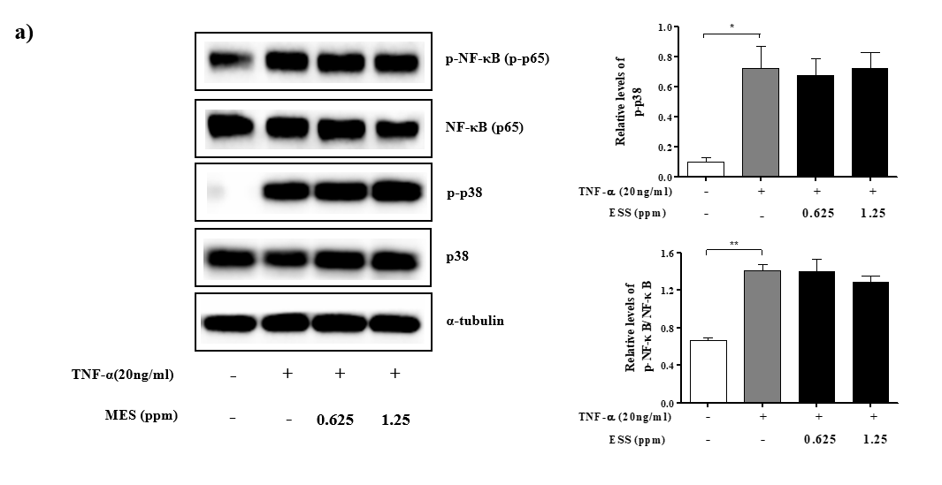
a) HaCaT cell were pretreated with different concentrations (0.625. 1.25 ppm) for 24 hours and then were stimulated with TNF-α for 30min-1hour. The phosphorylation of MAPKs was analyzed by western blot analysis. The phosphorylation of p38 and NF-κB was analyzed by the western blot. Phosphorylation of p38 and NF-κB was normalized by total form. Densitometric analysis was performed using a bioanalytical imaging system (Azure 300, AZI300-01, Azure biosystems, USA) and ImageJ (NIH, Rockville, MD, USA). The values presented are the mean ± SEM obtained from at least three independent experiments. Statistical significance is indicated as follows: ** p < 0.01, and * p < 0.05.
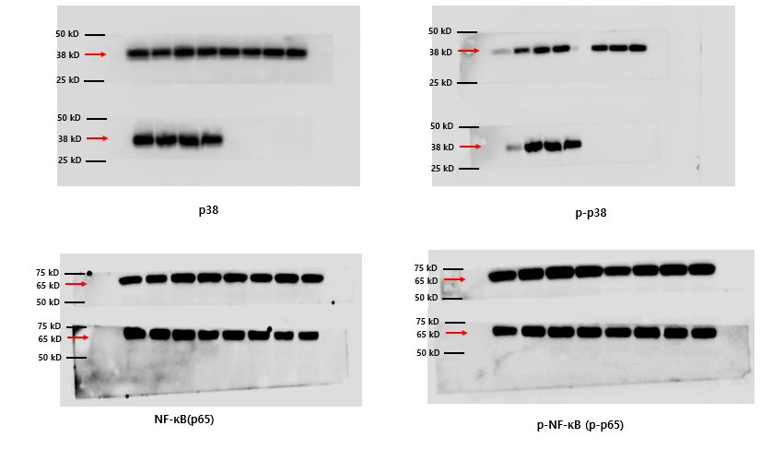
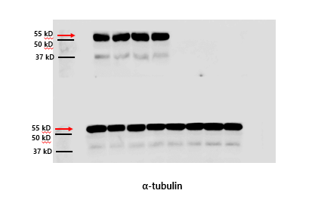
HaCaT cells (3×10^⁵ cells/well) were seeded onto a 6-well plate and cultured at 37°C for 48 hours. Following this, cells were pre-treated with ESS (0.625 and 1.25ppm) or DMSO for 1 hour, then stimulated with TNF-α (20ng/mL) for 30 minutes to 1 hour. After stimulation, cells were washed twice with cold PBS and protein extraction was performed on ice for 30 minutes using the ExKine™ Total Protein Extraction Kit (KTP3006, Abbkine, USA). The lysates were then centrifuged at 14,000 × g for 15 minutes, and the protein concentrations in the supernatants were measured. Equal amounts of protein (20 μg) were quantified and separated by SDS-polyacrylamide gel electrophoresis (PAGE), followed by transfer onto polyvinylidene difluoride (PVDF) membranes. The membranes were washed with Tris-buffered saline (TBS, 50 mM Tris-base, 200 mM NaCl, pH 7.4) containing 0.02% Tween 20 (TBST) and blocked with TBST containing 5% skim milk. Primary antibodies were added and incubated overnight at 4°C, followed by exposure to secondary antibodies for 1 hour and 30 minutes. The membranes were then washed three times with TBST at room temperature, and immunoreactivities were determined using an ECL detection kit. For multiplexing, the membrane was appropriately cut before primary antibody incubation to observe various proteins on a single membrane. Phospho proteins at the same position were probed again through stripping to enable band visualization. Densitometric analysis was carried out using the Azure 300 Chemiluminescent imaging system (AZI300-01, Azure biosystems, USA) and ImageJ (NIH, Rockville, MD, USA). It's noted that the Azure 300 Chemiluminescent imaging system automatically selects and saves the image with the clearest bands, potentially leading to obscured backgrounds or membrane edges.
Figure S2. The mRNA expression for atopic dermatitis-related inflammatory markers in DNCB-induced HR-1 mice.
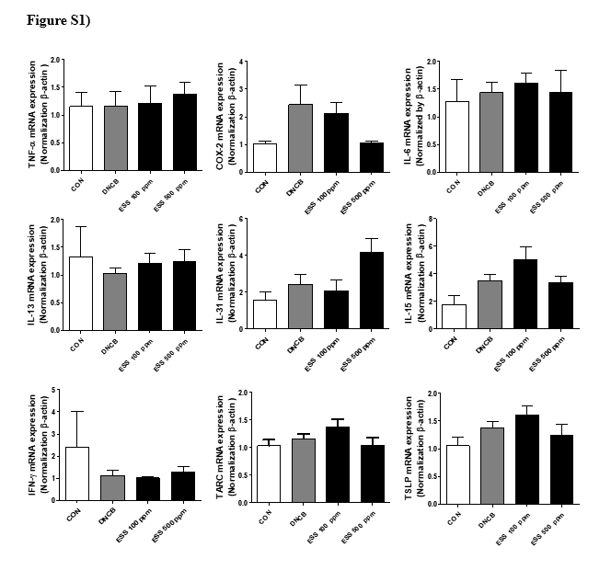
The modulation of inflammation-related gene expression in DNCB-induced HR-1 mouse skin by ESS treatment was investigated through RT-PCR. The values presented are the mean ± SEM obtained from at least seven independent experiments.

