Supplementary Material


Base materials (clay)
The glass
Types of tests
Mechanical test
Mechanical test
Mechanical test
Modified Proctor Test
CBR test
Shear test
Mixture (natural clay+ (0%, 10%, 20%) glass waste)
Results
Fig SI.1. Flowchart of the study on the treatment of clay with glass.
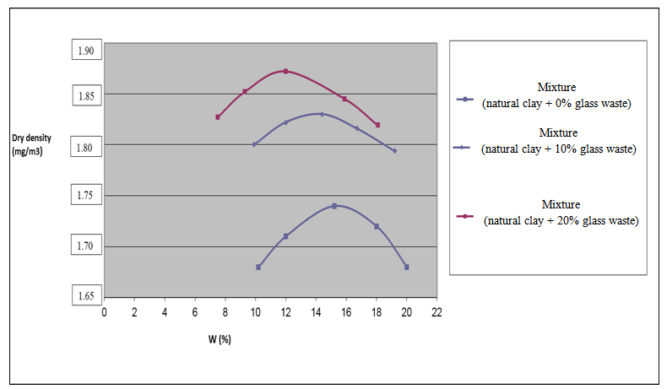
Fig. SI.2 Proctor curves of studied mixtures

Fig. SI.3 Evolution of compaction parameters as a function of glass content
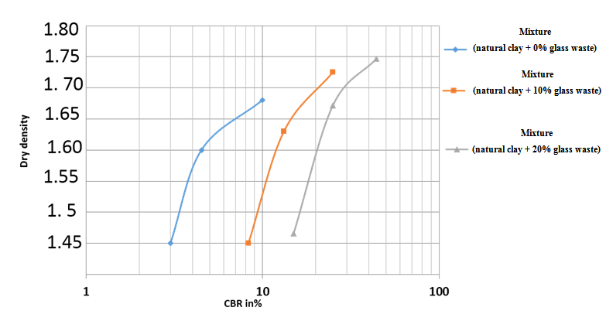
Fig. SI.4 Influence of mixture addition on CBR curves after immersion

