Supplementary material

Contents

Supplementary Tables 2
Table S1: Comparison of errors between incidence models for infections and hospitalizations for regional series. 2
Table S2a: Negative binomial response linear mixed model coefficients for the final and intermediate models for infections incidence rate. 4
Table S2b: Negative binomial response linear mixed model coefficients for the final and intermediate models for hospitalizations incidence rate. 5
Supplementary Figures 6
Figure S1: Incidence rate of COVID-19 total cases vs. SARI sentinel surveillance estimates adjusted by hospitalization rate 6
Figure S2: Incidence rate of COVID-19 total cases vs. SARI sentinel surveillance estimates by sex and age 7
Figure S3: Incidence rate of COVID-19 hospitalizations vs. SARI sentinel surveillance estimates by sex and age 8
Figure S4: Assessment of errors in the incidence estimation, March 2020 - March 2023 9
Figure S5: Bland-Altman plot for the incidence estimation, March 2020 - March 2023 10
Figure S6: Comparison between selected final model and rolling-time nowcasting model 11
Figure S7: Comparison between selected final model and alternative final model incorporating 2 weeks’ delay on variant circulation reporting. 12
Supplementary methods 13
Methods S1: Estimation of the catchment population size of the SARI sentinel centers geographic area of influence 13
Methods S2: Comparison between selected final model and alternative final model incorporating COVID-19 second and booster vaccination doses coverage within the population. 15
Methods S3: Variables and comparison methods formulas and definitions 16

Supplementary Tables

Table S1: Comparison of errors between incidence models for infections and hospitalizations for regional series.
Model | Level | Infections (total cases) |  |  |  |  |  | Hospitalizations (severe cases)
 |  | Cor | DTW | sMAPE | B/SE | MSE | 95% CI coverage | Cor | DTW | sMAPE | B/SE | MSE | 95% CI coverage
SARI rate (direct estimation) | Chile | 0.157 | 66.596 | 1.312 | -65.237 | 47627.479 | 0.006 | 0.892 | 8.565 | 1.222 | 5.47 | 317.201 | 0
SARI rate (direct estimation) | Metropolitana | 0.36 | 54.809 | 0.664 | -12.425 | 32687.017 | 0.156 | 0.908 | 21.597 | 1.399 | 2.362 | 1889.005 | 0.097
SARI rate (direct estimation) | Tarapacá | 0.366 | 70.576 | 0.767 | -38.984 | 83873.563 | 0.028 | 0.811 | 1.545 | 0.83 | 0.492 | 34.101 | 0.724
SARI rate (direct estimation) | Antofagasta | 0.357 | 89.089 | 0.762 | -48.539 | 79017.553 | 0 | 0.72 | 1.751 | 0.886 | 0.42 | 29.508 | 0.747
SARI rate (direct estimation) | Valparaíso | 0.024 | 70.125 | 0.68 | -32.688 | 57448.865 | 0.097 | 0.899 | 6.617 | 1.088 | 1.14 | 313.604 | 0.435
SARI rate (direct estimation) | Bío Bío | -0.035 | 78.526 | 0.628 | -29.537 | 89004.456 | 0.338 | 0.822 | 34.14 | 1.315 | 2.81 | 3522.528 | 0.179
SARI rate (direct estimation) | La Araucanía | 0.29 | 73.725 | 0.75 | -11.918 | 87099.737 | 0.182 | 0.773 | 20.699 | 1.501 | 1.727 | 1408.669 | 0.180
SARI rate (direct estimation) | Los Lagos | 0.087 | 59.851 | 0.746 | -9.764 | 84497.65 | 0.448 | 0.726 | 58.193 | 1.664 | 2.451 | 10020.092 | 0.059
SARI rate (direct estimation) | Magallanes | 0.668 | 79.543 | 0.66 | -10.527 | 88341.379 | 0.337 | 0.856 | 30.99 | 1.717 | 0.874 | 4539.584 | 0.439
Model 1: basic | Chile | 0.463 | 46.903 | 0.61 | 0.791 | 25904.375 | 0.104 | 0.862 | 1.374 | 0.462 | 2.063 | 12.9 | 0.091
Model 1: basic | Metropolitana | 0.43 | 45.651 | 0.664 | 0.868 | 20431.068 | 0.078 | 0.898 | 1.673 | 0.499 | 1.762 | 24.486 | 0.078
Model 1: basic | Tarapacá | 0.636 | 55.345 | 0.767 | 2.38 | 47349.456 | 0.103 | 0.861 | 1.425 | 0.734 | 2.997 | 14.965 | 0.106
Model 1: basic | Antofagasta | 0.456 | 71.782 | 0.762 | 1.035 | 41010.362 | 0.15 | 0.876 | 1.094 | 0.636 | 1.411 | 7.882 | 0.132
Model 1: basic | Valparaíso | 0.46 | 51.269 | 0.68 | 0.9 | 31496.551 | 0.091 | 0.826 | 1.284 | 0.586 | 2.303 | 12.27 | 0.082
Model 1: basic | Bío Bío | 0.431 | 55.978 | 0.628 | 0.663 | 56404.424 | 0.156 | 0.73 | 1.329 | 0.463 | 1.363 | 22.695 | 0.172
Model 1: basic | La Araucanía | 0.46 | 61.488 | 0.75 | 1.061 | 57048.345 | 0.11 | 0.797 | 1.35 | 0.607 | 1.833 | 13.041 | 0.128
Model 1: basic | Los Lagos | 0.29 | 64.714 | 0.746 | 1.31 | 68535.561 | 0.182 | 0.594 | 3.834 | 0.639 | 2.004 | 137.689 | 0.158
Model 1: basic | Magallanes | 0.746 | 66.768 | 0.66 | 1.751 | 36742.876 | 0.143 | 0.898 | 0.814 | 0.45 | 0.535 | 3.377 | 0.512
Model 2: intermediate | Chile | 0.702 | 34.984 | 0.423 | 0.68 | 16014.177 | 0.195 | 0.846 | 1.198 | 0.358 | 1.802 | 11.031 | 0.097
Model 2: intermediate | Metropolitana | 0.696 | 28.976 | 0.457 | 0.616 | 12797.822 | 0.117 | 0.904 | 1.18 | 0.367 | 1.171 | 12.874 | 0.234
Model 2: intermediate | Tarapacá | 0.352 | 65.029 | 0.705 | 2.388 | 63696.199 | 0.076 | 0.846 | 1.462 | 0.707 | 3.232 | 15.139 | 0.098
Model 2: intermediate | Antofagasta | 0.619 | 48.277 | 0.585 | 0.959 | 30555.374 | 0.106 | 0.846 | 1.087 | 0.595 | 1.393 | 8.377 | 0.187
Model 2: intermediate | Valparaíso | 0.655 | 43.596 | 0.551 | 0.61 | 22087.058 | 0.097 | 0.746 | 1.327 | 0.517 | 2.108 | 14.518 | 0.075
Model 2: intermediate | Bío Bío | 0.679 | 55.768 | 0.52 | 0.602 | 36819.712 | 0.182 | 0.651 | 1.945 | 0.45 | 1.19 | 32.261 | 0.113
Model 2: intermediate | La Araucanía | 0.718 | 57.446 | 0.667 | 0.799 | 36038.233 | 0.045 | 0.743 | 1.345 | 0.56 | 1.68 | 15.562 | 0.143
Model 2: intermediate | Los Lagos | 0.577 | 63.692 | 0.657 | 1.51 | 49552.276 | 0.156 | 0.531 | 4.497 | 0.586 | 1.707 | 178.407 | 0.171
Model 2: intermediate | Magallanes | 0.718 | 61.21 | 0.566 | 1.879 | 41424.779 | 0.173 | 0.949 | 0.674 | 0.389 | 0.205 | 2.214 | 0.634
Model 3: final | Chile | 0.935 | 19.358 | 0.274 | 0.167 | 6945.675 | 0.279 | 0.975 | 0.547 | 0.21 | 0.39 | 2.571 | 0.234
Model 3: final | Metropolitana | 0.901 | 20.096 | 0.314 | 0.451 | 6053.157 | 0.26 | 0.946 | 0.924 | 0.279 | 0.691 | 11.989 | 0.162
Model 3: final | Tarapacá | 0.657 | 35.333 | 0.509 | 1.734 | 37342.276 | 0.241 | 0.899 | 0.814 | 0.529 | 1.836 | 8.303 | 0.187
Model 3: final | Antofagasta | 0.756 | 35.799 | 0.403 | 0.869 | 22617.571 | 0.327 | 0.911 | 0.794 | 0.428 | 1.472 | 4.867 | 0.253
Model 3: final | Valparaíso | 0.915 | 28.189 | 0.391 | 0.164 | 12101.851 | 0.201 | 0.966 | 0.591 | 0.289 | 0.976 | 2.71 | 0.259
Model 3: final | Bío Bío | 0.913 | 38.403 | 0.455 | 0.248 | 20293.537 | 0.182 | 0.861 | 1.295 | 0.382 | 0.912 | 14.915 | 0.172
Model 3: final | La Araucanía | 0.903 | 39.82 | 0.55 | 0.471 | 22973.667 | 0.175 | 0.935 | 0.657 | 0.432 | -0.434 | 4.526 | 0.241
Model 3: final | Los Lagos | 0.833 | 45.931 | 0.625 | 0.897 | 31358.867 | 0.136 | 0.801 | 1.844 | 0.478 | 0.459 | 24.24 | 0.184
Model 3: final | Magallanes | 0.851 | 36.595 | 0.394 | 0.64 | 21383.479 | 0.265 | 0.930 | 0.631 | 0.366 | 0.381 | 2.267 | 0.537
Model 3: final (national series*) | Chile | 0.934 | 22.403 | 0.315 | 0.379 | 8855.792 | 0.592 | 0.957 | 0.806 | 0.283 | 1.127 | 8.815 | 0.815

Table S2a: Negative binomial response linear mixed model coefficients for the final and intermediate models for infections incidence rate.
Variables | Model 0: null | Model 1: basic | Model 2: intermedite | Model 3: final
Fixed effects [IRR (95%CI)]
(Intercept) | 0.002 (0.002 - 0.002) | 0 (0 - 0) | 0 (0 – 0.001) | 1.205e+23 (1.245e+21 - 1.169e+25)
Time (weeks) |  | 1.001 (1 - 1.001) | 1 (1 - 1) | 0.997 (0.996 - 0.997)
Sentinel surveillance IR |  | 1.003 (1.003 - 1.004) | 1.003 (1.003 - 1.003) | 1.002 (1.002 - 1.002)
Hospitalization probability |  | 0.954 (0.952 - 0.957) | 0.959 (0.956 - 0.961) | 0.965 (0.963 - 0.968)
Positivity |  |  | 1.090 (1.085 - 1.094) | 1.047 (1.042 - 1.052)
Alpha |  |  |  | 1.007 (0.993 - 1.020)
B.1.1.348 |  |  |  | 1.013 (1.009 - 1.016)
B.1.1 |  |  |  | 1.010 (1.008 - 1.013)
Delta |  |  |  | 1.015 (1.013 - 1.016)
Gamma |  |  |  | 1.014 (1.012 - 1.017)
Lambda |  |  |  | 1.023 (1.018 - 1.028)
Mu |  |  |  | 0.966 (0.961 - 0.971)
N.4 |  |  |  | 1.015 (1.006 - 1.024)
Omicron |  |  |  | 1.030 (1.028 - 1.032)
Otras |  |  |  | 1.016 (1.011 - 1.020)
Random effects [Variance]
Region:Age | 0.099 | 0.141 | 0.162 | 0.141
Residuals | 1.022 | 1.773 | 3.483 | 6.793
ICC | 0.088 | 0.074 | 0.044 | 0.02
Adjustment
AIC | 58525.934 | 57196.949 | 55610.766 | 54135.07
BIC | 58544.821 | 57234.722 | 55654.835 | 54242.095
logLik | -29259.967 | -28592.474 | -27798.383 | -27050.535
Deviance | 58519.934 | 57184.949 | 55596.766 | 54101.07
IRR: model coefficient expressed as incidence rate ratio; CI: confidence interval; IR: incidence rate; ICC: intraclass correlation coefficient; AIC: Akaike information criteria; BIC: Bayesian information criteria; logLik: log-likelihood. In bold: statistically significant coefficients for the explanatory variable.

Table S2b: Negative binomial response linear mixed model coefficients for the final and intermediate models for hospitalizations incidence rate.
Variables | Model 0: null | Model 1: basic | Model 2: intermedite | Model 3: final
Fixed effects [IRR (95%CI)]
(Intercept) | 0 (0 - 0) | 4,905.621 (610.307 – 39,431.155) | 20,834.936 (2,464.102 – 176,167.436) | 1,362,249,353.786 (12,787,980.244 – 145,114,651,925.174)
Time (weeks) |  | 0.999 (0.999 - 0.999) | 0.999 (0.999 - 0.999) | 0.998 (0.998 - 0.999)
Sentinel surveillance IR |  | 1.003 (1.002 - 1.003) | 1.003 (1.002 - 1.003) | 1.002 (1.001 - 1.002)
Sex (Male) |  | 1.181 (1.127 - 1.239) | 1.192 (1.140 - 1.247) | 1.241 (1.196 - 1.288)
Positivity |  |  | 1.040 (1.036 - 1.044) | 1.045 (1.041 - 1.049)
Alpha |  |  |  | 1.005 (0.994 - 1.015)
B.1.1.348 |  |  |  | 1.010 (1.007 - 1.013)
B.1.1 |  |  |  | 1.005 (1.003 - 1.007)
Delta |  |  |  | 1.005 (1.004 - 1.006)
Gamma |  |  |  | 1.012 (1.010 - 1.014)
Lambda |  |  |  | 1.018 (1.014 - 1.022)
Mu |  |  |  | 0.966 (0.960 - 0.972)
N.4 |  |  |  | 1.011 (1.004 - 1.019)
Omicron |  |  |  | 1.007 (1.005 - 1.009)
Otras |  |  |  | 1.007 (1.003 - 1.011)
Random effects [Variance]
Region:Age | 0.878 | 0.588 | 0.603 | 0.59
Residuals | 2.521 | 4.815 | 6.071 | 16.969
ICC | 0.258 | 0.109 | 0.09 | 0.034
Adjustment
AIC | 30512.552 | 29361.176 | 28931.7 | 27442.071
BIC | 30531.36 | 29398.792 | 28975.584 | 27548.648
logLik | -15253.276 | -14674.588 | -14458.85 | -13704.036
Deviance | 30506.552 | 29349.176 | 28917.7 | 27408.071
IRR: model coefficient expressed as incidence rate ratio; IR: incidence rate; CI: confidence interval; ICC: intraclass correlation coefficient; AIC: Akaike information criteria; BIC: Bayesian information criteria; logLik: log-likelihood. In bold: statistically significant coefficients for the explanatory variable.

Supplementary Figures

Figure S1: Incidence rate of COVID-19 total cases vs. SARI sentinel surveillance estimates adjusted by hospitalization rate
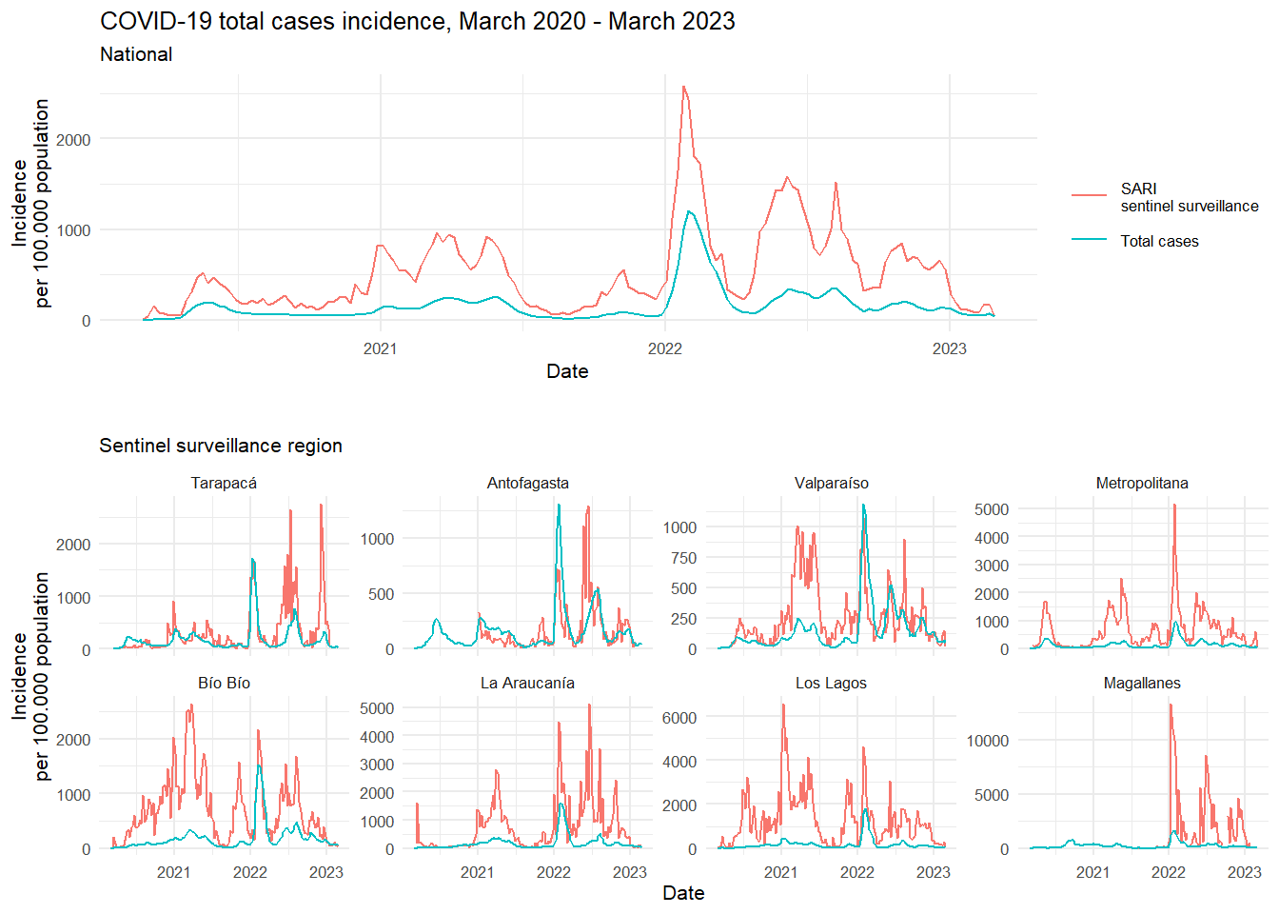
The SARI (Severe Acute Respiratory Infections) sentinel surveillance estimation has been adjusted using the hospitalization rate to estimate the total number of cases, as opposed to solely hospitalized cases.

Figure S2: Incidence rate of COVID-19 total cases vs. SARI sentinel surveillance estimates by sex and age
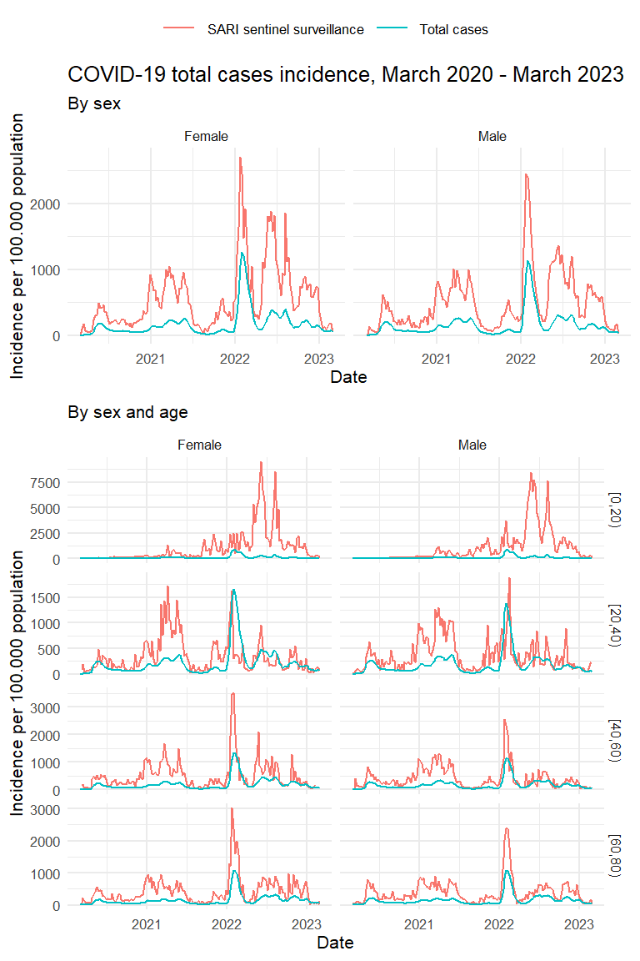
The SARI (Severe Acute Respiratory Infections) sentinel surveillance estimation has been adjusted using the hospitalization rate to estimate the total number of cases, as opposed to solely hospitalized cases.

Figure S3: Incidence rate of COVID-19 hospitalizations vs. SARI sentinel surveillance estimates by sex and age
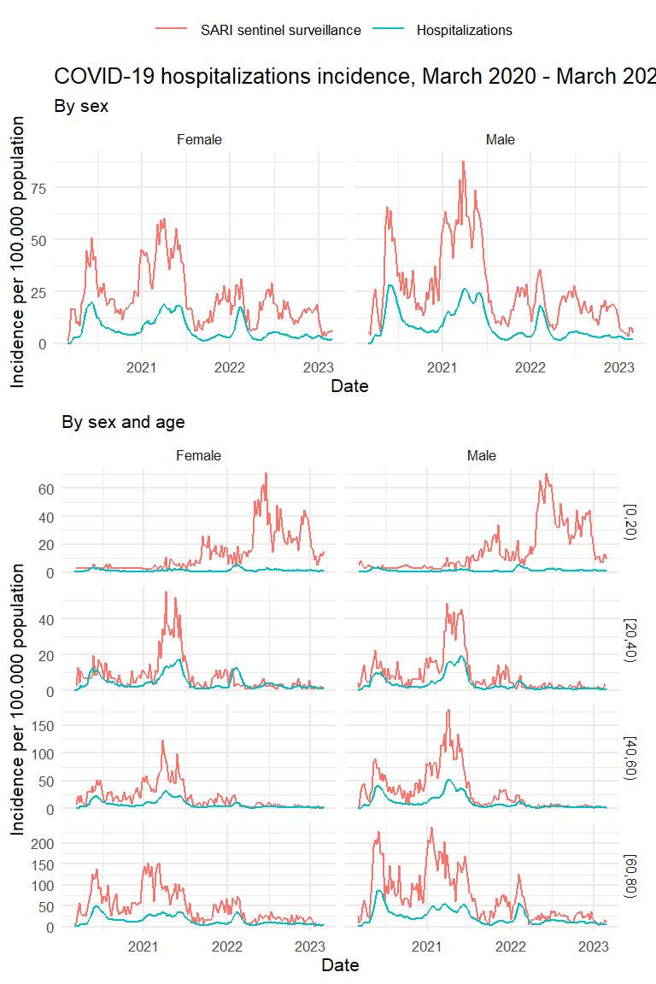

Figure S4: Assessment of errors in the incidence estimation, March 2020 - March 2023
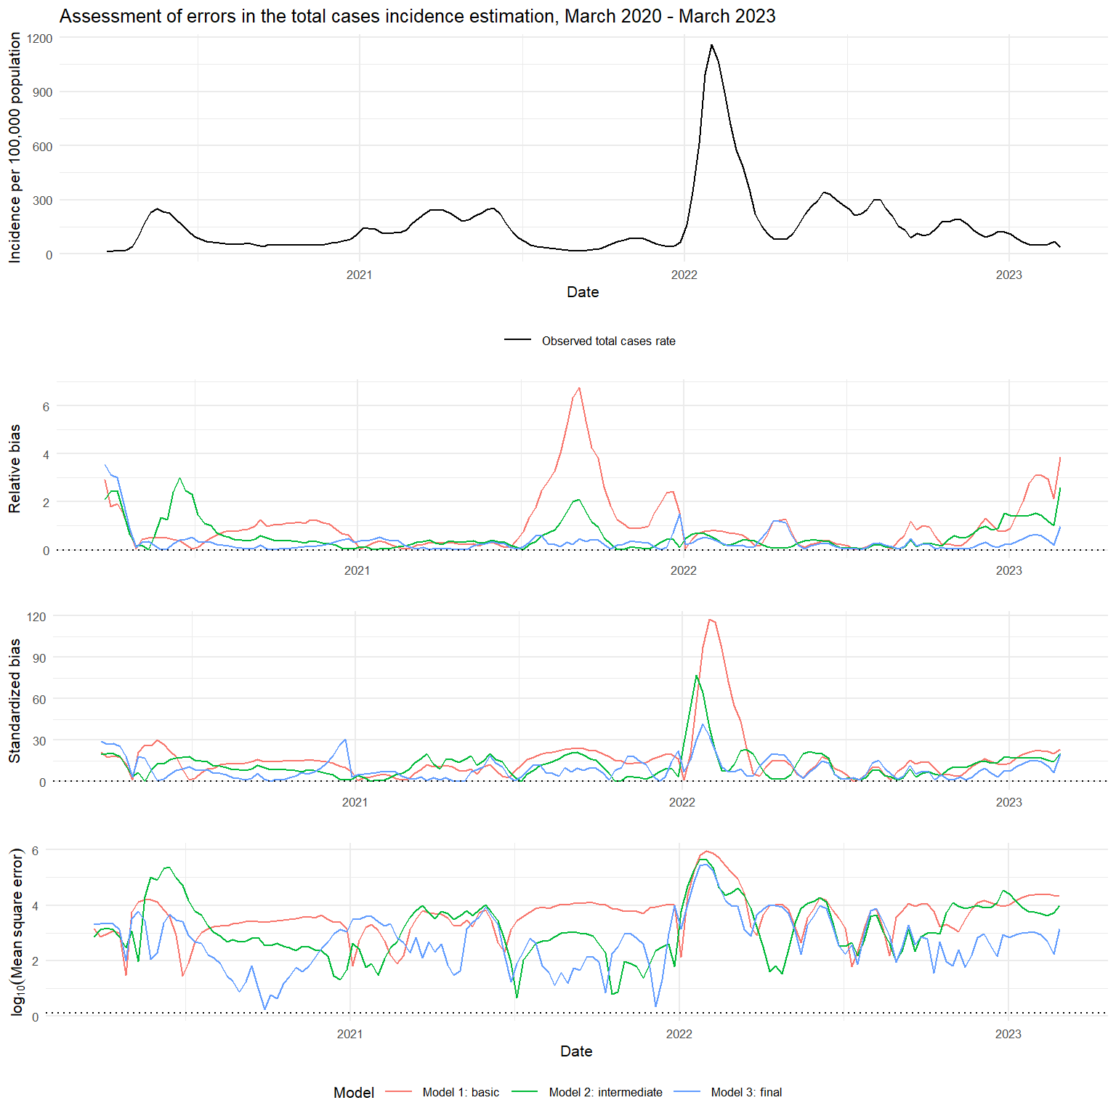 | 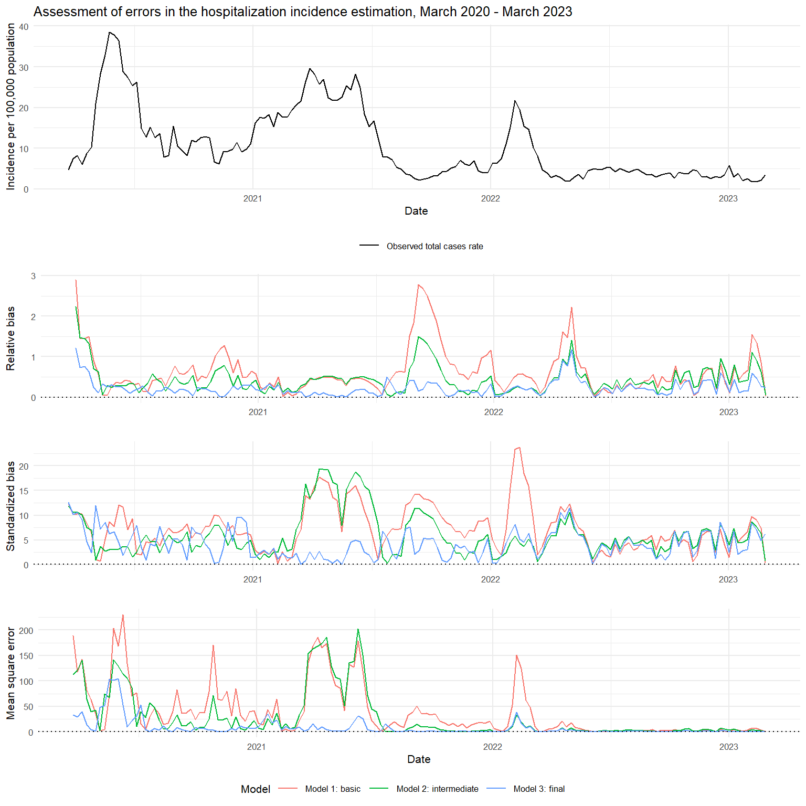

Figure S5: Bland-Altman plot for the incidence estimation, March 2020 - March 2023
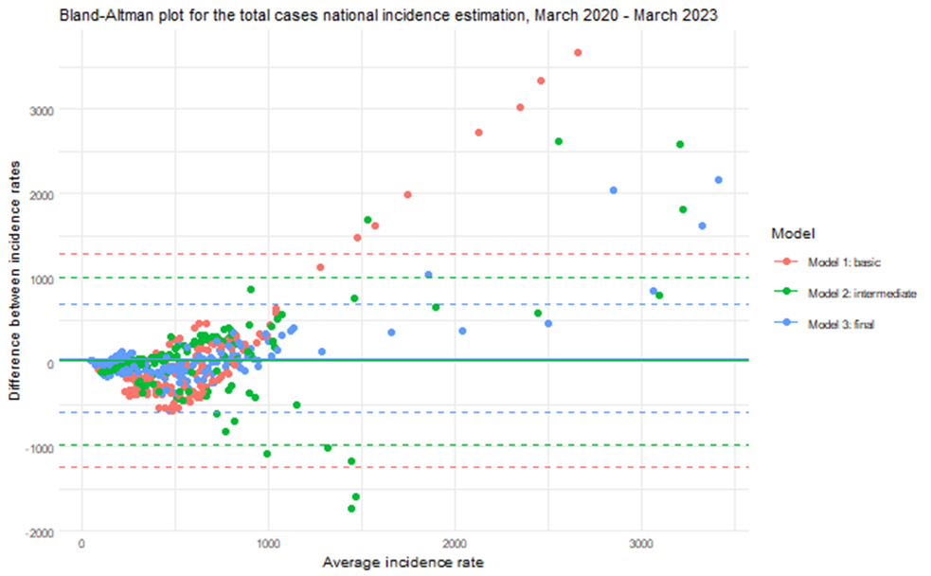 | 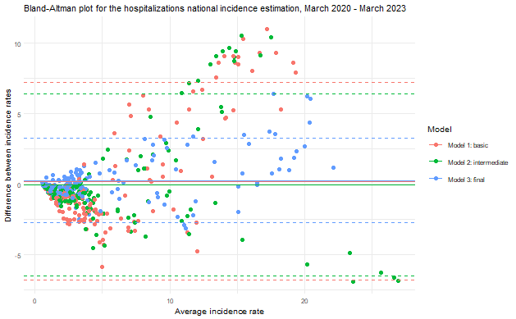

Figure S6: Comparison between selected final model and rolling-time nowcasting model
 | Infections (total cases) | Hospitalizations (severe cases)
Complete rolling-time nowcasting models | 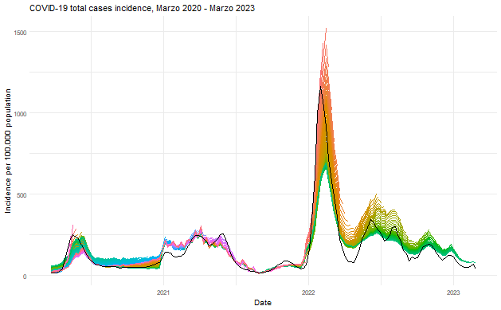 | 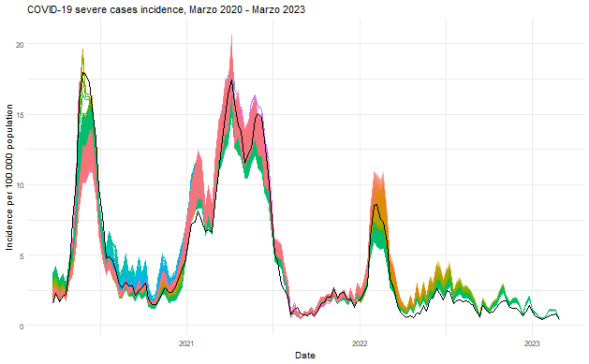 | In black: Final model adjusted with retrospective data available in week 159. In colors: Model adjusted with data from week=1 to week=t, t = {1, …, 159}.
Rolling-time model series constructed from the last point of each nowcasting model | 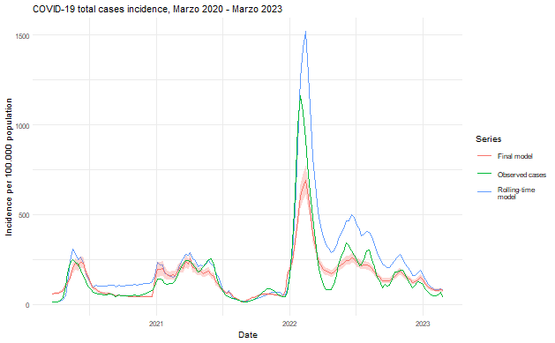 | 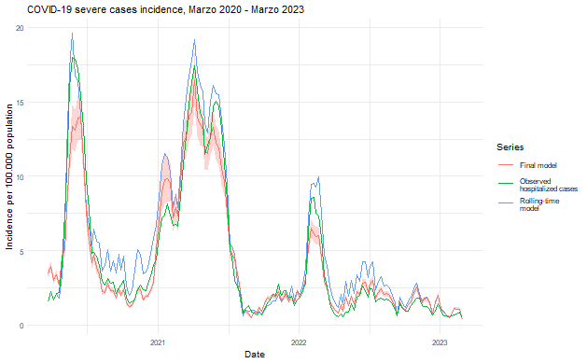 | Final model (red) was adjusted with retrospective data available in week 159. Rolling-time model (blue) series shows the last point of the model adjusted in week t, from t=4 to t=159.Both were compared to the observed series of cases and severe cases, respectively (green).

Figure S7: Comparison between selected final model and alternative final model incorporating 2 weeks’ delay on variant circulation reporting.

Infections (total cases) | Hospitalizations (severe cases)
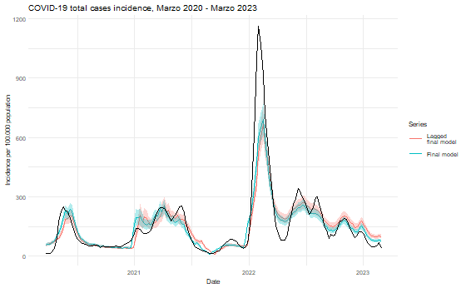 | 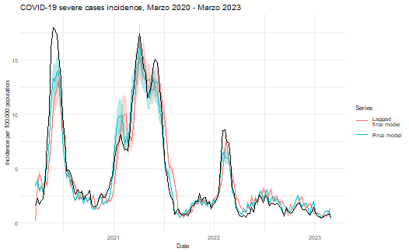
Black line represents the observed total or severe cases, respectively.

Supplementary methods

Methods S1: Estimation of the catchment population size of the SARI sentinel centers geographic area of influence

The accurate estimation of incidence rates for Severe Acute Respiratory Infections (SARI) using sentinel surveillance data necessitates the determination of an appropriate population denominator. This population represents the catchment area served by the sentinel centers, from which the reported cases are drawn. In this study, we applied the method based on the geographic area of influence, which uses the proportion of cases received by the sentinel center compared to other hospitals in neighboring areas to estimate population incidence. The applied method was based on the "Methodological Guide for the Estimation of the Disease Burden due to Severe Acute Respiratory Infections (SARI)" developed by PAHO/MINSAL (2017) to adapt the WHO`s guidelines (2015) to the Chilean context.
We used the following data sources to apply this method:
- Annual population projection by municipality, sex, and age (2020-2023)
- FONASA (Fondo Nacional de Salud) beneficiary population by year, municipality, sex, and age (2020-2022)
- Hospital discharges for respiratory causes J09-J22 and U07 (2020-2022)
- SARI sentinel surveillance (2020-2023)
We performed two separate catchment population size calculations. The first one considered the national population, and the second one considered the population covered by FONASA. For the first case, since population estimates are only performed up to the age of 80, we removed observations of individuals over 80 years old from the hospital discharge and SARI sentinel surveillance databases.
Municipality Case Allocation: We first identified municipalities with SARI case records and calculated the case counts ($n_{SARI}$) and population by region ($r$), municipality ($m$), establishment ($e$), sex ($s$), and age group ($a$) in the whole period.
$$n_{SARI}=∑a_{r,m,e, s,a}$$
Where $x=1$ for SARI cases. Municipalities served by multiple sentinel centers were assigned to the center with the majority of cases of that municipality.
Case Proportion Calculation: For each center, we calculated the proportion of cases from each municipality relative to the total cases at the center.
$${\hat{p}}_{e}=\frac{∑a_{SARI,m,e}}{∑a_{SARI,e}}$$
Where $p_{c}$ is the proportion of cases in a sentinel center (establishment) that are catched by one municipality.
Calculating Hospital Catchment Proportions: For municipalities served by more than one SARI sentinel center, a decision was made to attribute the municipality to the center where it constituted a larger proportion of cases. The proportions of cases from each municipality relative to the total cases handled by the center were calculated and sorted, with a cumulative sum used to retain municipalities contributing to up to 80% of the center's cases, so $∑{\hat{p}}_{e}≤0.8$.
Adjusting Population Figures: The catchment population estimates were adjusted by comparing the number of SARI cases ($n_{SARI}$) managed by the sentinel centers with the number of hospital discharges for respiratory causes ($n_{EH}$) in the same region, to account for the share of hospitalizations each center covers within its catchment area. This step involves aggregating data to the level of sentinel centers and calculating proportions of SARI cases to total respiratory hospital discharges, making further adjustments for years 2022 and 2023 based on observed trends and projections.
$$p_{m}=\frac{n_{SARIr,e}}{n_{EH,r}}$$
In cases where we observed atypical or implausible values in this proportion, we replaced the count of hospital discharges with the count from the previous year. In addition, since information on hospital discharges for 2023 is not yet available, we used those for 2022, weighted by the proportion of SARI cases up to the analysis cutoff date relative to the total cases in 2022.
Final Population Estimates for Sentinel Centers: Finally, we weighted the population projections or the total population or FONASA covered population ($N$) by year ($y$), region, municipality, sex, and age, by this proportion.
$${\hat{N}}_{catchment,y,r,m,s,a}=N_{y,r,m,s,a}×p_{m}$$
For the analyses, we used the catchment populations estimated using the census population projection. For each year, the populations for each SARI sentinel center calculated are as follows:
Facility | 2020 | 2021 | 2022 | 2023
Hospital Clínico Regional Dr. Guillermo Grant Benavente (Concepción) | 31.864 | 44.953 | 114.147 | 181.239
Hospital de Magallanes Dr. Lautaro Navarro Avaria | - | 25.684 | 7.234 | 9.846
Hospital de Puerto Montt | 9.693 | 14.970 | 59.233 | 54.026
Hospital Dr. Ernesto Torres Galdames (Iquique) | 80.467 | 106.719 | 103.864 | 106.091
Hospital Dr. Gustavo Fricke (Viña del Mar) | 71.763 | 38.627 | 88.475 | 125.388
Hospital Dr. Hernán Henríquez Aravena (Temuco) | 29.863 | 30.162 | 28.964 | 88.131
Hospital Dr. Leonardo Guzmán (Antofagasta) | - | 63.909 | 100.789 | 155.352
Hospital Militar de Santiago | 27.121 | 13.010 | 40.298 | 28.843
Hospital San Juan de Dios (Santiago) | 32.052 | 24.664 | 19.058 | 56.557
Total | 282.823 | 362.698 | 562.062 | 805.473

Methods S2: Comparison between selected final model and alternative final model incorporating COVID-19 second and booster vaccination doses coverage within the population.
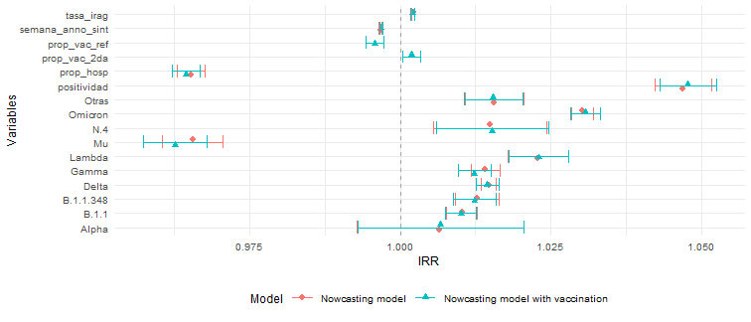

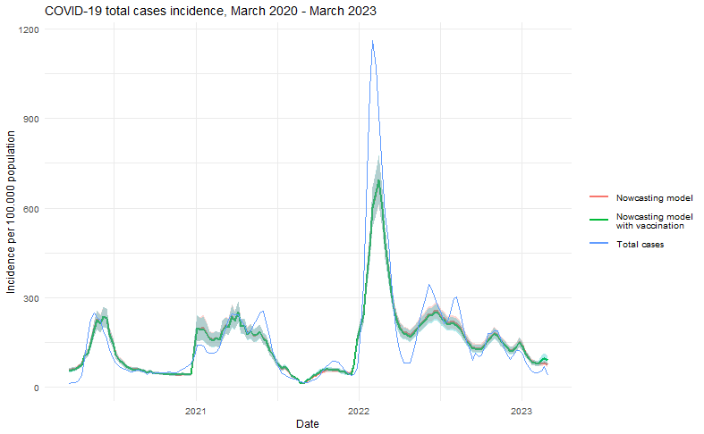

Methods S3: Variables and comparison methods formulas and definitions

Epidemiological variables
Level | Variables | Formula
Week, region, sex, age | Total cases incidence rate | $$\frac{new infections}{population}*100.000$$
Week, region, sex, age | Severe cases incidence rate | $$\frac{new hospitalizations}{population}*100.000$$
Week, region, sex, age | Sentinel surveillance incidence rate | $$IR_{SARI}=\frac{new SARI sentinel surveillance cases}{SARI sentinel surveillance population\text{*}}*100.000$$
Week, region, sex, age | Sentinel surveillance incidence rate adjusted by hospitalization rate | $$\frac{IR_{SARI}}{hospitalization rate}$$
Week, region, sex, age | Hospitalization rate | $$\frac{new hospitalizations}{new infections}*100$$
Week, region | Positivity rate | $$\frac{positive PCR tests}{total PCR tests}*100$$
Week | SARS-CoV-2 variant proportion | $$\frac{variant samples}{total samples}$$
Week | 2nd dose vaccination rate | $$\frac{\sum{vaccinated population}}{total population}*100$$
Week | Reinforcement vaccination rate | $$\frac{\sum{vaccinated population}}{total population}*100$$
*For SARI sentinel surveillance population estimation, see Methods S1.
Comparison metrics
Level | Comparison metrics | Formula / R library::function
Week | Bias ($B_{i}$) | $$\hat{θ_{i}}-θ_{i}$$
Week | Relative bias ($B_{ri}$) | $$\frac{B_{i}}{θ_{i}}$$
Week | Standardized bias (${\left[B/{SE}\right]}_{i}$) | $$\frac{B_{i}}{SE_{i}}$$
Week | Mean squared error ($MSE_{i}$) | $$B_{i}^{2}+SE_{i}^{2}$$
Full series | Mean relative bias ($B_{r}$) | $$\frac{1}{n}∑B_{ri}$$
Full series | Mean standardized bias ($B/{SE}$) | $$\frac{1}{n}∑{\left[\frac{B}{SE}\right]}_{i}$$
Full series | Mean mean squared error ($MSE$) | $$\frac{1}{n}∑{MSE}_{i}$$
Full series | Symmetric mean absolute percentage error ($sMAPE$) | $$\frac{1}{n}\sum{\frac{|θ_{i}-{\hat{θ}}_{i}|}{(|θ_{i}|+|{\hat{θ}}_{i}|)/2}}$$
Full series | Pearson’s correlation ($Cor$) | stats::cor()
Full series | Dynamic time warping ($DTW$) | dtw::dtw()
Full series | 95% Confidence interval coverage | $$\frac{1}{n}∑I_{i}, I_{i}= \left\{\begin{aligned}1 if \hat{θ}∈IC95\% \\ 0 \sim \end{aligned}\right.$$
$SE$: standard error; $θ$: target series (parameter); $θ_{i}$: target observation; $\hat{θ}$: predicted series (estimator); ${\hat{θ}}_{i}$: predicted observation; $n$: número de semanas

De la Fuente, Felipe. (2017). Guía metodológica para la estimación de carga de enfermedad por Infecciones respiratorias Agudas Graves (IRAG). Santiago, Chile: Organización Panamericana de la Salud / Ministerio de Salud de Chile.
WHO Global Influenza Progamme. (2015). A manual for estimating disease burden associated with seasonal influenza. Ginebra.

