Supplementary information

Housekeeping Protein-coding Genes Interrogated with Tissue and Individual Variations

Kuo-Feng Tung¹, Chao-Yu Pan¹, and Wen-chang Lin^{1*}

¹Institute of Biomedical Sciences, Academia Sinica, Taipei, Taiwan, R.O.C.

Supplemental Table 1. Numbers of samples in 52 tissue subtypes. The GTEx V8 datasets were retrieved from GTEx website and the Gini index-tissue values were determined for protein-coding genes in each tissue subtypes as described in the Methods.

GTEx_tissue_subtypes | Numbers of GTEx donor sample | Average Gini index-tissue values | Genes with Gini index  value<0.2
adipose_subcutaneous | 663 | 0.32 | 8283
adipose_visceral_omentum | 541 | 0.35 | 5794
adrenal_gland | 258 | 0.33 | 7433
artery_aorta | 432 | 0.31 | 8728
artery_coronary | 240 | 0.34 | 7380
artery_tibial | 663 | 0.33 | 8291
bladder | 21 | 0.32 | 7392
brain_amygdala | 152 | 0.38 | 373
brain_anterior_cingulate_cortex_ba24 | 176 | 0.35 | 1991
brain_caudate_basal_ganglia | 246 | 0.35 | 1156
brain_cerebellar_hemisphere | 215 | 0.30 | 7933
brain_cerebellum | 241 | 0.27 | 10525
brain_cortex | 255 | 0.30 | 7530
brain_frontal_cortex_ba9 | 209 | 0.32 | 3960
brain_hippocampus | 197 | 0.39 | 56
brain_hypothalamus | 202 | 0.38 | 255
brain_nucleus_accumbens_basal ganglia | 246 | 0.37 | 674
brain_putamen_basal_ganglia | 205 | 0.36 | 604
brain_spinal_cord_cervical_c-1 | 159 | 0.37 | 972
brain_substantia_nigra | 139 | 0.37 | 675
breast_mammary_tissue | 459 | 0.36 | 6145
cervix_ectocervix | 9 | 0.31 | 7356
cervix_endocervix | 10 | 0.28 | 9500
colon_sigmoid | 373 | 0.32 | 8065
colon_transverse | 406 | 0.36 | 5055
esophagus_gastroesophageal_junction | 375 | 0.33 | 7693
esophagus_mucosa | 555 | 0.32 | 7278
esophagus_muscularis | 515 | 0.32 | 8072
fallopian_tube | 9 | 0.29 | 8676
heart_atrial_appendage | 429 | 0.35 | 4662
heart_left_ventricle | 432 | 0.42 | 19
kidney_cortex | 85 | 0.41 | 13
kidney_medulla | 4 | 0.25 | 8702
liver | 226 | 0.37 | 3771
lung | 578 | 0.33 | 6539
minor_salivary_gland | 162 | 0.32 | 7435
muscle_skeletal | 803 | 0.39 | 3319
nerve_tibial | 619 | 0.28 | 9745
ovary | 180 | 0.33 | 7979
pancreas | 328 | 0.34 | 5711
pituitary | 283 | 0.30 | 8642
prostate | 245 | 0.34 | 6823
skin_not_sun_exposed_suprapubic | 604 | 0.31 | 7960
skin_sun_exposed_lower_leg | 701 | 0.30 | 8236
small_intestine_terminal_ileum | 187 | 0.36 | 4574
spleen | 241 | 0.30 | 8415
stomach | 359 | 0.38 | 3642
testis | 361 | 0.20 | 11353
thyroid | 653 | 0.30 | 8898
uterus | 142 | 0.32 | 8119
vagina | 156 | 0.35 | 6172
whole_blood | 755 | 0.50 | 35

Figure Legends

Supplementary Figure 1. Different types of Gini index distribution of human protein-coding genes. The box-and-whisker plot demonstrates Gini index-subject values (blue color); Gini index-TPM values (red color) and average Gini index-tissue values (green color) for protein-coding genes. The calculation of Gini index values is described in the Methods section. Statistical assessment is performed by RM one-way ANOVA test. ****: P-value<0.0001.

Supplementary Figure 1
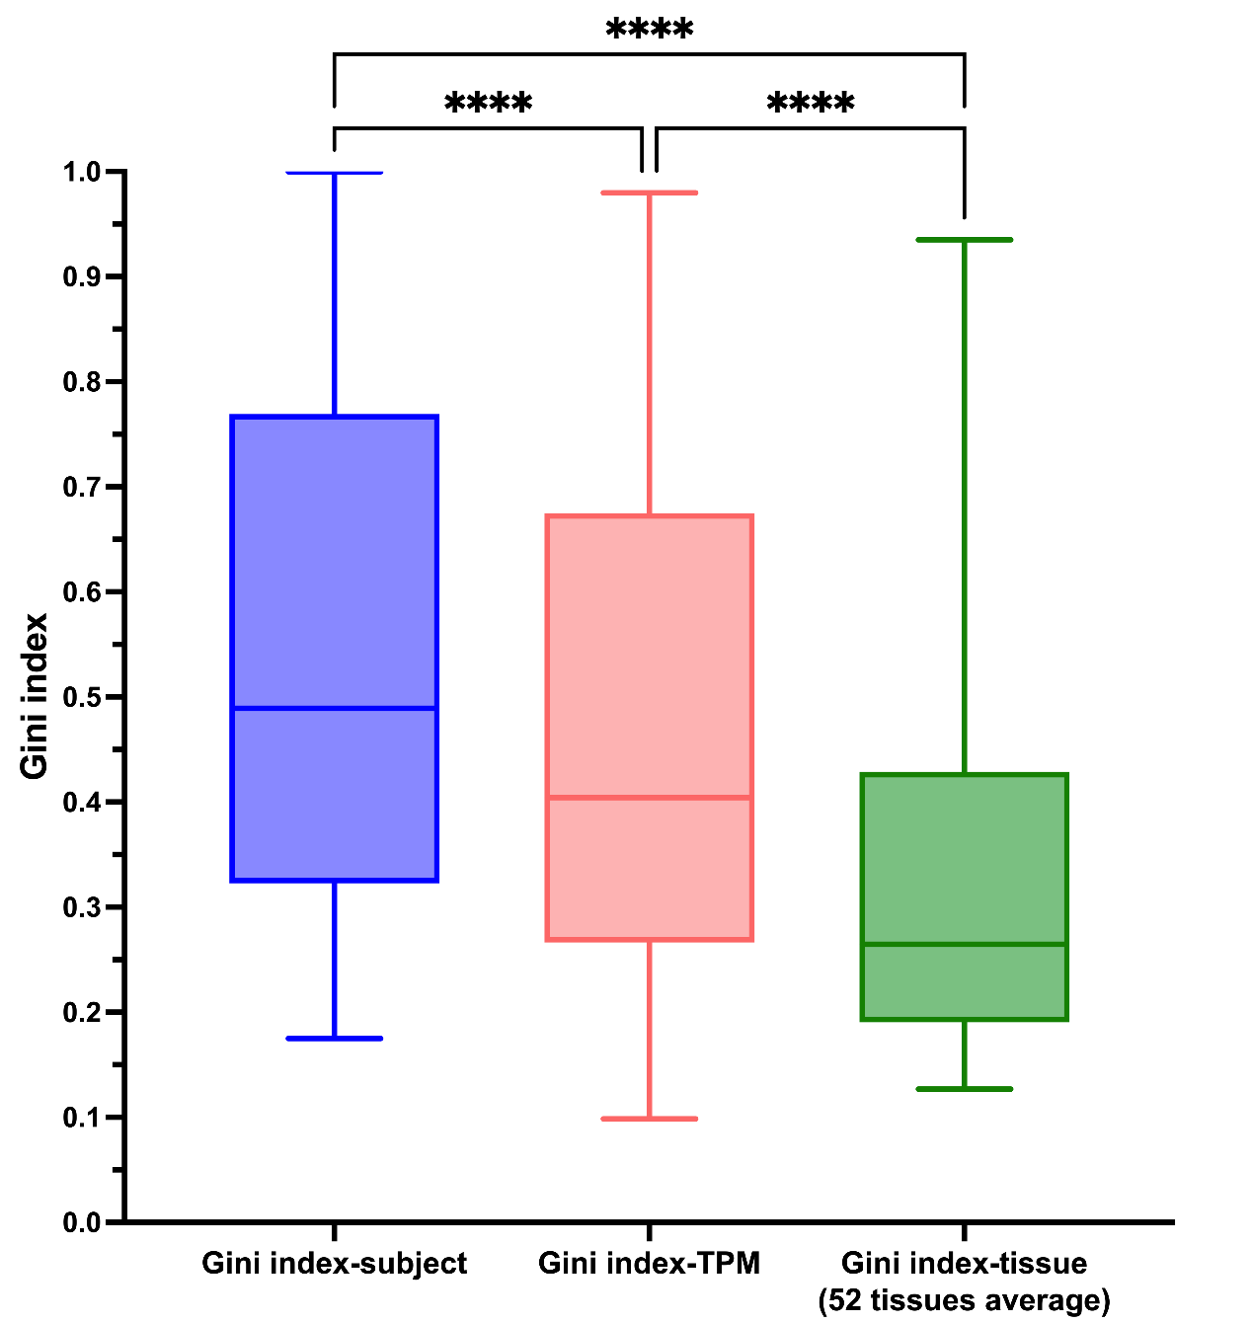

Supplementary Figure 2. Illustration of Gini index and gene expression information webpage for PZP Alpha-2-Macroglobulin Like (PZP) protein-coding gene. The information provided includes the fundamental information of the PZP protein-coding gene, such as its IDs and Gini index-subject. On the top panel, there is a visualization graph for the Gini index-tissue, Gini index-tissue(male), and Gini index-tissue(female). To activate or deactivate the display of the Gini index lines, simply click on the symbols. The gene expression information for the TPM is presented on the bottom panel. It is noted that the Gini index calculation for males and females do not include 7 specific tissue subtypes: bladder, ovary, prostate, testis, uterus, and vagina.

Supplementary Figure 2
