Supplementary Figure 1

Spectral and Temporal Resolution Thresholds by Age Group

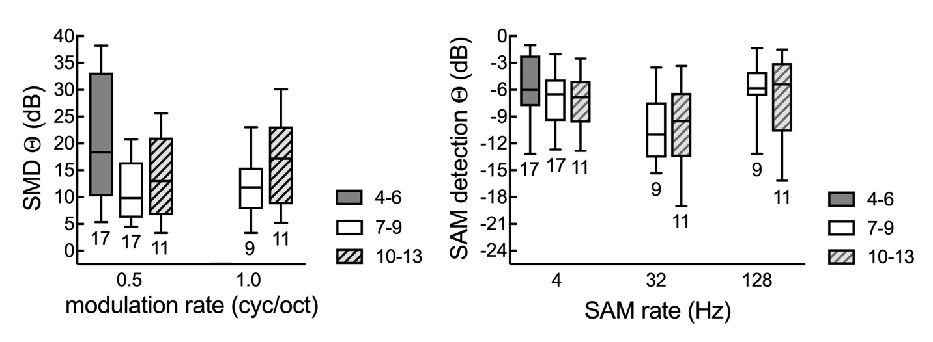

Note. Spectral (SMD) and temporal (SAM) resolution thresholds (Θ) were subdivided for three age groups: 4-6, 7-9, and 10-13 year olds. Sample sizes for each group are listed below each box and whisker plot. The box represents interquartile range, the horizontal line represents median, and the whiskers extend to the 5th and 95th percentile.

