Probing the design principles of photosynthetic systems through fluorescence noise measurement
Naama Maroudas-Sklare# ^{a,b}, Naama Goren# ª, Shira Yochelis ª, Grzegorz Jung ^{c,d}, Nir Keren ^{b}, Yossi Paltiel* ª
#Equal contribution

ª Department of Applied Physics, Hebrew University of Jerusalem, Jerusalem, Israel
^{b} Department of Plant & Environmental Sciences, The Alexander Silberman Institute of Life Sciences, Hebrew University of Jerusalem, Jerusalem, Israel
^{c} Department of Physics, Ben Gurion University of the Negev, 84105 Beer Sheva, Israel
^{d} Instytut Fizyki PAN, 02668 Warszawa, Poland

* Corresponding author: Yossi Paltiel, Department of Applied Physics, Hebrew University of Jerusalem, Jerusalem 91904, Israel
Email: paltiel@mail.huji.ac.il

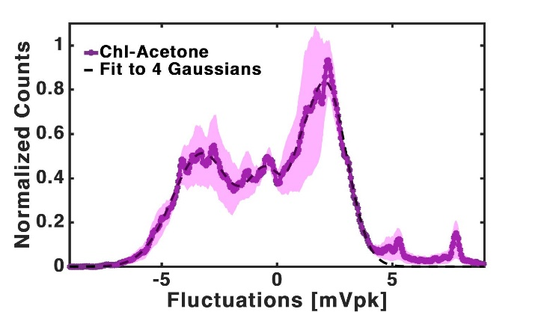
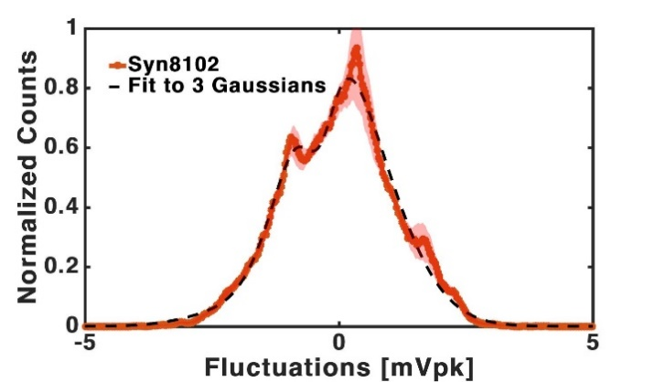
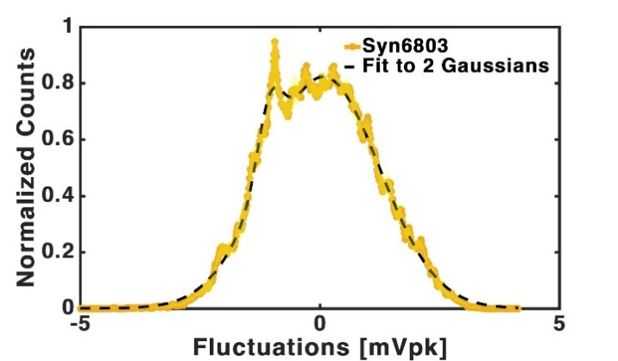
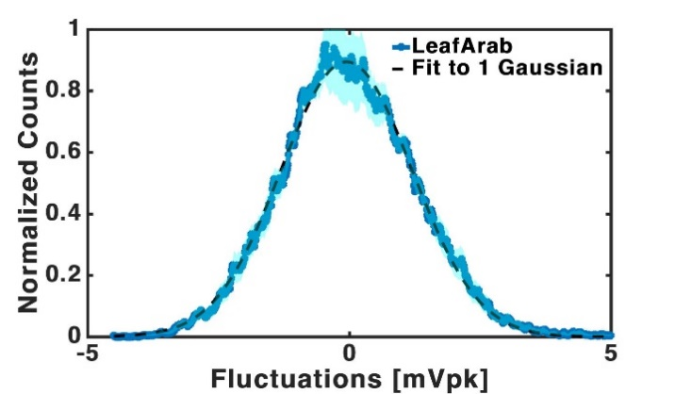
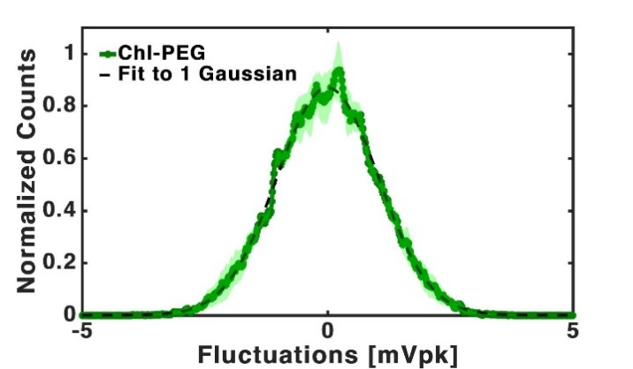
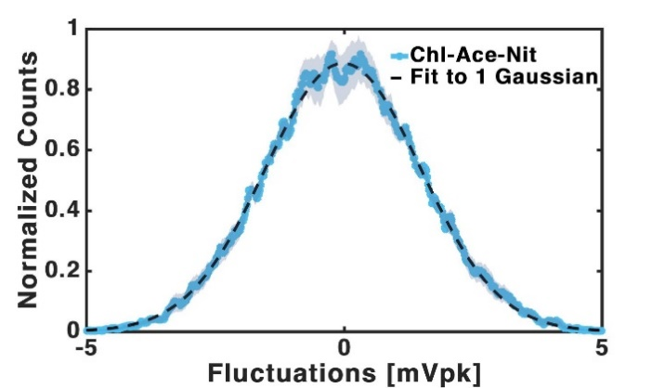
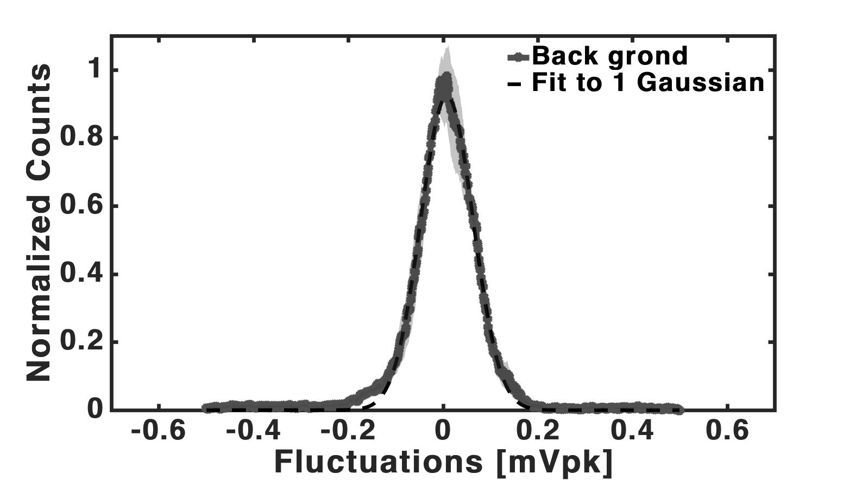
A
B
C
D
E
F
G
Figure S1: Histograms for all samples: (A) Chlorophyll in a PEG solution (Chl-PEG), (B) Chlorophyll in an Acetone solution after Nitrogen bubbling (Chl-Ace-Nit), (C) Leaves from Arabidopsis thaliana plants (LeafArb), (D) Syn6803, (E) Syn 8102, (F) Chlorophyll in an Acetone solution (Chl-Acetone) and (G) Background of the setup without any sample. Each histogram is an average of four measurement sets, shade area notes the averaging error. Each histogram was fitted to a gaussian model with different degrees shown in dashed black line. All coefficient of gaussian fits shown in table S2 below.

 | Degree | a | b | c | Set
Chl-PEG | 1 | 8.69E-01 | 1.52E-06 | 1.46E-03 | 1
Chl-Ace-Nit | 1 | 8.86E-01 | -2.00E-05 | 2.13E-03 | 1
LeafArb | 1 | 8.94E-01 | -5.19E-05 | 1.77E-03 | 1
Syn6803 | 2 | 2.37E-01 | -1.05E-03 | 3.62E-04 | 1
Syn6803 | 2 | 8.23E-01 | 7.35E-05 | 1.66E-03 | 2
Syn8102 | 3 | 9.88E-01 | -2.95E-04 | 1.60E-03 | 1
Syn8102 | 3 | -2.81E-01 | -3.87E-04 | 4.26E-04 | 2
Syn8102 | 3 | -2.57E-01 | -1.42E-03 | 1.06E-03 | 3
Chl-Acetone | 4 | 8.33E-01 | 2.09E-03 | 1.31E-03 | 1
Chl-Acetone | 4 | 8.61E-02 | 9.41E-04 | 5.33E-04 | 2
Chl-Acetone | 4 | 5.11E-01 | -3.24E-03 | 1.84E-03 | 3
Chl-Acetone | 4 | 3.83E-01 | -4.33E-04 | 1.15E-03 | 4
Back ground | 1 | 9.22E-01 | 8.40E-06 | 7.82E-05 | 1

Table 1: Fit coefficients for all histograms: All histograms were fitted to gaussian model with different degrees of the form: $\sum_{i=1}^{n}{a_{i}e^{[-{\left(\frac{x-b_{i}}{c_{i}}\right)}^{2}]}}$, as shown in figure S1 above.
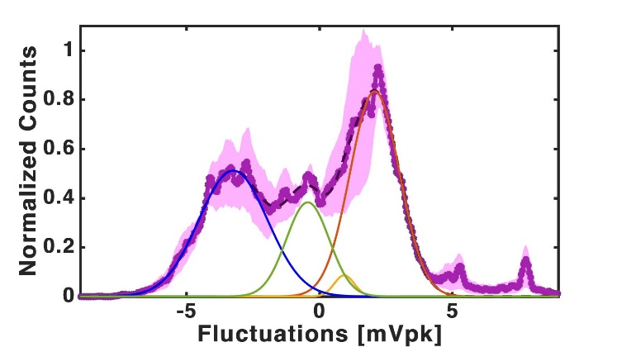

Figure S2: Gaussian Fit: Fit components of Chlorophyll in an Acetone solution (Chl-Acetone) histogram as presents in figure S1(F). Histograms coefficients are detailed in table S2.

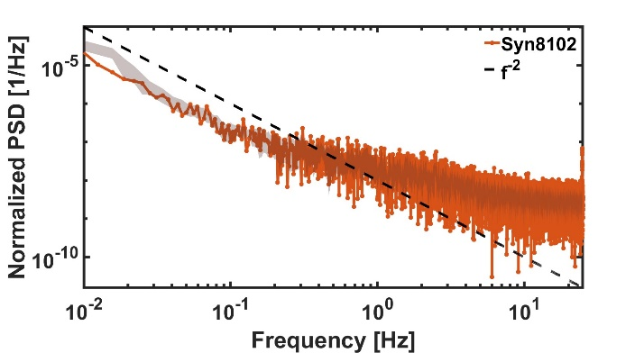
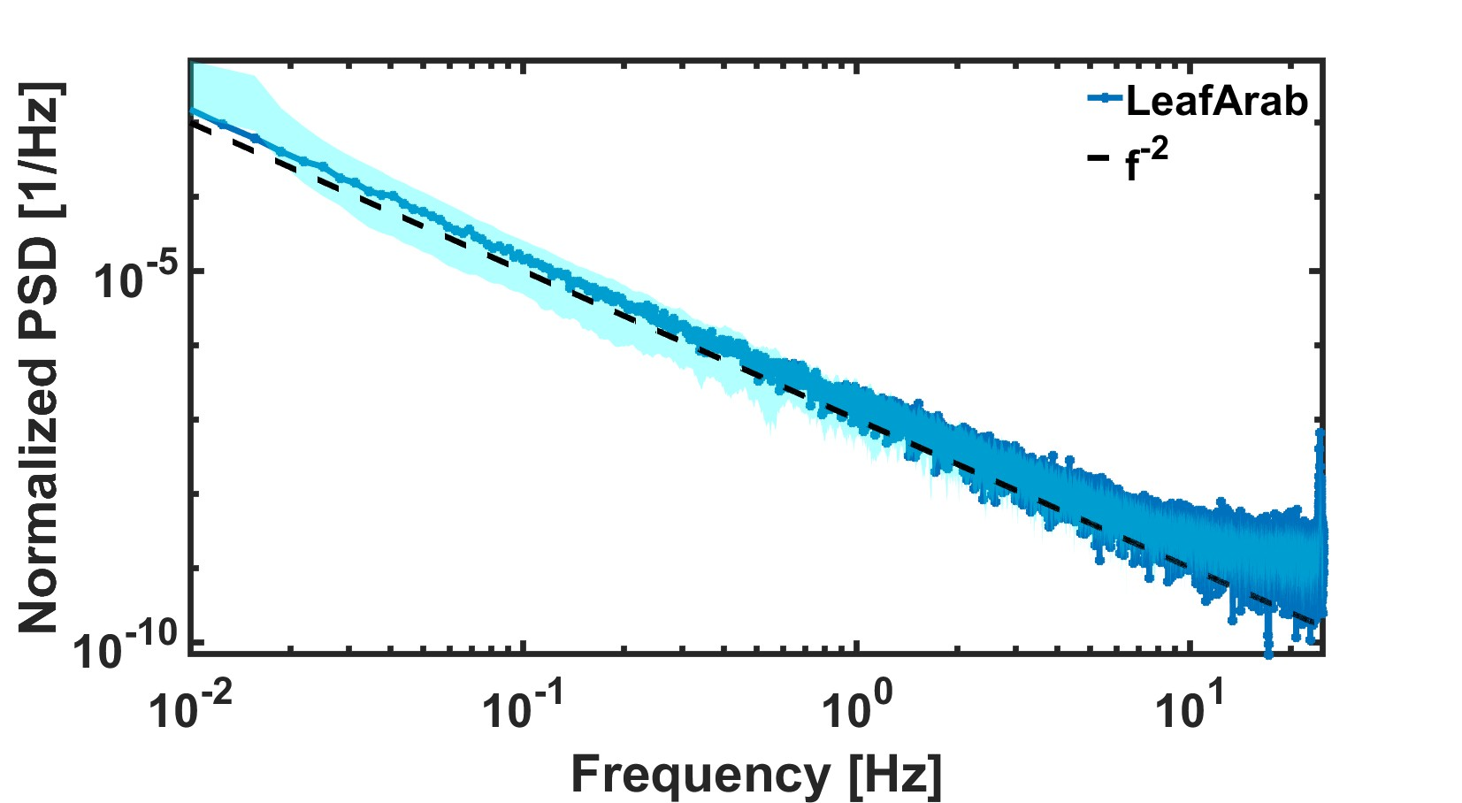
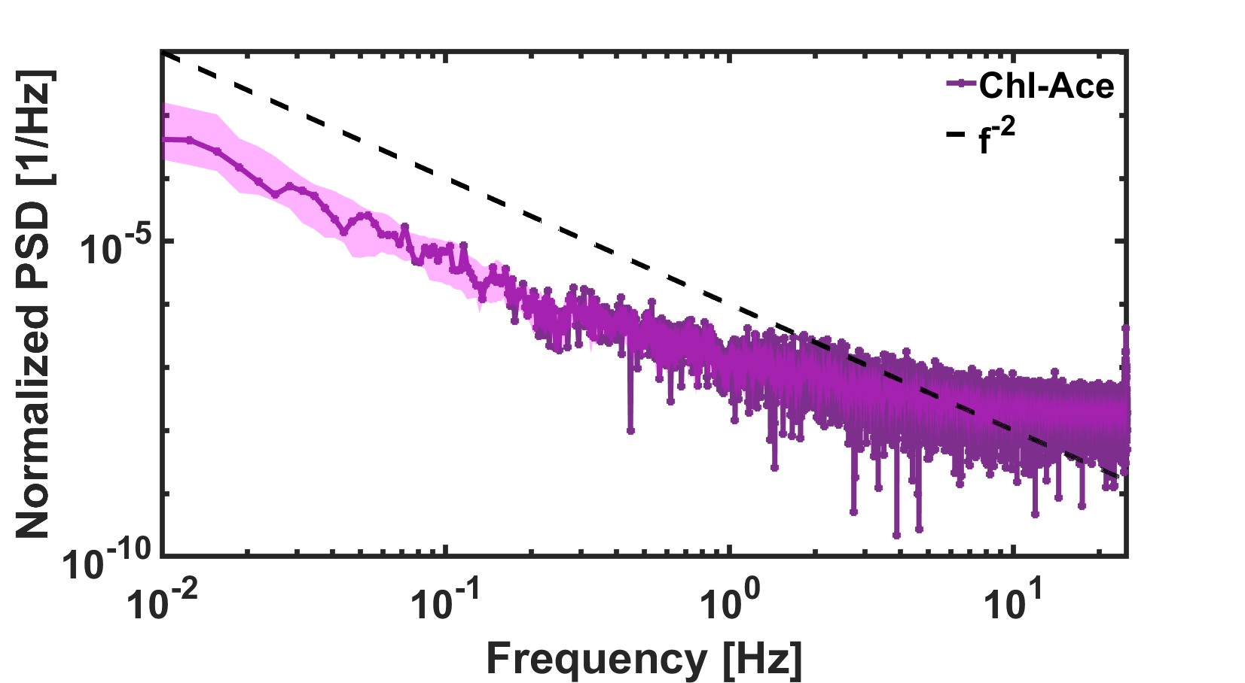
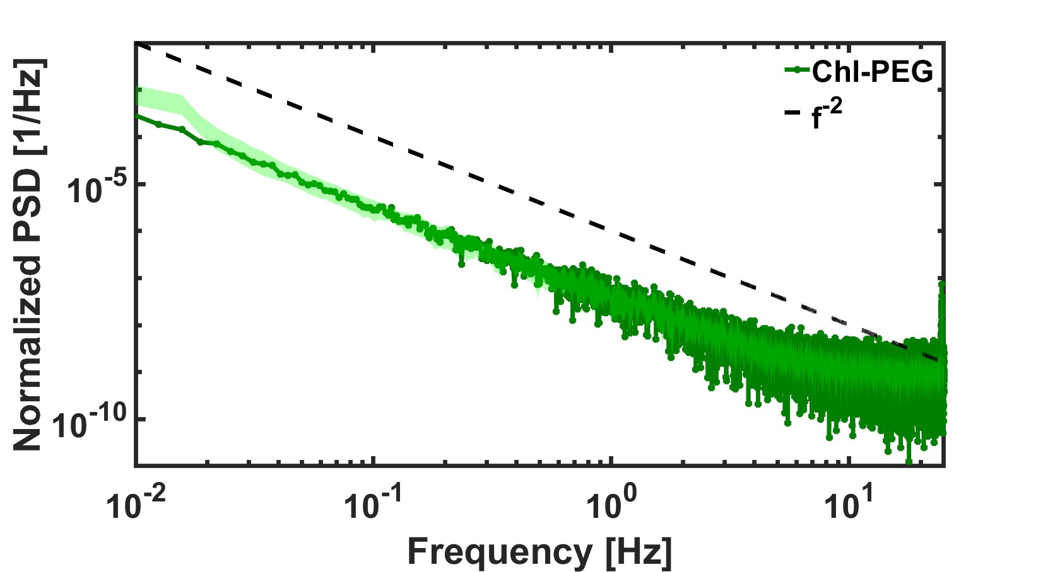
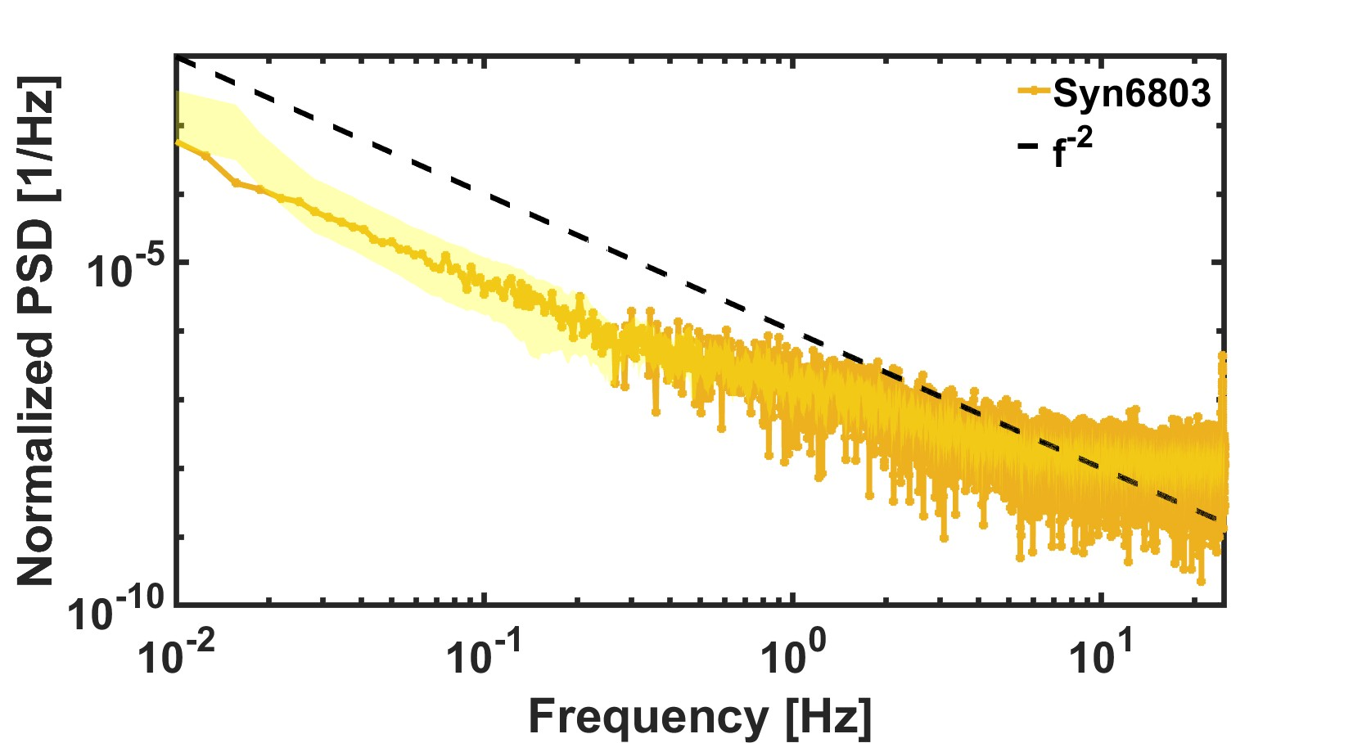
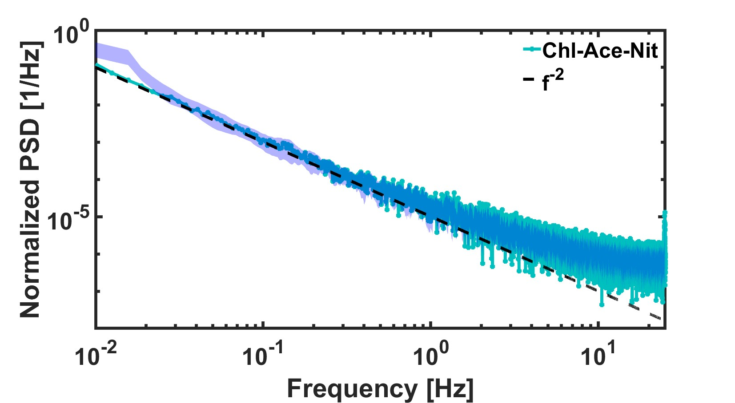
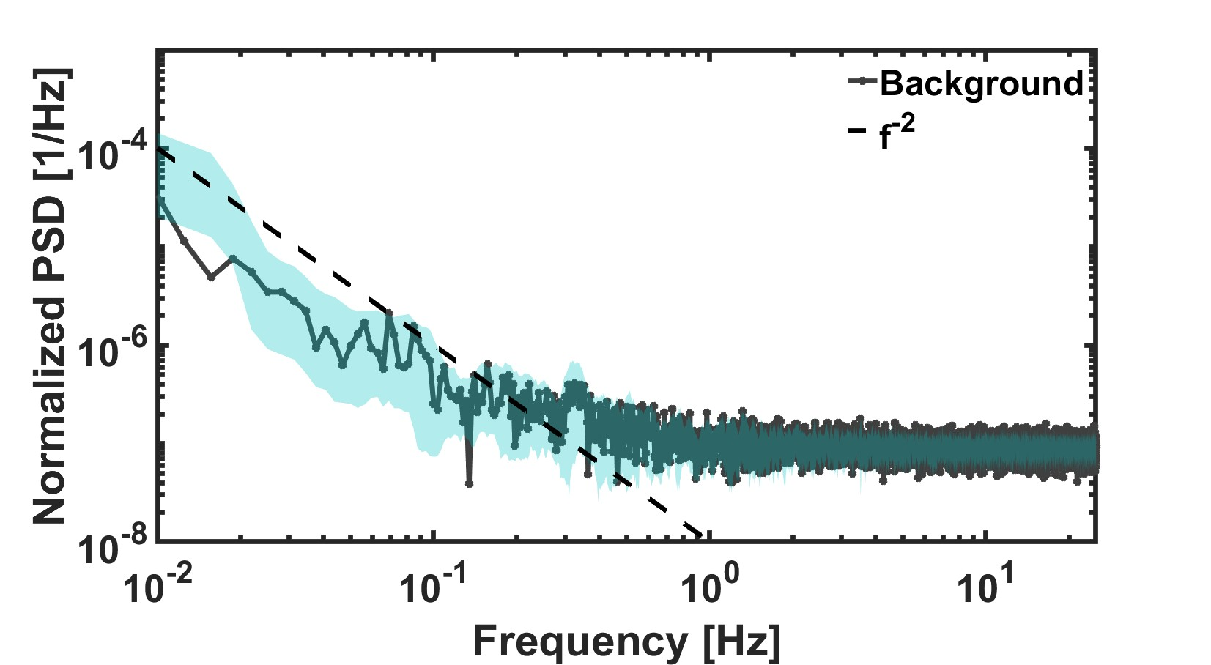
A
B
C
D
E
F
G

Figure S3: Power spectral density of all samples: (A) Chlorophyll in a PEG solution (Chl-PEG), (B) Chlorophyll in an Acetone solution after Nitrogen bubbling (Chl-Ace-Nit), (C) Leaves from Arabidopsis thaliana plants (LeafArb), (D) Syn6803, (E) Syn 8102, (F) Chlorophyll in an Acetone solution (Chl-Acetone) and (G) Background of the setup without any sample. Dashed black line present a first order power law fit $f^{-2}$. Shade area notes the averaging error.

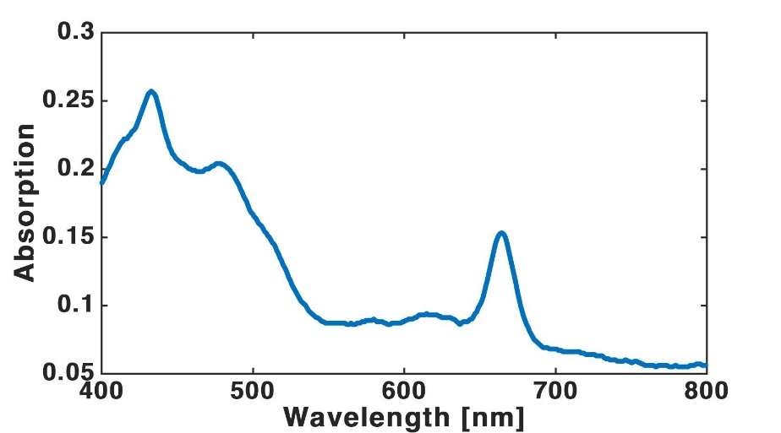

Figure S4: Absorption Signal For Chlorophyll in an Acetone solution (Chl-Acetone): According to Pora et al ¹ the peak of chlorophyll a in 80% acetone is at 663.6 nm. Jeffery 1975 ² has 664.3 nm. Our adsorption measurement presents a peak at 664 nm. In a protein context, chlorophylls are hydrogen bonded to the protein framework. Bond energy is the case of the red shift of the chlorophyll a peak.

References
1. Porra, R. J., Thompson, W. A. & Kriedemann, P. E. Determination of accurate extinction coefficients and simultaneous equations for assaying chlorophylls a and b extracted with four different solvents: verification of the concentration of chlorophyll standards by atomic absorption spectroscopy. Biochim. Biophys. Acta BBA - Bioenerg. 975, 384–394 (1989).
2. Jeffrey, S. W. & Humphrey, G. F. New spectrophotometric equations for determining chlorophylls a, b, c1 and c2 in higher plants, algae and natural phytoplankton. Biochem. Physiol. Pflanz. 167, 191–194 (1975).

