Supplementary data 1. Dengue 1 infection, dissemination, transmission rates and transmission efficiency in Aedes aegypti at 7, 14 and 21 days post-exposure (dpe) according to the presence (D+ATB) or absence (D-ATB) of Amoxicillin-Clavulanic acid association (Amox/Clav) in the blood meal.

Condition | DPE | Tested | Infection rate |  | Dissemination rate |  | Transmission rate |  | Transmission efficiency
Condition | DPE | Tested | N | % | N | % | N | % | N | %
D-ATB | 7 | 60 | 22 | 36.7 | 6 | 27.3 | 2 | 33.3 | 2 | 3.3
D-ATB | 14 | 60 | 32 | 53.3 | 6 | 18.8 | 3 | 50 | 3 | 5
D-ATB | 21 | 58 | 34 | 58.6 | 4 | 11.8 | 1 | 25 | 1 | 1.7
D+ATB | 7 | 60 | 12 | 20 | 4 | 33.3 | 2 | 50 | 2 | 3.3
D+ATB | 14 | 60 | 25 | 41.6 | 10 | 40 | 8 | 80 | 8 | 13.3
D+ATB | 21 | 48 | 28 | 58.6 | 13 | 46.4 | 9 | 69.2 | 9 | 18.8
N = number of positive samples
% = percentage of positive samples

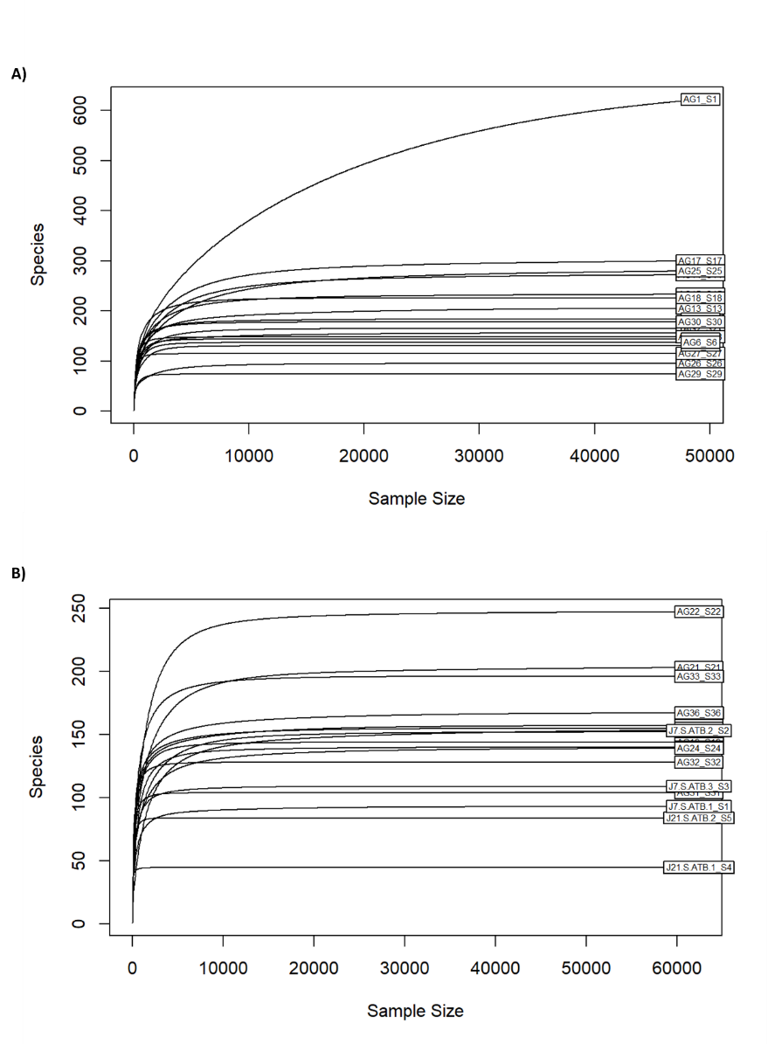
Supplementary data 2. Rarefaction curves obtained from Aedes aegypti midguts. Mosquitoes receiving Amoxicillin – Clavulanic Acid association (Amox/Clav) during blood meal (A), mosquitoes receiving simultaneously Amox/Clav and dengue-1 virus during the blood meal (B).

