Supplementary material

GC-MS-based untargeted plasma metabolomics identifies a 2-biomarker panel for possible diagnosis of precancerous cervical intraepithelial neoplasia stages from cervical cancer.
Gloria F. Nuer-Allornuvor, Raphael N. Alolga, Shenglian Liang, Zhang Ling, Wang Jingjing, Bo-Qun Xu, Zheng Jiangli, Vendish Kweku Ennin, Zhou Zoumin and Xiaoyan Ying

Table S1. List of differential metabolites identified from the comparison of cervical cancer patients vs healthy subjects (CC vs H)
Mol. Wt | VIP | FC | FDR | p-value | Name | HMDB ID
290.2 | 1.5042 | 3825.3 | 9.45 x10⁻⁶ | 1.335 x 10⁻⁶ | Etiocholanolone | HMDB0000490
73.11 | 1.7453 | 893.11 | 1.01 x10⁻⁷ | 4.174 x 10⁻⁹ | 2-Methyl-1-propylamine* | HMDB0034198
289.2104 | 1.8256 | 323.72 | 4.01 x10⁻⁸ | 7.895 x10⁻¹⁰ | Etiocholanedione | HMDB0003769
399.3286ª | 1.8374 | 331.77 | 5.17 x10⁻⁸ | 1.362 x10⁻⁹ | 4-Pyridoxic acid* | HMDB0000017
371.3018 | 1.9791 | 192.71 | 5.81 x10⁻⁹ | 2.19 x10⁻¹¹ | Estrone* | HMDB0000145
309.3 | 2.0374 | 169.03 | 1.39 x10⁻⁹ | 2.615 x10⁻¹² | N-Acetylneuraminic acid | HMDB0000230
133.14 | 1.4703 | 11.718 | 1.16 x10⁻⁵ | 1.679 x10⁻⁶ | L-Aspartic acid | HMDB0000191
188.1133 | 1.4031 | 10.098 | 3.69 x10⁻⁵ | 7.376 x10⁻⁶ | N-Acetylglutamine | HMDB0006029
243.1018 | 1.0824 | 13.61 | 1.05 x10⁻⁷ | 2.01 x10⁻⁷ | Cytidine | HMDB0000089
114.0677 | 1.2159 | 11.708 | 3.05 x10⁻⁷ | 4.812 x10⁻⁹ | 3-Amino-2-piperidone | HMDB0000323
174.19 | 1.1253 | 8.8525 | 1.41 x10⁻⁸ | 6.356 x10⁻¹⁰ | N2-Acetylornithine | HMDB0003357
290.1213 | 1.2453 | 18.81 | 2.34 x10⁻⁸ | 3.114 x10⁻⁹ | Dihydrotestosterone | HMDB0002961
117.11 | 1.1153 | 5.8601 | 4.66 x10⁻⁸ | 5.22 x10⁻¹¹ | L-Valine* | HMDB0000883
126.2 | 1.2412 | 4.3148 | 2.04 x10⁻⁹ | 4.682 x10⁻¹² | 5-Aminoimidazole-4-carboxamide | HMDB0003192
ª derivatized molecular weight. * Confirmed with pure standard reference compound.

Table S2. List of differential metabolites identified from the comparison of cervical cancer patients vs CIN I II III patients (CC vs CIN I II III)
Mol. Wt | VIP | FC | FDR | p-value | Name | HMDB ID
73.11 | 2.3046 | 5.976 | 0.000425 | 1.36 x10⁻⁵ | 2-Methyl-1-propylamine* | HMDB0034198
399.3286 | 1.1321 | 2.4056 | 0.01474 | 0.0226 | 4-Pyridoxic acid* | HMDB0000017
309.292 | 2.9420 | 7.167 | 1.08 x10⁻⁶ | 1.47 x10⁻⁸ | N-Acetylneuraminic acid | HMDB0000230
243.1018 | 1.2643 | 2.8665 | 0.08634 | 0.0169 | Cytidine | HMDB0000089
371.3018ª | 1.4112 | 11.512 | 2.41 x10⁻⁵ | 3.21 x10⁻⁵ | Estrone* | HMDB0000145
114.0677 | 1.3760 | 5.1234 | 0.0413 | 0.0054 | 3-Amino-2-piperidone | HMDB0000323
ª derivatized molecular weight. * Confirmed with pure standard reference compound.

Table S3. List of differential metabolites identified from the comparison of cervical cancer patients vs CIN III subjects (CC vs CIN III)
Mol. Wt | VIP | FC | FDR | p-value | Name | HMDB ID
73.11 | 1.0201 | 4.889 | 0.0488 | 0.0049 | 2-Methyl-1-propylamine* | HMDB0034198
243.1018 | 1.9918 | 2.4469 | 0.0411 | 0.0072 | Cytidine | HMDB0000089
371.3018ª | 1.0112 | 2.1123 | 0.0388 | 0.0065 | Estrone* | HMDB0000145
114.0677 | 1.0327 | 4.2157 | 0.0356 | 0.0085 | 3-Amino-2-piperidone | HMDB0000323
ª derivatized molecular weight. * Confirmed with pure standard reference compound.

Table S4. List of differential metabolites identified from the comparison of cervical cancer patients vs CIN II subjects (CC vs CIN II)
Mol. Wt | VIP | FC | FDR | p-value | Name | HMDB ID
73.11 | 1.430184 | 10.831 | 0.0414 | 0.0085 | 2-Methyl-1-propylamine* | HMDB0034198
399.3286 | 1.583757 | 100.76 | 0.0083 | 0.0008 | 4-Pyridoxic acid* | HMDB0000017
309.3 | 1.614457 | 27.458 | 0.0069 | 0.0006 | N-Acetylneuraminic acid | HMDB0000230
243.1018 | 1.067051 | 3.7661 | 0.0141 | 0.0404 | Cytidine | HMDB0000089
114.0677 | 1.33527 | 12.875 | 0.0414 | 0.0085 | 3-Amino-2-piperidone | HMDB0000323
371.3018ª | 1.228751 | 2.8752 | 0.0314 | 0.0455 | Estrone* | HMDB0000145
290.1213 | 1.159921 | 2.124 | 0.0225 | 0.0188 | Dihydrotestosterone* | HMDB0002961
ª derivatized molecular weight. * Confirmed with pure standard reference compound.

Table S5. List of differential metabolites identified from the comparison of cervical cancer patients vs CIN I subjects (CC vs CIN I)
Mol. Wt | VIP | FC | FDR | p-value | Name | HMDB ID
290.2 | 1.9031 | 55144 | 0.0003 | 1.91 x10⁻⁵ | Etiocholanolone | HMDB0000490
73.11 | 1.9357 | 13.941 | 0.0003 | 2.14 x10⁻⁵ | 2-Methyl-1-propylamine* | HMDB0034198
289.2104 | 1.6250 | 322.54 | 0.0037 | 0.0003 | Etiocholanedione | HMDB0003769
399.3286 | 2.3590 | 162.29 | 4.14 x10⁻⁷ | 8.56 x10⁻⁹ | 4-Pyridoxic acid* | HMDB0000017
371.3018ª | 2.2073 | 3.3346 | 7.87x10⁻⁶ | 1.92 x10⁻⁷ | Estrone* | HMDB0000145
309.3 | 1.8359 | 81.55 | 0.0003 | 1.79 x10⁻⁵ | N-Acetylneuraminic acid | HMDB0000230
243.1018 | 1.3965 | 6.7153 | 0.0197 | 0.0034 | Cytidine | HMDB0000089
114.0677 | 1.2389 | 10.262 | 0.0265 | 0.0058 | 3-Amino-2-piperidone | HMDB0000323
290.1213 | 1.7080 | 57.509 | 0.0026 | 0.0002 | Dihydrotestosterone* | HMDB0002961
ª derivatized molecular weight. * Confirmed with pure standard reference compound.

Table S6. List of differential metabolites identified from the comparison of cervical cancer vs HPV ⁺ healthy non-CIN subjects (CC vs HHPV+)
Mol. Wt | VIP | FC | FDR | p-value | Name | HMDB ID
73.11 | 1.1560 | 7.5816 | 0.0048 | 0.0013 | 2-Methyl-1-propylamine* | HMDB0034198
399.3286 | 2.1783 | 251.83 | 4.13 x10⁻¹¹ | 1.09 x10⁻¹² | 4-Pyridoxic acid* | HMDB0000017
371.3018ª | 2.3456 | 188.73 | 4.75 x10⁻¹⁴ | 8.04 x10⁻¹⁶ | Estrone* | HMDB0000145
309.3 | 2.0646 | 203.26 | 9.22 x10⁻¹⁰ | 3.52 x10⁻¹¹ | N-Acetylneuraminic acid | HMDB0000230
ª derivatized molecular weight. * Confirmed with pure standard reference compound.

Table S7. List of differential metabolites identified from the comparison of healthy vs CIN I II III subjects (H vs CIN I II III)
Mol. Wt | FC | VIP | p-value | FDR | Name | HMDB ID
73.11 | 8.4897 | 1.4446 | 1.30 x10⁻⁸ | 8.97 x10⁻⁸ | 2-Methyl-1-propylamine* | HMDB0034198
218.1021 | 7.7858 | 1.6985 | 2.59 x10⁻¹² | 4.11 x10⁻¹¹ | N-Acetylserotonin | HMDB0001238
116.1 | 7.6189 | 1.7664 | 7.55 x10⁻¹³ | 1.49 x10⁻¹¹ | Ethyl pyruvate | HMDB0031643
232.1096 | 5.1961 | 1.5160 | 1.94 x10⁻⁹ | 1.59 x10⁻⁸ | Melatonin | HMDB0001389
371.3143ª | 5.012 | 2.0011 | 7.66 x10⁻¹⁷ | 5.09 x10⁻¹⁵ | Estrone* | HMDB0000145
130.1 | 4.8646 | 1.2843 | 7.31 x10⁻⁷ | 3.27 x10⁻⁶ | N-Acetylputrescine | HMDB0002064
174.16 | 4.787 | 1.6776 | 3.41 x10⁻¹² | 4.77 x10⁻¹¹ | N2-Acetylornithine | HMDB0003357
173.1022 | 4.7858 | 1.7957 | 1.09 x10⁻¹³ | 2.91 x10⁻¹² | N-Acetyl-Leu | HMDB0011756
204.1039 | 4.6361 | 1.5656 | 6.09 x10⁻¹⁰ | 5.31 x10⁻⁹ | L-Tryptophan* | HMDB0000929
160.1 | 4.4949 | 1.7279 | 2.53 x10⁻¹² | 4.11 x10⁻¹¹ | Alanylalanine | HMDB0028680
59.11 | 4.4845 | 1.7279 | 2.53 x10⁻¹² | 4.11 x10⁻¹¹ | 1-Propylamine* | HMDB0034006
243.0833 | 3.9087 | 1.6374 | 2.05 x10⁻¹¹ | 2.43 x10⁻¹⁰ | Cytidine | HMDB0000089
ª derivatized molecular weight. * Confirmed with pure standard reference compound.

Table S8. List of differential metabolites identified from the comparison of healthy vs CIN I subjects (H vs CIN I)
Mol. Wt | FC | VIP | p-value | FDR | Name | HMDB ID
218.1021 | 27.621 | 1.6395 | 4.84 x10⁻¹⁰ | 1.47 x10⁻⁸ | N-Acetylserotonin | HMDB0001238
116.1 | 9.0663 | 1.4392 | 1.75 x10⁻⁷ | 1.46 x10⁻⁶ | Ethyl pyruvate | HMDB0031643
232.1096 | 4.5822 | 1.5085 | 4.35 x10⁻⁸ | 4.75 x10⁻⁷ | Melatonin | HMDB0001389
371.3143ª | 133.95 | 1.9081 | 7.83 x10⁻¹⁵ | 5.91 x10⁻¹³ | Estrone* | HMDB0000145
130.1 | 4.9905 | 1.0015 | 0.0004 | 0.0011 | N-Acetylputrescine | HMDB0002064
174.16 | 4.6892 | 1.4581 | 1.59 x10⁻⁷ | 1.34 x10⁻⁶ | N2-Acetylornithine | HMDB0003357
173.1022 | 2.8036 | 1.3246 | 2.03 x10⁻⁶ | 1.17 x10⁻⁵ | N-Acetyl-Leu | HMDB0011756
204.1039 | 3.0799 | 1.5900 | 2.31 x10⁻⁹ | 4.31 x10⁻⁸ | L-Tryptophan* | HMDB0000929
59.11 | 3.448 | 1.3625 | 1.31 x10⁻⁶ | 7.94 x10⁻⁶ | 1-Propylamine* | HMDB0034006
243.0833 | 15.336 | 1.6793 | 9.53 x10⁻¹¹ | 3.38 x10⁻⁹ | Cytidine | HMDB0000089
ª derivatized molecular weight. * Confirmed with pure standard reference compound.

Table S9. List of differential metabolites identified from the comparison of healthy vs CIN II subjects (H vs CIN II)
Mol. Wt | FC | VIP | p-value | FDR | Name | HMDB ID
73.11 | 973.4 | 1.3153 | 0.0004 | 0.0018 | 2-Methyl-1-propylamine* | HMDB0034198
218.1021 | 7.8689 | 1.1644 | 0.0010 | 0.0038 | N-Acetylserotonin | HMDB0001238
371.3143ª | 104.15 | 1.8539 | 7.32 x10⁻¹⁰ | 1.53 x10⁻⁸ | Estrone* | HMDB0000145
130.1 | 3.4031 | 2.0580 | 7.08 x10⁻¹⁵ | 3.86 x10⁻¹³ | N-Acetylputrescine | HMDB0002064
173.1022 | 2.9037 | 1.0696 | 0.0017 | 0.0059 | N-Acetyl-Leu | HMDB0011756
59.11 | 6.2651 | 1.3428 | 8.07 x10⁻⁵ | 0.0003 | 1-Propylamine* | HMDB0034006
243.0833 | 4.384 | 1.3757 | 2.33 x10⁻⁵ | 0.0001 | Cytidine | HMDB0000089
ª derivatized molecular weight. * Confirmed with pure standard reference compound.

Table S10. List of differential metabolites identified from the comparison of healthy vs CIN III subjects (H vs CIN III)
Mol. Wt | FC | VIP | p-value | FDR | Name | HMDB ID
73.11 | 6.4365 | 1.5191 | 1.45 x10⁻⁸ | 1.17 x10⁻⁷ | 2-Methyl-1-propylamine* | HMDB0034198
218.1021 | 6.6523 | 1.5440 | 4.98 x10⁻⁹ | 4.41 x10⁻⁸ | N-Acetylserotonin | HMDB0001238
116.1 | 7.6816 | 1.7568 | 3.51 x10⁻¹¹ | 5.92 x10⁻¹⁰ | Ethyl pyruvate | HMDB0031643
232.1096 | 7.2662 | 1.7782 | 5.27 x10⁻¹² | 1.07 x10⁻¹⁰ | Melatonin | HMDB0001389
371.3143ª | 3.1699 | 1.9422 | 3.58 x10⁻¹⁴ | 1.41 x10⁻¹² | Estrone* | HMDB0000145
130.1 | 4.9986 | 1.3048 | 2.03 x10⁻⁶ | 9.69 x10⁻⁶ | N-Acetylputrescine | HMDB0002064
174.16 | 5.5786 | 1.8196 | 2.28 x10⁻¹² | 4.90 x10⁻¹¹ | N2-Acetylornithine | HMDB0003357
173.1022 | 5.2754 | 1.9235 | 3.27 x10⁻¹⁴ | 1.36 x10⁻¹² | N-Acetyl-Leu | HMDB0011756
204.1039 | 5.2725 | 1.6109 | 1.69 x10⁻⁹ | 1.61 x10⁻⁸ | L-Tryptophan* | HMDB0000929
59.11 | 4.2351 | 1.7094 | 1.53 x10⁻¹⁰ | 2.05 x10⁻⁹ | 1-Propylamine* | HMDB0034006
243.0833 | 3.3982 | 1.4582 | 2.58 x10⁻⁸ | 1.93 x10⁻⁷ | Cytidine | HMDB0000089
ª derivatized molecular weight. * Confirmed with pure standard reference compound.

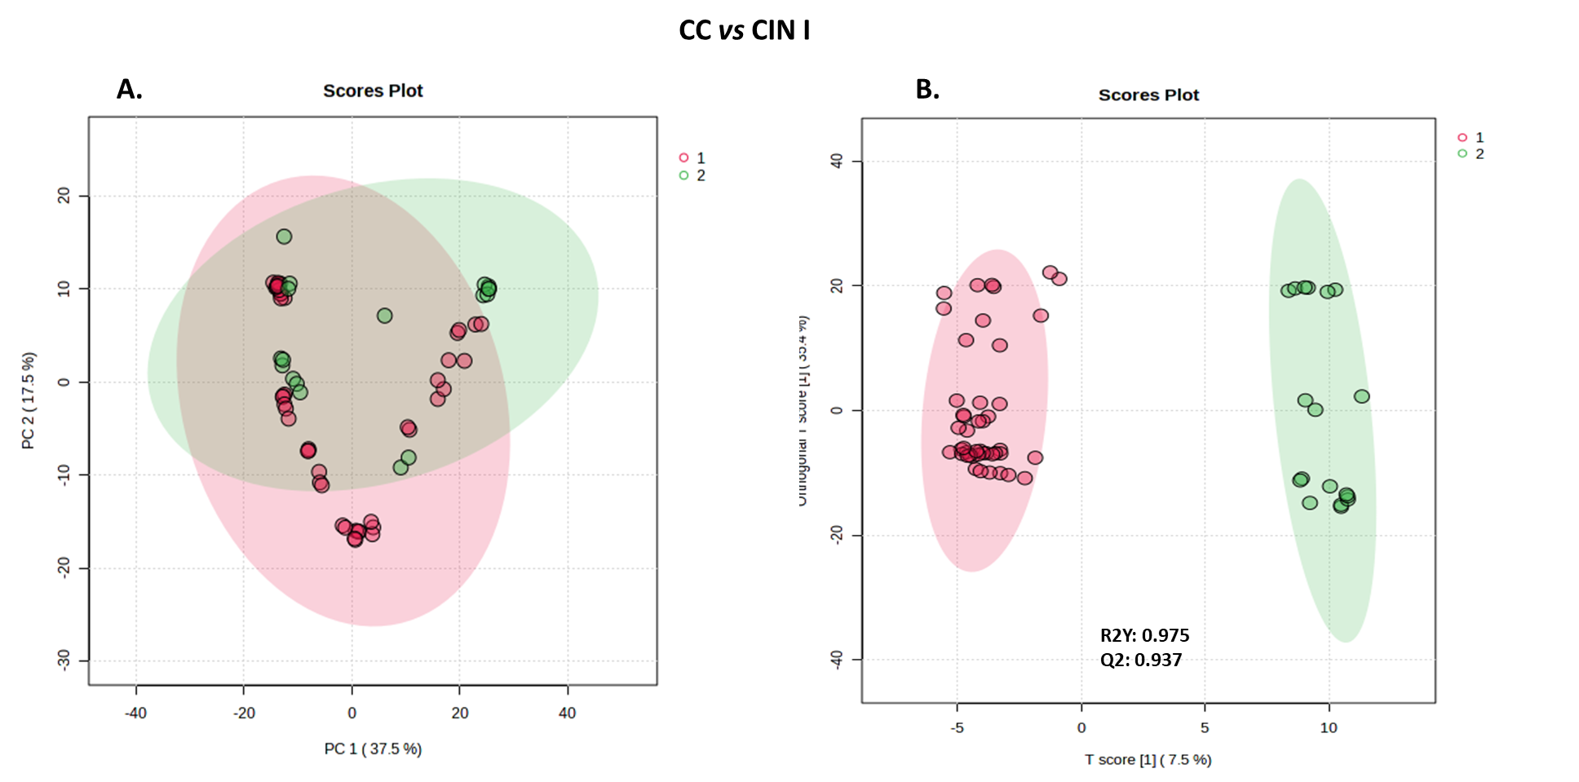
Figure S1. Global metabolome analysis from the comparison of cervical cancer (CC) patients versus CIN I subjects. Outcomes of multivariate analysis using unsupervised PCA (A) and supervised OPLS-DA (B) models.

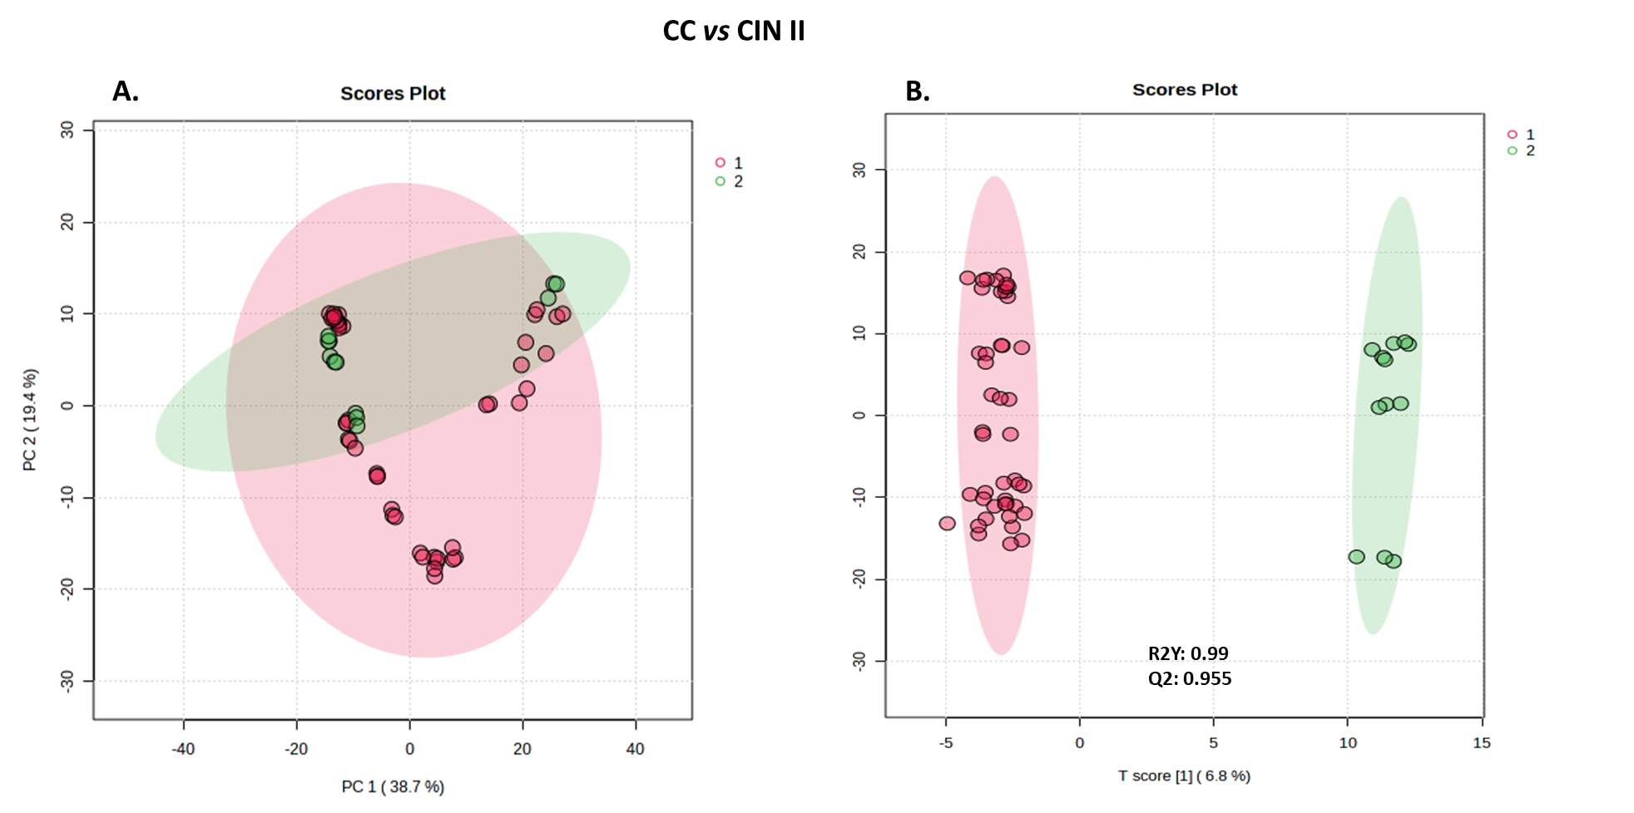
Figure S2. Global metabolome analysis from the comparison of cervical cancer (CC) patients versus CIN II subjects. Outcomes of multivariate analysis using unsupervised PCA (A) and supervised OPLS-DA (B) models.

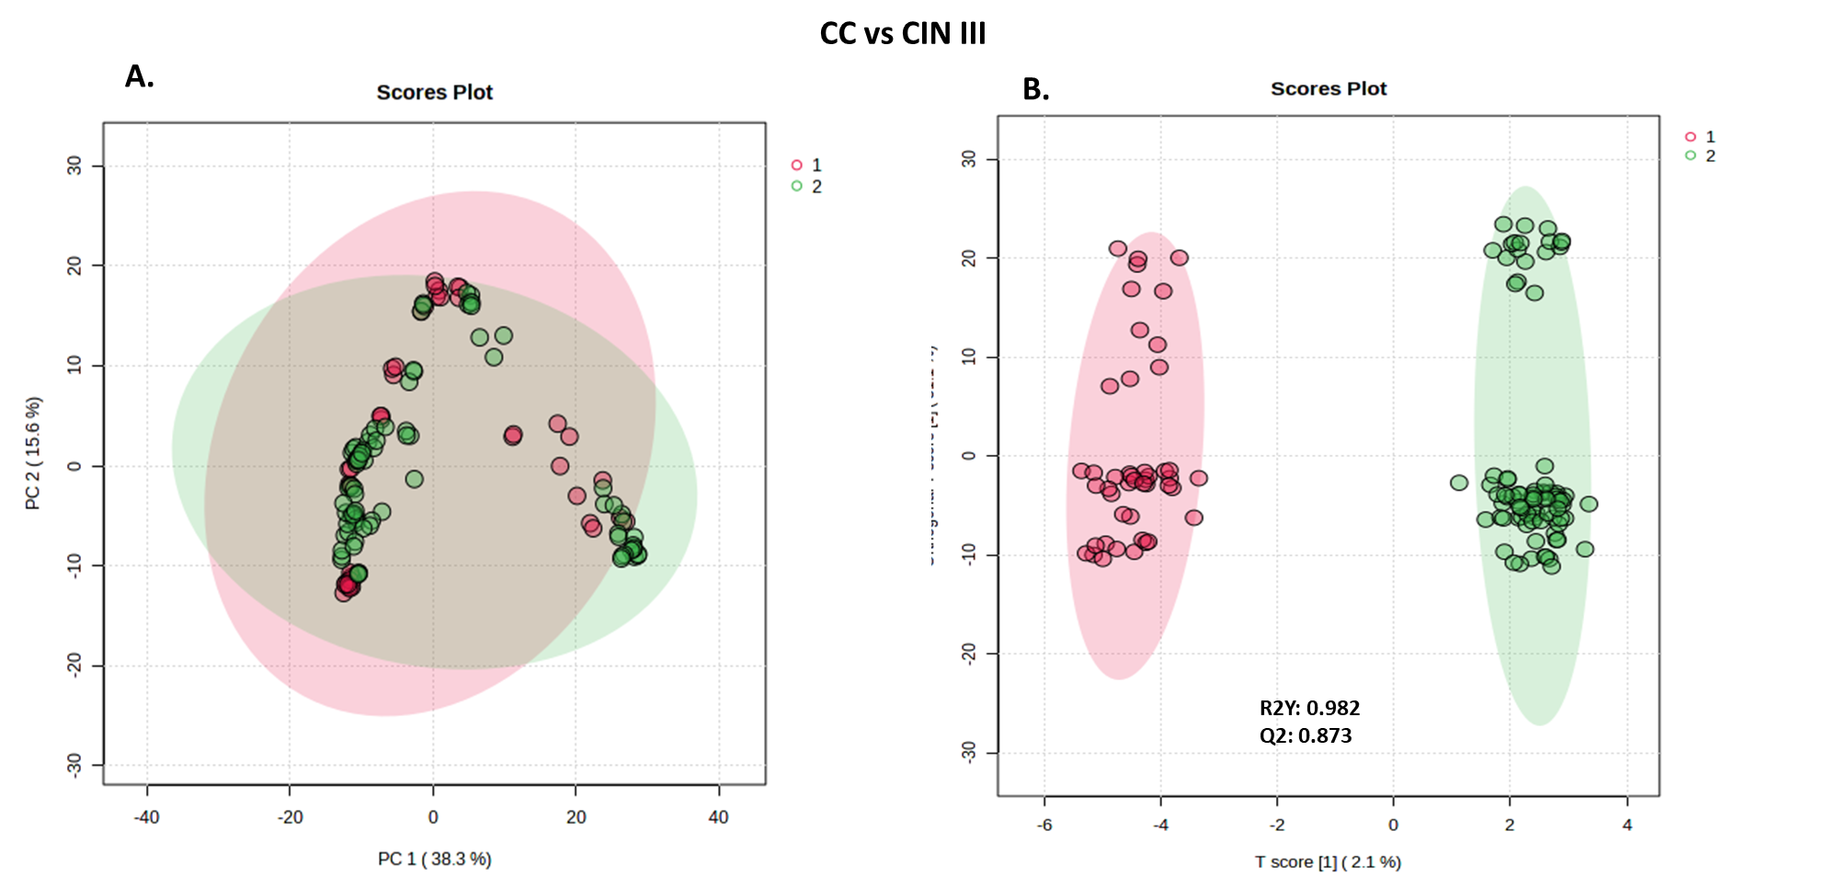
Figure S3. Global metabolome analysis from the comparison of cervical cancer (CC) patients versus CIN III subjects. Outcomes of multivariate analysis using unsupervised PCA (A) and supervised OPLS-DA (B) models.

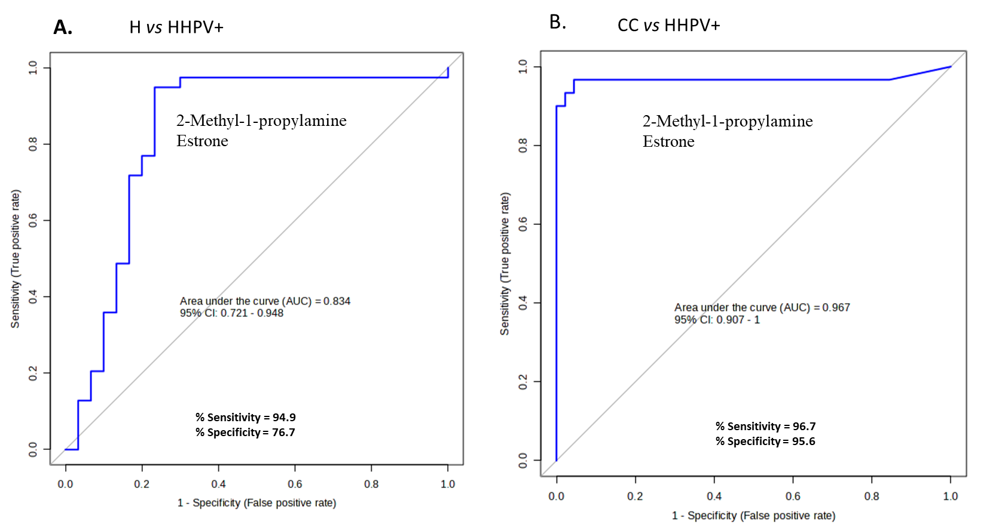
Figure S4. Receiver operating curves (ROC) showing the diagnostic potential of the 2-biomarker panel (2-Methyl-1-propylamine and estrone) in the comparisons of H vs HHPV⁺ (A), and CC vs HHPV⁺ (B). CC, cervical cancer; HHPV⁺, hr-HPV⁺ normal cytology participants; H, healthy.
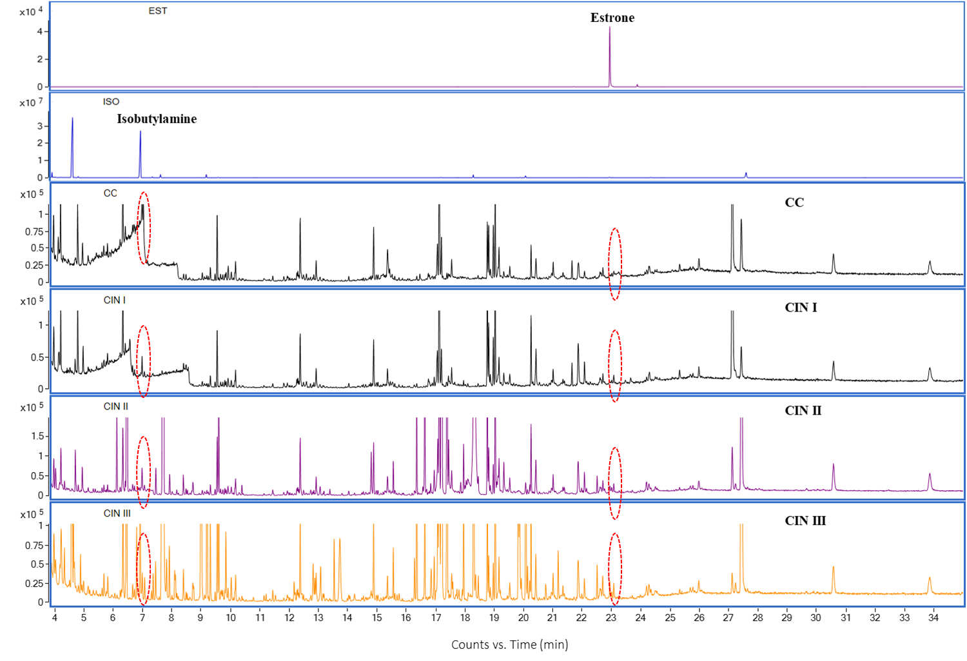
Figure S5. Total ion chromatograms showing the positions of the two diagnostic biomarkers, estrone and isobutylamine in the samples analyzed.

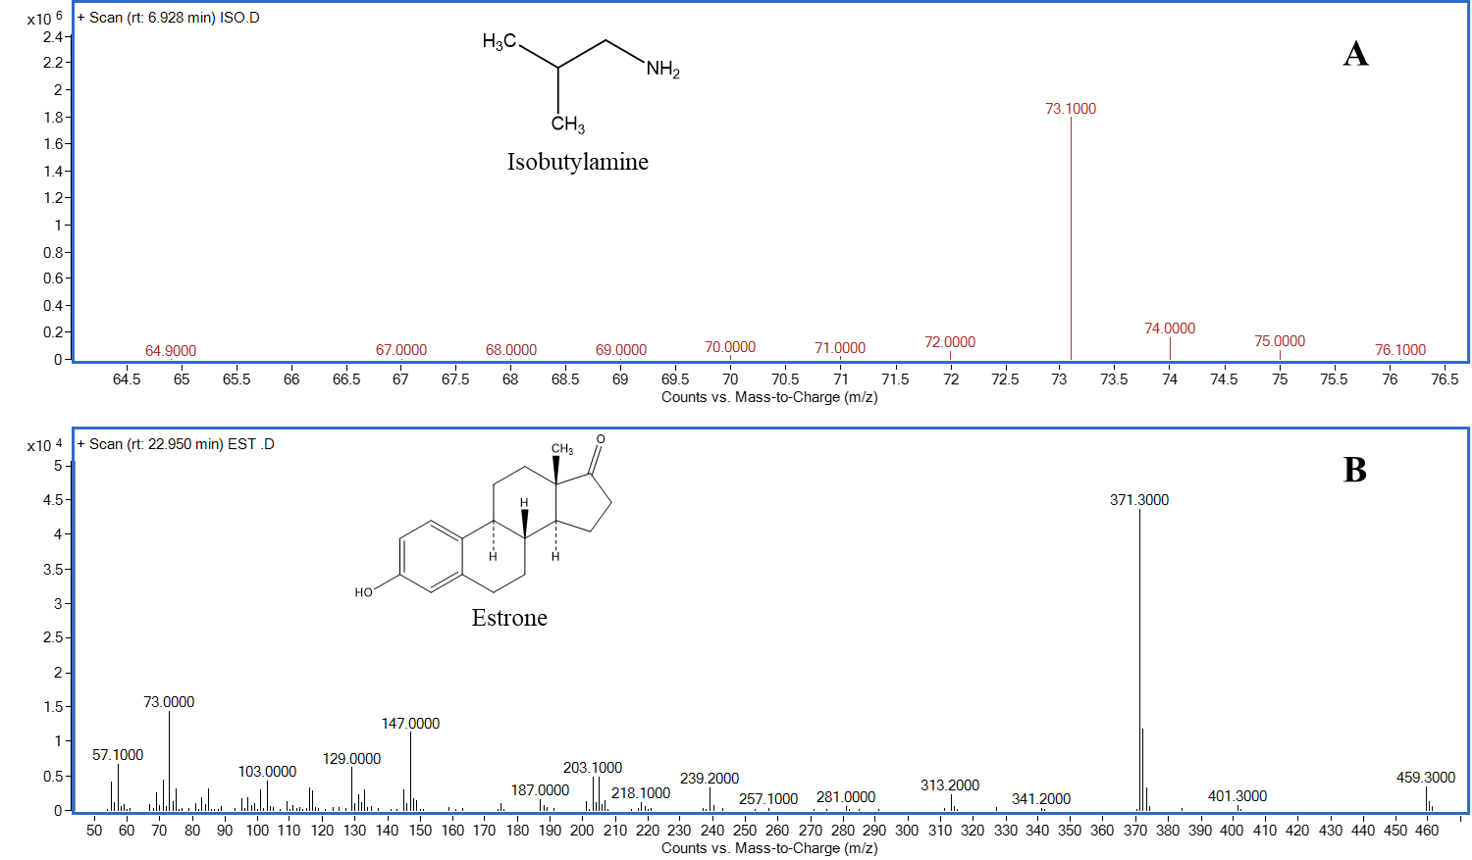
Figure S6. Detailed mass spectrometric data for two diagnostic biomarkers, isobutylamine (A) and estrone (B) showing their respective retention times. Mass spectrometric data are reported to 2 decimal places.

