Supplementary Information

Enhancing Hepatoprotective Action: Oxyberberine Amorphous Solid Dispersion System Targeting TLR4

Tingting Chen ^{a,g,1}, Qingguo Li ^{b 1}, Gaoxiang Ai ^{b}, Ziwei Huang ^{b}, Jun Liu ^{e,f}, Lingfeng Zeng ^{c,d,f}, Ziren Su ^{b}, Yaoxing Dou ^{a,c,d,f,*}

ª The Meizhou Hospital of Guangzhou University of Chinese Medicine (Meizhou Hospital of Traditional Chinese Medicine), Meizhou, China
^{b} School of Pharmaceutical Sciences, Guangzhou University of Chinese Medicine, Guangzhou, China
^{c} The Second Clinical Medical College of Guangzhou University of Chinese Medicine/Post-Doctoral Research Station, Guangzhou, China
^{d} The Second Affiliated Hospital of Guangzhou University of Chinese Medicine (Guangdong Provincial Hospital of Chinese Medicine), Guangzhou, China
^{e} Guangdong Second Traditional Chinese Medicine Hospital (Guangdong Province Enginering Technology Research Institute of Traditional Chinese Medicine), Guangzhou, China
^{f} Bone and Joint Research Team of Degeneration and Injury, Guangdong Provincial Academy of Chinese Medical Sciences, Guangzhou, China
^{g} School of Medicine, Southern University of Science and Technology, Shenzhen, China

¹ These authors contributed equally to this work.
* Corresponding author.
The Second Affiliated Hospital of Guangzhou University of Chinese Medicine, No.12, Jichang Road, Baiyun District, Guangzhou City, Guangdong, China (Y. Dou).
E-mail addresses: yaoxingdou@126.com (Y. Dou).
Phone: +86-13760723340 (Y. Dou)

List of Contents
Figure S1 The apparent solubility results of OBB raw material and OBB-ASDs samples.
Figure S2 Mice kidney histopathological Section (Hematoxylin and Eosin Staining), 200× magnification.
Figure S3 Figure S3. Stability testing of OBB-ASDs samples for 3 weeks.

- Apparent solubility investigation
Precisely weigh appropriate amounts of OBB active pharmaceutical ingredient, solid dispersion HPMCAS, PVP-K30, Soluplus, and VA64 (including 5 mg of API) into conical flasks. Add 50 mL of 0.02 mM phosphate buffer (pH 6.8) to each flask, and place them in a water bath at a constant temperature shaker (37 ± 0.5°C). Samples are taken at 5, 10, 20, 30 min, and 1, 2, 4, 8, and 24 hours, filtered, diluted, and analyzed using LC-MS/MS. Results are shown in Figure S1.
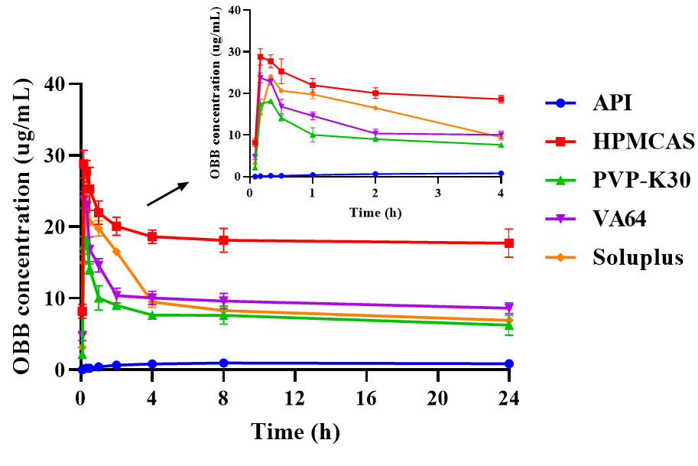
Figure S1. The apparent solubility results of OBB raw material and OBB-ASDs samples.

- Chronic nephrotoxicity assessment of OBB
Male C57BL/6 mice were orally administered OBB and OBB-HPMCAS at a dose of 50 mg/kg for 16 weeks. Kidney tissues were collected at 4, 8, and 16 weeks for HE staining to observe the long-term effects of OBB administration on the kidneys. As shown in Figure S2, there was no significant kidney damage after continuous administration of OBB and OBB-HPMCAS for 4, 8, and 16 weeks.
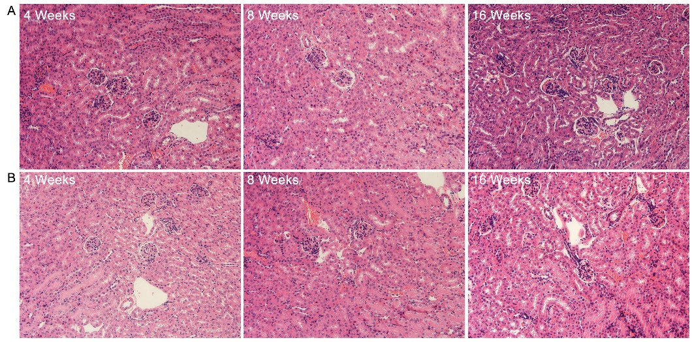
Figure S2. Mice kidney histopathological Section (Hematoxylin and Eosin Staining), 200× magnification. (A) OBB API; (B) OBB-HPMCAS.

- Stability testing of OBB-ASDs
Following the sealing of the OBB-ASDs samples with aluminum foil, they were stored in a closed container under accelerated stability conditions (25±2°C, 60±5% RH) for 3 weeks. Subsequently, dissolution testing was performed on the samples to evaluate their stability. The stability results are depicted in Figure S3, indicating that the dissolution profiles of OBB-ASDs particles remained consistent after 3 weeks of storage under accelerated stability conditions.
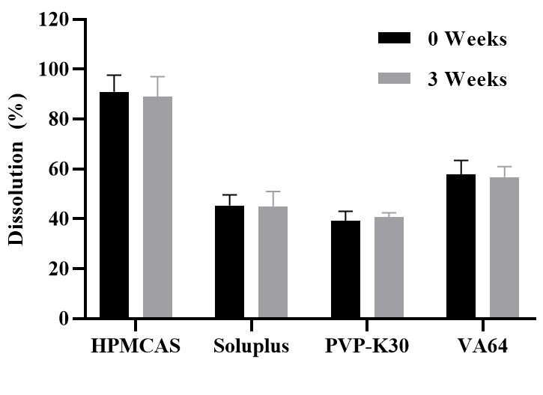
Figure S3. Stability testing of OBB-ASDs samples for 3 weeks.
