Patient characteristics disaggregated by sex

Female
 | Healthy controls  (n=15) | Septic shock  (n = 26) | Septic shock  survivors  (n = 15) | Septic shock  non-survivors  (n = 11) | P value  survivors vs. non survivors
Age (years) | 28 (25 - 36) | 59 (49 - 72) | 60 (49 – 73) | 57 (47 – 72) | 0.721
Sex (% male) | 0 | 0 | 0 | 0 | NA
APACHE II |  | 26.5 (21 – 37) | 24 (20 – 32) | 30.0 (27 – 39) | 0.061
SAPS II |  | 51.5 (45 – 74) | 47 (40 – 74) | 66.0 (48 – 75) | 0.109
SOFA d1 |  | 12 (10 – 16) | 11 (8 – 13) | 15 (12 - 18) | 0.006
SIRS d1 |  | 3.0 (3 – 3) | 3 (2 – 3) | 3 (3 – 3) | 0.76
SOFA max |  | 13 (11 - 18) | 12 (8 - 13) | 18 (14 - 20) | 0.001
Mechanical ventilation (%) |  | 65.4 | 53.3 | 81.8 | 0.217
Renal replacement therapy (%) |  | 46.2 | 20.0 | 81.8 | 0.004
CRP max (mg/dl) |  | 29.3 (19.5 – 41.4) | 26.7 (22.3 – 41.2) | 31.8 (12.7 – 41.7) | 0.919
PCT max (µg/l) |  | 36.8 (5.6 – 86.6) | 50.9 (12.9 – 87.7) | 9.5 (5.0 – 86.3) | 0.443
Creatinine max (mg/dl) |  | 2.56 (1.48 -3.51) | 1.96 (1.18 – 2.82) | 2.85 (1.93 – 4.24) | 0.087
Leukocytes max (G/l) |  | 19.3 (9.3 – 32.4) | 19.5 (9.7 – 34.2) | 12.6 (2.2 – 25.6) | 0.217
Lactate max (mg/dl) |  | 40.0 (23.5 – 68.3) | 31.0 (21.0 – 40.0) | 81.0 (42.0 – 152.0)) | 0.004
VIS max |  | 40.9 (17.3 – 65.9) | 25.0 (16.0 – 48.6) | 62.5 (45.1 – 115.4) | 0.027
INR max |  | 1.4 (1.4 – 1.7) | 1.4 (1.3 – 1.6) | 1.5 (1.4 – 2.0) | 0.047
Primary sepsis focus (site: %) |  | Lung: 65.4  Abdomen: 11.5  Blood: 15.4  Urinary tract: 7.7  Skin/soft tissue: 0 | Lung: 73.3  Abdomen: 13.3  Blood: 6.7  Urinary tract: 6.7  Skin/soft tissue: 0 | Lung: 54.5  Abdomen: 9.1  Blood: 27.3  Urinary tract: 9.1  Skin/soft tissue: 0
Positive blood culture (%) |  | 53.8 | 53.3 | 54.5 | 1.0
ESM Table 1: Characteristics of the female study population. Data are presented as median (25th – 75th percentile), if not indicated otherwise. Metric variables were compared with Mann-Whitney-U-test and categorial variables with Pearson-Chi-Square test.

Male
 | Healthy controls  (n=14) | Septic shock  (n = 63) | Septic shock  survivors  (n = 33) | Septic shock  non-survivors  (n = 30) | P value  survivors vs. non survivors
Age (years) | 30 (26 – 46) | 64 (57 - 76) | 63(49 - 76) | 66 (61 - 75) | 0.173
Sex (% male) | 100 | 100 | 100 | 100 | NA
APACHE II |  | 25 (20 - 32) | 22 (18 – 27) | 31 (24 - 36) | <0.001
SAPS II |  | 55 (38 - 69) | 47 (33-55) | 68 (61 - 81) | <0.001
SOFA d1 |  | 13 (8 - 15) | 10 (8 - 13) | 14 (12 – 17) | <0.001
SIRS d1 |  | 3 (2 - 4) | 3 (2 - 4) | 3 (2 – 4) | 0.125
SOFA max |  | 13 (9 - 17) | 10 (8 - 13) | 15 (13 - 19) | <0.001
Mechanical ventilation (%) |  | 58.7 | 33.3 | 86.7 | <0.001
Renal replacement therapy (%) |  | 41.3 | 24.2 | 60.0 | 0.005
CRP max (mg/dl) |  | 25.1 (17.7 – 32.9) | 24.0 (18.4 – 34.6) | 25.1 (15.9 – 31.9) | 0.773
PCT max (µg/l) |  | 17.6 (2.6 – 66.1) | 19.3 (5.7 – 47.9) | 13.1 (2.1 – 72.3) | 0.794
Creatinine max (mg/dl) |  | 2.07 (1.42 – 3.57) | 1.87 (1.52 – 3.57) | 2.22 (1.35 – 3.50) | 0.869
Leukocytes max (G/l) |  | 16.4 (5.9 – 22.0) |  |  | 0.984
Lactate max (mg/dl) |  | 27.0 (20.0 – 63.0) | 22 (17 - 34) | 53 (23 - 134) | <0.001
VIS max |  | 20.8 (11.1 – 52.1) | 13 (7 - 21) | 47 (23 - 183) | <0.001
INR max |  | 1.5 (1.3 – 1.9) | 1.4 (1.3 – 1.5) | 1.5 (1.4 – 2.0) | 0.173
Primary sepsis focus (site: %) |  | Lung: 41.3  Abdomen: 20.6  Blood: 15.9  Urinary tract: 12.7  Skin/soft tissue: 9.5 | Lung:  Abdomen:  Blood:  Urinary tract:  Skin/soft tissue: | Lung: 36.7  Abdomen: 23.3  Blood: 16.7  Urinary tract: 13.3  Skin/soft tissue: 10.0
Positive blood culture (%) |  | 60.3 | 63.6 | 56.7 | 0.614
ESM Table 2: Characteristics of the male study population. Data are presented as median (25th – 75th percentile), if not indicated otherwise. Metric variables were compared with Mann-Whitney-U-test and categorial variables with Pearson-Chi-Square test.

TF, TFPI and TF/TFPI ratio in healthy controls and patients with septic shock on day one and analyses disaggregated by sex
Data from day one were also analyzed disaggregated by sex. Thereby, female patients (ESM Figure 1a-c) with septic shock had significantly higher levels of TF (109 (86 – 136) vs. 53 (46 – 67) pg/ml, p < 0.001) and TFPI (48615 (24879 – 77100) vs. 9088 (5996 – 10165) pg/ml, p < 0.001) and a lower TF/TFPI ratio (0.003 (0.002 – 0.004) vs. 0.007 (0.005 – 0.009), p < 0.001) compared to healthy controls. Male patients with septic shock (ESM Figure 1d-f) had significantly higher levels of TF (81 (67 – 110) vs. 55 (48 – 75) pg/ml, p = 0.02) and TFPI (27327 (21765 – 39917) vs. 11565 (8646 – 12065) pg/ml, p < 0.001) and a lower TF/TFPI ratio (0.003 (0.002 – 0.005) vs. 0.006 (0.004 – 0.006), p < 0.001) compared to healthy controls.
In median, TF increase was 2.1-fold in females and 1.5-fold in males, whereas TFPI increased 5.3-fold in females and 2.3-fold in males.

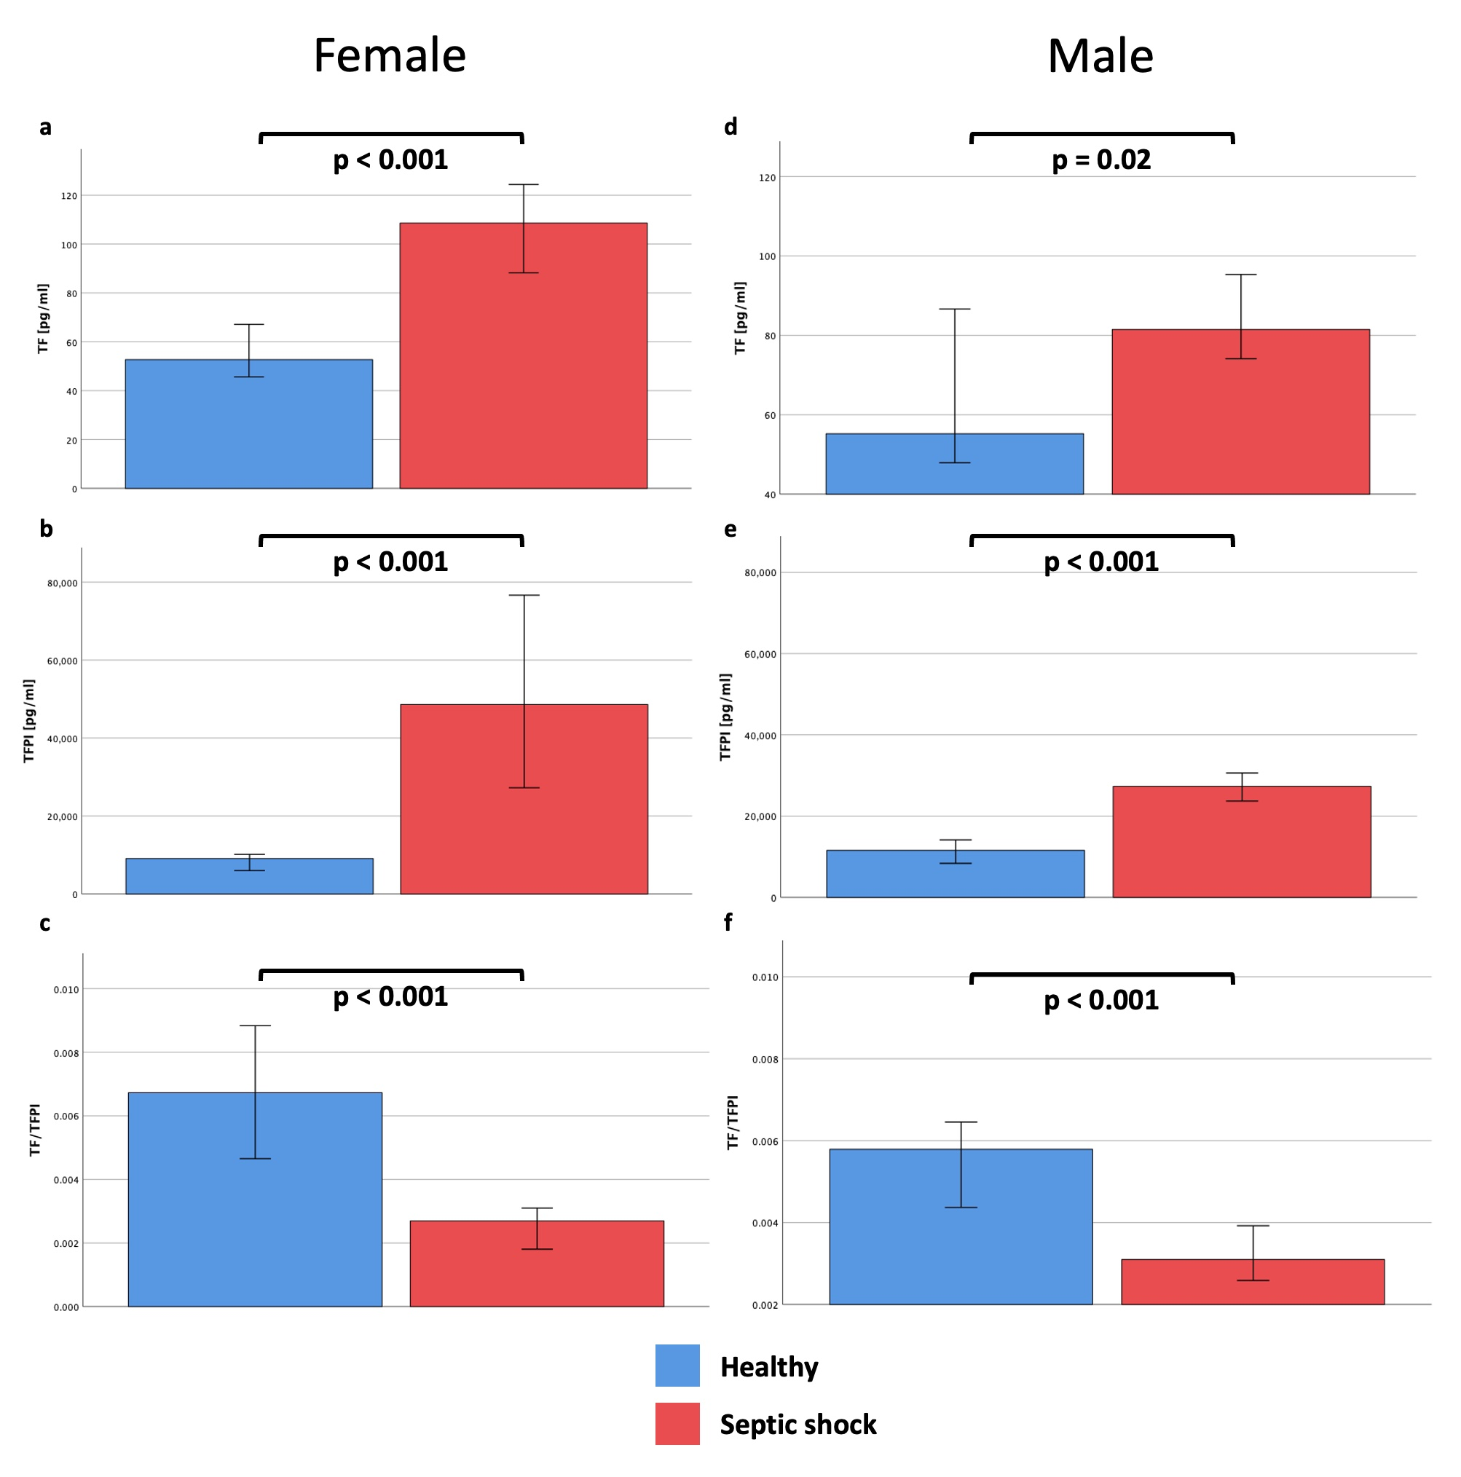
ESM Figure 1: Overview of parameters between healthy controls and patients with septic shock from day one disaggregated by sex. Mann-Whitney-U-Test was used for comparison between healthy controls and patients with septic shock on day one. Female subjects in a-c and male subjects in d-f. Data are presented as median and 95 % confidence interval.

Kinetics of TF and TFPI in patients with septic shock and healthy controls
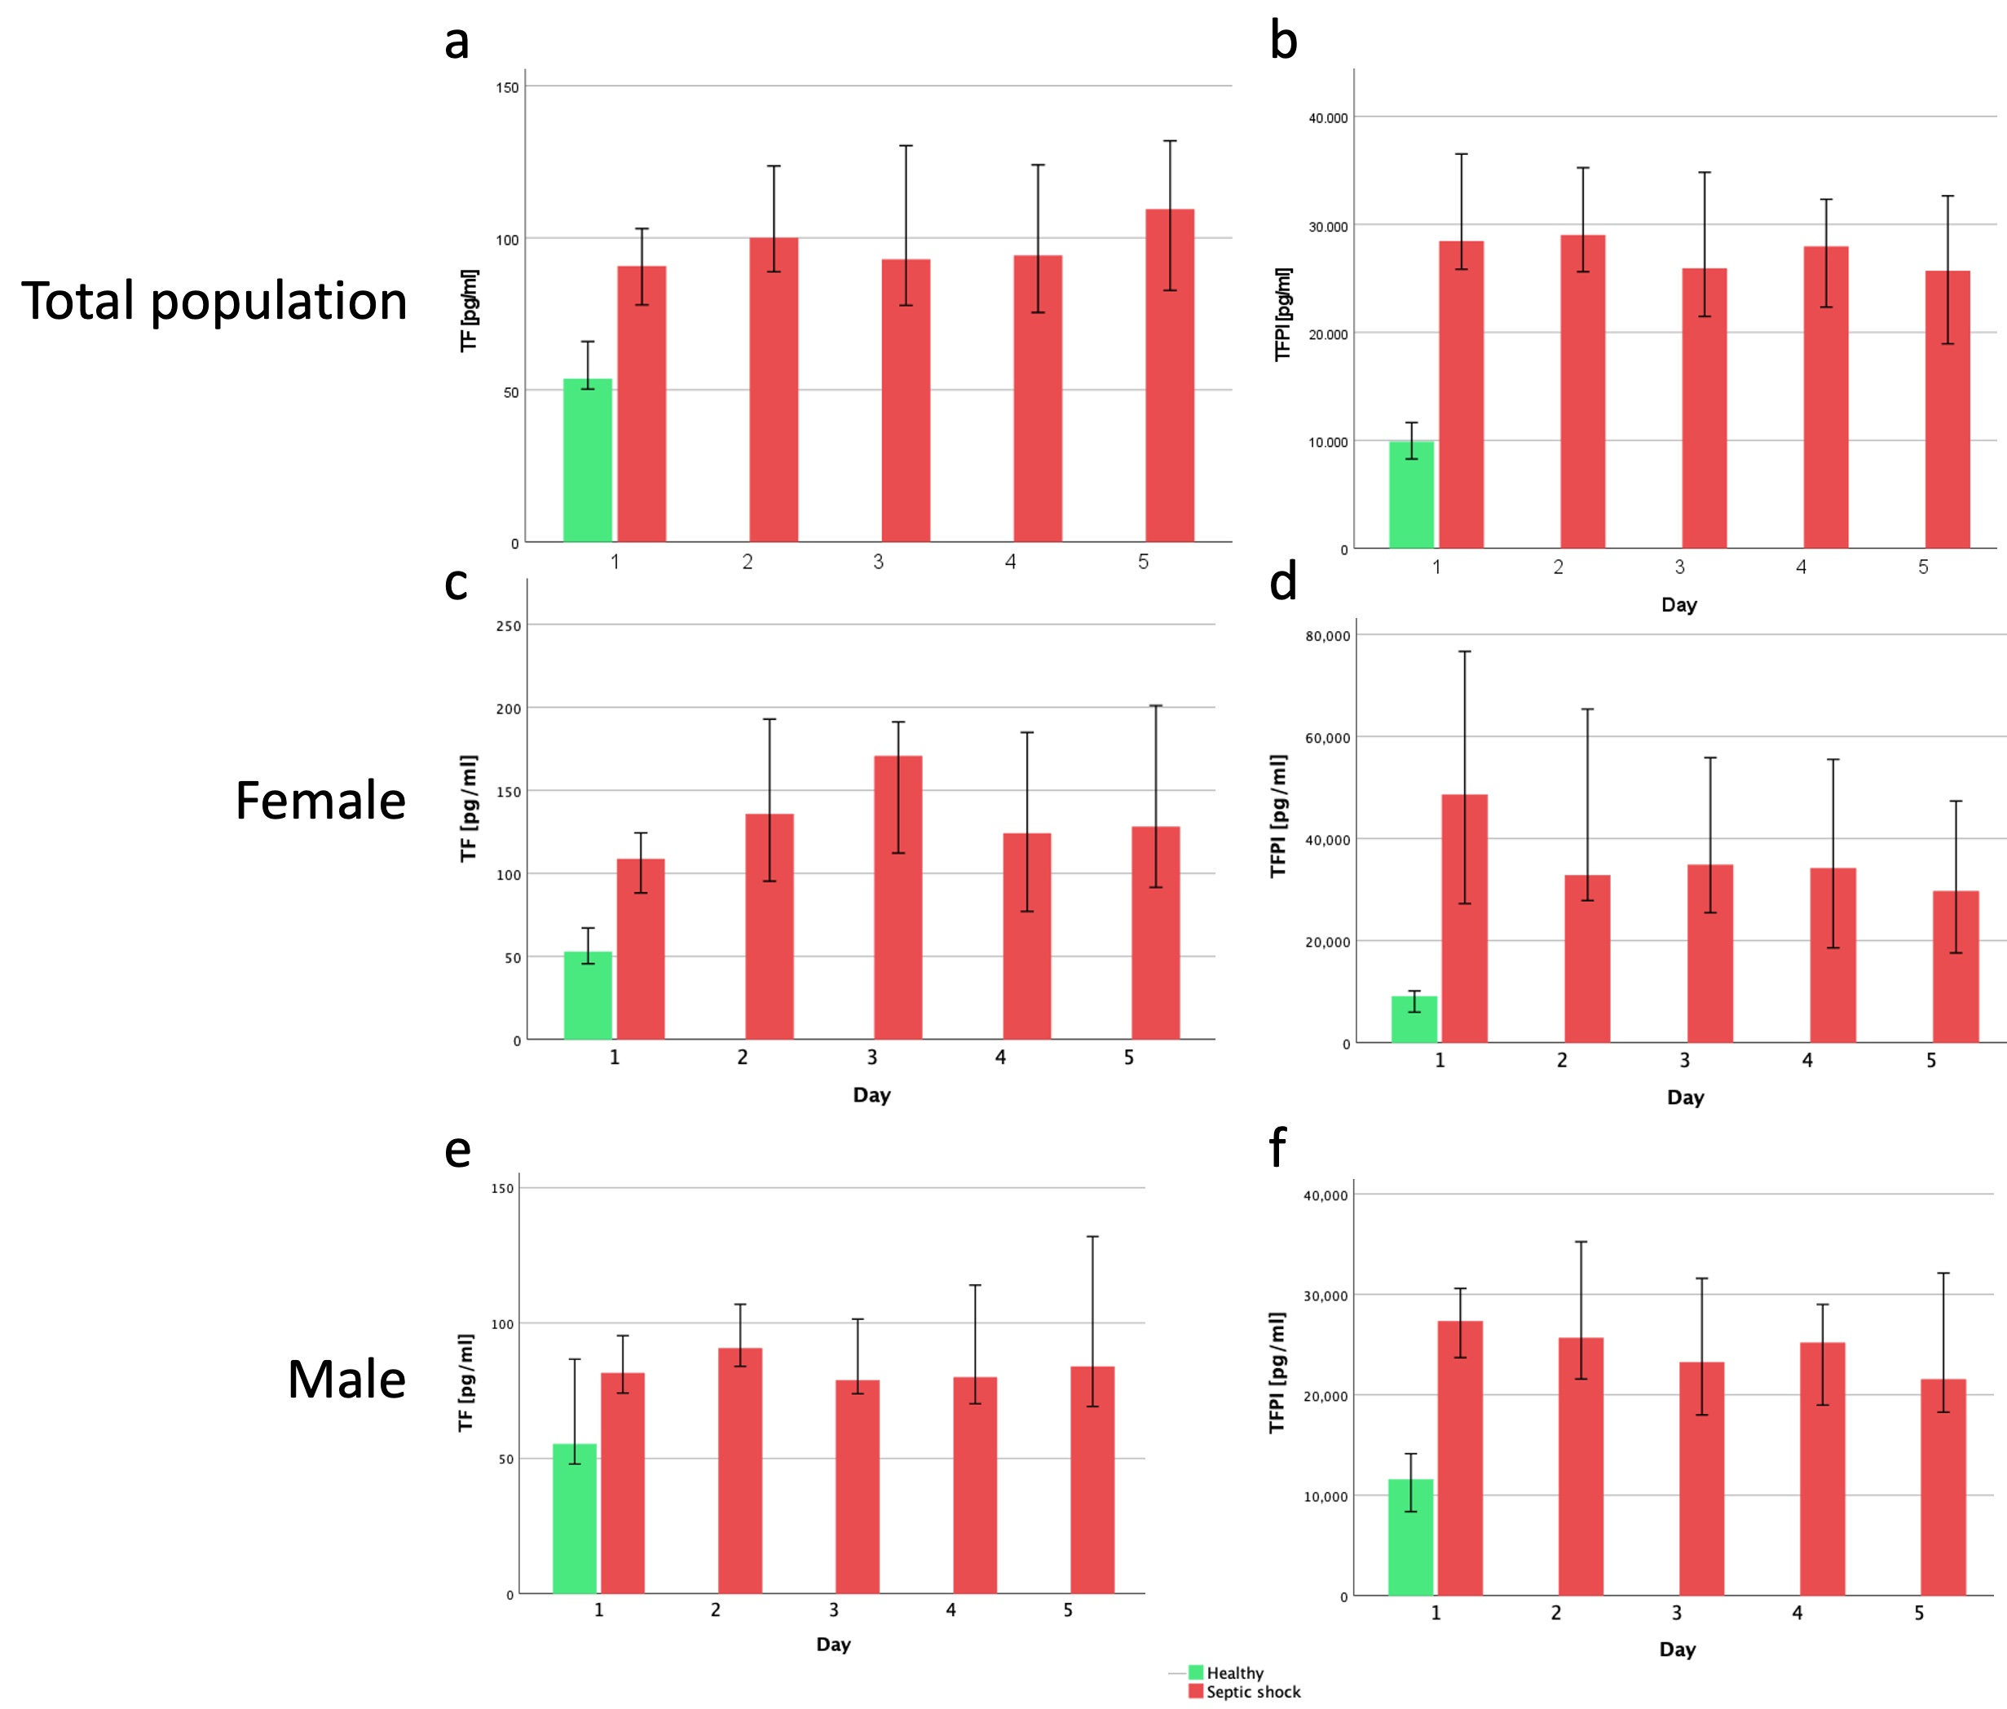
ESM Figure 2: Overview and kinetics of TF and TFPI in healthy controls and patients with septic shock from day one to five. The total population is presented in a-b and data disaggregated by sex are presented in c-f (c-d = female, e-f = male) as median and 95 % confidence interval.

TF/TFPI ratio disaggregated by sex in healthy controls and patients with septic shock stratified according to survival
There was no statistical significant difference in TF/TFPI between survivors and non-survivors on day one when data were disaggregated by sex, neither in the female (0.004 (0.003 – 0.005) vs. 0.004 (0.002 – 0.005), p = 0.199, ESM Figure 3b) nor in the male population (0.004 (0.003 – 0.005) vs. 0.003 (0.002 – 0.005), p = 0.089, ESM Figure 3c).
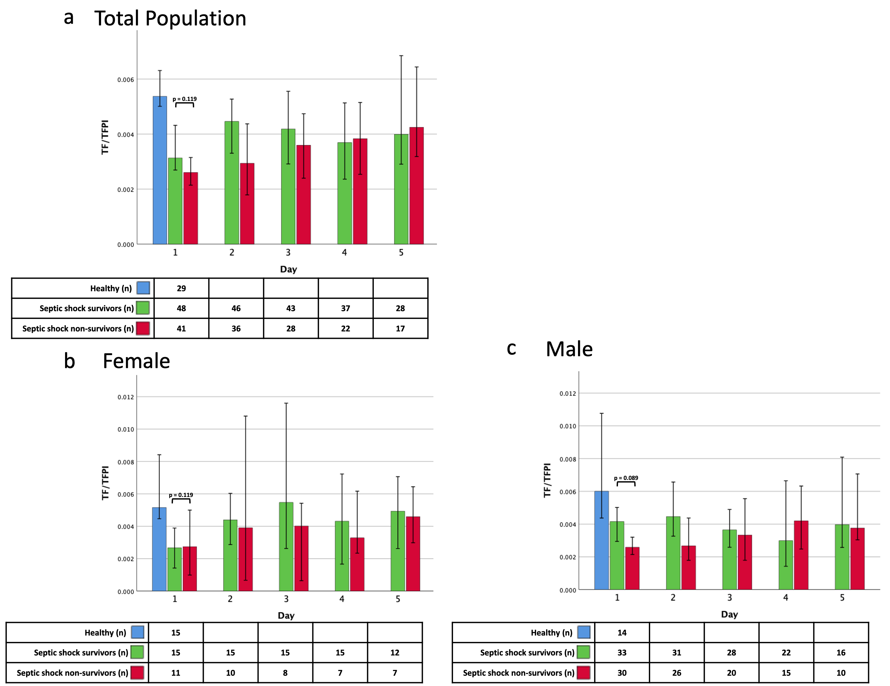
ESM Figure 3: TF/TFPI in healthy controls and patients with septic shock stratified according to ICU survival in the total population (a) and disaggregated by sex (b = female, c = male). Mann-Whitney-U-Test was used for comparison of parameters between septic shock survivors and non-survivors on day one.

Associations between TF/TFPI ratio and organ dysfunctions
The link between TF/TFPI and troponin T was confirmed by a significant positive correlation of peak levels during study period (ESM Figure 4), and also disaggregated by sex in females (ESM Figure 5a) and males (ESM Figure 5b).

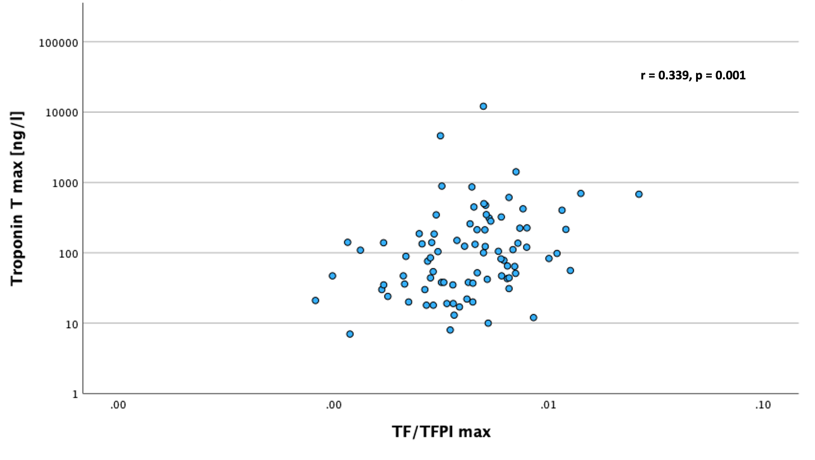
ESM Figure 4: Correlation between maximum levels of troponin T and TF/TFPI during study period. Correlation was tested with Spearman’s correlation coefficient (r).

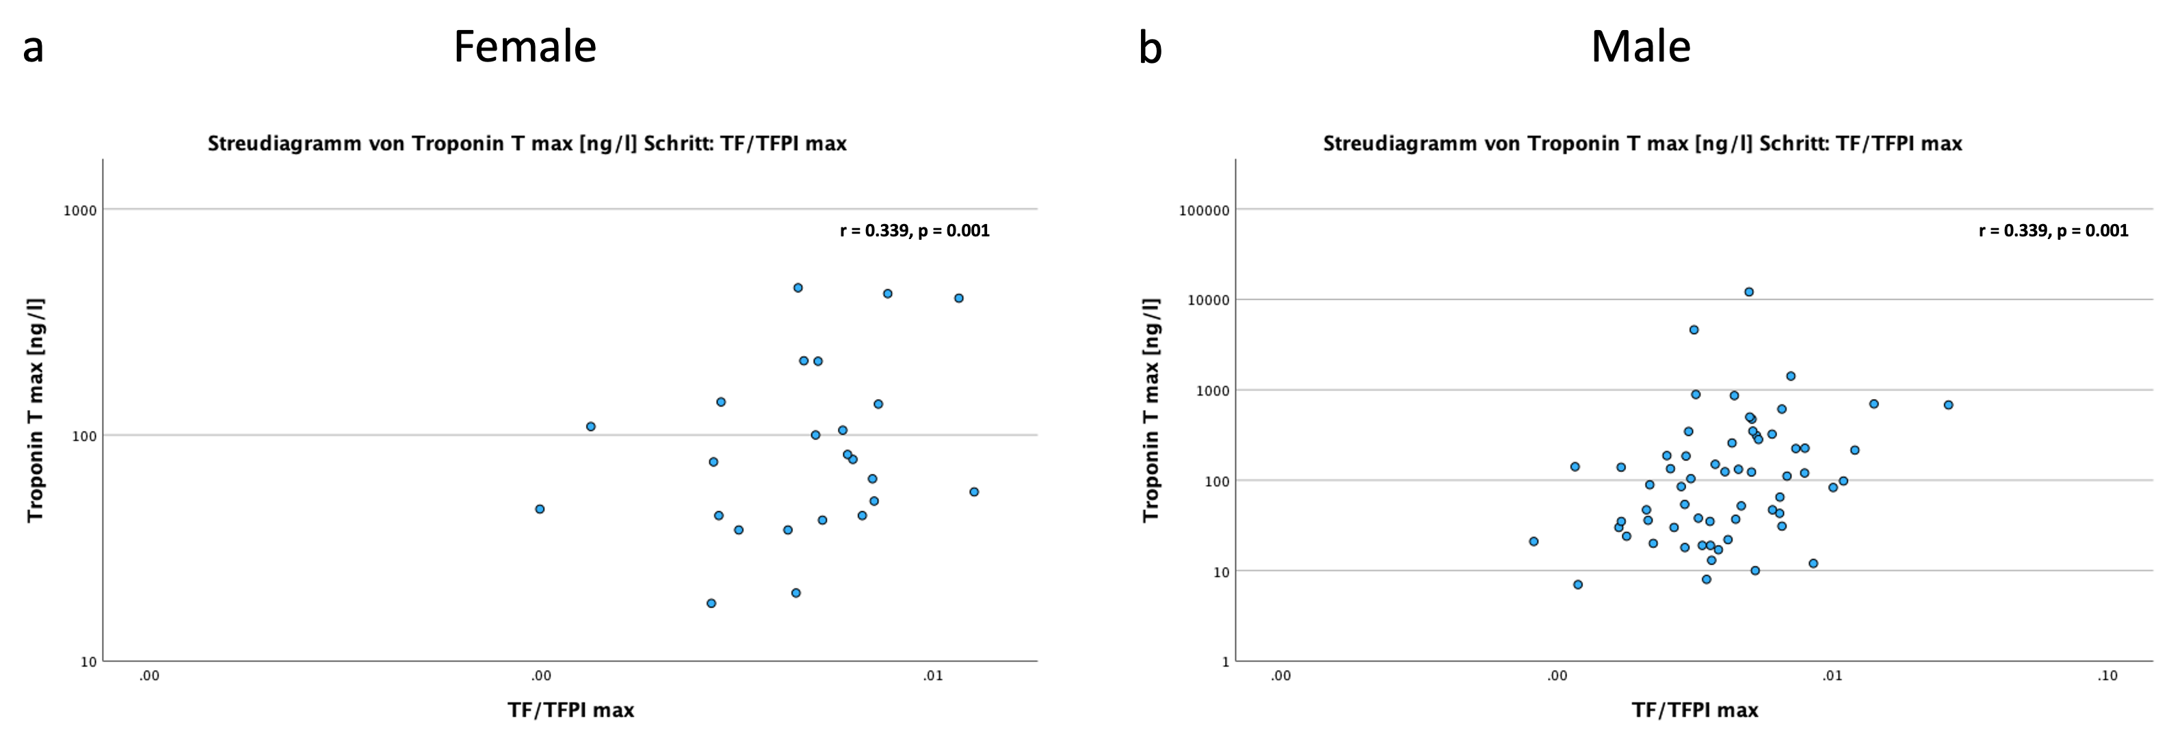
ESM Figure 5: Correlation between maximum levels of troponin T and TF/TFPI during study period disaggregated by sex, in female (a) and male (b) patients with septic shock. Correlation was tested with Spearman’s correlation coefficient (r).

Total population
ESM Table 3 summarizes detailed associations between parameters of organ dysfunction and individual parameters of tissue factor pathway. Data disaggregated by sex are presented for females in ESM Table 4 and for males in ESM Table 5.
ESM Table 3: Associations between parameters of organ dysfunction and individual parameters of tissue factor pathway in patients with septic shock by using a generalized estimating equation model.
Parameter | TF [pg/ml]  b | p | TFPI [pg/ml]  b | p | TF/TFPI  b | p
ARDS stage | 0.236  (0.741 – 1.214) | 0.636 | -0.154  (-0.933 – 0.625) | 0.699 | 0.313  (-0.301 – 0.926) | 0.318
Horovitz | -0.03  (-0-264 – 0.204)) | 0.802 | -0.004  (-0.214 – 0.205)) | 0.968 | -0.038  (-0.205 – 0.128) | 0.65
KDIGO AKI stage | 0.621  (-0.338 – 1.579) | 0.204 | 1.339  (0.672 – 2.005) | <0.001 | -0.483  (-1.034 – 0.068) | 0.086
Troponin T | 0.392  (-0.078 – 0.862) | 0.102 | -0.492  (-0.823 - -0.16) | 0.004 | 0.531  (0.309 – 0.754) | <0.001
NT-Pro-BNP | 1.335  (-0.896 – 3.566) | 0.241 | -0.134  (-0.92 – 0.652) | 0.738 | 0.398  (-0.326 – 1.112) | 0.282
Bilirubin | 0.2  (-0.53 – 0.93) | 0.592 | 0.52  (0.218 – 0.823) | <0.001 | -0.226  (-0.699 – 0.248) | 0.35
Lactate | -0.232  (-0.564 – 0.1) | 0.17 | 0.264  (0.086 – 0.442) | 0.004 | -0.176  (-0.38 – 0.028) | 0.09
SOFA | 0.705  (-1.337 – 2.746) | 0.499 | 1.757  (0.302 – 3.211) | 0.018 | -0.575  (-2.02 – 0.869) | 0.435
Respiratory SOFA | -0.101  (-0.799 – 0.598) | 0.777 | -0.094  (-0.771 – 0.583) | 0.785 | 0.151  (-0.372 – 0.673) | 0.572
CNS  SOFA | 0.368  (-0.412 – 1.148) | 0.355 | 0.164  (-0.425 – 0.753) | 0.585 | 0.079  (-0.35 – 0.509) | 0.717
Cardiovascular SOFA | -0.407  (-1.148 – 0.334) | 0.281 | 0.435  (-0.317 – 1.187) | 0.257 | -0.21  (-0.729 – 0.308) | 0.427
Renal  SOFA | 1.107  (0.22 – 1.994) | 0.014 | 0.667  (0.153 – 1.181) | 0.011 | -0.076  (-0.546 – 0.393) | 0.75
Coagulation SOFA | -0.436  (-1.312 – 0.439) | 0.329 | 0.376  (-0.164 – 0.916) | 0.173 | -0.351  (-0.815 – 0.112) | 0.137
Liver  SOFA | 0.401  (-0.739 – 1.54) | 0.491 | 1.034  (0.484 – 1.584) | <0.001 | -0.588  (-1.27- 0.095) | 0.091
VIS | -0.289  (-0.738 – 0.16) | 0.207 | 0.312  (-0.034 – 0.658) | 0.078 | -0.178  (-0.483 – 0.127) | 0.252
D-Dimer | -0.252  (-0.638 – 0.133 | 0.2 | 0.312  (0.028 – 0.597) | 0.032 | -0.213  (-0.478 – 0.051) | 0.114
PT | -0.057  (-0.225 – 0.111) | 0.507 | 0.016  (-0.148 – 0.18) | 0.847 | -0.05  (-0.186 – 0.086) | 0.469
INR | 0.052  (-0.06 – 0.164) | 0.359 | -0.005  (-0.124 – 0.115) | 0.936 | 0.032  (-0.067 – 0.132) | 0.522
INR category  (<1.2 vs. ≥1.2; daily) | 0.577  (-0.388 – 1.542)) | 0.241 | -0.027  (-0.738 – 0.683) | 0.94 | 0.075  (-0.449 – 0.598) | 0.779
ISTH non-overt DIC category (daily) | 0.068  (-0.61 – 0.747) | 0.843 | -0.077  (-0.654 – 0.501) | 0.795 | -0.019  (-0.48 – 0.443) | 0.937
ISTH overt-DIC category (daily) | 0.353  (-0.673 – 1.378) | 0.5 | -0.304  (-0.931 – 0.322) | 0.341 | 0.205  (-0.362 – 0.772) | 0.479
ISTH non-overt DIC category (max) | -0.225  (-2.048 – 1.598) | 0.809 | 0.252  (-0.996 – 1.501) | 0.692 | -0.292  (-1.13 – 0.546) | 0.495
ISTH overt-DIC category (max) | 0.182  (-0.853 – 1.216) | 0.73 | -0.353  (-1.009 – 0.304) | 0.292 | 0.205  (-0.378 – 0.788) | 0.491
INR category  (<1.2 vs. ≥1.2; max) | 0.555  (-0.971 – 2.081) | 0.476 | 0.122  (-0.93 – 1.175) | 0.82 | 0.027  (-0.855 – 0.909) | 0.952

Female
ESM Table 4: Associations between parameters of organ dysfunction and individual parameters of tissue factor pathway in female patients with septic shock by using a generalized estimating equation model.
Parameter | TF [pg/ml]  b | p | TFPI [pg/ml]  b | p | TF/TFPI  b | p
ARDS stage | 1.123  (-0.231 – 2.477) | 0.104 | -0.381  (-1.458 – 0.697) | 0.489 | 0.577  (-0.369 – 1.523) | 0.232
Horovitz | -0.211  (-0.539 – 0.117) | 0.207 | -0.002  (-0.213 – 0.208) | 0.984 | -0.075  (-0.282 – 0.133) | 0.48
KDIGO AKI stage | -0.876  (-2.934 – 1.182) | 0.404 | 2.642  (1.258 – 4.025) | <0.001 | -1.155  (-2.391 – 0.08) | 0.067
Troponin T | -0.257  (-0.84 – 0.325) | 0.387 | -0.267  (-0.528 - -0.005) | 0.046 | 0.134  (-0.136 – 0.403) | 0.331
NT-Pro-BNP | -0.307  (-2.943 – 2.33) | 0.819 | 1.506 (0.377 – 2.635) | 0.009 | -0.965  (-2.255 – 0.324) | 0.142
Bilirubin | -0.808  (-1.669 – 0.053) | 0.066 | 0.923  (0.412 – 1.434) | <0.001 | -0.846  (-1.468 - -0.225) | 0.008
Lactate | -0.509  (-0.85 - -0.169) | 0.003 | 0.41  (0.113 – 0.708) | 0.007 | -0.378  (-0.717 - -0.04) | 0.029
SOFA | -0.019  (-1.188 – 1.15) | 0.975 | 1.024  (0.286 – 1.763) | 0.007 | -0.484  (-1.332 – 0.364) | 0.263
Respiratory SOFA | 0.612  (-0.488 – 1.711) | 0.276 | -0.003  (-0.876 – 0.871) | 0.995 | 0.269  (-0.483 – 1.02) | 0.483
CNS  SOFA | 1.189  (-0.055 – 2.432) | 0.061 | -0.318  (-1.301 – 0.665) | 0.526 | 0.601  (-0.137 – 1.34) | 0.11
Cardiovascular SOFA | -0.864  (-2312 – 0.584) | 0.242 | 0.595  (-0.307 – 1.497) | 0.196 | -0.465  (-1.202 – 0.272) | 0.216
Renal  SOFA | 0.867  (-0.478 – 2.212) | 0.206 | 0.932  (0.206 – 1.658) | 0.012 | -0.344  (-1.118 – 0.429) | 0.383
Coagulation SOFA | -1.449  (-2.717 - -0.181) | 0.025 | 0.575  (-0.4 – 1.55) | 0.248 | -0.635  (-1.293 – 0.022) | 0.058
Liver  SOFA | 0.477  (-0.612 – 1.566) | 0.391 | 1.212  (0.693 – 1.731) | <0.001 | -1.217  (-2.284 - -0.151) | 0.025
VIS | -0.406  (-1.093 – 0.282) | 0.247 | 0.301  (-0.089 – 0.691) | 0.131 | -0.279  (-0.721 – 0.162) | 0.215
D-Dimer | -0.396  (-1.076 – 0.284) | 0.254 | 0.264  (-0.213 – 0.741) | 0.279 | -0.242  (-0.743 – 0.258) | 0.343
PT | 0.13  (-0.077 – 0.336) | 0.218 | -0.086  (-0.254 – 0.083) | 0.319 | 0.084  (-0.026 – 0.195) | 0.135
INR | -0.093  (-0.237 – 0.051) | 0.207 | 0.6  (-0.047 – 0.167) | 0.273 | -0.06  (-0.129 – 0.008) | 0.084
INR category  (<1.2 vs. ≥1.2; daily) | 1.592  (0.152 – 3.032) | 0.03 | -0.605  (-1.607 – 0.396) | 0.236 | 0.763  (-0.001 – 1.527) | 0.05
ISTH non-overt DIC category (daily) | 0.908  (0.071 – 1.744) | 0.033 | -0.018  (-0.781 – 0.745) | 0.963 | 0.219  (-0.417 – 0.855) | 0.499
ISTH overt-DIC category (daily) | 2.521  (0.446 – 4.596) | 0.017 | -0.699  (-1.914 – 0.515) | 0.259 | 0.719  (-0.139 – 1.577) | 0.1
ISTH non-overt DIC category (max) | 2.548  (1.340 – 3.756) | <0.001 | 1.666  (0.303 – 3.029) | 0.017 | -0.689  (-1.32 - -0.059) | 0.032
ISTH overt-DIC category (max) | 1.576  (-0.217 – 3.369) | 0.085 | -1.077  (-2.512 – 0.358) | 0.141 | 0.708  (-0.391 – 1.808) | 0.207
INR category  (<1.2 vs. ≥1.2; max) | 6.639  (0.649 – 12.63) | 0.03 | -0.892  (-2.546 – 0.762) | 0.29 | 0.987  (0.032 – 1.941) | 0.043

Male
ESM Table 5: Associations between parameters of organ dysfunction and individual parameters of tissue factor pathway in male patients with septic shock by using a generalized estimating equation model.
Parameter | TF [pg/ml]  b | p | TFPI [pg/ml]  b | p | TF/TFPI  b | p
ARDS stage | -0.304  (-1.213 – 0.604) | 0.512 | -0.436  (-1.516 – 0.643) | 0.428 | 0.287  (-0.469 – 1.043) | 0.457
Horovitz | 0.107  (-0.173 – 0.387) | 0.454 | 0.036  (-0.268 – 0.34) | 0.816 | -0.024  (-0.245 – 0.197) | 0.832
KDIGO AKI stage | 1.03  (-0.042 – 2.102) | 0.060 | 1.099  (0.287 – 1.91) | 0.008 | -0.277  (-0.894 – 0.339) | 0.378
Troponin T | 0.842  (0.16 – 1.524) | 0.016 | -0.36  (-0.881 – 0.161) | 0.175 | 0.689  (0.429 – 0.949) | <0.001
NT-Pro-BNP | -0.354  (-3.621 – 2.913) | 0.832 | -0.652  (-1.478 – 0.174) | 0.122 | 0.935  (0.187 – 1.683) | 0.014
Bilirubin | 0.781  (0.133 – 1.429) | 0.018 | 0.427  (0.148 – 0.705) | 0.003 | 0.024  (-0.506 – 0.554) | 0.929
Lactate | -0.106  (-0.486 – 0.275) | 0.587 | 0.219  (-0.022 – 0.461) | 0.075 | -0.089  (-0.306 – 0.128) | 0.422
SOFA | 1.582  (-0.797 – 3.961) | 0.192 | 1.793  (-0.625 – 4.21) | 0.146 | -0.312  (-2.114 – 1.489) | 0.734
Respiratory SOFA | -0.234  (-1.019 – 0.55) | 0.558 | -0.048  (-1.022 – 0.927) | 0.924 | 0.093  (-0.583 – 0.769) | 0.787
CNS  SOFA | -0.035  (-0.902 – 0.831) | 0.937 | 0.266  (-0.531 – 1.063) | 0.513 | -0.142  (-0.693 – 0.41) | 0.615
Cardiovascular SOFA | -0.317  (-1.248 – 0.614) | 0.505 | 0.408  (-0.653 – 1.468) | 0.451 | -0.121  (-0.761 – 0.519) | 0.711
Renal  SOFA | 1.532  (0.397 – 2.666) | 0.008 | 0.587  (-0.125 – 1.299) | 0.106 | 0.075  (-0.494 – 0.643) | 0.796
Coagulation SOFA | 0.235  (-0.661 – 1.13) | 0.607 | 0.363  (-0.362 – 1.087) | 0.326 | -0.226  (-0.806 – 0.354) | 0.444
Liver  SOFA | 1.665  (0.311 – 3.019) | 0.016 | 1.115  (0.459 – 1.771) | <0.001 | -0.335  (-1.18 – 0.51) | 0.437
VIS | -0.163  (-0.695 – 0.369) | 0.548 | 0.425  (-0.144 – 0.995) | 0.143 | -0.13  (-0.527 – 0.266) | 0.519
D-Dimer | -0.08  (-0.483 – 0.323) | 0.698 | 0.423  (0.062 – 0.784) | 0.022 | -0.202  (-0.514 – 0.11) | 0.205
PT | -0.213  (-0.372 - -0.053) | 0.009 | -0.001  (-0.208 – 0.205) | 0.992 | -0.106  (-0.285 – 0.072) | 0.242
INR | 0.171  (0.063 – 0.279) | 0.002 | 0.012  (-0.139 – 0.164) | 0.873 | 0.071  (-0.061 – 0.204) | 0.292
INR category  (<1.2 vs. ≥1.2; daily) | -0.394  (-1.651 – 0.863) | 0.539 | -0.059  (-0.958 – 0.839) | 0.897 | -0.264  (-0.955 – 0.428) | 0.455
ISTH non-overt DIC category (daily) | -0.626  (-1.508 – 0.256) | 0.164 | -0.319  (-1.037 – 0.399) | 0.383 | -0.116  (-0.708 – 0.475) | 0.7
ISTH overt-DIC category (daily) | -0.628  (-1.697 – 0.441) | 0.249 | -0.405  (-1.206 – 0.397) | 0.322 | 0.021  (-0.664 – 0.705) | 0.953
ISTH non-overt DIC category (max) | -0.632  (-2.838 – 1.574) | 0.575 | -0.074  (-1.634 – 1.486) | 0.926 | -0.191  (-1.209 – 0.827) | 0.713
ISTH overt-DIC category (max) | -0.696  (-2.069 – 0.676) | 0.32 | -0.327  (-1.198 – 0.544) | 0.462 | -0.004  (-0.697 – 0.689) | 0.991
INR category  (<1.2 vs. ≥1.2; max) | -0.043  (-1.32 – 1.233) | 0.947 | 0.256  (-1.145 – 1.657) | 0.72 | -0.234  (-1.315 – 0.847) | 0.671

TF/TFPI ratio stratified according to INR disaggregated by sex
Patients with septic shock were stratified according to INR on the first study day and analyzed disaggregated by sex. Four female patients had an INR <1.2 and 20 female patients an INR ≥1.2. There was no significant difference in TF/TFPI ratio on day one between female patients with an INR <1.2 and those with an INR ≥1.2 (0.002 (0.03 – 0.004) vs. 0.002 (0.001 – 0.004), p = 0.388, ESM Figure 6a). Nine male patients had an INR <1.2 and 51 male patients an INR ≥1.2. There was no significant difference in TF/TFPI ratio on day one between male patients with an INR <1.2 and those with an INR ≥1.2 (0.003 (0.003 – 0.004) vs. 0.003 (0.002 – 0.005), p = 0.733, ESM Figure 6b).
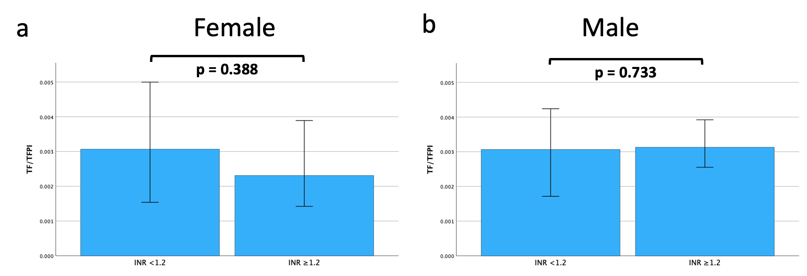
ESM Figure 6: TF/TFPI ratio stratified according to INR 1.2 on day one in female (a) an male (b) patients with septic shock. Bars represent medians and 95 % confidence intervals. Statistical significance was tested with Mann-Whitney U.

Peak levels TF, TFPI and TF/TFPI ratio
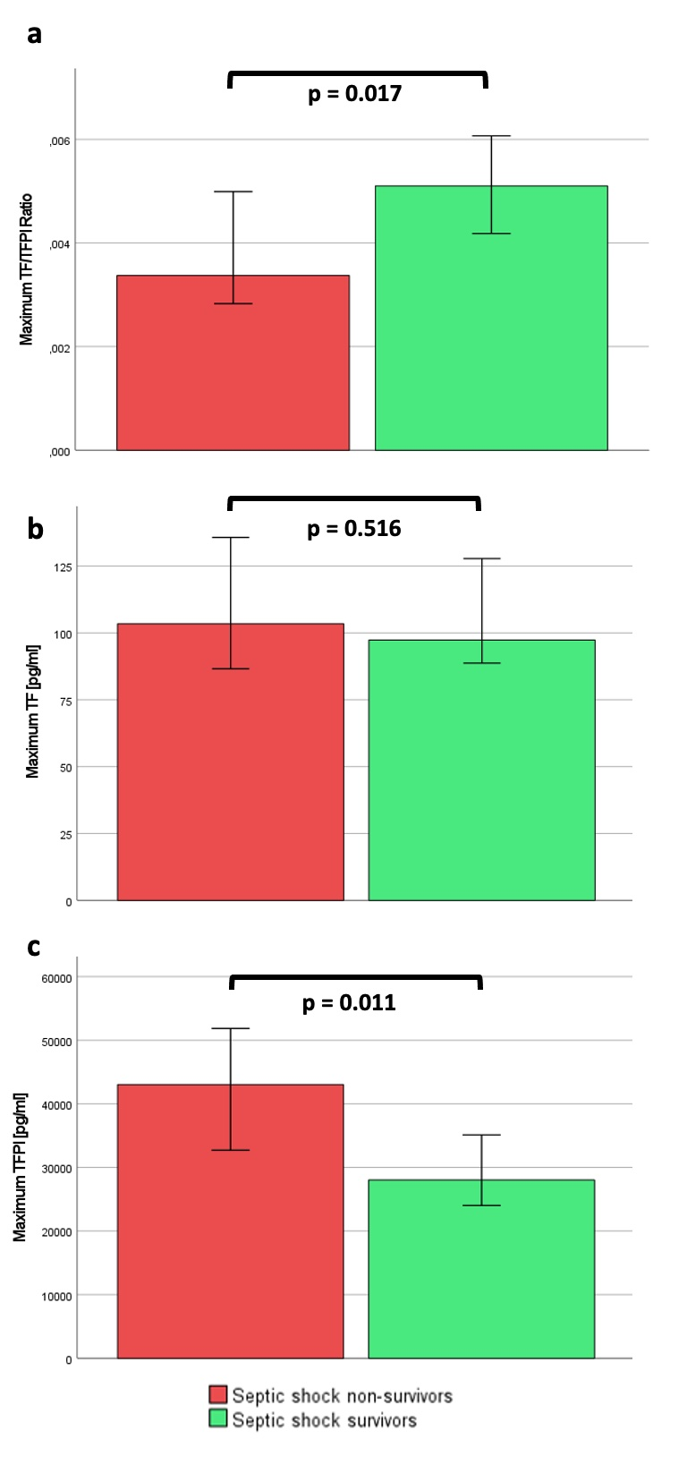
ESM Figure 7: Graph bars showing maximum values of TF (a), TFPI (b) and TF/TFPI ratio (c) in patients with septic shock stratified according to ICU survival. Data are presented as median and 95% confidence interval. Comparisons between the groups were performed by Mann-Whitney-U-Test.

Peak levels TF, TFPI and TF/TFPI ratio disaggregated by sex and outcome
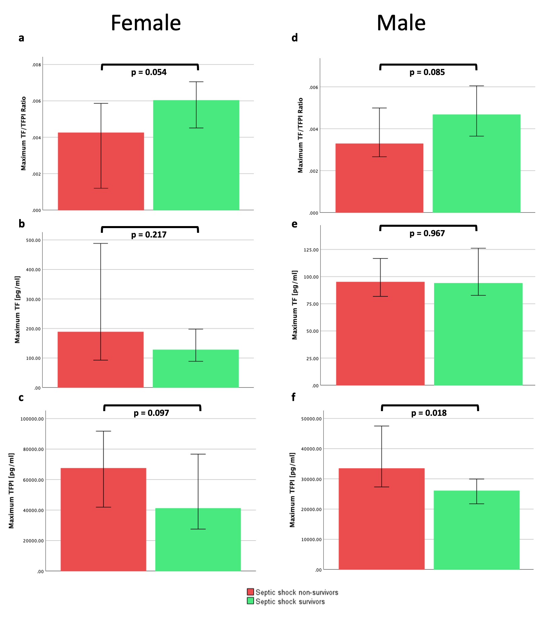
ESM Figure 8: Graph bars showing maximum values in female (a-c) and male (d-f) patients with septic shock stratified according to ICU survival. Data are presented as median and 95% confidence interval. Comparisons between the groups were performed by Mann-Whitney-U-Test.

Correlation of TFPI with inflammatory and endothelial markers disaggregated by sex

 | female (n=6) |  | male (n=21)
Parameter | TFPI  r | p | TFPI  r | p
E-selectin | -0.2 | 0.704 | -0.003 | 0.991
GM-CSF | -0.185 | 0.552 | -0.26 | 0.911
IFN-alpha | -0.314 | 0.544 | 0.326 | 0.149
IFN-gamma | -0.464 | 0.354 | 0.077 | 0.739
IL1-alpha | 0.6 | 0.208 | 0.377 | 0.092
IL-1-beta | -0.309 | 0.552 | 0.03 | 0.898
IL-10 | 0.657 | 0.156 | 0.322 | 0.154
IL-12p70 | -0.143 | 0.787 | 0.239 | 0.297
IL-13 | -0.377 | 0.461 | 0.339 | 0.132
IL-17 | -0.829 | 0.042 | 0.258 | 0.259
IL-4 | -0.371 | 0.468 | 0.09 | 0.699
IL-6 | -0.771 | 0.072 | 0.318 | 0.16
IL-8 | 0.657 | 0.156 | 0.506 | 0.019
IP-10 | -0.257 | 0.623 | 0.026 | 0.911
MCP-1 | 0.6 | 0.285 | 0.308 | 0.175
MIP-1-alpha | 0.829 | 0.042 | 0.404 | 0.069
MIP-1-beta | 0.6 | 0.208 | 0.395 | 0.077
P-selectin | 0.029 | 0.957 | -0.14 | 0.544
sICAM-1 | -0.257 | 0.623 | 0.36 | 0.109
TNF-alpha | 0.257 | 0.623 | 0.302 | 0.183
ESM Table 6: Correlation of TFPI with inflammatory and endothelial markers by using the two-tailed Spearman’s rank-order test, disaggregated by sex. IFN = interferon, IL = interleukin, IP10 = interferon-gamma induced protein 10, GM-CSF = granulocyte-macrophage colony-stimulating factor, MCP = monocyte chemoattractant protein-1, MIP = macrophage inflammatory protein, sICAM = soluble intercellular adhesion molecule, TNF = tumor necrosis factor, r = correlation coefficient.

Levels of troponin T, creatinine and TF/TFPI stratified according to AKI and use of RRT

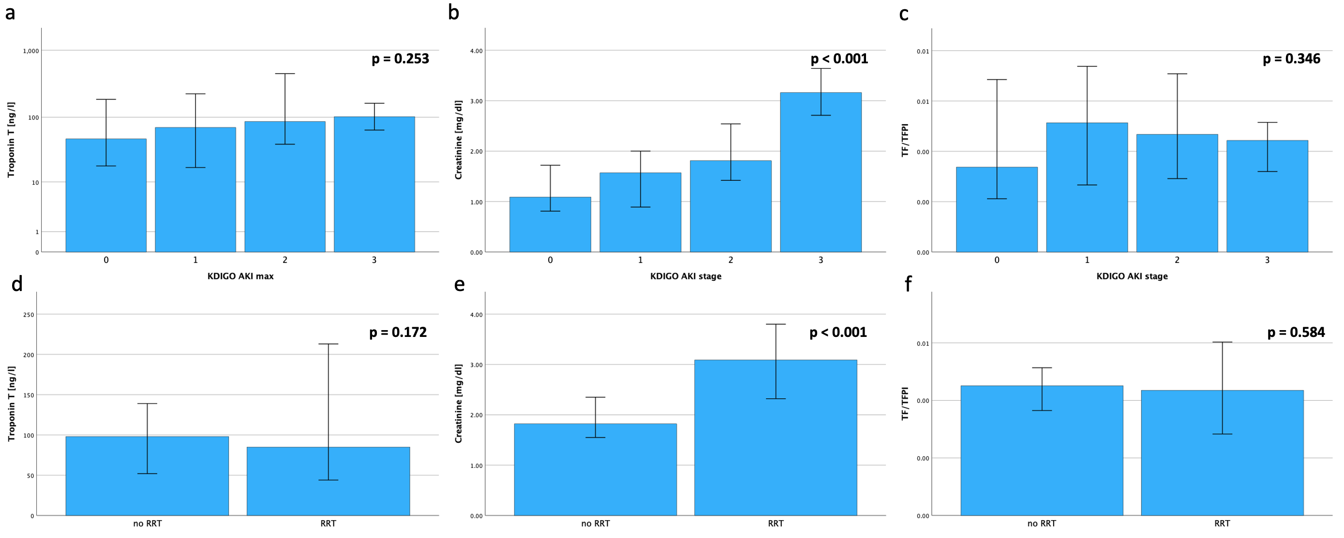
ESM Figure 9: Maximum levels of troponin T and creatinine as well as maximum TF/TFPI ratios were analyzed in subgroups stratified according to stage of KDIGO AKI (a-c) and use of RRT (d-f). P values refer to comparison of groups with Kruskal-Wallis-Test (a-c) and Mann-Whitney-U-Test (d-f).

