Supporting Information
Investigation of the antimycobacterial activity of African medicinal plants combined with chemometric analysis to identify potential leads
Phanankosi Moyo^{1,a}, Michael Ofori^{2,3a}, Olusola S. Bodede¹, Madelien Wooding¹, Ndivhuwo Kevin Khorommbi¹, Lyndy J. McGaw⁴, Cynthia A. Danquah^{2,}*, and Vinesh J. Maharaj^{1,}*
¹ Biodiscovery Center, Department of Chemistry, University of Pretoria, Pretoria 0028, South Africa
²Department of Pharmacology, Faculty of Pharmacy and Pharmaceutical Sciences, College of Health Sciences, Kwame Nkrumah University of Science and Technology, PMB, Kumasi Ghana.
³Department of pharmaceutical sciences, Dr Hilla Limann Technical University, Wa Ghana
⁴Phytomedicine Programme, Department of Paraclinical Sciences, Faculty of Veterinary Science, University of Pretoria, Private Bag X04, Onderstepoort, Pretoria 0110, South Africa
Phanankosi Moyo (phanankosimoyo@gmail.com)
Michael Ofori (michof2825@gmail.com)
Olusola Bodede (olusolabodede@gmail.com)
Madelien Wooding (madelien.wooding@up.ac.za)
Ndivhuwo Kevin Khorommbi (khorombink@gmail.com)
Lyndy J. McGaw (lyndy.mcgaw@up.ac.za)
Cynthia Amaning Danquah (cadanquah.pharm@knust.edu.gh)
Vinesh Maharaj (vinesh.maharaj@up.ac.za)
*Corresponding author: Vinesh J. Maharaj (Natural Products Chemistry Analysis)
Tel: +27 (0824665466)
Email address: vinesh.maharaj@up.ac.za
Department of Chemistry
University of Pretoria
Private Bag x 20
Hatfield, 0028
South Africa
*Corresponding author: Cynthia A. Danquah (Antimycobacterial Analysis)
Tel: +233 (0265458216)
Email address: cadanquah.pharm@knust.edu.gh
Department of Pharmacology
Faculty of Pharmacy and Pharmaceutical Sciences
College of Health Sciences
Kwame Nkrumah University of Science and Technology.
Kumasi
Ghana.
ª Contributed equally to this work.

Table S1: Plants species selected for in vitro antimycobacterial screening.
Plant species (Family) | Part | Local name* | Traditional use*
Solanum aculeastrum (Solanaceae) | L | Murulwa (Venda), Umthuma, itunga (Xhosa) and thola (Tswana). | Used for the treatment of different human and animal ailments [1]. Related species used for tuberculosis treatment [2].
Geranium robustum (Geraniaceae) | L | Vrouebossie – amarabossie (Afrikaans) and ngope-sethsoha, tlako (Sotho) [3]. | Genera within the Geraniaceae family, including Geranium, and Perlagonium are used for treatment of several diseases including bladder infections, diarrhoea [4] and tuberculosis [5].
Terminalia phanerophlebia (Combretaceae) | L | AmaNgwe-amnyama, amaNgwe-omphofu (Zulu) and mambonjwane (Swati). | Used for the treatment of many diseases including pneumonia [1]. Related species used for tuberculosis treatment [2].
Momordica cardiospermoides (Cucurbitaceae) | WP | Inshubaba (Swati) and ntwe (Tswana). | Used traditionally for the treatment of different diseases [6, 7]. Related species used for tuberculosis treatment [2].
Burchellia bubalina (Rubiaceae) | L | Thobankomo (Xhosa), Golwane (Zulu) and Hlosana (Swati). | The plant is widely used in folk medicine [8-10] and ethnoveterinary including for the treatment of heart water [11].
Catha edulis (Celastraceae) | L | Umhlwazi (Zulu), iqgwaka (Xhosa), lehlatse, lewang, and molomomonate (Sepedi) [2]. | It is used for the treatment of common cold and respiratory of disorders [12] including tuberculosis [2] amongst others.
Senegalia burkei (Fabaceae) | L | Umkhaya wehlalahlathi, umbabampala (Zulu), umkhaya (Swati), mokgwa (Tswana), and munanga (Venda). | Used to treat eye and back pain [13]. Related species used for tuberculosis treatment [2].
Hedychium flavescens (Zingiberaceae) | S | Wild ginger (English) [14]. | Used for ritual purposes generally and additionally for traditional medicinal use [14, 15].
Hedychium flavescens (Zingiberaceae) | F | Wild ginger (English) [14].
Siphonochilus aethiopicus (Zingiberaceae) | WP | Indungulo, isiphephetho (Zulu) and African ginger (English) [16]. | Used for the treatment of many disorders including tuberculosis [2], malaria, asthma, and inflammation [16, 17].
Leonotis leonurus (Lamiaceae) | L | Wilde dagga (Afrikaans), umfincafincane, (isiXhosa), and utshwala-bezinyoni (isiZulu). | Its widely used in traditional medicine including for influenza, epilespsy, chest infection, tuberculosis and headaches [2, 18].
Salvia runcinata (Lamiaceae) | L | Isicakathi [1]. | The plant is used as a disinfectant and for the treatment of hives [19], burns and sores [20].
Salvia africana-lutea (Lamiaceae) | L | Ssand sage (English), bruinsalie, sandsalie, strandsalie, and geelblomsalie (Afrikaans). | Used for the treatment of tuberculosis, influenza, common cold fever amongst many other ailments [21].
Jatropha erythropoda (Euphorbiaceae) | T | Rooikambroo (Afrikaans)¹ and Thotamadi (Tswana and Sepedi) [22, 23]. | Plant is administered as an immune booster for HIV/AIDS management [22] and other sexual transmitted diseases [23]. Related species used for tuberculosis treatment [2].
Hypericum roeperianum (Hypericaceae) | L | Isivumelelwane (Zulu) [1]. | Used for treatment of different disorders including diarrhoea, pain, indigestion and bacterial diseases [24].
Garcinia gerrardii (Hypericaceae) | L | Bosgeelmelkhout (Afrikaans), umbande (Xhosa), isibinda, (Zulu) and sikhwelamkhala (Swati). | Used traditionally for the treatment of tuberculosis [2].
Ptaeroxylon obliquum (Rutaceae) | L | Mogabaletswana (Sepedi) [2] and umThathi (Xhosa). | Used traditionally for the treatment of tuberculosis [2].
*Data collated from PlantZAfrica (https://pza.sanbi.org/about) which is provided by the South African National Biodiversity Institute (https://www.sanbi.org/). Additional information on plants has been acquired from other sources including published peer reviewed articles. Traditional uses provided are not exhaustive. ¹http://redlist.sanbi.org/species.php?species=576-6. ²https://www.herbgarden.co.za/mountainherb/herbinfo.php?id=215.
Continued Table S1: Plants species selected for in vitro antimycobacterial screening.
Plant species (Family) | Part | Local name* | Traditional use*
Ekebergia capensis (Meliaceae) | L | Cape ash, dogplum (English), essenhout (Afrikaans), umnyamatsi (Swati), nyamaru (Tswana). | Used to facilitate child birth, treat headaches, and skin diseases [25].
Turraea obtusifolia (Meliaceae) | LF | Dima (Sepedi) [22]. | Used traditionally for the treatment of tuberculosis [2].
Drimia sp. (Asparagaceae) | WP |  | Related species used for tuberculosis treatment [2].
Cyrtanthus mackenii (Amaryllidaceae) | L | Ifafa lily (English), and impingizana encane empofu (Zulu) [1]. | Used for treatment of cough, headache, cystitis and leprosy [26].
Cyrtanthus mackenii (Amaryllidaceae) | R
Tulbaghia simmleri (Amaryllidaceae) | R | Ssweet wild garlic, sweet garlic, fragrant tulbaghia (English), and soetwildeknoffel (Afrikaans). | Used for ornamental purposes. Related species used for tuberculosis treatment [2].
Tulbaghia simmleri (Amaryllidaceae) | L
Crinum jagus (Amaryllidaceae) | L | Sukooko (Akan, Ghana) [27]. | Used for asthma and tuberculosis treatment [28].
Crinum jagus (Amaryllidaceae) | B | Sukooko (Akan, Ghana) [27]. | Used for asthma and tuberculosis treatment [28].
Crinum asiaticum (Amaryllidaceae) | L |  | Used to treat respiratory tract infections [29] and skin infections. Related species is used for tuberculosis treatment [28].
Crinum asiaticum (Amaryllidaceae) | B
Crinum sp. (Amaryllidaceae) | B |  | Related species is used for tuberculosis treatment [28].
Arctotis stoechadifolia (Asteraceae) | L | Trailing arctotis (English), kusgousblom, bittergousblom, and witgousblom (Afrikaans). | Used to “clean kidneys” [30].
Eriocephalus africanus var. paniculatus (Asteraceae) | WP | Wild rosemary (English), wilderoosmaryn, and kapokbos (Afrikaans). | Used for many diseases including coughs, cold, expectorant, and antimicrobial agent [31].
Helichrysum odoratissimum (Asteraceae) | L | Kooigoed, kruie (Afrikaans) and imphepho (Xhosa and Zulu). | Used as an incense, urinary tract infections, fever [1, 32]. Related species used for tuberculosis treatment [2].
Artemisia annua (Asteraceae) | L | Sweet wormwood (English)². | Used for the treatment of fever, and malaria [33]. Related species used for tuberculosis treatment [2].
Artemisia afra (Asteraceae) | L | African wormwood (English), wilde-als (Afrikaans), mhlonyane (isiZulu) and lengana (Tswana). | Used for tuberculosis treatment [2, 30] amongst a plethora of ailments [34]
Gymnanthemum corymbosum (Asteraceae) | L | Mountain vernonia (English) and uhlunguhlungu (Zulu). | Used to treat fever, and malaria [35].
Gymnanthemum myrianthum (Asteraceae) | L | Uhluhlunga, umhlungahlunga (Zulu) and linyatselo (Swati). | Related species used for malaria, fever, skin wounds and diarrhoea amongst other ailments [36].

Supplementary Files F1 to F8 for used for the tentative annotation of compounds from Crinum asiaticum using MassLynx.
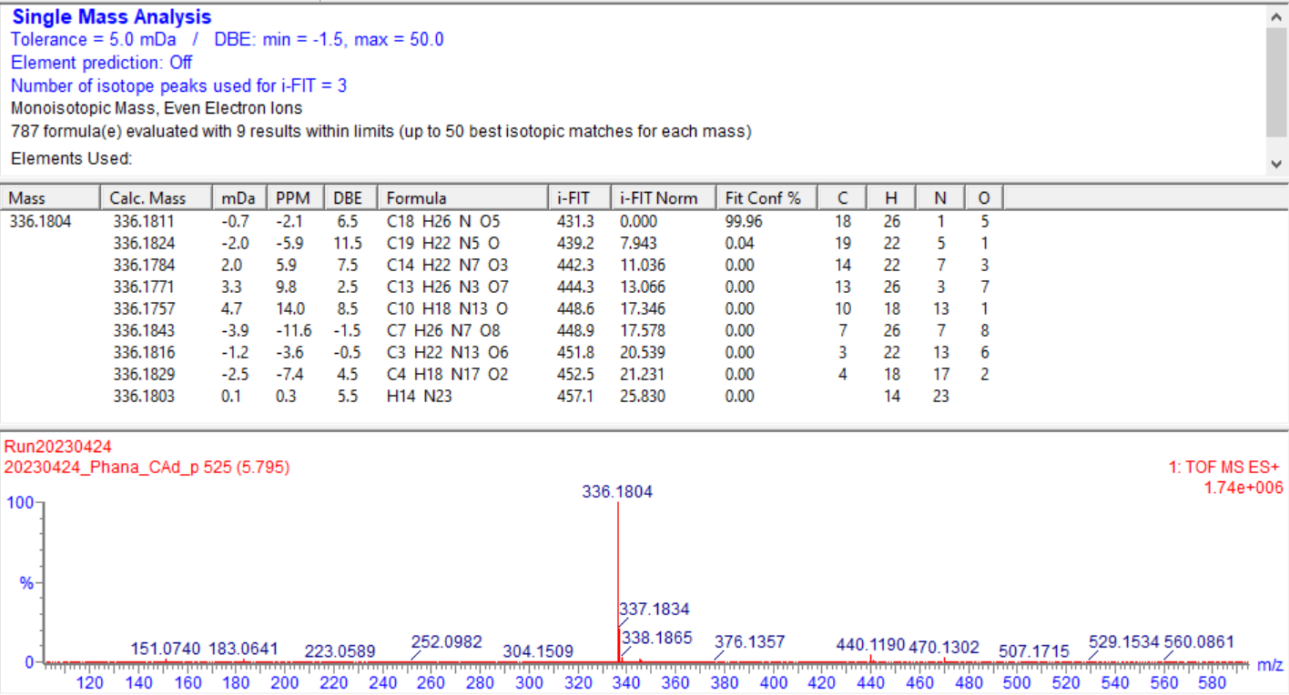
[M+H]⁺
Figure F1: Annotation for compound 1 on MassLynx
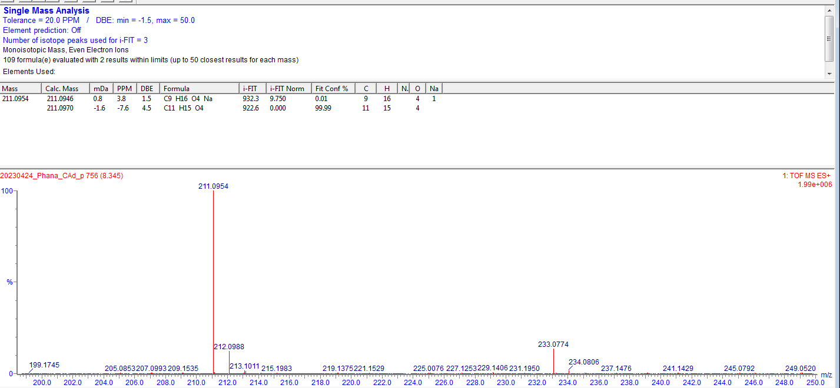
[M+Na]⁺
[M+H]⁺
Figure F2: Annotation for compound 2 on MassLynx
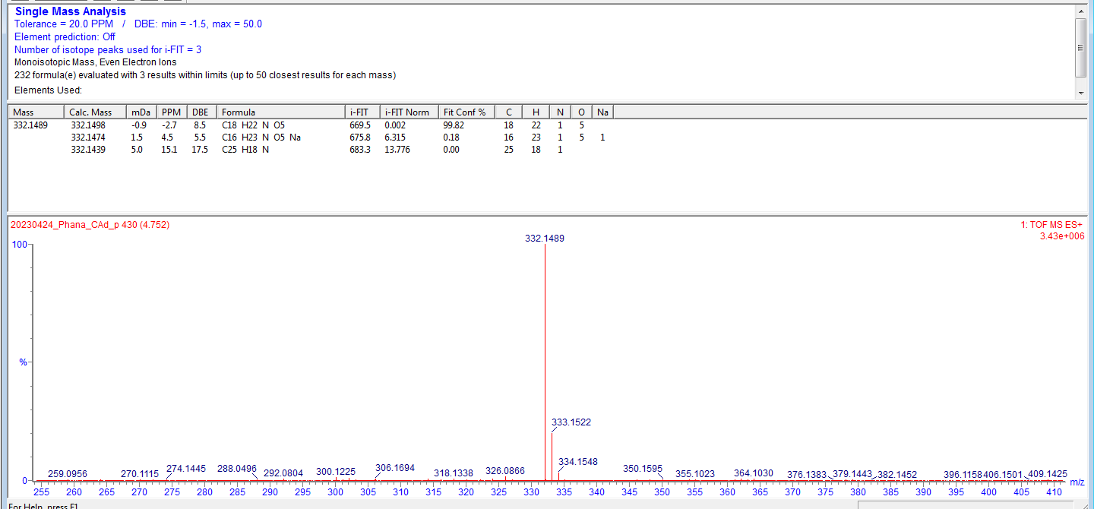
[M+H]⁺
Figure F3: Annotation for compound 3 on MassLynx
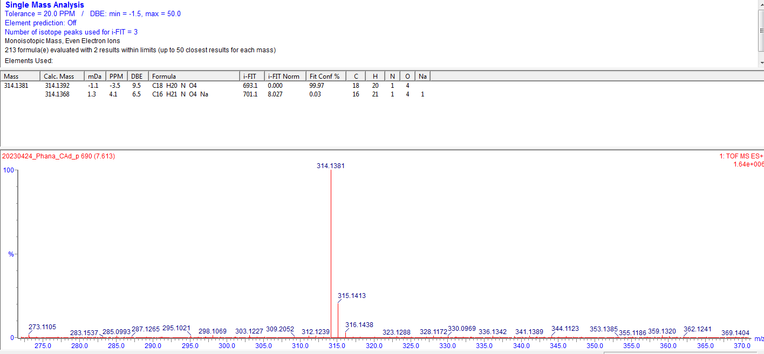
[M+H]⁺
Figure F4: Annotation for compound 4 on MassLynx

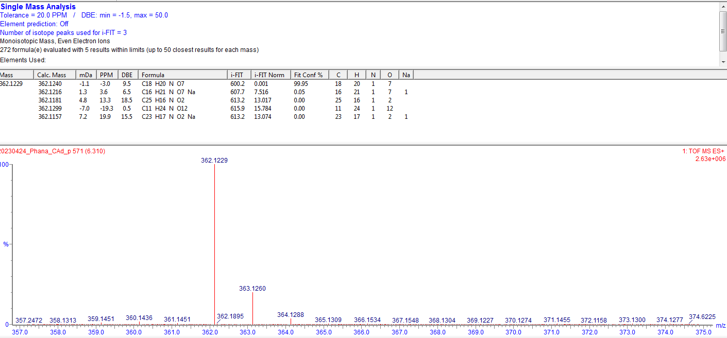
[M+H]⁺
Figure F5: Annotation for compound 5 on MassLynx
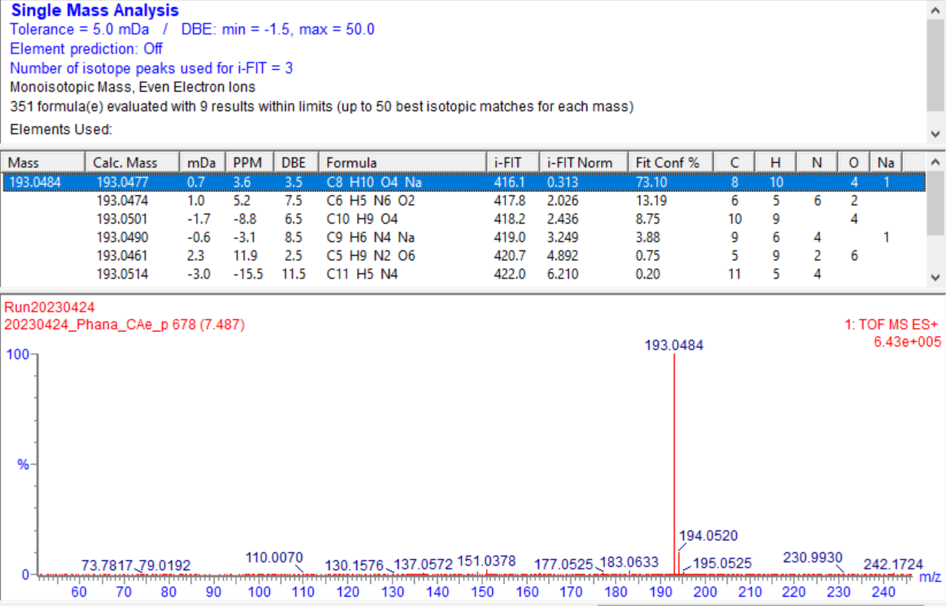
[M+H]⁺
Figure F6: Annotation for compound 6 on MassLynx

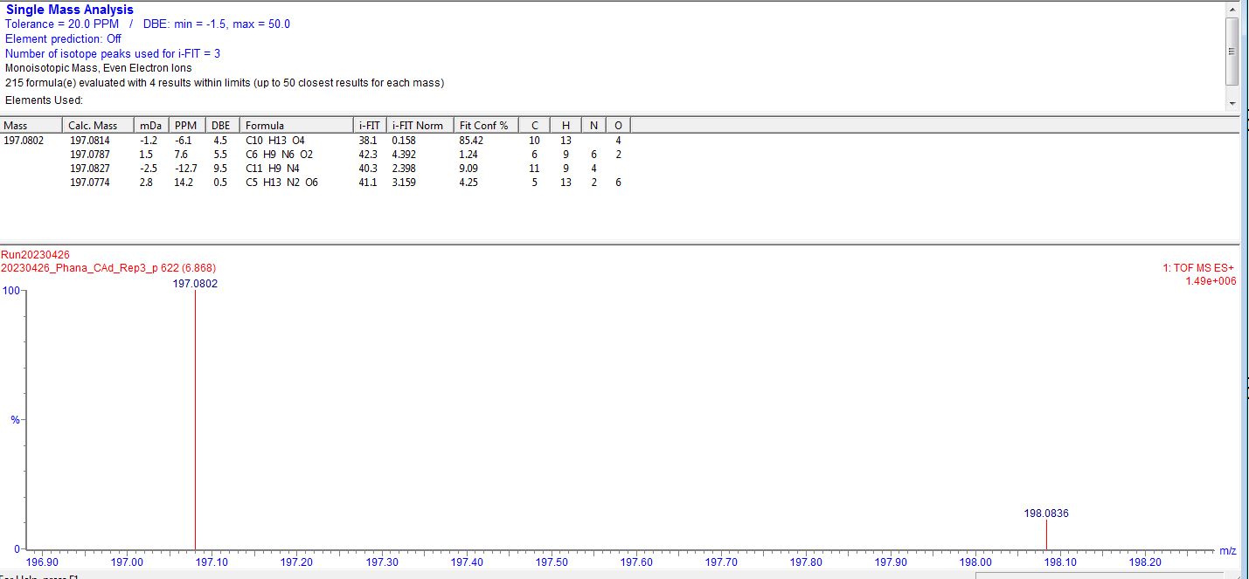
[M+H]⁺
Figure F7: Annotation for compound 7 on MassLynx
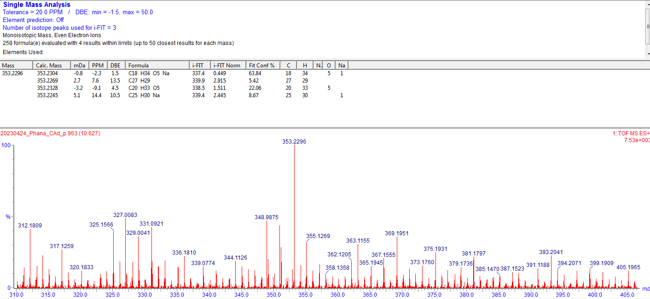
[M+H]⁺
Figure F8: Annotation for compound 8 on MassLynx

7
5
4
3
1
Compound 2
Compound 6
c
b
a
Figure F9: a) EIC (m/z 193.04) showing compound 6; b) EIC (m/z 233.07) showing compound 2; c) BPI chromatogram showing Compounds 1, 3, 4, 5 and 7.

References
1. Hutchings A: Zulu medicinal plants: An inventory. University of Natal press; 1996.
2. Semenya SS, Maroyi A: Ethnobotanical survey of plants used by Bapedi traditional healers to treat tuberculosis and its opportunistic infections in the Limpopo Province, South Africa. South African Journal of Botany 2019, 122:401-421.
3. Babajide JO, Mabusela WT, Green I, Ameer F, Weitz F, Iwuoha EI: Phytochemical screening and biological activity studies of five South African indigenous medicinal plants. 2010.
4. Amabeoku GJ: Antidiarrhoeal activity of Geranium incanum Burm. f. (Geraniaceae) leaf aqueous extract in mice. Journal of Ethnopharmacology 2009, 123:190-193.
5. Brendler T, van Wyk BE: A historical, scientific and commercial perspective on the medicinal use of Pelargonium sidoides (Geraniaceae). Journal of Ethnopharmacology 2008, 119:420-433.
6. Ramabulana A-T, Petras D, Madala NE, Tugizimana F: Metabolomics and molecular networking to characterize the chemical space of four Momordica plant species. Metabolites 2021, 11:763.
7. Muronga M, Quispe C, Tshikhudo PP, Msagati TAM, Mudau FN, Martorell M, Salehi B, Abdull Razis AF, Sunusi U, Kamal RM, Sharifi-Rad J: Three Selected Edible Crops of the Genus Momordica as Potential Sources of Phytochemicals: Biochemical, Nutritional, and Medicinal Values. Frontiers in Pharmacology 2021, 12.
8. Amoo SO, Ndhlala AR, Finnie JF, Van Staden J: Antibacterial, antifungal and anti-inflammatory properties of Burchellia bubalina. South African Journal of Botany 2009, 75:60-63.
9. Mhlongo LS, Van Wyk BE: Zulu medicinal ethnobotany: new records from the Amandawe area of KwaZulu-Natal, South Africa. South African Journal of Botany 2019, 122:266-290.
10. Rana M, Rana M, Sharma D, Chauhan P: Commonly used medicinal plants in tehsil Bangana, district una, Himachal Pradesh. Journal of Ayurvedic and Herbal Medicine 2017, 3:102-107.
11. Kambizi L: Indigenous plants for ethnoveterinary uses in the Pondoland, South Africa. In XXIX International Horticultural Congress on Horticulture: Sustaining Lives, Livelihoods and Landscapes (IHC2014): V World 11252014: 309-314.
12. Ye S, Hu J, Liu Z, Liang M: Progress and Research Trends on Catha edulis (Vahl) Endl. (Catha edulis): A Review and Bibliometric Analysis. Frontiers in Pharmacology 2021, 12.
13. Grace O, Prendergast H, Jäger A, Van Staden J, Van Wyk A: Bark medicines used in traditional healthcare in KwaZulu-Natal, South Africa: An inventory. South African Journal of Botany 2003, 69:301-363.
14. Rojas-Sandoval J: Hedychium gardnerianum (kahili ginger). 2023.
15. Wu Z, Raven P, Hong D: Flora of China; Missouri Botanical Garden Press: St. Louis, MO, USA 1994, 2013.
16. Adebayo SA, Amoo SO, Mokgehle SN, Aremu AO: Ethnomedicinal uses, biological activities, phytochemistry and conservation of African ginger (Siphonochilus aethiopicus): A commercially important and endangered medicinal plant. J Ethnopharmacol 2021, 266:113459.
17. Seile BP, Bareetseng S, Koitsiwe MT, Aremu AO: Indigenous Knowledge on the Uses, Sustainability and Conservation of African Ginger (Siphonochilus aethiopicus) among Two Communities in Mpumalanga Province, South Africa. Diversity 2022, 14:192.
18. Nsuala BN, Enslin G, Viljoen A: “Wild cannabis”: A review of the traditional use and phytochemistry of Leonotis leonurus. Journal of Ethnopharmacology 2015, 174:520-539.
19. Kamatou GPP, Makunga NP, Ramogola WPN, Viljoen AM: South African Salvia species: A review of biological activities and phytochemistry. Journal of Ethnopharmacology 2008, 119:664-672.
20. Rattray RD, Van Wyk B-E: The Botanical, Chemical and Ethnobotanical Diversity of Southern African Lamiaceae. Molecules 2021, 26:3712.
21. Ezema CA, Aguchem RN, Aham EC, Ezeorba WFC, Okagu IU, Ezeorba TPC: Salvia africana-lutea L.: a review of ethnobotany, phytochemistry, pharmacology applications and future prospects. Advances in Traditional Medicine 2023.
22. Tietjen I, Gatonye T, Ngwenya BN, Namushe A, Simonambanga S, Muzila M, Mwimanzi P, Xiao J, Fedida D, Brumme ZL, et al: Croton megalobotrys Müll Arg. and Vitex doniana (Sweet): Traditional medicinal plants in a three-step treatment regimen that inhibit in vitro replication of HIV-1. Journal of Ethnopharmacology 2016, 191:331-340.
23. Mathibela MK, Potgieter MJ, Tshikalange TE: Medicinal plants used to manage sexually transmitted infections by Bapedi traditional health practitioners in the Blouberg area, South Africa. South African Journal of Botany 2019, 122:385-390.
24. Demgne OMF, Damen F, Fankam AG, Guefack MF, Wamba BEN, Nayim P, Mbaveng AT, Bitchagno GTM, Tapondjou LA, Penlap VB, et al: Botanicals and phytochemicals from the bark of Hypericum roeperianum (Hypericaceae) had strong antibacterial activity and showed synergistic effects with antibiotics against multidrug-resistant bacteria expressing active efflux pumps. J Ethnopharmacol 2021, 277:114257.
25. Irungu BN, Orwa JA, Gruhonjic A, Fitzpatrick PA, Landberg G, Kimani F, Midiwo J, Erdélyi M, Yenesew A: Constituents of the Roots and Leaves of Ekebergia capensis and Their Potential Antiplasmodial and Cytotoxic Activities. Molecules 2014, 19:14235-14246.
26. Kumari A, Baskaran P, Van Staden J: In vitro propagation via organogenesis and embryogenesis of Cyrtanthus mackenii: a valuable threatened medicinal plant. Plant Cell, Tissue and Organ Culture (PCTOC) 2017, 131:407-415.
27. Minkah PAB, Danquah CA: Anti-infective, anti-inflammatory and antipyretic activities of the bulb extracts of Crinum jagus (J. Thomps.) Dandy (Amaryllidaceae). Scientific African 2021, 12:e00723.
28. Idu M, Erhabor JO, Efijuemue HM: Documentation on medicinal plants sold in markets in Abeokuta, Nigeria. Tropical Journal of Pharmaceutical Research 2010, 9.
29. Michael Ofori CAD, Paul Poku Sampene Ossei, Gilbrene Rahamani,, Isaac Newton Nugbemado, Peace Doe, Theophilus Kwesi Ninkyi: Antitubercular activities of Crinum asiaticum bulb extract using aeroso-linduced Mycobacterium smegmatis in mice model. Issue: 5; 2022.
30. Semenya S, Potgieter M, Tshisikhawe M: Use, conservation and present availability status of ethnomedicinal plants of Matebele-Village in the Limpopo Province, South Africa. African Journal of Biotechnology 2013, 12.
31. Khalil N, Elhady SS, Diri RM, Fekry MI, Bishr M, Salama O, El-Zalabani SM: Salicylic Acid Spraying Affects Secondary Metabolites and Radical Scavenging Capacity of Drought-Stressed Eriocephalus africanus L. Agronomy 2022, 12:2278.
32. Serabele K, Chen W, Combrinck S: Chapter 10 - Helichrysum odoratissimum. In The South African Herbal Pharmacopoeia. Edited by Viljoen A, Sandasi M, Fouche G, Combrinck S, Vermaak I: Academic Press; 2023: 247-258
33. Hien TT, White NJ: Qinhaosu. The Lancet 1993, 341:603-608.
34. Liu NQ, Van der Kooy F, Verpoorte R: Artemisia afra: A potential flagship for African medicinal plants? South African Journal of Botany 2009, 75:185-195.
35. Kizito IG, Mohammed K: Phytochemical analysis, antimicrobial and antioxidant activities of leaf extract of Vernonia tigna Klatt (Asteraceae). World 2022, 3:016-023.
36. Vonia S, Hartati R, Insanu M: In Vitro Alpha-Glucosidase Inhibitory Activity and the Isolation of Luteolin from the Flower of Gymnanthemum amygdalinum (Delile) Sch. Bip ex Walp. Molecules 2022, 27:2132.

