Figure S1: Details of repeated assessments per study participants.
Note: Except for the first measurement, the number of participants reported for the other measurement includes incident deaths occurring after the last data collection wave, as they contribute to the calculation of total life expectancy.

Table S1: Repartition of the number of person-years and participation time in the pooled sample and per cohort.
Cohorts | Total sample size analyzed (% of women) | Median age [Q1 – Q3]; in years | Statistics of participation time |  |  | Number of deaths recorded
Cohorts | Total sample size analyzed (% of women) | Median age [Q1 – Q3]; in years | Total person-years  (for women) | (Min-max); in years | Median  [Q1 – Q3]; in years | Number of deaths recorded
AMI | 978 (37%) | 76 [71 – 81] | 5,959 (2,413) | (0 – 12) | 6 [3 - 10] | 378
3C | 2,101 (61%) | 74 [71 – 78] | 20,624 (13,503) | (0 – 18) | 10 [6 – 16] | 1,241
PAQUID | 1,389 (62%) | 81 [78 – 86] | 8,795 (5,852) | (0 – 21) | 5 [2 – 10] | 1,313
Pooled sample | 4,468 (56%) | 77 [72 – 81] | 35,378 (21,768) | (0 – 21) | 7 [3 – 12] | 2,932

Table S2: Baseline characteristics of participants according to their status at the end of the study.
Baseline characteristics | Status at end of the follow-up |  |  | p-value | Effect size coefficient
 | Alive (n=382) | dropout (n=1154) | Died (n=2932)
age, median [IQR], in years | 71 [69 - 75] | 73 [69 - 77] | 79 [76 - 84] | <0.001$ | 0.23⁺
Sex Female, n(%) | 256 (67.0) | 651 (56.4) | 1613 (55.0) | <0.001 | 0.067#
Poor Self-rated Health, n(%) | 142 (37.1) | 479 (41.5) | 1519 (51.8) | <0.001 | 0.11#
Disability, n(%) | 16 (4.2) | 125 (10.8) | 1042 (35.5) | <0.001 | 0.286#
Participation time, Median  [Q1 – Q3]; in years | 17 [16 – 17] | 9 [6 – 11] | 6 [2 – 10] | <0.001$ | 0.29⁺
⁺Eta squared; #Cramer's V; $Kruskal-Wallis rank sum test.

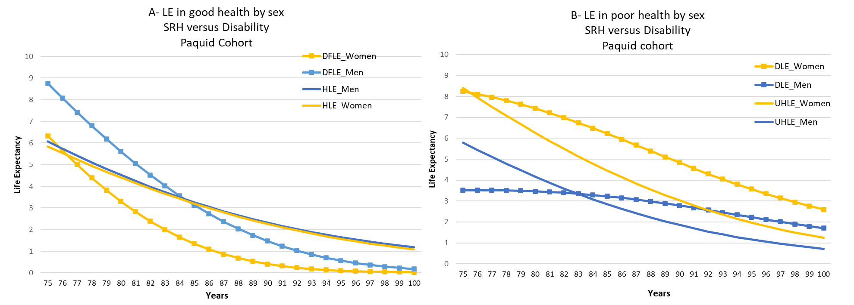
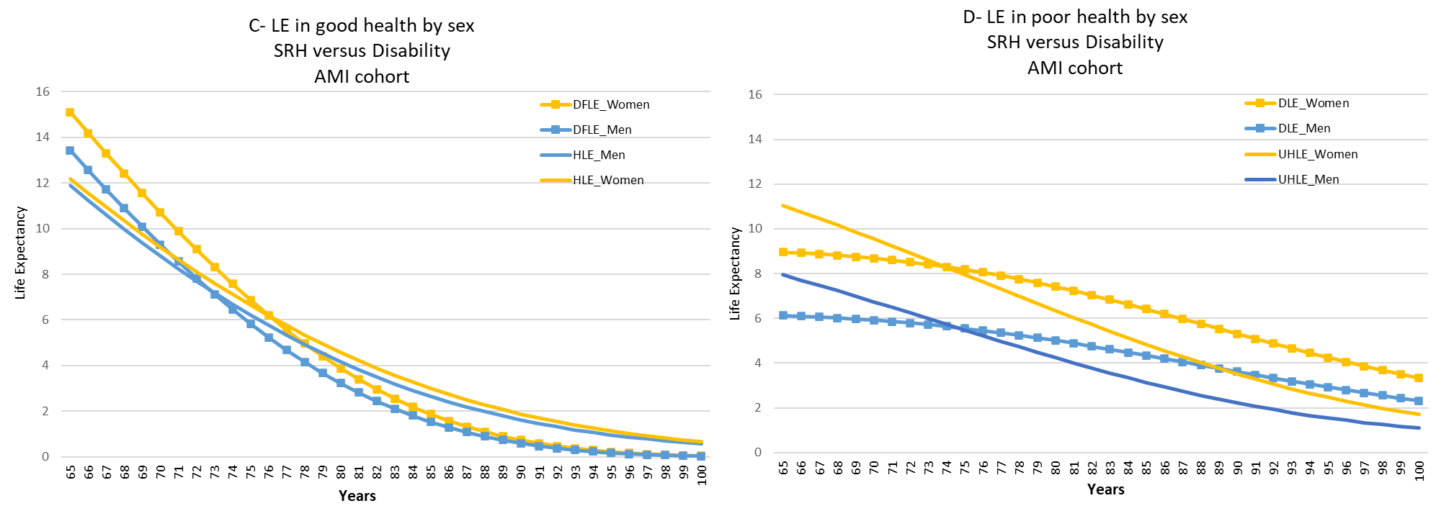
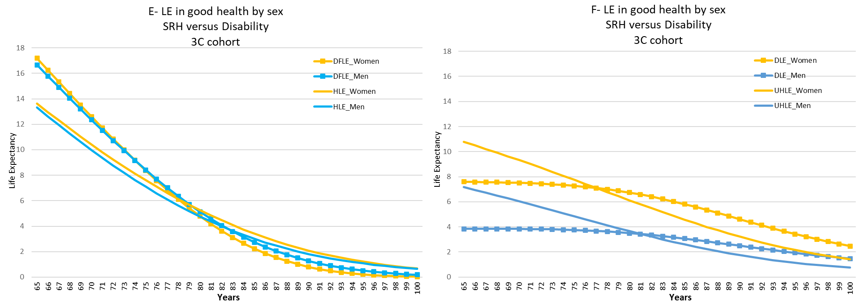

Figure S2: Age-evolution of the life expectancy in good/poor SRH and without/with disability by sex, in each study cohort.

