Supplementary
Table 1. Primer Sequence, Length and PCR conditions for the detected genes.
Sr. No | Gene | Primer Sequence | Length (bp) | PCR Conditions | Reference
1 | 16SrRNA | ATTAGATACCCTGGTAGTCCACGCC-F  CGTCATCCCCACCTTCCTCC-R | 409 | PCR was performed following these conditions: Initial denaturation 94ºC for 5 min; Denaturation 94ºC for 45 seconds; Annealing 60ºC for 45 seconds; Amplification 72ºC for 30 seconds; Final extension 72ºC for 10 minutes then resting at 22ºC and run the thermocycler for 30 cycles. | (Fang et al., 2018)
2 | LukPV | ATCATTAGGTAAAATGTCTGGACATGATCCA-F  GCATCAASTGTATTGGATAGCAAAAGC-R | 433 | Initial denaturation 95ºC for 5 min; Denaturation 95ºC for 1 min; Annealing 55ºC for 1 min; Amplification 72ºC for 1 min 30 seconds; Final extension 72ºC for 10 minutes for 30 cycles. | (Makgotlho et al., 2009)
3 | mecA | GTAGAAATGACTGAACGTCCGATAA-F  CCAATTCCACATTGTTTCGGTCTAA-R | 310 |  | (Makgotlho et al., 2009)
4 | Hla | TGCCGCAGATTCTGATATTAA-F  TTTCTGAAGAACGATCTGTCCA-R | 845 | Initial denaturation at 94º C for 5 min; 35 cycles of 94º C for 30s, 51.5º C for 30s, and 72º C for 30–90s depending on the PCR product length and a final extension at 72ºC for 7 min. | (Ote et al., 2011)
5 | Hlb | GCGGTTGTGGATTCGATAAT-F  GGCTTTGATTGGGTAATGATC-R | 524 | Initial denaturation at 94º C for 5 min; 35 cycles of 94º C for 30s, 50.9º C for 30s, and 72º C for 30–90s depending on the PCR product length and a final extension at 72ºC for 7 min. | (Ote et al., 2011)
6 | fnbA | GTGAAGTTTTAGAAGGTGGAAAGATTAG-F  GCTCTTGTAAGACCATTTTTCTTCAC-R | 643 | Initial denaturation at 94º C for 5 min; 25 cycles of 94º C for 1min, 55º C for 1min, and 72º C for 1min and a final extension at 72ºC for 10 min. | (Tristan et al., 2003)
7 | fnbB | GTAACAGCTAATGGTCGAATTGATACT-F  CAAGTTCGATAGGAGTACTATGTTC-R | 524 |  | (Tristan et al., 2003)
8 | clfA | ATTGGCGTGGCTTCAGTGCT-F  CGTTTCTTCCGTAGTTGCATTTG-R | 292 |  | (Tristan et al., 2003)
9 | clfB | ACATCAGTAATAGTAGGGGGCAAC-F  TTCGCACTGTTTGTGTTTGCAC-R | 205 |  | (Tristan et al., 2003)
10 | Cap5 | GTCAAAGATTATGTGATGCTACTGAG-F  ACTTCGAATATAAACTTGAATCAATGTTATACAG-R | 361 | Initial denaturation at 94º C for 5 min; 25 cycles of 94º C for 30s, 55º C for 30s, and 72º C for 1min and a final extension at 72ºC for 5 min. | (Verdier et al., 2007)
11 | Cap8 | GCCTTATGTTAGGTGATAAACC-F  GGAAAAACACTATCATAGCAGG-R | 173 |  | (Verdier et al., 2007)
12 | nuc | GCGATTGATGGTGATACGGTT-F  AGCCAAGCCTTGACGAACTAAAGC-R | 270 | A total of 37 PCR cycles were run under the following conditions: DNA denaturation at 94°C for 1 min, primer annealing at 55°C for 30s, and DNA extension at 72°C for 90s. After the final cycle, the reaction was terminated by keeping it at 72°C  for 3.5 min. | (Brakstad et al., 1992)
13 | α3 | R-TAAAGGCATCAATGCACAAACACT | 937 | Total of 34 PCR cycles were run under following conditions:  Initial Denaturation at 95˚C for 4 min  Denaturation at 95˚C for 1min, primer annealing at 53˚C for 1 min, extension at 72˚C for 1 min 30 sec and final extension at 72˚C for 4 min | (Boye et al. 2007)
14 | β | F-ATTGCCTTGATAATAGCCYTCT
15 | 5RmecA | F-TATACCAAACCCGACAACTAC | 359
16 | 5R431 | R-CGGCTACAGTGATAACATCC
17 | ccrC | F-CGTCTATTACAAGATGTTAAGGATAAT  R-CCTTTATAGACTGGATTATTCAAAATAT | 518
18 | 1272 | F- GCCACTCATAACATATGGAA | 415

Supplementary Figures

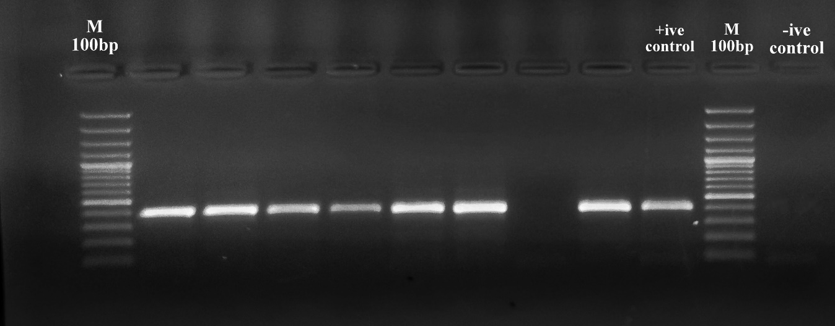
409bp
Supplementary Figure 1. PCR products of 409bp for 16SrRNA gene of S. aureus

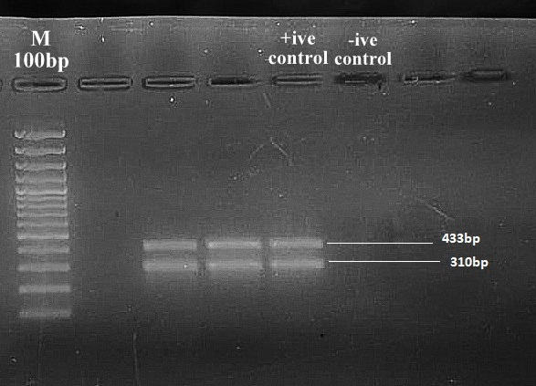
Supplementary Figure 2: PCR Products for mecA (310bp) and LukPVL (433bp) genes with 100bp gene marker.

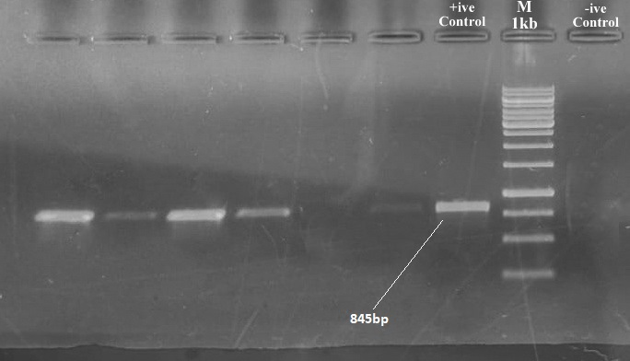
Supplementary Figure 3: PCR products for hla gene (845bp) with 1kb gene marker.

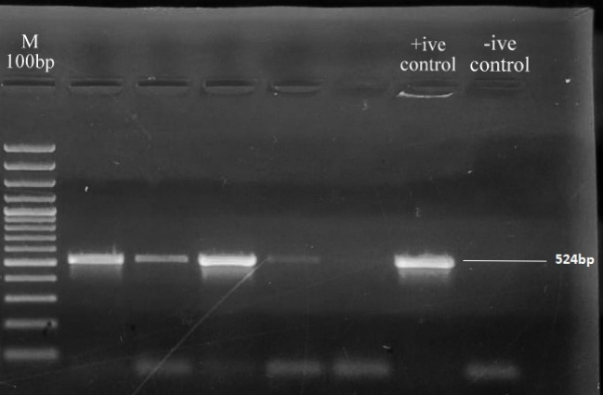
Supplementary Figure 4: PCR Product of hlb gene (524bp) with 100bp gene marker.

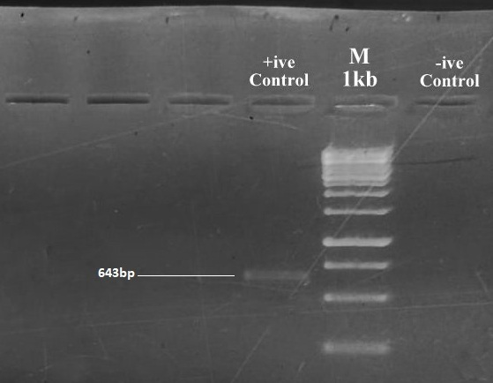
Supplementary Figure 5: PCR Product of fnbA gene (643bp) with 1kb gene marker.

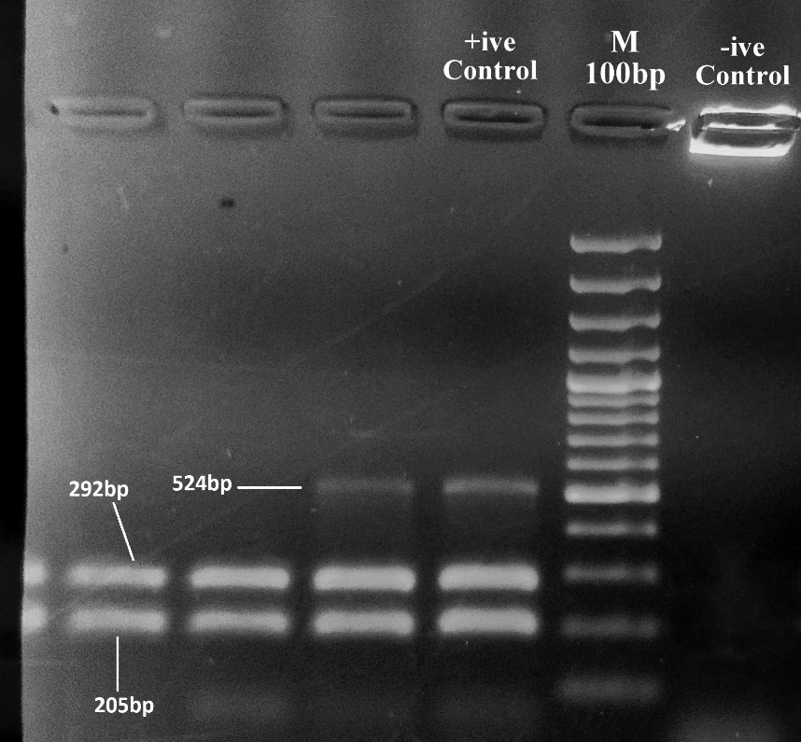
Supplementary Figure 6: PCR Product for clfB gene (205bp), clfA gene (292bp), & fnbB gene (524bp) along with 100bp gene marker.
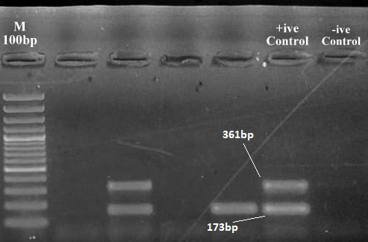
Supplementary Figure 7: PCR Products for Cap8 gene (173bp) & Cap5 gene (361bp) along with 100bp gene marker.

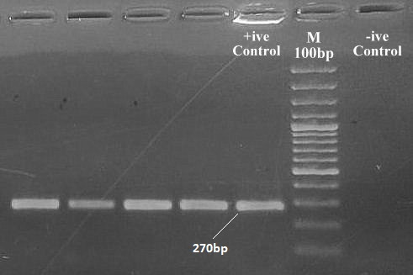
Supplementary Figure 8: PCR Product for nuc gene (270bp) along with 100bp gene marker.

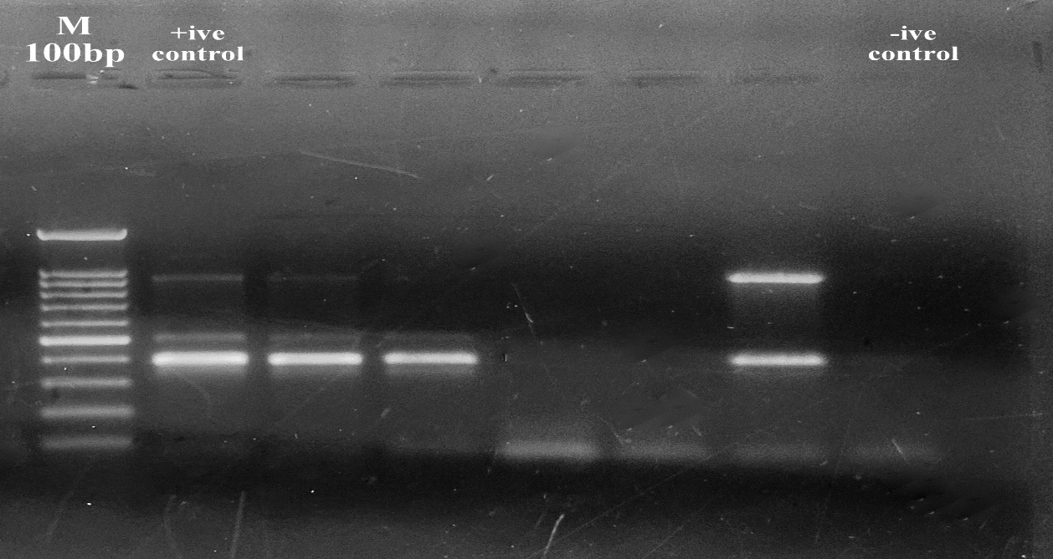
Supplementary Figure 9: SCCmec typing of MRSA obtained from livestock sources

