Supplementary Table 1. Summary of balance for matched data

 | Pre-COVID-19 means | During COVID-19 means | Std. mean difference | Variance ratio | eCDF mean | eCDF max | Std. Pair distance
Distance | 0.61 | 0.61 | 0.00 | 1.00 | 0.00 | 0.00 | 0.00
Age | 73.57 | 73.49 | 0.01 | 1.03 | 0.01 | 0.02 | 0.48
Gender | 0.17 | 0.16 | 0.02 | . | 0.01 | 0.01 | 0.40
Education level | 2.43 | 2.39 | 0.03 | 1.05 | 0.01 | 0.02 | 0.35
Mobility | 1.31 | 1.29 | 0.02 | 1.11 | 0.00 | 0.01 | 0.50
Low-income | 0.21 | 0.19 | 0.04 | . | 0.02 | 0.02 | 0.39
Living alone | 0.44 | 0.44 | 0.01 | . | 0.00 | 0.00 | 0.30
Marital status | 2.33 | 2.24 | 0.05 | 1.08 | 0.02 | 0.03 | 0.59
eCDF: empirical cumulative distribution functions; Std: standardized

Supplementary Table 2. Means, standard deviations, t test, p value, and Cohen’s d in matched pre-COVID-19 (N=2549) and during COVID-19 (N=3506) groups

 | Pre-COVID-19 | During COVID-19 | Comparison
Network items | Mean (SD) | Mean (SD) | p | Cohen’s d
PHQ-9_1 (D1) | 1.14 (0.93) | 1.51 (0.85) | <0.001 | 0.42
PHQ-9_2 (D2) | 1.38 (0.86) | 1.61 (0.76) | <0.001 | 0.28
PHQ-9_3 (D3) | 1.68 (0.97) | 1.82 (0.92) | <0.001 | 0.15
PHQ-9_4 (D4) | 1.47 (0.88) | 1.57 (0.83) | <0.001 | 0.12
PHQ-9_5 (D5) | 0.34 (0.69) | 0.73 (0.84) | <0.001 | 0.51
PHQ-9_6 (D6) | 0.69 (0.88) | 1.00 (0.9) | <0.001 | 0.35
PHQ-9_7 (D7) | 0.84 (0.8) | 1.08 (0.83) | <0.001 | 0.29
PHQ-9_8 (D8) | 0.33 (0.62) | 0.63 (0.78) | <0.001 | 0.43
PHQ-9_9 (D9) | 0.29 (0.59) | 0.36 (0.65) | <0.001 | 0.11
PHQ-9 item average | 0.91 (0.80) | 1.15 (0.82) | <0.001 | 0.30
GAD-7_1 (A1) | 0.93 (0.88) | 1.29 (0.84) | <0.001 | 0.42
GAD-7_2 (A2) | 0.89 (0.87) | 1.17 (0.87) | <0.001 | 0.32
GAD-7_3 (A3) | 0.81 (0.84) | 1.06 (0.88) | <0.001 | 0.29
GAD-7_4 (A4) | 0.81 (0.89) | 1.25 (0.87) | <0.001 | 0.50
GAD-7_5 (A5) | 0.69 (0.82) | 1.03 (0.84) | <0.001 | 0.41
GAD-7_6 (A6) | 0.87 (0.85) | 1.03 (0.84) | <0.001 | 0.19
GAD-7_7 (A7) | 0.60 (0.81) | 0.80 (0.86) | <0.001 | 0.24
GAD-7 item average | 0.80 (0.85) | 1.09 (0.86) | <0.001 | 0.34
UCLA-3_1 (L1) | 1.49 (1.08) | 1.69 (0.92) | <0.001 | 0.20
UCLA-3_2 (L2) | 1.35 (1.06) | 1.43 (0.96) | 0.002 | 0.08
UCLA-3_3 (L3) | 1.69 (1.10) | 1.78 (0.90) | <0.001 | 0.09
UCLA-3 item average | 1.51 (1.08) | 1.63 (0.93) | <0.001 | 0.12
GAD-7: the Generalized Anxiety Disorder 7-item scale; PHQ-9: the Patient Health Questionnaire-9 item scale; SD: standard deviation; UCLA-3: Three-Item Loneliness Scale.

Supplementary Table 3. Adjacency matrix – left lower panel (pre-COVID-19), right upper panel (during COVID-19)
 | D1 | D2 | D3 | D4 | D5 | D6 | D7 | D8 | D9 | A1 | A2 | A3 | A4 | A5 | A6 | A7 | L1 | L2 | L3
D1 | - | 0.264 | 0.000 | 0.101 | 0.068 | 0.049 | 0.019 | 0.000 | 0.063 | 0.020 | 0.000 | 0.011 | 0.000 | 0.052 | 0.000 | 0.000 | 0.059 | 0.000 | 0.000
D2 | 0.219 | - | 0.044 | 0.084 | 0.058 | 0.084 | 0.059 | 0.000 | 0.131 | 0.074 | 0.061 | 0.000 | 0.032 | 0.005 | 0.031 | 0.000 | 0.000 | 0.044 | 0.018
D3 | -0.06 | 0.000 | - | 0.139 | 0.000 | -0.04 | 0.007 | -0.03 | 0.000 | 0.026 | 0.000 | 0.000 | 0.031 | 0.000 | 0.011 | 0.013 | 0.000 | -0.02 | 0.000
D4 | 0.068 | -0.04 | 0.144 | - | 0.100 | 0.000 | 0.075 | 0.000 | 0.010 | 0.017 | 0.000 | 0.000 | 0.044 | 0.042 | 0.005 | 0.034 | 0.000 | 0.000 | 0.007
D5 | 0.028 | 0.000 | 0.000 | 0.039 | - | 0.046 | 0.058 | 0.086 | 0.022 | 0.000 | 0.000 | 0.017 | 0.000 | 0.071 | 0.000 | 0.000 | 0.000 | 0.000 | -0.01
D6 | 0.086 | 0.070 | 0.015 | 0.000 | 0.086 | - | 0.028 | 0.115 | 0.154 | 0.000 | 0.000 | 0.009 | 0.000 | 0.058 | 0.040 | 0.067 | 0.000 | 0.000 | 0.041
D7 | 0.000 | 0.000 | -0.06 | 0.000 | 0.013 | 0.000 | - | 0.154 | 0.000 | 0.017 | 0.001 | 0.068 | 0.032 | 0.008 | 0.015 | 0.020 | 0.000 | 0.047 | 0.010
D8 | -0.01 | -0.01 | -0.03 | 0.012 | 0.025 | 0.026 | 0.000 | - | 0.035 | 0.000 | 0.000 | 0.000 | 0.000 | 0.097 | 0.000 | 0.054 | 0.000 | -0.01 | 0.000
D9 | 0.032 | 0.074 | 0.000 | 0.000 | 0.095 | 0.206 | 0.000 | 0.078 | - | 0.000 | 0.002 | 0.000 | 0.021 | 0.000 | 0.066 | 0.049 | 0.005 | 0.000 | 0.088
A1 | 0.041 | 0.045 | 0.009 | 0.016 | 0.011 | 0.000 | 0.000 | 0.000 | 0.032 | - | 0.187 | 0.070 | 0.172 | 0.155 | 0.193 | 0.028 | 0.000 | 0.000 | 0.000
A2 | 0.000 | 0.041 | 0.000 | 0.000 | 0.000 | 0.000 | 0.005 | 0.000 | 0.000 | 0.147 | - | 0.429 | 0.123 | 0.061 | 0.000 | 0.104 | 0.013 | 0.026 | 0.016
A3 | 0.000 | 0.067 | 0.000 | 0.000 | 0.000 | 0.000 | 0.045 | -0.03 | 0.000 | 0.042 | 0.503 | - | 0.131 | 0.016 | 0.039 | 0.162 | 0.012 | 0.034 | 0.000
A4 | 0.000 | 0.055 | 0.000 | 0.000 | 0.012 | 0.023 | 0.042 | 0.000 | 0.004 | 0.183 | 0.127 | 0.141 | - | 0.241 | 0.123 | 0.034 | 0.010 | 0.013 | 0.006
A5 | 0.006 | 0.000 | 0.014 | 0.058 | 0.011 | 0.043 | 0.000 | 0.158 | 0.036 | 0.077 | 0.068 | 0.052 | 0.211 | - | 0.186 | 0.201 | 0.031 | 0.000 | 0.000
A6 | 0.000 | 0.087 | 0.000 | 0.000 | 0.000 | 0.000 | 0.004 | 0.000 | 0.006 | 0.272 | 0.032 | 0.037 | 0.138 | 0.222 | - | 0.079 | 0.000 | 0.038 | 0.013
A7 | 0.000 | -0.01 | 0.000 | 0.005 | 0.024 | 0.126 | 0.000 | 0.054 | 0.044 | 0.114 | 0.055 | 0.071 | 0.066 | 0.241 | 0.019 | - | 0.002 | 0.000 | 0.041
L1 | 0.049 | 0.034 | 0.00 | 0.000 | 0.007 | 0.000 | 0.000 | 0.000 | 0.000 | 0.000 | 0.000 | 0.000 | 0.000 | 0.000 | 0.000 | 0.000 | - | 0.265 | 0.469
L2 | 0.000 | 0.000 | 0.000 | -0.01 | 0.000 | 0.000 | 0.035 | 0.000 | 0.000 | 0.000 | 0.028 | 0.075 | 0.000 | 0.007 | 0.024 | 0.000 | 0.424 | - | 0.217
L3 | 0.045 | 0.075 | 0.000 | 0.000 | 0.000 | 0.000 | 0.000 | 0.000 | 0.050 | 0.017 | 0.000 | 0.000 | 0.000 | 0.039 | 0.000 | 0.000 | 0.440 | 0.282 | -
A: Anxiety symptoms, items from the Generalized Anxiety Disorder-7 item scale; D: Depression symptoms, items from the Patient Health Questionnaire-9 item scale; L: Loneliness, items from the UCLA-3 item loneliness scale.

Supplementary Table 4. Summary of significant edge differences between pre-COVID-19 network and during COVID-19 network after Bonferroni-Holm correction

Edges | Pre-COVID-19 | During COVID-19 | Absolute difference | p
D1 – D3 | -0.060 | 0.000 | -0.060 | <.001
D2 – D3 | 0.000 | 0.044 | 0.044 | .013
D2 – D4 | -0.040 | 0.084 | 0.124 | <.001
D3 – D6 | 0.015 | -0.039 | 0.054 | <.001
D3 – D7 | -0.056 | 0.007 | 0.062 | <.001
D4 – D7 | 0.000 | 0.075 | 0.075 | <.001
D6 – D8 | 0.026 | 0.115 | 0.089 | <.001
D7 – D8 | 0.000 | 0.154 | 0.154 | <.001
D5 – D9 | 0.095 | 0.022 | 0.072 | .045
D2 – A3 | 0.067 | 0.000 | 0.067 | .024
D4 – A4 | 0.000 | 0.044 | 0.044 | <.001
D8 – A5 | 0.158 | 0.097 | 0.061 | .045
A1 – A6 | 0.272 | 0.193 | 0.079 | .04
A1 – A7 | 0.114 | 0.028 | 0.086 | .03
A3 – A7 | 0.071 | 0.162 | 0.092 | .013
L1 – L2 | 0.424 | 0.265 | 0.160 | <.001
D1 – L3 | 0.045 | 0.000 | 0.045 | .04
D6 – L3 | 0.000 | 0.040 | 0.040 | .01
A7 – L3 | 0.000 | 0.041 | 0.041 | <.001
A: Anxiety symptoms, items from the Generalized Anxiety Disorder-7 item scale; D: Depression symptoms, items from the Patient Health Questionnaire-9 item scale; L: Loneliness, items from the UCLA-3 item loneliness scale.

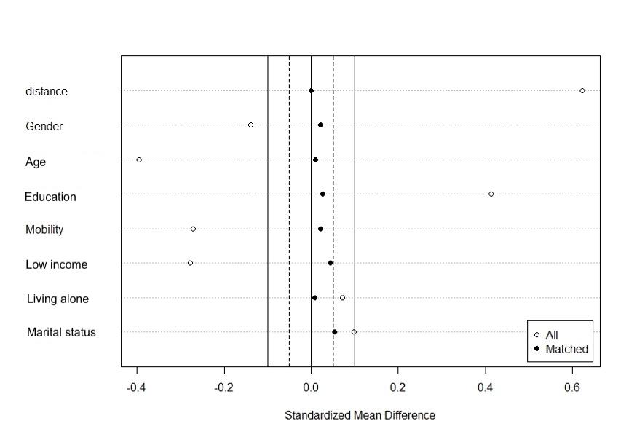
Supplementary Figure 1. Standardized bias (%) across covariates in the propensity score before and after matching.

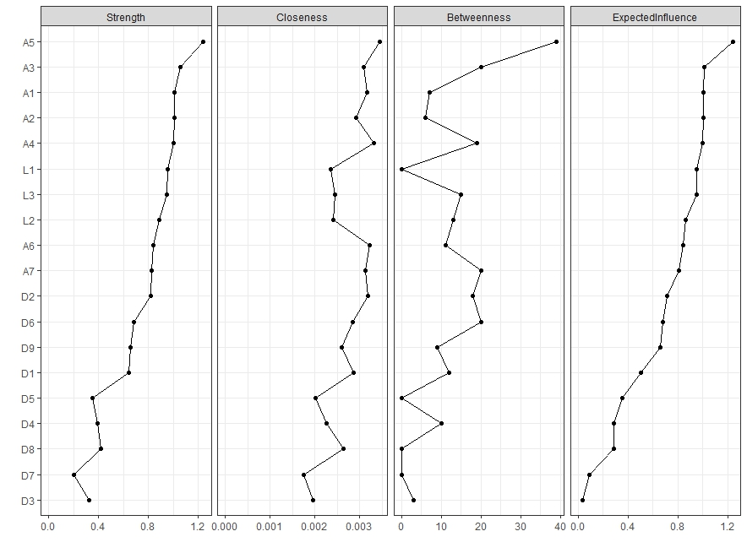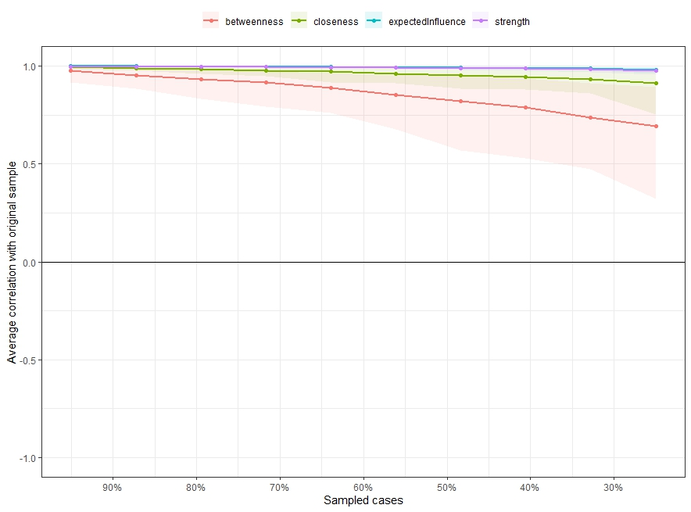
a)
b)
Supplementary Figure 2a) Centrality measure (Strength, Betweenness, Closeness) of all items within the network before COVID-19 (z-scores). b) Stability of centrality indices by case dropping subset bootstrap. The x-axis represents the percentage of cases of the original sample used at each step. The y-axis represents the average of correlations between the centrality indices from the original network and the centrality indices from the networks that were re-estimated after excluding increasing percentages of cases. Each line indicates the correlations among betweenness, closeness, strength, and expected influence.

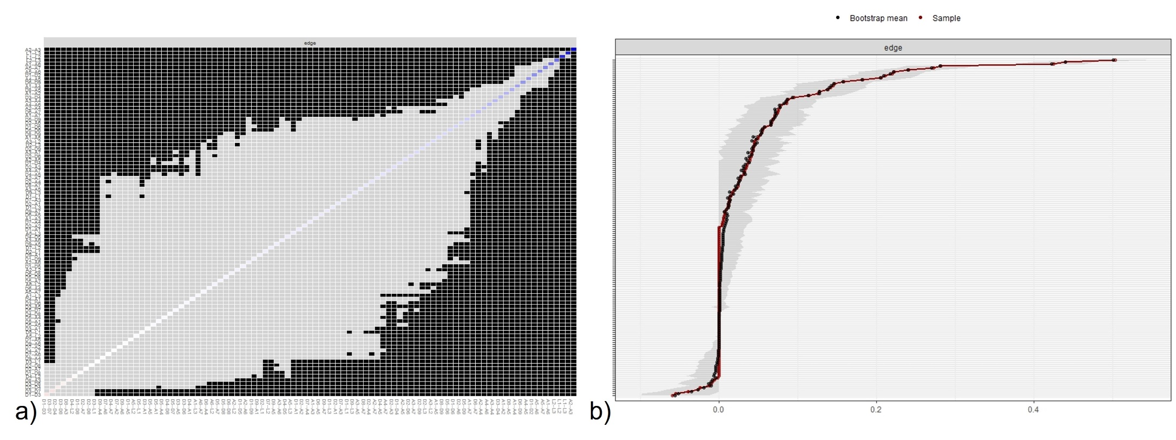
Supplementary Figure 3a) Nonparametric bootstrapped difference test for edges in networks of before COVID-19 sample. Gray boxes indicate no significant difference, whereas black boxes indicate a statistically significant difference (p < 0.05). Diagonal color and saturation represent the magnitude and direction of each estimated edge. b) Bootstrapped confidence intervals of edge weights in the before COVID-19 sample. The black dots indicate the values of each edge weight, ordered from the highest to the lowest value. The gray area represents the 95% Confidence
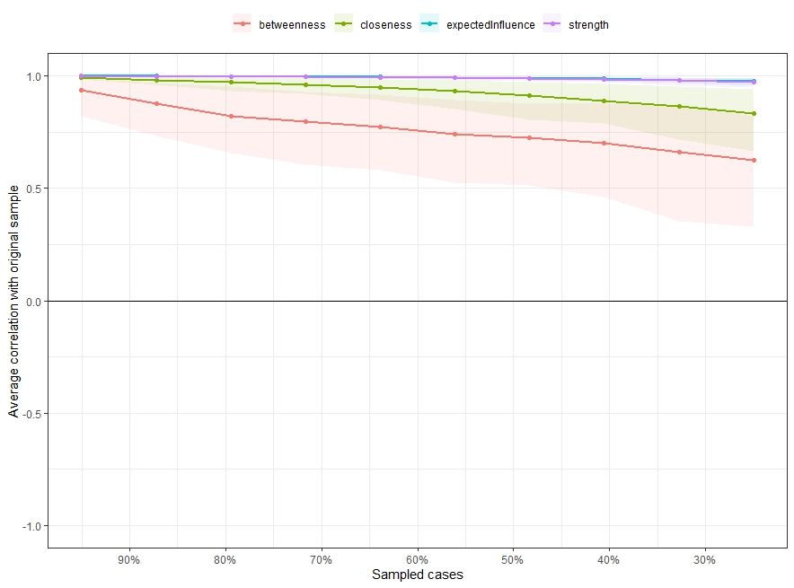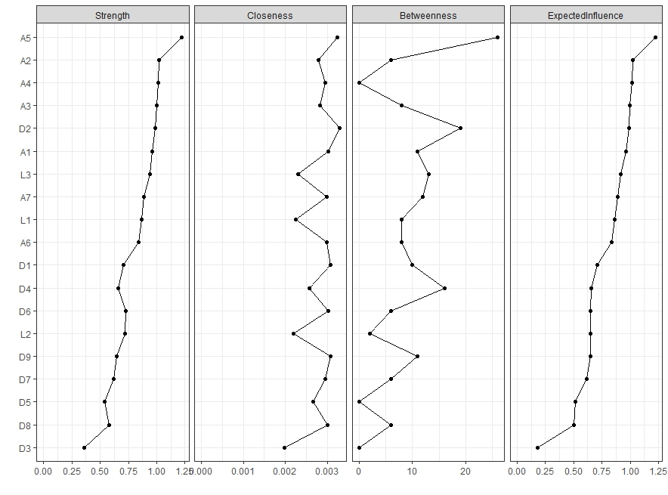Supplementary Figure 4a) Centrality measure (Strength, Betweenness, Closeness) of all items within the network during COVID-19 (z-scores). b) Stability of centrality indices by case dropping subset bootstrap. The x-axis represents the percentage of cases of the original sample used at each step. The y-axis represents the average of correlations between the centrality indices from the original network and the centrality indices from the networks that were re-estimated after excluding increasing percentages of cases. Each line indicates the correlations among betweenness, closeness, strength, and expected influence.
a)
b)

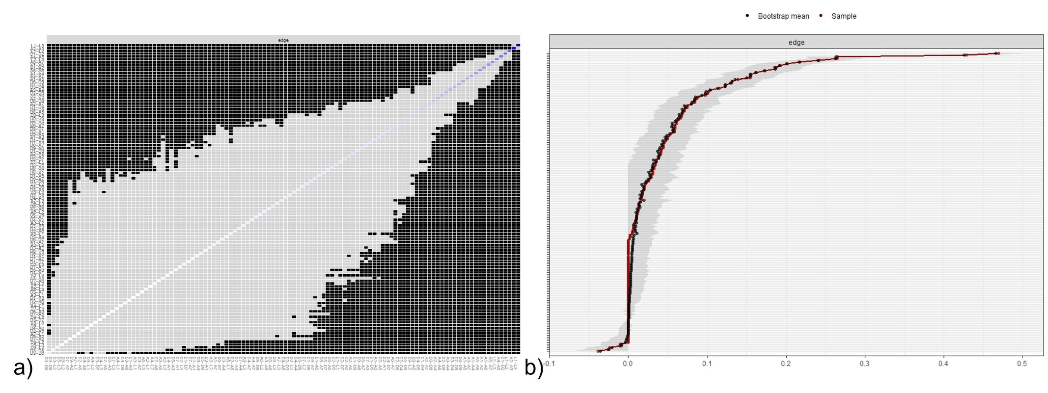

Supplementary Figure 5a) Nonparametric bootstrapped difference test for edges in networks of before COVID-19 sample. Gray boxes indicate no significant difference, whereas black boxes indicate a statistically significant difference (p < 0.05). Diagonal color and saturation represent the magnitude and direction of each estimated edge. b) Bootstrapped confidence intervals of edge weights in the before COVID-19 sample. The black dots indicate the values of each edge weight, ordered from the highest to the lowest value. The gray area represents the 95% Confidence Intervals of edge weights, estimated with the non-parametric bootstrap procedure. Wide intervals indicate lower stability, and narrow intervals indicate higher stability.

