Supporting information
S1 figure: Plasma volume does not correlate with cfDNA concentration
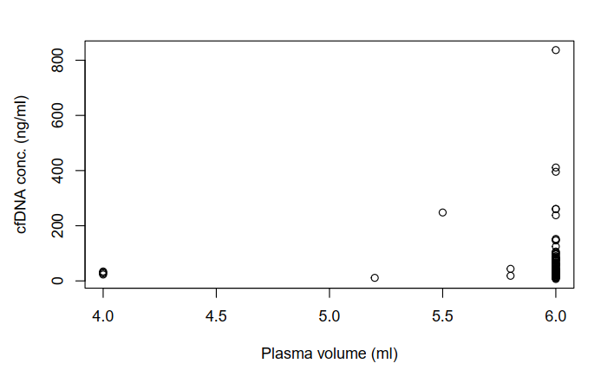

S2 figure: The median depth of coverage is not correlated with input cfDNA
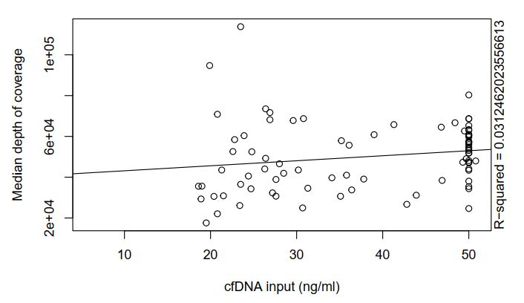

S3 Figure: Tumor staging
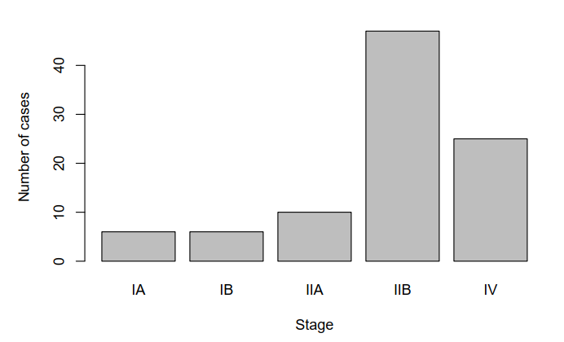

S4 Figure: Relationship of overall cfDNA to tumor stage

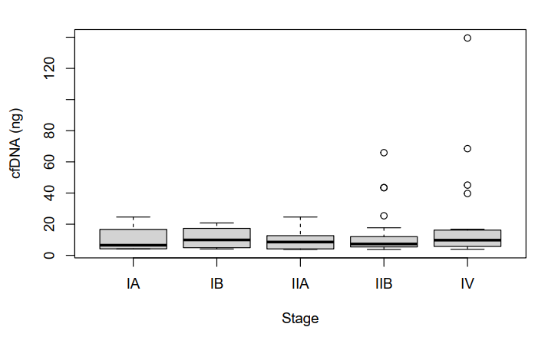

S1 Table: Tissue and ctDNA concordance
Case | Tumor KRAS | Tumor TP53 | ctDNA KRAS | ctDNA TP53
1293 | KRAS G12V, V8L | TP53 G244S | KRAS G12V | Not detected
1157 | KRAS G12V | Not detected | KRAS G12V | Not detected
1082 | KRAS G12R | Not detected | KRAS G12R | Not detected
1185 | KRAS G12D | Not detected | KRAS G12D | Not detected
1210 | Not detected | Not detected | Not detected | TP53 Y220C
1033 | KRAS G12D | Not detected | Not detected | TP53 G245C
1104 | KRAS G12D | TP53 L264fs | Not detected | Not detected
0782 | KRAS G12D | Not detected | Not detected | Not detected
1229 | KRAS G12R | TP53 R175H | Not detected | Not detected
0718 | KRAS G12D | Not detected | Not detected | Not detected
0810 | KRAS G12D | TP53 I195T | Not detected | Not detected
1304 | KRAS G12D | TP53 R175H | Not detected | Not detected
1239 | KRAS G12D | Not detected | Not detected | Not detected
1121 | KRAS G12D | Not detected | Not detected | Not detected
1259 | KRAS G12V | TP53 R248W | Not detected | Not detected
1286 | KRAS G12D | TP53 del29 E285fs | Not detected | Not detected
1294 | KRAS Q61H | TP53 V157F | Not detected | Not detected
1065 | KRAS G12R | Not detected | Not detected | Not detected

S2 Table: Neo-adjuvant status and ctDNA detection
 | Neo-adjuvant | No neo-adjuvant | Unknown
ctDNA mutation detected | 6 | 19 | 0
Mutation not detected | 23 | 46 | 2
Total | 29 | 65 | 2

