SUPPLEMENTARY MATERIAL
-
OBSERVATIONAL THREAT LEARNING INFLUENCES COSTLY AVOIDANCE BEHAVIOUR IN HEALTHY HUMANS

Madeleine Mueller¹, Oded Cohen², Tomer Shechner² & Jan Haaker^{1,*}

[1] University Medical Center Hamburg-Eppendorf (Germany), Department of Systems Neuroscience
[2] School of Psychological Sciences and the Integrated Brain and Behavior Research Center, University of Haifa, Israel

*Corresponding author: Jan Haaker; Martinistr.52, 20251 Hamburg, Germany; j.haaker@uke.de; phone: +49 (0) 40 7410 – 27300; Fax: +49 (0) 40 7410-59955

Material & Methods

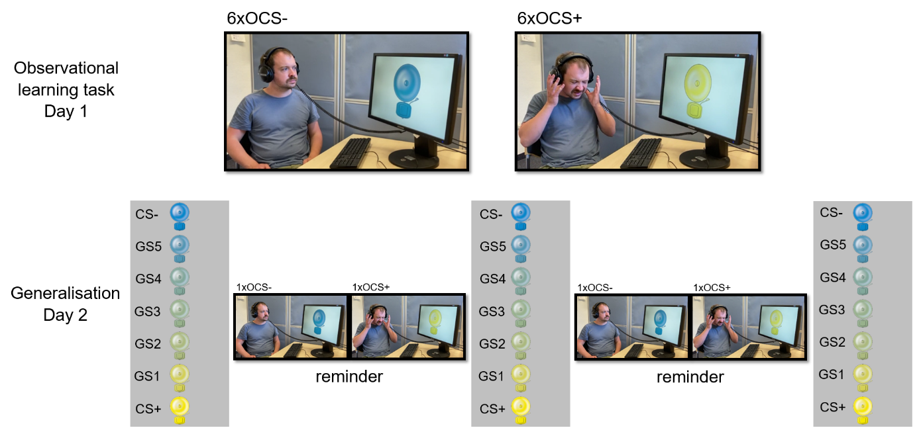
Supplementary Figure S1: Experimental procedure observational learning task and generalisation task.

Results
Supplementary Table S1: ANOVA results of fear, discomfort and physical arousal rating in observational learning task on day 1. Based on linear mixed model.
Observational learning task D1 | F | Df | p | Post-hoc test of interaction (corrected) | Post-hoc test of interaction (corrected)
FEAR RATING |  |  |  | CS+ - CS-, pre | CS+ - CS-, post
Stimulus | 0.0227 | 1,267 | 0.8804
Time | 1.1405 | 1,267 | 0.2865
Stimulus*time | 24.0361 | 1,267 | <0.001 | t(267)=0.151,p=0.880 | t(267)=7.084,p<0.001
DISCOMFORT RATING
Stimulus | 0.0552 | 1,267 | 0.8144
Time | 18.4500 | 1,267 | <0.001
Stimulus*time | 27.6412 | 1,267 | <0.001 | t(267)=-0.235,p=0.814 | t(267)=7.200,p<0.001
PHYS. AROUSAL RATING
Stimulus | 0.3128 | 1,267 | 0.5764
Time | 1.4327 | 1,267 | 0.2324
Stimulus*time | 21.1139 | 1,267 | <0.001 | t(267)=0.559,p=0.576 | t(267)=7.058,p<0.001

Main effect of trial in steps analysis
We included CS door decision (2 levels: CS+ door/CS- door), the trial (20 levels: 1-20) and the pathlength (2 levels: long path/short path) into the model (steps~(1|subject) + CSdoor*pathlength+trial) and found a main effect of trial (F(19,1608.20)= 16.672, p<0.001) (Supplementary Figure S2).

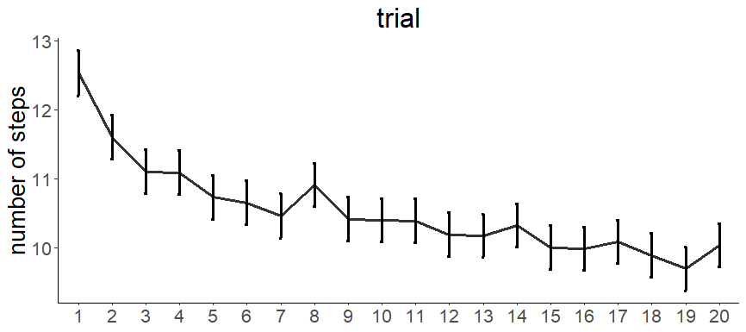
Supplementary Figure S2: Main effect of trial in the steps analysis shows that the number of steps is decreasing over time likely due to decrease in effort willing to take after several repetitions.

Supplementary Table S2: Results of ANOVA Type 3, based on the linear mixed model. Only effects with p<0.1 are shown. Dependent variable is number of steps (steps~(1|subject)+CSdoor*pathlength+trial).
 | F | Df | p
CS door decision | 118.632 | 1,1635.06 | <0.001
pathlength | 126.564 | 1,1614.40 | <0.001
trial | 16.672 | 19,1608.20 | <0.001
CS door decision * pathlength | 24.588 | 1,1618.77 | <0.001
Post-hoc tests of the interaction:
CS+,short – CS-,short | t(1635) = -10.892, p_{corr} < 0.001
CS+,short – CS+,long | t(1614) = -11.250, p_{corr} < 0.001
CS-,short – CS-,long | t(1614) = -4.057, p_{corr} = 0.001
CS+,long – CS-,long | t(1634) = -4.650, p_{corr} < 0.001

Supplementary Table S3: Results of ANOVA Type 3, based on the linear mixed model. Only effects with p<0.1 are shown. Dependent variable is number of steps. Differential ratings are included in the model. Only results that included rating effects are shown.
Model: lmer(steps~(1|subject)+ratingdifference*CS*pathlength+trial)
 | F | Df | p
Discomfort, post D2
Rating*CS | 4.0176 | 1,1628.70 | 0.04519
Rating*CS*pathlength | 3.9566 | 1,1615.89 | 0.04686
Fear, post D2
Rating*CS | 2.9737 | 1,1625.63 | 0.08482
Rating*CS*pathlength | 3.0746 | 1,1614.08 | 0.07972
Physical Arousal, pre D1
Rating*CS*pathlength | 2.9676 | 1,1617.95 | 0.08514
Physical Arousal, post D2
Rating*CS | 4.3780 | 1,1630.88 | 0.03656
Rating*CS*pathlength | 4.0594 | 1,1615.63 | 0.04409

Supplementary Table S4: Results of ANOVA Type 3, based on the linear mixed model. Only effects with p<0.1 are shown. Dependent variable is the reaction time per step before or after door decision (lmer(reactiontime~(1|subject)+Csdoor*pathlength+steps+trial).
RT PRE DOOR DECISION | F | Df,Dfres | p
trial | 26.4817 | 1,8784.4 | <0.001
steps | 33.8796 | 19,8733.3 | <0.001
RT POST DOOR DECISION
trial | 168.1539 | 1,7237.9 | <0.001
steps | 20.9536 | 19,7347.5 | <0.001

Supplementary Table S5: Results of ANOVA Type 3, based on the linear mixed model. Only effects with p<0.1 are shown. Dependent variable is the wallfactor, i.e. how close to the wall subjects moved. (lmer(wallfactor~(1|subject)+CS *pathlength+trial).
 | F | Df,Dfres | p
CS | 70.1281 | 1, 1654.93 | <0.001
Pathlength | 33.4875 | 1, 1623.36 | <0.001
Block | 5.4230 | 19,1613.31 | <0.001
CS*pathlength | 7.1402 | 1,1630.46 | 0.007612

