Biostimulant and antagonistic potential of entomopathogenic and endophytic fungi against fusarium wilt pathogen of tomato Fusarium oxysporum f. sp. lycopersici

Marie Cecile Muhorakeye^{1,2,3}, Everlyne Samita Namikoye², Fathiya M. Khamis¹, Waceke Wanjohi², Komivi S. Akutse^{1,4*}

¹International Centre of Insect Physiology and Ecology (icipe), P.O. Box 30772-00100, Nairobi, Kenya.
²Kenyatta University, Department of Agricultural Science and Technology, P.O. Box 43844-00100, Nairobi, Kenya.
³Rwanda Polytechnic, Integrated Polytechnic Regional College (IPRC) Musanze, P.O. Box 226 Musanze, Rwanda
⁴Unit of Environmental Sciences and Management, North-West University, Private Bag X6001, Potchefstroom 2520, South Africa.
*Corresponding author: kakutse@icipe.org

Supplementary Figures

Figure S1. Morphological identification of Fusarium oxysporum lycopersici (FOL). Images A and B show the upper and basal surfaces of the FOL colony on the PDA medium, respectively.

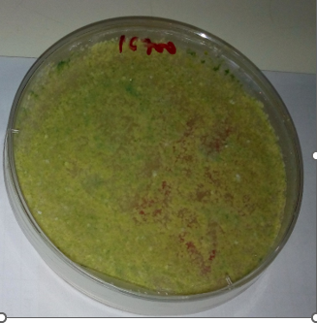 |  | 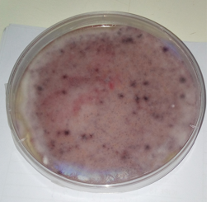 | 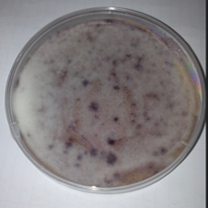
Co-culture of T. asperellum M2RT4 and FOL at 7th day of co-culture assay | Co-culture of T. asperellum M2RT4 and FOL at 14th day of co-culture assay | Co-culture of FOL and B. bassiana ICIPE 273 at 7th day of co-culture assay | Co-culture of FOL and B. bassiana ICIPE 273 at 14th day of co-culture assay
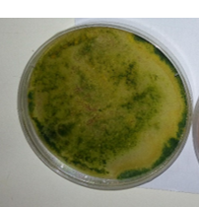 | 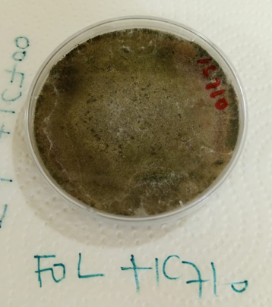 | 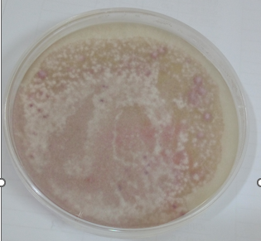 | 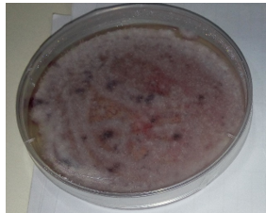
Co-culture of T. atroviride ICIPE710 and FOL at 7th day of co-culture assay | Co-culture of T. harzianum KF2R41 and FOL at 14th day of co-culture assay | Co-culture of FOL and M. anisopliae ICIPE 20 at 7th day of co-culture assay | Co-culture of FOL and M. anisopliae ICIPE 20  at 14th day of co-culture assay
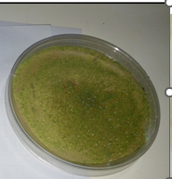 | 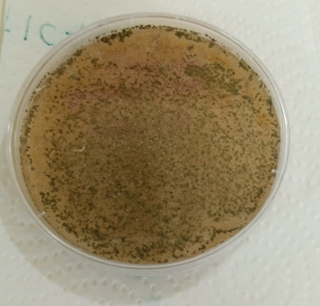 | 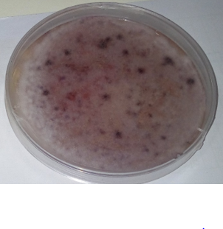 | 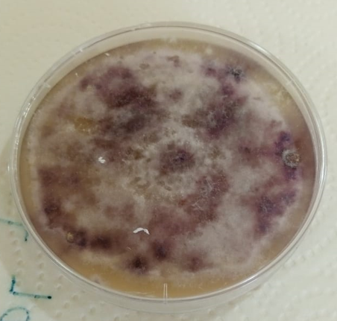
Co-culture of T. harzianum KF2R41 and FOL at 7th day of co-culture assay | Co-culture of T. harzianum KF2R41 and FOL at 14th day of co-culture assay | Sole culture of FOL (control) at 7th day of co-culture assay | Sole culture of FOL (control) at 14th day of co-culture assay

Figure S2. Morphological observation of dominance in mycelia and pigment produced by the selected fungal endophytes and entomopathogens on the 7th day and 14th day of the co-culture

Figure S3. Area Under Disease Progress Curve (AUDPC) for the Fusarium oxysporum lycopersici infected tomato plants pre-treated with the selected endophytes and the control treatment (CT).

