Synthesis, Biological Evaluation, Molecular Docking, and MD Simulation of Novel 2,4-Disubstituted Quinazoline Derivatives as Selective Butyrylcholinesterase Inhibitors and Antioxidant Agents
Sara Sadeghian^{a1}, Raziyeh Razmi^{a1}, Soghra Khabnadideh ^{a,b}, Mehdi Khoshneviszadehª, Pegah Mardaneh ^{a,c}, Arman Talashanª, Arman Piroutiª, Fatemeh Khebre ª, Zahra Zahmatkeshª, Zahra Rezaei^{a,b} ∗

ª Department of Medicinal Chemistry, School of Pharmacy, Shiraz University of Medical Sciences, Shiraz, Iran.
^{b} Pharmaceutical Sciences Research Center, Shiraz University of Medical Sciences, Shiraz, Iran.

^{c} Medicinal and Natural Products Chemistry Research Center, Shiraz University of Medical Sciences, Shiraz, Iran.

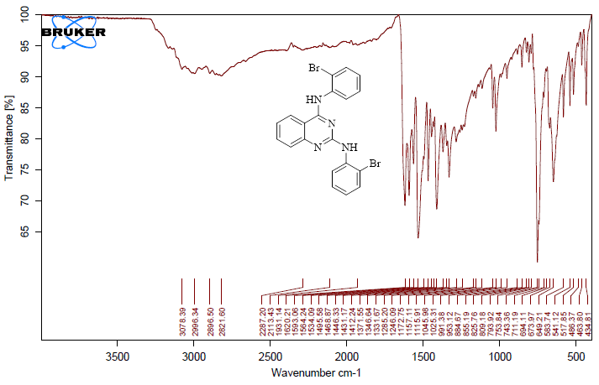

Figure S1. IR spectrum of 6a.

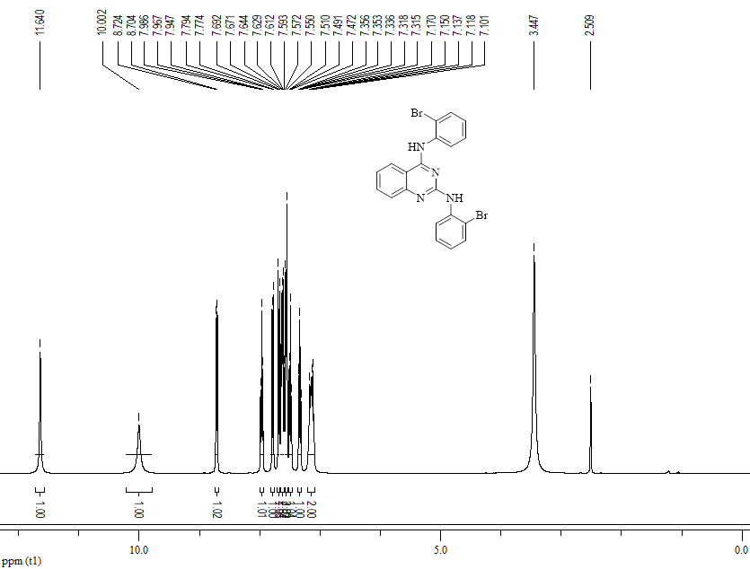

Figure S2. ¹H-NMR spectrum of 6a.

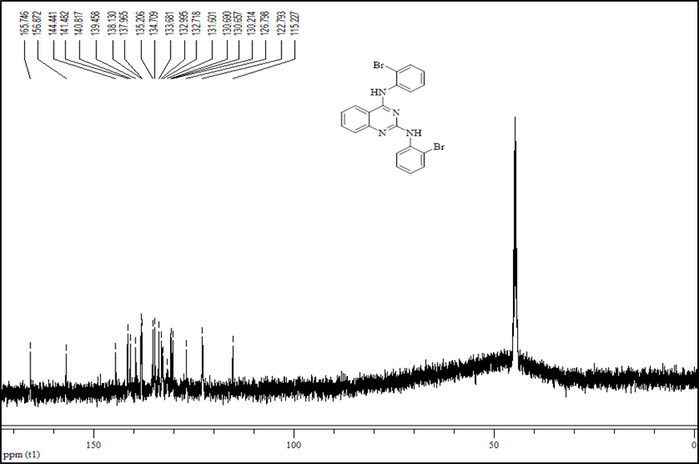

Figure S3. ¹³C-NMR spectrum of 6a.

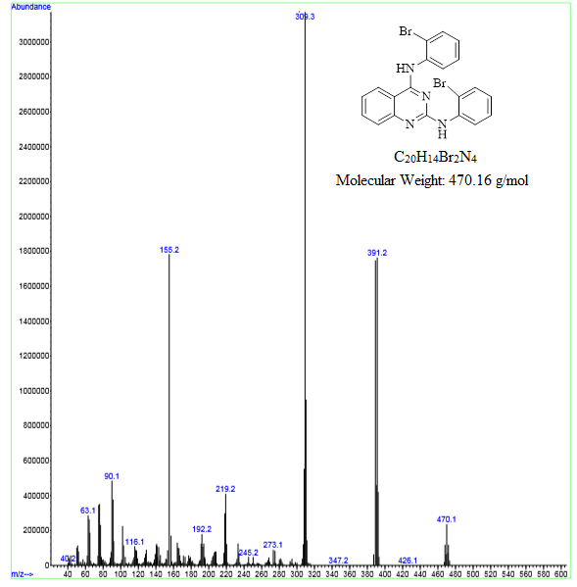

Figure S4. MASS spectrum of 6a.

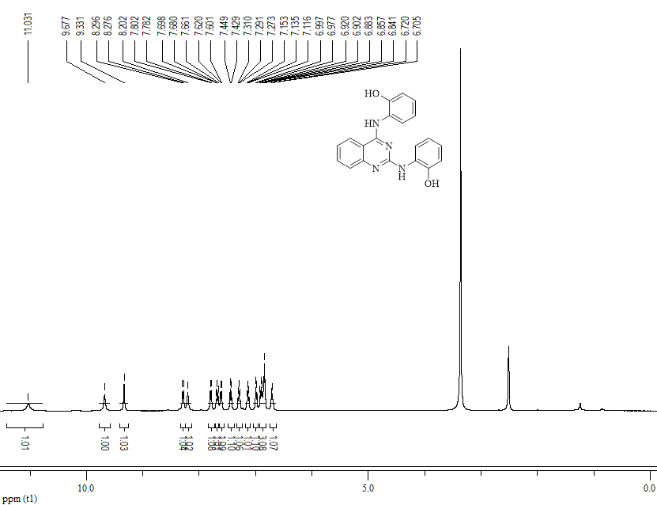

Figure S5. ¹H-NMR spectrum of 6b.

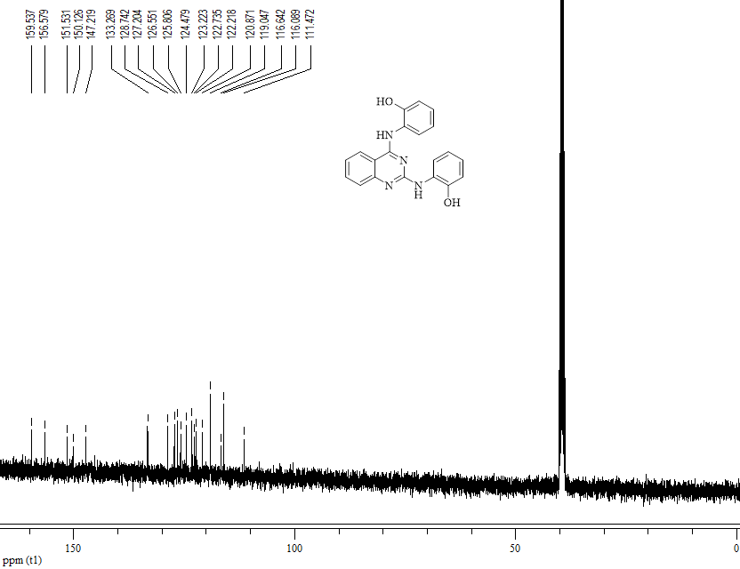

Figure S6. ¹³C-NMR spectrum of 6b.

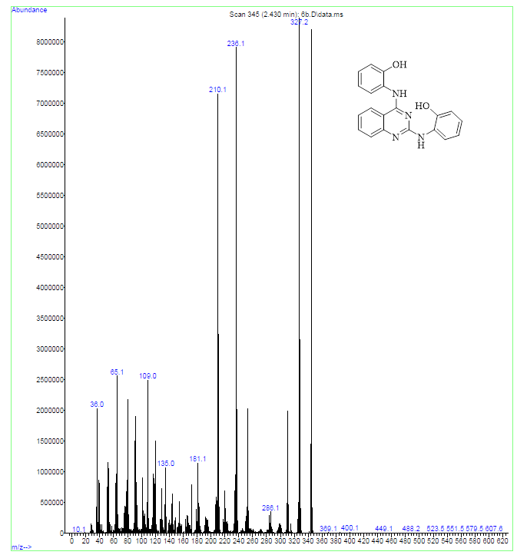

Figure S7. MASS spectrum of 6b.

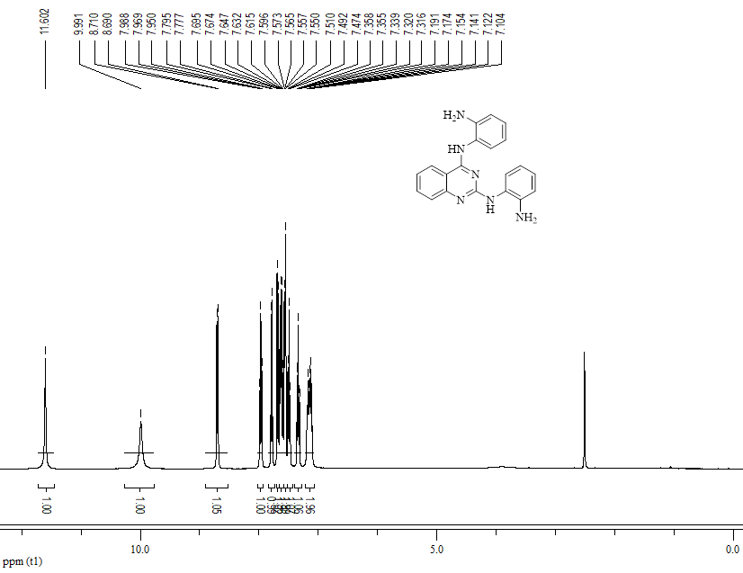

Figure S8. ¹H-NMR spectrum of 6c.

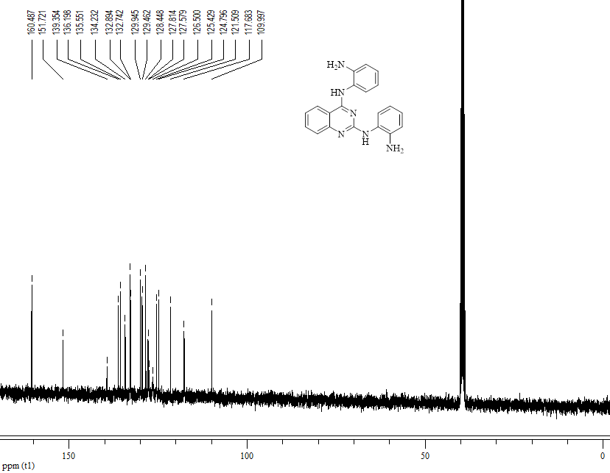

Figure S9. ¹³C-NMR spectrum of 6c.

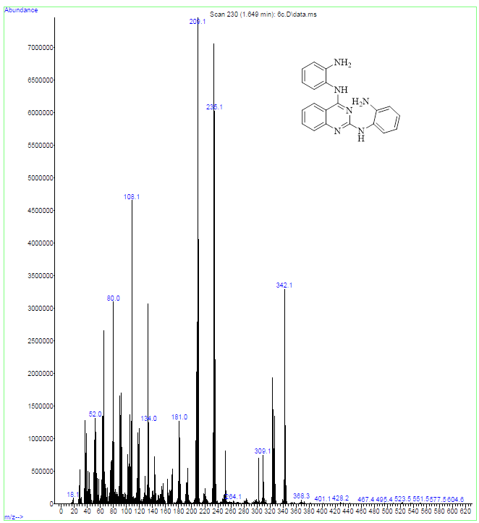

Figure S10. MASS spectrum of 6c.

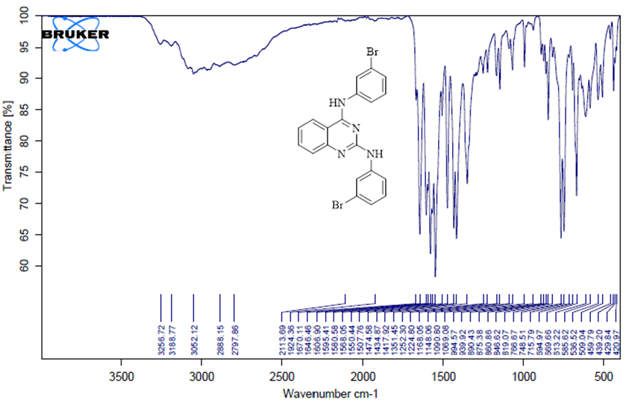

Figure S11. IR spectrum of 6d.

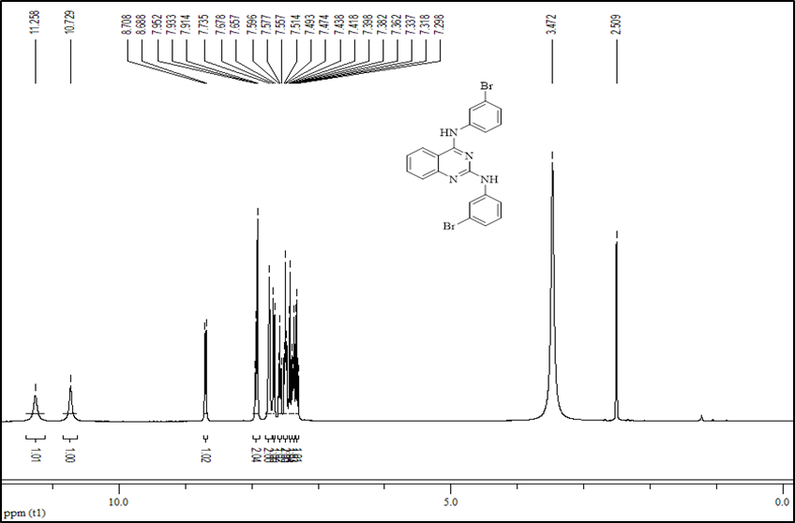

Figure S12. ¹H-NMR spectrum of 6d.

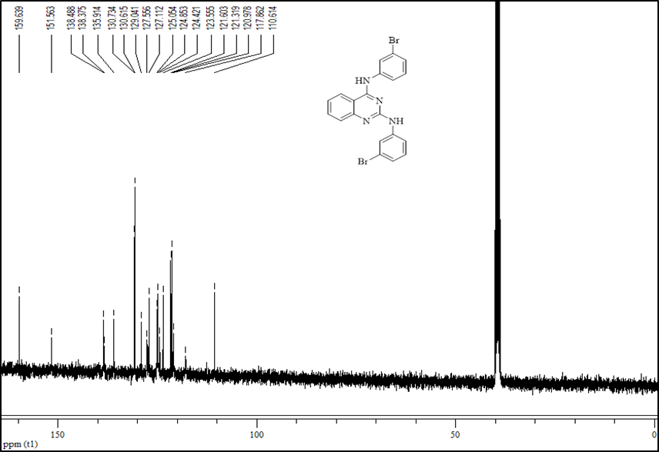

Figure S13. ¹³C-NMR spectrum of 6d.

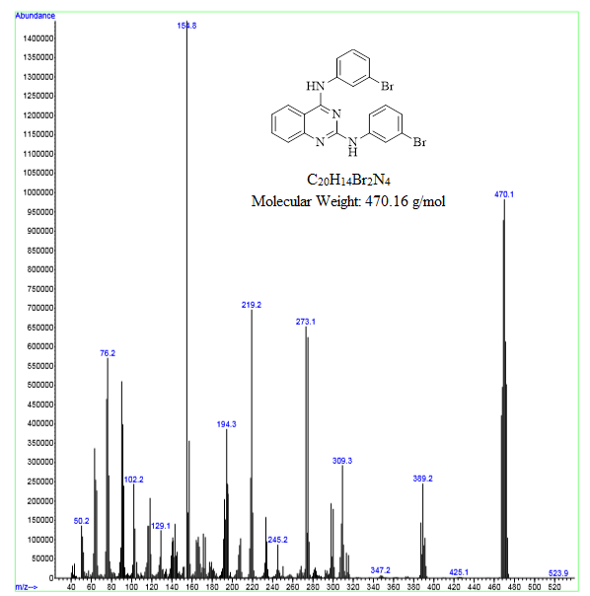

Figure S14. MASS spectrum of 6d.

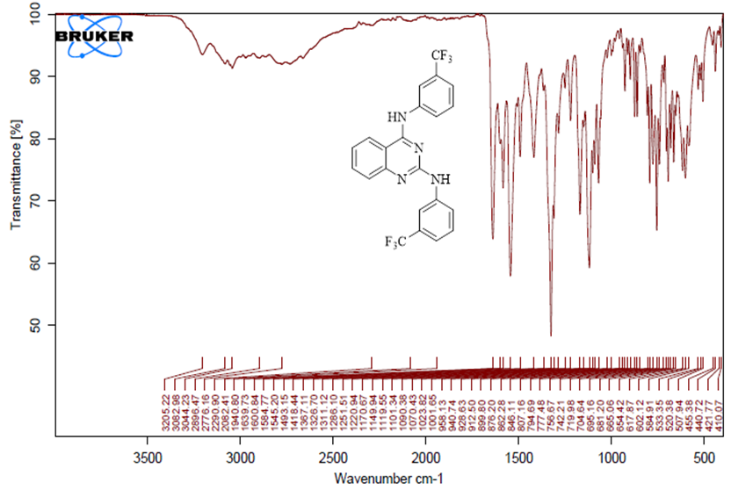

Figure S15. IR spectrum of 6e.

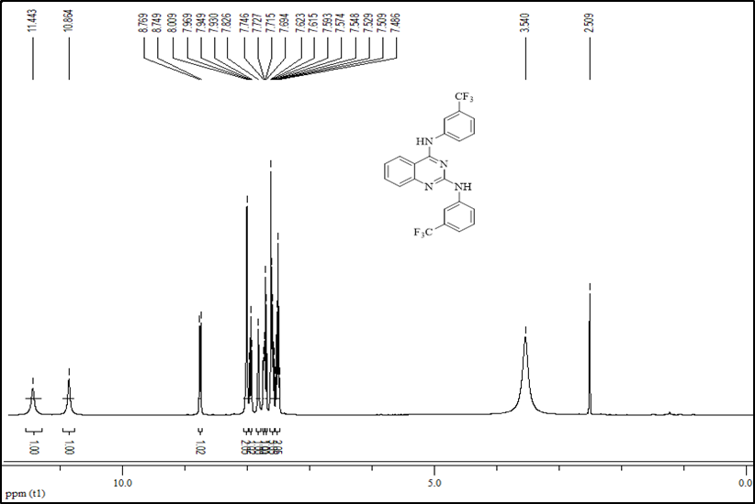

Figure S16. ¹H-NMR spectrum of 6e.

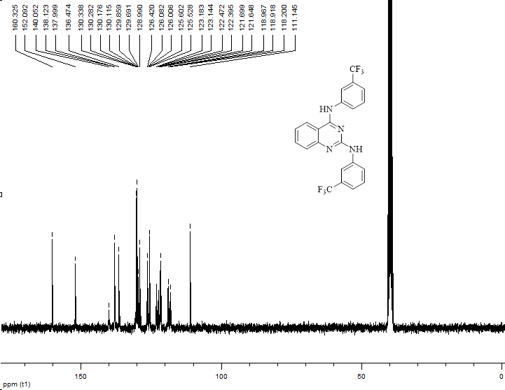
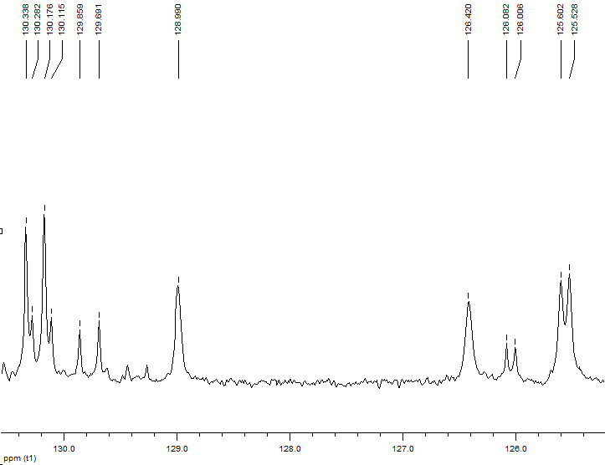

Figure S17. ¹³C-NMR spectrum of 6e.

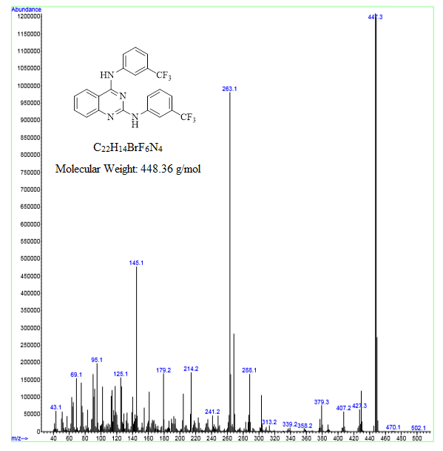

Figure S18. MASS spectrum of 6e.

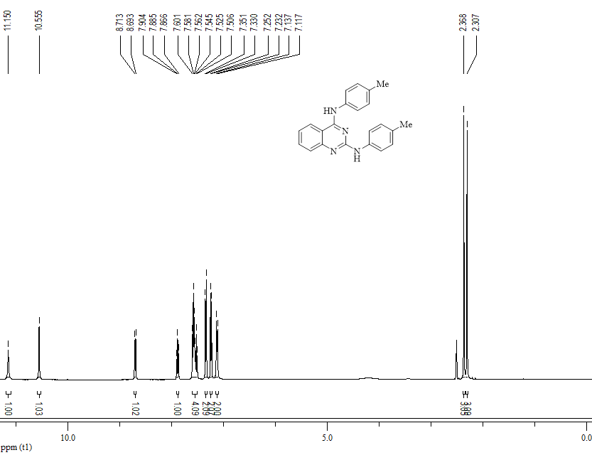

Figure S19. ¹H-NMR spectrum of 6f.

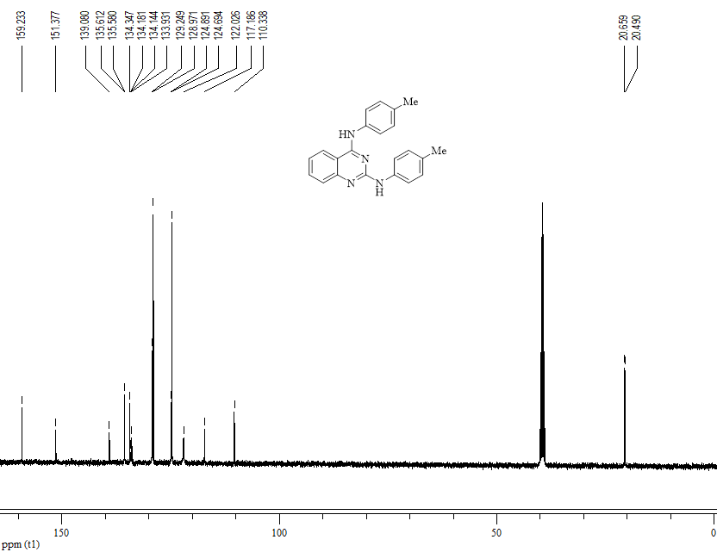

Figure S20. ¹³C-NMR spectrum of 6f.

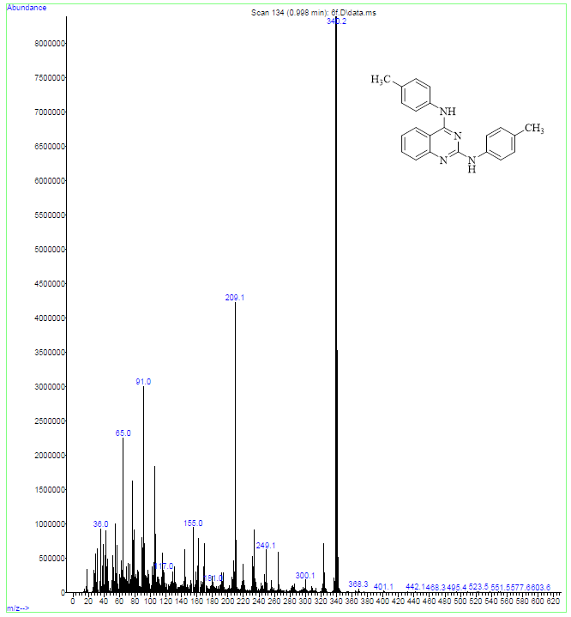

Figure S21. MASS spectrum of 6f.

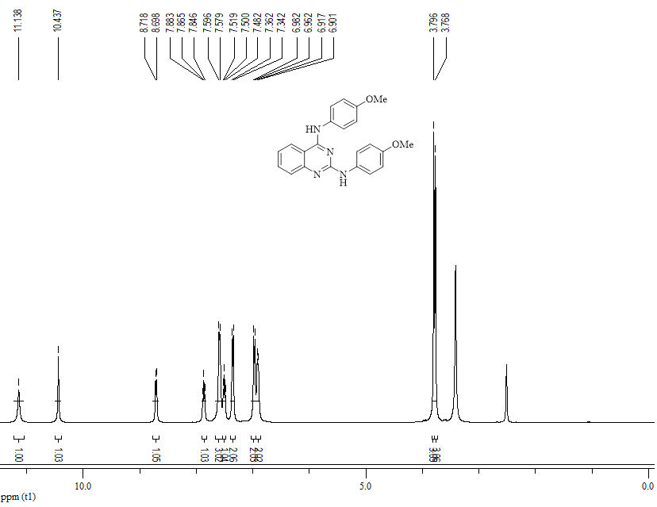

Figure S22. ¹H-NMR spectrum of 6g.

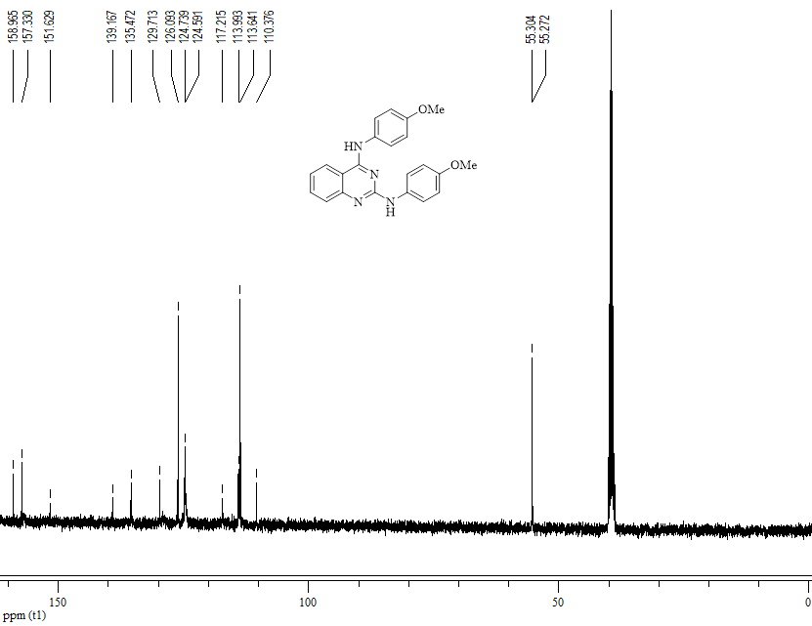

Figure S23. ¹³C-NMR spectrum of 6g.

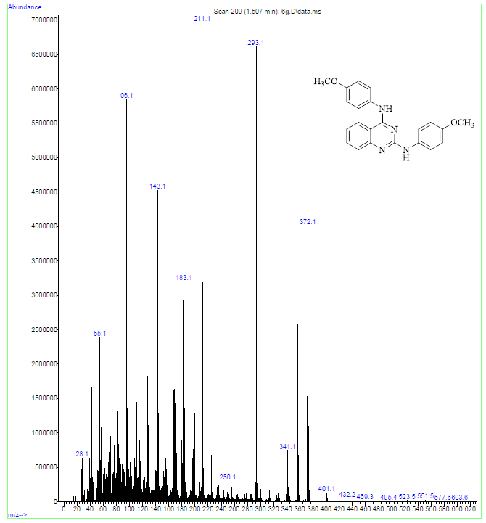

Figure S24. MASS spectrum of 6g.

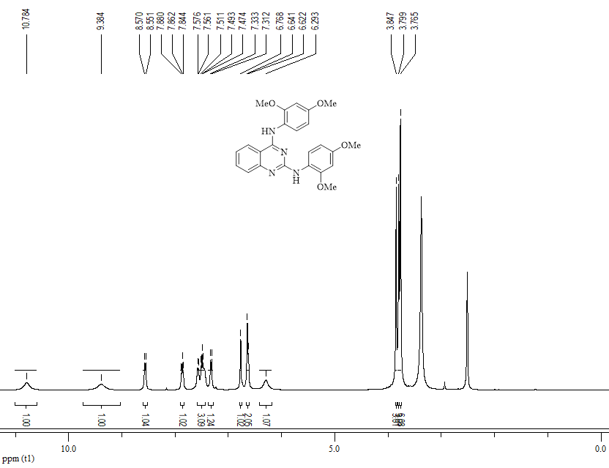

Figure S25. ¹H-NMR spectrum of 6h.

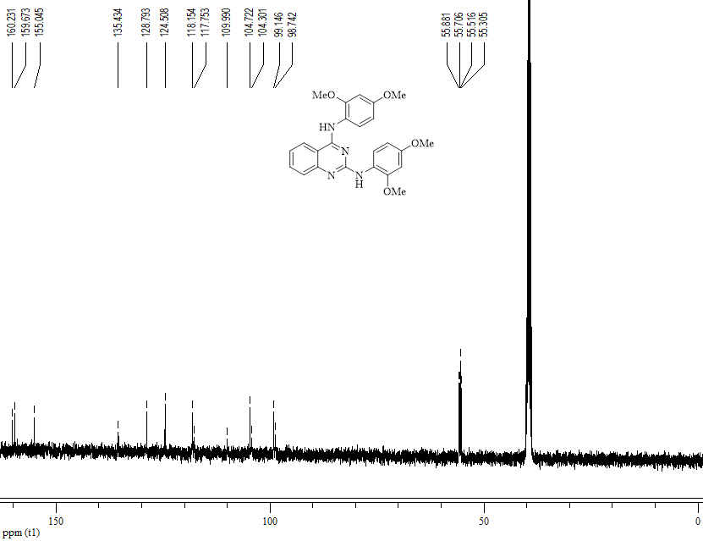

Figure S26. ¹³C-NMR spectrum of 6h.

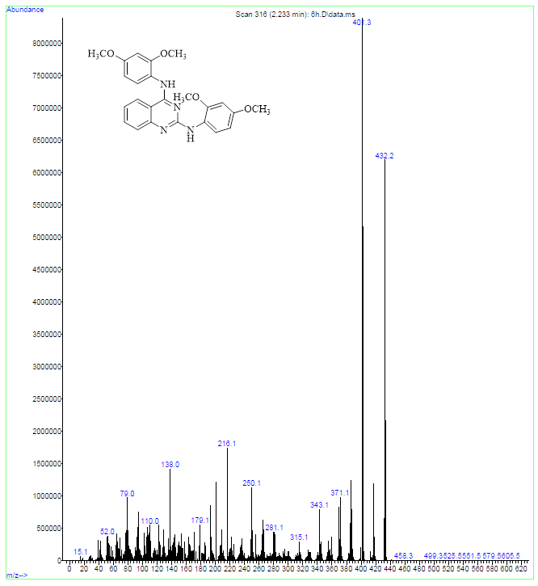

Figure S27. MASS spectrum of 6h.

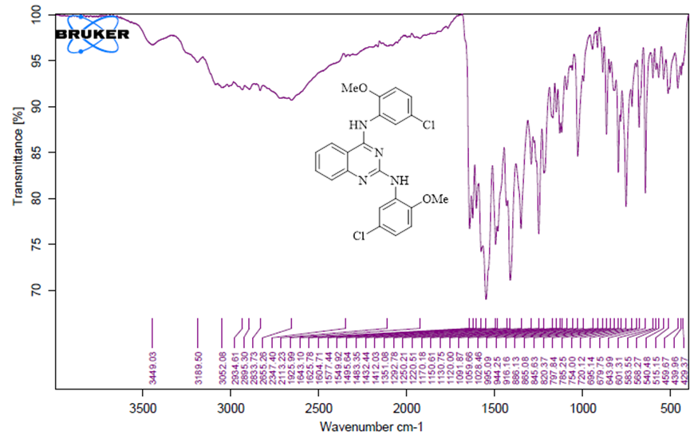

Figure S28. IR spectrum of 6i.

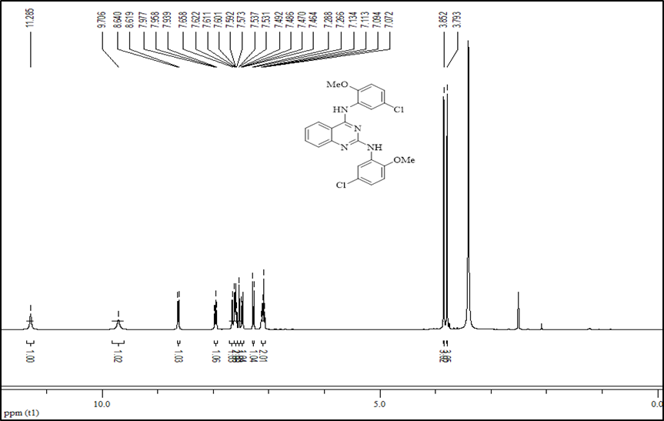

Figure S29. ¹H-NMR spectrum of 6i.

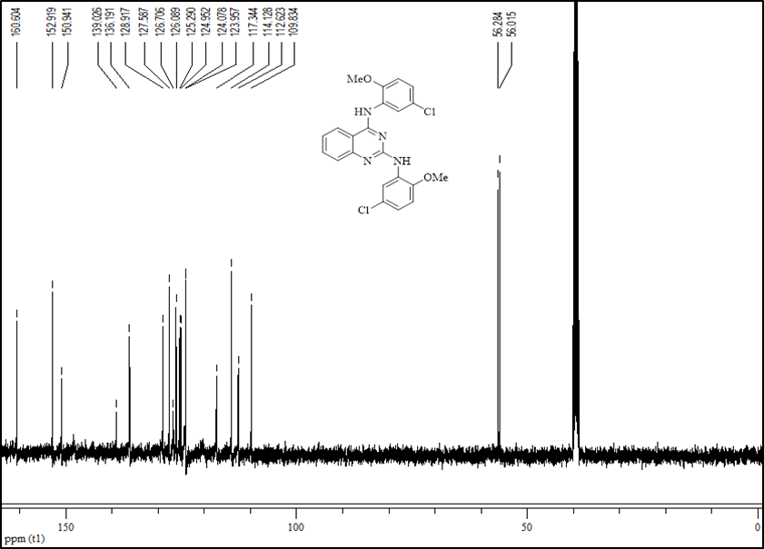

Figure S30. ¹³C-NMR spectrum of 6i.

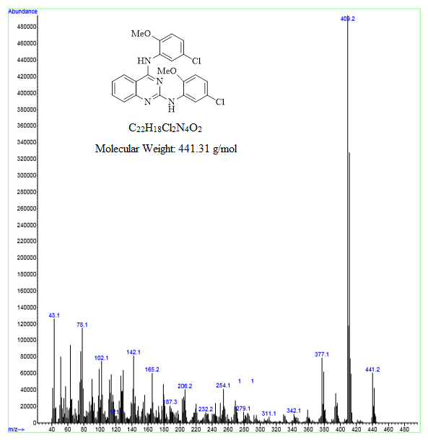

Figure S31. MASS spectrum of 6i.

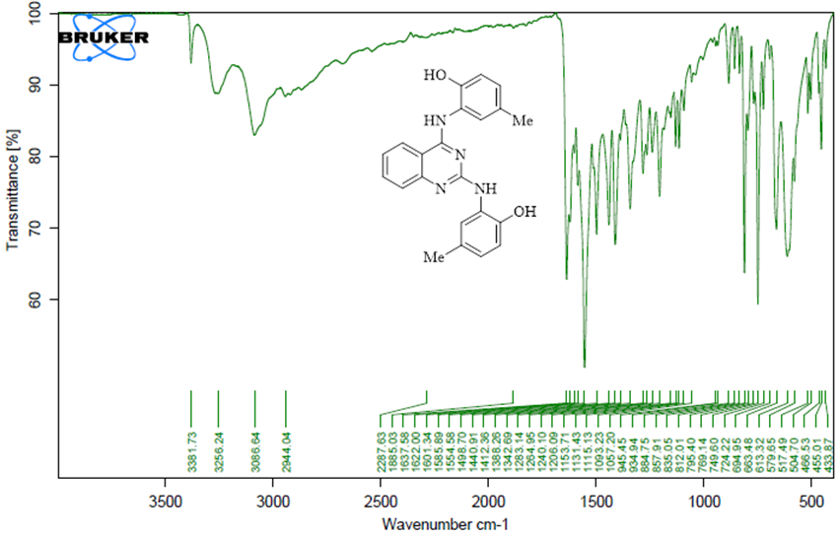

Figure S32. IR spectrum of 6j.

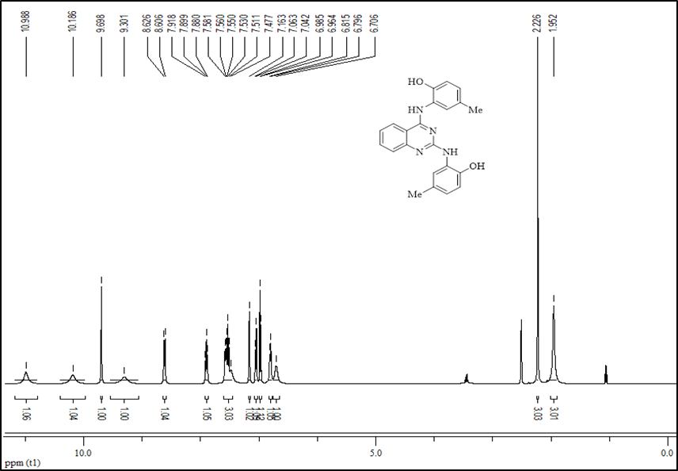

Figure S33. ¹H-NMR spectrum of 6j.

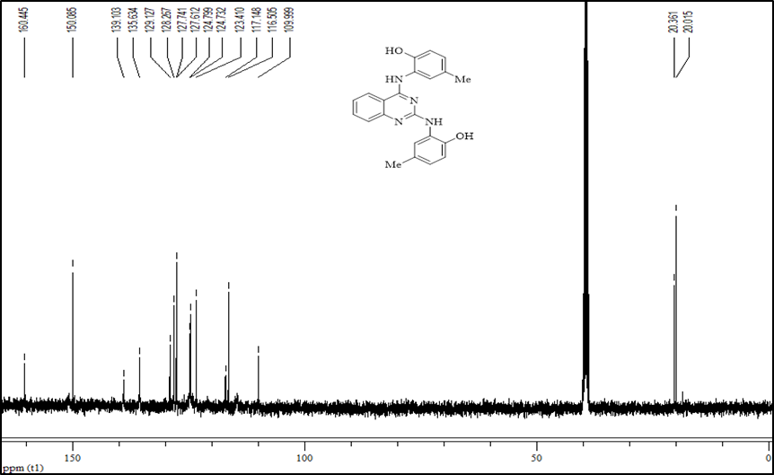

Figure S34. ¹³C-NMR spectrum of 6j.

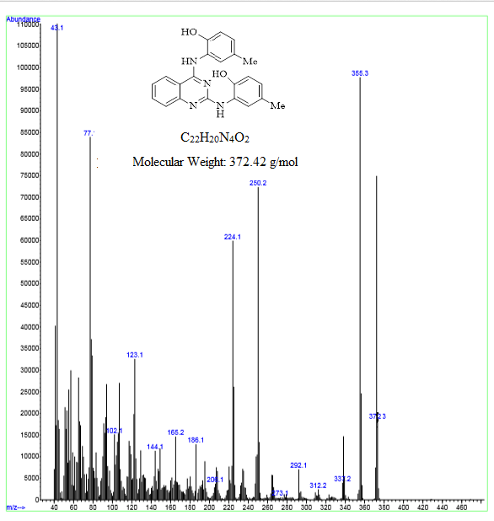

Figure S35. MASS spectrum of 6j.

*Corresponding author: Zahra Rezaei, Pharmaceutical Sciences Research Center, Shiraz University of Medical Sciences, P.O. Box: 71345-1798 Shiraz, Iran. Email: rezaeiza@sums.ac.ir 1: These authors contributed equally to this work.

