Supplementary Information

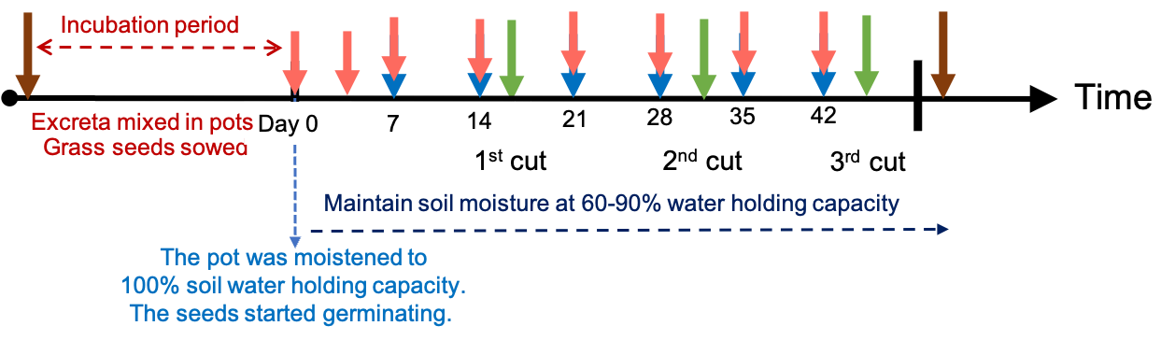
Figure S1 Timeline of the pot experiment. The arrows in brown, pink, blue and green indicate the timings of sampling soil, sampling soil solution, applying the heavy rain event, and cutting the grass, respectively. Figure modified from Kao et al. (2023a).

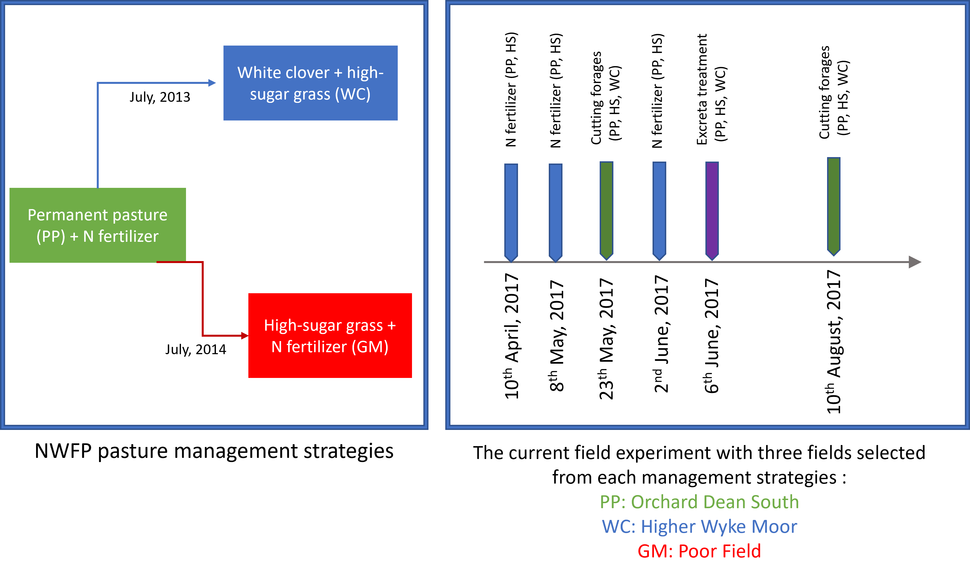
Figure S2 Timeline of the pasture management strategies of NWFP (left) and the timeline of the current field experiment (right).

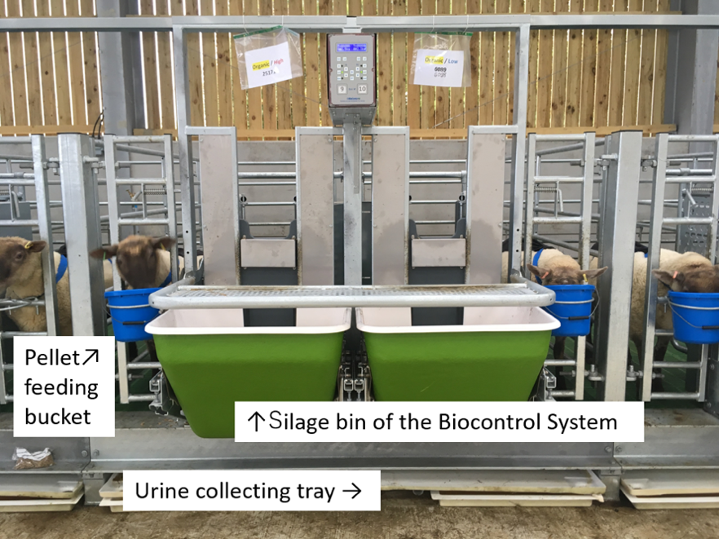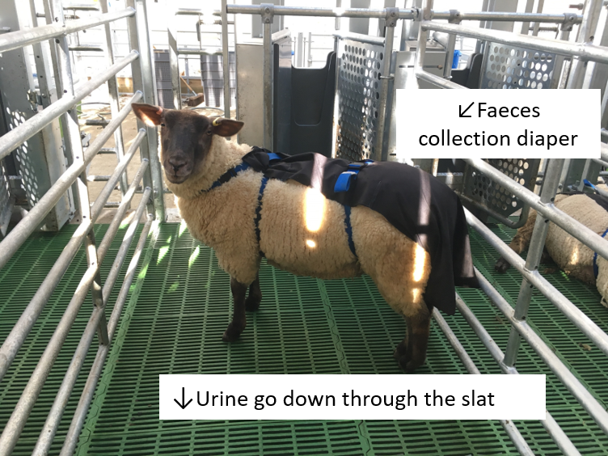
Figure S3 The facility used for feeding the sheep and collecting the sheep urine and faeces. (a) Biocontrol system with individual silage bin of which the weight can be measured and recorded automatically. (b) The inside of an individual pen. The faeces was collected using the diaper and the urine went down through the slat and was collected in the tray shown in (a). Figure modified from Kao et al. (2023b).
(a)
(b)

Table S1. The isotope mass and wavelength used and detection limit for each element in the ICP-MS and ICP-OES
Element | ICP-MS |  | ICP-OES
Element | Isotope mass (amu) | Detection limit  (µg L⁻¹) | Wavelength (nm) | Detection limit plant digests (mg L⁻¹) | Detection limit soil digests (mg L⁻¹)
Cd | 111 | 0.01 | -
Co | 59 | 0.05 | 228.616 | 0.002 | 0.002
Cu | 63 | 0.03 | 327.393 | 0.005 | 0.006
Fe | 57 | 0.10 | 238.204 | 0.031 | 0.695
Mn | 55 | 0.02 | 257.610 | 0.001 | 0.020
Mo | 95 | 0.02 | -
P | - |  | 213.617 | 0.256 | 0.132
S | - |  | 181.975 | 0.098 | 0.670
Se | 78 | 0.04 | -
Zn | - |  | 206.200 | 0.007 | 0.029
Na | - |  | 589.592 | 0.170 | 0.149
Ca | - |  | 315.887 | 0.027 | 0.283

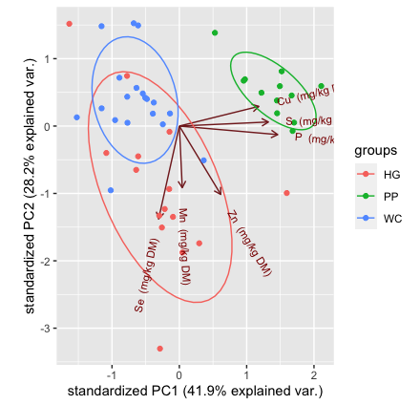
PP
WC
GM

Figure S4 PCA analysis of soil of different fields using the concentrations of Cu, Zn, Mn, Se, S and P in the soils. The soil samples were collected in June 2016 (approximately one year before the field experiment).
Table S2. Nutrient concentrations in the forages before the application of cattle manure to the fields
 | PP | WC | GM
N (w/w% in DM) | 3.08 (n=9) | 2.13 (n=11) | 2.59 (n=9)
P (mg kg-DM⁻¹) | 3415 (n=2) | 3280 (n=2) | 3364 (n=2)
S (mg kg-DM⁻¹) | 2760 (n=2) | 2914 (n=2) | 2383 (n=2)
Cu (mg kg-DM⁻¹) | 6.86 (n=2) | 6.23 (n=2) | 6.22 (n=2)
Zn (mg kg-DM⁻¹) | 23.0 (n=2) | 19.0 (n=2) | 22.3 (n=2)
Mn (mg kg-DM⁻¹) | 98.8 (n=2) | 103 (n=2) | 71.5 (n=2)
Se (mg kg-DM⁻¹) | 0.062 (n=2) | 0.056 (n=2) | 0.053 (n=2)

Table S3. Nutrient input from the animal excreta in the pot experiment and the field trial
Applied excreta |  | N | P | S | Cu | Zn | Mn | Se
Pot experiment
(Faeces from inorganic treatment: 22 g-DM pot⁻¹; Faeces from organic treatment: 26 g-DM pot⁻¹; Urine: 70 mL pot⁻¹)
 |  | (g pot⁻¹) | (mg pot⁻¹) | (mg pot⁻¹) | (mg pot⁻¹) | (mg pot⁻¹) | (mg pot⁻¹) | (μg pot⁻¹)
Faeces from the inorganic treatment |  | - | 271 | 77.4 | 1.05 | 7.55 | 8.58 | 12.7
Faeces from the organic treatment |  | - | 316 | 96.1 | 1.24 | 8.58 | 11.1 | 15.8
Urine from the inorganic treatment |  | 105 | 0.245 | 82.3 | 0.003 | 0.383 | 0.008 | 2.087
Urine from the organic treatment |  | 116 | 0.255 | 74.3 | 0.003 | 0.376 | 0.008 | 1.553
Field | Applied excreta | Field trial (Faeces: 20 kg m⁻²; Urine: 5 L m⁻²)
Field | Applied excreta | (g pot⁻¹) | (g pot⁻¹) | (g pot⁻¹) | (mg pot⁻¹) | (mg pot⁻¹) | (g pot⁻¹) | (mg pot⁻¹)
PP | Faeces | 2524 | 757 | 267 | 2104 | 6065 | 37.5 | 12.9
PP | Urine | 62.1 | 276 | 62.1 | 0.267 | 3.22 | 0.001 | 1.473
WC | Faeces | 2380 | 711 | 265 | 1740 | 5508 | 50.1 | 15.9
WC | Urine | 36.7 | 243 | 36.7 | 0.452 | 13.2 | 0.001 | 1.012
GM | Faeces | 2598 | 759 | 269 | 1994 | 6352 | 31.7 | 16.1
GM | Urine | 32.5 | 290 | 32.5 | 0.394 | 4.48 | 0.001 | 1.441

Table S4. Soil extractable Cu, Zn and Mn in the pot experiment
Treatments |  | Extractable Cu  (mg kg⁻¹) | Extractable Zn  (mg kg⁻¹) | Extractable Mn  (mg kg⁻¹) | Extractable NO₂⁻+NO₃⁻+NH₄⁺  (g-N kg-DM⁻¹ soil) | Extractable K  (mg kg⁻¹) | Extractable PO₄³⁻  (mg kg⁻¹)
 |  | (mean ± SE)†
Soil of low organic carbon | Untreated | 0.00±0.001 | 0.33±0.004 | 14.2±0.28 | 8.74±0.752 | 277±1.4 | 29.5±0.47
Soil of low organic carbon | Faeces from inorganic treatment | 0.04±0.004 | 0.11±0.004 | 6.93±0.239 | 39.4±1.78 | 385±0.7 | 63.9±1.85
Soil of low organic carbon | Faeces from organic treatment | 0.07±0.006 | 0.18±0.008 | 24.9±0.56 | 22.2±2.31 | 377±3.0 | 89.9±1.84
Soil of low organic carbon | Urine from inorganic treatment | 0.03±0.001 | 0.02±0.004 | 4.11±0.058 | 268±25.3 | 964±3.9 | 32.3±0.14
Soil of low organic carbon | Urine from organic treatment | 0.02±0.001^{i} | 0.02±0.001 | 3.47±0.042 | 287±11.0 | 869±2.3 | 31.9±0.54
Soil of low organic carbon | Urine and faeces from inorganic treatment | 0.08±0.001 | 0.04±0.001 | 5.08±0.014 | 282±6.79 | 1070±9.0 | 73.3±2.27
Soil of low organic carbon | Urine and faeces from organic treatment | 0.05±0.002 | 0.06±0.001 | 9.88±0.056 | 313±23.5 | 936±7.4 | 66.8±1.66
Soil of high organic carbon | Untreated | 0.02±0.001 | 1.39±0.005 | 12.0±0.05 | 15.9±2.82 | 147±0.4 | 64.8±0.79
Soil of high organic carbon | Faeces from inorganic treatment | 0.05±0.001 | 0.63±0.009 | 3.84±0.018 | 62.3±4.89 | 228±1.1 | 95.0±4.03
Soil of high organic carbon | Faeces from organic treatment | 0.06±0.001 | 0.69±0.005 | 4.13±0.124 | 65.0±5.02 | 208±3.1 | 117±3.3
Soil of high organic carbon | Urine from inorganic treatment | 0.02±0.001 | 0.21±0.002 | 0.65±0.010 | 349±14.8 | 807±4.1 | 60.9±1.79
Soil of high organic carbon | Urine from organic treatment | 0.03±0.000 | 0.18±0.002 | 0.68±0.003 | 299±6.0 | 757±4.1 | 64.9±1.15
Soil of high organic carbon | Urine and faeces from inorganic treatment | 0.08±0.001 | 0.18±0.003 | 1.07±0.024 | 358±12.9 | 873±1.0 | 107±4.7
Soil of high organic carbon | Urine and faeces from organic treatment | 0.10±0.007 | 0.15±0.005 | 1.05±0.090 | 377±10.6 | 808±7.2 | 123±4.7

