Automatic wild bird repellent system that is based on deep-learning-based wild bird detection and integrated with a laser rotation mechanism
Yu-Chieh Chen¹, Jing-Fang Chu², Kuang-Wen Hsieh^{2,3}, Tzung-Han Lin⁴, Pei-Zen Chang¹, and Yao-Chuan Tsai^{2,3,*}
¹ National Taiwan University, Institute of Applied Mechanics, Taipei, 106319, Taiwan
² National Chung Hsing University, Department of Bio-Industrial Mechatronics Engineering, Taichung, 402202, Taiwan
³ Smart Sustainable New Agriculture Research Center (SMARTer), Taichung, 402, Taiwan
⁴ National Taiwan University of Science and Technology, Graduate Institute of Color and Illumination Technology, Taipei, 106335, Taiwan
* yctsaii@dragon.nchu.edu.tw

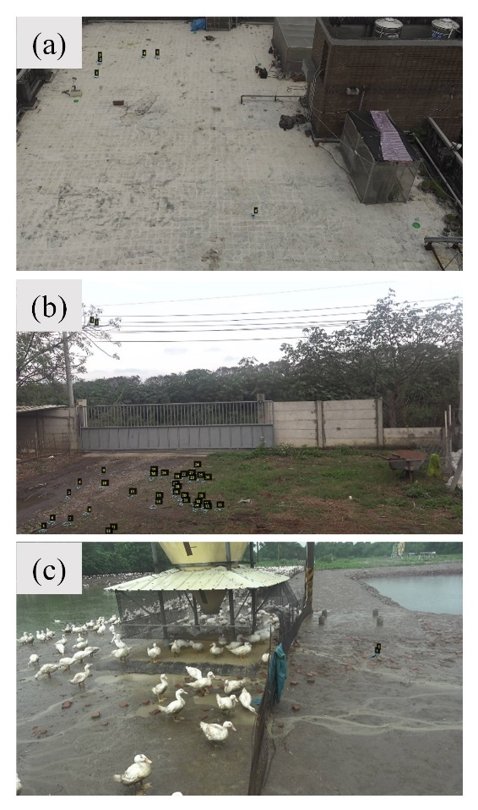
Fig. S1. Wild bird images captured from (a) the roof of the agricultural machinery factory at National Chung Hsing University in Taichung, (b) a goose farm in Yunlin, and (c) a duck farm in Yunlin.
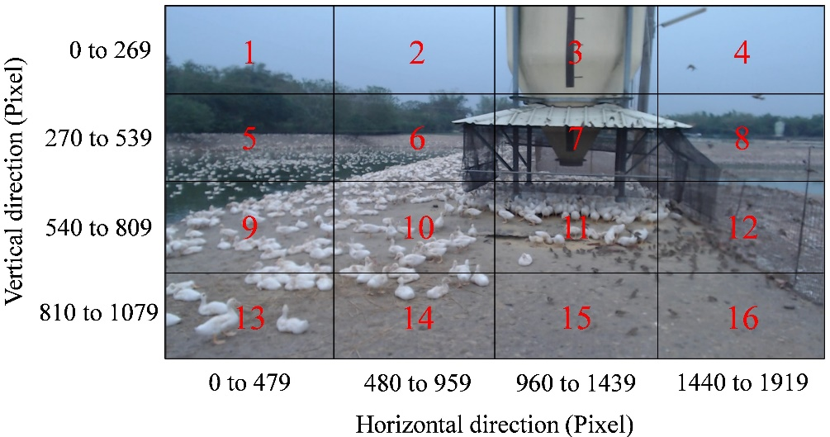
Fig. S2. Division of a captured image into 16 regions.
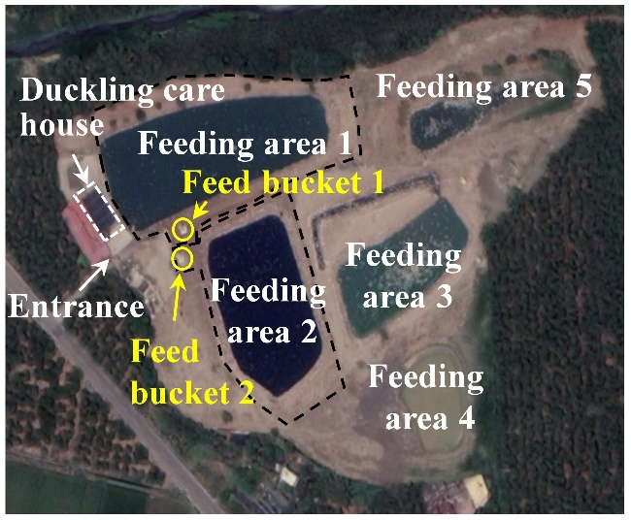
Fig. S3. Aerial photo of the experimental field (source: Google Earth, 2020).
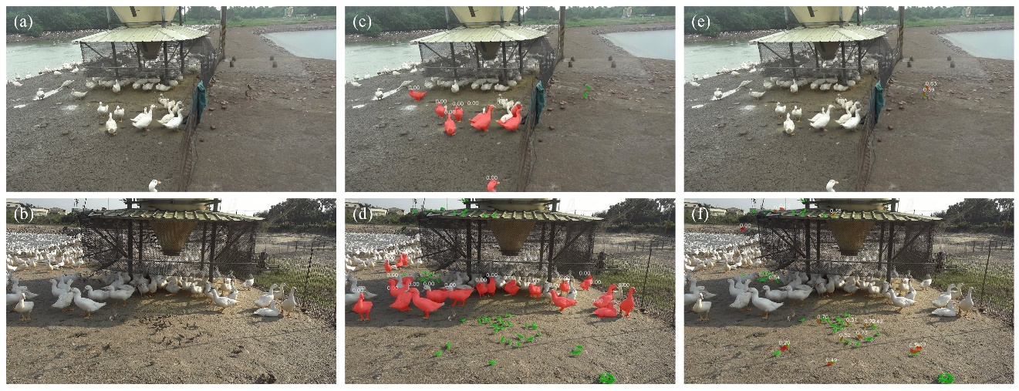
Fig. S4. Visual examples of the wild bird detection results at the feed bucket 1 and the feed bucket 2. (a)(b) Original image. (c)(d) Detected with COCO pre-trained model. (e)(f) Detected with optimized wild bird detection model.

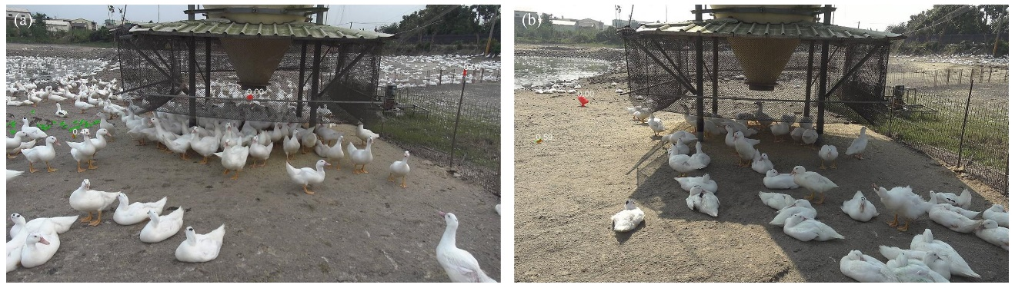
Fig. S5. Visual examples of the false detection of wild birds.
Table S1. Wild bird population distribution of each dataset.
Range of  bird number | Number of images in  the training dataset | Number of images in  the validation dataset | Number of images  in the test dataset
1~10 | 179 | 172 | 39
11~20 | 60 | 41 | 8
21~30 | 26 | 13 | 7
31~40 | 12 | 16 | 6
41~50 | 11 | 3 | 6
51~60 | 4 | 2 | 6
61~70 | 8 | 0 | 2
71~80 | 10 | 2 | 4
81~90 | 4 | 1 | 2
91~100 | 2 | 0 | 0
101~110 | 1 | 0 | 0
111~120 | 0 | 0 | 0
121~130 | 0 | 0 | 0
131~140 | 1 | 0 | 0
141~150 | 0 | 0 | 0
151~160 | 0 | 0 | 0
161~170 | 1 | 0 | 0
171~180 | 0 | 0 | 0
181~190 | 1 | 0 | 0

